**Report**

**32 threads:**

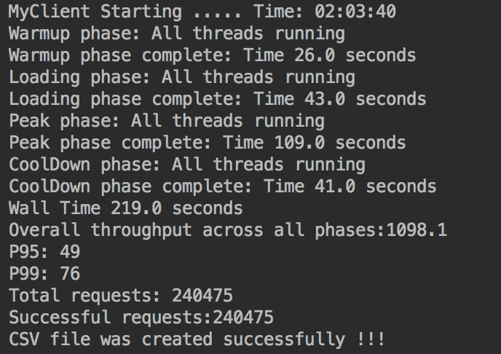

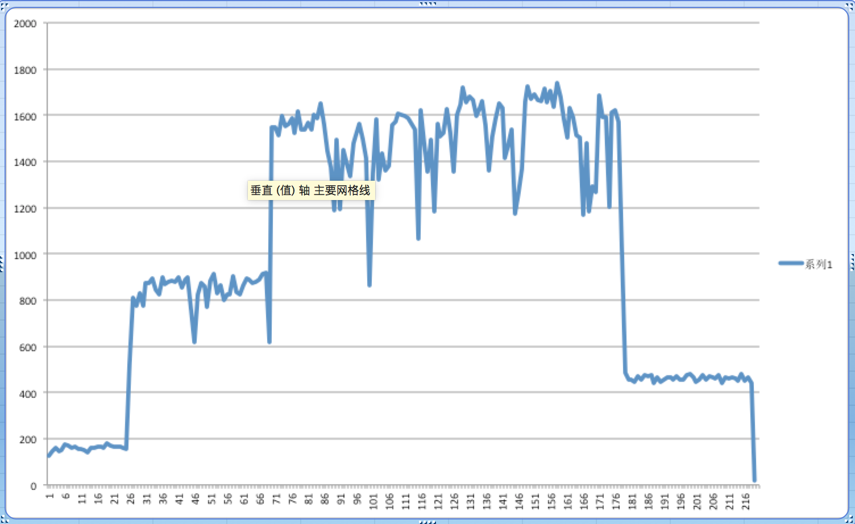

**64 threads:**

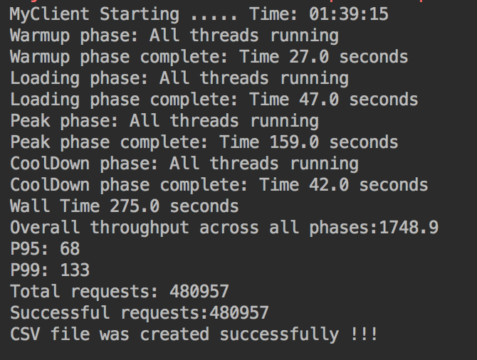

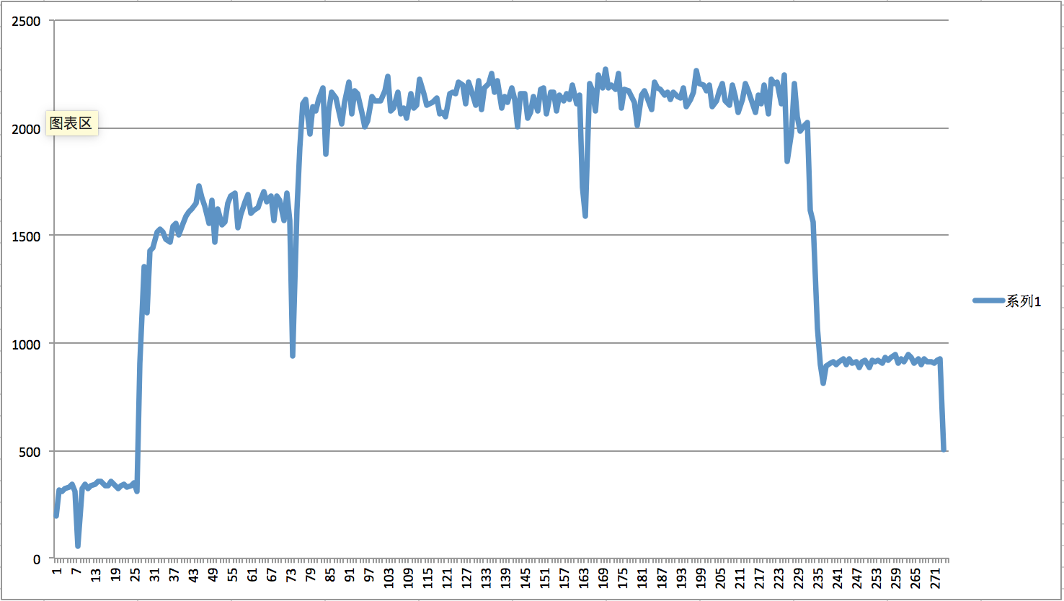

**128 threads:**

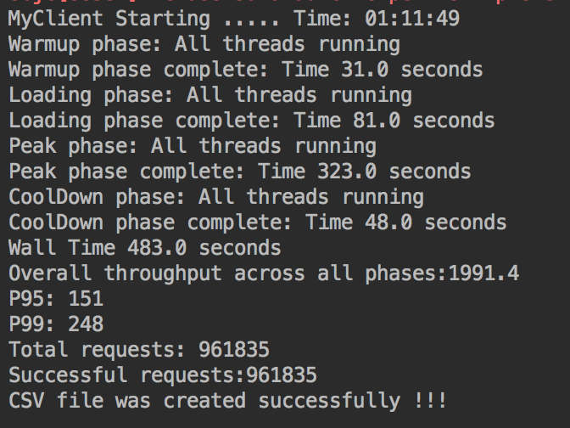

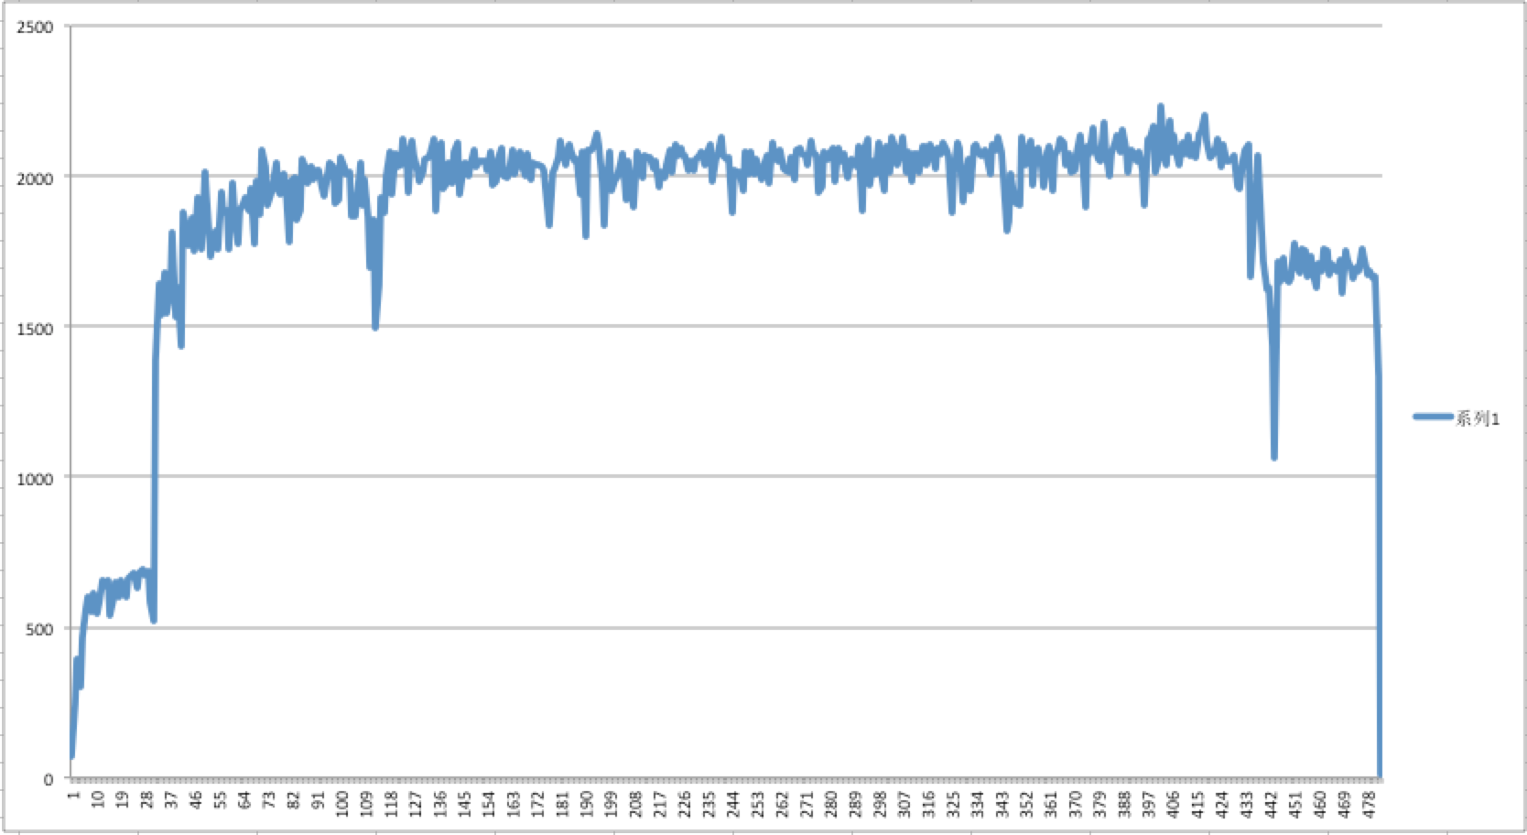

**256 threads:**

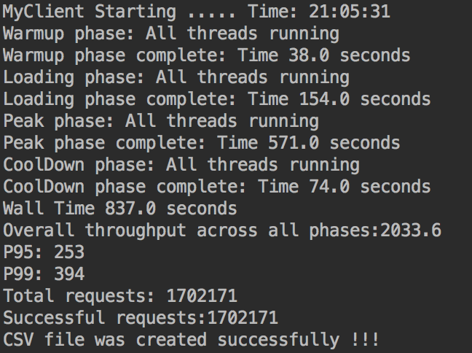

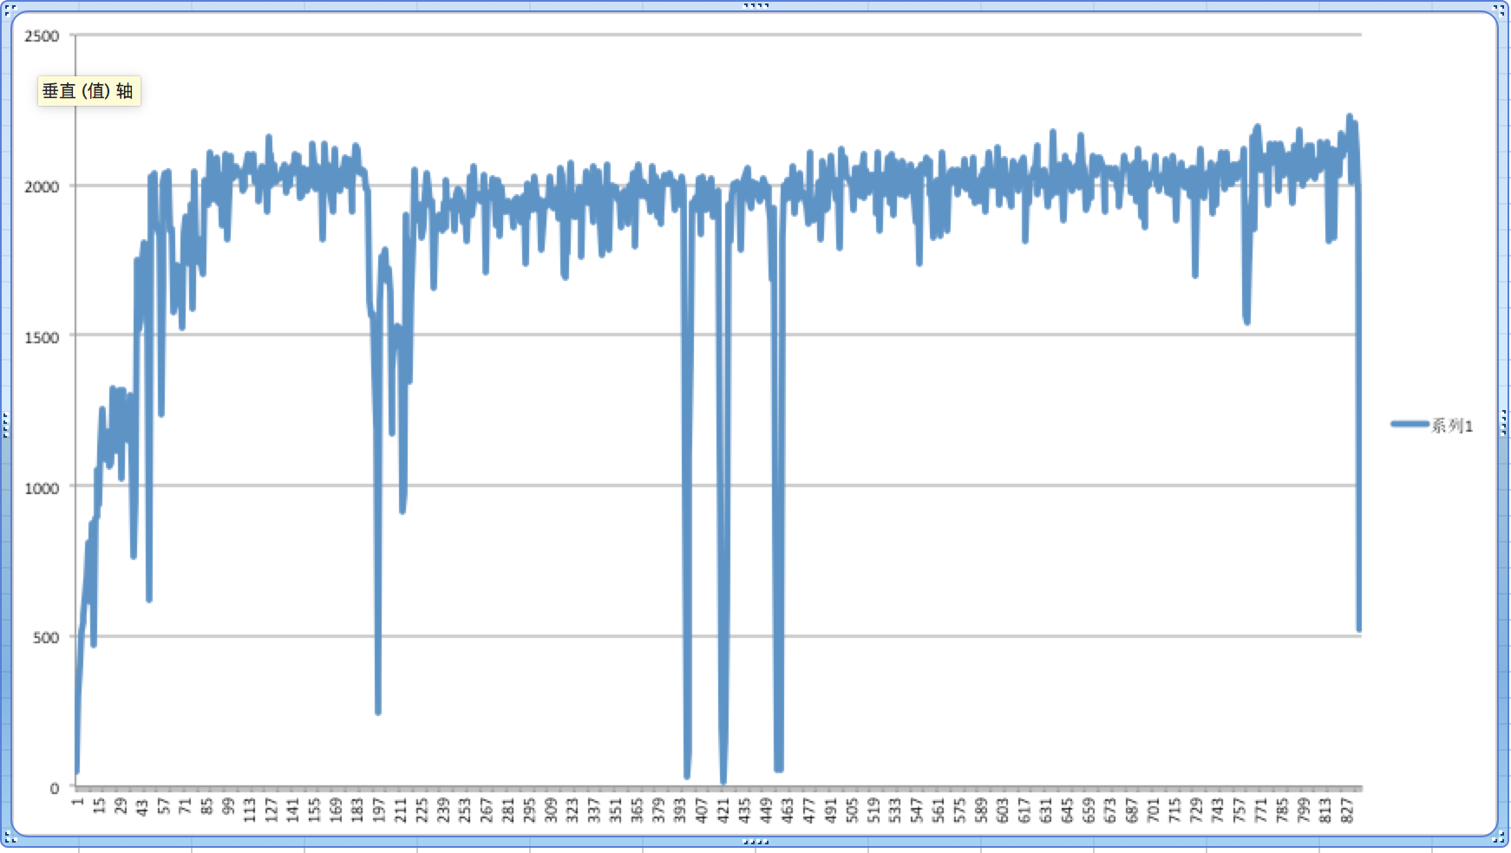

**Using Load Balancer: 4 instances in N California**

**32Threads:**

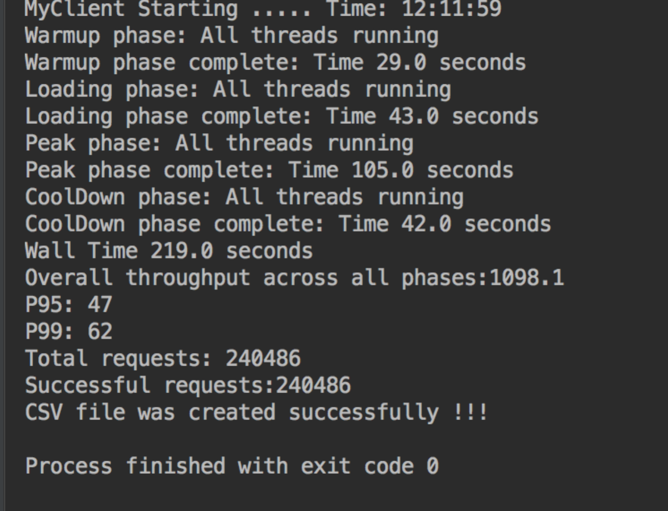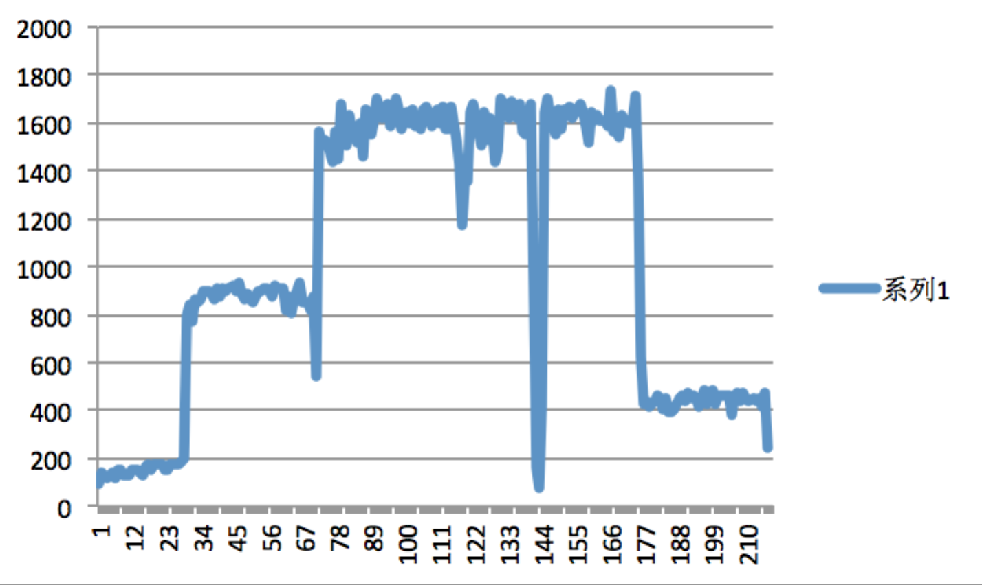

**64 threads:**

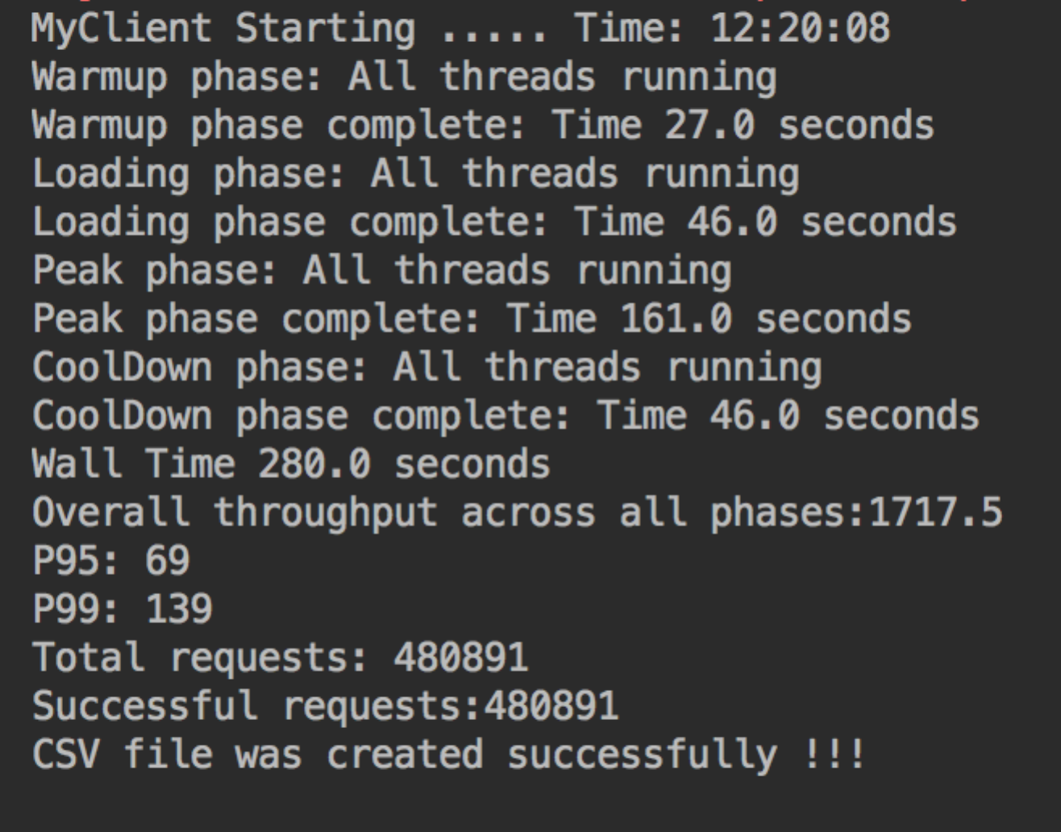

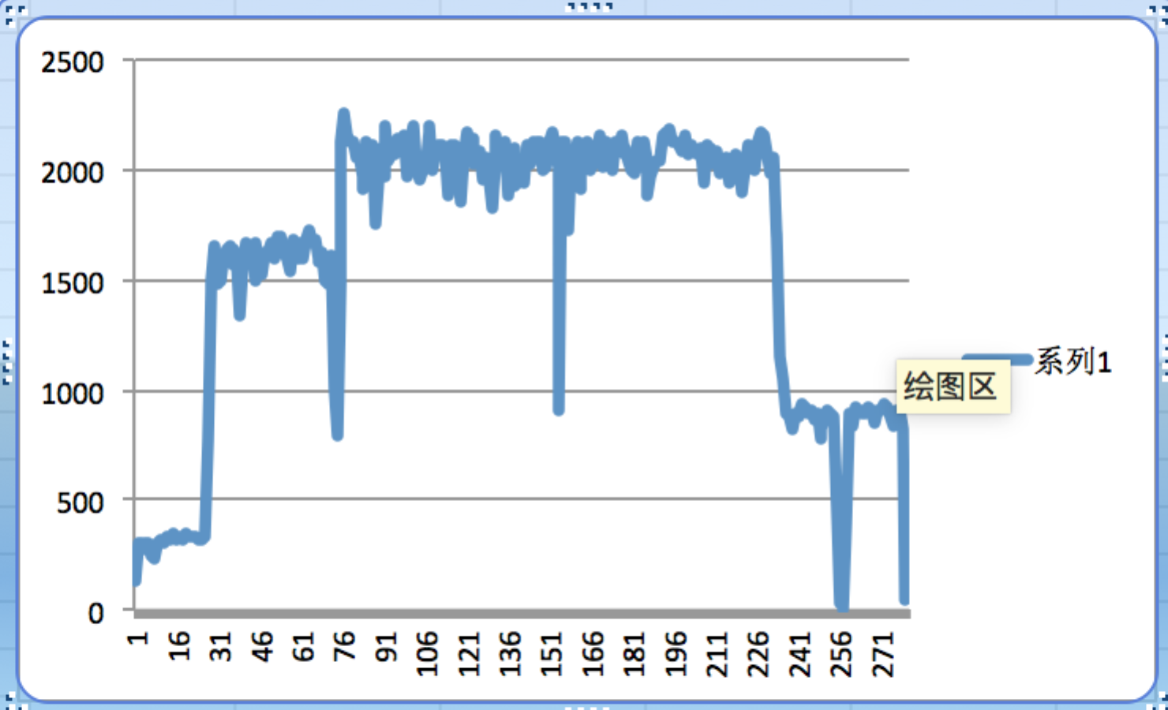

**128 threads:**

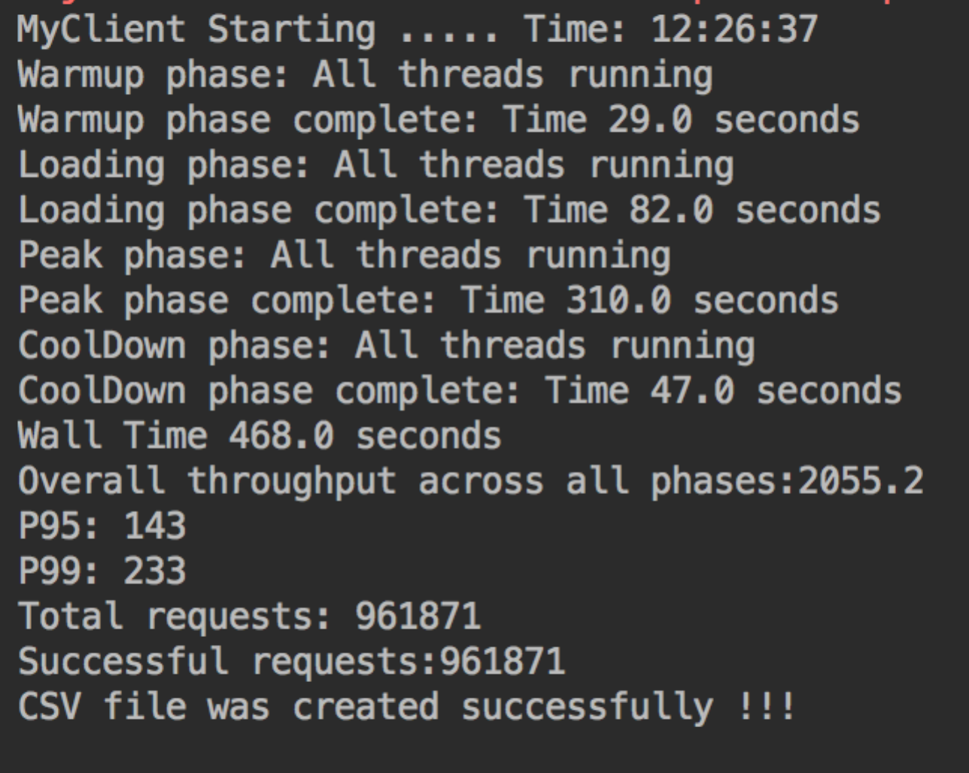

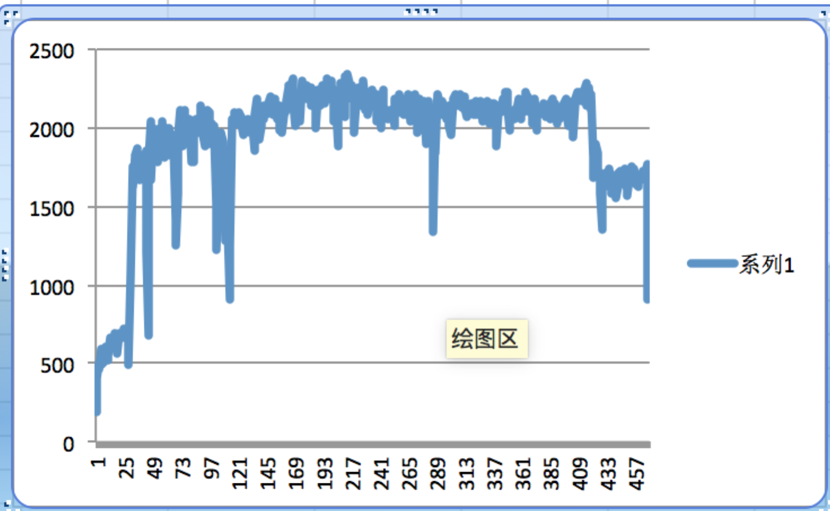

**256 threads:**

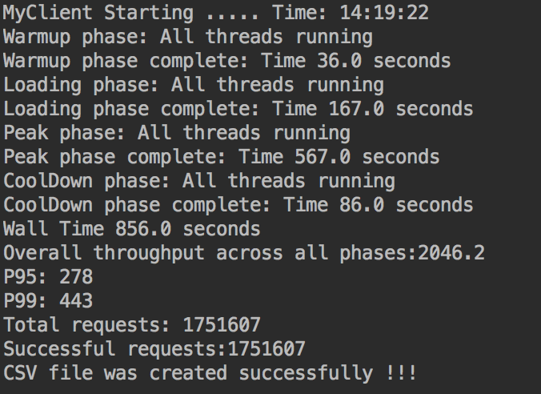

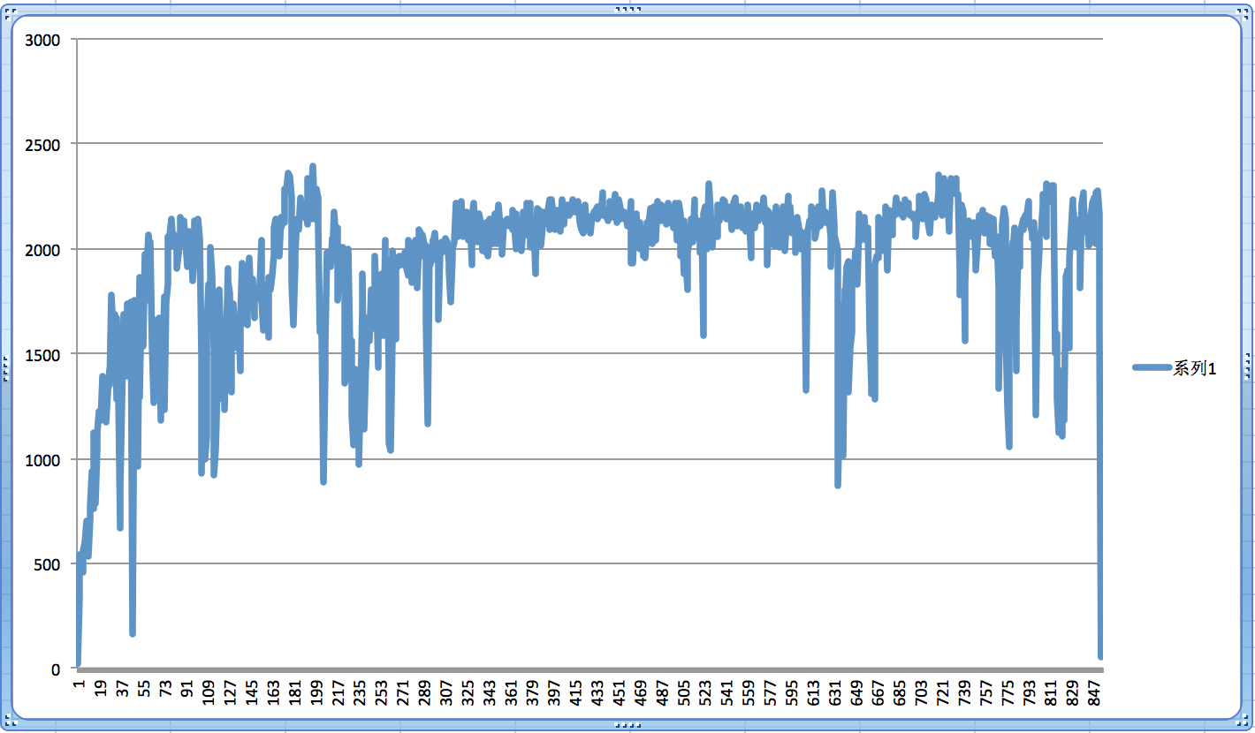

Statement and Comparison:

Launched 4 instance in N California and run them at the same time to get connection with my local client. The number of connections meanwhile grows from 60-70 to almost 300 by using the load balancer. Wall time makes no much difference, I guess because I set both database and ec2 instance in California, it will cause propagation delay on wall time. In theory, by using loading balancer, it should’ve saved a lot of time on sending and receiving requests because of the scalability of using the multiple servers.