1. We created Line Chart of Sales by Month by converting order date to Months.

Here maximum sales happen in the month of November of all the years. Which is around 352K.

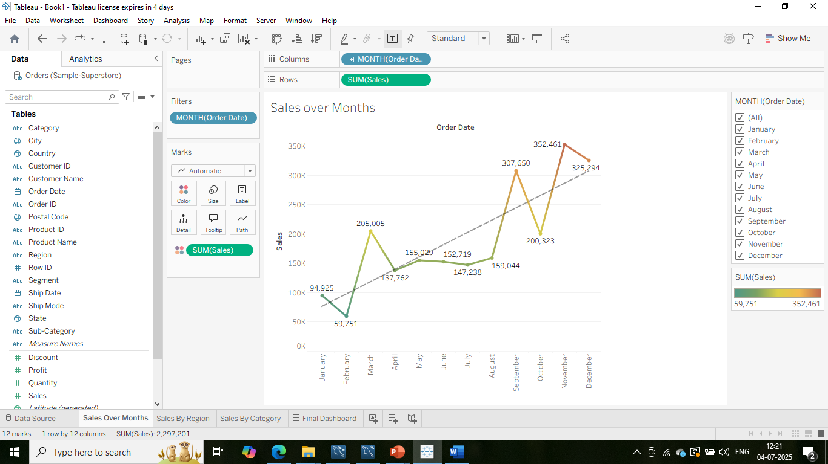

1. We created Sales by region Bar Chart and the maximum sales happened in the region of west which is around 725k

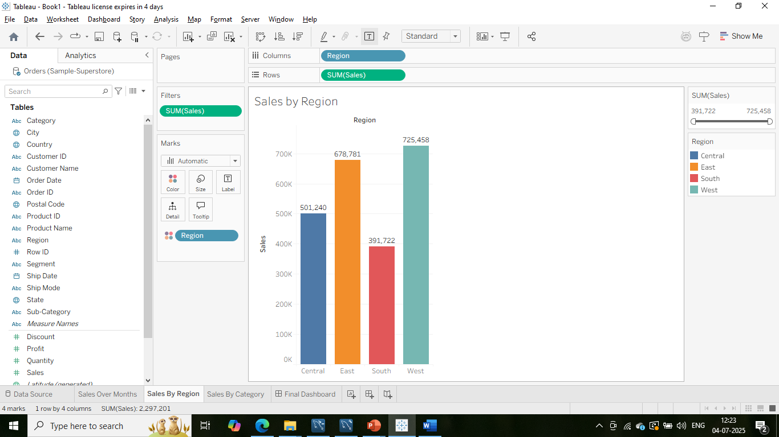

1. We created Donut Chart of Sales By Category where maximum sales happen in Technology category which is 836k and total sales is 2297k.

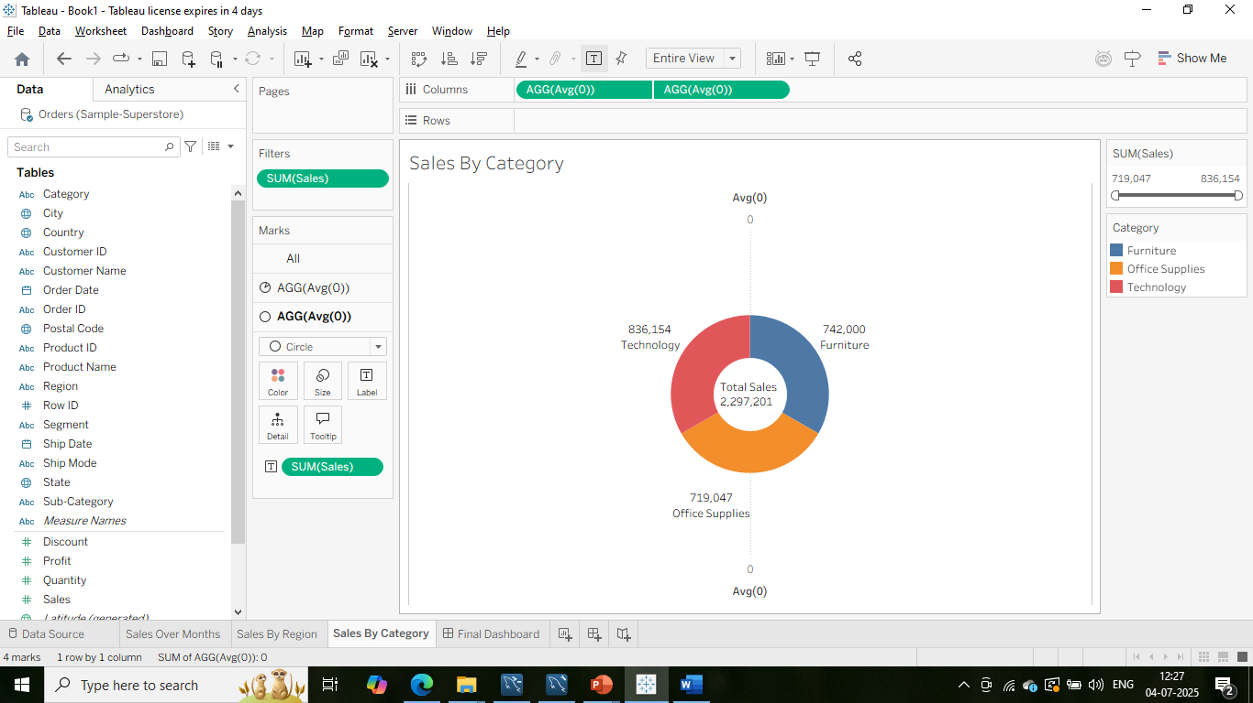

1. Here is the final dashboard where all three charts : line chart, bar chart and donut chart are getting displayed.

