NSE Options Analytics System
Real-Time Options Data Ingestion & Metrics Engine
Technical Documentation & Setup Guide
Platform | Python 3.8+ · FastAPI · React
Data source | NSE India (www.nseindia.com) — live polling
Symbols | NIFTY · BANKNIFTY
Metrics | Greeks (Δ Γ Θ V) · PCR · Max Pain · IV Skew · OI Buildup/Unwind
Storage | SQLite · CSV / Parquet
Run command | python main.py

1. System Architecture
The system is designed as a single-process, laptop-friendly application that runs entirely with python main.py. Three parallel scraper processes ingest live data from NSE simultaneously, feeding a shared in-memory queue consumed by FastAPI's asyncio loop, which computes all metrics and pushes results to a React dashboard over WebSocket.

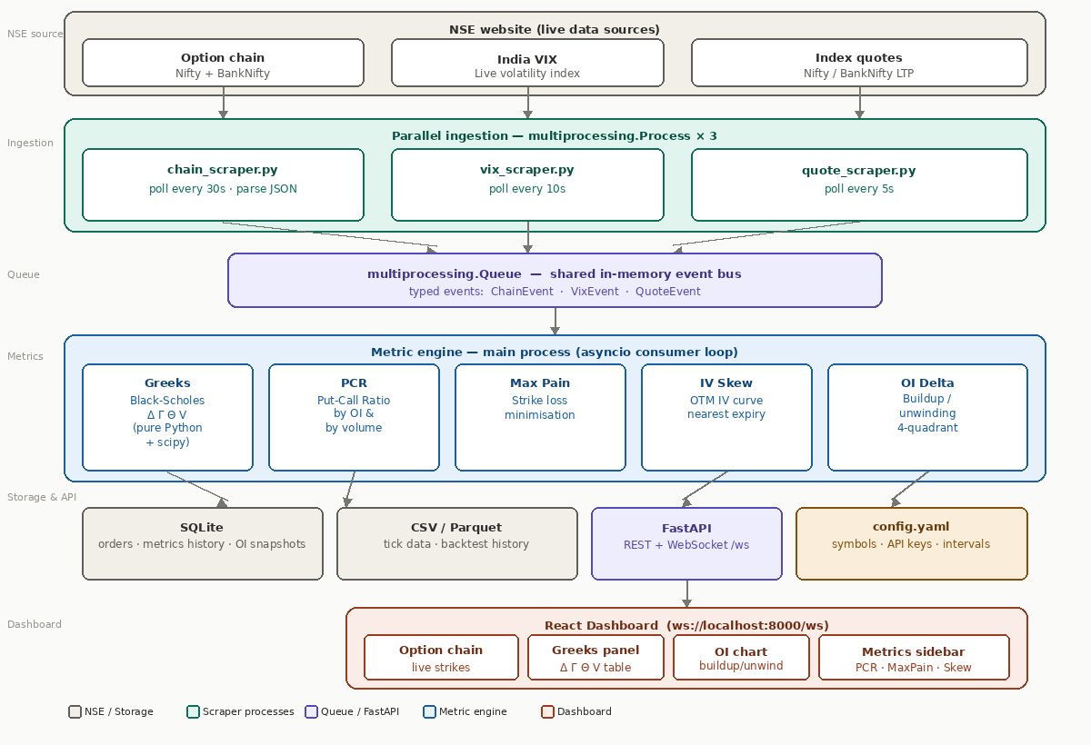
Figure 1 — NSE Options Analytics system architecture

Architecture layers
Layer | Component | Description
1 — NSE sources | Option chain, VIX, Quotes | Live HTTP polling of NSE JSON APIs. Three separate URLs, each polled at its own interval.
2 — Ingestion | 3 × multiprocessing.Process | Each scraper runs in a fully isolated OS process. They never share memory — only the Queue. Crashes in one scraper don't affect the others.
3 — Event bus | multiprocessing.Queue | Typed event dicts (ChainEvent, VixEvent, QuoteEvent) flow from scrapers to the main process. Max size 500 — oldest events dropped if full.
4 — Metrics | asyncio consumer loop | Drains the queue every 0.5s. For each chain event, computes all 5 metrics sequentially: Greeks → PCR → Max Pain → IV Skew → OI Delta.
5 — Storage & API | SQLite + FastAPI | Every computed snapshot is saved to SQLite. FastAPI exposes REST endpoints and a WebSocket that pushes live metric updates to all connected clients.
6 — Dashboard | React (Vite) | Connects to ws://localhost:8000/ws. Receives live metric events and renders option chain, Greeks table, OI chart, and metrics sidebar.

2. Project Structure
File / Folder | Purpose
main.py | Entry point. Spawns 3 scraper processes, starts watchdog thread, launches uvicorn.
config.yaml | Symbols to scrape, poll intervals, SQLite path, broker API keys (if added later).
ingestion/__init__.py | Makes ingestion/ a Python package (required for imports).
ingestion/nse_session.py | Shared requests.Session with NSE browser headers and automatic cookie refresh on 401/403.
ingestion/chain_scraper.py | Polls NSE option chain JSON for NIFTY and BANKNIFTY every 30s. Parses strikes into flat dicts and puts a ChainEvent onto the Queue.
ingestion/vix_scraper.py | Polls NSE allIndices every 10s, extracts India VIX value and % change.
ingestion/quote_scraper.py | Polls NSE allIndices every 5s, extracts Nifty 50 and Bank Nifty LTP, OHLC.
metrics/__init__.py | Makes metrics/ a Python package.
metrics/metrics.py | All 5 metric functions in one file: bs_greeks, compute_greeks, compute_pcr, compute_max_pain, compute_iv_skew, compute_oi_delta.
app/__init__.py | Makes app/ a Python package.
app/consumer.py | asyncio loop that drains the Queue, triggers metric computation, saves to SQLite, and broadcasts results via WebSocket.
app/api.py | FastAPI app. Defines REST endpoints (/api/metrics, /api/vix, /api/quote) and WebSocket endpoint (/ws).
web/ | React + Vite frontend. Run separately with npm install && npm run dev.

3. Installation & Setup

3.1 Prerequisites
- Python 3.8 or higher
- pip (Python package manager)
- Node.js 16+ and npm (for React dashboard only)
- Internet connection during market hours (09:15–15:30 IST weekdays)

3.2 Install Python dependencies
pip install fastapi uvicorn[standard] requests scipy pandas pyarrow

Package | Used for
fastapi | REST API and WebSocket server
uvicorn[standard] | ASGI server to run FastAPI
requests | HTTP polling of NSE APIs inside scraper processes
scipy | scipy.stats.norm — CDF/PDF for Black-Scholes Greeks (replaces mibian)
pandas | Data manipulation for tick data and backtest CSV/Parquet files
pyarrow | Parquet file read/write backend for pandas

3.3 Run the application
From the project root folder (AutoTradeNSE/):

python main.py

On startup you will see:
[main] started chain_scraper (pid=XXXX)
[main] started vix_scraper (pid=XXXX)
[main] started quote_scraper (pid=XXXX)
[main] starting FastAPI on http://localhost:8000

To also run the React dashboard, open a second terminal and run:
cd web && npm install && npm run dev
Then open http://localhost:5173 in your browser.

4. Data Flow & Poll Intervals
Scraper | Interval | NSE Endpoint | Event put on Queue
chain_scraper.py | 30 seconds | /api/option-chain-indices | ChainEvent — list of strike records with CE/PE OI, IV, LTP
vix_scraper.py | 10 seconds | /api/allIndices | VixEvent — India VIX value and % change
quote_scraper.py | 5 seconds | /api/allIndices | QuoteEvent — Nifty/BankNifty LTP, OHLC, % change

Why separate processes? NSE HTTP calls block for 1–3 seconds. Running them as asyncio tasks would stall the FastAPI event loop. Separate OS processes keep scraping fully isolated from serving.

Why different intervals? The option chain is large (~400KB JSON) and NSE refreshes it every ~3 minutes, so 30s is safe. VIX changes quickly but is small, so 10s. Index quotes are tiny and traders want near-tick LTP, so 5s.

5. Computed Metrics

5.1 Greeks (Δ Γ Θ V)
Computed using a pure Python Black-Scholes implementation — no external options library required. Uses scipy.stats.norm for the normal distribution CDF and PDF.

Greek | Formula basis | Interpretation
Delta (Δ) | N(d1) for calls, N(d1)−1 for puts | Rate of change of option price per ₹1 move in underlying. Range: 0 to 1 (calls), −1 to 0 (puts).
Gamma (Γ) | n(d1) / (S·σ·√T) | Rate of change of Delta. Same value for calls and puts at the same strike. High near ATM and near expiry.
Theta (Θ) | Daily decay ÷ 365 | Daily time decay in ₹. Negative for long options — you lose this value each day from the option price.
Vega (V) | S·n(d1)·√T ÷ 100 | Change in option price per 1% move in Implied Volatility.

NSE-provided IV per strike is used when available. India VIX is used as a fallback for strikes where IV is missing or zero.

5.2 Put-Call Ratio (PCR)
Computed two ways — by Open Interest and by traded Volume — aggregated across all strikes for the selected symbol.
- PCR > 1.2 — Bearish sentiment (more put OI than call OI)
- PCR 0.8–1.2 — Neutral
- PCR < 0.8 — Bullish sentiment

5.3 Max Pain
The strike price at which the total financial loss for all option buyers (both calls and puts) is minimised. This is the price the market is said to gravitate toward at expiry, because it represents maximum loss for buyers = maximum profit for option sellers (typically institutions).

For each candidate strike S: Total Pain = Σ(CE_OI × max(S−K, 0)) + Σ(PE_OI × max(K−S, 0)) — Max pain = strike with lowest total pain.

5.4 IV Skew
Plots the Implied Volatility curve across OTM strikes for the nearest expiry. A negative skew (put IVs higher than call IVs) is the norm in equity markets — it reflects demand for downside protection. The skew steepens ahead of events like RBI policy or earnings.

5.5 OI Buildup / Unwinding
Classifies each strike using the classic 4-quadrant OI interpretation:

Price change | OI change | Signal | Implication
↑ Up | ↑ Up | Long buildup | Bullish
↓ Down | ↑ Up | Short buildup | Bearish
↑ Up | ↓ Down | Short covering | Bullish
↓ Down | ↓ Down | Long unwinding | Bearish

6. API Reference
Method | Endpoint | Returns
GET | /api/metrics/{symbol} | Latest computed metrics snapshot for NIFTY or BANKNIFTY (PCR, Max Pain, IV skew, OI delta)
GET | /api/vix | Current India VIX value and % change
GET | /api/quote/{symbol} | LTP, open, high, low, % change for NIFTY or BANKNIFTY
GET | /api/health | {'status': 'ok'} — use to verify server is running
WS | /ws | WebSocket — pushes VixEvent, QuoteEvent, ChainMetricsEvent in real time to all connected clients

7. Known Issues & Notes

NSE session / cookie
NSE requires a browser-like HTTP session with a valid cookie before accepting API calls. nse_session.py handles this automatically by hitting the NSE home page first to set the cookie. If scraping stops working, NSE may have changed their anti-bot headers — update the User-Agent string in nse_session.py.

Market hours
NSE live data is only available during market hours: 09:15 to 15:30 IST, Monday to Friday. Outside these hours the scrapers will get stale or empty responses. The watchdog will keep restarting them — this is normal.

Python version compatibility
- X | None type hints require Python 3.10+ — replaced with Optional[X] from typing (compatible with Python 3.7+)
- list[dict] built-in generics require Python 3.9+ — replaced with List[Dict] from typing
- mp.set_start_method('spawn') raises RuntimeError on Windows if called twice — guarded with mp.get_start_method(allow_none=True)

8. Recommended Next Steps
- React dashboard: Build OptionChain.jsx (live strike table), GreeksPanel.jsx, OIChart.jsx (Chart.js bar chart), MetricsSidebar.jsx (PCR + Max Pain live display)
- Backtesting engine: Replay saved CSV tick data through the same metric functions to evaluate strategy performance historically
- Strategy signals: Add a signal_engine.py that reads metrics from consumer.py and emits BUY/SELL signals based on PCR threshold + Max Pain proximity
- Broker execution: Integrate Zerodha Kite API or Fyers API to place actual option orders based on generated signals
- Alerting: Add email/Telegram notifications when PCR crosses thresholds or large OI buildup is detected at key strikes

