
I-TECH COLLEGE BAGO CITY, INC
Ramon Gonzaga Compound, 1084 Araneta Street, Brgy. Poblacion
Bago City, 6101

Experts Evaluation Form based on McCall’s Software Quality Model

Capstone Title: Guidance Record Management System
Capstone Adviser: Edrian Magan
Proponents: Daryl Flores , Ricky Palmes , Davonn Rando , John RJ Sardua
Expert Evaluator: ____Janssen Rey Romero _____________________________
Date: ______09/07/2026________
Please evaluate the system according to the following software quality factors. Encircle or check the rating that best represents your assessment. Provide comments where necessary. Use the verbal interpretation below as your guide.

Rating Scale with verbal interpretation Scale
Verbal Interpretation
5 — Excellent – Exceeds expectations; no or minimal improvement needed
4 — Good – Meets expectations; minor improvements suggested
3 — Fair – Acceptable but needs noticeable improvement
2 — Poor – Does not meet expectations; major improvements required
1 — Very Poor – Fails to meet expectations

A. Product Operation Factors
1. Correctness:  ○ The system meets the functional requirements.  ○ The outputs generated are accurate and reliable. | 1 | 2 | 3 | 4 | 5  ✅
2. Reliability  ○ Does the system perform consistently without failure?  ○ Is error handling effective? | 1 | 2 | 3 | 4 | 5  ✅
3. Efficiency  ○ Does the system respond quickly and optimize resources?  ○ Are processes efficient and minimizing delays? | 1 | 2 | 3 | 4 | 5  ✅
4. Integrity (Security)  ○ Is data secured from unauthorized access?  ○ Are authentication and validation properly implemented? | 1 | 2 | 3 | 4 | 5  ✅
5. Usability  ○ Is the system interface user-friendly and intuitive?  ○ Can users operate the system with minimal training? | 1 | 2 | 3  ✅ | 4 | 5
B. Product Revision Factors
6. Maintainability  ○ Can the system be easily fixed or updated?  ○ Does documentation support troubleshooting? | 1 | 2 | 3 | 4  ✅ | 5
7. Flexibility  ○ Can the system adapt to new requirements or changes?  ○ Are modifications easy to implement? | 1 | 2 | 3 | 4  ✅ | 5
8. Testability  ○ Can the system be tested thoroughly?  ○ Are testing procedures effective? | 1 | 2 | 3 | 4 | 5  ✅
C. Product Transition Factors
9. Portability  ○ Can the system run across different platforms (PC, web, mobile)?  ○ Is installation and setup manageable? | 1 | 2 | 3 | 4 | 5  ✅
10. Reusability  ○ Can components be reused in other applications?  ○ Is the code/design modular and reusable? | 1 | 2 | 3 | 4 | 5  ✅
11. Interoperability  ○ Does the system integrate with other software or databases?  ○ Is data exchange with external systems supported? | 1 | 2 | 3 | 4 | 5  ✅

Suggestions/Recommendations:

____________________________________________________________________

Evaluator’s Signature over Printed Name: ___________________________________________________
Remove this after fix or you can simply remove this:
Sidebar Navigation State: Multiple sidebar items appear active or highlighted simultaneously, creating visual confusion about which page is currently open.
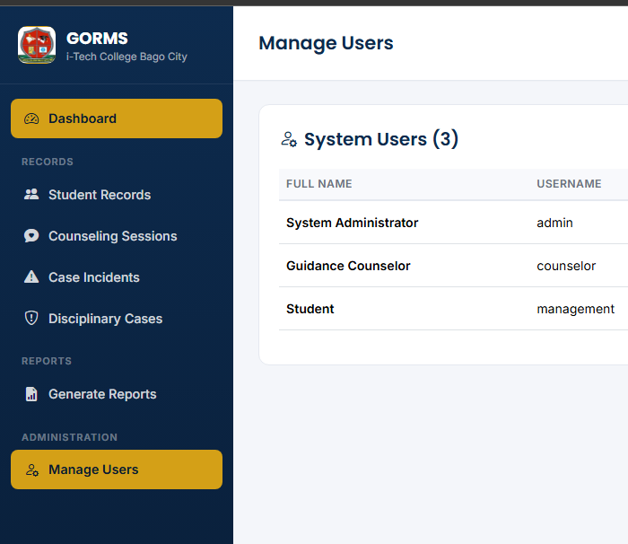

Inefficient Export Workflow: Clicking to print opens the browser's default print preview modal instead of directly offering structured data downloads.
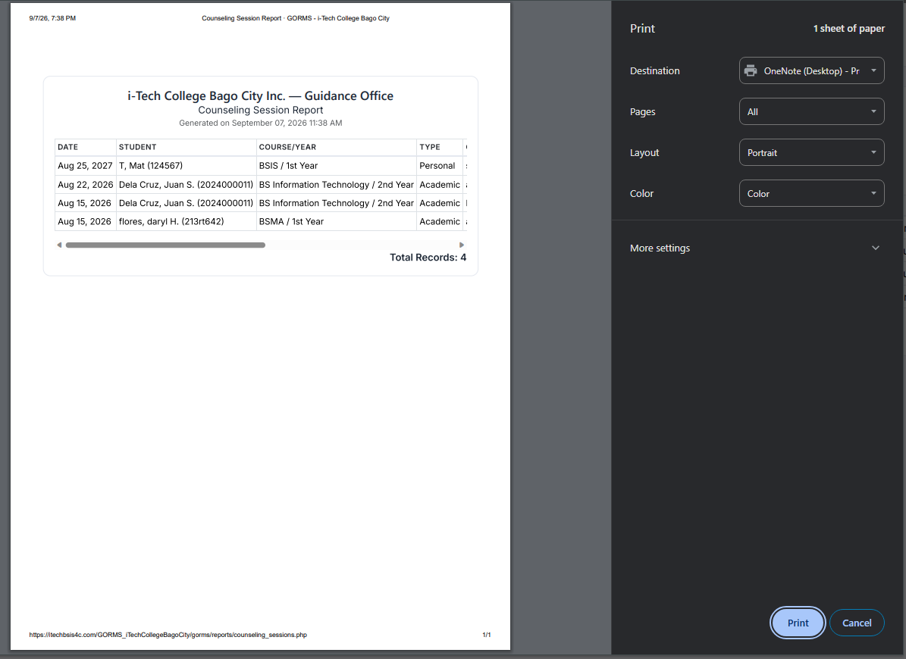
Limited Filtering Options: Filtering is currently restricted only to date ranges (From / To), making it difficult to sort records by specific criteria directly on the page.
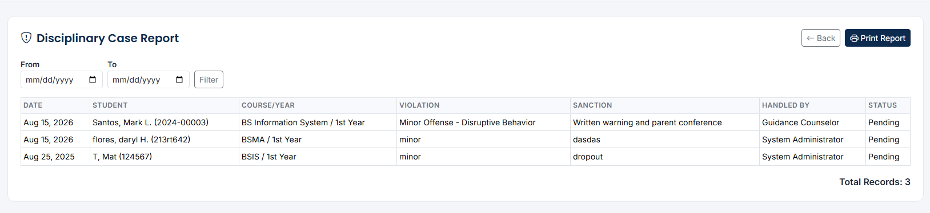

Record Table Filtering: Lack of combined filtering mechanisms (such as Course AND/OR Year Level) above the Student Records table.
Degree / Course Options: "Degree Applied For" relies on unstructured text input instead of dynamic option management for administrators.
Inconsistent Year & Section Inputs: "Year Level" shows descriptive text strings ("1st Year") instead of standardized numeric levels, and "Section" is disconnected from Course/Year combinations.
School Year Format: "School Year" fields use single year values (e.g., "2020") instead of explicit start and end range formats (e.g., "2020 - 2021").
Manual Student ID Entry: Student ID field relies on manual typing rather than system auto-generation.

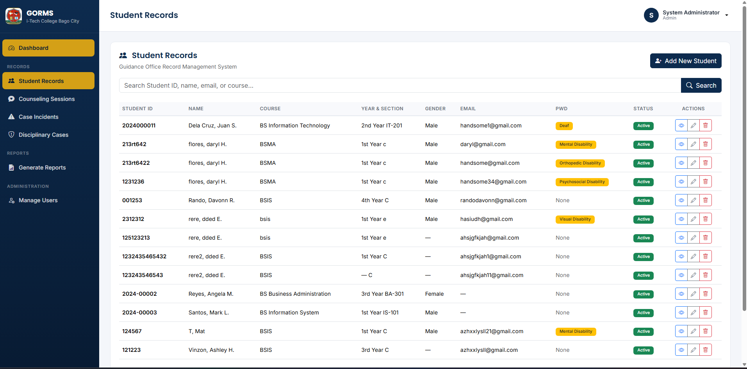
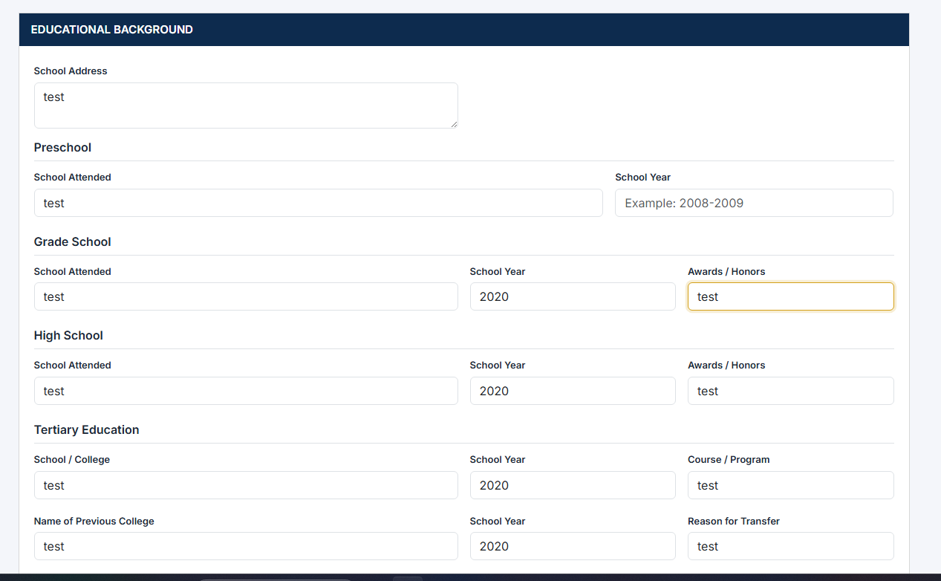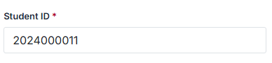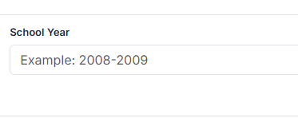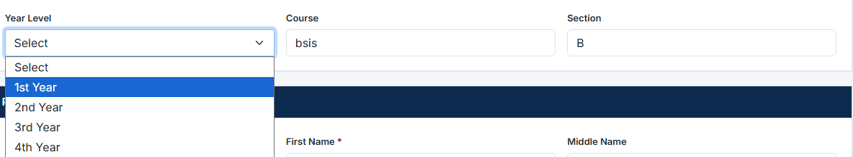

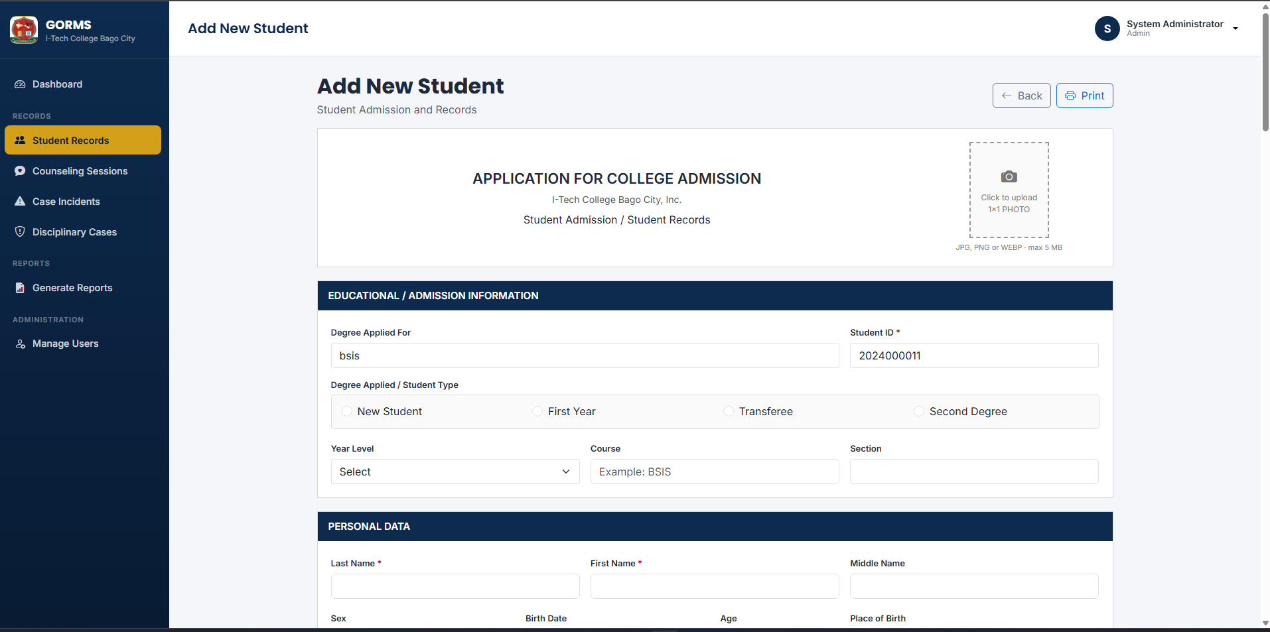

Enhanced Table Filtering:
- Add multi-select dropdown filters for Course (e.g., BSIS, BSMA, BSIT) and Year Level (1, 2, 3, 4) next to the main search bar.
- Support logical AND/OR matching so admins can filter specifically by Course = BSMA AND Year = 1.
Dynamic "Degree Applied For" Selector:
- Convert "Degree Applied For" into a select dropdown containing existing courses.
- Add an inline "+ Add New Degree" action modal allowing admins to insert new degree programs on the fly if not listed.
Standardized Year Level & Dynamic Section:
- Year Level: Limit options strictly to numeric values: 1, 2, 3, 4.
- Section: Automatically populate section options or auto-generate preview tags based on the selected Course and Year Level (e.g., Selecting BSIS and Year 1 dynamically filters available sections to BSIS 1-A, BSIS 1-B).
- UX Helper Message: Display helper text directly below the inputs: "Section options are dynamically updated based on your selected Course and Year Level."
Split School Year Range Inputs:
- Replace single-year inputs under Educational Background with paired inputs: Start Year and End Year (e.g., [ 2020] to [ 2021]).
Auto-Generated Student ID:
- Set the Student ID field to Read-Only / Disabled during creation, displaying an auto-incremented preview ID (e.g., 2026-00012) calculated automatically based on admission year and sequence.

