
I-TECH COLLEGE BAGO CITY, INC.
Ramon Gonzaga Compound, 1084 Araneta Street,
Brgy. Población, Bago City, 6101
BLENDED LEARNING SYSTEM WITH SYLLABUS MAPPING
A Capstone
Presented to
The Faculty of
I-TECH COLLEGE BAGO CITY, INC.
Ramon Gonzaga Compound, 1084 Araneta St.
Brgy. Poblacion, Bago City
In Partial Fulfillment of the Requirements for the Degree
BACHELOR OF SCIENCE IN INFORMATION SYSTEMS
By:
Cristian Felix Demateo
Emmanuelle Margaux Nomat
Sherry Lou Belanio
Justine Joy Deniola

CHAPTER I
INTRODUCTION
Background of the Study
The continuous advancement of information and communication technology has transformed the way educational institutions deliver instruction. One of the most widely adopted approaches is blended learning, which combines traditional face-to-face instruction with online learning to provide greater flexibility, accessibility, and student engagement (Graham, 2019). As higher education institutions continue to integrate technology into teaching, there is an increasing need for systems that effectively organize course content and support the achievement of learning outcomes.

At I-Tech College Inc., blended learning is utilized to support classroom instruction through digital learning platforms. However, instructors still encounter challenges in organizing course materials and ensuring that lessons, learning activities, and assessments are consistently aligned with the course syllabus. Syllabus mapping is often managed through separate documents or manual processes, making it difficult to monitor syllabus coverage and maintain consistency throughout the semester. According to Biggs and Tang (2011), the alignment of learning outcomes, teaching strategies, and assessments is essential for improving instructional quality and student learning.

Although many Learning Management Systems provide tools for online learning, few systems integrate syllabus mapping as part of the teaching and learning process. Existing platforms primarily focus on content delivery and assessment management, with limited support for aligning course objectives with instructional activities and assessments. This gap highlights the need for a system that not only facilitates blended learning but also strengthens curriculum alignment and instructional planning within the institution.

In response to these challenges, this study proposes the development of a Blended Learning System with Syllabus Mapping for I-Tech College Inc. The proposed system aims to provide a centralized platform where instructors can organize course content, align learning outcomes with learning activities and assessments, and monitor student progress more efficiently. Likewise, students will benefit from a structured learning environment that clearly presents course objectives, learning materials, and academic requirements. The implementation of the proposed system is expected to improve instructional organization, strengthen curriculum alignment, and enhance the overall teaching and learning experience at I-Tech College Inc.

Objectives of the Study
This study aims to develop a blended learning system with syllabus mapping that supports effective lesson tracking and alignment of learning activities.
Specifically, the study aims to:
- Develop a system that maps lessons, activities, and assessments directly to syllabus objectives.
- Provide instructors with tools to monitor lesson progress and syllabus coverage in a blended learning environment.
- Enable students to track their learning activities and understand their progress in the course.
- Improve lesson organization and reduce missed or duplicated topics in blended learning.
- Support effective teaching and learning through a centralized and organized learning system.

Significance of the Study
This study is significant to the following groups:
Students. The system helps students clearly understand their lessons, activities, and progress, making it easier for them to follow course requirements in a blended learning setup.
Instructors. The system assists instructors in organizing lessons, tracking syllabus coverage, and monitoring student progress more efficiently.
Administrator. The system enables administrators to oversee lesson delivery, monitor program implementation, and ensure consistency across blended learning courses.

Scope of the Study
This study focuses on the implementation of a Blended Learning System with Syllabus Mapping in the teaching and learning process. It examines how the combination of face-to-face classes and online learning, guided by syllabus mapping, helps organize lessons, deliver content effectively, and maintain learning continuity.
The study aims to evaluate the effectiveness of the blended learning system in aligning learning objectives, instructional activities, and assessments through syllabus mapping.
It also looks into how syllabus mapping assists teachers in managing course content and how students perceive its usefulness in understanding lesson flow, requirements, and expectations.
The study is conducted in selected college-level educational institutions within I-Tech College Inc. Bago City. It is limited to this area and does not include institutions outside the chosen setting.
The research covers one academic semester, during which data are gathered and analyzed. The participants include teachers and students who regularly use the blended learning system in their classes.
In terms of methodology, the study uses a descriptive research design. Data are collected through surveys, interviews, and system evaluation tools to assess the system’s usability, effectiveness, and the challenges encountered during its use.

Limitations of the Study
This study has several limitations that may affect the
generalizability of the results. First, the number of participants is limited to a specific group of teachers and students, which may not represent other institutions or educational levels.

Second, the study is conducted over a short period of one semester; therefore, it does not measure the long-term effects of the blended learning system with syllabus mapping on students’ academic performance.
Third, data collection may be affected by participants’ availability and willingness to provide complete and honest responses, which could limit the depth of the findings.
Fourth, technological factors such as internet access, availability of devices, and users’ familiarity with digital tools may influence how effectively the system is used.
Lastly, the study may be influenced by response bias, as the data are largely based on self-reported surveys and interviews. External factors, including institutional policies and unexpected changes in learning modalities, may also affect the results but are beyond the control of the researcher.

CHAPTER II

RELATED LITERATURE AND PRIOR ARTS SEARCH

PRIOR ARTS
This section presents local and international systems, institutional implementations, and related technologies relevant to blended learning, syllabus mapping, and curriculum alignment. Each prior art is discussed in relation to its contribution, strengths, and identified limitations that justify the development of the proposed Blended Learning System with Syllabus Mapping.
A. International Related Studies (2021–2024)

Müller, C., & Mildenberger, T. (2021) – Facilitating flexible learning by replacing classroom time with online learning: A systematic review of blended learning in higher education. This review found that blended learning improves flexibility, student engagement, and learning outcomes when supported by appropriate instructional design.
Ashraf, M. A., et al. (2021) – A Systematic Review of Systematic Reviews on Blended Learning. The study concluded that blended learning positively affects student achievement, engagement, and instructional effectiveness.
Archibald, D. E., Graham, C. R., & Larsen, R. (2021) – The Blended Teaching Readiness Instrument. The authors developed an instrument to measure instructors’ readiness for blended teaching, emphasizing instructional planning and technology integration.
Bond, M., Bedenlier, S., Marín, V. I., & Händel, M. (2022) – The study examined student engagement in technology-enhanced learning and found that well-designed digital learning environments improve participation and learning outcomes.
Limniou, M., Schermbrucker, I., & Lyons, M. (2022) – The researchers found that curriculum alignment and well-organized online learning resources significantly influence student satisfaction and academic performance.
Castañeda, L., & Selwyn, N. (2023) – The study emphasized that educational technology should support curriculum quality and meaningful learning rather than simply digitizing instruction.
UNESCO (2023) – UNESCO highlighted that digital learning systems should support curriculum implementation, equitable access, and quality assurance in higher education.
Harrison, J. M., & Rey Williams, V. (2024) – The authors explained that curriculum mapping improves alignment between learning outcomes, instructional activities, and assessments.
Martin, F., Sun, T., & Westine, C. D. (2022) – The study identified instructional design, communication, and course organization as major factors influencing learner satisfaction in blended learning.
Boelens, R., De Wever, B., & Voet, M. (2021) – The researchers concluded that successful blended learning requires constructive alignment among learning outcomes, instructional strategies, and assessment methods.

B. Local Related Studies (Philippines, 2021–2025)

Barrot, J. S., Llenares, I. I., & del Rosario, L. S. (2021) – Students’ online learning challenges during the pandemic and how they cope with them: The case of the Philippines. The study identified internet access, instructional organization, and learning resources as major challenges experienced by Filipino college students.
Lapitan, L. D. S., Tiangco, C. E., Sumalinog, D. A. G., Sabarillo, N. S., & Diaz, J. M. (2021) – An effective blended online teaching and learning strategy during the COVID-19 pandemic. The researchers demonstrated that blended teaching strategies improved student engagement and learning continuity in Philippine higher education.
Barrot, J. S. (2023) – K to 12 curriculum reform in the Philippines: Towards making students future ready. The study emphasized constructive alignment, technology integration, and curriculum improvement to meet 21st-century educational needs.
Dalusong, M. T. B., Dones, V., & Grageda, M. E. (2025) – Instructional Quality in a Blended Teaching and Learning Approach. The review identified course design, LMS quality, assessment, and instructional support as key dimensions of effective blended learning.
Institutional Policy Analysis on the Implementation of Blended Learning Modality (2024) – This Philippine study analyzed institutional policies supporting blended learning and emphasized curriculum alignment and instructional planning.
Commission on Higher Education (CHED, 2020–2024) – CHED’s flexible learning policies promote Outcome-Based Education (OBE), constructive alignment, and the integration of technology into higher education.
University of Santo Tomas (2021) – The university’s implementation of blended learning demonstrated that integrating online and face-to-face instruction improves learning continuity and student participation.
National University Philippines (2021) – Research by Barrot and colleagues highlighted the importance of improving digital learning environments to address instructional and technological challenges faced by Filipino students.
Philippine State Universities’ Moodle Implementations (2021–2023) – Several state universities reported that Moodle supported blended learning by improving content delivery, communication, and assessment, although syllabus mapping remained largely manual.
Philippine Higher Education Institutions implementing Outcome-Based Education (2021–2024) – Studies and institutional reports consistently show that while OBE is widely implemented, many institutions still rely on manual curriculum and syllabus mapping, creating opportunities for integrated LMS solutions.

Synthesis
The reviewed local and international systems demonstrate significant advancement in blended learning implementation and LMS functionality. However, a consistent gap remains in integrating structured syllabus mapping directly within learning management systems. Many platforms provide content management and assessment tools but rely on manual alignment processes to ensure curriculum coherence.
This study addresses this gap by developing a Blended Learning System with built in Syllabus Mapping that directly connects syllabus objectives, lessons, assessments, and student progress tracking in a centralized and automated platform.

METHODOLOGY
The descriptive developmental approach was employed in this study. This approach involves the systematic process of analyzing existing problems, designing a solution, developing the proposed system, and evaluating its effectiveness. It focuses on the creation and assessment of an educational system to ensure that it meets specific instructional and technical standards. In this study, the approach was used to develop a Blended Learning System with Syllabus Mapping that addresses issues in lesson tracking, curriculum alignment, and monitoring of instructional progress.

Phases of Agile Model
Planning
During this phase, the researchers identified the challenges encountered in the current blended learning implementation at I-Tech College Inc. through interviews and observations with faculty members and students. The findings revealed that while learning management systems were used, syllabus mapping was not systematically integrated. Based on these findings, the researchers established the system requirements, including user authentication, course management, syllabus mapping, assessment management, and progress monitoring.

Design
During this phase, the researchers designed the overall structure, database, and user interface of the proposed Blended Learning System with Syllabus Mapping. System models such as the Entity Relationship Diagram (ERD), Data Flow Diagram (DFD), Use Case Diagram, and System Flowchart were created using Draw.io to visualize the system architecture and workflow. The system interface was designed to be simple, organized, and user-friendly for administrators, instructors, and students. For the system development, PHP was used as the server-side programming language, CSS for the user interface design and styling, MySQL for database management, and XAMPP as the local server environment for developing, testing, and running the system before deployment.
Development
During this phase, the researchers developed the system using the Agile methodology through iterative sprints. The core features implemented included user authentication, course management, learning material uploads, syllabus mapping, assessment management, and progress monitoring. The database was structured to ensure proper alignment among learning outcomes, lessons, activities, and assessments.
Testing
After development, the researchers conducted unit testing, integration testing, and user acceptance testing to evaluate the system’s functionality, usability, and accuracy. Selected instructors and students tested the system, and their feedback was used to identify errors and improve system performance before implementation.
Evaluation
In the final phase, the researchers evaluated the effectiveness of the proposed Blended Learning System with Syllabus Mapping using the respondents’ feedback and software quality evaluation instruments. The results determined the system’s usability, functionality, and effectiveness in improving syllabus alignment, course organization, and the overall blended learning process. The findings also served as the basis for further system enhancement.

Research Design
The Blended Learning system with Syllabus Mapping adopts a descriptive developmental approach. The research team will be in contact with I-Tech College’s administrator to gain information. The descriptive aspect focuses on analyzing existing practices, particularly in terms of curriculum alignment, instructional quality, faculty readiness, and student engagement. At the same time, the developmental aspect aims to use the findings as a basis for designing an improved syllabus mapping framework that can strengthen the coherence between learning outcomes, instructional strategies, and assessment methods. This design is appropriate because it allows the study to both assess the present situation and provide a concrete, research-based output that contributes to the enhancement of blended learning implementation.

Locale of the Study
The study will be conducted in I-Tech College Inc. Bago City, Negros Occidental. The institution utilizes a Learning Management System (LMS) to support online instruction alongside traditional face-to-face classes. The locale is selected due to its active implementation of blended learning, making it relevant to the objectives of the study.

Sample Size
The sample size consists of instructors, administrator and student involved in the blended learning system.

Participant Population | Number of Respondents
Administrator | 1
Instructor | 8
Student | 34
Total | 43

Sampling Technique
Data collection from faculty members and students will utilize convenience sampling. The respondents will be selected based on their availability and active involvement in the blended learning system of the institution. Since both faculty and students are accessible within the selected departments, this method allows efficient and practical data collection within a limited timeframe. This approach ensures a smooth and manageable gathering of relevant information necessary for the study.

Respondents of the Study

The primary respondents of this study are the instructor and students of I-Tech College Inc. Instructors will provide information regarding course design, syllabus mapping practices, and instructional alignment, while the students provide the feedback on engagement, clarity of learning outcomes, and alignment of activities and assessments. Their responses are essential in describing current practices and identifying areas for development.

Research Instrument
The researchers will use a researcher-made questionnaire as the primary instrument for data collection.

Data Gathering Procedure

- Observation - The research team will observe the current instructional strategies in I-Tech College Inc. to examine their way of teaching. This gives us a perspective on how to arrange our system to make it easier for students and instructors.
- Interview - The researcher will conduct interviews with selected faculty members to better understand their experiences, challenges, and current practices in implementing syllabus mapping within the blended learning system.

Through these interviews, the researcher aims to identify specific concerns and gather suggestions that will serve as a basis in improving and developing a more structured syllabus mapping framework.
- Survey Questionnaire – The researcher will distribute survey questionnaires to both faculty members and students to collect quantitative data regarding the effectiveness of the current blended learning system and syllabus mapping practices. The responses gathered will be analyzed and used as a foundation in designing and enhancing the proposed blended learning system with improved syllabus mapping alignment.

Data Analysis Procedure
The data gathered were analyzed using descriptive statistical tools, including:

•McCall’s Software Quality Model
•Computer System Usability Questionnaire (CSUQ)

McCall’s Software Quality Model was used to evaluate the quality of the developed Blended Learning System with Syllabus Mapping in terms of its functionality, reliability, efficiency, usability, maintainability, and other software quality factors. Meanwhile, the Computer System Usability Questionnaire (CSUQ) was utilized to determine the respondents’ level of satisfaction regarding the system’s usefulness, ease of use, interface quality, and overall usability.

Context Flow Diagram
The Context Flow Diagram illustrates the interaction between external entities and the system. The main external entities include:
- Administrator
- Instructor
- Student
These users interact with the Blended Learning System to manage courses, upload lessons, map syllabus outcomes, enroll students, and monitor progress.

Figure 3. Context Flow Diagram
Figure 3 presents the Context Diagram of the proposed Blended Learning System with Syllabus Mapping. The diagram illustrates the overall interaction between the system and its primary external users, namely the Administrator, Instructor, and Student.

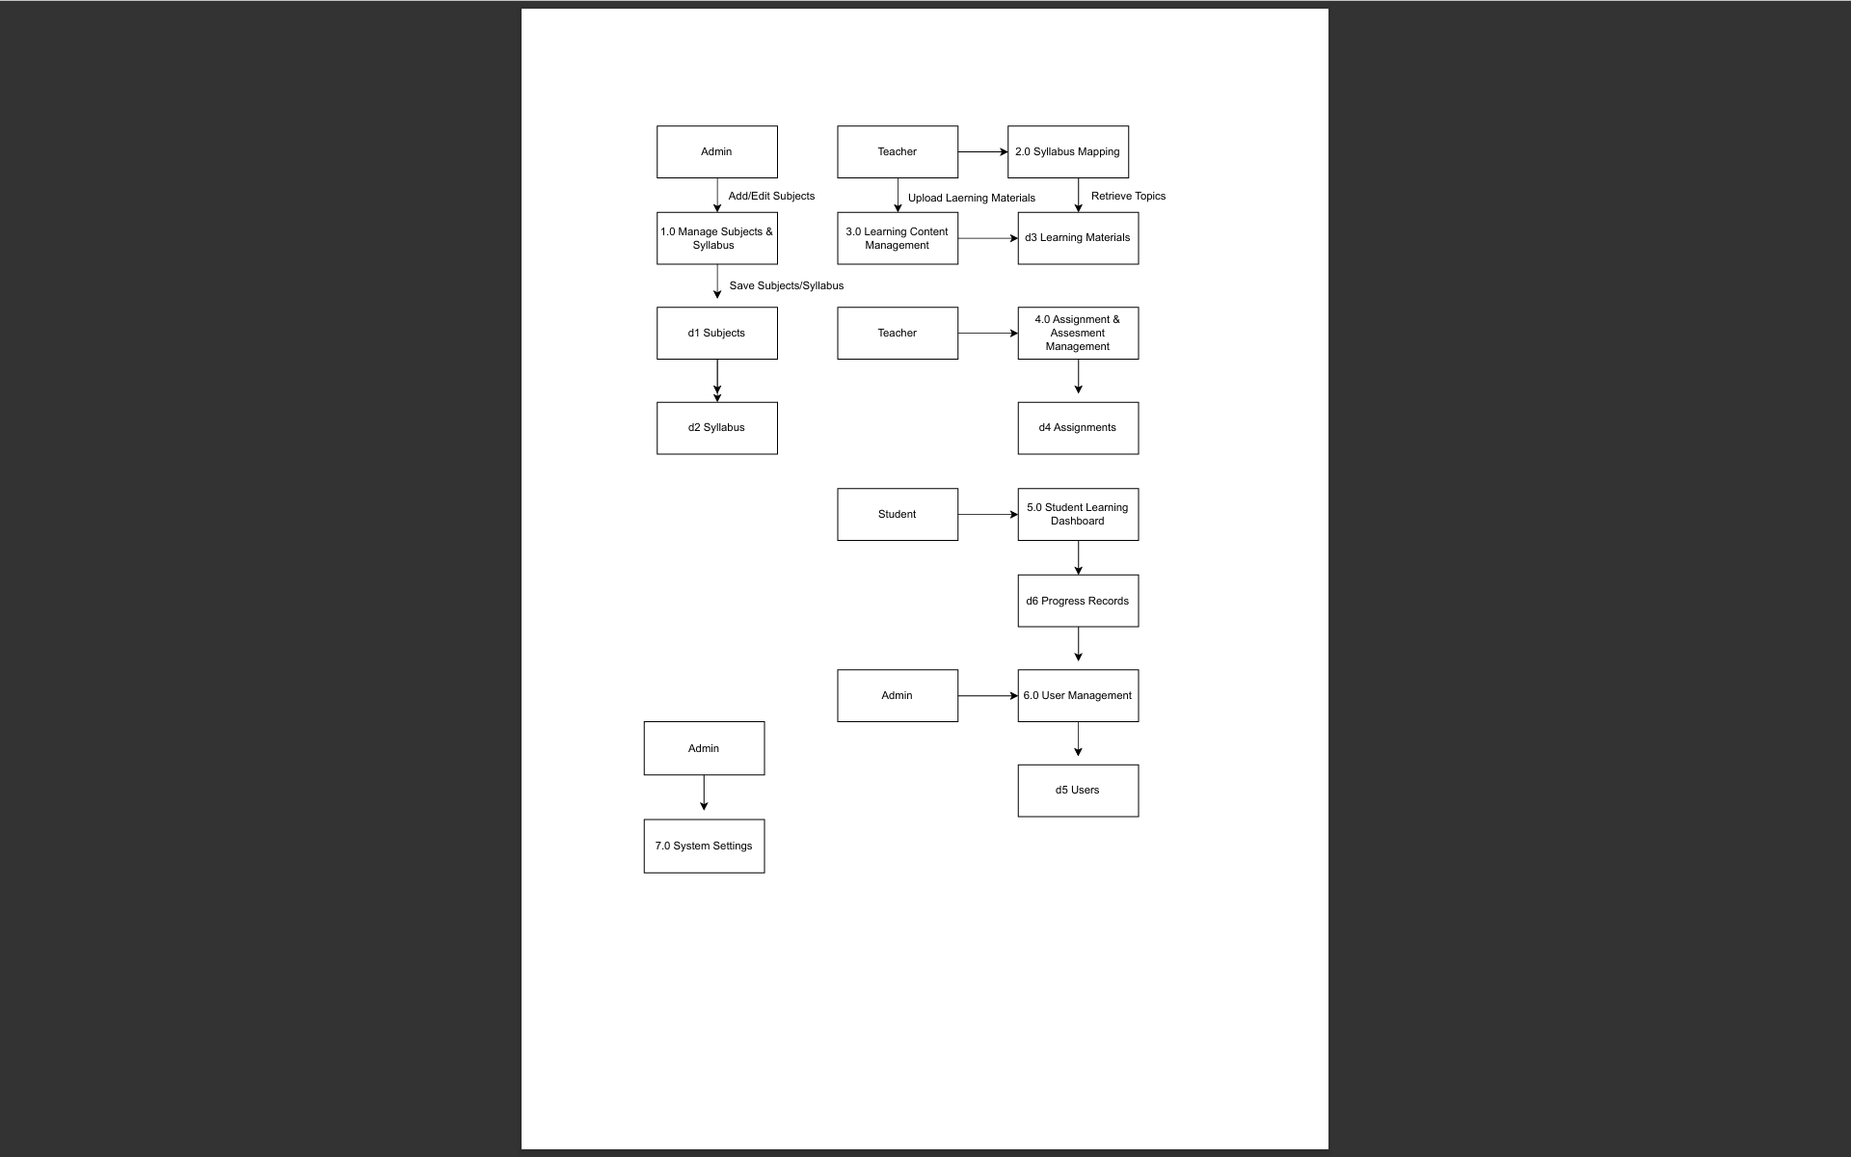

Figure 4. Data Flow Diagram

Figure 4 presents the Data Flow Diagram of the proposed Blended Learning System with Syllabus Mapping. The diagram illustrates how data moves within the system through the interaction of the Administrator, Teacher, and Student.

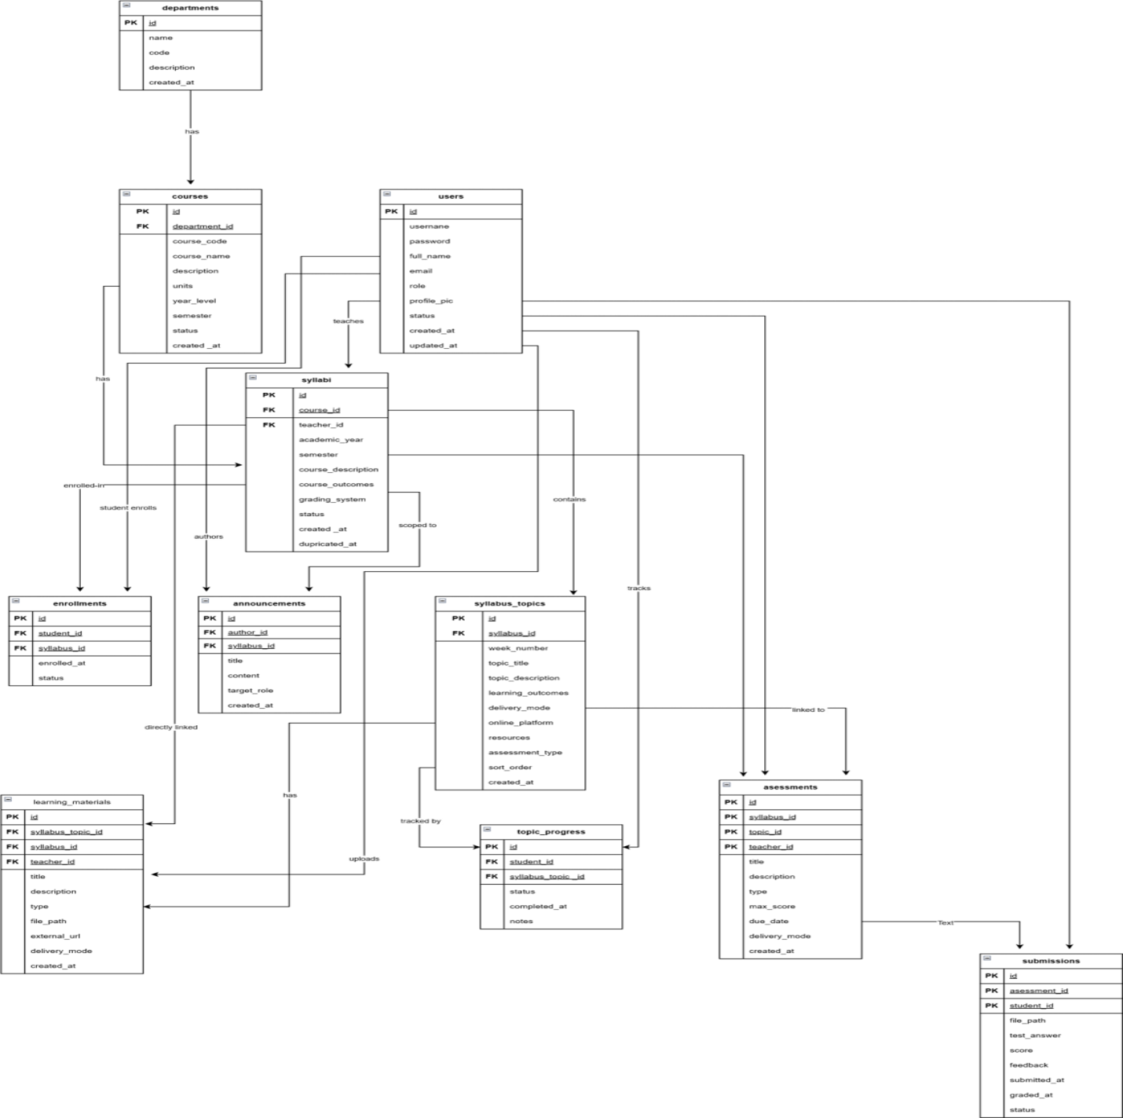

Figure 5. Entity-Relationship Diagram
Figure 5 illustrates the Entity Relationship Diagram (ERD) of the proposed Blended Learning System with Syllabus Mapping. The diagram presents the structure of the database and shows how different data entities are interconnected to support system operations.

Figure 6. Application Architecture
Figure 6 illustrates the overall architecture of the proposed Blended with Syllabus Mapping. The architecture demonstrates components interact to deliver learning materials and manage academic activities effectively.

Manage Users
Generate Reports
Monitor Course
Create Course
Upload Lessons
Map Syllabus Outcomes
Create Assessments
Monitor Student Progress
View Lessons
Submit Assesments
Student
Track Progress
Upload Lessons
Create Assignments
Instructor
Administrator
Figure 7. Use Case Diagram
Figure 7 presents the Use Case Diagram of the proposed Blended Learning System with Syllabus Mapping. The diagram illustrates the interaction between the different system users Administrator, Instructor, and Student and the specific functions they can perform.

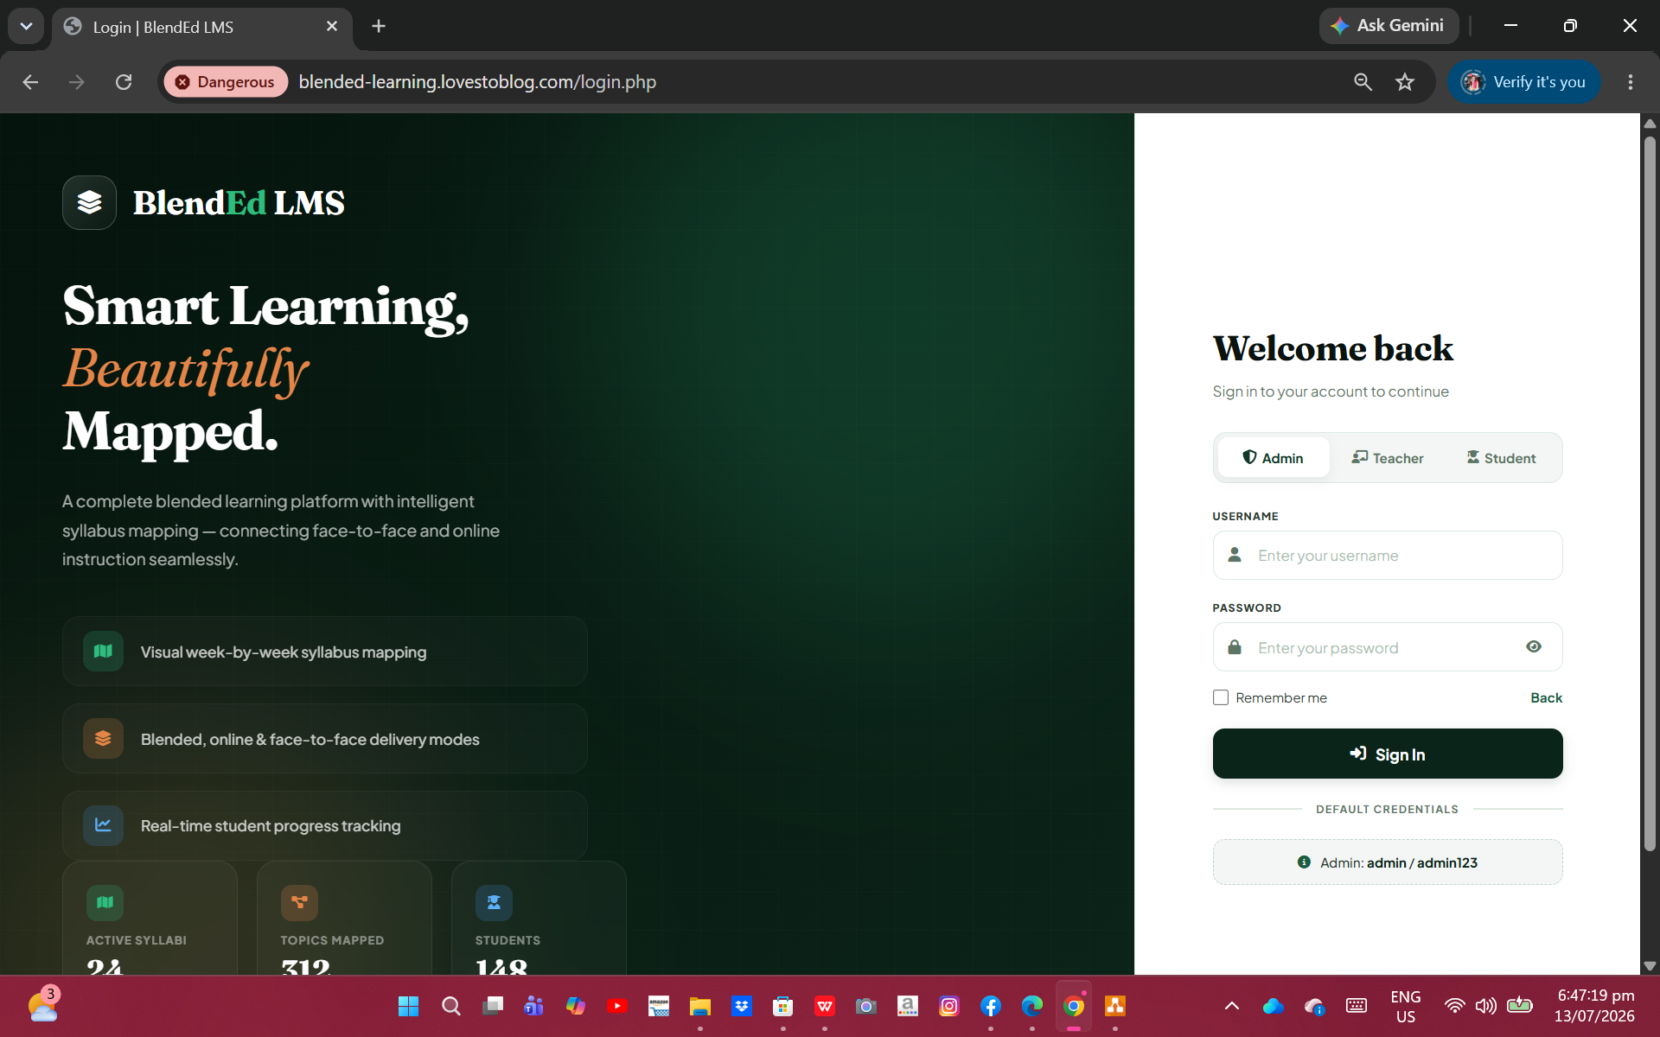
Figure 8: Log in Page
This Log in page authenticates users based on their selected role (Admin, Teacher, or Student). Users enter their username and password to securely access the system, which redirects them to their respective dashboards after successful authentication.
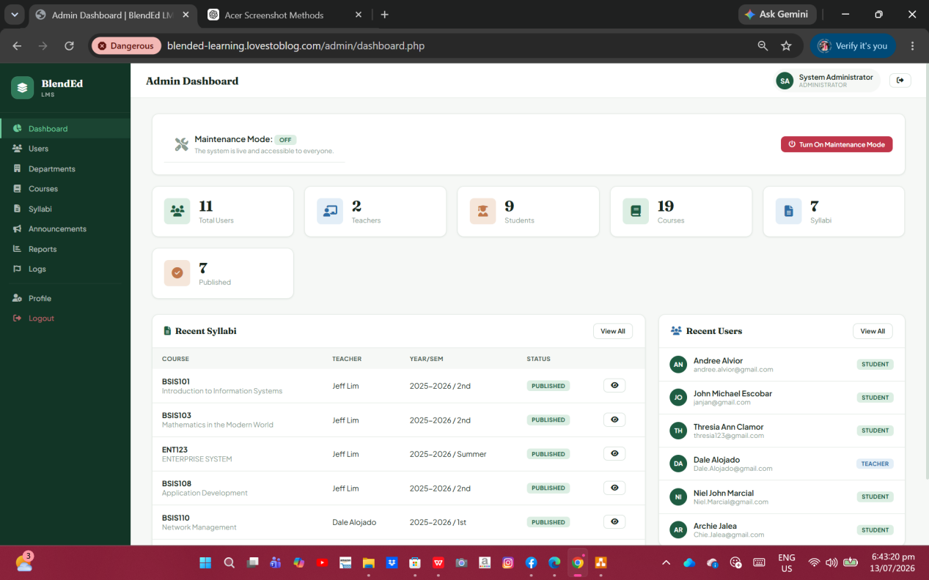
Figure 9: Admin Dashboard
This page is the Admin Dashboard, which provides an overview of the entire system by displaying key statistics such as total users, teachers, students, courses, published syllabi, and recent activities. It also allows administrators to enable or disable Maintenance Mode and quickly access recent syllabi and newly registered users.

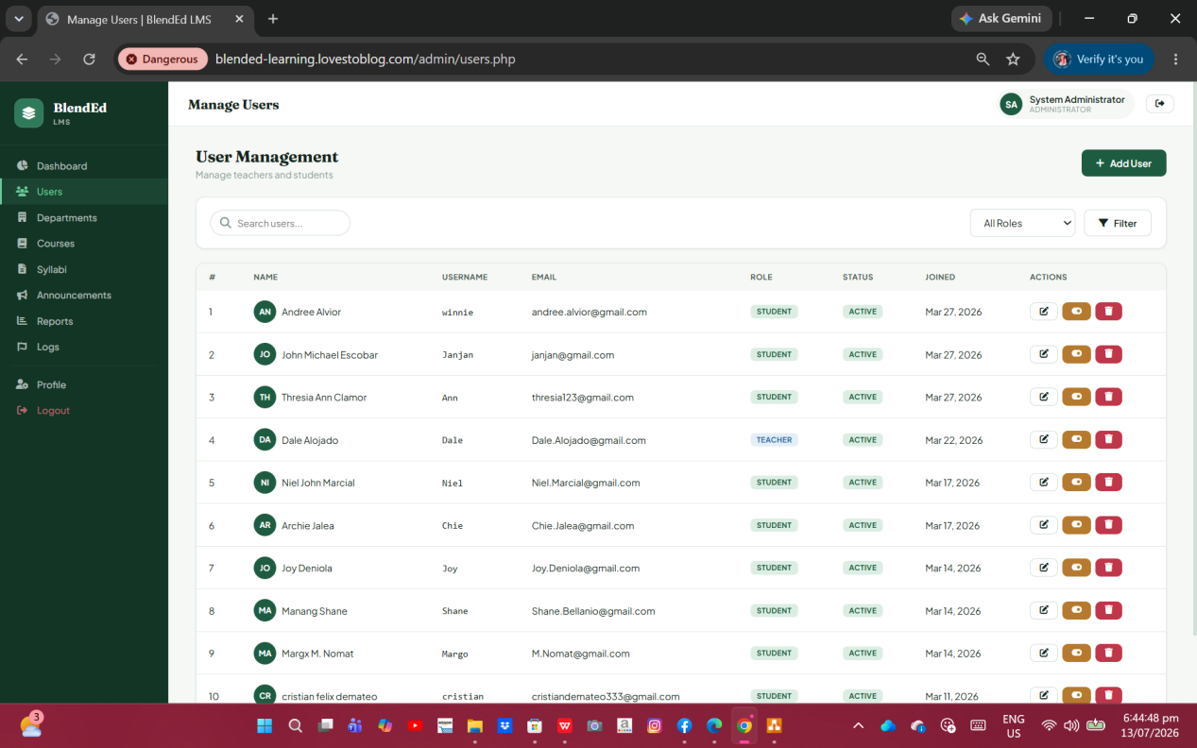
Figure 10: User Management
This page enables administrators to add, edit, view, search, filter, and delete teacher and student accounts. It centralizes user information, making it easier to manage access and maintain user records.

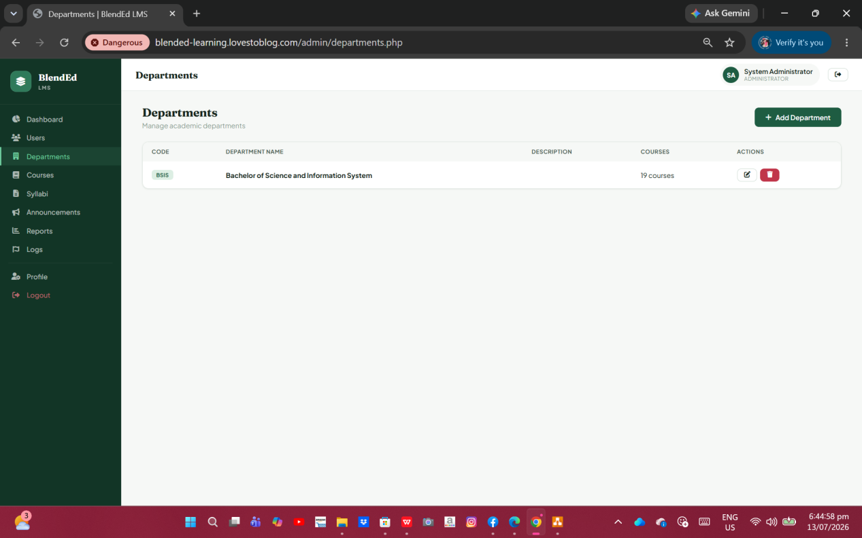
Figure 11: Departments
This page allows administrators to create and manage academic departments. Each department serves as a container for related courses, helping organize programs within the system.

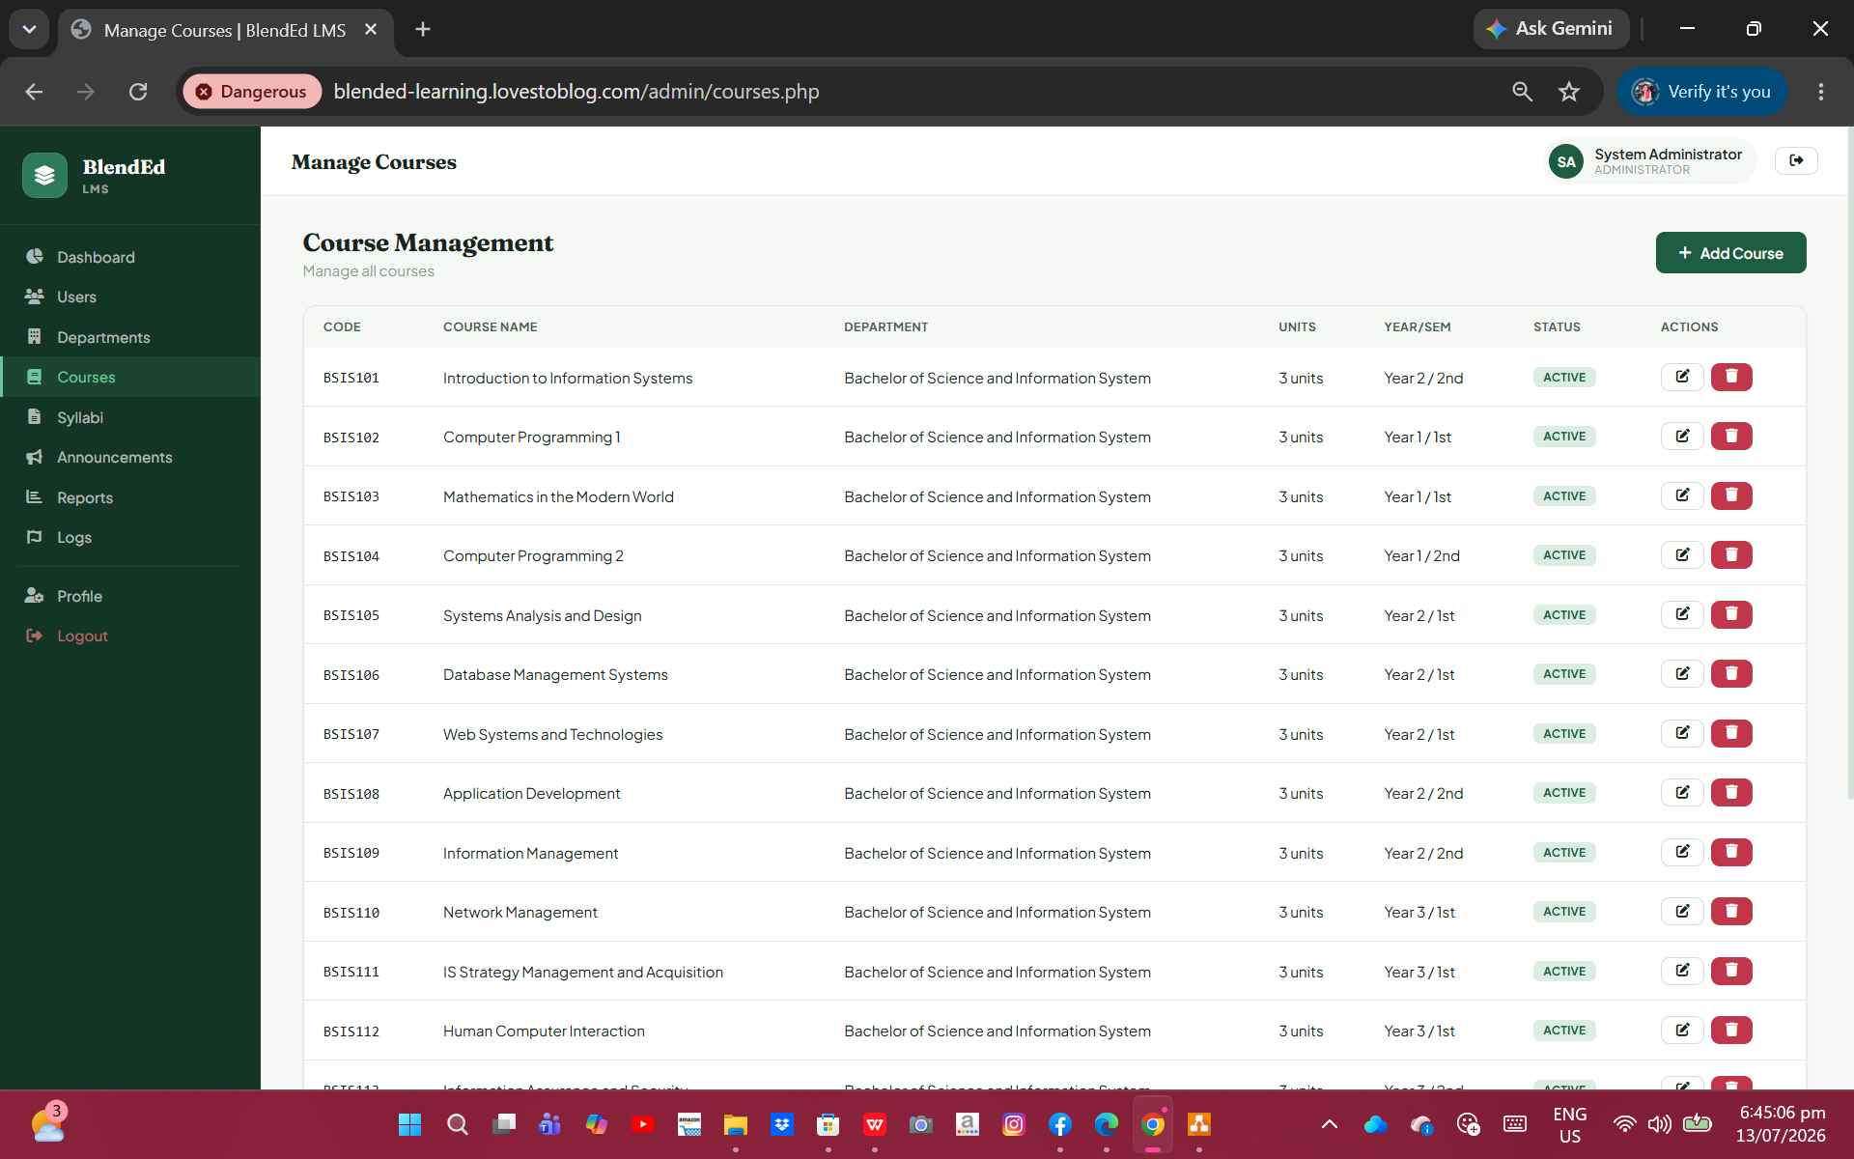
Figure 12: Course Management
This page allows administrators to add, edit, and manage courses under each department. It stores course details such as course code, title, units, year/semester, and status, providing the foundation for syllabus creation and enrollment management.
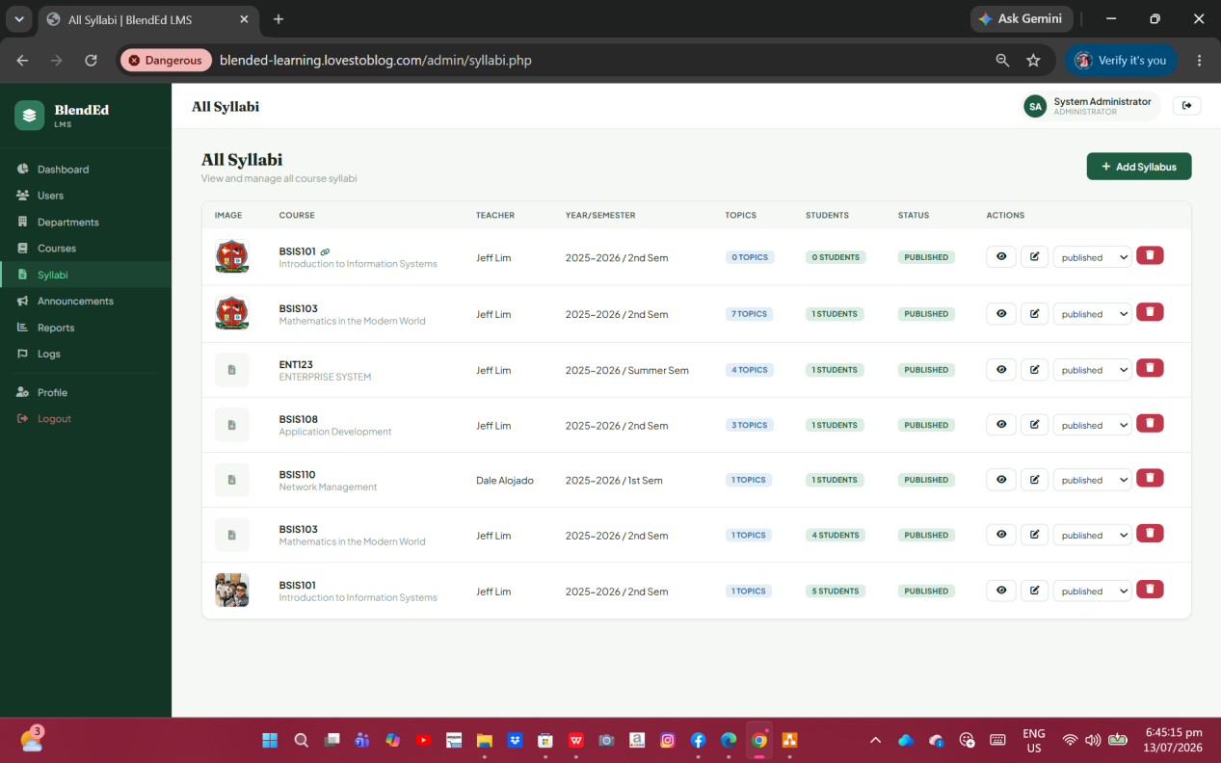
Figure 13: Syllabi
This page allows the administrator to create, manage, and publish course syllabi. It displays course information, assigned teachers, semester, topics, enrolled students, and publication status, enabling efficient syllabus organization and monitoring.
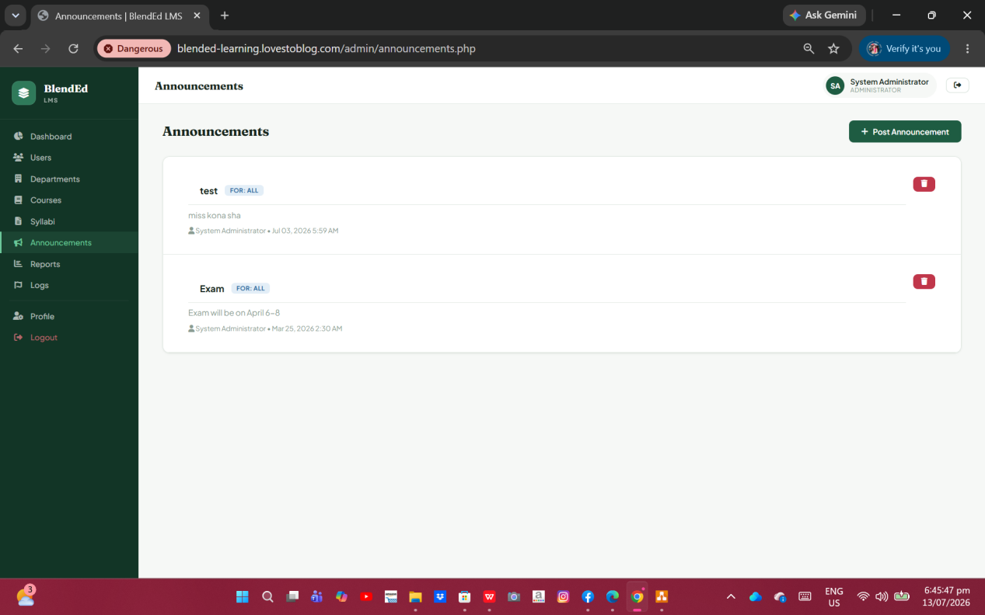
Figure 14: Announcements
This page enables administrators to post important updates and notices for all users. Announcements are displayed with the title, content, target audience, author, and posting date, ensuring timely communication.
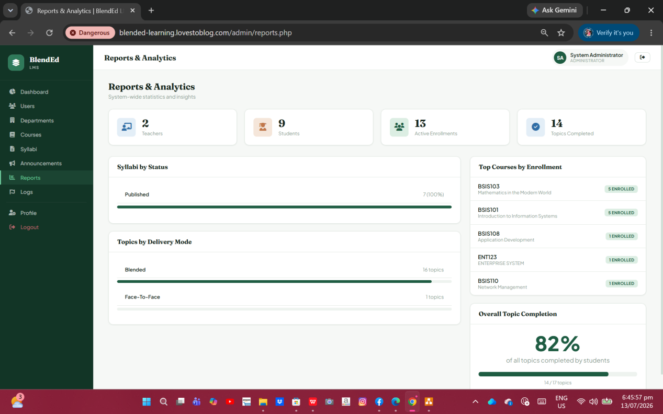
Figure 15: Reports & Analytics
This page provides a visual summary of system performance. It displays statistics such as the number of teachers, students, enrollments, published syllabi, topic completion rates, and course enrollment trends to support monitoring and decision-making.

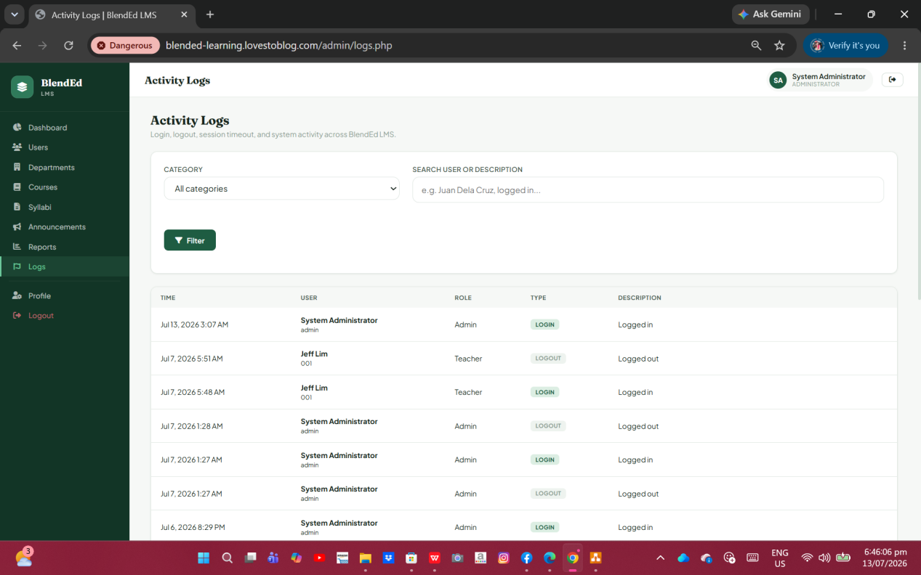
Figure 16: Activity Logs
This page records user activities such as logins, logouts, and other system actions. Administrators can search and filter logs by category or user, allowing them to monitor system usage, enhance security, and maintain accountability.

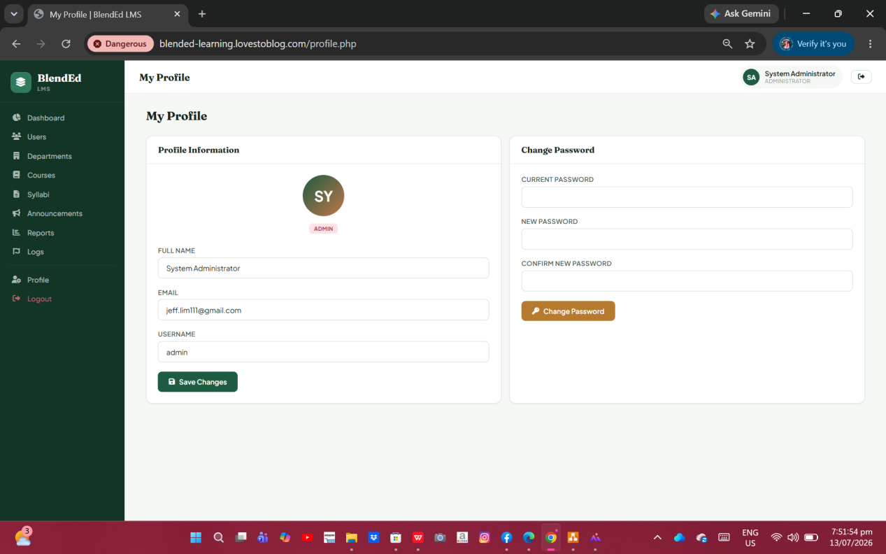
Figure 17: Profile
This page allows the administrator to update personal information (name, email, and username) and securely change their password to keep the account accurate and protected.

Software Requirements
Windows 10/11: Operating System
XAMPP: Local web server
PHP: Server-side programming language
MySQL: Database Management System
CSS3: User Interface design
Draw.io
Hardware and Other Required Devices
Processor: Intel Core i3 (8th Gen) or AMD Ryzen 3 or higher
RAM: 4 GB 8GB
Storage: 256 GB SSD or 500 GB HDD
Monitor: 1366 × 768 resolution or higher
Keyboard and Mouse: Standard USB Keyboard and Mouse
Internet Connection: Broadband or Wi-Fi connection

