## 注册实例

1、数据库

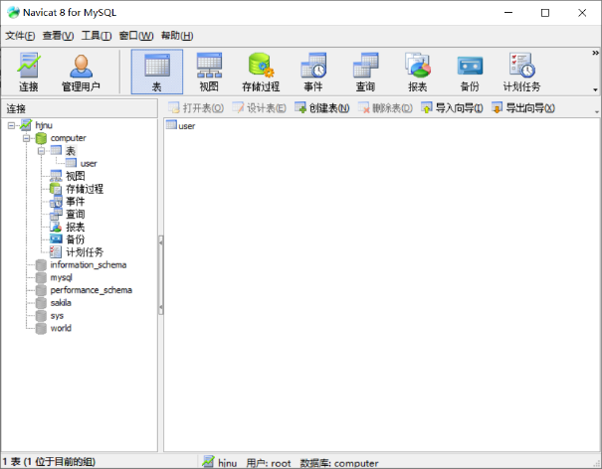

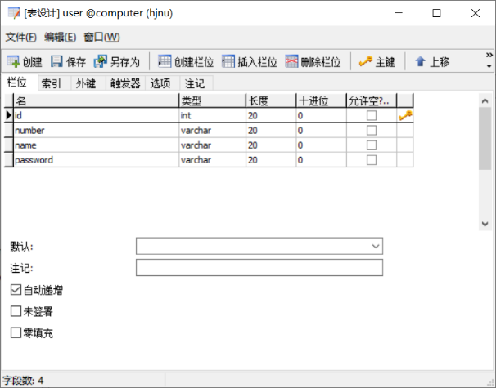

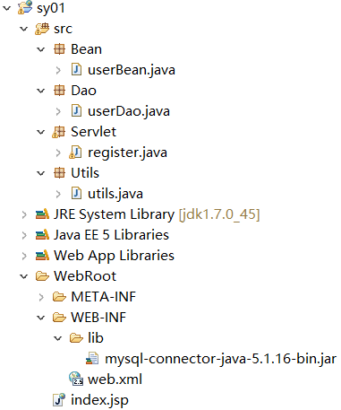

2、原始代码为：

//index.jsp

<body>

<form action="register" method="post">

<table>

<tr>

<td>学号：</td>

<td><input type="text" name="number"></td>

</tr>

<tr>

<td>姓名：</td>

<td><input type="text" name="name"></td>

</tr>

<tr>

<td>密码：</td>

<td><input type="password" name="password"></td>

</tr>

<tr>

<td colspan="2"><input type="submit" name="提交"></td>

</tr>

</table>

</form>

</body>

//web.xml

<servlet>

<servlet-name>register</servlet-name>

<servlet-class>Servlet.register</servlet-class>

</servlet>

<servlet-mapping>

<servlet-name>register</servlet-name>

<url-pattern>/register</url-pattern>

</servlet-mapping>

//userBean.java

package Bean;

public class userBean {

private String number;

private String name;

private String password;

public userBean(){}

public String getNumber() {

return number;

}

public void setNumber(String number) {

this.number = number;

}

public String getName() {

return name;

}

public void setName(String name) {

this.name = name;

}

public String getPassword() {

return password;

}

public void setPassword(String password) {

this.password = password;

}

}

//register.java

package Servlet;

import java.io.IOException;

import javax.servlet.ServletException;

import javax.servlet.http.HttpServlet;

import javax.servlet.http.HttpServletRequest;

import javax.servlet.http.HttpServletResponse;

import Bean.userBean;

import Dao.userDao;

public class register extends HttpServlet {

@Override

protected void doPost(HttpServletRequest req, HttpServletResponse resp)

throws ServletException, IOException {

// TODO Auto-generated method stub

//super.doPost(req, resp);

req.setCharacterEncoding("utf-8");

resp.setCharacterEncoding("utf-8");

String xh = req.getParameter("number");

String xm = req.getParameter("name");

String mm = req.getParameter("password");

userBean user = new userBean();

user.setNumber(xh);

user.setName(xm);

user.setPassword(mm);

userDao userdao = new userDao();

userdao.addUser(user);

System.out.println("注册成功");

}

}

//utils.java：解决数据库版本问题："jdbc:mysql://localhost:3306/computer?useUnicode=true&characterEncoding=UTF-8"

package Utils;

import java.sql.Connection;

import java.sql.DriverManager;

import java.sql.SQLException;

public class utils {

private static Connection conn = null;

private static String url = "jdbc:mysql://localhost:3306/computer";

private static String user = "root";

private static String password = "root";

static{

try{

Class.forName("com.mysql.jdbc.Driver");

}catch(Exception e){

e.printStackTrace();

}

}

public static Connection getConnection() {

try{

conn = DriverManager.getConnection(url,user,password);

}catch(SQLException e){

e.printStackTrace();

}

return conn;

}

public static void close(Connection conn) {

if(conn!=null){

try{

conn.close();

}catch(SQLException e){

e.printStackTrace();

}

}

}

}

//userDao.java

package Dao;

import java.sql.Connection;

import java.sql.PreparedStatement;

import java.sql.SQLException;

import Bean.userBean;

import Utils.utils;

public class userDao {

Connection conn = null;

PreparedStatement pst = null;

public void addUser(userBean user){

try{

conn = utils.getConnection();

String sql = "insert into user(number,name,password) values (?,?,?)";

pst = conn.prepareStatement(sql);

pst.setString(1, user.getNumber());

pst.setString(2, user.getName());

pst.setString(3, user.getPassword());

pst.executeUpdate();

}catch(SQLException e){

e.printStackTrace();

}finally{

utils.close(conn);

}

}

}