注册实例
1、数据库
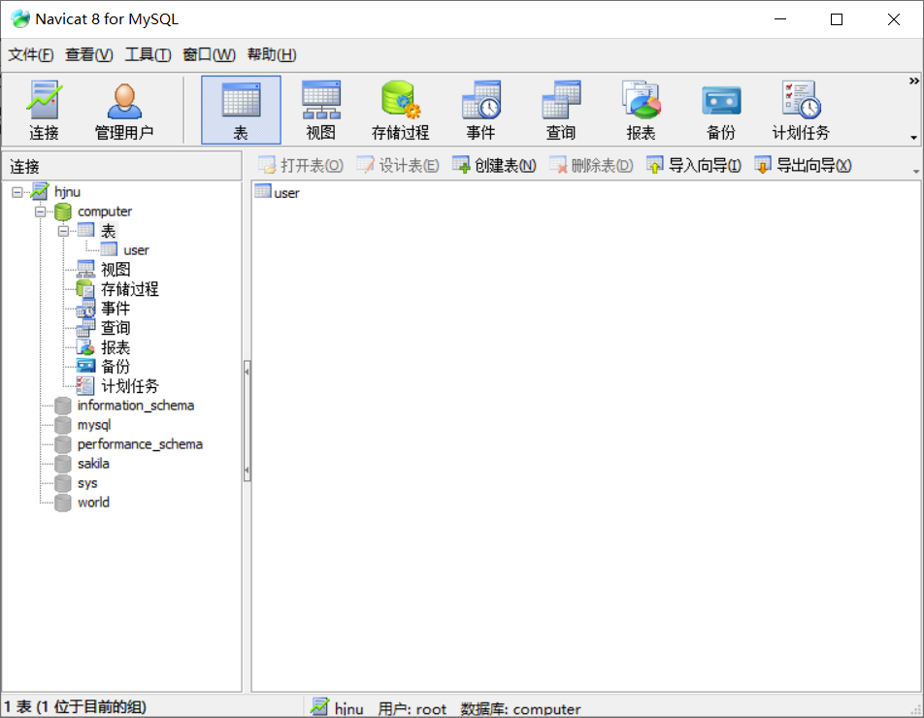
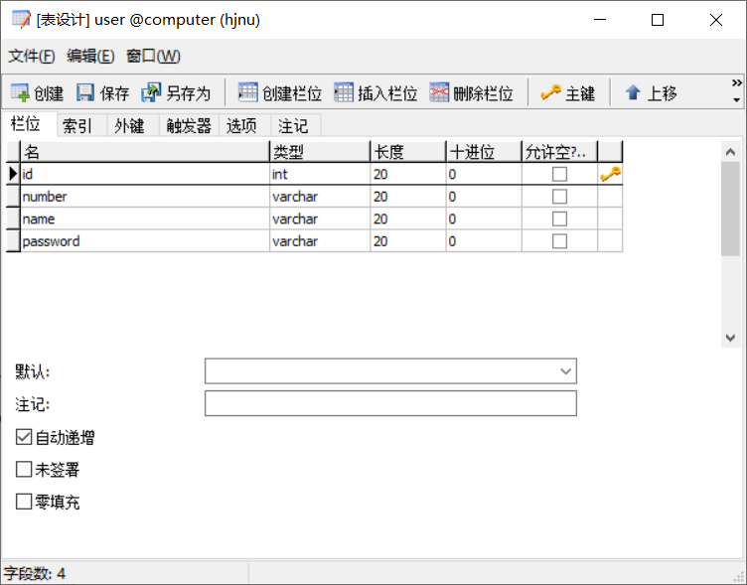
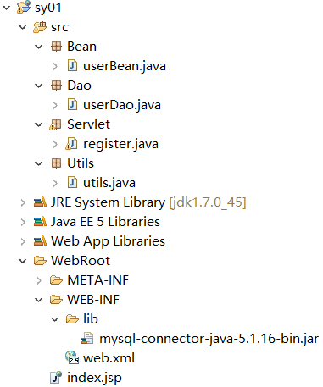
2、原始代码为：
//index.jsp
<body>
<form action="register" method="post">
<table>
<tr>
<td>学号：</td>
<td><input type="text" name="number"></td>
</tr>
<tr>
<td>姓名：</td>
<td><input type="text" name="name"></td>
</tr>
<tr>
<td>密码：</td>
<td><input type="password" name="password"></td>
</tr>
<tr>
<td colspan="2"><input type="submit" name="提交"></td>
</tr>
</table>
</form>
</body>
//web.xml
<servlet>
<servlet-name>register</servlet-name>
<servlet-class>Servlet.register</servlet-class>
</servlet>
<servlet-mapping>
<servlet-name>register</servlet-name>
<url-pattern>/register</url-pattern>
</servlet-mapping>
//userBean.java
package Bean;

public class userBean {

private String number;
private String name;
private String password;
public userBean(){}
public String getNumber() {
return number;
}
public void setNumber(String number) {
this.number = number;
}
public String getName() {
return name;
}
public void setName(String name) {
this.name = name;
}
public String getPassword() {
return password;
}
public void setPassword(String password) {
this.password = password;
}

}
//register.java
package Servlet;

import java.io.IOException;
import javax.servlet.ServletException;
import javax.servlet.http.HttpServlet;
import javax.servlet.http.HttpServletRequest;
import javax.servlet.http.HttpServletResponse;

import Bean.userBean;
import Dao.userDao;

public class register extends HttpServlet {

@Override
protected void doPost(HttpServletRequest req, HttpServletResponse resp)
throws ServletException, IOException {
// TODO Auto-generated method stub
//super.doPost(req, resp);
req.setCharacterEncoding("utf-8");
resp.setCharacterEncoding("utf-8");
String xh = req.getParameter("number");
String xm = req.getParameter("name");
String mm = req.getParameter("password");
userBean user = new userBean();
user.setNumber(xh);
user.setName(xm);
user.setPassword(mm);
userDao userdao = new userDao();
userdao.addUser(user);
System.out.println("注册成功");
}

}
//utils.java：解决数据库版本问题："jdbc:mysql://localhost:3306/computer?useUnicode=true&characterEncoding=UTF-8"
package Utils;

import java.sql.Connection;
import java.sql.DriverManager;
import java.sql.SQLException;

public class utils {
private static Connection conn = null;
private static String url = "jdbc:mysql://localhost:3306/computer";
private static String user = "root";
private static String password = "root";
static{
try{
Class.forName("com.mysql.jdbc.Driver");
}catch(Exception e){
e.printStackTrace();
}
}
public static Connection getConnection() {
try{
conn = DriverManager.getConnection(url,user,password);
}catch(SQLException e){
e.printStackTrace();
}
return conn;
}
public static void close(Connection conn) {
if(conn!=null){
try{
conn.close();
}catch(SQLException e){
e.printStackTrace();
}
}
}
}
//userDao.java
package Dao;

import java.sql.Connection;
import java.sql.PreparedStatement;
import java.sql.SQLException;

import Bean.userBean;
import Utils.utils;

public class userDao {

Connection conn = null;
PreparedStatement pst = null;

public void addUser(userBean user){
try{
conn = utils.getConnection();
String sql = "insert into user(number,name,password) values (?,?,?)";
pst = conn.prepareStatement(sql);
pst.setString(1, user.getNumber());
pst.setString(2, user.getName());
pst.setString(3, user.getPassword());
pst.executeUpdate();
}catch(SQLException e){
e.printStackTrace();
}finally{
utils.close(conn);
}
}

}
3、注册时需要判断是否学号已经存在，改进后代码为：
//userDao.java
package Dao;

import java.sql.Connection;
import java.sql.PreparedStatement;
import java.sql.ResultSet;
import java.sql.SQLException;

import Bean.userBean;
import Utils.utils;

public class userDao {

Connection conn = null;
PreparedStatement pst = null;
ResultSet rs = null;
public void addUser(userBean user){
try{
conn = utils.getConnection();
String sqls = "select * from user where number='"+user.getNumber()+"'";
pst = conn.prepareStatement(sqls);
rs = pst.executeQuery();
if(rs.next()){
System.out.println("用户已注册");
}
else{
String sqli = "insert into user(number,name,password) values (?,?,?)";
pst = conn.prepareStatement(sqli);
pst.setString(1, user.getNumber());
pst.setString(2, user.getName());
pst.setString(3, user.getPassword());
pst.executeUpdate();
System.out.println("注册成功");
}
}catch(SQLException e){
e.printStackTrace();
}finally{
utils.close(conn);
}
}

}
//register.java
package Servlet;

import java.io.IOException;
import javax.servlet.ServletException;
import javax.servlet.http.HttpServlet;
import javax.servlet.http.HttpServletRequest;
import javax.servlet.http.HttpServletResponse;

import Bean.userBean;
import Dao.userDao;

public class register extends HttpServlet {

@Override
protected void doPost(HttpServletRequest req, HttpServletResponse resp)
throws ServletException, IOException {
// TODO Auto-generated method stub
//super.doPost(req, resp);
req.setCharacterEncoding("utf-8");
resp.setCharacterEncoding("utf-8");
String xh = req.getParameter("number");
String xm = req.getParameter("name");
String mm = req.getParameter("password");
userBean user = new userBean();
user.setNumber(xh);
user.setName(xm);
user.setPassword(mm);
userDao userdao = new userDao();
userdao.addUser(user);
}

}
4、注册完毕需要跳转页面，完成代码为：
//userDao.java
package Dao;

import java.sql.Connection;
import java.sql.PreparedStatement;
import java.sql.ResultSet;
import java.sql.SQLException;

import Bean.userBean;
import Utils.utils;

public class userDao {

Connection conn = null;
PreparedStatement pst = null;
ResultSet rs = null;

public boolean findUser(userBean user){
try{
conn = utils.getConnection();
String sql = "select * from user where number='"+user.getNumber()+"'";
pst = conn.prepareStatement(sql);
// pst.setString(1, user.getNumber());
rs = pst.executeQuery();
if(rs.next()){
System.out.println("用户已注册");
conn.close();
return false;
}
}catch(SQLException e){
e.printStackTrace();
}finally{
utils.close(conn);
}
return true;
}

public void addUser(userBean user){
try{
conn = utils.getConnection();
String sql = "insert into user(number,name,password) values (?,?,?)";
pst = conn.prepareStatement(sql);
pst.setString(1, user.getNumber());
pst.setString(2, user.getName());
pst.setString(3, user.getPassword());
pst.executeUpdate();
System.out.println("注册成功");
}catch(SQLException e){
e.printStackTrace();
}finally{
utils.close(conn);
}
}

}
//register.java
package Servlet;

import java.io.IOException;
import javax.servlet.ServletException;
import javax.servlet.http.HttpServlet;
import javax.servlet.http.HttpServletRequest;
import javax.servlet.http.HttpServletResponse;

import Bean.userBean;
import Dao.userDao;

public class register extends HttpServlet {

@Override
protected void doPost(HttpServletRequest req, HttpServletResponse resp)
throws ServletException, IOException {
// TODO Auto-generated method stub
//super.doPost(req, resp);
req.setCharacterEncoding("utf-8");
resp.setCharacterEncoding("utf-8");
String xh = req.getParameter("number");
String xm = req.getParameter("name");
String mm = req.getParameter("password");
userBean user = new userBean();
user.setNumber(xh);
user.setName(xm);
user.setPassword(mm);
userDao userdao = new userDao();
if(userdao.findUser(user)==false){
resp.sendRedirect("fail.jsp");
}
else{
userdao.addUser(user);
req.getRequestDispatcher("succ.jsp").forward(req, resp);
}
}

}
//succ.jsp
<body>
注册成功
</body>
//fail.jsp
<body>
用户已注册
</body>

完整实例
1、数据库
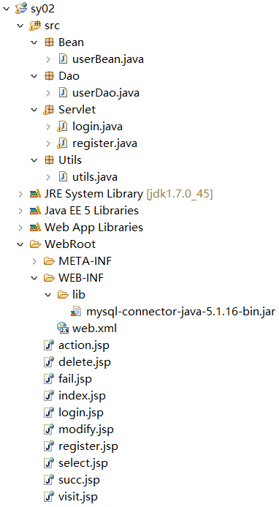
//userBean.java
package Bean;

public class userBean {

private String number;
private String name;
private String password;
public userBean(){}
public String getNumber() {
return number;
}
public void setNumber(String number) {
this.number = number;
}
public String getName() {
return name;
}
public void setName(String name) {
this.name = name;
}
public String getPassword() {
return password;
}
public void setPassword(String password) {
this.password = password;
}
public userBean(String number, String name, String password) {
super();
this.number = number;
this.name = name;
this.password = password;
}

}
//userDao.java
package Dao;

import java.sql.Connection;
import java.sql.PreparedStatement;
import java.sql.ResultSet;
import java.sql.SQLException;

import Bean.userBean;
import Utils.utils;

public class userDao {

Connection conn = null;
PreparedStatement pst = null;
ResultSet rs = null;

public boolean findUser(userBean user){
try{
conn = utils.getConnection();
String sql = "select * from user where number='"+user.getNumber()+"'";
pst = conn.prepareStatement(sql);
// pst.setString(1, user.getNumber());
rs = pst.executeQuery();
if(rs.next()){
System.out.println("用户已注册");
conn.close();
return false;
}
}catch(SQLException e){
e.printStackTrace();
}finally{
utils.close(conn);
}
return true;
}

public void addUser(userBean user){
try{
conn = utils.getConnection();
String sql = "insert into user(number,name,password) values (?,?,?)";
pst = conn.prepareStatement(sql);
pst.setString(1, user.getNumber());
pst.setString(2, user.getName());
pst.setString(3, user.getPassword());
pst.executeUpdate();
System.out.println("注册成功");
}catch(SQLException e){
e.printStackTrace();
}finally{
utils.close(conn);
}
}

public userBean login(String number, String password){
userBean u = null;
try {
conn = utils.getConnection();
String sql = "select * from user where number=? and password=?";
pst = conn.prepareStatement(sql);
pst.setString(1,number);
pst.setString(2,password);
rs = pst.executeQuery();
if(rs.next()){
u = new userBean();
u.setNumber(rs.getString("number"));
u.setPassword(rs.getString("password"));
}
}catch(SQLException e){
e.printStackTrace();
}finally{
utils.close(conn);
}
return u;
}

}
//login.java
package Servlet;

import java.io.IOException;
import java.io.PrintWriter;

import javax.servlet.ServletException;
import javax.servlet.http.HttpServlet;
import javax.servlet.http.HttpServletRequest;
import javax.servlet.http.HttpServletResponse;

import Bean.userBean;
import Dao.userDao;

public class login extends HttpServlet {

@Override
protected void doPost(HttpServletRequest req, HttpServletResponse resp)
throws ServletException, IOException {
// TODO Auto-generated method stub
//super.doPost(req, resp);
req.setCharacterEncoding("utf-8");
resp.setCharacterEncoding("utf-8");
String xh = req.getParameter("number");
String mm = req.getParameter("password");
userDao userdao = new userDao();
userBean user = userdao.login(xh, mm);
if(user!=null){
System.out.println("登录成功");
req.getRequestDispatcher("action.jsp").forward(req, resp);
}
else{
System.out.println("用户名或密码错误");
resp.sendRedirect("index.jsp");
}
}

}
//register.java
package Servlet;

import java.io.IOException;
import javax.servlet.ServletException;
import javax.servlet.http.HttpServlet;
import javax.servlet.http.HttpServletRequest;
import javax.servlet.http.HttpServletResponse;

import Bean.userBean;
import Dao.userDao;

public class register extends HttpServlet {

@Override
protected void doPost(HttpServletRequest req, HttpServletResponse resp)
throws ServletException, IOException {
// TODO Auto-generated method stub
//super.doPost(req, resp);
req.setCharacterEncoding("utf-8");
resp.setCharacterEncoding("utf-8");
String xh = req.getParameter("number");
String xm = req.getParameter("name");
String mm = req.getParameter("password");
userBean user = new userBean();
user.setNumber(xh);
user.setName(xm);
user.setPassword(mm);
userDao userdao = new userDao();
if(userdao.findUser(user)==false){
resp.sendRedirect("fail.jsp");
}
else{
userdao.addUser(user);
req.getRequestDispatcher("succ.jsp").forward(req, resp);
}
}

}
//utils.java
package Utils;

import java.sql.Connection;
import java.sql.DriverManager;
import java.sql.SQLException;

public class utils {
private static Connection conn = null;
private static String url = "jdbc:mysql://localhost:3306/computer";
private static String user = "root";
private static String password = "root";
static{
try{
Class.forName("com.mysql.jdbc.Driver");
}catch(Exception e){
e.printStackTrace();
}
}
public static Connection getConnection() {
try{
conn = DriverManager.getConnection(url,user,password);
}catch(SQLException e){
e.printStackTrace();
}
return conn;
}
public static void close(Connection conn) {
if(conn!=null){
try{
conn.close();
}catch(SQLException e){
e.printStackTrace();
}
}
}
}
//web.xml
<?xml version="1.0" encoding="UTF-8"?>
<web-app version="2.5"
xmlns="http://java.sun.com/xml/ns/javaee"
xmlns:xsi="http://www.w3.org/2001/XMLSchema-instance"
xsi:schemaLocation="http://java.sun.com/xml/ns/javaee
http://java.sun.com/xml/ns/javaee/web-app_2_5.xsd">
<servlet>
<servlet-name>register</servlet-name>
<servlet-class>Servlet.register</servlet-class>
</servlet>
<servlet>
<servlet-name>login</servlet-name>
<servlet-class>Servlet.login</servlet-class>
</servlet>

<servlet-mapping>
<servlet-name>register</servlet-name>
<url-pattern>/register</url-pattern>
</servlet-mapping>
<servlet-mapping>
<servlet-name>login</servlet-name>
<url-pattern>/login</url-pattern>
</servlet-mapping>
</web-app>
//action.jsp
<%@ page language="java" import="java.util.*" contentType="text/html; charset=utf-8"%>
<%
String path = request.getContextPath();
String basePath = request.getScheme()+"://"+request.getServerName()+":"+request.getServerPort()+path+"/";
%>

<!DOCTYPE HTML PUBLIC "-//W3C//DTD HTML 4.01 Transitional//EN">
<html>
<head>
<base href="<%=basePath%>">

<title>My JSP 'index.jsp' starting page</title>
<meta http-equiv="pragma" content="no-cache">
<meta http-equiv="cache-control" content="no-cache">
<meta http-equiv="expires" content="0">
<meta http-equiv="keywords" content="keyword1,keyword2,keyword3">
<meta http-equiv="description" content="This is my page">
<!--
<link rel="stylesheet" type="text/css" href="styles.css">
-->
</head>

<body>
<a href="visit.jsp">查看所有内容</a>
<form action="select.jsp">
<input type="text" name="number">
<input type="submit" value="按学号查询">
</form>
<a href="index.jsp">返回</a>
</body>
</html>
//delete.jsp
<%@ page language="java" import="java.util.*" contentType="text/html; charset=utf-8"%>
<%@page import="Bean.userBean"%>
<%@page import="java.sql.ResultSet"%>
<%@page import="java.sql.PreparedStatement"%>
<%@page import="java.sql.DriverManager"%>
<%@page import="java.sql.Connection"%>
<%
String number = request.getParameter("number");
Class.forName("com.mysql.jdbc.Driver");
Connection conn = null;
String url = "jdbc:mysql://localhost:3306/computer";
String user = "root";
String password = "root";
conn = DriverManager.getConnection(url,user,password);
String sql = "delete from user where number=?";
PreparedStatement pst = conn.prepareStatement(sql);
pst.setString(1, number);
pst.executeUpdate();
pst.close();
conn.close();
%>
删除成功
<a href="action.jsp">返回</a>
//fail.jsp
<%@ page language="java" import="java.util.*" contentType="text/html; charset=utf-8"%>
<%
String path = request.getContextPath();
String basePath = request.getScheme()+"://"+request.getServerName()+":"+request.getServerPort()+path+"/";
%>

<!DOCTYPE HTML PUBLIC "-//W3C//DTD HTML 4.01 Transitional//EN">
<html>
<head>
<base href="<%=basePath%>">

<title>My JSP 'index.jsp' starting page</title>
<meta http-equiv="pragma" content="no-cache">
<meta http-equiv="cache-control" content="no-cache">
<meta http-equiv="expires" content="0">
<meta http-equiv="keywords" content="keyword1,keyword2,keyword3">
<meta http-equiv="description" content="This is my page">
<!--
<link rel="stylesheet" type="text/css" href="styles.css">
-->
</head>

<body>
用户已注册<br>
<a href="register.jsp">返回</a>
</body>
</html>
//index.jsp
<%@ page language="java" import="java.util.*" contentType="text/html; charset=utf-8"%>
<%
String path = request.getContextPath();
String basePath = request.getScheme()+"://"+request.getServerName()+":"+request.getServerPort()+path+"/";
%>

<!DOCTYPE HTML PUBLIC "-//W3C//DTD HTML 4.01 Transitional//EN">
<html>
<head>
<base href="<%=basePath%>">

<title>My JSP 'index.jsp' starting page</title>
<meta http-equiv="pragma" content="no-cache">
<meta http-equiv="cache-control" content="no-cache">
<meta http-equiv="expires" content="0">
<meta http-equiv="keywords" content="keyword1,keyword2,keyword3">
<meta http-equiv="description" content="This is my page">
<!--
<link rel="stylesheet" type="text/css" href="styles.css">
-->
</head>

<body>
Java Web实例<br>
<a href="register.jsp">注册</a>
<a href="login.jsp">登录</a>
</body>
</html>
//login.jsp
<%@ page language="java" import="java.util.*" contentType="text/html; charset=utf-8"%>
<%
String path = request.getContextPath();
String basePath = request.getScheme()+"://"+request.getServerName()+":"+request.getServerPort()+path+"/";
%>

<!DOCTYPE HTML PUBLIC "-//W3C//DTD HTML 4.01 Transitional//EN">
<html>
<head>
<base href="<%=basePath%>">

<title>My JSP 'index.jsp' starting page</title>
<meta http-equiv="pragma" content="no-cache">
<meta http-equiv="cache-control" content="no-cache">
<meta http-equiv="expires" content="0">
<meta http-equiv="keywords" content="keyword1,keyword2,keyword3">
<meta http-equiv="description" content="This is my page">
<!--
<link rel="stylesheet" type="text/css" href="styles.css">
-->
</head>

<body>
<form action="login" method="post">
<table>
<tr>
<td>学号：</td>
<td><input type="text" name="number"></td>
</tr>
<tr>
<td>密码：</td>
<td><input type="password" name="password"></td>
</tr>
<tr>
<td colspan="2"><input type="submit" name="提交"></td>
</tr>
</table>
</form>
<a href="index.jsp">返回</a>
</body>
</html>
//modify.jsp
<%@ page language="java" import="java.util.*" contentType="text/html; charset=utf-8"%>
<%@page import="Bean.userBean"%>
<%@page import="java.sql.ResultSet"%>
<%@page import="java.sql.PreparedStatement"%>
<%@page import="java.sql.DriverManager"%>
<%@page import="java.sql.Connection"%>
<%
String xh = request.getParameter("number");
String xm = request.getParameter("name");
String mm = request.getParameter("password");
Class.forName("com.mysql.jdbc.Driver");
Connection conn = null;
String url = "jdbc:mysql://localhost:3306/computer";
String user = "root";
String password = "root";
conn = DriverManager.getConnection(url,user,password);
String sql = "update user set name=?,password=? where number=?";
PreparedStatement pst = conn.prepareStatement(sql);
pst.setString(1,xm);
pst.setString(2,mm);
pst.setString(3,xh);
pst.executeUpdate();
pst.close();
conn.close();
%>
修改成功
<a href="action.jsp">返回</a>
//register.jsp
<%@ page language="java" import="java.util.*" contentType="text/html; charset=utf-8"%>
<%
String path = request.getContextPath();
String basePath = request.getScheme()+"://"+request.getServerName()+":"+request.getServerPort()+path+"/";
%>

<!DOCTYPE HTML PUBLIC "-//W3C//DTD HTML 4.01 Transitional//EN">
<html>
<head>
<base href="<%=basePath%>">

<title>My JSP 'index.jsp' starting page</title>
<meta http-equiv="pragma" content="no-cache">
<meta http-equiv="cache-control" content="no-cache">
<meta http-equiv="expires" content="0">
<meta http-equiv="keywords" content="keyword1,keyword2,keyword3">
<meta http-equiv="description" content="This is my page">
<!--
<link rel="stylesheet" type="text/css" href="styles.css">
-->
</head>

<body>
<form action="register" method="post">
<table>
<tr>
<td>学号：</td>
<td><input type="text" name="number"></td>
</tr>
<tr>
<td>姓名：</td>
<td><input type="text" name="name"></td>
</tr>
<tr>
<td>密码：</td>
<td><input type="password" name="password"></td>
</tr>
<tr>
<td colspan="2"><input type="submit" name="提交"></td>
</tr>
</table>
</form>
<a href="index.jsp">返回</a>
</body>
</html>
//select.jsp
<%@ page language="java" import="java.util.*" contentType="text/html; charset=utf-8"%>
<%@page import="Bean.userBean"%>
<%@page import="java.sql.ResultSet"%>
<%@page import="java.sql.PreparedStatement"%>
<%@page import="java.sql.DriverManager"%>
<%@page import="java.sql.Connection"%>
<%
String path = request.getContextPath();
String basePath = request.getScheme()+"://"+request.getServerName()+":"+request.getServerPort()+path+"/";
%>
<%
String number = request.getParameter("number");
Class.forName("com.mysql.jdbc.Driver");
Connection conn = null;
String url = "jdbc:mysql://localhost:3306/computer";
String user = "root";
String password = "root";
conn = DriverManager.getConnection(url,user,password);
String sql = "select number,name,password from user where number=?";
if(conn!=null){
PreparedStatement pst = conn.prepareStatement(sql);
pst.setString(1,number);
ResultSet rs = pst.executeQuery();
userBean u = new userBean();
if(rs.next()){
u.setNumber(rs.getString("number"));
u.setName(rs.getString("name"));
u.setPassword(rs.getString("password"));
}
rs.close();
pst.close();
conn.close();
%>
<!DOCTYPE HTML PUBLIC "-//W3C//DTD HTML 4.01 Transitional//EN">
<html>
<head>
<base href="<%=basePath%>">

<title>My JSP 'index.jsp' starting page</title>
<meta http-equiv="pragma" content="no-cache">
<meta http-equiv="cache-control" content="no-cache">
<meta http-equiv="expires" content="0">
<meta http-equiv="keywords" content="keyword1,keyword2,keyword3">
<meta http-equiv="description" content="This is my page">
<!--
<link rel="stylesheet" type="text/css" href="styles.css">
-->
<Script Language="JavaScript">
function modi()
{
document.sform.action="modify.jsp?number=<%= u.getNumber()%>";
}

function dele()
{
document.sform.action="delete.jsp?number=<%= u.getNumber()%>";
}
</Script>
</head>

<body>
<form name="sform">
<table width="200px" border="1px">
<tr>
<td>学号</td>
<td><input type="text" name="number" value="<%= u.getNumber()%>"></td>
</tr>
<tr>
<td>姓名</td>
<td><input type="text" name="name" value="<%= u.getName()%>"></td>
</tr>
<tr>
<td>密码</td>
<td><input type="text" name="password" value="<%= u.getPassword()%>"></td>
</tr>
<tr>
<td><input type="submit" value="修改" onClick="modi()"></td>
<td><input type="submit" value="删除" onClick="dele()"></td>
</tr>
</table>
</form>
<a href="action.jsp">返回</a>
</body>
</html>
<%
}
%>
//succ.jsp
<%@ page language="java" import="java.util.*" contentType="text/html; charset=utf-8"%>
<%
String path = request.getContextPath();
String basePath = request.getScheme()+"://"+request.getServerName()+":"+request.getServerPort()+path+"/";
%>

<!DOCTYPE HTML PUBLIC "-//W3C//DTD HTML 4.01 Transitional//EN">
<html>
<head>
<base href="<%=basePath%>">

<title>My JSP 'index.jsp' starting page</title>
<meta http-equiv="pragma" content="no-cache">
<meta http-equiv="cache-control" content="no-cache">
<meta http-equiv="expires" content="0">
<meta http-equiv="keywords" content="keyword1,keyword2,keyword3">
<meta http-equiv="description" content="This is my page">
<!--
<link rel="stylesheet" type="text/css" href="styles.css">
-->
</head>

<body>
注册成功<br>
<a href="login.jsp">返回</a>
</body>
</html>
//visit.jsp
<%@ page language="java" import="java.util.*" contentType="text/html; charset=utf-8"%>
<%@page import="Bean.userBean"%>
<%@page import="java.sql.ResultSet"%>
<%@page import="java.sql.PreparedStatement"%>
<%@page import="java.sql.DriverManager"%>
<%@page import="java.sql.Connection"%>
<%
String path = request.getContextPath();
String basePath = request.getScheme()+"://"+request.getServerName()+":"+request.getServerPort()+path+"/";
%>

<!DOCTYPE HTML PUBLIC "-//W3C//DTD HTML 4.01 Transitional//EN">
<html>
<head>
<base href="<%=basePath%>">

<title>My JSP 'index.jsp' starting page</title>
<meta http-equiv="pragma" content="no-cache">
<meta http-equiv="cache-control" content="no-cache">
<meta http-equiv="expires" content="0">
<meta http-equiv="keywords" content="keyword1,keyword2,keyword3">
<meta http-equiv="description" content="This is my page">
<!--
<link rel="stylesheet" type="text/css" href="styles.css">
-->
</head>

<body>
<table width="300px" border="1px">
<tr>
<td>学号</td>
<td>姓名</td>
<td>密码</td>
</tr>
<%
Class.forName("com.mysql.jdbc.Driver");
Connection conn = null;
String url = "jdbc:mysql://localhost:3306/computer";
String user = "root";
String password = "root";
conn = DriverManager.getConnection(url,user,password);
String sql = "select number,name,password from user";
PreparedStatement pst = conn.prepareStatement(sql);
ResultSet rs = pst.executeQuery();
List<userBean> data = new ArrayList<userBean>();
while (rs.next()) {
data.add(new userBean(rs.getString("number"),rs.getString("name"), rs.getString("password")));
}
rs.close();
pst.close();
conn.close();
for (userBean u : data){
%>
<tr>
<td><%=u.getNumber()%></td>
<td><%=u.getName()%></td>
<td><%=u.getPassword()%></td>
</tr>
<%
}
%>

</table>
<a href="action.jsp">返回</a>
</body>
</html>

