Minikube cluster

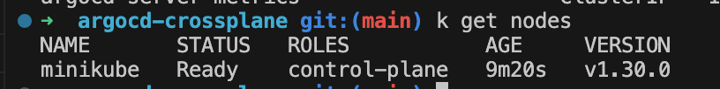

ArgoCD installed

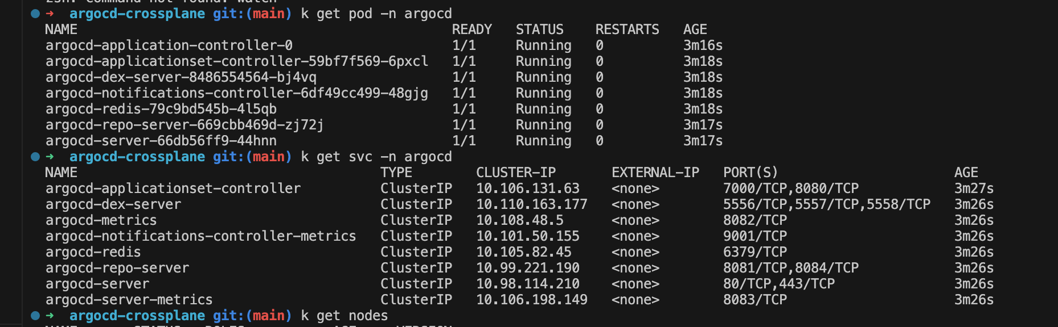

Login console

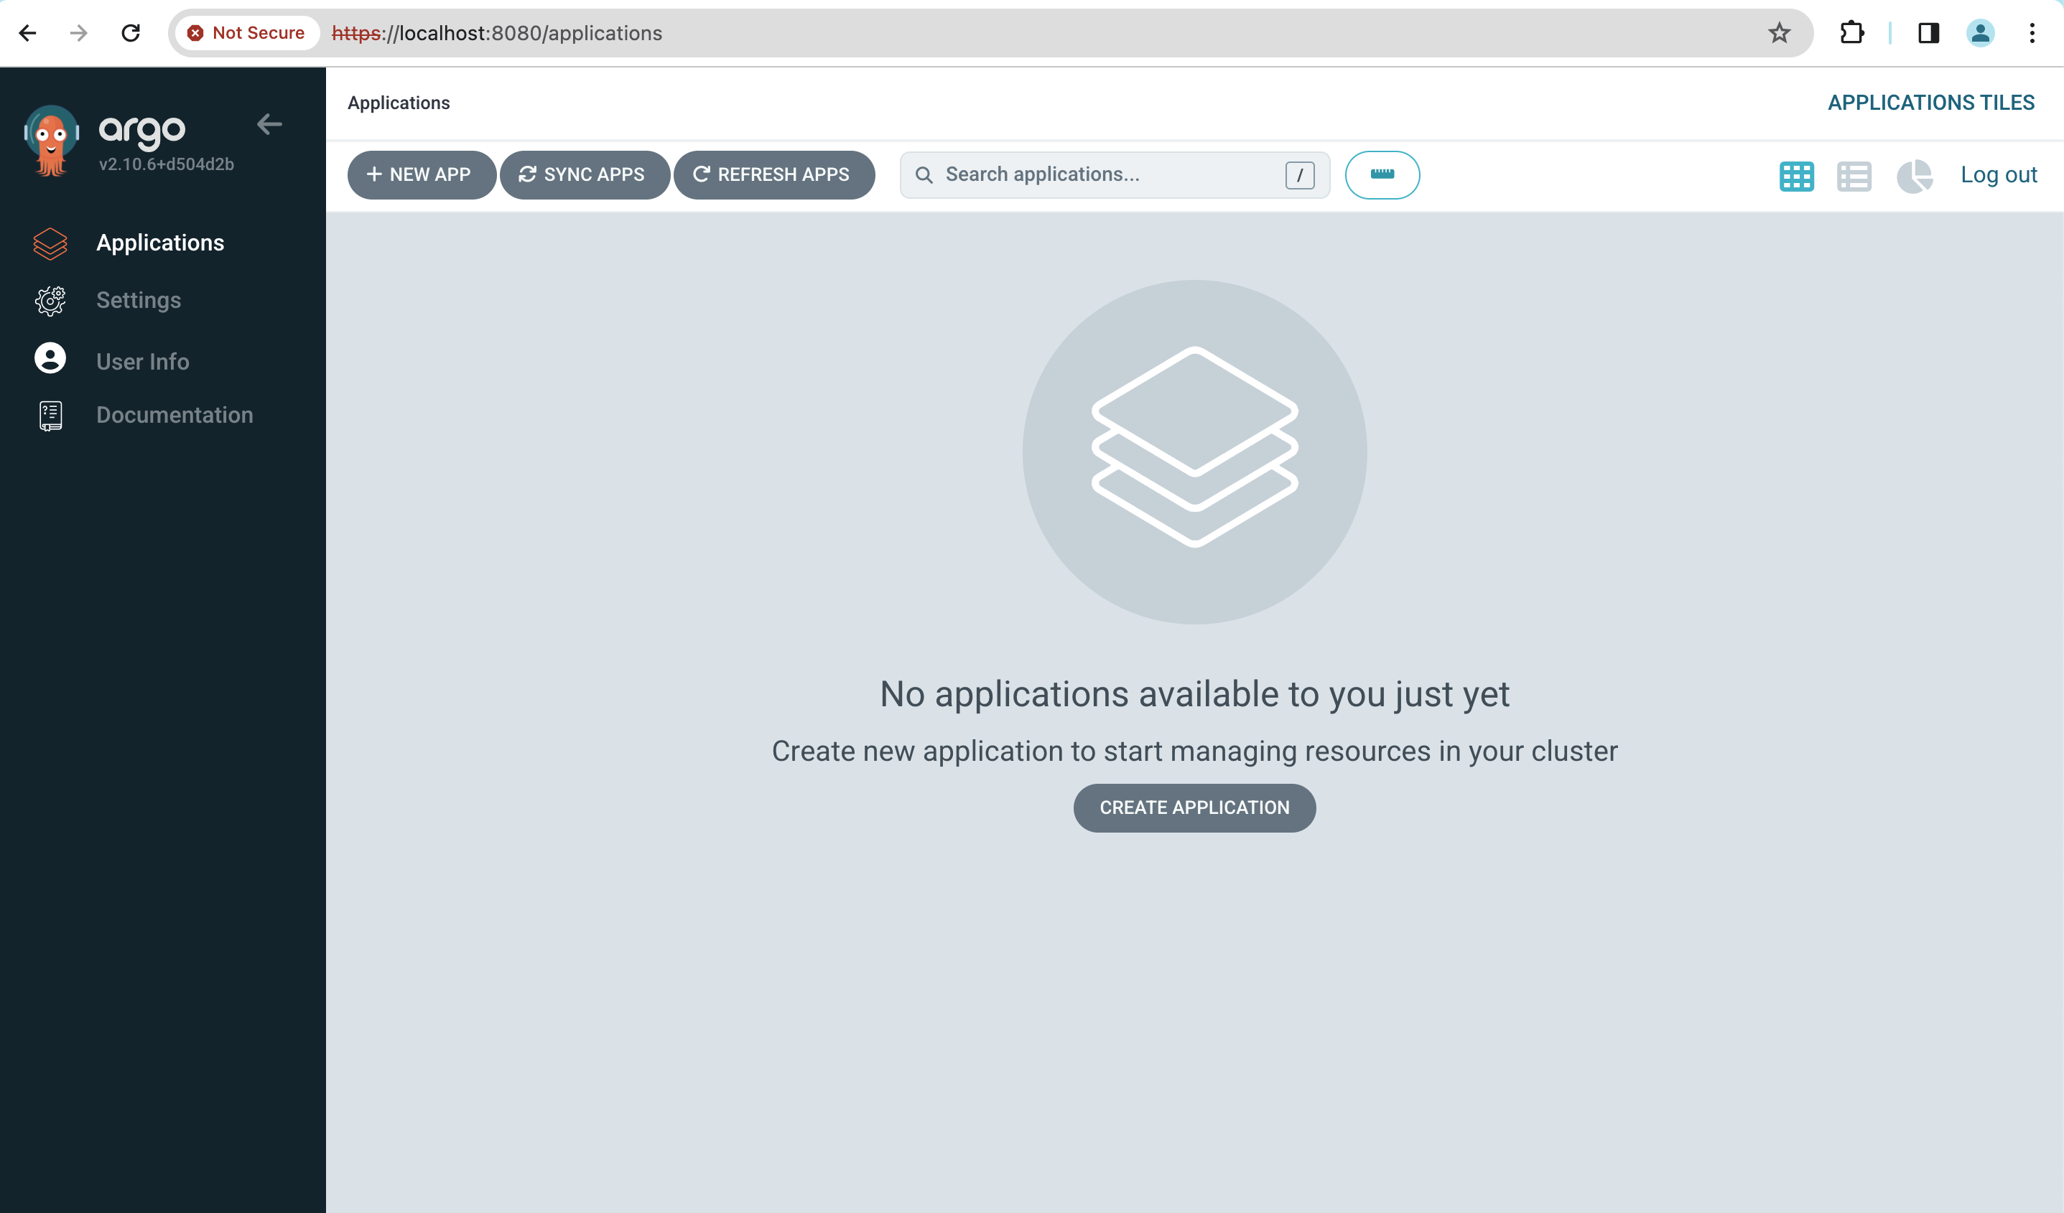

Install crossplane by helm and ready

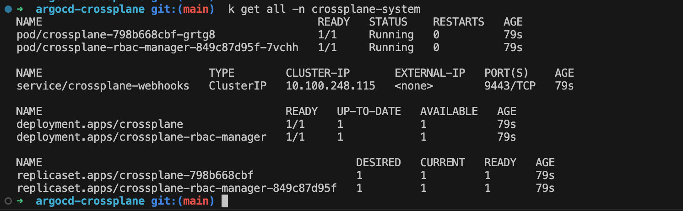

Crossplane deployed also from manifest file via ArgoCD

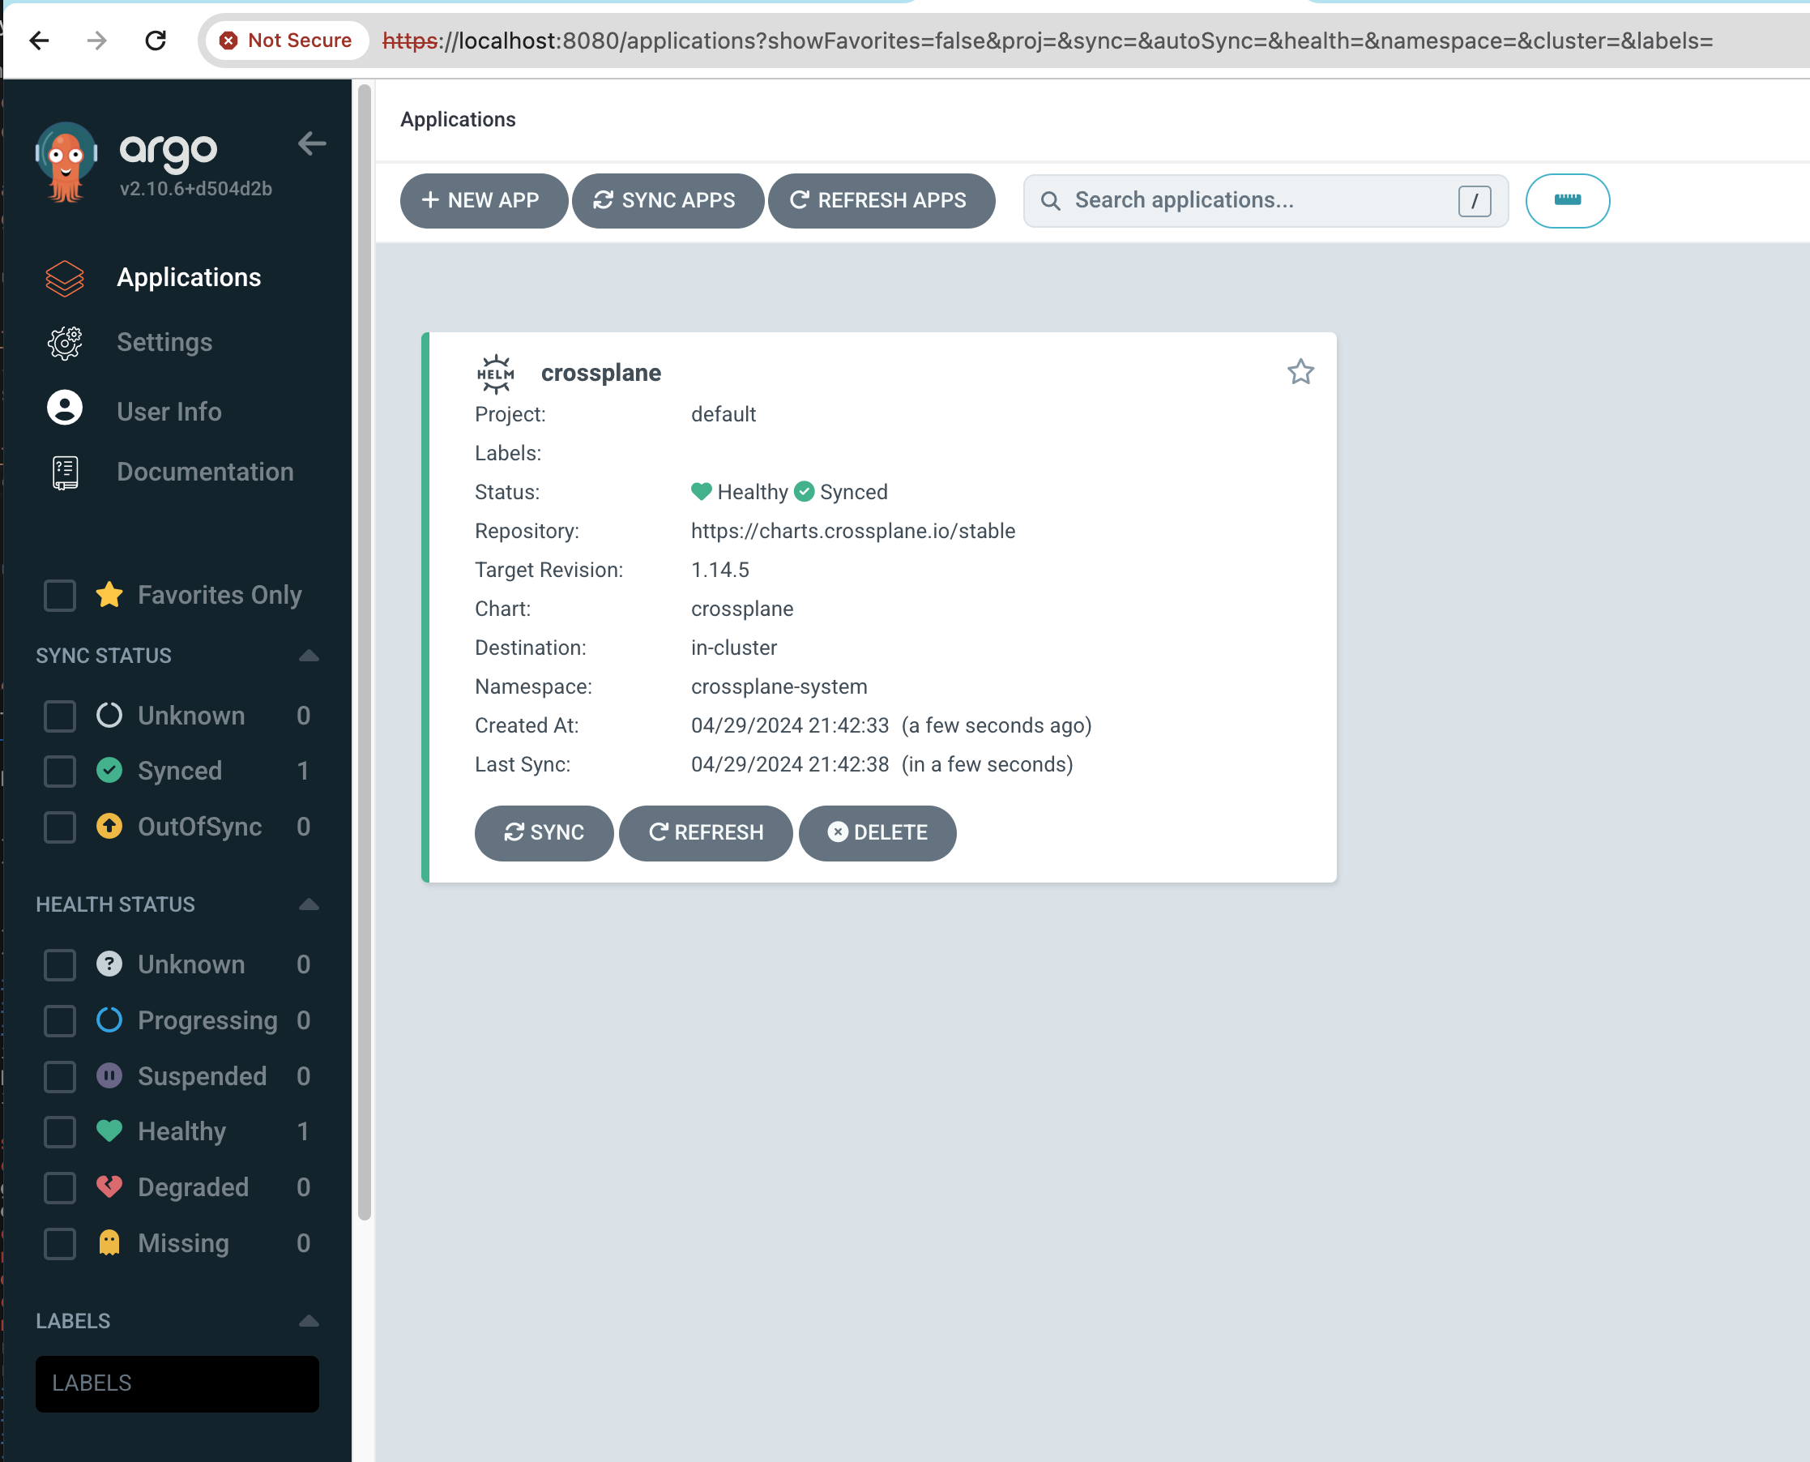

Created an Application in ArgoCD to proviosn EKS cluster

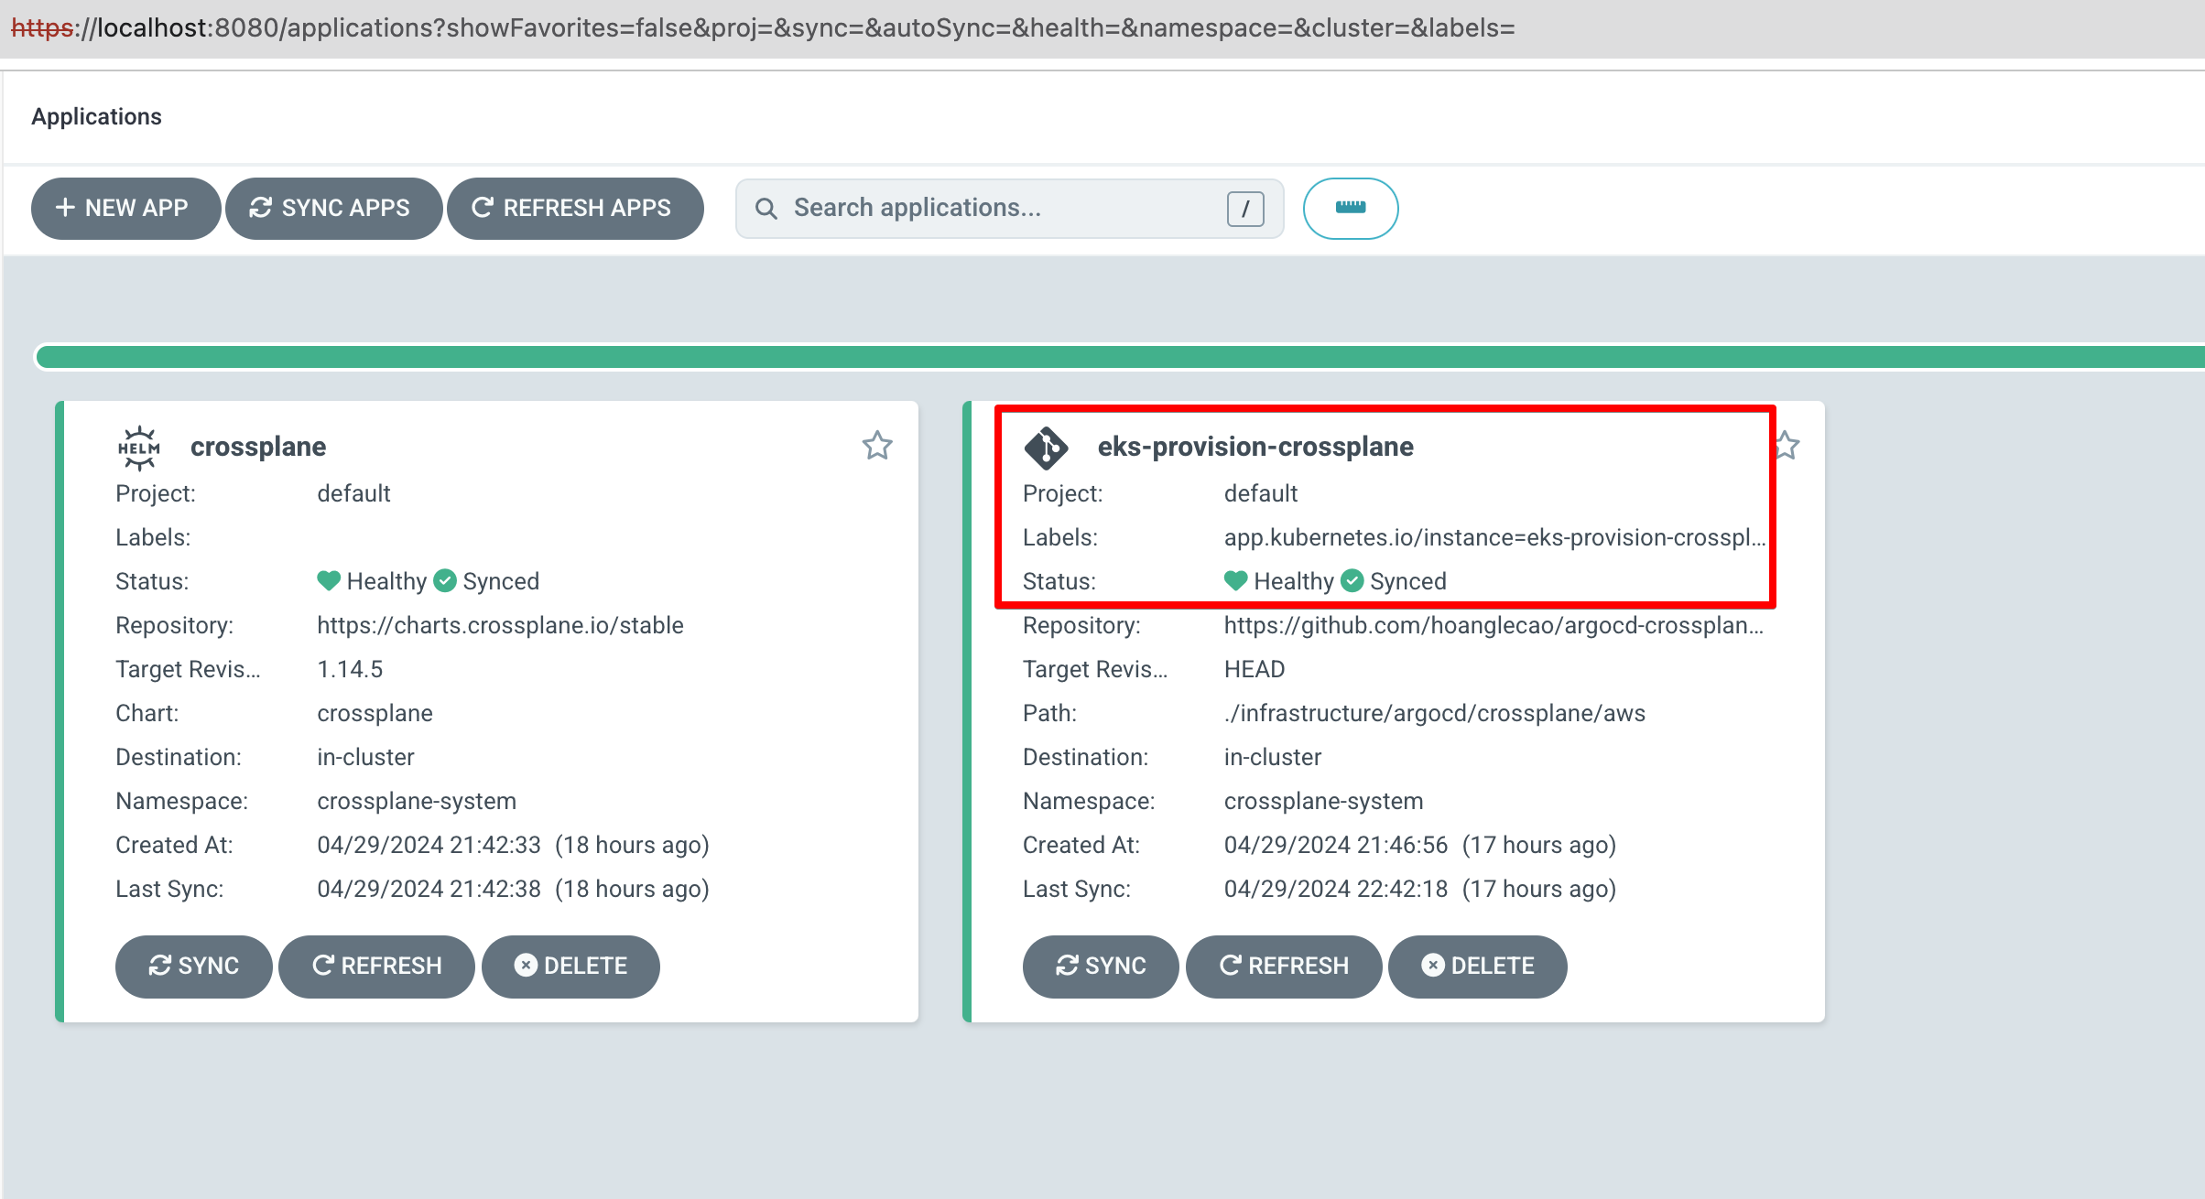

Done to provision EKS cluster

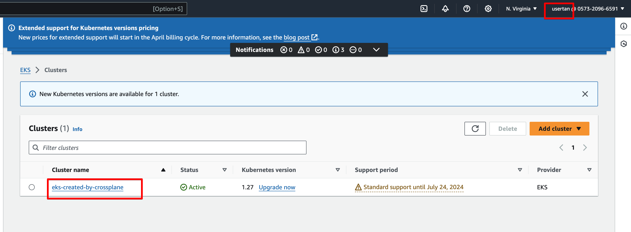

Created an Application in ArgoCD to proviosn AKS cluster

