ASSIGNMENT / TITLE: ______________________________________________
NAME: ____________________________________________________________
REGISTER NUMBER: __________________________________________________
BATCH: ___________________________________________________________
DEPARTMENT: ______________________________________________________
COURSE / SUBJECT: ________________________________________________
FACULTY NAME: ____________________________________________________
DATE OF SUBMISSION: ______________________________________________

Department of ______________________________

SIGNALS AND SYSTEMS LABORATORY
CO1: Identify and classify signals, apply operations on elementary signals such as Dirac delta and ECG, evaluate system properties including LTI, causality, and stability, distinguish energy and power signals in IoT and wireless contexts, and assess real-time system characteristics such as causality and time-invariance in automation.
CO Mapping: CO1
Bloom’s Level: K4 – Analyze
WK Level: WK3 – Fundamental Engineering Concepts
Topics Covered: Continuous-time and discrete-time signals, elementary signals, unit impulse, step, ramp and exponential signals, sinusoidal and pulse signals, periodic and aperiodic signals, deterministic and random signals, even and odd signals.

EXPERIMENT NO. 1
GENERATION AND CLASSIFICATION OF CONTINUOUS-TIME AND DISCRETE-TIME SIGNALS
OBJECTIVES
(i) To generate and visualize basic continuous-time signals such as unit step, unit impulse, ramp, sinusoidal, and exponential signals.
(ii) To generate and visualize basic discrete-time signals and analyze their amplitude and time-index characteristics.
(iii) To generate and classify continuous-time and discrete-time signals as periodic or aperiodic based on their periodicity characteristics.
(iv) To decompose a given signal into its even and odd components and verify the reconstruction of the original signal.

PART I: GENERATION OF CONTINUOUS-TIME SIGNALS
OBJECTIVE
To generate and visualize basic continuous-time signals such as unit step, unit impulse, ramp, exponential, and sinusoidal signals.
EXPECTED OUTCOMES
- Generate impulse, step, ramp, exponential, and sinusoidal continuous-time signals.
- Obtain correctly scaled time-domain plots.
- Determine measurable parameters with preferably ≤5% deviation wherever applicable.
- Explain the generated waveform using its mathematical expression.
SOFTWARE / LABORATORY ENVIRONMENT
MATLAB
INPUT PARAMETER TABLE
S. No. | Input Parameter | Symbol | Value | Unit
1 | Time vector | (t) | −1 to 1 | s
2 | Sampling interval | (\Delta t) | 0.001 | s
3 | Sinusoidal amplitude | (A) | 2 | V
4 | Sinusoidal frequency | (f_0) | 5 | Hz
5 | Exponential constant | (a) | 1 | s⁻¹
OUTPUT PARAMETER TABLE
S. No. | Output Parameter | Theoretical / Expected Value | Practical / Simulated Value | % Deviation / Acceptance
1 | Amplitude | Specified input value | Record simulated value | Record deviation
2 | Frequency | 5 Hz | Measure from plot | ≤5%
3 | Time period | 0.2 s | Measure from plot | ≤5%
4 | Waveform shape | Theoretical elementary shape | Record observation | Qualitative match
FORMULAE / ANALYSIS
Sinusoidal signal:
(x(t)=A\sin(2\pi f_0t+\phi))
Time period of a sinusoidal signal:
(T_0=\dfrac{1}{f_0})
Decaying exponential signal:
(x(t)=e^{-at}u(t))
Continuous-time signals are defined for every value of time (t).
Percentage deviation:
[
%\text{ Deviation}=
\frac{|\text{Practical}-\text{Theoretical}|}
{|\text{Theoretical}|}\times100
]
EXPERIMENTAL PROCEDURE
- Define a continuous-time vector with a sufficiently small simulation interval.
- Generate unit impulse, unit step, ramp, exponential, and sinusoidal signals.
- Plot each waveform against time using suitable amplitude and time scales.
- Measure amplitude, frequency, and period wherever applicable.
- Compare the simulated waveform with its theoretical expression.
- Record observations and justify the signal characteristics.
KEY CONDITIONS AND THRESHOLD VALUES FOR ANALYSIS
- Use a sufficiently small simulation interval to represent the waveform accurately.
- The time axis must clearly display the relevant waveform features.
- For a sinusoidal signal, (T_0=1/f_0).
- Numerical deviation for measurable parameters should preferably be ≤5%.
MATLAB CODING
% Experiment 1: Generation of Continuous-Time Signals
clc;
clear;
close all;

t = -1:0.001:1;
A = 2;
f0 = 5;
a = 1;

imp = double(abs(t)<0.0005);
step = double(t>=0);
ramp = t.*step;
expSig = exp(-a*t).*step;
sinSig = A*sin(2*pi*f0*t);

figure;

subplot(3,2,1);
plot(t,imp);
grid on;
title('Unit Impulse');
xlabel('t');
ylabel('Amplitude');

subplot(3,2,2);
plot(t,step);
grid on;
title('Unit Step');
xlabel('t');
ylabel('Amplitude');

subplot(3,2,3);
plot(t,ramp);
grid on;
title('Ramp');
xlabel('t');
ylabel('Amplitude');

subplot(3,2,4);
plot(t,expSig);
grid on;
title('Exponential');
xlabel('t');
ylabel('Amplitude');

subplot(3,2,5);
plot(t,sinSig);
grid on;
title('Sinusoidal');
xlabel('t');
ylabel('Amplitude');
INPUT AND OUTPUT GRAPHS

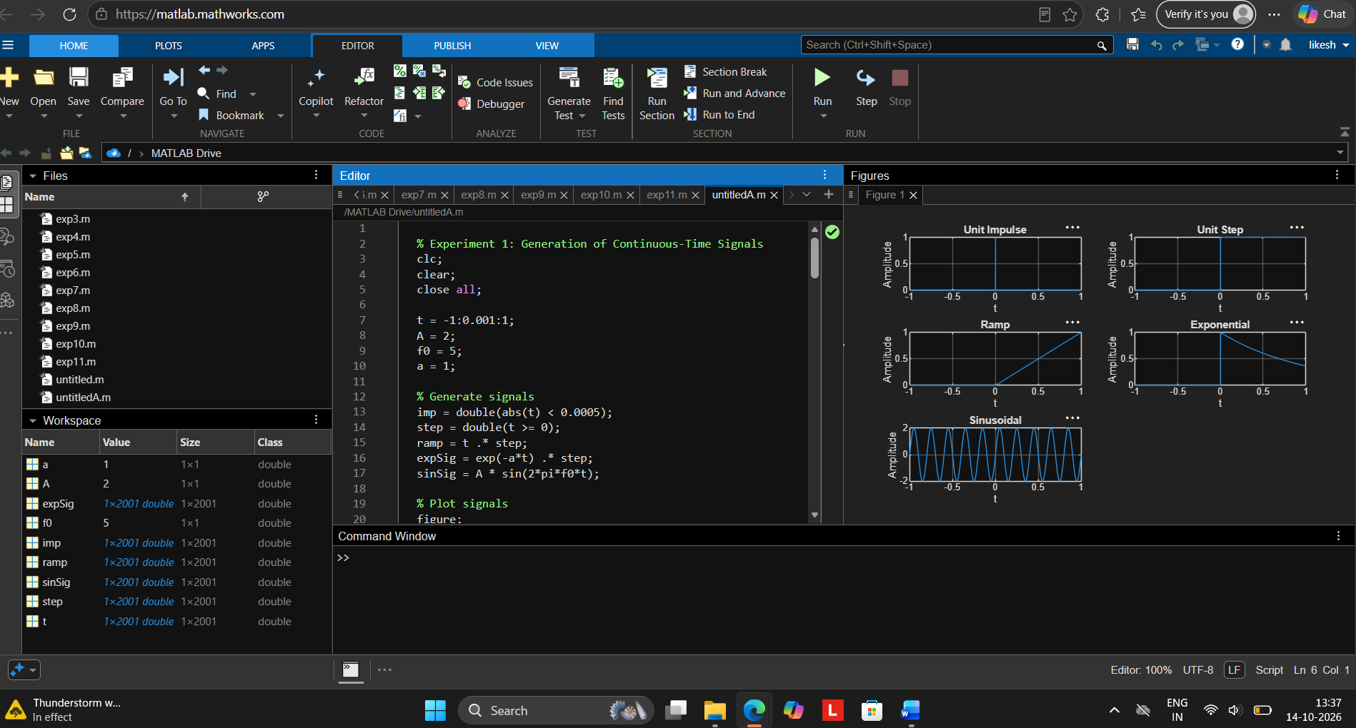

PART II: GENERATION OF DISCRETE-TIME SIGNALS
OBJECTIVE
To generate and visualize basic discrete-time signals and analyze their amplitude and time-index characteristics.
EXPECTED OUTCOMES
- Generate correctly indexed discrete-time sequences.
- Plot sequences using stem representation.
- Identify discrete-time waveform characteristics and periodicity.
- Validate the generated samples against theoretical expressions.
SOFTWARE / LABORATORY ENVIRONMENT
MATLAB
INPUT PARAMETER TABLE
S. No. | Input Parameter | Symbol | Value | Unit
1 | Sample index | (n) | −20 to 20 | Samples
2 | Sinusoidal amplitude | (A) | 2 | V
3 | Normalized frequency | (f_0) | 0.1 | Cycles/sample
4 | Exponential base | (r) | 0.8 | Dimensionless
OUTPUT PARAMETER TABLE
S. No. | Output Parameter | Theoretical / Expected Value | Practical / Simulated Value | % Deviation / Acceptance
1 | Sample amplitude | Specified value | Record sample value | Record deviation
2 | Sequence period | Theoretical (N_0), where applicable | Measure or derive | ≤5% where applicable
3 | Sequence type | CT / DT classification | Record observation | Exact classification
4 | Stem waveform | Theoretical sample pattern | Record plot | Qualitative match
FORMULAE / ANALYSIS
Discrete-time sinusoidal signal:
(x[n]=A\sin(2\pi f_0n+\phi))
Periodicity condition:
(x[n+N_0]=x[n])
where (N_0) is a positive integer.
Discrete-time exponential signal:
(x[n]=r^nu[n])
Even sequence:
(x[n]=x[-n])
Odd sequence:
(x[n]=-x[-n])
Discrete-time signals are defined only at integer sample indices.
EXPERIMENTAL PROCEDURE
- Define the integer sample index (n).
- Generate unit impulse, unit step, ramp, exponential, and sinusoidal sequences.
- Display each sequence using a stem plot.
- Determine sample amplitudes and period wherever applicable.
- Classify the sequence as periodic or non-periodic and even or odd wherever applicable.
- Compare the generated samples with theoretical values and record observations.
KEY CONDITIONS AND THRESHOLD VALUES FOR ANALYSIS
- Discrete-time signals are defined only at integer indices.
- Stem plots should be used to emphasize discrete samples.
- Discrete-time sinusoidal periodicity depends on the normalized frequency satisfying the rationality condition.
- Use a sufficient sample range to observe the sequence behavior.
MATLAB CODING
% Experiment 2: Generation of Discrete-Time Signals
clc;
clear;
close all;

n = -20:20;
A = 2;
f0 = 0.1;
r = 0.8;

imp = double(n==0);
step = double(n>=0);
ramp = n.*step;
expSig = (r).^n .* step;
sinSig = A*sin(2*pi*f0*n);

figure;

subplot(3,2,1);
stem(n,imp,'filled');
grid on;
title('Unit Impulse');

subplot(3,2,2);
stem(n,step,'filled');
grid on;
title('Unit Step');

subplot(3,2,3);
stem(n,ramp,'filled');
grid on;
title('Ramp');

subplot(3,2,4);
stem(n,expSig,'filled');
grid on;
title('Exponential');

subplot(3,2,5);
stem(n,sinSig,'filled');
grid on;
title('Discrete Sinusoid');
xlabel('n');
INPUT AND OUTPUT GRAPHS

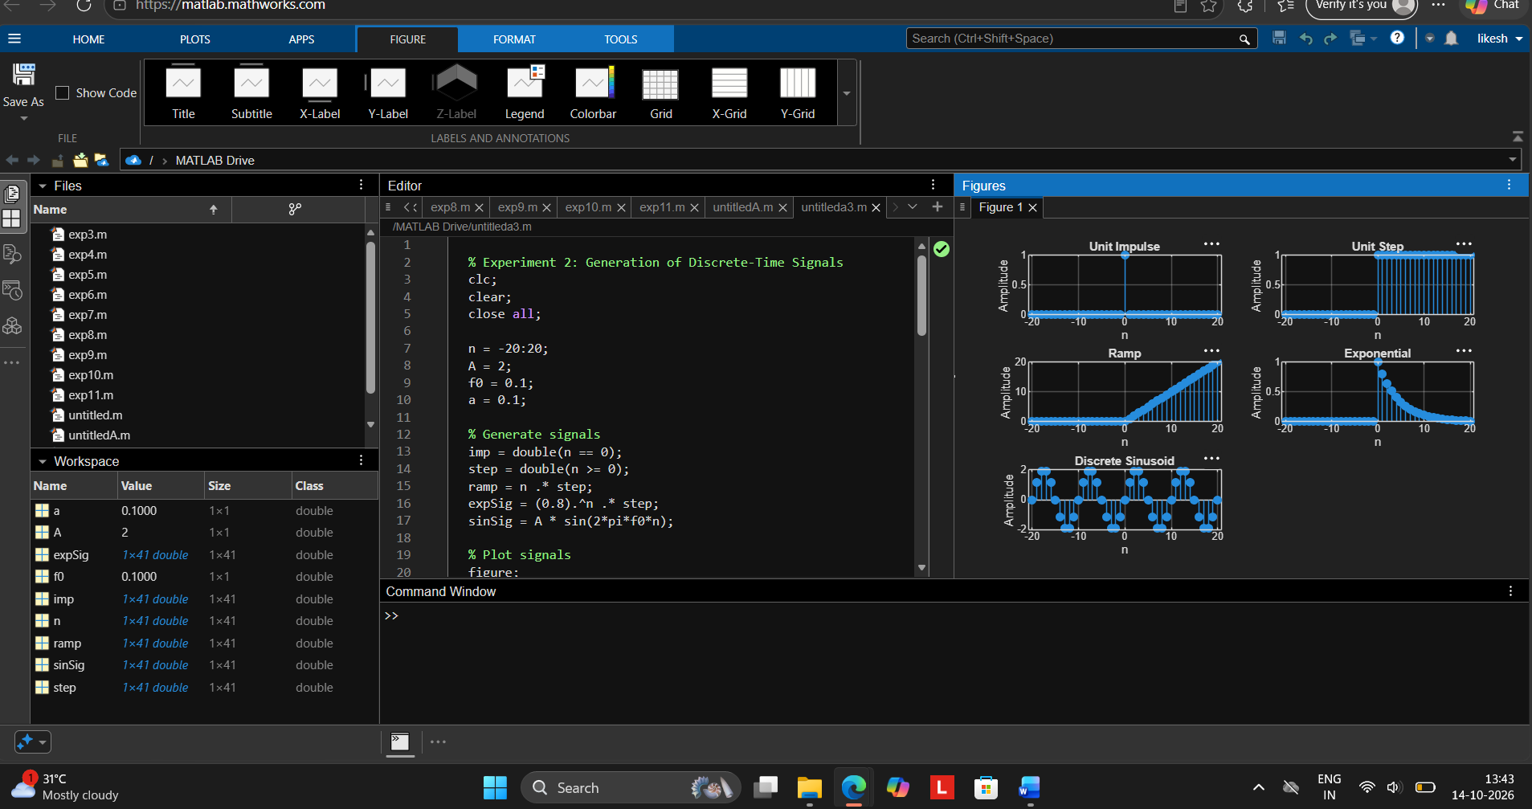
RESULT
The continuous-time and discrete-time signals were generated and analyzed successfully using MATLAB. The unit impulse, unit step, ramp, exponential, and sinusoidal signals were visualized. The periodic and aperiodic signals were classified using their periodicity characteristics. Finally, the even and odd components of the given signal were obtained, and the original signal was reconstructed successfully with negligible numerical error.

EXPERIMENT NO. 2
SIGNAL OPERATIONS AND TRANSFORMATIONS
OBJECTIVES
(i) To perform amplitude scaling and time scaling of continuous-time and discrete-time signals and analyze their effects on signal characteristics.
(ii) To perform time shifting and time reversal of continuous-time and discrete-time signals and analyze the resulting transformations.
(iii) To perform addition and multiplication of two discrete-time sequences and analyze the resulting signal characteristics.
(iv) To visualize and compare the original and transformed signals using MATLAB and interpret the effects of different signal operations.

PART I: AMPLITUDE SCALING AND TIME SCALING
OBJECTIVE
To perform amplitude scaling, time compression, and time expansion of continuous-time signals and analyze their effects on amplitude and time period.
EXPECTED OUTCOMES
- Correctly implement amplitude scaling.
- Perform time compression and time expansion.
- Measure the resulting amplitude and period.
- Explain the observed changes using scaling equations.
SOFTWARE / LABORATORY ENVIRONMENT
MATLAB
INPUT PARAMETER TABLE
S. No. | Input Parameter | Symbol / Setting | Value | Unit
1 | Base signal | (x(t)) | (\sin(2\pi5t)) | —
2 | Amplitude scaling factor | (A) | 2 | —
3 | Time compression factor | (a) | 2 | —
4 | Time expansion factor | (a) | 2 | —
5 | Time vector | (t) | −1 to 1 | s
6 | Sampling interval | (\Delta t) | 0.001 | s
OUTPUT PARAMETER TABLE
S. No. | Output Parameter | Theoretical / Expected Value | Practical / Simulated Value | % Deviation / Acceptance
1 | Amplitude of original signal | 1 | Record value | ≤5%
2 | Amplitude after scaling | 2 | Record value | ≤5%
3 | Original time period | 0.2 s | Measure from plot | ≤5%
4 | Compressed time period | 0.1 s | Measure from plot | ≤5%
5 | Expanded time period | 0.4 s | Measure from plot | ≤5%
FORMULAE / ANALYSIS
Amplitude scaling:
[
y(t)=Ax(t)
]
Time compression:
[
y(t)=x(at),\quad a>1
]
Time expansion:
[
y(t)=x(t/a),\quad a>1
]
For a sinusoidal signal:
[
x(t)=\sin(2\pi f_0t)
]
The time period is:
[
T_0=\frac{1}{f_0}
]
For (f_0=5\text{ Hz}):
[
T_0=\frac{1}{5}=0.2\text{ s}
]
After time compression by a factor of 2:
[
T_C=\frac{T_0}{2}=0.1\text{ s}
]
After time expansion by a factor of 2:
[
T_E=2T_0=0.4\text{ s}
]
Percentage deviation:
[
%\text{ Deviation}=
\frac{|\text{Practical}-\text{Theoretical}|}
{|\text{Theoretical}|}\times100
]
EXPERIMENTAL PROCEDURE
- Generate the base signal (x(t)=\sin(2\pi5t)).
- Apply amplitude scaling using (A=2).
- Apply time compression using (x(2t)).
- Apply time expansion using (x(t/2)).
- Plot the original and transformed signals using suitable axes.
- Measure the amplitude and period of the transformed signals.
- Compare the measured results with the theoretical scaling relationships.
KEY CONDITIONS AND THRESHOLD VALUES FOR ANALYSIS
- Use identical axes when comparing waveforms.
- Amplitude scaling should not change the time period.
- Time compression decreases the period, while time expansion increases the period.
- Numerical parameter deviation should preferably be ≤5%.
MATLAB CODING
% Experiment 2(i): Amplitude and Time Scaling
clc;
clear;
close all;

t = -1:0.001:1;

% Original signal
x = sin(2*pi*5*t);

% Amplitude scaling
yA = 2*x;

% Time compression
yC = sin(2*pi*5*(2*t));

% Time expansion
yE = sin(2*pi*5*(t/2));

% Plot the signals
figure;

subplot(2,2,1);
plot(t,x);
grid on;
title('Original x(t)');
xlabel('Time (s)');
ylabel('Amplitude');

subplot(2,2,2);
plot(t,yA);
grid on;
title('Amplitude Scaling: 2x(t)');
xlabel('Time (s)');
ylabel('Amplitude');

subplot(2,2,3);
plot(t,yC);
grid on;
title('Time Compression: x(2t)');
xlabel('Time (s)');
ylabel('Amplitude');

subplot(2,2,4);
plot(t,yE);
grid on;
title('Time Expansion: x(t/2)');
xlabel('Time (s)');
ylabel('Amplitude');
INPUT AND OUTPUT GRAPHS – AMPLITUDE AND TIME SCALING
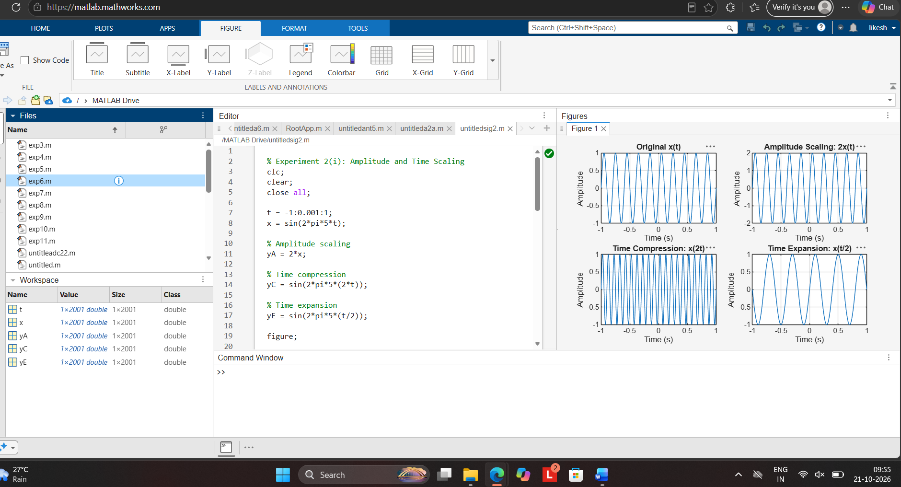
PART II: ADDITION AND MULTIPLICATION OF DISCRETE-TIME SEQUENCES
OBJECTIVE
To perform addition and multiplication of two discrete-time sequences and analyze the resulting signal characteristics.
EXPECTED OUTCOMES
- Obtain correct sum and product sequences.
- Preserve the common sample index for aligned sequences.
- Verify representative output samples numerically.
- Interpret how addition and multiplication change sequence values.
SOFTWARE / LABORATORY ENVIRONMENT
MATLAB
INPUT PARAMETER TABLE
S. No. | Input Parameter | Symbol / Setting | Value | Unit
1 | First sequence | (x[n]) | ({1,2,1}) | —
2 | Second sequence | (y[n]) | ({1,1,2}) | —
3 | Index range | (n) | 0 to 2 | Samples
OUTPUT PARAMETER TABLE
S. No. | Output Parameter | Theoretical / Expected Value | Practical / Simulated Value | % Deviation / Acceptance
1 | Sum sequence | ({2,3,3}) | Record sequence | Exact
2 | Product sequence | ({1,2,2}) | Record sequence | Exact
3 | Maximum sum | 3 | Record value | Exact
4 | Sequence length | 3 | Record value | Exact
FORMULAE / ANALYSIS
Addition of sequences:
[
z[n]=x[n]+y[n]
]
Multiplication of sequences:
[
p[n]=x[n]y[n]
]
The operations are performed on corresponding samples having the same index.
Given:
[
x[n]={1,2,1}
]
[
y[n]={1,1,2}
]
Addition:
[
z[n]={1+1,2+1,1+2}
]
[
\boxed{z[n]={2,3,3}}
]
Multiplication:
[
p[n]={1\times1,2\times1,1\times2}
]
[
\boxed{p[n]={1,2,2}}
]
Percentage error, where applicable:
[
%\text{ Error}=
\frac{|\text{Measured}-\text{Theoretical}|}
{|\text{Theoretical}|}\times100
]
EXPERIMENTAL PROCEDURE
- Define the sample index (n).
- Enter (x[n]) and (y[n]) with aligned indices.
- Compute the sum sequence.
- Compute the product sequence using pointwise multiplication.
- Plot the input and resulting sequences using stem plots.
- Compare the calculated samples with manual or theoretical results.
KEY CONDITIONS AND THRESHOLD VALUES FOR ANALYSIS
- Both sequences must use a clearly defined and aligned index set.
- Do not confuse pointwise multiplication with convolution.
- Use a sufficient plotting range to show all samples.
- Numerical results should match the theoretical calculations.
MATLAB CODING
% Experiment 2(iii): Addition and Multiplication
% of Two Discrete-Time Sequences
clc;
clear;
close all;

% Define sample index and input sequences
n = 0:2;
x = [1 2 1];
y = [1 1 2];

% Addition and multiplication
zSum = x + y;
zProd = x .* y;

% Plot input and output sequences
figure;

subplot(2,2,1);
stem(n,x,'filled');
grid on;
title('Input x[n]');
xlabel('n');
ylabel('Amplitude');

subplot(2,2,2);
stem(n,y,'filled');
grid on;
title('Input y[n]');
xlabel('n');
ylabel('Amplitude');

subplot(2,2,3);
stem(n,zSum,'filled');
grid on;
title('Addition x[n] + y[n]');
xlabel('n');
ylabel('Amplitude');

subplot(2,2,4);
stem(n,zProd,'filled');
grid on;
title('Multiplication x[n]y[n]');
xlabel('n');
ylabel('Amplitude');

% Display numerical results
disp('Sum sequence:');
disp(zSum);

disp('Product sequence:');
disp(zProd);
INPUT AND OUTPUT GRAPHS – ADDITION AND MULTIPLICATION
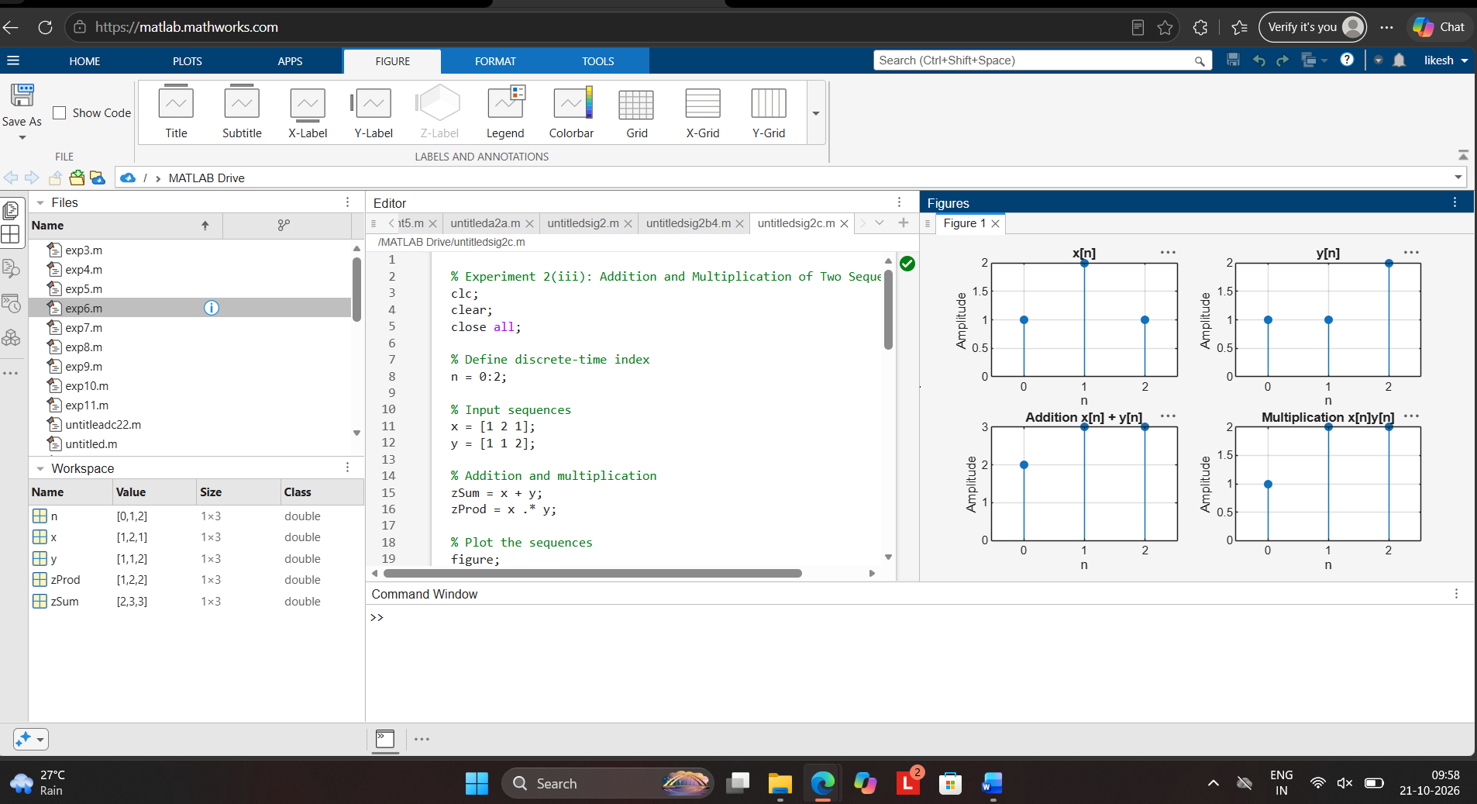

CONCLUSION
Amplitude and time scaling, time shifting, time reversal, sequence addition and sequence multiplication were successfully implemented. The original and transformed signals were compared, and the observed waveform changes agreed with the corresponding theoretical signal-operation relationships.

EXPERIMENT NO. 3
ENERGY AND POWER ANALYSIS OF SIGNALS
OBJECTIVE
To calculate the energy and average power of given continuous-time and discrete-time signals and classify them as energy signals, power signals, or neither based on their energy and power characteristics.
EXPECTED OUTCOMES
- Calculate finite energy for an energy-type signal.
- Calculate average power for a periodic or power-type signal.
- Classify signals based on their calculated energy and power.
- Obtain numerical results consistent with theoretical expectations.
SOFTWARE / LABORATORY ENVIRONMENT
Software: MATLAB
INPUT PARAMETER TABLE
S. No. | Input Parameter | Symbol / Setting | Value
1 | Signal 1 (energy signal) | (x_1(t)) | (e^{-t}u(t))
2 | Signal 2 (power signal) | (x_2(t)) | (\sin(2\pi5t))
3 | Integration interval | (t) | 0 to 5 s
4 | Period for power calculation | (T_0) | 0.2 s
OUTPUT PARAMETER TABLE
S. No. | Output Parameter | Theoretical / Expected Value | Practical / Simulated Value
1 | Energy of (x_1(t)) | 0.5 | Approximately 0.5000
2 | Average power of (x_2(t)) | 0.5 | Approximately 0.5000
3 | Classification of (x_1(t)) | Energy signal | Energy signal
4 | Classification of (x_2(t)) | Power signal | Power signal
FORMULAE / ANALYSIS
1. Energy of a continuous-time signal
[
E=\int_{-\infty}^{\infty}|x(t)|^2,dt
]
For the signal (x_1(t)=e^{-t}u(t)),
[
E=\int_0^\infty |e^{-t}|^2,dt
]
[
E=\int_0^\infty e^{-2t},dt
]
[
E=\left[-\frac{e^{-2t}}{2}\right]_0^\infty
=\frac{1}{2}=0.5
]
Therefore, (x_1(t)) is an energy signal.
2. Average power of a continuous-time signal
[
P=\lim_{T\to\infty}\frac{1}{2T}
\int_{-T}^{T}|x(t)|^2,dt
]
For a sinusoidal signal,
[
x_2(t)=\sin(2\pi f_0t)
]
The average power of a unit-amplitude sinusoid is
[
P=\frac{A^2}{2}=\frac{1^2}{2}=0.5
]
Given (f_0=5\text{ Hz}),
[
T_0=\frac{1}{f_0}=\frac{1}{5}=0.2\text{ s}
]
Therefore, (x_2(t)) is a power signal.
3. Percentage deviation
[
%\text{ Deviation}=
\frac{|\text{Practical}-\text{Theoretical}|}
{|\text{Theoretical}|}\times100
]
EXPERIMENTAL PROCEDURE
- Define the time vector and sampling interval in MATLAB.
- Generate the energy signal (x_1(t)=e^{-t}u(t)) and the power signal (x_2(t)=\sin(2\pi5t)).
- Calculate the squared magnitude of each signal.
- Use numerical integration to calculate the energy of the decaying exponential signal.
- Calculate the average power of the sinusoidal signal over an interval containing complete cycles.
- Plot both signals using MATLAB.
- Compare the simulated results with the theoretical values.
- Classify the signals based on their energy and average power.
KEY CONDITIONS AND THRESHOLD VALUES
- The integration interval should be sufficiently long for decaying signals.
- For periodic signals, use an interval containing complete cycles wherever practical.
- Use an adequate sampling resolution for numerical integration.
- Energy and average power definitions must not be interchanged.
- A finite, non-zero energy with zero average power indicates an energy signal.
- A finite, non-zero average power with infinite total energy indicates a power signal.
- The expected energy of (e^{-t}u(t)) is 0.5.
- The expected average power of (\sin(2\pi5t)) is 0.5.
MATLAB CODING
% Experiment 3: Energy and Power Analysis of Signals
clc;
clear;
close all;

% Time vector
dt = 0.001;
t = 0:dt:5;

% Generate signals
xE = exp(-t); % Energy signal: e^(-t)u(t)
xP = sin(2*pi*5*t); % Power signal: sin(2*pi*5t)

% Calculate numerical energy
E_num = trapz(t, abs(xE).^2);

% Calculate average power over 2 seconds
% 2 seconds contains 10 complete cycles
idx = t <= 2;
tP = t(idx);
xP_interval = xP(idx);

P_num = trapz(tP, abs(xP_interval).^2) ...
/ (tP(end) - tP(1));

% Plot signals
figure;

subplot(2,1,1);
plot(t, xE, 'b', 'LineWidth', 1.5);
grid on;
title('Energy Signal e^{-t}u(t)');
xlabel('Time (s)');
ylabel('Amplitude');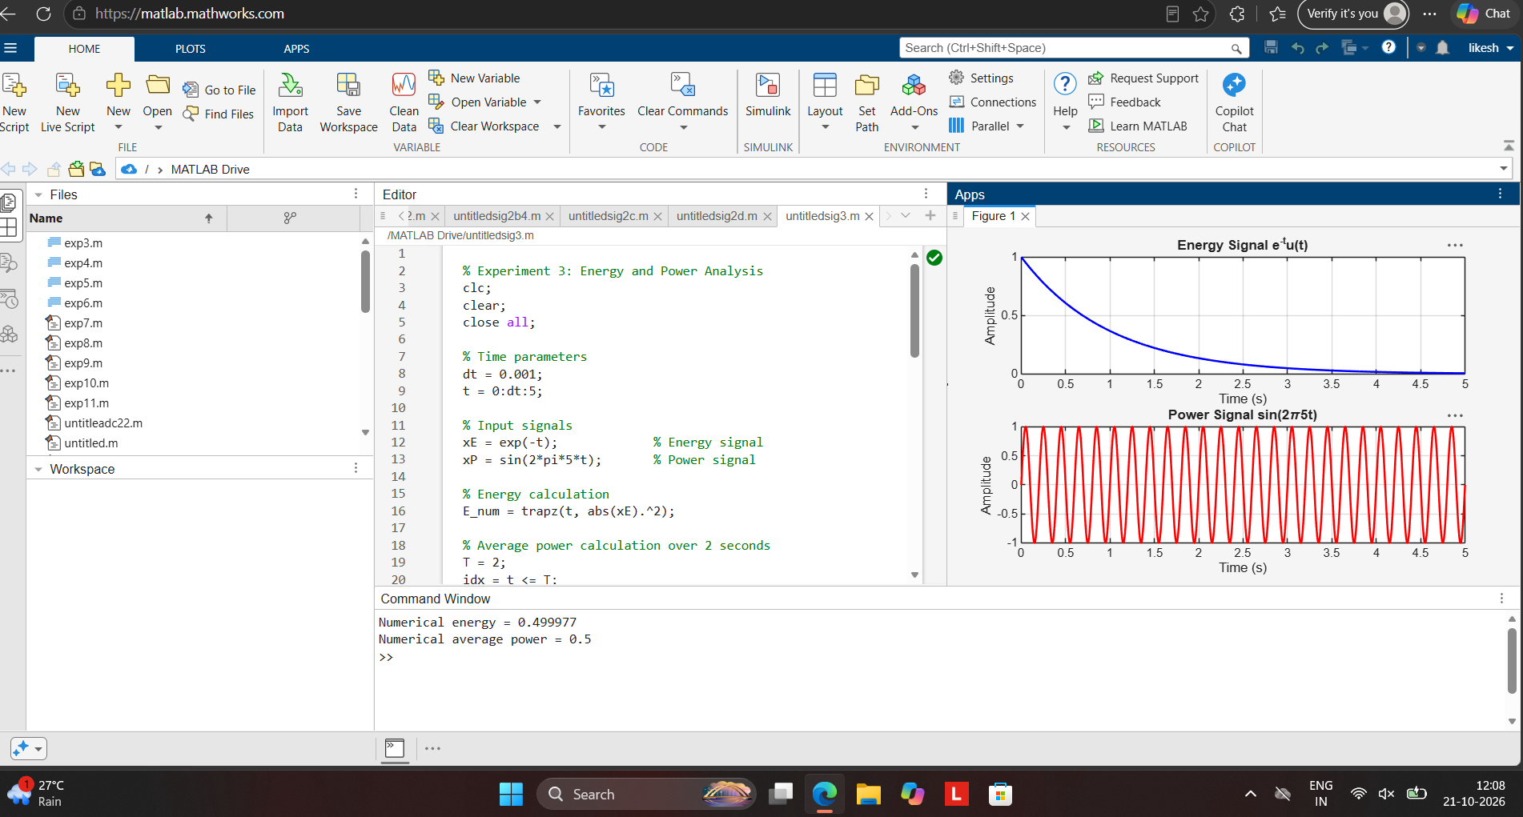

subplot(2,1,2);
plot(t, xP, 'r', 'LineWidth', 1.5);
grid on;
title('Power Signal sin(2\pi5t)');
xlabel('Time (s)');
ylabel('Amplitude');

% Display results
fprintf('Numerical energy = %.6f\n', E_num);
fprintf('Theoretical energy = %.6f\n', 0.5);

fprintf('Numerical average power = %.6f\n', P_num);
fprintf('Theoretical average power = %.6f\n', 0.5);
INPUT AND OUTPUT GRAPHS – ENERGY AND POWER ANALYSIS

Graph 1: Energy Signal
The graph of (x_1(t)=e^{-t}u(t)) starts at an amplitude of 1 at (t=0) and decreases exponentially towards zero as time increases.
Graph 2: Power Signal
The graph of (x_2(t)=\sin(2\pi5t)) is a periodic sinusoidal waveform with amplitude ranging from −1 to +1 and a period of 0.2 seconds.
OBSERVATION / RESULT
The numerical energy of the signal (x_1(t)=e^{-t}u(t)) is approximately 0.5000, which agrees with the theoretical energy of 0.5.
The numerical average power of the signal (x_2(t)=\sin(2\pi5t)) is approximately 0.5000, which agrees with the theoretical average power of 0.5.
Thus, (x_1(t)) is classified as an energy signal, and (x_2(t)) is classified as a power signal.
CONCLUSION
The energy and average power of the given signals were calculated successfully using MATLAB. The simulated results agree with the theoretical values within numerical accuracy, and the signals were correctly classified based on their energy and power characteristics.

EXPERIMENT NO. 4
VERIFICATION OF SYSTEM PROPERTIES: LINEARITY, TIME INVARIANCE, CAUSALITY, MEMORYLESSNESS AND STABILITY
OBJECTIVES
- To verify the linearity and time-invariance properties of continuous-time and discrete-time systems using suitable input signals and system responses.
- To analyze and classify continuous-time and discrete-time systems as causal or non-causal based on their input-output relationships.
- To analyze and classify systems as memoryless or dynamic based on their dependence on present and past input values.
- To verify the BIBO stability of given systems and classify them as stable or unstable for real-time automation applications.
EXPECTED OUTCOMES
- Determine whether a system satisfies homogeneity and additivity.
- Verify whether delaying the input produces the corresponding output delay.
- Distinguish linear and nonlinear systems, and time-invariant and time-varying systems.
- Classify systems as causal or non-causal.
- Distinguish memoryless and dynamic systems.
- Verify BIBO stability using bounded input signals.
- Support conclusions using plots and numerical errors.
SOFTWARE / LABORATORY ENVIRONMENT
Software: MATLAB
INPUT PARAMETER TABLE
S. No. | Input Parameter | Symbol / Setting | Value
1 | Test system | (T{x}=2x) | Continuous-time example
2 | Input 1 | (x_1(t)) | (\sin(2\pi5t))
3 | Input 2 | (x_2(t)) | (\cos(2\pi5t))
4 | Scalar coefficients | (a,b) | 2, 3
5 | Time shift | (t_0) | 0.2 s
6 | Discrete-time input | (x[n]) | ([1,2,3,4,5,6])
OUTPUT PARAMETER TABLE
S. No. | Output Parameter | Theoretical / Expected Value | Practical / Simulated Value
1 | Linearity error | 0 | Approximately 0
2 | Time-invariance error | 0 | Approximately 0
3 | Causality classification | Depends on system | Causal / Non-causal
4 | Memory classification | Depends on system | Memoryless / Dynamic
5 | BIBO stability classification | Depends on system | Stable / Unstable
FORMULAE / ANALYSIS
1. Linearity
A system is linear if it satisfies both homogeneity and additivity.
Homogeneity:
[
T{ax(t)}=aT{x(t)}
]
Additivity:
[
T{x_1(t)+x_2(t)}
=T{x_1(t)}+T{x_2(t)}
]
Superposition:
[
T{ax_1(t)+bx_2(t)}
=aT{x_1(t)}+bT{x_2(t)}
]
If the difference between the two sides is zero, the system satisfies the linearity condition.
2. Time Invariance
A system is time-invariant if a time shift in the input produces the same time shift in the output.
If
[
y(t)=T{x(t)}
]
then
[
T{x(t-t_0)}=y(t-t_0)
]
A zero difference between these responses indicates time invariance.
3. Causality
A system is causal if its output at the present time depends only on present and past input values.
- (y[n]=x[n]+x[n-1]): Causal system.
- (y[n]=x[n+1]): Non-causal system because it depends on a future input value.
4. Memorylessness
A system is memoryless if its output depends only on the input at the same instant.
- (y[n]=3x[n]): Memoryless system.
- (y[n]=x[n]+x[n-1]): Dynamic system because it depends on a previous input value.
5. BIBO Stability
A system is BIBO (Bounded-Input, Bounded-Output) stable if every bounded input produces a bounded output.
[
|x[n]|\leq M_x<\infty
]
must imply
[
|y[n]|\leq M_y<\infty
]
For example:
- (y[n]=2x[n]): Stable system.
- (y[n]=nx[n]): Unstable system because a bounded constant input can produce an unbounded output as (n) increases.
EXPERIMENTAL PROCEDURE
- Define the time vector and generate two test input signals in MATLAB.
- Apply the selected system to each input individually.
- Verify linearity by comparing the response to a weighted sum of inputs with the weighted sum of individual responses.
- Verify time invariance by shifting the input and comparing the resulting output with the shifted original output.
- Test causality using systems that depend on present, past, or future input values.
- Test memorylessness by checking whether the output depends only on the current input.
- Test BIBO stability using bounded inputs and observe whether the output remains bounded.
- Plot the results, calculate numerical errors, and record the system classifications.
KEY CONDITIONS AND THRESHOLD VALUES
- Use identical time or sample grids for comparisons.
- Use the same scaling coefficients in both sides of the linearity test.
- Exclude boundary samples affected by interpolation when calculating time-invariance error.
- Small floating-point differences are acceptable.
- A system must satisfy both homogeneity and additivity to be linear.
- A causal system must not depend on future input values.
- A memoryless system depends only on the present input.
- A BIBO-stable system must produce bounded outputs for every bounded input.
MATLAB CODING
% Experiment 4: Verification of System Properties
clc;
clear;
close all;

%% Part 1: Linearity and Time Invariance
dt = 0.001;
t = -1:dt:1;

x1 = sin(2*pi*5*t);
x2 = cos(2*pi*5*t);

a = 2;
b = 3;
t0 = 0.2;

% Linear, time-invariant system: y(t) = 2x(t)
T = @(x) 2*x;

% Linearity verification
lhs = T(a*x1 + b*x2);
rhs = a*T(x1) + b*T(x2);

linError = max(abs(lhs-rhs));

% Time-invariance verification
xDelay = sin(2*pi*5*(t-t0));

lhsTI = T(xDelay);
originalOutput = T(x1);

rhsTI = interp1(t, originalOutput, t-t0, ...
'linear', NaN);

% Exclude samples outside the available interpolation interval
valid = ~isnan(rhsTI);

tiError = max(abs(lhsTI(valid)-rhsTI(valid)));

% Plot linearity and time-invariance errors
figure;

subplot(2,1,1);
plot(t, lhs-rhs);
grid on;
title('Linearity Error');
xlabel('Time (s)');
ylabel('Error');

subplot(2,1,2);
plot(t(valid), lhsTI(valid)-rhsTI(valid));
grid on;
title('Time-Invariance Error');
xlabel('Time (s)');
ylabel('Error');

%% Part 2: Causality and Memorylessness
n = 0:5;
x = [1 2 3 4 5 6];

% Causal system: y[n] = x[n-1]
yCausal = [0 x(1:end-1)];

% Non-causal system: y[n] = x[n+1]
yNonCausal = [x(2:end) 0];

% Memoryless system: y[n] = 3x[n]
yMemoryless = 3*x;

% Dynamic system: y[n] = x[n] + x[n-1]
yDynamic = x + yCausal;

figure;

subplot(2,2,1);
stem(n, yCausal, 'filled');
grid on;
title('Causal System: x[n-1]');
xlabel('n');
ylabel('Output');

subplot(2,2,2);
stem(n, yNonCausal, 'filled');
grid on;
title('Non-Causal System: x[n+1]');
xlabel('n');
ylabel('Output');

subplot(2,2,3);
stem(n, yMemoryless, 'filled');
grid on;
title('Memoryless System: 3x[n]');
xlabel('n');
ylabel('Output');

subplot(2,2,4);
stem(n, yDynamic, 'filled');
grid on;
title('Dynamic System: x[n]+x[n-1]');
xlabel('n');
ylabel('Output');

%% Part 3: BIBO Stability
n2 = 0:50;
xBounded = ones(size(n2));

% Stable system: y[n] = 2x[n]
yStable = 2*xBounded;

% Unstable system: y[n] = n*x[n]
yUnstable = n2.*xBounded;

figure;

subplot(2,1,1);
stem(n2, yStable, 'filled');
grid on;
title('Stable System: y[n] = 2x[n]');
xlabel('n');
ylabel('Output');

subplot(2,1,2);
stem(n2, yUnstable, 'filled');
grid on;
title('Unstable System: y[n] = nx[n]');
xlabel('n');
ylabel('Output');

%% Display results
fprintf('Linearity error = %.10g\n', linError);
fprintf('Time-invariance error = %.10g\n', tiError);

fprintf('\nSystem Classifications:\n');
fprintf('T{x} = 2x: Linear and Time-Invariant\n');
fprintf('y[n] = x[n-1]: Causal\n');
fprintf('y[n] = x[n+1]: Non-causal\n');
fprintf('y[n] = 3x[n]: Memoryless\n');
fprintf('y[n] = x[n]+x[n-1]: Dynamic\n');
fprintf('y[n] = 2x[n]: BIBO Stable\n');
fprintf('y[n] = nx[n]: BIBO Unstable\n');
INPUT AND OUTPUT GRAPHS
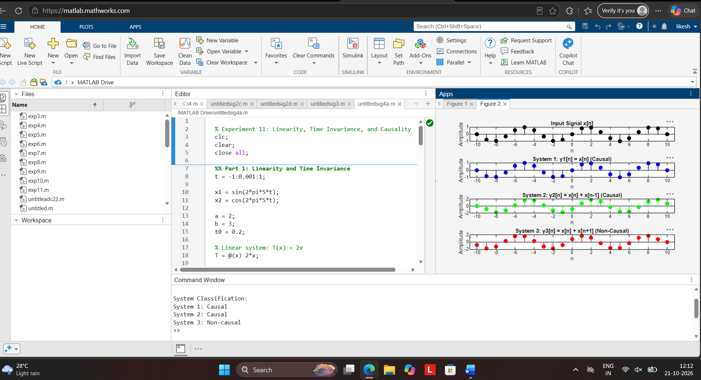
Graph 1: Linearity Error
The graph should remain at zero, indicating that the system satisfies the linearity property.
Graph 2: Time-Invariance Error
The graph should remain approximately at zero over the valid comparison interval, indicating that the system is time-invariant.
Graph 3: Causal and Non-Causal Systems
The causal system uses the previous input sample, while the non-causal system uses the next input sample.
Graph 4: Memoryless and Dynamic Systems
The memoryless system depends only on the current input. The dynamic system depends on both the current and previous input samples.
Graph 5: BIBO Stability
The stable system produces a bounded output for the bounded input. The output of the unstable system increases with the sample index.
OBSERVATION / RESULT
- The system (T{x(t)}=2x(t)) satisfies linearity and time invariance. The calculated errors are approximately zero.
- The system (y[n]=x[n-1]) is causal, whereas (y[n]=x[n+1]) is non-causal.
- The system (y[n]=3x[n]) is memoryless, whereas (y[n]=x[n]+x[n-1]) is dynamic.
- The system (y[n]=2x[n]) is BIBO stable, whereas (y[n]=nx[n]) is BIBO unstable.
CONCLUSION
The properties of linearity, time invariance, causality, memorylessness, and BIBO stability were verified using MATLAB. Numerical errors and output plots were used to support the classifications of the selected systems.
Objective | Assessment Criterion | Excellent – 4 | Good – 3 | Satisfactory – 2 | Needs Improvement – 1 | Weightage | Marks(10) | Marks obtained
1. Generate and visualize basic continuous-time signals such as unit step, unit impulse, ramp, sinusoidal and exponential. | CT Signal Generation & MATLAB Implementation | Generates all five CT signals accurately with a suitable time vector and step size. Uses correct MATLAB commands . Plots are correctly scaled, with titles, axis labels and grid. | Generates the required CT signals and plots correctly, with minor errors in code, time range, parameters or labelling. | Generates basic CT signals but has noticeable errors in code, step or impulse representation, or plots, and needs assistance. | Unable to generate the required CT signals or produce meaningful plots. | 25 | 2.5
2. Generate and visualize basic discrete-time signals such as unit sample, unit step, ramp, sinusoidal and exponential sequences. | DT Signal Generation & MATLAB Implementation | Generates all five DT sequences accurately with a proper index vector n. Uses stem correctly. Plots are correctly scaled, with titles, axis labels and grid. | Generates the required DT sequences and plots correctly, with minor errors in index range, stem usage, parameters or labelling. | Generates basic DT sequences but has noticeable errors in code, indexing or stem plots, and needs assistance. | Unable to generate the required DT sequences or produce meaningful stem plots. | 25 | 2.5
3. Classify CT and DT signals as periodic or aperiodic and identify their waveform characteristics. | Signal Classification & Periodicity Analysis | Correctly classifies all signals using DT. Determines the period where applicable. Identifies frequency, phase, and growth or decay. Explains the reasoning clearly with mathematical conditions and waveform evidence. | Classifies most signals correctly and finds most periods, with minor errors or limited justification. | Gives basic classifications. Period calculation or justification is incomplete and needs guidance. | Unable to classify the signals correctly or justify the classification. | 25 | 2.5
4. Analyze the amplitude and time-index characteristics of discrete-time signals. | Amplitude & Time-Index Analysis | Correctly determines maximum and minimum amplitude, the index n at which each occurs, and signal energy. Correctly shows the effect of time shifting and folding on the index. Interprets the results clearly. | Analyzes most amplitude and index characteristics correctly, with minor errors in values or interpretation. | Gives basic amplitude and index analysis with noticeable errors, and needs guidance. | Unable to analyze the amplitude and time-index characteristics or interpret the results. | 25 | 2.5
 |  |  |  |  | Total | 100 | 10

LABORATORY PERFORMANCE ASSESSMENT RUBRICS:

2.
Objective | Assessment Criterion | Excellent – 4 | Good – 3 | Satisfactory – 2 | Needs Improvement – 1 | Weightage | Marks(10) | Marks obtained
(i) Perform amplitude scaling and time scaling of continuous-time and discrete-time signals and analyze their effects on signal characteristics. | Amplitude & Time Scaling Implementation (MATLAB) | Generates the original and scaled versions correctly for CT and DT with correct index handling. Uses plot for CT and stem for DT, with proper time and index vectors. Original and scaled plots are placed in subplots with matching axes, titles, axis labels and grid. | Generates most scaled signals correctly, with minor errors in scaling factors, index handling, axis limits or labelling. | Generates only basic scaled signals, with noticeable errors in code, time or index vectors, or plots, and needs assistance. | Unable to generate the scaled signals or produce meaningful plots. | 25 | 2.5
(i) Perform amplitude scaling and time scaling of continuous-time and discrete-time signals and analyze their effects on signal characteristics. | Analysis of Scaling Effects | Correctly explains that amplitude scaling changes amplitude and energy but not duration or period. Explains that time compression shortens duration and period (T/a) and raises frequency, that expansion does the opposite, and that a < 0 reverses time. Explains that DT scaling discards samples and needs interpolation. Supports every point with waveform evidence. | Explains most effects correctly, with minor errors or limited justification. | Gives basic observations on the effects. The explanation is incomplete and needs guidance. | Unable to analyze or explain the effects of scaling. | 25 | 2.5
(iii) Perform addition and multiplication of two discrete-time sequences and analyze the resulting signal characteristics. | Addition & Multiplication Implementation (MATLAB) | Adds and multiplies two sequences correctly even when their index ranges differ. Aligns the sequences on a common index vector with zero padding, and uses element-wise operator. Plots both inputs and the results with stem, correct n-axis, titles, axis labels and grid. | Performs both operations correctly, with minor errors in index alignment, padding, operators or labelling. | Performs the operations on simple equal-length sequences only, with noticeable errors in code or plots, and needs assistance. | Unable to perform the operations or produce meaningful stem plots. | 25 | 2.5
(iii) Perform addition and multiplication of two discrete-time sequences and analyze the resulting signal characteristics. | Analysis of Resulting Signal Characteristics | Correctly determines the amplitude, the length or range of n, and the energy of the sum and product. Explains the periodicity of the result (for example, the sum is periodic with period equal to the LCM of the two periods). Explains how multiplication acts as gating or modulation. Interprets the results clearly with waveform evidence. | Analyzes most characteristics correctly, with minor errors or limited justification. | Gives basic observations on the resulting signals. The analysis is incomplete and needs guidance. | Unable to analyze or interpret the resulting signals. | 25 | 2.5
 |  |  |  |  | Total | 100 | 10

3.
Objective | Assessment Criterion | Excellent – 4 | Good – 3 | Satisfactory  – 2 | Needs  Improve ment – 1 | Weight age | Marks given | Marks obtained
Calculate the energy and average power of given signals | Energy & Power Calculation | Correctly calculates signal energy and average power using appropriate mathematical expressions and MATLAB  implementation  independently. | Performs calculation s correctly with minor numerical or coding errors. | Performs basic calculations but requires guidance or has noticeable errors. | Unable to correctly calculate energy or power. | 25 | 2.5
Distinguish energy signals and power signals | Signal Classificatio n | Correctly classifies signals as energy or power signals based on calculated values and theoretical conditions. | Correctly classifies signals with minor errors or limited justificatio  n. | Performs basic classification but requires assistance or provides incomplete  justification. | Unable to classify the signal correctly. | 25 | 2.5
Implement numerical energy/power computation using MATLAB | MATLAB  Implementat ion & Numerical Analysis | Develops accurate MATLAB code, obtains reliable numerical values and appropriately selects the integration/summation interval. | Code and numerical results are mostly correct with minor errors. | Implements the basic computation with assistance or noticeable numerical errors. | Unable to impleme nt the required MATLA B  computat  ion. | 25 | 2.5
Compare analytical and simulated results | Theoretical Validation & Comparison | Accurately compares theoretical and simulated values, calculates deviation where applicable and explains discrepancies  clearly. | Provides correct compariso n with minor deviations  and | Provides basic comparison but validation or interpretatio  n is limited. | Unable to compare or validate the  results. | 25 | 2.5

4.
Objective | Assessment Criterion | Excellent – 4 | Good – 3 | Satisfactory – 2 | Needs Improvement – 1 | Weightage | Marks(10) | Marks obtained
(i) To verify the linearity and time-invariance properties of continuous-time and discrete-time systems using suitable input signals and system responses. | Linearity Verification (Homogeneity & Additivity) | Correctly applies the homogeneity test and the additivity test (or the combined superposition test) to every CT and DT system. Chooses suitable input signals and scaling constants, compares the two responses accurately, and concludes linear or non-linear correctly. | Applies the linearity tests correctly to most systems, with minor errors in the choice of inputs, algebra or comparison. | Performs a basic linearity test (only one of homogeneity or additivity, or only some systems) with noticeable errors, and needs guidance. | Unable to apply or interpret the linearity test. | 20 | 2
 | Time-Invariance Verification (Time-Shift Test) | Correctly applies the time-shift test, comparing the response to the shifted input with the shifted output for every system. Handles systems with time-scaling or time-varying coefficients correctly and concludes time-invariant or time-varying correctly. | Applies the time-shift test correctly to most systems, with minor errors in shifting or comparison. | Performs a basic time-shift test with noticeable errors (for example shifting only the input or only the output), and needs guidance. | Unable to apply or interpret the time-invariance test. | 20 | 2
 | MATLAB Implementation & Numerical Verification | Writes correct MATLAB code with suitable time and index vectors to generate the test inputs, the system responses, the scaled, summed and shifted versions, and the plots. Computes numerical errors between the compared responses, and uses a tolerance to decide pass or fail. Plots have titles, axis labels and legends. | Code, plots and numerical comparison are correct, with minor errors in range, parameters, tolerance or labelling. | Code runs but has noticeable errors in vectors, shifting or error calculation, and needs assistance. | Unable to implement the tests or produce meaningful responses and plots in MATLAB. | 20 | 2
 | System Classification & Mathematical Justification | Independently classifies each CT and DT system as linear or non-linear and time-invariant or time-varying Supports each classification with correct mathematical working and with the waveform or error evidence from MATLAB. | Classifies most systems correctly, with minor errors or limited justification. | Gives basic classifications. Justification is incomplete or not linked to the test results, and needs guidance. | Unable to classify the systems correctly or justify the classification. | 20 | 2
 | Engineering Analysis, Record & Interpretation | Provides a technically accurate interpretation of the results and links them to the importance of linear time-invariant (LTI) systems Maintains a complete, well-organized record with code, plots, observations and conclusions. | Maintains a proper record with minor omissions. Interpretation is correct but brief. | Record and interpretation are basic or partly incomplete, and need guidance. | Incomplete record, limited or no interpretation of the results. | 20 | 2
 |  |  |  |  | Total | 100 | 0

1.
Objective | Assessment Criterion | Excellent – 4 | Good – 3 | Satisfactory – 2 | Needs Improvement – 1 | Weightage | Marks(10) | Marks obtained
(i) To analyze the Fourier series of continuous-time periodic signals and analyze their waveform characteristics. | Fourier Series Analysis | Correctly determines the fundamental period and frequency and computes the Fourier coefficients for every given periodic signal, analytically or in MATLAB. Uses suitable commands with correct limits and obtains accurate coefficient values. | Computes the coefficients for most signals correctly, with minor errors in limits, algebra, code or parameters. | Computes the coefficients for only some signals, or has noticeable errors in integration, limits or code, and needs guidance. | Unable to compute the Fourier coefficients of the given signals. | 20 | 2
 | Waveform Characteristics & Spectrum Analysis | Correctly identifies symmetry (even, odd, half-wave), DC value and the harmonics present. Plots the amplitude and phase spectra with titles, axis labels and grid. Explains how symmetry and the shape of the waveform determine the harmonic content and the rate of decay of the coefficients. | Identifies most waveform characteristics and plots the spectra correctly, with minor errors or limited explanation. | Identifies basic characteristics. Spectra have noticeable errors or the explanation is incomplete, and needs guidance. | Unable to identify the waveform characteristics or plot the spectra. | 20 | 2
(ii) To reconstruct periodic signals using the Fourier series and verify the reconstructed waveform with the original signal. | Signal Reconstruction using Fourier Series | Correctly synthesizes each periodic signal as a partial sum of N harmonics in MATLAB, using a suitable time vector and loop or vectorized code. Reconstructs with several values of N and plots them clearly against the original. | Reconstructs the signals correctly with minor errors in code, time range, parameters or labelling, and uses fewer values of N. | Reconstructs only some signals or uses a single value of N, with noticeable errors in code or plots, and needs assistance. | Unable to reconstruct the signals using the Fourier series. | 20 | 2
 | Verification of Reconstructed Waveform | Verifies the reconstruction against the original waveform using overlay plots and numerical error for each N. Shows that the error decreases as N increases, and identifies the Gibbs phenomenon at discontinuities with a correct explanation. | Verifies the reconstruction with overlay plots and some error measure, with minor errors in calculation or interpretation of convergence. | Performs basic visual comparison only, with noticeable errors or no numerical error. Convergence or Gibbs phenomenon is not explained, and needs guidance. | Unable to verify the reconstructed waveform against the original signal. | 20 | 2
Interpret the Fourier series results and maintain the record. | Engineering Analysis, Record & Interpretation | Provides technically accurate interpretation of the results, relating the number of harmonics, symmetry and discontinuities to reconstruction accuracy. Maintains a complete, well-organized record with code, plots, observations and conclusions. | Maintains a proper record with mostly accurate interpretation, with minor omissions in observations or conclusions. | Record and interpretation are basic or partly incomplete, with limited technical reasoning. | Incomplete record, limited or incorrect interpretation of the results. | 20 | 2
 |  |  |  |  | Total | 100 | 10

2.
Objective | Assessment Criterion | Excellent – 4 | Good – 3 | Satisfactory – 2 | Needs Improvement – 1 | Weightage | Marks(10) | Marks obtained
(i) To verify Parseval's relation for continuous-time periodic signals and analyze the relationship between time-domain and frequency-domain power. | Fourier Series Coefficient Computation | Correctly identifies the fundamental period T0 and frequency ω0 of the periodic signal. Computes the Fourier series coefficients (c_k, or a_k and b_k) accurately, analytically or in MATLAB, and plots the signal with its harmonic reconstruction with correct labels and scaling. | Computes the coefficients correctly with minor errors in the period, limits, scaling or labelling. | Computes only some coefficients correctly, or has noticeable errors in T0, integration or code, and needs guidance. | Unable to determine the period or compute the Fourier series coefficients. | 20 | 2
 | Time-Domain Power & Parseval Verification | Correctly computes the average power P .Applies Parseval's relation correctly, verifies that the two values agree within a small numerical error, and explains the time-frequency relationship clearly. | Computes the power and applies Parseval's relation correctly, with minor numerical or interpretation errors. | Computes the time-domain power or applies Parseval's relation only partly. Verification is incomplete or has noticeable errors, and needs guidance. | Unable to compute the power or verify Parseval's relation. | 20 | 2
(ii) To compare the total power obtained in the time domain with the harmonic power distribution in the frequency domain. | Harmonic Power Distribution | Correctly computes the power in each harmonic and the DC power. Plots the power spectrum (stem plot) with labelled axes, shows the cumulative power, and identifies the dominant harmonics accurately. | Computes the harmonic powers and plots the spectrum correctly, with minor errors in indexing, scaling or labelling. | Computes some harmonic powers but has noticeable errors in the spectrum or the DC and harmonic terms, and needs assistance. | Unable to compute or plot the harmonic power distribution. | 20 | 2
 | Time vs Frequency Power Comparison | Compares total time-domain power with the sum of harmonic powers for an increasing number of harmonics. Reports the percentage error and the power captured, explains convergence and the effect of truncation (for example for square or triangular waves), and draws correct conclusions. | Compares the total powers correctly, with minor errors in the error calculation or limited explanation of convergence. | Makes a basic comparison with incomplete error analysis, or gives limited explanation, and needs guidance. | Unable to compare the time-domain and frequency-domain power correctly. | 20 | 2
Interpret the results for both objectives and maintain a proper technical record. | Engineering Analysis, Record & Interpretation | Provides technically accurate interpretation of the results, relating power to harmonic content and signal waveform. Maintains a complete record with aim, theory, MATLAB code, plots, observations, result and conclusion, with clear organization. | Maintains a proper record and gives mostly accurate interpretation, with minor omissions in explanation or presentation. | Record and interpretation are basic, with partial explanation or missing elements. | Incomplete record, limited or incorrect interpretation of the results. | 20 | 2
 |  |  |  |  | Total | 100 | 10

3.
Objective | Assessment Criterion | Excellent – 4 | Good – 3 | Satisfactory – 2 | Needs Improvement – 1 | Weightage | Marks(10) | Marks obtained
(ii) To determine the magnitude and phase spectra of continuous-time signals and analyze their significant spectral components. | Fourier Transform Computation & MATLAB Implementation | Computes X(jω) of every given CT signal correctly, analytically and numerically . Uses a suitable time range, sampling rate and frequency axis in rad/s or Hz. | Computes the spectra correctly, with minor errors in scaling, sampling rate, frequency axis or parameters. | Computes the spectra for only some signals, or has noticeable errors in code, scaling or frequency axis, and needs assistance. | Unable to compute the Fourier transform or produce meaningful spectra. | 20 | 2
 | Magnitude & Phase Spectrum Plots | Plots |X(jω)| and ∠X(jω) correctly for every signal, with proper scaling, titles, axis labels and grid. Handles phase wrapping and phase near zero-magnitude points correctly. | Plots both spectra correctly, with minor errors in scaling, labelling, phase wrapping or axis range. | Plots the spectra with noticeable errors in scaling, phase handling or labelling, and needs guidance. | Unable to plot the magnitude and phase spectra. | 20 | 2
 | Spectral Component Analysis | Correctly identifies dominant frequencies, peaks, bandwidth and the frequency range holding most of the signal energy. Uses symmetry (even magnitude, odd phase for real signals) and relates the spectral lines or lobes to the signal parameters. | Identifies most significant spectral components and bandwidth, with minor errors or limited justification. | Identifies only basic spectral components. Bandwidth or symmetry reasoning is incomplete, and needs guidance. | Unable to identify or justify the significant spectral components. | 20 | 2
 | Analytical vs Numerical Verification | Compares the analytical and MATLAB spectra, quantifies the difference and explains its causes such as truncation, sampling and spectral leakage. Shows how signal parameters change the spectrum. | Compares analytical and numerical results correctly, with brief explanation of differences. | Makes a basic comparison with noticeable errors, and the explanation of differences is incomplete. | Unable to verify the numerical spectra against the analytical results. | 20 | 2
 | Engineering Analysis, Record & Interpretation | Provides technically accurate interpretation of the results and relates them to the physical or engineering meaning of the signal. Maintains a complete, well-organized record with observations, tables, plots and conclusions. | Maintains a proper record with correct interpretation, with minor omissions in explanation or conclusions. | Record and interpretation are partial or only descriptive, and need guidance. | Incomplete record, limited or incorrect interpretation of the results. | 20 | 2
 |  |  |  |  | Total | 100 | 10

4.
Objective | Assessment Criterion | Excellent – 4 | Good – 3 | Satisfactory – 2 | Needs Improvement – 1 | Weightage | Marks given | Marks obtained
(i) Determine the inverse Laplace transform of a given frequency-domain representation and reconstruct the corresponding time-domain signal. | Inverse Laplace Transform Evaluation | Correctly expands X(s) using partial fractions (distinct, repeated and complex poles) and applies the standard transform pairs and properties. Obtains the exact time-domain expression x(t), including the unit step u(t) and any shifts, with correct constants. | Applies partial fractions and transform pairs correctly, with minor errors in residues, constants or step-function terms. | Performs basic inverse transforms but has noticeable errors in partial fractions or transform pairs, and needs guidance. | Unable to determine the inverse Laplace transform. | 20 | 2
 | Time-Domain Reconstruction & MATLAB Implementation | Uses suitable MATLAB commands (residue, ilaplace, syms, impulse or step) with a proper time vector. Reconstructs and plots x(t) with titles, axis labels and grid, and verifies the numerical result against the analytical expression. | Reconstructs and plots the signal correctly, with minor errors in code, time range, parameters or labelling. | Generates a basic reconstruction with noticeable errors in code or plots, and needs assistance. | Unable to reconstruct the time-domain signal or produce meaningful plots. | 20 | 2
(ii) Determine the Region of Convergence (ROC) of Laplace transforms and analyze its significance in characterizing continuous-time signals and systems. | ROC Determination | Correctly determines the ROC for right-sided, left-sided, two-sided and finite-duration signals from the pole locations. States the ROC as a proper inequality on Re(s) and shows it on the s-plane with poles and zeros marked. | Determines the ROC correctly for most signals, with minor errors in the boundary, signal type or s-plane plot. | Determines the ROC for basic cases only, with noticeable errors, and needs guidance. | Unable to determine the ROC of the given Laplace transforms. | 20 | 2
 | ROC Significance for Signals and Systems | Clearly relates the ROC to the signal type, causality and BIBO stability (ROC contains the jω-axis), and shows that the same X(s) with different ROCs gives different time signals. Supports the reasoning with mathematical conditions and pole-zero evidence. | Relates the ROC to causality and stability correctly, with minor errors or limited justification. | Gives a basic explanation of the ROC's significance. Justification is incomplete and needs guidance. | Unable to explain the significance of the ROC. | 20 | 2
Interpret the Laplace-domain results and document the experiment. | Engineering Analysis, Interpretation & Record | Provides technically accurate interpretation of the results (pole locations, ROC and signal behaviour). Maintains a complete, well-organized record with code, outputs, plots and conclusions. | Maintains a proper record with generally accurate interpretation, with minor omissions. | Record and interpretation are basic and incomplete, with some technical inaccuracies. | Incomplete record, limited or incorrect interpretation of the results. | 20 | 2
 |  |  |  |  | Total | 100 | 10

