resume

# **杰**

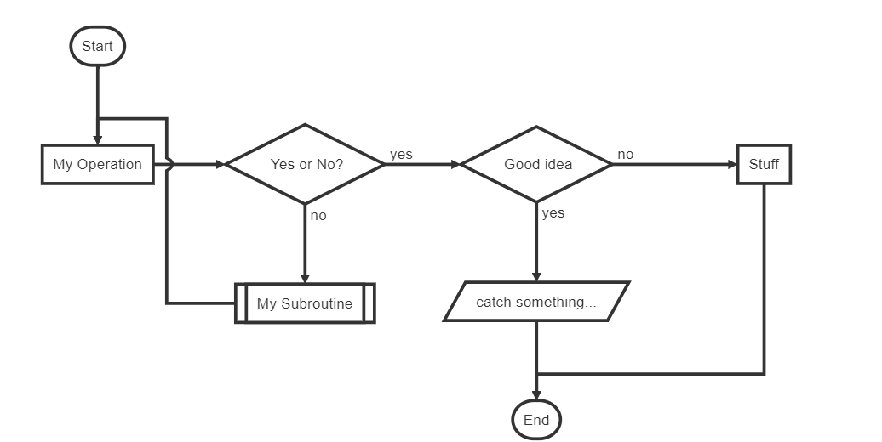

|  |  |  |  |
| --- | --- | --- | --- |
| 手机 |  |  |  |
| 邮箱 |  |  |  |

717-254-7403

## Education

### **Pennsylvania State University** Fall 2016 - Present

State College, PA

* GPA: **3.71**
* Major GPA: **3.70**

### **Dickinson College** Fall 2014 - Spring 2016

Carlisle, PA

* GPA: **3.5**

## Honors and Awards

* Dean’s list All Semesters
* Penn State Health and Human Development Honor Society Spring 2017 - current

## Professional Experience

### **Physical Therapy Department in Hospital** May 2016 - August 2016, August 2017

*Intern*

* Conduct simple therapy procedures
* Educate patients in anatomy, pathology, treatment and injury prevention
* Document subjective and objective measures and patients process
* Evaluate and assess patients to restore body functions

### **Phoenix Rehabilitation** Sep 2017 - current

*Intern*

* Assist disabled patients
* Educate and instruct patients in functional tasks, exercise and safety
* Provide superlative care in collaboration with other clinical professions
* Document subjective and objective measures and patients process

### **Kline Fitness Center** Spring 2015 - Spring 2016

*Trainer and Gym assistant*

* Prevent dangerous use of gym equipments
* Arrange, clean, and manage the fitness center daily
* Guide and train students with exercise programs
* Train and advise new employees

## Research Experience

### **The Biomechanics Laboratory** May 2017 - July 2017

*Research Assistant*

* Measure and recreate human body movement using 3D model
* Analysis motion data captured from athletes by running Visual 3D

### **Laboratory for Comparative Morphology and Mechanics** Feb 2018 - current

*Research Assistant*

* Investigate clinical cases on abnormal morphology of human wrist

## Certifications

**CPR/AED for Health Professionals**

## Skills

* Microsoft Office / Apple iWork
* Java programming
* Visual 3D

## References

**Elizabeth Myers, M. Ed.**: *Advisor* (elm122@psu.edu)

**John Challis, Ph.D.**: *Research Advisor* (jhc10@psu.edu)

**Robert B. Eckhardt, Ph.D.**: *Research Advisor* (eyl@psu.edu)

**Carly Onkotz Wheaton, PT, DPT**: *Facility Supervisor* (814-278-1912)