CS3335 Assignment 8 Due: 10/02/17

(10 points)
Introduction

There are two basic statistical values for a given a list of data double x[MAX_ITEM]:

- Mean: average of all data.
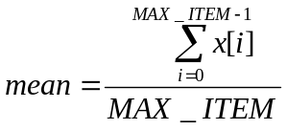

- Standard deviation: a measure of the spread of the data values around the mean. A small (or large) standard deviation indicates that the data values are all relatively close to (or far from) the average.
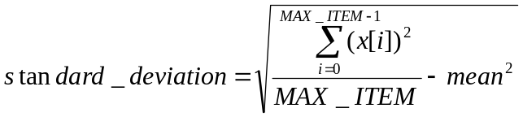

Program details

In this assignment, you are asked to prompt the user to enter a set of numbers, compute and print the mean and standard deviation of them, and also print a table of differences between these numbers and the mean. To simplify your program, you may hardcode the size of this number set in your program:

#define MAX_ITEM 8

Please find below a screenshot of the sample output:

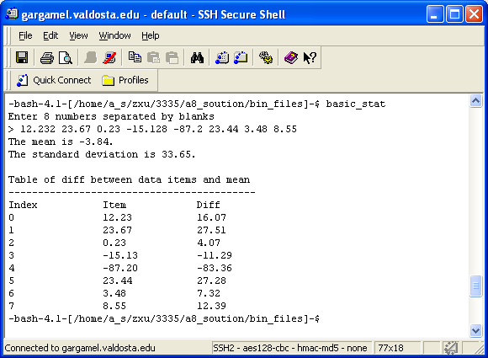

Although it is totally up to you how you design your program, it needs to satisfy the following rules:

- It consists of at least 3 source files (.c files) and at least 3 header files (.h files).
- Use “make_examples_multiple_folders” that we went over in class as your reference to organize your program:
  - bin_files/ : a subfolder that holds executable file(s)
  - obj_files/ : a subfolder that holds object file(s)
  - inc_files/ : a subfolder that holds header file(s)
  - src_files/ : a subfolder that holds source file(s)

- It comes with a workable makefile. Use makefile.5 that we went over in class as your reference.

What to submit?
Create a tarball by the name of cs3335_a8_yourlastname.tar that contains your entire program folder.

Submit the tarball file through BlazeVIEW by the due time.

