CS1301 MyCarpet8

Fares

10/12/2016

The ABC Carpet Company has asked you to write an application that calculates the price of carpeting for rectangular rooms. To calculate the price, you multiply the area of the floor (width times length) by the price per square foot of carpet. For example, the area of floor that is 12 feet long and 10 feet wide is 120 square feet. To cover that floor with carpet that costs $8 per square foot would cost $960. (12 \* 10 \* 8 = 960.)

Use the UML diagram and to complete the following two classes:

RoomDimension and RoomCarpet.

Use the attached driver with any modification.

Attach (do not turn in any hardcopy) via BlazeView a zipped file named with your last name, for example Smith8. The zipped file should contain the following items:

* 1. MyReport8: A single typed page report with your name, class, date, and program title. The report should include what you learned from the programming assignment, problems faced, skills learned, and your observations.
  2. RoomDimension.java
  3. RoomCarpet.java
  4. MyOutput8 (sample output)
  5. DO NOT attach the driver

Make sure that your program is well documented, readable, and the output is well labeled and aligned

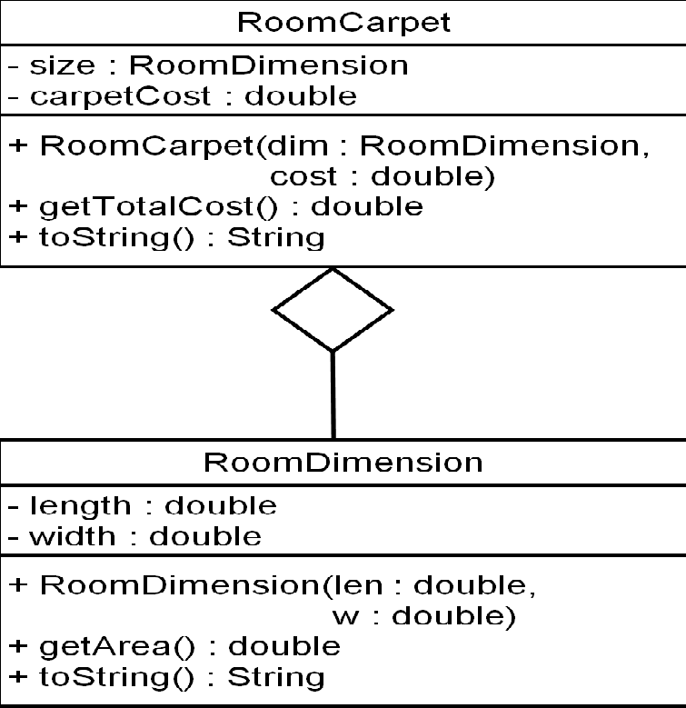

Sample output:

This program will display price to

carpet a room. You must input the

room's dimensions in feet.

Enter the length first: 20

Now enter the width: 10

enter the price of carpet per square foot: 8

Room dimensions:

Length: 20.0

Width: 10.0

Area: 200.0

Carpet cost: $1,600.00