1. TweetSentimentalAnalysis is the IntelliJ project.Unzip the folder tweet. Open the TweetSentimentalAnalysis folder In IntelliJ, Import it as sbt project and. Click on build-> click on build project 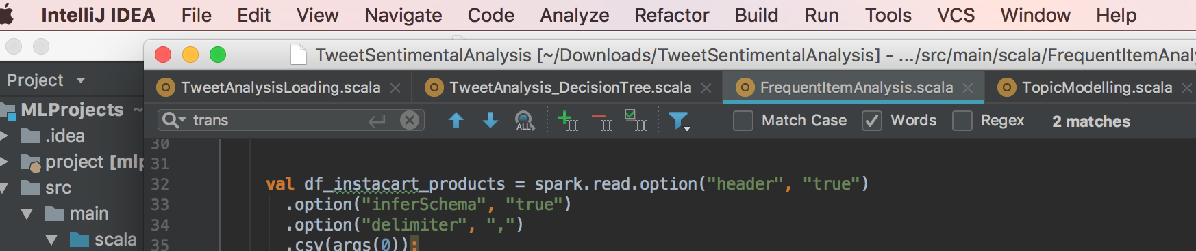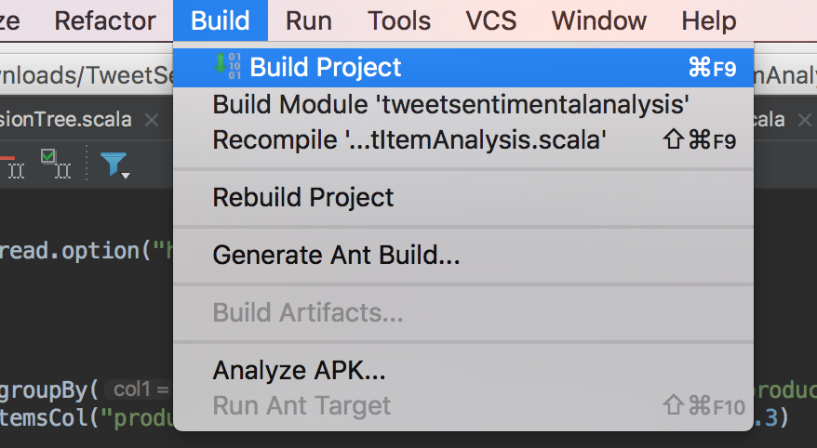
2. Go to View->Tool Windows->Click on sbt-> Go to sbt tasks-> Click on package->it builds the project After build success, we can see the tweetsentimentalanalysis jar in target folder in scala-2.11 folder in the target folder.

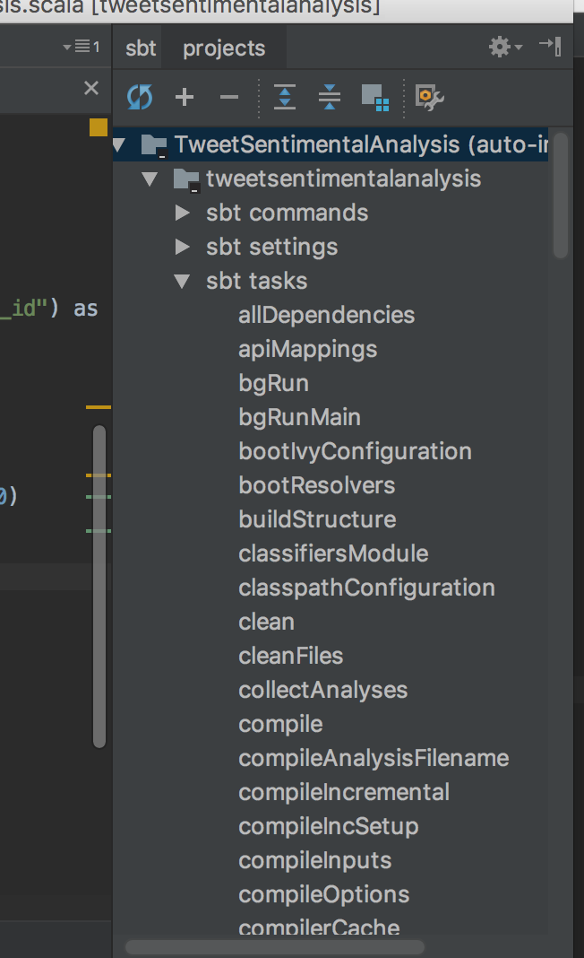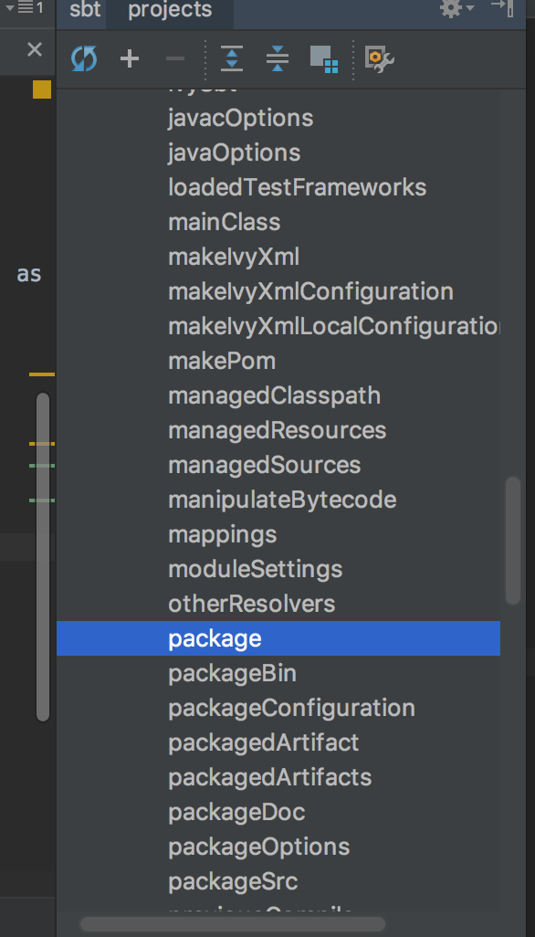

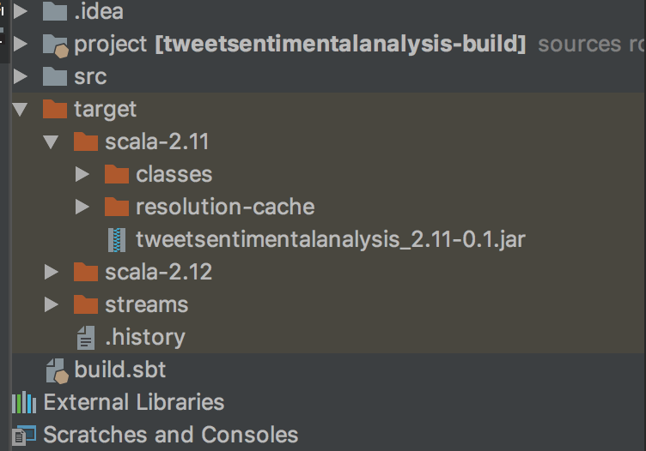

Now go to [https://s3.console.aws.amazon.com/s3/home?region=us-west-1#](https://s3.console.aws.amazon.com/s3/home?region=us-west-1) and upload the jar tweetsentimentalanalysis_2.11-0.1.jar generated in s3 bucket and also the csv files Tweets.csv, order_products_train.csv, products.csv in the s3 bucket

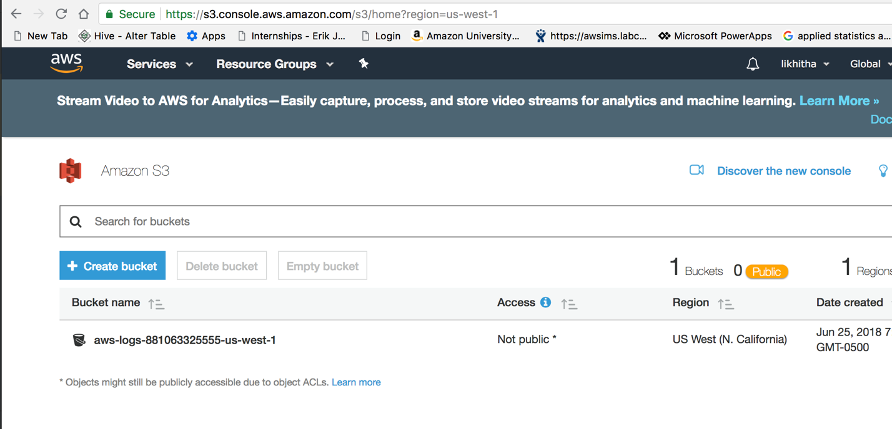

Now go to <https://us-west-1.console.aws.amazon.com/elasticmapreduce/home?region=us-west-1#cluster-list>:

Here create a cluster or select the existing active cluster and go to steps view and there click on add step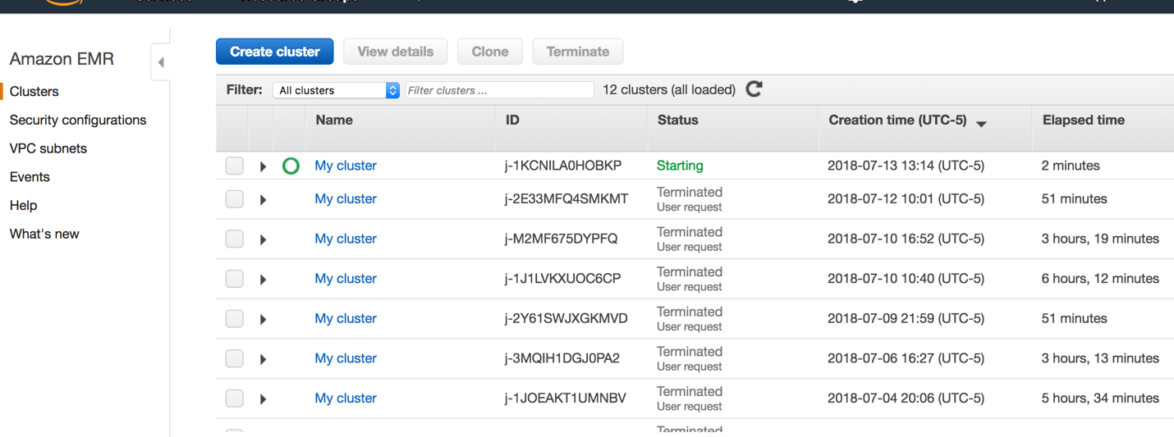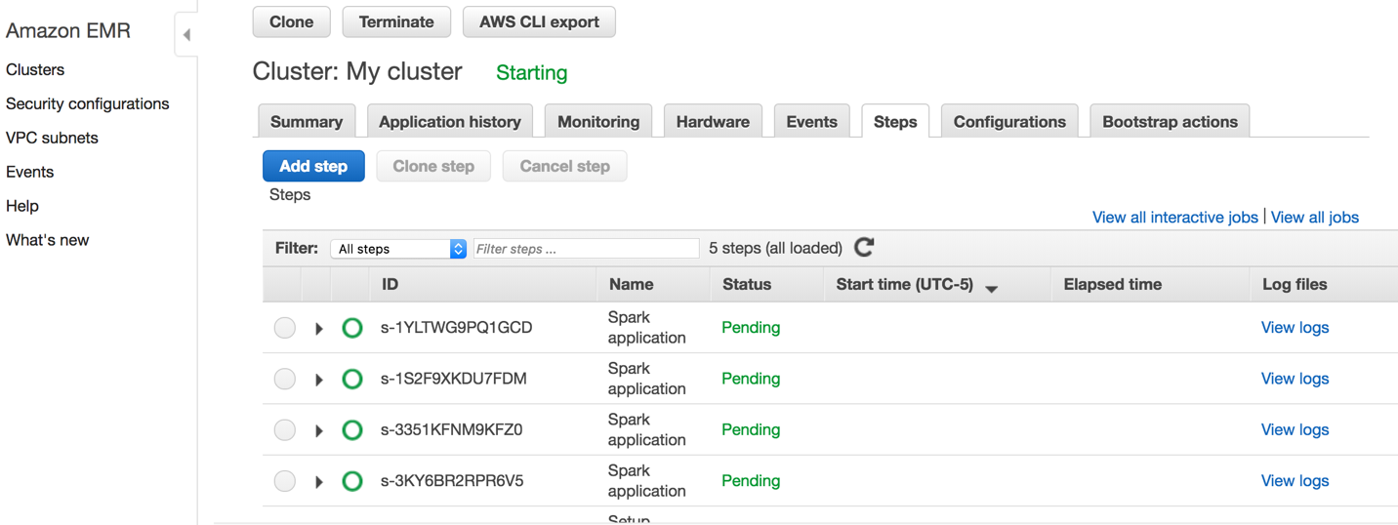

After clicking on add step

**part1**

* **Classification model 1 logistic regression**
* The csv file should be Tweets.csv .. The second argument should be output file path to save data in s3 bucket .Click on add to add step

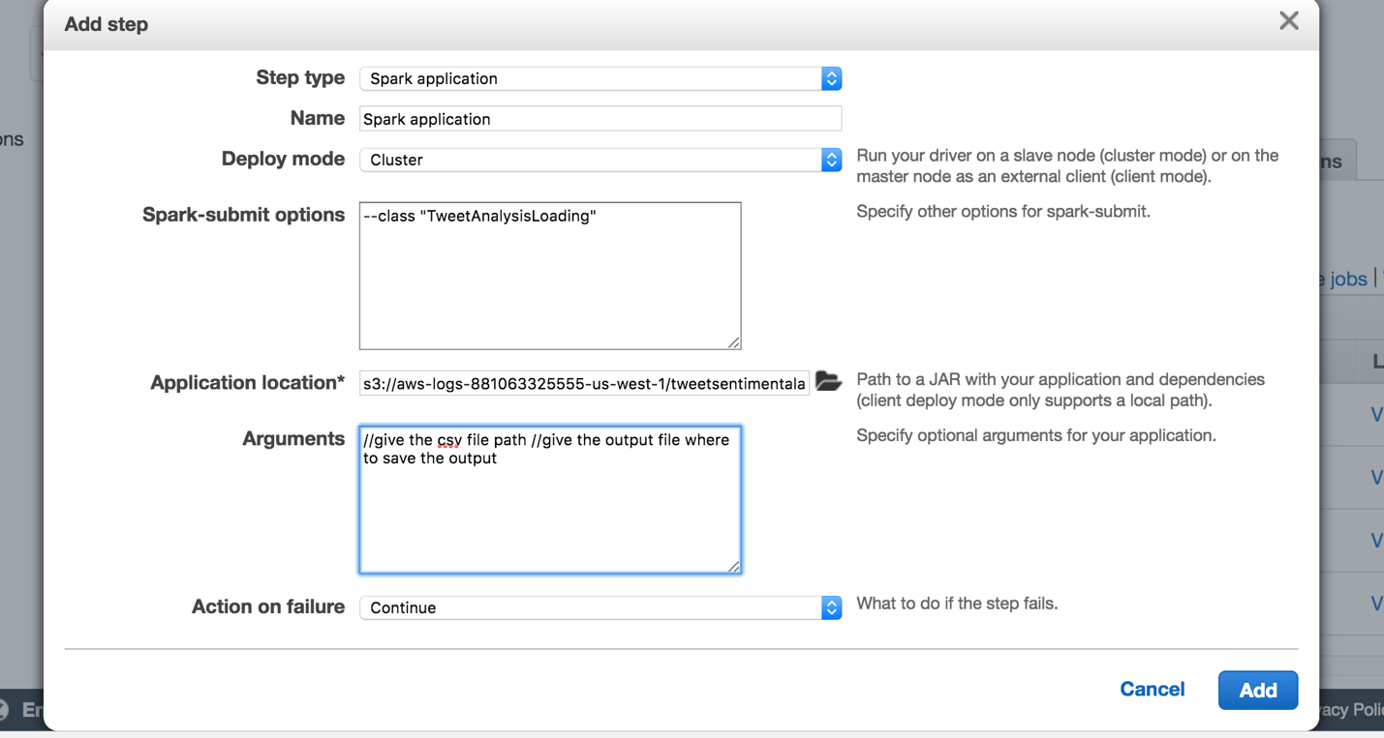

* **Classification model 2 decision tree**
* The csv file should be Tweets.csv .. The second argument should be output file path to save data in s3 bucket .Click on add to add step

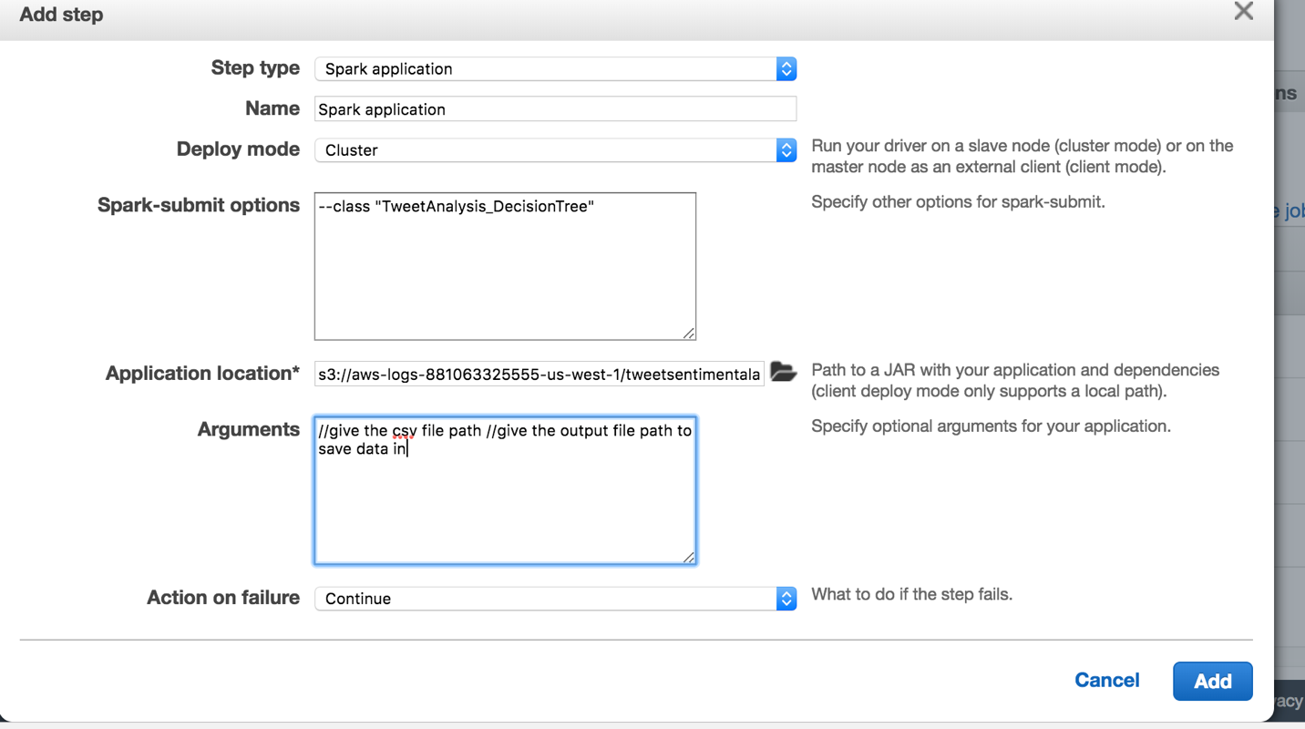

**part2**

* The csv file should be Tweets.csv .. The second argument should be output file path to save data in s3 bucket .Click on add to add step

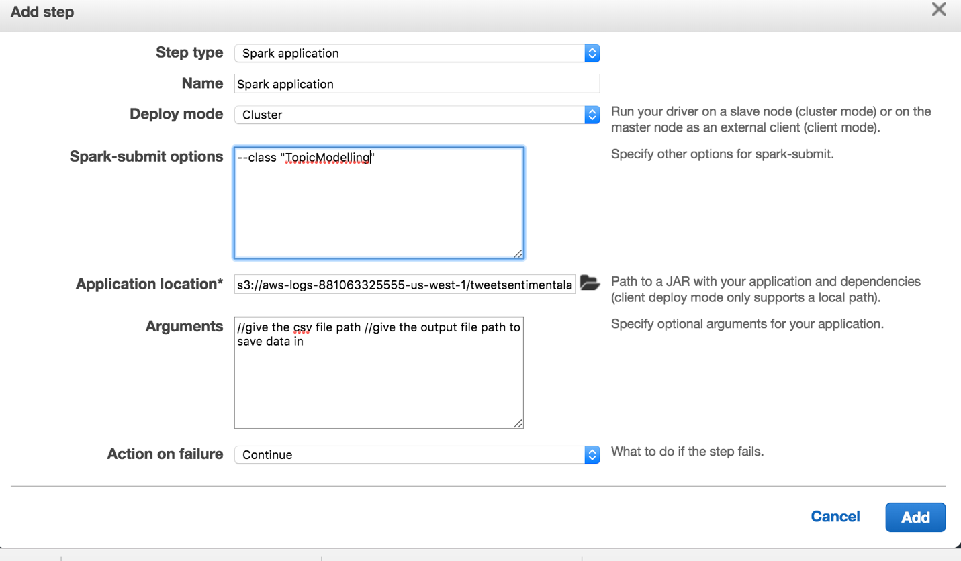

**Part3**

* The csv file should be order_product__train.csv ..The second argument should be output file path to save data in s3 bucket. Click on add to add step

After all steps are completed you can go to s3 and check the output files to verify the output of every part

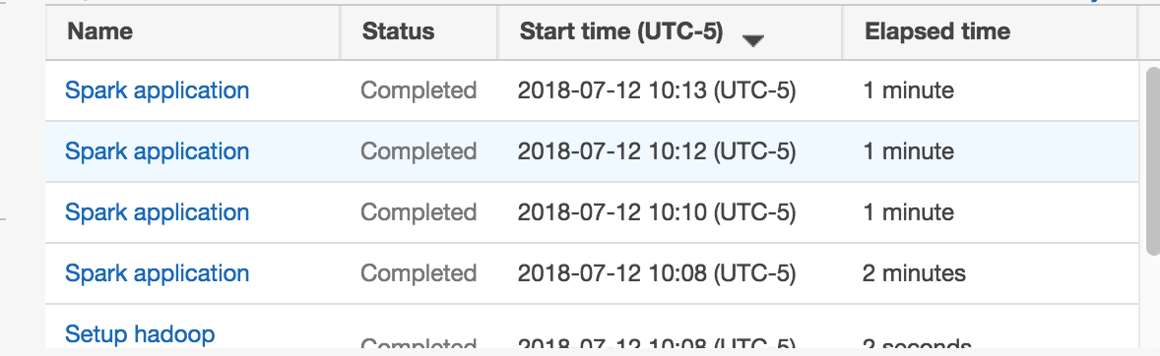

Go to[**https://s3.console.aws.amazon.com/s3/buckets/aws-logs-881063325555-us-west-1/?region=us-west-1&tab=overview**](https://s3.console.aws.amazon.com/s3/buckets/aws-logs-881063325555-us-west-1/?region=us-west-1&tab=overview) **and verify the** output files to check the output of every path

