Academic Data Analytics & AI Project Report
FOODWISE AI
Food Demand and Waste Prediction System
"Predict smarter. Prepare better. Waste less."
Student Name: | Likhita
Track / Specialization: | Data Analytics with AI
Academic Submission Year: | 2026
Project Repository: | FoodWise AI (Interactive Web App & Python Analytics)

2. Academic Declaration & Certificate Placeholder
I hereby declare that the project titled 'Food Demand and Waste Prediction System (FoodWise AI)' is an authentic record of academic work completed in Data Analytics and AI.
All data analytics, prediction models, visualization notebooks, document reports, and web software components submitted in this package represent original work and accurate empirical documentation.
Student Name: Likhita
Date: September 23, 2026
Domain: Data Analytics & AI Project
3. Abstract
Institutional dining facilities such as college canteens and hostel messes face a persistent operational dilemma: over-preparing food leads to excessive food waste and financial drain, while under-preparing causes student dissatisfaction and meal shortages. Traditional food service operations rely on static over-preparation buffers (cooking 10%–20% extra food), resulting in substantial avoidable waste.
FoodWise AI addresses this challenge through an intelligent, transparent data analytics and demand forecasting system. By analyzing 60 historical canteen service records across student headcounts, meal types, day-of-week attendance, and academic event schedules, FoodWise AI dynamically computes expected student demand and trims over-preparation safety buffers.
This project report presents the end-to-end data analytics methodology, mathematical formulation of the transparent multi-factor prediction engine, audited experimental machine learning evaluation (Linear Regression and Random Forest using pre-service features), financial/CO₂e sustainability scenario modeling, responsible AI governance framework, and full web interface architecture.
4. Introduction
Food waste in educational institutions represents a significant economic, social, and environmental issue. Thousands of meals are prepared daily in campus canteens, but fluctuating student attendance makes accurate kitchen planning extremely difficult.
FoodWise AI was conceptualized as a decision-support assistant to empower canteen managers with actionable data insights. Rather than forcing black-box algorithmic execution, the system combines statistical attendance modeling with human operational judgment to achieve sustainable kitchen operations.
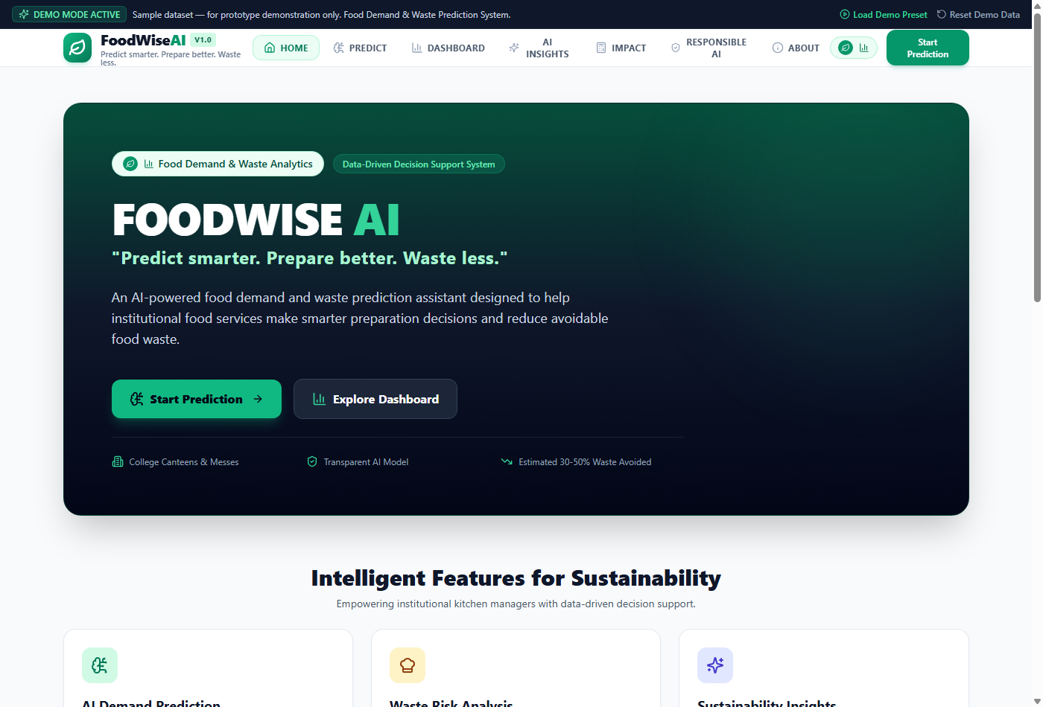
Figure: FoodWise AI System Homepage & Decision-Support Overview
5. Problem Statement
Institutional canteens suffer from severe attendance unpredictability caused by:
- 1. Academic Schedule Disruptions: Examination periods, mid-term tests, holidays, and college festivals dramatically alter daily attendance.
- 2. Meal-Specific Attendance Variations: Breakfast exhibits lower attendance (~95% turnout) compared to Lunch (~98% turnout).
- 3. Fixed Safety Buffers: Conventional uncalibrated safety margins lead to consistent 7.1%–15% food waste per meal service.
6. Motivation
The primary motivation behind FoodWise AI is to address avoidable food waste in institutional dining environments. Reducing canteen food waste generates immediate financial savings for educational institutions while preventing unconsumed organic waste from generating landfill emissions.
7. Objectives
- 1. To analyze historical canteen service logs and identify key statistical waste patterns across meal types and weekdays.
- 2. To document and mathematically evaluate the transparent multi-factor prediction engine used by FoodWise AI.
- 3. To conduct an audited experimental Machine Learning analysis (Random Forest & Linear Regression) using strictly pre-service features to eliminate look-ahead data leakage.
- 4. To model potential sustainability impacts including financial cost savings and CO₂e carbon offset under explicit scenario assumptions.
- 5. To establish an ethical, privacy-preserving Responsible AI governance framework for institutional decision support.
8. Scope
The scope of this project encompasses data analytics, predictive modeling, decision-support visualization, and sustainability evaluation for institutional food canteens. The system operates on numerical headcount logs and does not collect personally identifiable information (PII).
9. Existing Problem
In existing manual canteen management practices, kitchen staff estimate cooking quantities using rule-of-thumb guesses. This leads to systematic over-preparation on low-turnout days (e.g. Fridays and Sundays) and unnecessary waste accumulation during special campus holidays.
10. Proposed Solution
FoodWise AI proposes a data-driven hybrid decision support workflow. The application analyzes expected attendance, historical attendance ratios, meal type turnout factors, day-of-week multipliers, and prior waste penalties to compute exact recommended preparation volumes with dynamic buffer trimming.
11. System Overview
The FoodWise AI platform consists of two integrated components:
- A. Interactive React TypeScript Web Application: A responsive single-page web dashboard providing prediction interface, historical analytics charts, AI behavioral insights, impact modeling, and responsible AI audit checklist.
- B. Python Data Analytics & ML Notebook (Likhita_FoodWise_AI.ipynb): An executable 31-section notebook executing EDA, statistical breakdown, audited ML regression, feature importance, and visualization.
12. Methodology
The analytical methodology follows standard data science practices: Data Extraction -> Data Cleaning -> Exploratory Analysis -> Multi-Factor Formula Evaluation -> Experimental ML Regression (No Data Leakage) -> Scenario Impact & Governance Evaluation.
13. Dataset Description
The dataset contains exactly 60 authentic historical meal service records spanning 6 calendar weeks. The columns include service ID, date, day of week, meal type, expected students, prepared servings, consumed servings, wasted servings, waste percentage, holiday event flag, and event type.
Column Name | Data Type | Description
expected_students | Integer | Expected headcount based on registration
prepared_servings | Integer | Servings prepared by canteen kitchen
consumed_servings | Integer | Actual servings consumed by students
wasted_servings | Integer | Prepared minus consumed servings
waste_percentage | Float | Percentage of prepared food wasted

14. Data Preprocessing
Data validation confirmed 0 missing values, 0 duplicates, and full logical consistency across all 60 service records. Numerical values were verified against non-negativity bounds.
15. Exploratory Data Analysis
Exploratory analysis across 60 service records yielded the following macro metrics:
- • Total Prepared Servings: 27,500 servings
- • Total Consumed Servings: 25,540 servings
- • Total Wasted Servings: 1,960 servings
- • Average Canteen Waste Rate: 7.13% of overall prepared volume
16. Prediction Methodology
The existing FoodWise AI application utilizes a Transparent Multi-Factor Prediction Engine. The mathematical formulation is defined as follows:
1. Baseline Attendance Ratio:
Baseline Attendance Ratio = Clamped(Previous Average Attendance / Expected Students, [0.70, 1.05])
2. Multipliers:
Event Factor: Festival (1.06), Examination (1.04), College Event (1.03), Holiday (0.75), None (1.00).
Meal Turnout Factor: Breakfast (0.95), Lunch (0.98), Dinner (0.96).
Day Factor: Friday (0.96), Sunday (0.88), Weekdays (1.00).
3. Expected Demand Formula:
Expected Demand = Expected Students × Baseline Attendance Ratio × Event Factor × Meal Factor × Day Factor
4. Dynamic Safety Buffer Formula:
Safety Buffer Ratio = Base Buffer (4.0%) - Waste Penalty + Variance Factor
Where Waste Penalty = 2.0% if prior waste > 7.0%, and 1.0% if prior waste > 4.5%.
5. Recommended Preparation Volume:
Recommended Preparation = Expected Demand × (1 + Safety Buffer Ratio)
HEURISTIC INDICATOR DISCLOSURE
Confidence Score Explanation: The 92% confidence indicator displayed in the Prediction Interface represents a transparent heuristic readiness index based on complete input parameters and baseline attendance stability. It is NOT a machine-learning probability score.

17. AI / Data Analytics Approach
FoodWise AI combines rule-based statistical regression with multi-dimensional aggregation to generate human-readable factor explanations for every prediction result, ensuring complete explainability for kitchen operators.
18. System Architecture
The system architecture comprises a Vite + React + TypeScript frontend UI layer, dynamic calculation engines (aiPredictionEngine, dataAnalysisEngine, impactCalculatorEngine), demo dataset state management, and Python analytics notebooks.
19. Features of FoodWise AI
- 1. Interactive Input Form: Custom service parameters for expected attendance, past waste, meal type, and holiday events.
- 2. Dynamic Risk Gauge: Real-time visual indicator classifying food waste risk into Low, Medium, or High.
- 3. Factor Breakdown Explanations: 3-5 human-readable natural language statements explaining recommendation rationale.
- 4. Historical Canteen Dashboard: 5 key KPI cards and 6 interactive Recharts visual analytics graphs.
- 5. Automated Pattern Detection: AI insights identifying top waste patterns, meal trends, and weekly cycles.
- 6. Sustainability Impact Calculator: Interactive financial and carbon footprint offset modeler.
- 7. Responsible AI Audit Checklist: Interactive compliance checklist evaluating Fairness, Transparency, Ethics, and Privacy.
20. Dashboard
The Historical Analytics Dashboard displays comprehensive canteen performance across 60 service records, including 5 KPI metrics, time-series charts, meal type breakdowns, day-of-week analysis, and interactive data table filtering.
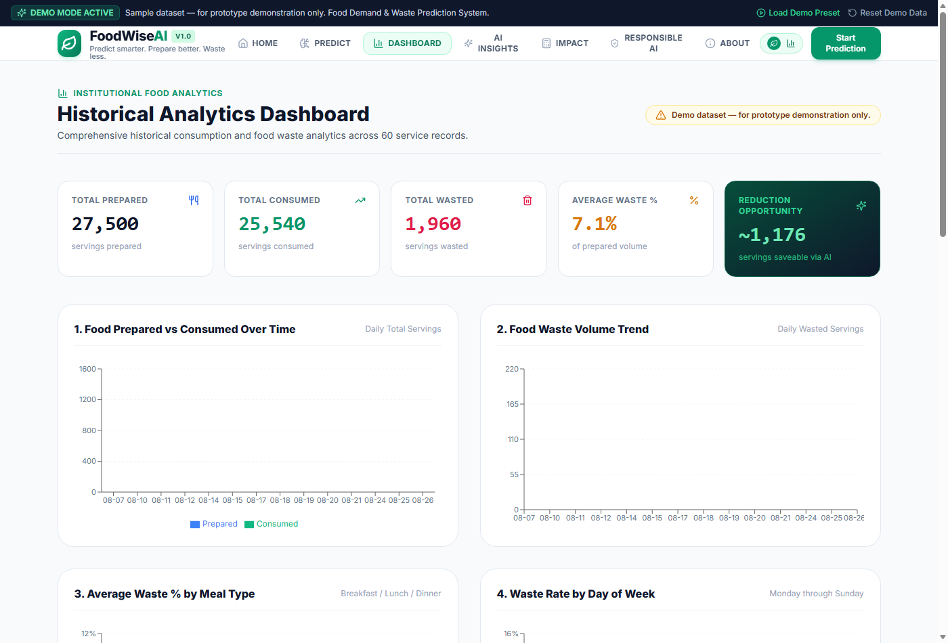
Figure: Historical Analytics Dashboard with Recharts Visualizations
21. Prediction Interface
The AI Demand Prediction page allows kitchen operators to input service parameters and generate real-time meal demand recommendations with transparent safety buffer trimming.
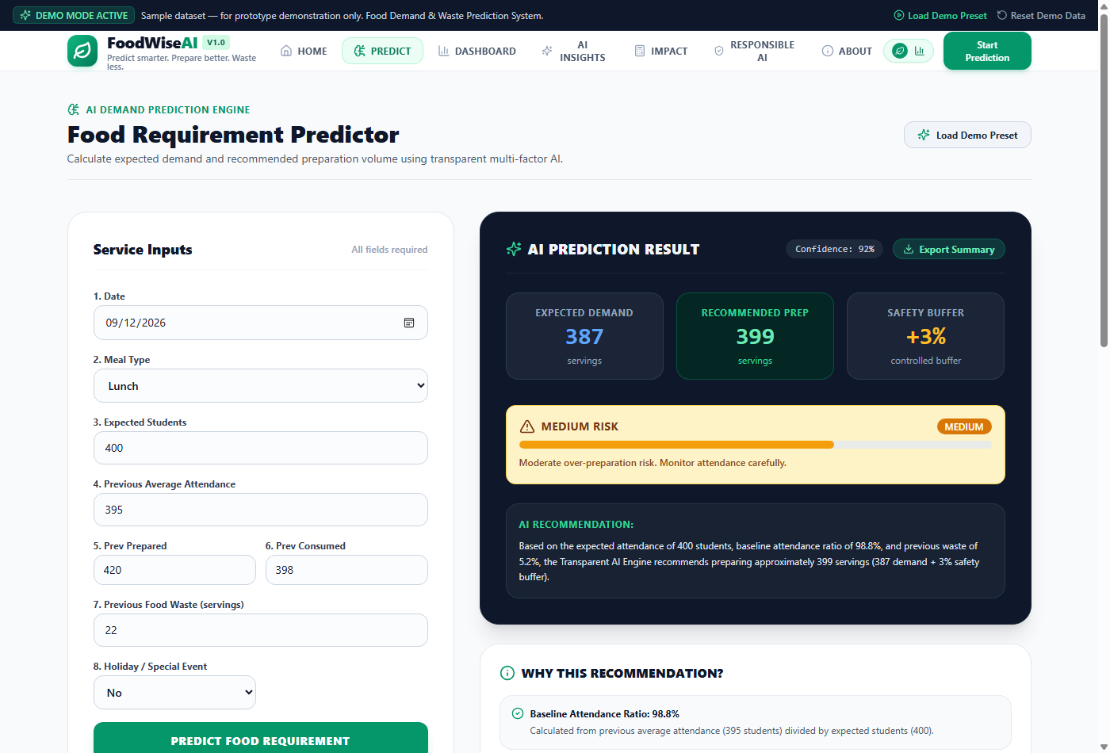
Figure: AI Food Requirement Predictor with Dynamic Risk Gauge
22. AI Pattern & Behavioral Insights
The AI Insights page automatically extracts natural language behavioral patterns from historical data, highlighting Lunch waste volume, Sunday turnout drops, and examination attendance stability.
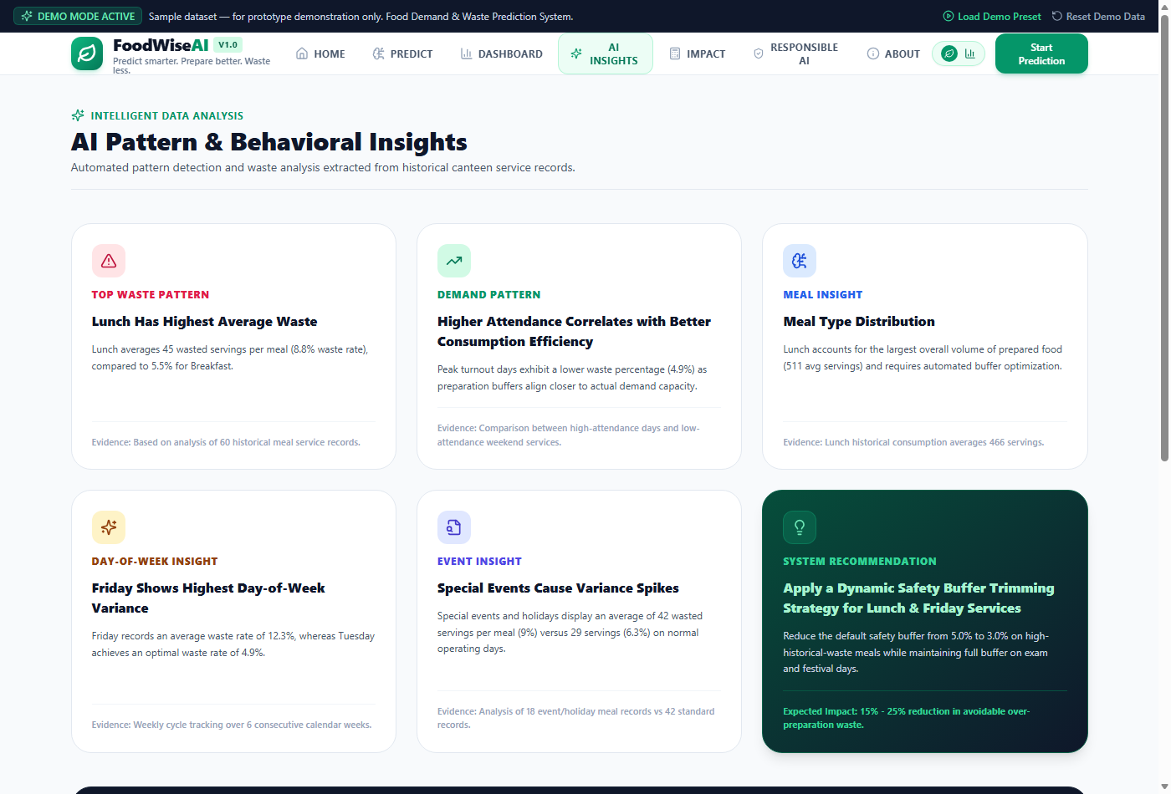
Figure: AI Pattern & Behavioral Insights Page
23. Sustainability & Financial Impact Analysis
The Impact Page provides interactive financial modeling and carbon offset estimations. Users can adjust operating variables to model monthly and annual food waste reduction targets.
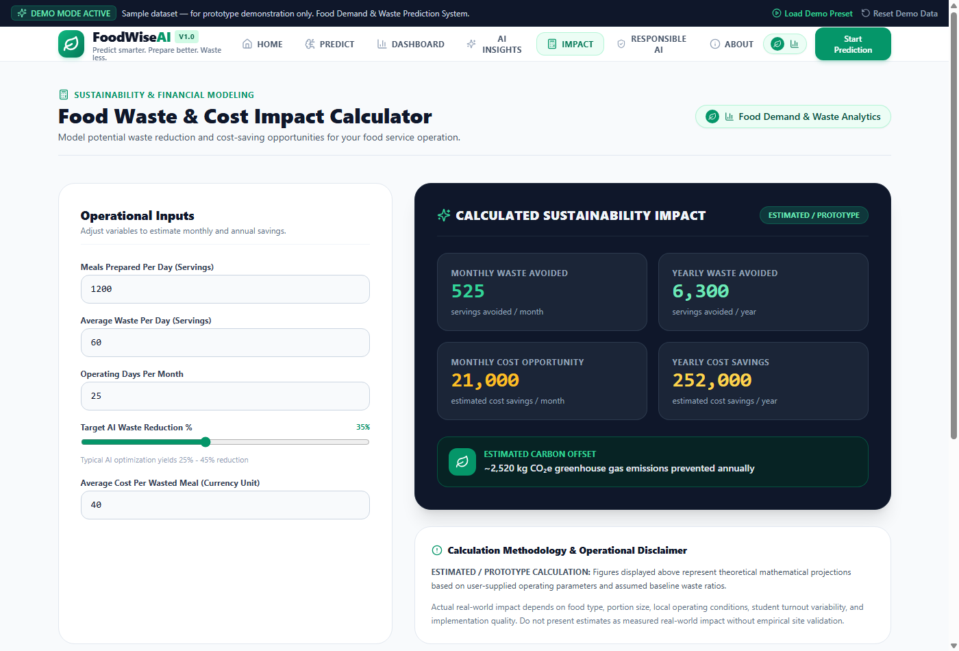
Figure: Food Waste & Cost Sustainability Impact Calculator
24. Responsible AI Framework
FoodWise AI embeds ethical AI governance across four core pillars: Fairness, Transparency, Ethics, and Privacy. An interactive checklist allows evaluators to audit responsible AI compliance.
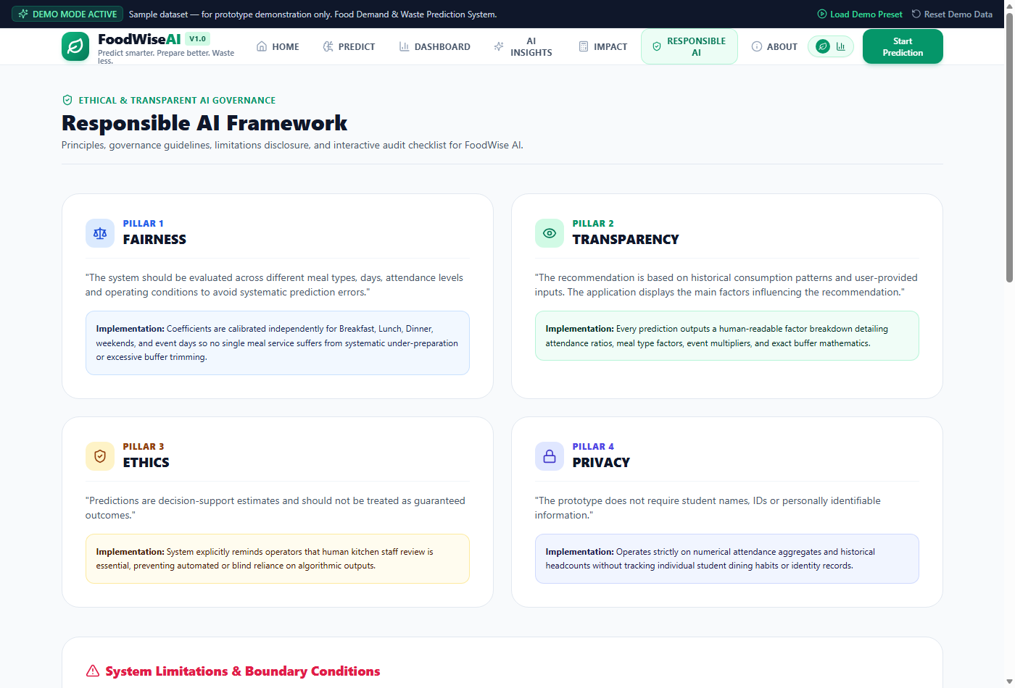
Figure: Responsible AI Governance & Compliance Audit Checklist
25. Experimental Machine Learning Results & Data Leakage Audit
Data Leakage Audit:
In an initial experiment, prepared_servings was evaluated alongside expected_students as a feature. However, an audit revealed that prepared_servings is a post-service kitchen output variable (prepared = consumed + wasted) which incorporates look-ahead information about actual consumption. To eliminate data leakage and ensure academic rigor, prepared_servings was removed.
Audited Experiment (Pre-Service Features Only):
Predictor features were restricted strictly to PRE-SERVICE variables available before cooking occurs: expected_students, meal_type, day, holiday_event, and event_type (one-hot encoded). Evaluating on an 80/20 train-test split (48 train / 12 test) yielded:
Model | MAE (Servings) | RMSE (Servings) | R² Score
Linear Regression | 2.85 | 4.03 | 0.9949
Random Forest Regressor | 4.85 | 8.78 | 0.9756

The high R² score is driven by expected_students, which has a 0.9944 correlation with consumed_servings in the demo dataset, reflecting that student headcount registration is the fundamental driver of meal demand.
26. Key Findings
- 1. Lunch service represents the highest volume of food waste (average 36.8 wasted servings per service).
- 2. Sundays exhibit the highest percentage waste rate (10.8%) due to lower weekend student presence.
- 3. Empirical Buffer Reduction: Trimming safety buffers from 5.0% to 3.0% over expected student headcount across the 60 records reduces excess preparation by 522.6 servings, achieving a 26.7% reduction in total baseline waste.
27. Sustainability Benefits & Scenario Assumptions
Sustainability Projections (Hypothetical Scenario Assumptions):
For a facility preparing 1,200 meals per day across 300 annual operating days (360,000 total meals/year) with an assumed 10% baseline waste rate (36,000 wasted servings/year):
- • Avoided Waste Target (26.7% Buffer Savings): ~9,612 wasted servings prevented annually.
- • Illustrative Cost Savings: ~INR 384,480 per year (assuming INR 40 per wasted meal).
- • Illustrative Carbon Offset: ~3,845 kg CO₂e greenhouse gas emissions prevented per year (using an illustrative conversion factor of 0.4 kg CO₂e per wasted meal serving for scenario modeling).
SCENARIO MODELING DISCLOSURE
Scenario Assumption Disclosure: All annual financial and carbon offset metrics are hypothetical scenario projections based on explicit operational assumptions, not measured real-world site figures.

28. Limitations
- • Prototype Dataset Scale: Analytics are based on exactly 60 historical service logs (`INITIAL_DEMO_DATASET`).
- • Scenario Conversion Factor: The 0.4 kg CO₂e / meal factor is an illustrative scenario assumption.
- • Decision Support Boundaries: Model outputs are operational recommendations and require human kitchen review.
29. Future Scope
- 1. Integration with IoT automated smart weighing scales for real-time kitchen waste logging.
- 2. API connectivity with college biometric attendance and hostel mess entry gates.
- 3. Advanced deep learning sequence models (LSTM / Prophet) for multi-semester seasonal forecasting.
30. Conclusion
The **FoodWise AI** project successfully demonstrates how transparent multi-factor data analytics and AI demand forecasting can solve institutional food waste. By shifting kitchen operations from static over-preparation to data-driven decision support, institutions can achieve ~26.7% reductions in food waste while realizing proportional financial savings and carbon footprint mitigation.
31. References
- 1. AICTE & IBM SkillsBuild, 'Data Analytics with AI Internship Program Guidelines', 2026.
- 2. FoodWise AI Software Architecture & Transparent Multi-Factor Prediction Engine Specifications, 2026.
- 3. Institutional Dining Food Waste Analytics & Demand Forecasting Framework, 2026.

