**Parking Management Application**

**Summary :-**

It is a simple web application which is used to manage parkings of vehicle . It is build with technologies like React Js, Html and Css .

**Flow of the Application** :-

The application started from home page which contain two fields parking spaces and parking slots. parking spaces are total number of spaces available in parking lot and parking slots are slots which already contain some vehicle.

After submitting parking spaces and parking slots , aplication automatically generate vehicle number and colour of vehicle and all vehicle are listed in parking list . admin can manage that list by adding new parking for vehicle, search vehicles, or by exit the vehicle from exit button.

**Application Link** : https://parking-management-sys.herokuapp.com

**Diagram Flow**:-

**Home Page**

**Exit from parking**

**Search Vehicles**

**Add New Parking**

**Add Parking**

**Screens :-**

**1. Home Page:-**

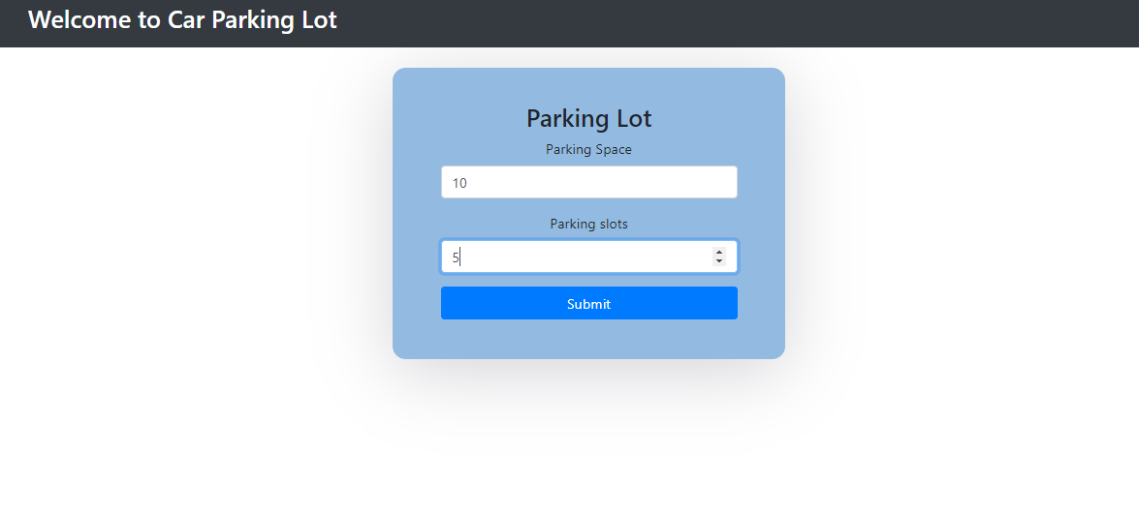

**1. Parking Management Screen:-**

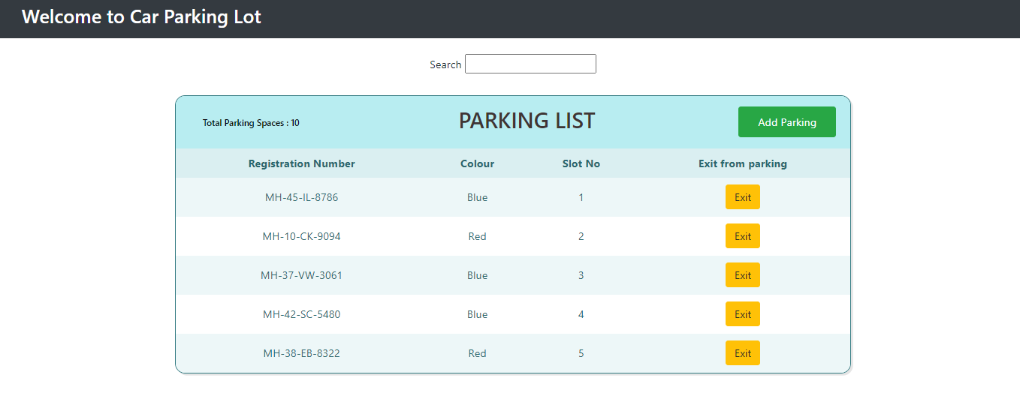

**!! Thank you !!**