University
School of Computing

Reddit Multi-Community Trend Analysis
Comparative Search Overlap & Machine Learning Prediction

Prepared by
Author

April 2026

Abstract

This report presents a comprehensive multi-community trend analysis across Reddit, systematically comparing the top-50 search result posts from 14 distinct subreddits for 150 curated queries spanning five topic categories: Technology, News, Health, HowTo, and Science. Three complementary overlap metrics are computed for each of the 91 subreddit pairs: Jaccard similarity at rank cut-offs of 5 and 10, Spearman rank correlation for shared URLs, and Rank-Biased Overlap with a persistence parameter of 0.9. All results are stored in MongoDB 7.0 and exposed through a FastAPI REST API consumed by a React and TypeScript frontend. Six machine learning models are trained to predict inter-subreddit Jaccard@10 overlap from eight engineered query features, with hyperparameter tuning via GridSearchCV and 5-fold cross-validation.

1. Introduction

1.1 Background & Motivation
Reddit is one of the world's largest social aggregation platforms, hosting thousands of topic-specific communities called subreddits. Each subreddit curates content through upvotes and moderation, resulting in community-specific perspectives on shared topics. Understanding how differently these communities rank and surface the same queries has implications for information retrieval diversity research, content recommendation, and cross-community knowledge transfer.
The Project treats each subreddit as a retrieval engine and measures the degree to which different communities agree or diverge on the top results for the same search queries. By aggregating results for 150 queries across 14 subreddits, the project enables statistical analysis of community agreement patterns and trains predictive machine learning models over query features.

1.2 Objectives
- Collect top-50 Reddit posts per subreddit for 150 queries across 5 categories using the public Reddit JSON API, requiring no API key.
- Compute Jaccard@5, Jaccard@10, Spearman rank correlation, and Rank-Biased Overlap for all 91 subreddit pairs.
- Persist all data in MongoDB 7.0 with compound unique indexes and efficient upsert logic.
- Engineer 8 query features and train 6 ML models to predict inter-subreddit Jaccard@10 overlap.
- Visualise results through 8 Plotly charts, a composite HTML dashboard, and a React frontend.
- Expose all processed data through a FastAPI server with 14 REST endpoints.

1.3 Scope & Constraints
The project is scoped to the Reddit public search JSON API, which requires no authentication. Requests are rate-limited with a mandatory 1.5-second inter-request sleep and a three-attempt retry policy. The subreddit r/worldpolitics was excluded after exhibiting a 100% fetch failure rate, leaving 14 active subreddits and 91 pairs. Spearman rank correlation is set to NaN when fewer than three shared URLs exist for a pair, to maintain statistical validity.

2. Data Collection

2.1 Query Design
The query corpus consists of 150 queries organised into five thematic categories of 30 queries each: Technology, News, Health, HowTo, and Science. Queries are stored in queries.json and loaded into the MongoDB queries collection with IDs of the form category_NN. Each query carries a unique ID, the query text, and a category label enabling category-level aggregation throughout the pipeline.

2.2 Subreddits Analysed
Fourteen subreddits were selected to represent a broad spread of community focus areas: r/science, r/technology, r/worldnews, r/news, r/todayilearned, r/askscience, r/programming, r/explainlikeimfive, r/Futurology, r/environment, r/learnprogramming, r/datascience, r/economics, and r/history. Together they form 91 unique pairs over which all overlap metrics are computed.

2.3 Fetch Pipeline
Data ingestion is implemented in fetch_reddit() within analysis.py. The Reddit JSON search endpoint is queried with parameters: sort=relevance, limit=50, restrict_sr=1, and type=link. A custom User-Agent string identifies the project as an academic exercise. Each result record stores the rank (1–50), URL, title, and up to 300 characters of the post snippet. Records are upserted into the raw_results collection by the composite key (query_id, subreddit, rank).
The pipeline incorporates several resilience mechanisms. Each fetch attempt is retried up to three times with exponential back-off (5, 8, and 11 seconds between attempts). HTTP 429 responses trigger a longer 10-second hold. A mandatory 1.5-second sleep follows every successful fetch. Failed fetches are recorded in the fetch_failures collection so that subsequent runs skip already-attempted pairs rather than hammering the API. Passing --force-refresh clears all collections and re-fetches everything from scratch.

2.4 URL Normalisation
To reduce false non-matches caused by trivial URL variations, all URLs are normalised before any metric computation: the full URL is lowercased, the www. prefix is stripped from the host, and trailing slashes are removed from the path. This normalisation is applied consistently across Jaccard, Spearman, and RBO calculations.

3. Overlap Metrics & Results

Overlap metrics quantify the degree to which two subreddits agree on the top search results for a given query. All three metrics are computed for every (query, subreddit pair) combination, yielding up to 13,650 metric records stored in the overlap_metrics collection.

3.1 Jaccard Similarity
Jaccard similarity measures the intersection of two URL sets divided by their union at rank cut-off k. Two cut-offs are stored: Jaccard@5 and Jaccard@10. A full Jaccard over all 50 results is also computed. Values range from 0.0 (complete divergence) to 1.0 (identical result sets). Jaccard@10 is selected as the ML prediction target because it balances discriminating power with practical relevance.
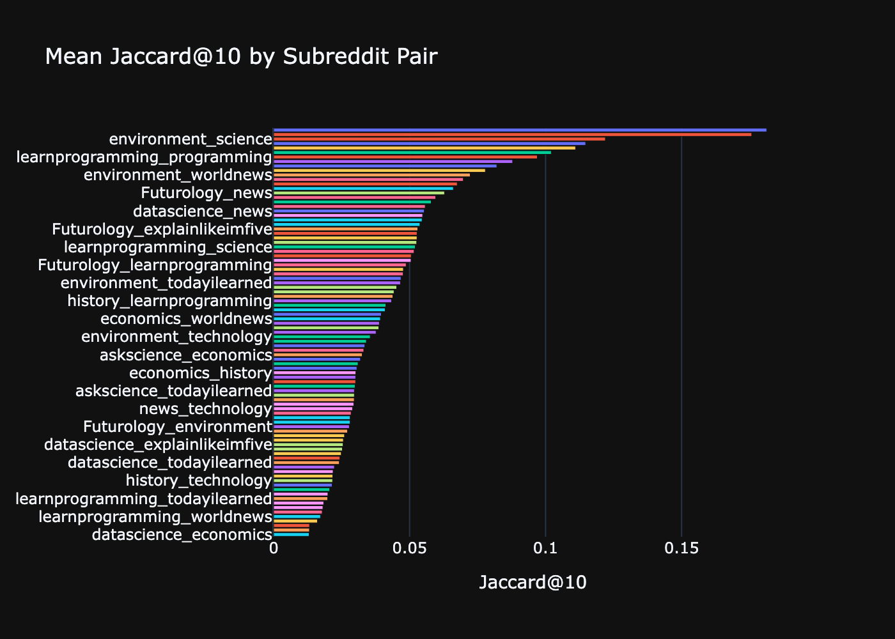
Figure 1. Mean Jaccard@10 by subreddit pair across all 150 queries.
Figure 1 shows the mean Jaccard@10 score for each of the 91 subreddit pairs, sorted in ascending order. Most pairs exhibit very low overlap, reflecting the distinct community curation styles across Reddit. A small number of thematically adjacent subreddit pairs (e.g., r/science and r/askscience) tend to score noticeably higher.
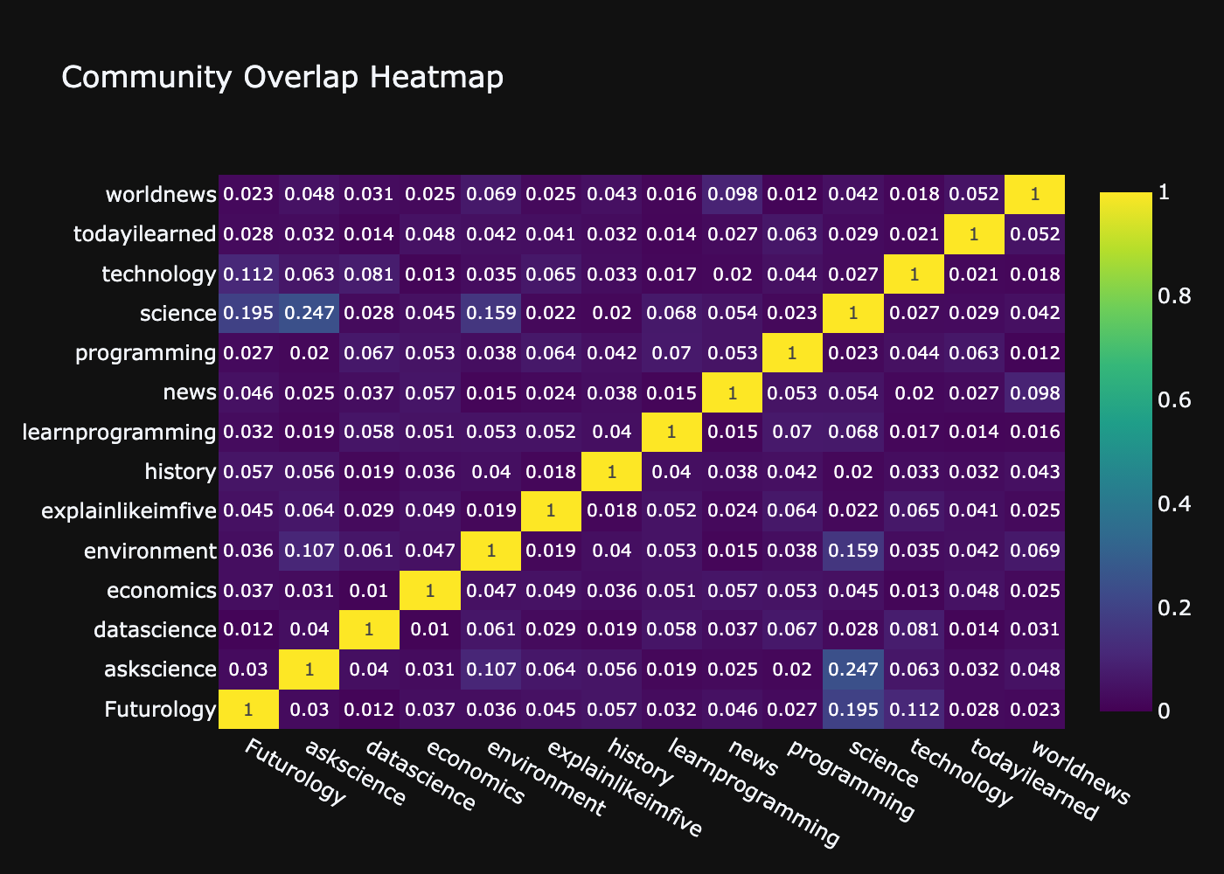
Figure 2. Community overlap heatmap — mean Jaccard@10 across all queries.
The heatmap in Figure 2 provides a full 14×14 view of pairwise overlap. The diagonal is 1.0 by definition. Warm cells indicate subreddit pairs with higher agreement; the predominantly cool palette confirms that cross-community overlap is generally low, with pockets of higher agreement among thematically related communities.
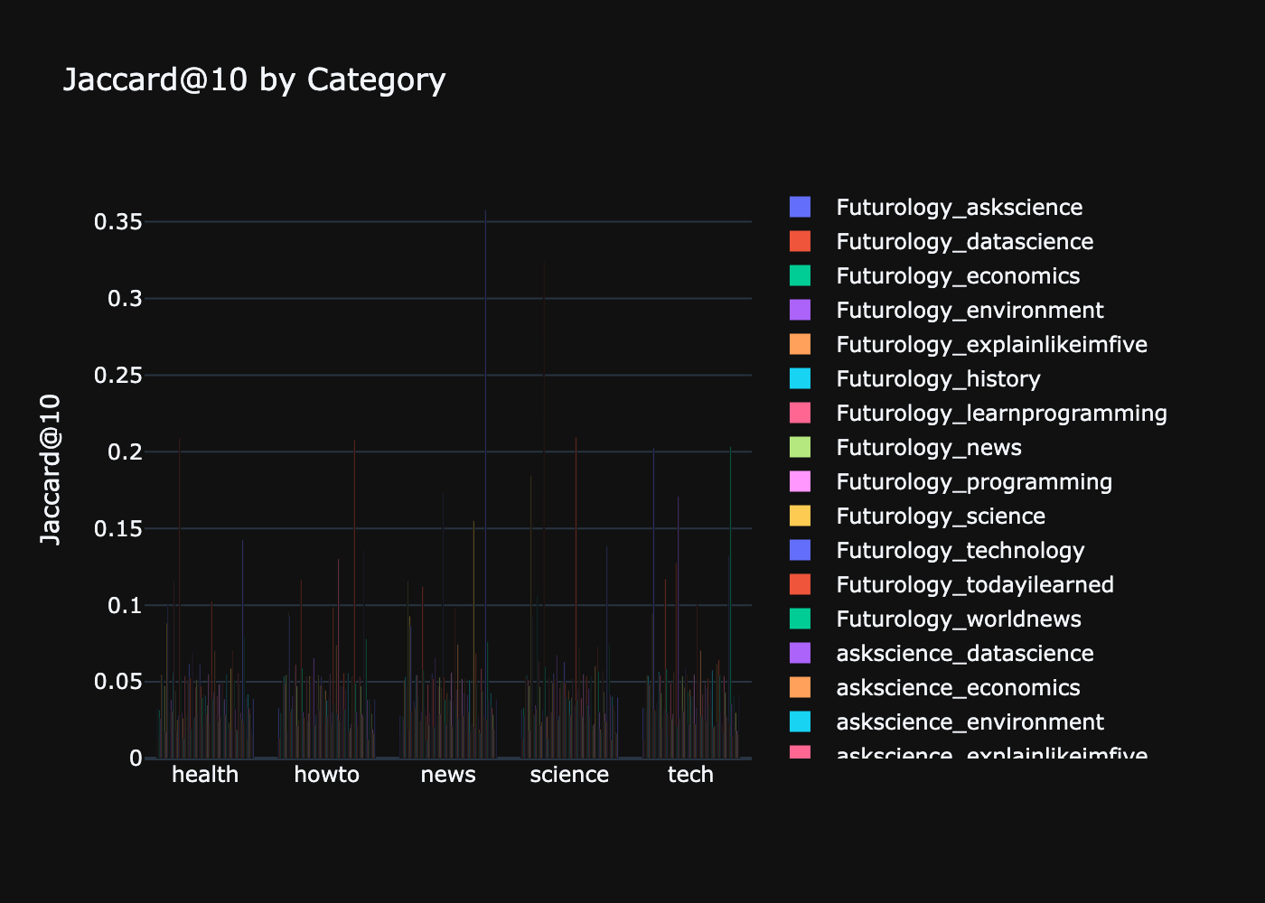
Figure 3. Mean Jaccard@10 by query category for selected subreddit pairs.
Figure 3 breaks Jaccard@10 down by the five query categories. Science and Technology queries tend to produce higher overlap between certain pairs, while HowTo and News queries are more divergent, suggesting that community curation of actionable or current-events content is more idiosyncratic.

3.2 Spearman Rank Correlation
Spearman rank correlation measures ordinal agreement restricted to the shared URLs of two result lists. For each URL appearing in both subreddits, its rank positions in list A and list B are extracted. The Spearman statistic is then computed on these paired ranks using scipy.stats.spearmanr. The metric is set to NaN when fewer than three shared URLs exist, as the statistic is unreliable on very small samples.
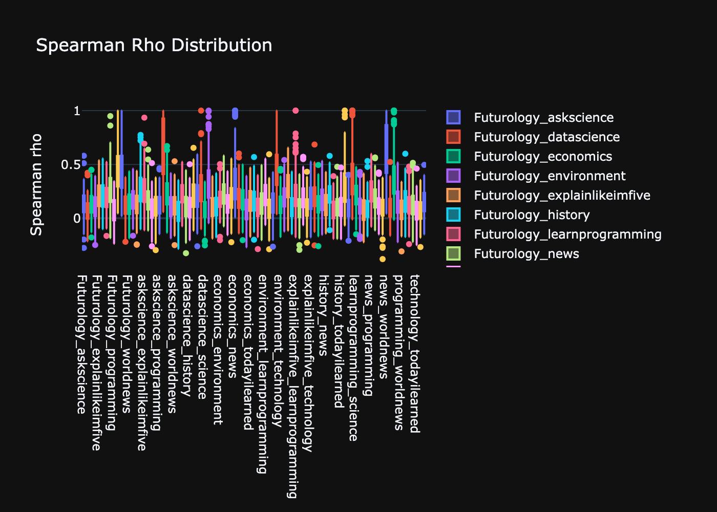
Figure 4. Distribution of Spearman rank correlation (ρ) by subreddit pair.
Figure 4 shows the distribution of Spearman ρ values across queries for each pair. The wide interquartile ranges indicate high query-to-query variability in ordering agreement. Many pairs have a median near zero, meaning that even when subreddits share URLs, they tend to rank them quite differently.

3.3 Rank-Biased Overlap (RBO)
RBO is a top-weighted list similarity metric that gives higher importance to agreement at the top of the rankings. The persistence parameter p = 0.9 is used, meaning approximately 86% of the RBO score comes from the top 22 positions. Tail extrapolation is applied when the two lists differ in length. Unlike Jaccard, RBO rewards partial agreement at top ranks: two subreddits sharing the top three results score higher than two sharing only results ranked 45–50.
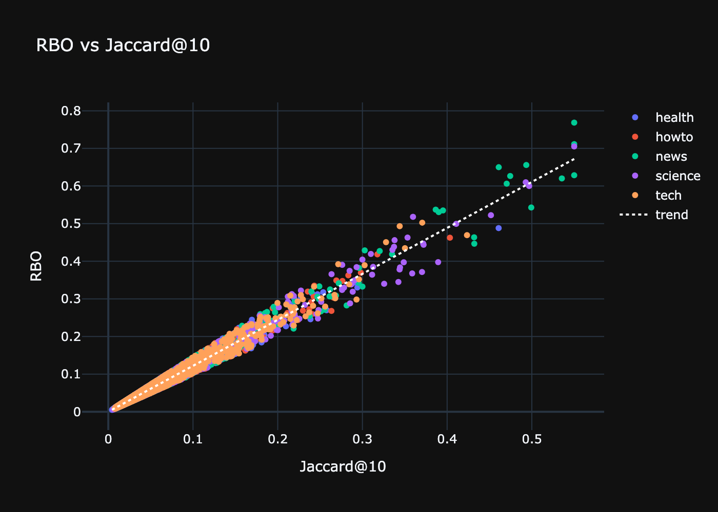
Figure 5. RBO vs Jaccard@10 scatter plot with linear trend line.
Figure 5 plots RBO against Jaccard@10 for every (query, pair) observation, coloured by query category. The positive linear trend confirms that the two metrics are correlated but not redundant: RBO assigns non-zero scores to many observations where Jaccard@10 is zero, capturing partial top-rank agreement that set-based Jaccard misses entirely.

3.4 Bootstrap Confidence Intervals
For each of the 91 subreddit pairs, a 95% bootstrap confidence interval on mean Jaccard@10 is computed using 500 bootstrap resamples with fixed random seed 42. These confidence intervals are stored in the overlap_summary collection and served by the /api/overlap-summary endpoint, enabling uncertainty-aware comparisons in the frontend.

4. Feature Engineering

Eight features are derived from each query's text to enable ML prediction of inter-subreddit overlap. Query length (character count) and word count capture query verbosity. The has_question flag is set when the first token is a question word such as what, how, why, when, where, which, who, is, are, can, does, or will. The is_navigational flag fires when the query is a single word or contains a token with an initial capital letter beyond the first position, signalling a proper noun. Average word length captures lexical complexity. The has_number flag fires when any digit appears in the query. The unique character ratio is the count of distinct non-space characters divided by the total non-space character count, reflecting lexical diversity.
A category label encoding was initially considered but excluded from the final feature set after analysis revealed that Jaccard@10 varies substantially by category, introducing target leakage. The final models therefore train on seven numeric features.

5. Machine Learning Methodology

5.1 Models
Six regression models are trained independently for each of the 91 subreddit pairs, each predicting Jaccard@10 from the seven query features:

Model Key | Algorithm | Hyperparameters Tuned
linear | Linear Regression | None (closed-form OLS)
ridge | Ridge Regression | α ∈ {0.01, 0.1, 1, 10, 100}
rf | Random Forest | n_estimators ∈ {50,100}; max_depth ∈ {None,3,5}
gbr | Gradient Boosting | n_estimators ∈ {50,100}; learning_rate ∈ {0.05,0.1,0.2}
svr | SVR (RBF) + StandardScaler | C ∈ {0.1,1,10}; gamma ∈ {scale, auto}
baseline | DummyRegressor (mean) | None — predicts training mean

5.2 Training & Evaluation Protocol
Each per-pair dataset is split 70/30 into training and test sets, stratified by query category where sample sizes allow. Hyperparameter tuning uses GridSearchCV with 3-fold cross-validation scored by negative MAE, parallelised with n_jobs=-1. The winning hyperparameter combination is re-fitted on the full training set before test-set evaluation. Predictions are clipped to [0, 1] since Jaccard is a probability.
Four metrics are reported for each (model, subreddit pair) combination: MAE and RMSE on the held-out test set, R² on the held-out test set, and CV-MAE (5-fold cross-validation MAE on the full per-pair dataset), which serves as the primary ranking metric.
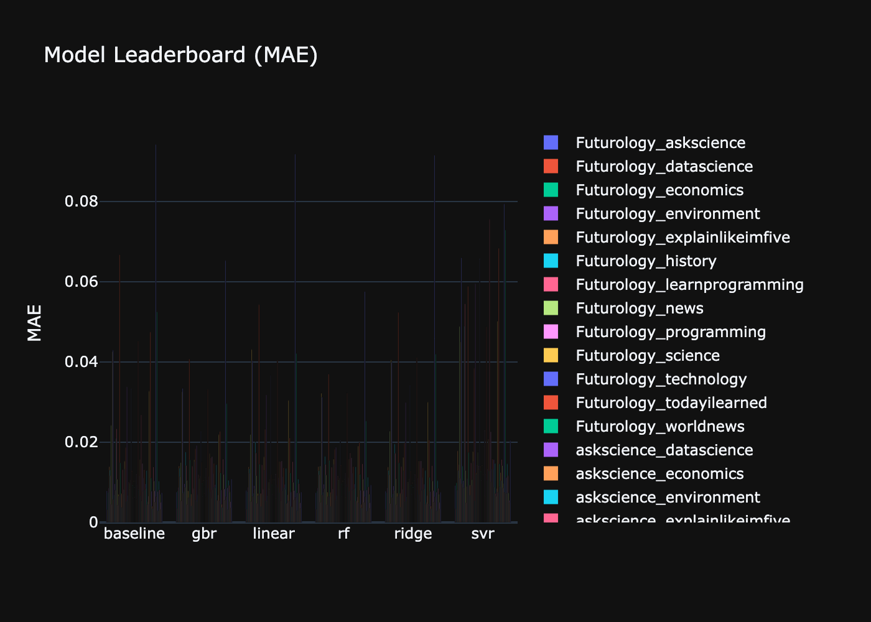
Figure 6. Model leaderboard — MAE by model and subreddit pair.
Figure 6 compares all six models by MAE across subreddit pairs. The DummyRegressor sets the performance floor. Ensemble methods generally achieve lower MAE than linear models and SVR, though differences are modest given the inherently noisy prediction target.
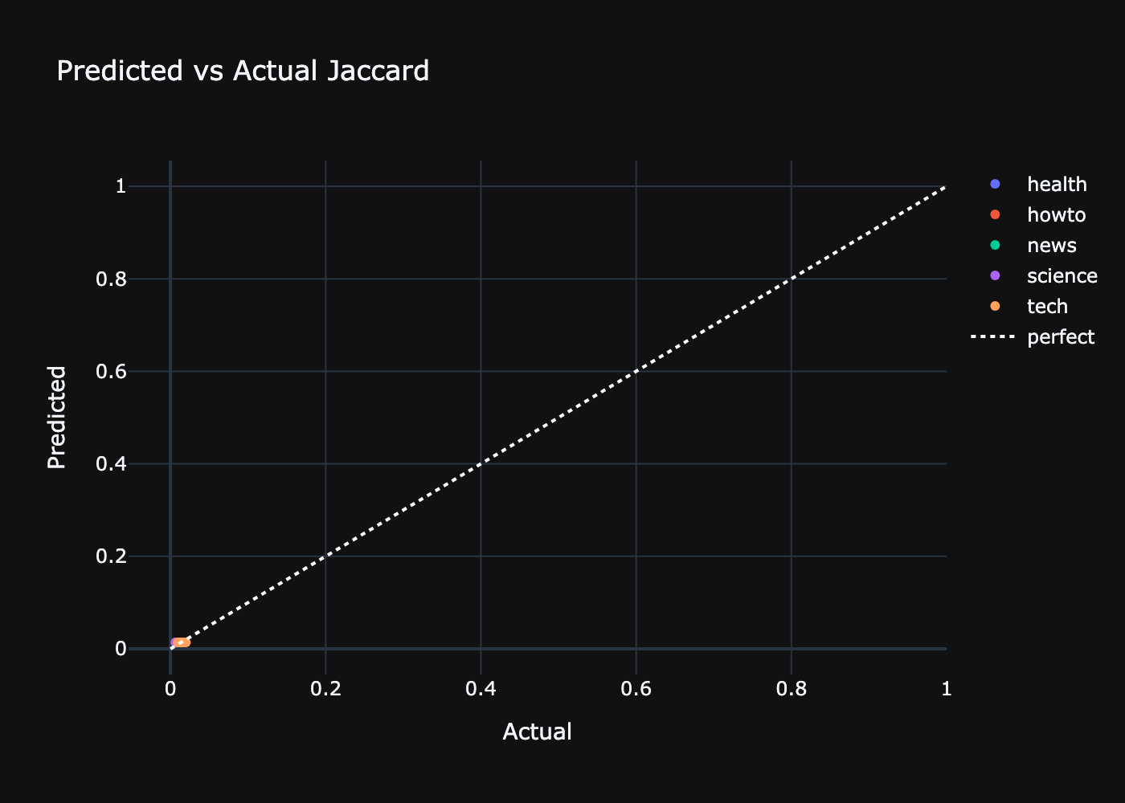
Figure 7. Predicted vs actual Jaccard@10 for the best-performing model and pair.
Figure 7 shows the scatter of predicted versus actual Jaccard@10 for the best model-pair combination selected by CV-MAE. Points cluster near zero, consistent with overall low overlap. Colour coding by query category reveals that certain categories are systematically easier to predict.

5.3 Feature Importance
Tree-based models expose native feature_importances_ attributes. For all other models — Linear Regression, Ridge, SVR, and the Dummy baseline — permutation importance is computed using sklearn.inspection.permutation_importance with 10 repeats on the held-out test set. For SVR wrapped in a StandardScaler pipeline, the named_steps accessor retrieves the correct underlying estimator. The top-3 features by importance are reported in insights.txt for the Random Forest model on each pair.

6. System Architecture & Tech Stack

6.1 Architecture Overview
The project follows a four-layer architecture. The data ingestion and processing layer (analysis.py) fetches Reddit data, computes all metrics, trains models, generates plots, and writes insights. The persistence layer (db.py + MongoDB) stores all intermediate and final artefacts in seven collections. The REST API layer (api.py, FastAPI) reads from MongoDB and serves 14 JSON endpoints. The presentation layer (React 18 + TypeScript frontend) consumes the API to render an interactive dashboard.
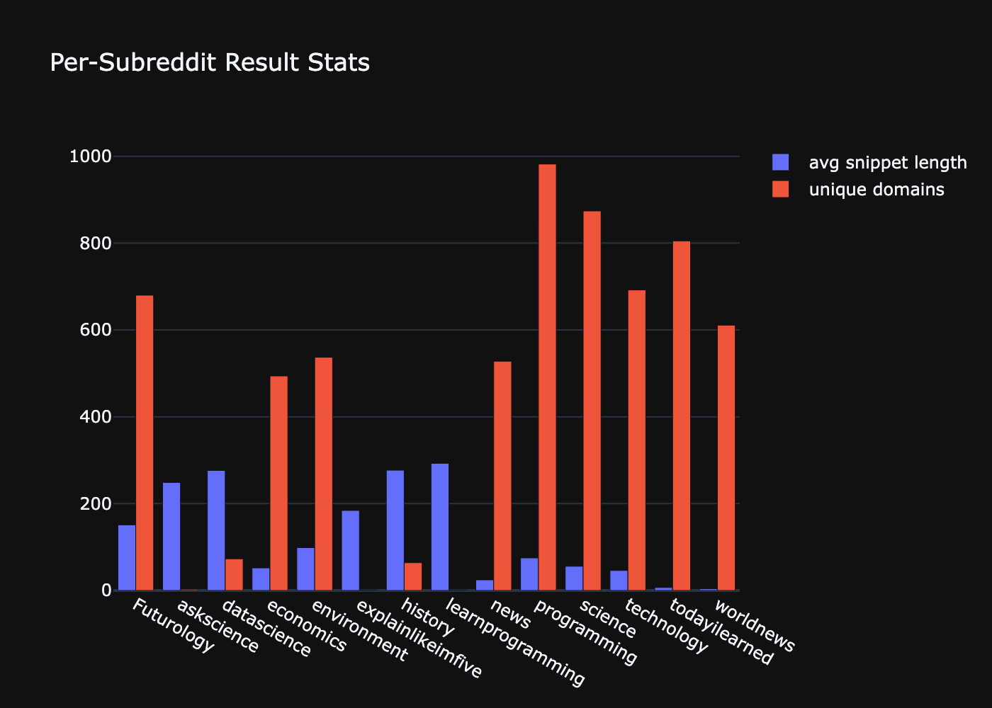
Figure 8. Per-subreddit result statistics — average snippet length and unique domains.
Figure 8 compares subreddits on two result-quality proxies: average snippet length and the number of unique domains appearing across all results. Subreddits like r/datascience and r/science tend to surface a broader range of external domains, while discussion-heavy communities show shorter snippets due to more self-post content.

6.2 Technology Choices
Python 3.12 with the requests library handles all HTTP ingestion. NumPy and SciPy provide the numerical backbone for metric computation; pandas is used for DataFrame manipulation and joins. Scikit-learn covers the full ML workflow: preprocessing, model training, GridSearchCV, cross-validation, and permutation importance. Plotly generates all static PNG charts and the composite HTML dashboard, chosen over matplotlib and seaborn for its richer interactivity and consistent theming. MongoDB 7.0, deployed via Docker Compose, stores all project data with compound unique indexes enforcing idempotent upserts. FastAPI serves the REST API on port 8000 with CORS configured for the Vite dev server on port 5173. The frontend uses React 18, TypeScript, Tailwind CSS v3, and Recharts.

6.3 MongoDB Collections
All project data lives in the reddit_trend_analysis database across seven collections. The queries collection holds 150 query documents. The raw_results collection stores up to 50 ranked posts per subreddit per query, indexed uniquely on (query_id, subreddit, rank). The overlap_metrics collection holds Jaccard@5, Jaccard@10, full Jaccard, Spearman, and RBO per (query_id, sub_a, sub_b, k). The predictions collection stores per-row ML predictions indexed on (run_id, query_id, sub_pair, model). The model_eval collection holds aggregated evaluation metrics and feature importances per (run_id, model, sub_pair). The fetch_failures collection records failed fetch attempts for auditing and skip logic. Finally, the overlap_summary collection stores the 95% bootstrap confidence intervals on mean Jaccard@10 per subreddit pair.

6.4 REST API
The FastAPI server exposes 14 GET endpoints. The /api/health endpoint checks database connectivity. The /api/summary endpoint returns run metadata including counts and the latest run ID. The /api/subreddit-overlaps and /api/overlaps endpoints serve all overlap metrics joined with query categories, with the latter using an engine_a/engine_b naming convention expected by the frontend. The /api/model-eval and /api/subreddit-model-eval endpoints serve evaluation results for the latest run. The /api/overlap-summary endpoint returns the bootstrap confidence intervals. The /api/failure-analysis endpoint returns a cross-tabulation of fetch failures by subreddit and category. The /api/predictions and /api/subreddit-predictions endpoints serve per-query ML predictions. The /api/subreddit-stats and /api/engine-stats endpoints report per-subreddit result statistics. The /api/fetch-failures endpoint returns raw failure records, and /api/queries returns the full query list.

6.5 Frontend Design
The React 18 + TypeScript frontend adopts an Editorial Light aesthetic: warm parchment background (#faf8f4), deep ink typography (#1c1917), and a crimson accent (#c0392b). Typography uses Fraunces for display text and numbers, Space Mono for labels and data, and Libre Baskerville for body copy. Key components include CategoryFilter for cross-chart filtering, OverlapBarChart, RboScatter, PredictionScatter, ModelLeaderboard with a pair selector dropdown, FailureHeatmap, SummaryBar with animated counters, and ProjectHero as the landing banner.

7. Running the Project

7.1 Prerequisites
The project requires Docker (to run MongoDB 7.0 as a container), Python 3.12 with a virtual environment at .venv/, and Node.js 18 or later with npm for the React frontend. All Python packages are installed with uv pip.

7.2 Execution Sequence
# 1. Start MongoDB
docker compose up -d mongo
# 2. Activate the virtual environment and install dependencies
source .venv/bin/activate
uv pip install -r requirements.txt
# 3. Copy environment config and run analysis
cp .env.example .env
python analysis.py --force-refresh
# 4. (Optional) Apply domain affinity priors
python recalibrate.py
# 5. Start API and frontend
uvicorn api:app --port 8000
cd frontend && npm run dev # http://localhost:5173

7.3 Outputs Generated
- plots/01_jaccard_by_pair.png through 08_predicted_vs_actual.png — eight Plotly static charts.
- dashboard.html — composite 4×2 Plotly dashboard embedding all eight charts.
- insights.txt — textual summary covering per-subreddit stats, overlap metrics by pair, the ML leaderboard, and a fetch failure cross-tabulation.
- MongoDB collections populated with queries, raw results, overlap metrics, predictions, model evaluations, and bootstrap confidence intervals.

8. Conclusion

The Project delivers a complete, end-to-end data engineering and machine learning pipeline for Reddit multi-community trend analysis. The project demonstrates that different Reddit communities exhibit measurably different search result profiles for the same queries, with Jaccard@10 overlap varying significantly across subreddit pairs and query categories.
The three-metric framework — Jaccard, Spearman, and RBO — provides complementary views of community agreement. Jaccard measures raw set overlap, Spearman captures ordering agreement among shared results, and RBO rewards top-rank alignment. Together these metrics reveal nuanced patterns in how communities curate and rank information differently.
The machine learning component tests whether query characteristics alone can predict inter-community overlap. While Jaccard@10 values are generally low and exhibit high variance, the framework establishes a rigorous evaluation baseline: six models are compared against a mean dummy regressor across all 91 subreddit pairs, with 5-fold cross-validation as the primary ranking criterion.
The full-stack implementation — from unauthenticated Reddit ingestion through MongoDB persistence, FastAPI serving, and a React Editorial Light frontend — demonstrates the integration of modern data engineering tools in a coherent, reproducible research workflow.

References

- Reddit JSON API — https://www.reddit.com/dev/api/ (public, no authentication required).
- Webber, Moffat & Zobel (2010). A Similarity Measure for Indefinite Rankings. ACM Transactions on Information Systems 28(4). — RBO metric.
- Pedregosa et al. (2011). Scikit-learn: Machine Learning in Python. JMLR 12, 2825–2830.
- FastAPI — https://fastapi.tiangolo.com/
- Plotly Python — https://plotly.com/python/
- MongoDB 7.0 — https://www.mongodb.com/docs/manual/
- React 18 — https://react.dev/

