Dr. Ambedkar Institute of Technology

Bangalore



Semester: V

Data base Management System Lab

Manual

Prepared By

Dr. Shilpa Biradar

Assistant Professor

Department of Information Science & Engineering

| **1.Consider the customer-sale scenario given below.**  **CUSTOMER (Cust id : integer, cust_name: string)**  **ITEM (item_id: integer, item_name: string, price: integer)**  **SALE (bill_no: integer, bill_data: date, cust_id: integer, item_id: integer, qty_sold: integer)**  For the above schema, perform the following:  a) Create the tables with the appropriate integrity constraints  b) Insert around 10 records in each of the tables  c) List all the bills for the current date with the customer names and item numbers  d) List the total Bill details with the quantity sold, price of the item and the final amount  e) List the details of the customer who have bought a product which has a price>200  f) Give a count of how many products have been bought by each customer  g) Give a list of products bought by a customer having cust_id as 5  h) List the item details which are sold as of today  i) Create a view which lists out the bill_no, bill_date, cust_id, item_id, price, qty_sold, amount. | |
| --- | --- |
| **2** | **Consider the following schema for a Library Database:**  BOOK(Book_id, Title, Publisher_Name, Pub_Year)  BOOK_AUTHORS(Book_id, Author_Name)  PUBLISHER(Name, Address, Phone)  BOOK_COPIES(Book_id, Programme_id, No-of_Copies)  BOOK_LENDING(Book_id, Programme_id, Card_No, Date_Out, Due_Date)  LIBRARY_PROGRAMME(Programme_id, Programme_Name, Address)  Write SQL queries to   1. Retrieve details of all books in the library – id, title, name of publisher, authors, number of copies in each Programme, etc. 2. Get the particulars of borrowers who have borrowed more than 3 books, but from Jan 2019 to Jun 2019 3. Delete a book in BOOK table. Update the contents of other tables to reflect this data manipulation operation. 4. Partition the BOOK table based on year of publication. Demonstrate its working with a simple query. 5. Create a view of all books and its number of copies that are currently available in the Library. |
|  |  |
| **3** | **Consider the Employee-pay scenario given below.**  EMPLOYEE(**emp_id : integer**, emp_name: string)  DEPARTMENT(**dept_id: integer**, dept_name:string)  PAYDETAILS(**emp_id : integer**, **dept_id: integer**, basic: integer, deductions: integer, additions: integer, DOJ: date)  PAYROLL**(emp_id : integer**, pay_date: date)  For the above schema, perform the following:  a) Create the tables with the appropriate integrity constraints  b) Insert around 10 records in each of the tables  c) List the employee details department wise  d) List all the employee names who joined after particular date  e) List the details of employees whose basic salary is between 10,000 and 20,000  f) Give a count of how many employees are working in each department  g) Give a names of the employees whose netsalary>10,000  h) List the details for an employee_id=5  i) Create a view which lists out the emp_name, department, basic, dedeuctions, netsalary  j) Create a view which lists the emp_name and his netsalary |
| **4** | Consider the following relational schema for the Office of the Controller of Examinations Application.  Student (**Rollno, Name, Dob, Gender, Doa, Bcode**);  Implement a check constraint for Gender  Branch (**Bcode, Bname, Dno**);  Department (**Dno, Dname**);  Course (**Ccode, Cname, Credits, Dno**);  Branch_Course (**Bcode, Ccode, Semester**);  Enrolls (**Rollno, Ccode, Sess, Grade**);  For Example,  SESS can take values **‘MAY2019’, ‘DEC2019’**  Implement a check constraint for grade Value Set **(‘S’, ‘A’, ‘B’, ‘C’, ‘D’, ‘E’, ‘U’ );**  Students are admitted to Branches and they are offered by Departments. A branch is offered by only one department.  Each branch has a set of Courses (Subjects). Each student must enroll during a semester. Courses are offered by Departments. A course is offered only by one department. If a student is unsuccessful in a course he/she must enroll for the course during next session. A student has successfully completed a course if the grade obtained by is from the list**(A, B, C, D, and E).**  A student is unsuccessful if he/she have grade **‘U’** in a course.  *Primary Keys* are underlined.   1. Develop a SQL query to list details of Departments that offer more than 3 branches. 2. Develop a SQL query to list the details of Departments that offer more than 6 courses. 3. Develop a SQL query to list the details of courses that are common for more than 3 branches. 4. Develop a SQL query to list students who got ‘S’ in more than 2 courses during single enrollment. 5. Create a view that will keep track of the roll number, name and number of courses, a student has completed successfully. |
| **5** | **Consider the schema for Movie Database:**  ACTOR (Act_id, Act_Name, Act_Gender)  DIRECTOR (Dir_id, Dir_Name, Dir_Phone)  MOVIES (Mov_id, Mov_Title, Mov_Year, Mov_Lang, Dir_id)  MOVIE_CAST (Act_id, Mov_id, Role)  RATING (Mov_id, Rev_Stars)  Write SQL queries to   1. List the titles of all movies directed by ‘Hitchcock’. 2. Find the movie names where one or more actors acted in two or more movies. 3. List all actors who acted in a movie before 2000 and also in a movie after 2015 (use JOIN operation). 4. Find the title of movies and number of stars for each movie that has at least one rating and find the highest number of stars that movie received. Sort the result by movie title. 5. Update rating of all movies directed by ‘Steven Spielberg’ to 5. |
|  | **6.** Demonstrate the CRUD operations on Mongodb database.  **II.OPEN ENDED QUESTIONS** |
|  | 1. Develop the Database applications for any of the following:    1. customer-sales    2. Student Library    3. Employee-payroll    4. Video Library    5. Any Application 2. NO SQL Examples |
|  | |

**NOTE :**

1. **THE EXERCISES ARE TO BE SOLVED IN AN RDBMS ENVIRONMENT LIKE ORACLE OR DB2.**

**2. STUDENT IS PERMITED TO SUBMIT OPEN ENDED SOLUTION TO ANY OTHER OPEN ENDED QUESTION APART FROM THE LIST ABOVE . BUT IT HAS TO BE APPROVED BY THE STAFF IN CHARGE.**

**3.IN THE EXAMINATION EACH STUDENT PICKS ONE QUESTION FROM A LOT OF ALL 5 QUESTIONS AND STUDENT NEED TO DO EXTRA QUERIES ALSO.**

| **Course Outcomes:**  After completing the course the students are able to:  **CO1**: Apply the underlying concepts of database technologies.  **CO2**: Design and implement a relational database schema for a given problem-domain using SQL/MongoDb.  **CO3**: Develop sophisticated queries to extract information from large datasets. |
| --- |

| **COs** | **Mapping with POs** |
| --- | --- |
| CO1 | PO1,PO2,PO3 |
| CO2 | PO3,PO4,PO5,PO9 |
| CO3 | PO3,PO4,PO5, PO12 |

1. **Consider the customer-sale scenario given below.**

**CUSTOMER(Cust id : integer, cust_name: string)**

**ITEM(item_id: integer, item_name: string, price: integer)**

**SALE(bill_no: integer, bill_date: date, cust_id: integer, item_id: integer, qty_sold: integer)**

For the above schema, perform the following:

a) Create the tables with the appropriate integrity constraints

b) Insert around 10 records in each of the tables

c) List all the bills for the current date with the customer names and item numbers

d) List the total Bill details with the quantity sold, price of the item and the final amount

e) List the details of the customer who have bought a product which has a price>200

f) Give a count of how many products have been bought by each customer

g) Give a list of products bought by a customer having cust_id as 5

h) List the item details which are sold as of today

i) Create a view which lists out the bill_no, bill_date, cust_id, item_id, price, qty_sold, amount.

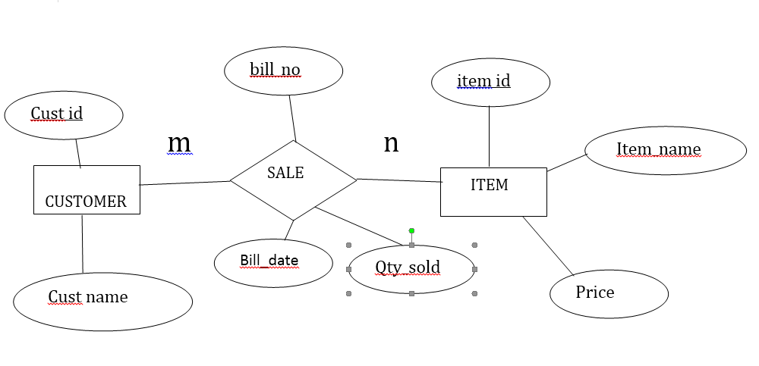

**Table Creation and insertion of data in table**

1. create table customer1 (cust_id number(5) primary key, cust_name varchar2(15));
2. desc customer1

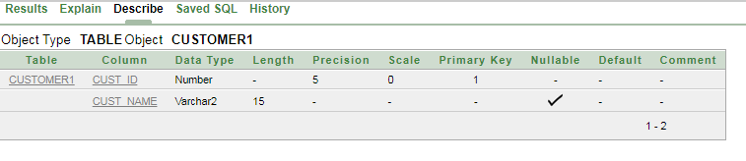

1. create table item(item_id number(4) primary key, item_name varchar2(15), price number);
2. create table sale(bill_no number(5) primary key,bill_date date, cust_id number(5) references customer1(cust_id), item_id number(4) references item(item_id),qty_sold number(4));
3. desc customer1;

Name                               Null?             Type

CUST_ID                         NOT NULL     NUMBER(5)

CUST_NAME                                               VARCHAR2(15)

5. dsec item;

 Name                                 Null?              Type

Cust_id                                NOT NULL        NUMBER(4)

Item_name                                                        VARCHAR2(15)

PRICE                                                                NUMBER(6,2)

6. dsec sale;

Name                             Null?                  Type

BILL_NO                    NOT NULL          NUMBER(4)

BILL_DATE                                          DATE

CUST_ID                                            NUMBER(5)

ITEM_ID                                            NUMBER(4)

QTY_SOLD                                         NUMBER(4)

7. insert into customer1 values(&custid,’&custname’);

/* insert 5 customer data */

8. select * from customer1;

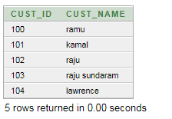

9. insert into item values(&item_id,’&item_name’,&price)

/* insert 5 rows */

10. select * from item;

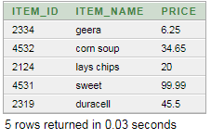

11. insert into Sale values(1450,to_date(‘04-Jan-2008’,’dd-mm-yyyy’),100,2124.2)

/* insert 5 rows */

to see the system date use command

select sysdate from dual

12. select * from sale;

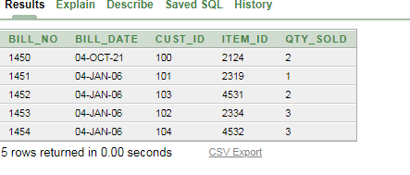

**QUERIES**

1. List all the bills for the current date with the customer names and item numbers

select c.cust_name, i.item_id, s.bill_no from customer1 c, item I, sale s

where c.cust_id=s.cust_id and s.bill_date=to_char(sysdate);

**CUST_NAME         ITEM_ID      BILL_NO**

John                  5001         332

2. List the total Bill details with the quantity sold, price of the item and the final amount.

select i.price,s.item_id, (i.price*s.qty_sold) as total from item I, sale s where i.item_id=s.item_id group by ( i.price ,s.item_id,s.qty_sold);

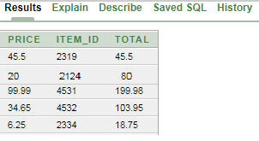

3. List the details of the customer who have bought a product which has a price>200

select c.cust_id, c.cust_name from customer1 c, sale s, item i where i.price>50 and

c.cust_id=s.cust_id and i.item_id=s.item_id;

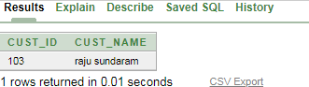

4. Give a count of how many products have been bought by each customer

sselect cust_id, count(item_id) from sale group by cust_id;

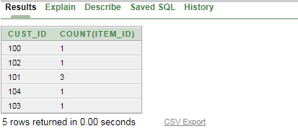

5. Give a list of products bought by a customer having cust_id as 5

select i.item_name from item i, sale s where s.cust_id=101 and i.item_id=s.item_id;

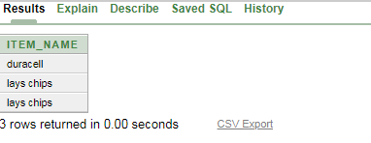

6. List the item details which are sold as of today

select i.item_id, i.item_name from item I, sale s where i.item_id=s.item_id and s.bill_date=to_char(sysdate);

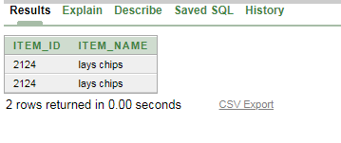

7. Create a view which lists out the bill_no, bill_date, cust_id, item_id, price, qty_sold, amount

create view cust as (select s.bill_no, s.bill_date, c.cust_id, i.item_id, i.price, s.qty_sold from customer1 c,sale s, item i where c.cust_id=s.cust_id and i.item_id=s.item_id);

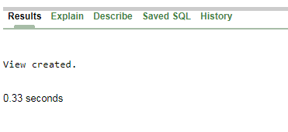

select * from cust;

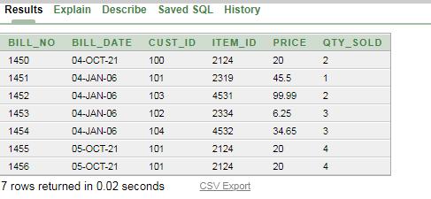

| **2** | **Consider the following schema for a Library Database:**  BOOK(Book_id, Title, Publisher_Name, Pub_Year)  BOOK_AUTHORS(Book_id, Author_Name)  PUBLISHER(Name, Address, Phone)  BOOK_COPIES(Book_id, Programme_id, No-of_Copies)  BOOK_LENDING(Book_id, Programme_id, Card_No, Date_Out, Due_Date)  LIBRARY_BRANCH (Programme_id, Programme_Name, Address)  Write SQL queries to   1. Retrieve details of all books in the library – id, title, name of publisher, authors, number of copies in each Programme, etc. 2. Get the particulars of borrowers who have borrowed more than 3 books, but from Jan 2017 to Jun 2017 3. Delete a book in BOOK table. Update the contents of other tables to reflect this data manipulation operation. 4. Partition the BOOK table based on year of publication. Demonstrate its working with a simple query. 5. Create a view of all books and its number of copies that are currently available in the Library. |
| --- | --- |

ER Diagram 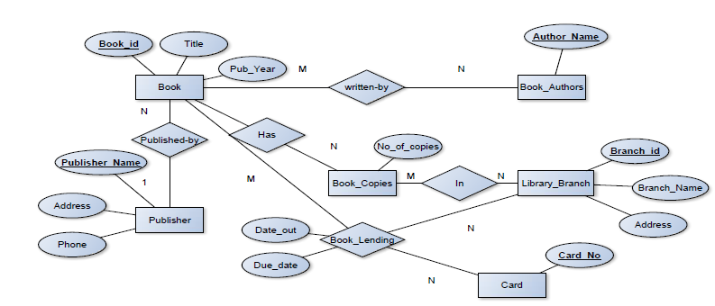

Schema Diagram

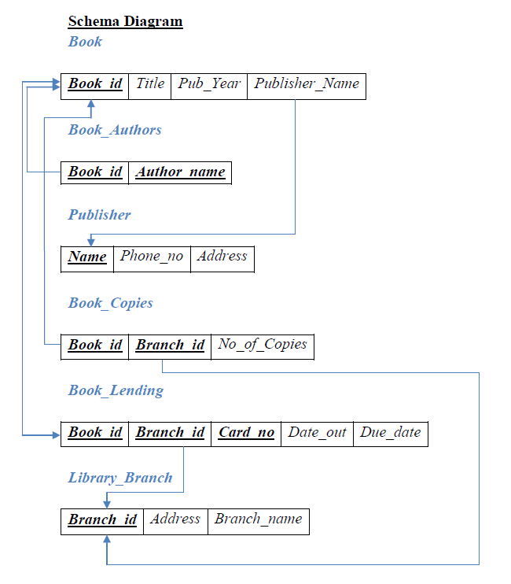

Table Creation

1. CREATE TABLE PUBLISHER

(NAME VARCHAR2 (20) PRIMARY KEY, PHONE INTEGER, ADDRESS VARCHAR2 (20));

2. CREATE TABLE BOOK

(BOOK_ID INTEGER PRIMARY KEY, TITLE VARCHAR2 (20), PUB_YEAR VARCHAR2 (20), PUBLISHER_NAME REFERENCES PUBLISHER (NAME) ON DELETE CASCADE);

3. CREATE TABLE BOOK_AUTHORS

(AUTHOR_NAME VARCHAR2 (20), BOOK_ID REFERENCES BOOK (BOOK_ID) ON DELETE CASCADE, PRIMARY KEY (BOOK_ID, AUTHOR_NAME));

4. CREATE TABLE LIBRARY_BRANCH

(BRANCH_ID INTEGER PRIMARY KEY, BRANCH_NAME VARCHAR2 (50),

ADDRESS VARCHAR2 (50));

5. CREATE TABLE BOOK_COPIES

(NO_OF_COPIES INTEGER, BOOK_ID REFERENCES BOOK (BOOK_ID) ON DELETE CASCADE, BRANCH_ID REFERENCES LIBRARY_BRANCH (BRANCH_ID) ON DELETE CASCADE, PRIMARY KEY (BOOK_ID, BRANCH_ID));

6. CREATE TABLE CARD

(CARD_NO INTEGER PRIMARY KEY);

7. CREATE TABLE BOOK_LENDING

(DATE_OUT DATE, DUE_DATE DATE, BOOK_ID REFERENCES BOOK (BOOK_ID) ON DELETE CASCADE,

BRANCH_ID REFERENCES LIBRARY_BRANCH (BRANCH_ID) ON DELETE CASCADE,

CARD_NO REFERENCES CARD (CARD_NO) ON DELETE CASCADE, PRIMARY KEY (BOOK_ID, BRANCH_ID, CARD_NO));

Table Descriptions

DESC PUBLISHER;

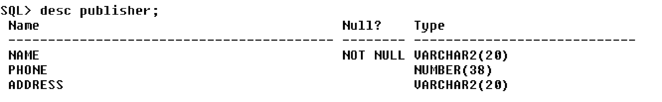

DESC BOOK; 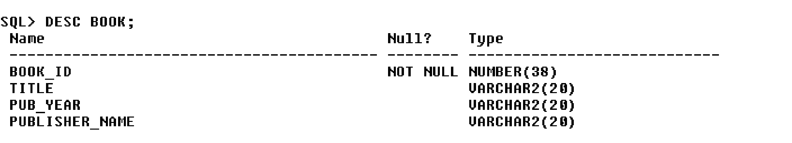

DESC BOOK_AUTHORS;

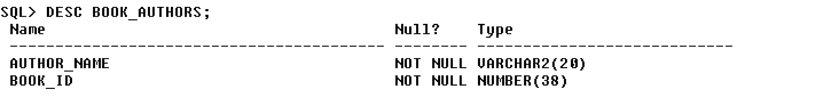

DESC LIBRARY_BRANCH;

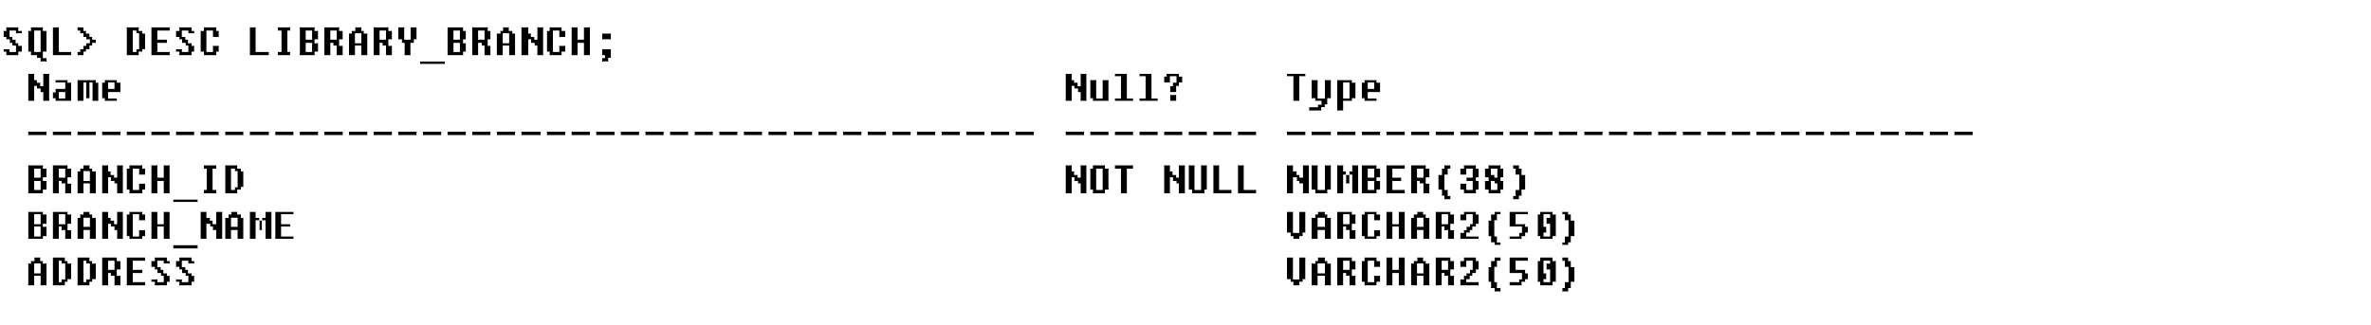

DESC BOOK_COPIES;

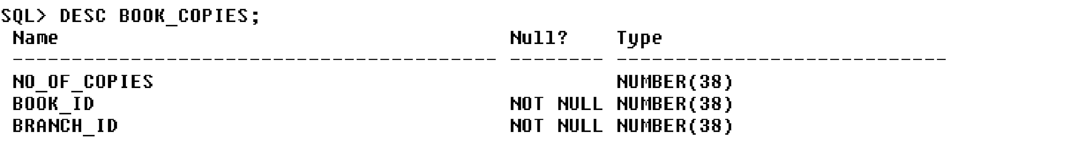

DESC CARD;

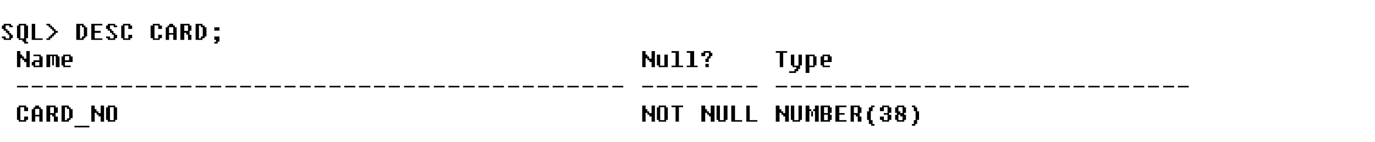

DESC BOOK_LENDING;

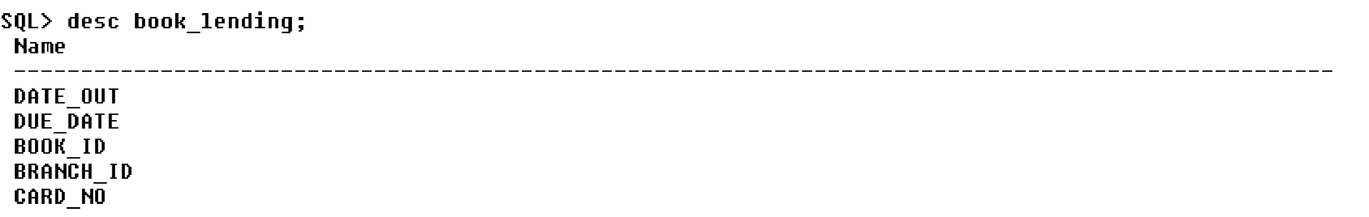

Insertion of Values to Tables

INSERT INTO PUBLISHER VALUES (‗MCGRAW-HILL‘, 9989076587, ‗BANGALORE‘);

INSERT INTO PUBLISHER VALUES (‗PEARSON‘, 9889076565, ‗NEWDELHI‘);

INSERT INTO PUBLISHER VALUES (‗RANDOM HOUSE‘, 7455679345, ‗HYDRABAD‘);

INSERT INTO PUBLISHER VALUES (‗HACHETTE LIVRE‘, 8970862340, ‗CHENAI‘);

INSERT INTO PUBLISHER VALUES (‗GRUPO PLANETA‘, 7756120238, ‗BANGALORE‘);

INSERT INTO BOOK VALUES (1,‘DBMS‘,‘JAN-2017‘, ‗MCGRAW-HILL‘);

INSERT INTO BOOK VALUES (2,‘ADBMS‘,‘JUN-2016‘, ‗MCGRAW-HILL‘);

INSERT INTO BOOK VALUES (3,‘CN‘,‘SEP-2016‘, ‗PEARSON‘);

INSERT INTO BOOK VALUES (4,‘CG‘,‘SEP-2015‘, ‗GRUPO PLANETA‘);

INSERT INTO BOOK VALUES (5,‘OS‘,‘MAY-2016‘, ‗PEARSON‘);

INSERT INTO BOOK_AUTHORS VALUES (‘NAVATHE‘, 1);

INSERT INTO BOOK_AUTHORS VALUES (‘NAVATHE‘, 2);

INSERT INTO BOOK_AUTHORS VALUES (‘TANENBAUM‘, 3);

INSERT INTO BOOK_AUTHORS VALUES (‘EDWARD ANGEL‘, 4);

INSERT INTO BOOK_AUTHORS VALUES (‘GALVIN‘, 5);

INSERT INTO LIBRARY_BRANCH VALUES (10,‘RR NAGAR‘,‘BANGALORE‘);

INSERT INTO LIBRARY_BRANCH VALUES (11,‘RNSIT‘,‘BANGALORE‘);

INSERT INTO LIBRARY_BRANCH VALUES (12,‘RAJAJI NAGAR‘, ‘BANGALORE‘);

INSERT INTO LIBRARY_BRANCH VALUES (13,‘NITTE‘,‘MANGALORE‘);

INSERT INTO LIBRARY_BRANCH VALUES (14,‘MANIPAL‘,‘UDUPI‘);

INSERT INTO BOOK_COPIES VALUES (10, 1, 10);

INSERT INTO BOOK_COPIES VALUES (5, 1, 11);

INSERT INTO BOOK_COPIES VALUES (2, 2, 12);

INSERT INTO BOOK_COPIES VALUES (5, 2, 13);

INSERT INTO BOOK_COPIES VALUES (7, 3, 14);

INSERT INTO BOOK_COPIES VALUES (1, 5, 10);

INSERT INTO BOOK_COPIES VALUES (3, 4, 11);

INSERT INTO CARD VALUES (100);

INSERT INTO CARD VALUES (101);

INSERT INTO CARD VALUES (102);

INSERT INTO CARD VALUES (103);

INSERT INTO CARD VALUES (104);

INSERT INTO BOOK_LENDING VALUES (‘01-JAN-17‘,‘01-JUN-17‘, 1, 10, 101);

INSERT INTO BOOK_LENDING VALUES (‘11-JAN-17‘,‘11-MAR-17‘, 3, 14, 101);

INSERT INTO BOOK_LENDING VALUES (‘21-FEB-17‘,‘21-APR-17‘, 2, 13, 101);

INSERT INTO BOOK_LENDING VALUES (‘15-MAR-17‘,‘15-JUL-17‘, 4, 11, 101);

INSERT INTO BOOK_LENDING VALUES (‗12-APR-17‘,‘12-MAY-17‘, 1, 11, 104);

SELECT * FROM PUBLISHER;

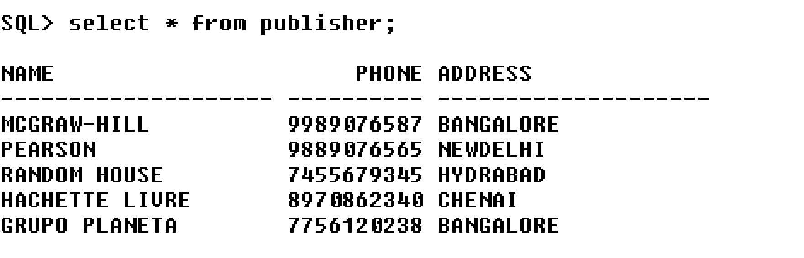

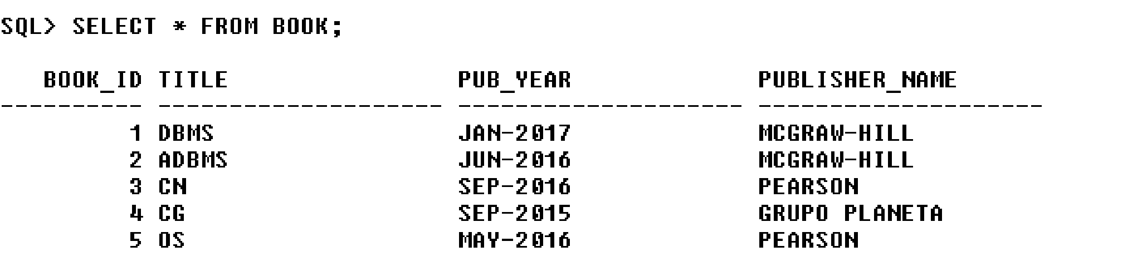

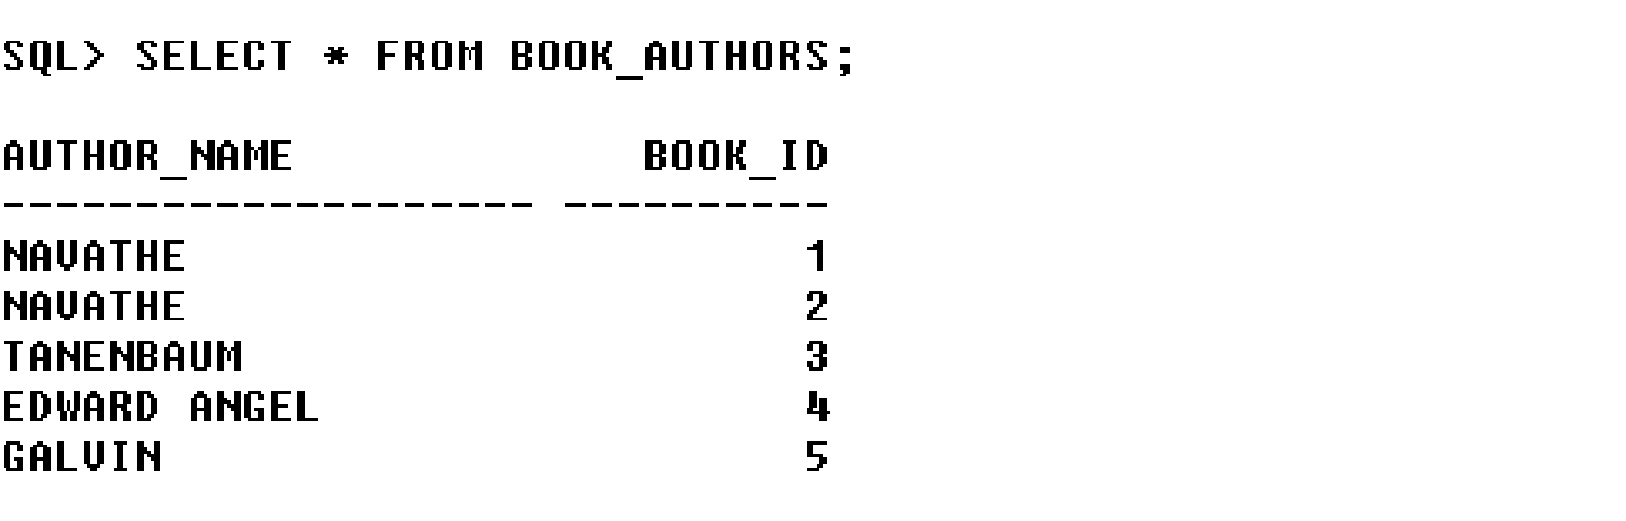

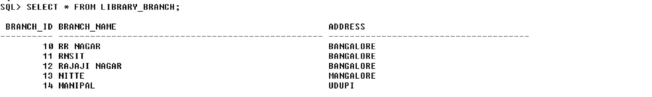

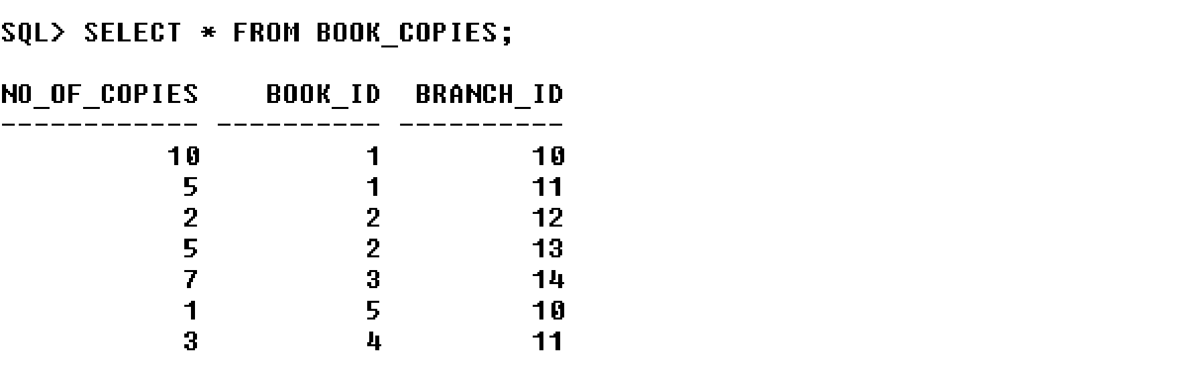

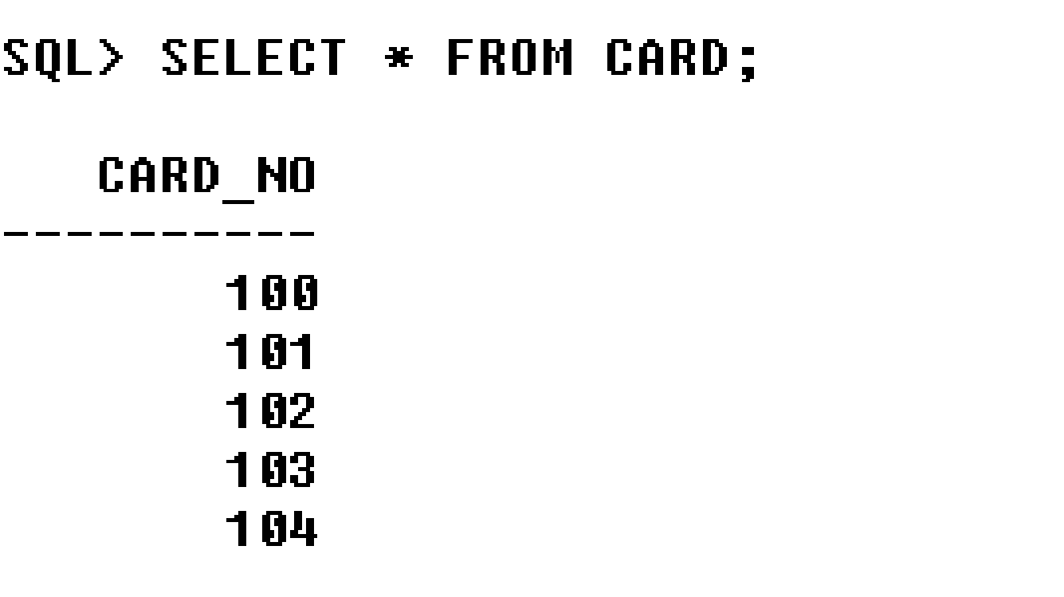

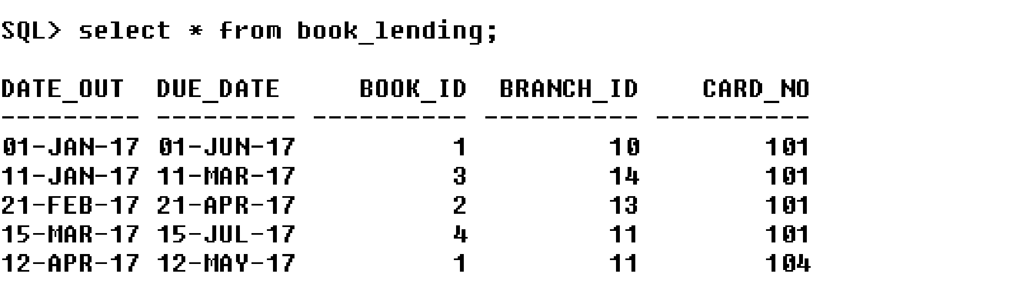

Queries:

1. Retrieve details of all books in the library – id, title, name of publisher, authors, number of copies in each branch, etc.

SELECT B.BOOK_ID, B.TITLE, B.PUBLISHER_NAME, A.AUTHOR_NAME, C.NO_OF_COPIES, L.BRANCH_ID FROM BOOK B, BOOK_AUTHORS A, BOOK_COPIES C, LIBRARY_BRANCH L

WHERE B.BOOK_ID=A.BOOK_ID AND B.BOOK_ID=C.BOOK_ID AND L.BRANCH_ID=C.BRANCH_ID;

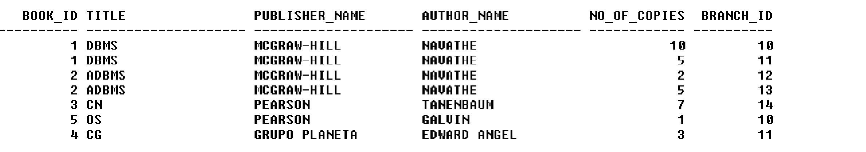

2. Get the particulars of borrowers who have borrowed more than 3 books, but from Jan 2017 to Jun 2017.

SELECT CARD_NO FROM BOOK_LENDING WHERE DATE_OUT BETWEEN ‘01-JAN-2017‘ AND ‘01-JUL-2017‘ GROUP BY CARD_NO HAVING COUNT (*)>3;

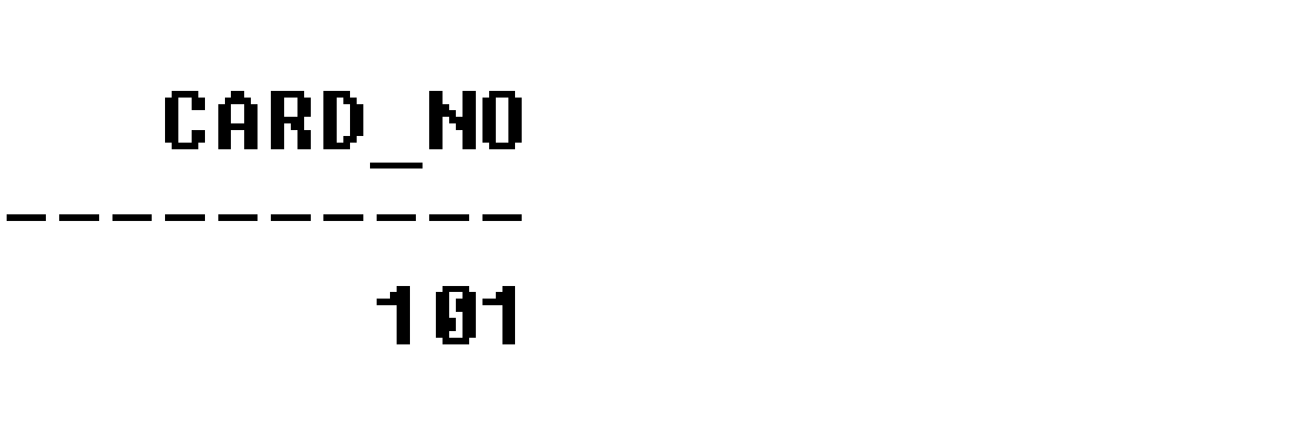

3. Delete a book in BOOK table. Update the contents of other tables to reflect this data manipulation operation.

DELETE FROM BOOK

WHERE BOOK_ID=3;

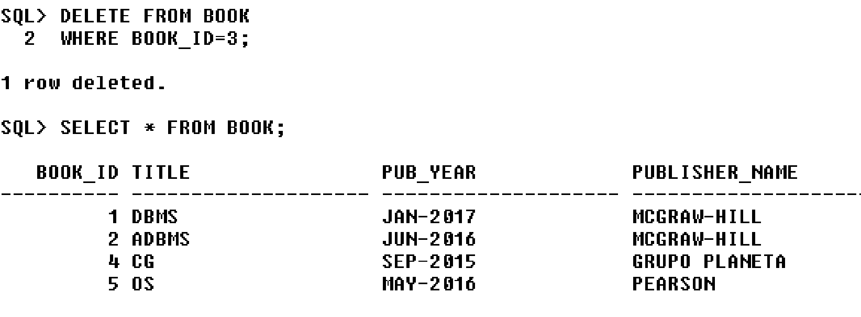

4. Partition the BOOK table based on year of publication. Demonstrate its working with a simple query.

CREATE VIEW V_PUBLICATION AS SELECT PUB_YEAR FROM BOOK;

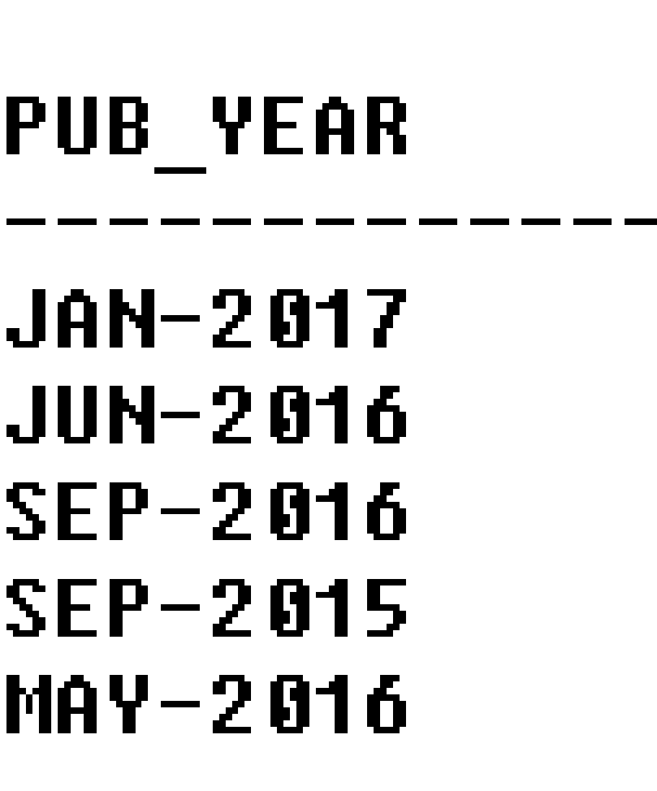

5. Create a view of all books and its number of copies that are currently available in the Library.

CREATE VIEW V_BOOKS AS SELECT B.BOOK_ID, B.TITLE, C.NO_OF_COPIES

FROM BOOK B, BOOK_COPIES C, LIBRARY_BRANCH L WHERE B.BOOK_ID=C.BOOK_ID

AND C.BRANCH_ID=L.BRANCH_ID;

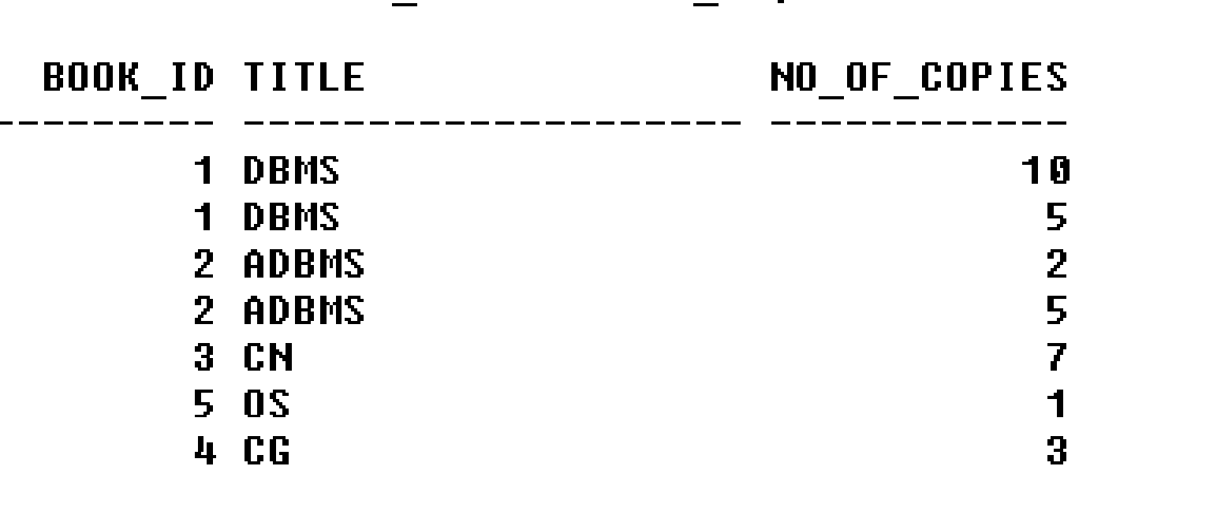

| **3** | **Consider the Employee-pay scenario given below.**  EMPLOYEE(**emp_id : integer**, emp_name: string)  DEPARTMENT(**dept_id: integer**, dept_name:string)  PAYDETAILS(**emp_id : integer**, **dept_id: integer**, basic: integer, deductions: integer, additions: integer, DOJ: date)  PAYROLL**(emp_id : integer**, pay_date: date)  For the above schema, perform the following:  a) Create the tables with the appropriate integrity constraints  b) Insert around 10 records in each of the tables  c) List the employee details department wise  d) List all the employee names who joined after particular date  e) List the details of employees whose basic salary is between 10,000 and 20,000  f) Give a count of how many employees are working in each department  g) Give a names of the employees whose netsalary>10,000  h) List the details for an employee_id=5  i) Create a view which lists out the emp_name, department, basic, dedeuctions, netsalary  j) Create a view which lists the emp_name and his netsalary |
| --- | --- |

1. create table employee(emp_id int(5) primary key,emp_name varchar2(25));
2. create table department(dept_id int(5) primary key,dept_name varchar2(20));
3. create table paydetails(emp_id int(5) references employee(emp_id),dept_id int(5) reerences department(dept_id),basic int(7,2),deductions int(5,2),additions int(5,2),doj date);
4. create table payroll(emp_id int(5)references employee(emp_id),pay_date date);
5. desc employee;

**Name                                      Null?     Type**

EMP_ID                                      NOT NULL          NUMBER(5)

EMP_NAME                                                         VARCHAR2(25)

6. desc department;

**Name                                Null?          Type**

DEPT_ID                           NOT NULL   NUMBER(5)

DEPT_NAME                                          VARCHAR2(20)

7. desc paydetails;

Name                                      Null?              Type

EMP_ID                                                      NUMBER(5)

DEPT_ID                                                  NUMBER(5)

BASIC                                                        NUMBER(7,2)

DEDUCTIONS                                        NUMBER(5,2)

ADDITIONS                                           NUMBER(5,2)

DOJ                                                            DATE

8. desc payroll;

**Name                                      Null?    Type**

EMP_ID                                               NUMBER(5)

PAY_DATE                                           DATE

9. insert into employee values(&emp_id,’&emp_name’);

/* insert 5 rows*/

select * from employee;

**EMP_ID          EMP_NAME**

10                 Robert

21                         Coulthard

30                  Fernando Alonso

39                  Kartikeyan

87                         Kimmi

10. insert  into department values(&dept_id,’&dept_name’);

/* insert 5 rows*/

select * from department;

**DEPT_ID                             DEPT_NAME**

100 sales

101 accounts

102 administration

103 production

104 supervisor

11. insert into paydeatils values(&emp_id,&dept_id, &basic,&deductions,&additions,&doj);

 /* insert 5 rows*/

select * from paydeatils;

 EMP_ID  DEPT_ID     BASIC    DEDUCTIONS     ADDITIONS   DOJ

10         101           25023.12    43.09            71.23        08-JAN-93

21          100            10500.29    23.98          40.9         01-JAN-06

30          102            6500.5        30.54             15         06-JUL-97

39          103            9700.45      32.78            65.09       08-AUG-03

87          104            15000         97.66           154.8       24-SEP-04

12. insert into payroll values(&emp_id,’&date’);

 /* insert 5 rows*/

 select * from payroll;

**EMP_ID            PAY_DATE**

10                     31-JAN-06

21                     03-FEB-06

30                     15-JAN-06

39                     27-JAN-06

87                     04-FEB-06

**QUERIES**

13. List all the employee names who joined after particular date

SQL**>**select e,empname from employee e,paydet p where e.empid=p.empid

and p.doj>=’05-mar-06’;

14. List the details of employees whose basic salary is between 10k and 20k

SQL>Select empid,empname  from employee where salary between 10kand 20k;

**select e.emp_id , e.emp_name,d.dept_id , d.dept_name , pd.basic from employee e , department d , paydetails pd , payroll pr where e.emp_id=pd.emp_id and d.dept_id=pd.dept_id and e.emp_id=pr.emp_id and pd.basic between 600 and 1000;**

15. Give a count of how many employees are working in each department

SQL>select count(empid),deptid from paydet group by deptid;

16. Give a names of the employees whose netsalary>10,000

SQL> select empname from employee where empid in(select empid from

paydet where basic-deduction>10000);

17. List the details for an employee_id=5

sql> select * from employee where empid=5;

18. Create a view which lists out the emp_name, department, basic, dedeuctions, netsalary

create view vw as select e.emp_name , d.dept_name , pd.basic,pd.deductions , (pd.basic+pd.additions-pd.deductions) netsalary from employee e, department d, paydetails pd,payroll pr where e.emp_id=pd.emp_id and d.dept_id=pd.dept_id and e.emp_id=pr.emp_id ;

To see the view

select * from vw ;

19. Create a view which lists the emp_name and his netsalary

create view vew as select e.emp_name , (pd.basic+pd.additions-pd.deductions) netsalary from employee e, department d, paydetails pd,payroll pr where e.emp_id=pd.emp_id and d.dept_id=pd.dept_id and e.emp_id=pr.emp_id ;

to see the view

select * from vew ;

| **4** | Consider the following relational schema for the Office of the Controller of Examinations Application.  Student (**Rollno, Name, Dob, Gender, Doa, Bcode**);  Implement a check constraint for Gender  Branch (**Bcode, Bname, Dno**);  Department (**Dno, Dname**);  Course (**Ccode, Cname, Credits, Dno**);  Branch_Course (**Bcode, Ccode, Semester**);  Enrolls (**Rollno, Ccode, Sess, Grade**);  For Example,SESS can take values **‘MAY2019’, ‘DEC2019’**  Implement a check constraint for grade Value Set **(‘S’, ‘A’, ‘B’, ‘C’, ‘D’, ‘E’, ‘U’ );**Students are admitted to Branches and they are offered by Departments. A branch is offered by only one department.Each branch has a set of Courses (Subjects). Each student must enroll during a semester. Courses are offered by Departments. A course is offered only by one department. If a student is unsuccessful in a course he/she must enroll for the course during next session. A student has successfully completed a course if the grade obtained by is from the list**(A, B, C, D, and E).**A student is unsuccessful if he/she have grade **‘U’** in a course.  *Primary Keys* are underlined.   1. Develop a SQL query to list details of Departments that offer more than 3 branches. 2. Develop a SQL query to list the details of Departments that offer more than 6 courses. 3. Develop a SQL query to list the details of courses that are common for more than 3 branches. 4. Develop a SQL query to list students who got ‘S’ in more than 2 courses during single enrollment. 5. Create a view that will keep track of the roll number, name and number of courses, a student has completed successfully. |
| --- | --- |

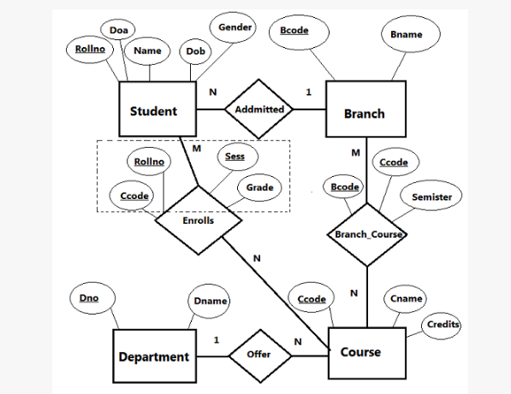

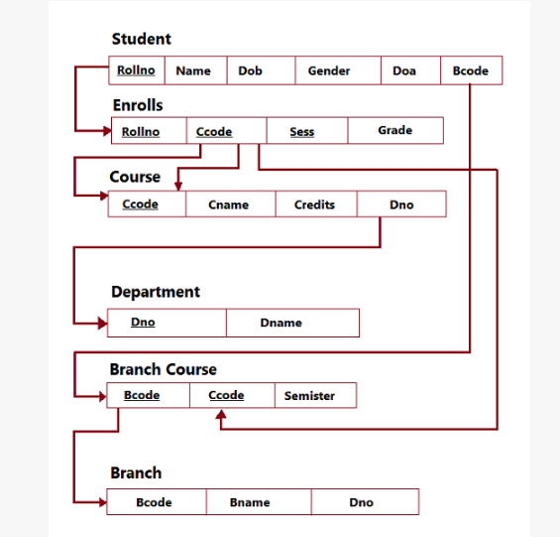

1. CREATE TABLE DEPARTMENT (DNO NUMBER (2), DNAME VARCHAR2 (20));

2. ALTER TABLE DEPARTMENT ADD PRIMARY KEY (DNO);

3. CREATE TABLE BRANCH (BCODE NUMBER (3), BNAME VARCHAR2 (25), DNO NUMBER (2));

4. ALTER TABLE BRANCH ADD PRIMARY KEY (BCODE);

5. ALTER TABLE BRANCH ADD FOREIGN KEY (DNO) REFERENCES DEPARTMENT (DNO);

6. CREATE TABLE BRANCH_COURSE (BCODE NUMBER(3),

CCODE NUMBER(4),

SEMESTER NUMBER(2));

7. ALTER TABLE BRANCH_COURSE ADD PRIMARY KEY (BCODE, CCODE);

8. ALTER TABLE BRANCH_COURSE ADD FOREIGN KEY (BCODE) REFERENCES BRANCH (BCODE);

9. ALTER TABLE BRANCH_COURSE ADD FOREIGN KEY (CCODE) REFERENCES COURSE (CCODE);

10. CREATE TABLE STUDENT (ROLLNO NUMBER (5),

NAME VARCHAR2 (20),

DOB DATE, GENDER CHAR(2),

DOA DATE, BCODE NUMBER(3));

11. ALTER TABLE STUDENT ADD PRIMARY KEY (ROLLNO);

ALTER TABLE STUDENT ADD FOREIGN KEY (BCODE) REFERENCES BRANCH (BCODE);

ALTER TABLE ADD CONSTRAINT CHK CHECK (GENDER IN ('M','F'));

ALTER TABLE ADD CONSTRAINT CHK2 CHECK (DOA < TO_DATE('31-4-2016,'DD-MM-YYYY');

12. CREATE TABLE COURSE (CCODE NUMBER (4), CNAME VARCHAR2 (25), CREDITS NUMBER (2), DNO NUMBER (2));

13. ALTER TABLE COURSE ADD PRIMARY KEY (CCODE);

14. ALTER TABLE COURSE ADD FOREIGN KEY (DNO) REFERENCES DEPARTMENT (DNO));

15. CREATE TABLE ENROLLS (ROLLNO NUMBER (5), CCODE NUMBER (4), SESS VARCHAR2 (15), GRADE CHAR (2));

16. ALTER TABLE ENROLLS ADD PRIMARY KEY (ROLLNO, CCODE, SESS);

17. ALTER TABLE ENROLLS ADD FOREIGN KEY ROLLNO) REFERENCES STUDENT

(ROLLNO);

18. ALTER TABLE ENROLLS ADD FOREIGN KEY (CCODE) REFERENCES COURSE (CCODE);

**Insert data into the Tables**

19. INSERT INTO COURSE VALUES (1011, 'LINEAR ALGEBRA', 2,1);

20. INSERT INTO STUDENT VALUES ( 12001, 'RAMESH KAUSHIK', TO_DATE( '3-4-1989',DD-MM-YYYY') ,'M' , TO_DATE( '24-4-2016','DD-MM-YYYY'), 110);

21. INSERT INTO ENROLLS VALUES( 12001, 1112, 'APRIL2013','D');

QUERIES

22. Develop a SQL query to list details of Departments that offer more than 3 branches.

SELECT * FROM DEPARTMENT D WHERE D.DNO IN (SELECT B.DNO FROM BRANCH B GROUP BY B.DNO HAVING COUNT (B.DNO) > 3);

23. Develop a SQL query to list the details of Departments that offer more than 6 courses.

SELECT * FROM DEPARTMENT D WHERE D.DNO IN (SELECT C.DNO FROM COURSE C GROUP BY C.DNO HAVING COUNT (C.CCODE) > 6);

24. Develop a SQL query to list the details of courses that are common for more than 3 branches.

SELECT * FROM COURSE C WHERE C.CCODE IN (SELECT B.CCODE FROM BRANCH_COURSE B GROUP BY B.CCODE HAVING COUNT (B.BCODE) > 3);

25. Develop a SQL query to list students who got ‘S’ in more than 2 courses during single enrollment.

SELECT * FROM STUDENT S WHERE S.ROLLNO IN (SELECT E.ROLLNO FROM ENROLLS E WHERE E.GRADE = 'S' GROUP BY E.ROLLNO HAVING COUNT (E.GRADE) > 2);

26. Create a view that will keep track of the roll number, name and number of courses, a student has completed successfully.

CREATE VIEW STUDATA AS SELECT E.ROLLNO, S.NAME, COUNT (E.CCODE) AS CC FROM STUDENT S, ENROLLS E WHERE E.ROLLNO = S.ROLLNO AND E.GRADE ! = 'U' GROUP BY E.ROLLNO, S.NAME;

**5. Consider the schema for Movie Database:**

ACTOR (Act_id, Act_Name, Act_Gender)

DIRECTOR (Dir_id, Dir_Name, Dir_Phone)

MOVIES (Mov_id, Mov_Title, Mov_Year, Mov_Lang, Dir_id)

MOVIE_CAST (Act_id, Mov_id, Role)

RATING (Mov_id, Rev_Stars)

Write SQL queries to

1. List the titles of all movies directed by ‘Hitchcock’.
2. Find the movie names where one or more actors acted in two or more movies.
3. List all actors who acted in a movie before 2000 and also in a movie after 2015 (use JOIN operation).
4. Find the title of movies and number of stars for each movie that has at least one rating and find the highest number of stars that movie received. Sort the result by movie title.

Update rating of all movies directed by ‘Steven Spielberg’ to 5.

ER Diagram

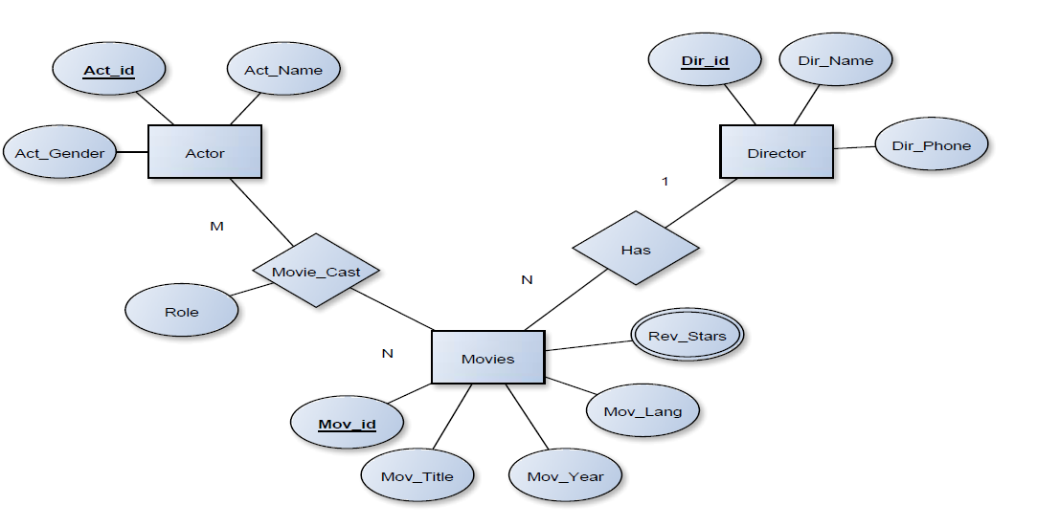

Schema Diagram

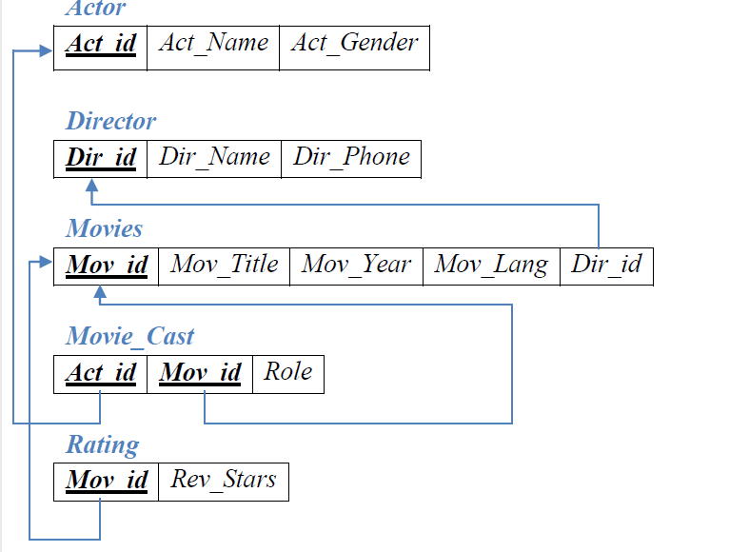

**Table Creation**

CREATE TABLE ACTOR (

ACT_ID NUMBER (3),

ACT_NAME VARCHAR (20),

ACT_GENDER CHAR (1),

PRIMARY KEY (ACT_ID));

CREATE TABLE DIRECTOR (

DIR_ID NUMBER (3),

DIR_NAME VARCHAR (20),

DIR_PHONE NUMBER (10),

PRIMARY KEY (DIR_ID));

CREATE TABLE MOVIES (

MOV_ID NUMBER (4),

MOV_TITLE VARCHAR (25),

MOV_YEAR NUMBER (4),

MOV_LANG VARCHAR (12),

DIR_ID NUMBER (3),

PRIMARY KEY (MOV_ID),

FOREIGN KEY (DIR_ID) REFERENCES DIRECTOR (DIR_ID));

CREATE TABLE MOVIE_CAST (

ACT_ID NUMBER (3),

MOV_ID NUMBER (4),

ROLE VARCHAR (10),

PRIMARY KEY (ACT_ID, MOV_ID),

FOREIGN KEY (ACT_ID) REFERENCES ACTOR (ACT_ID),

FOREIGN KEY (MOV_ID) REFERENCES MOVIES (MOV_ID));

CREATE TABLE RATING (

MOV_ID NUMBER (4),

REV_STARS VARCHAR (25),

PRIMARY KEY (MOV_ID),

FOREIGN KEY (MOV_ID) REFERENCES MOVIES (MOV_ID));

**Table Descriptions**

DESC ACTOR;

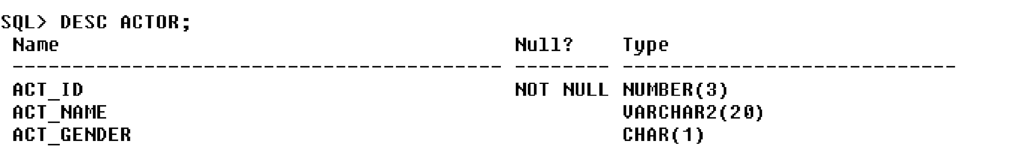

DESC DIRECTOR;

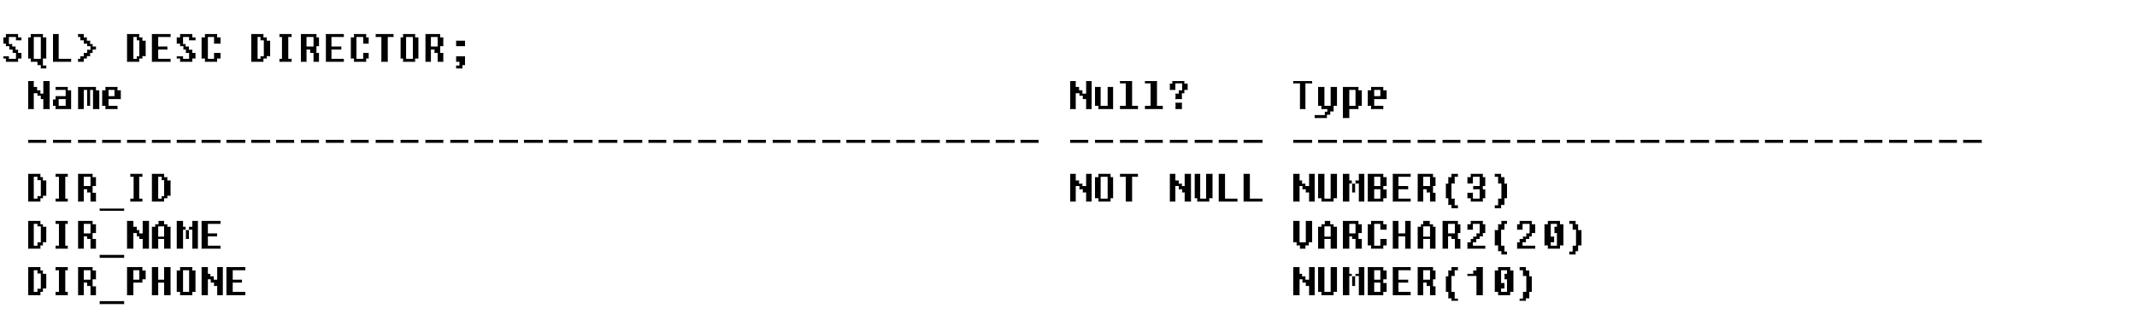

DESC MOVIES;

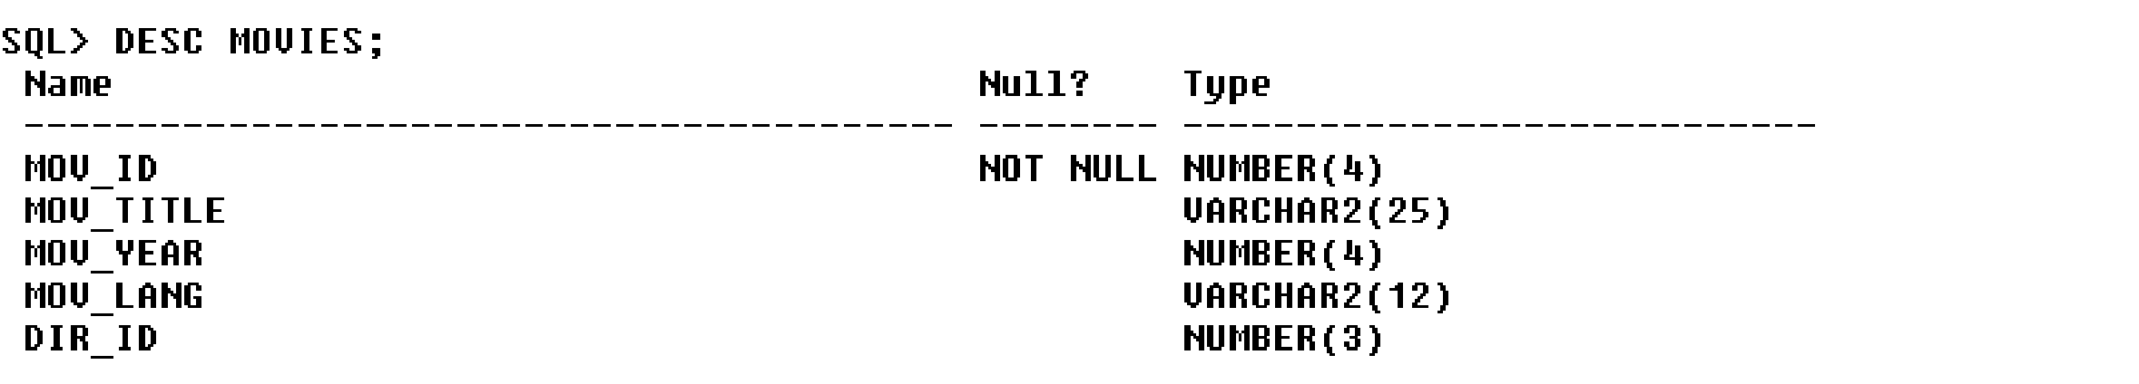

DESC MOVIE_CAST;

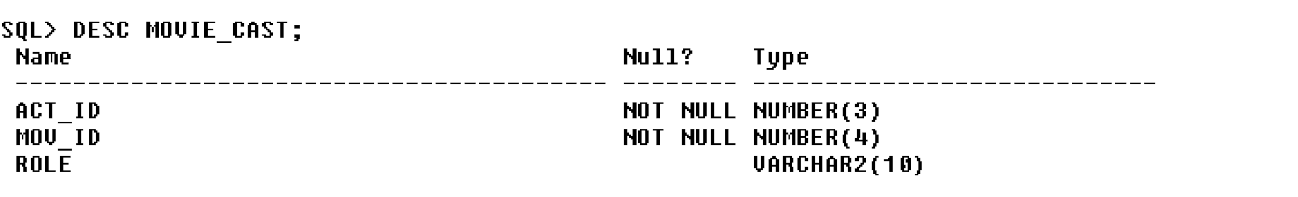

DESC RATING;

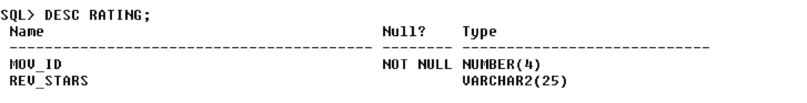

**Insertion of Values to Tables**

INSERT INTO ACTOR VALUES (301,‘ANUSHKA‘,‘F‘);

INSERT INTO ACTOR VALUES (302,‘PRABHAS‘,‘M‘);

INSERT INTO ACTOR VALUES (303,‘PUNITH‘,‘M‘);

INSERT INTO ACTOR VALUES (304,‘JERMY‘,‘M‘);

INSERT INTO DIRECTOR VALUES (60,‘RAJAMOULI‘, 8751611001);

INSERT INTO DIRECTOR VALUES (61,‘HITCHCOCK‘, 7766138911);

INSERT INTO DIRECTOR VALUES (62,‘FARAN‘, 9986776531);

INSERT INTO DIRECTOR VALUES (63,‘STEVEN SPIELBERG‘, 8989776530);

INSERT INTO MOVIES VALUES (1001,‘BAHUBALI-2‘, 2017, ‗TELAGU‘, 60);

INSERT INTO MOVIES VALUES (1002,‘BAHUBALI-1‘, 2015, ‗TELAGU‘, 60);

INSERT INTO MOVIES VALUES (1003,‘AKASH‘, 2008, ‗KANNADA‘, 61);

INSERT INTO MOVIES VALUES (1004,‘WAR HORSE‘, 2011, ‗ENGLISH‘, 63);

INSERT INTO MOVIE_CAST VALUES (301, 1002, ‗HEROINE‘);

INSERT INTO MOVIE_CAST VALUES (301, 1001, ‗HEROINE‘);

INSERT INTO MOVIE_CAST VALUES (303, 1003, ‗HERO‘);

INSERT INTO MOVIE_CAST VALUES (303, 1002, ‗GUEST‘);

INSERT INTO MOVIE_CAST VALUES (304, 1004, ‗HERO‘);

INSERT INTO RATING VALUES (1001, 4);

INSERT INTO RATING VALUES (1002, 2);

INSERT INTO RATING VALUES (1003, 5);

INSERT INTO RATING VALUES (1004, 4);

SELECT * FROM ACTOR;

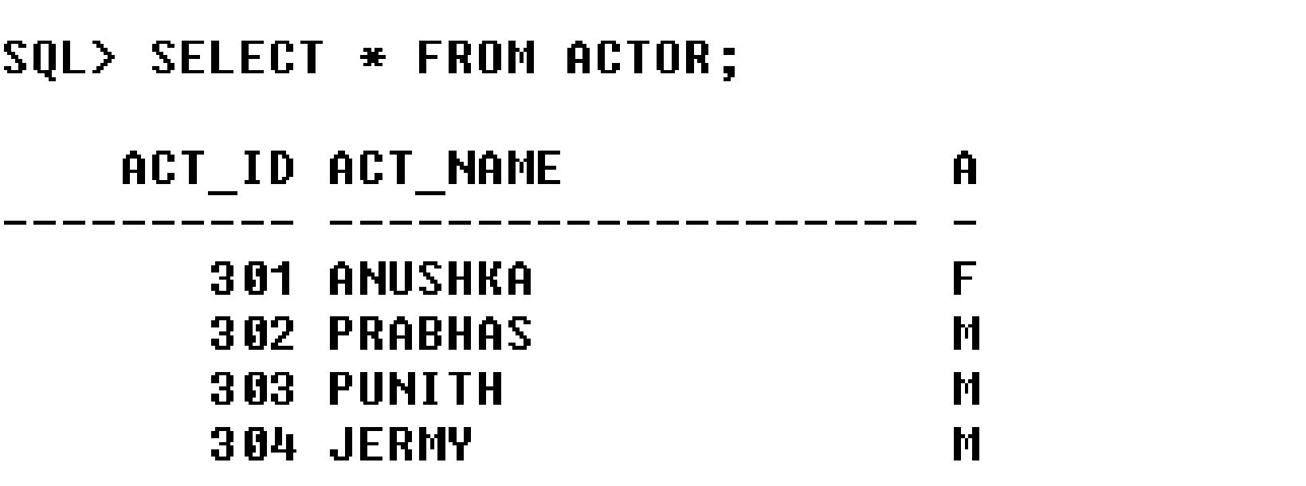

SELECT * FROM DIRECTOR;

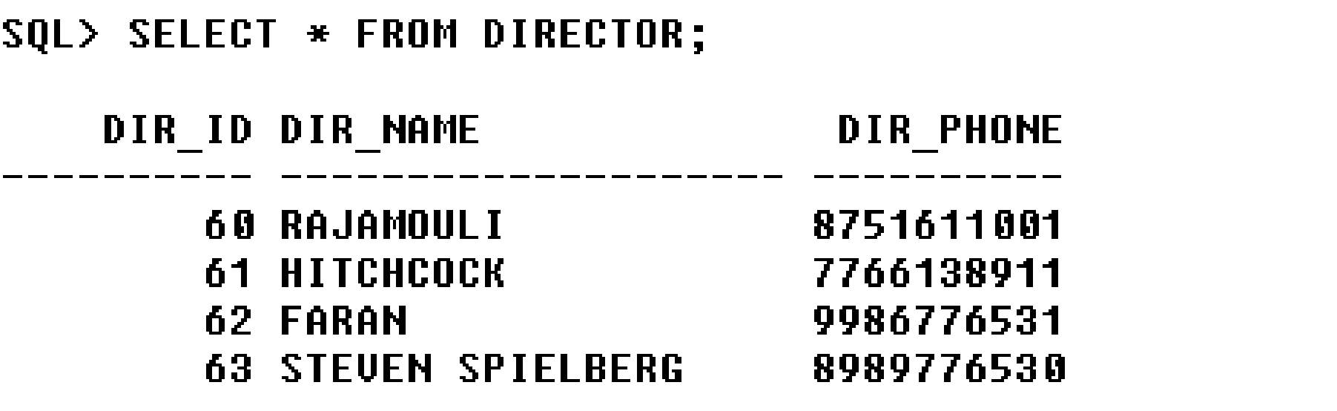

SELECT * FROM MOVIES;

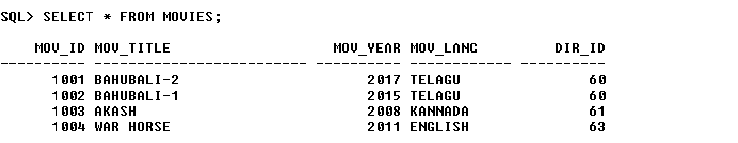

SELECT * FROM MOVIE_CAST;

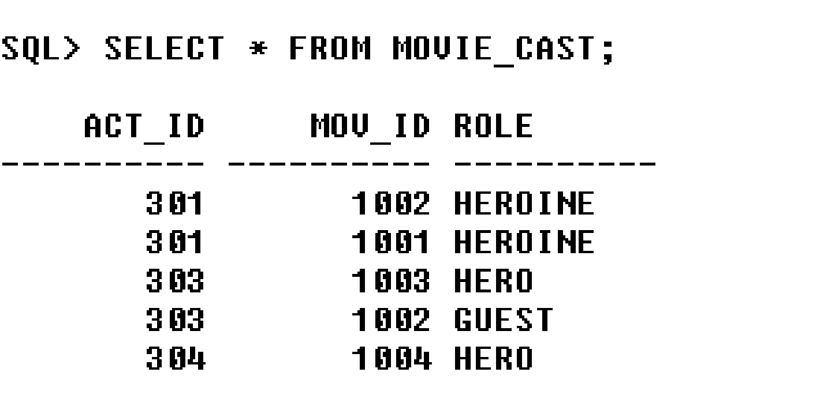

SELECT * FROM RATING;

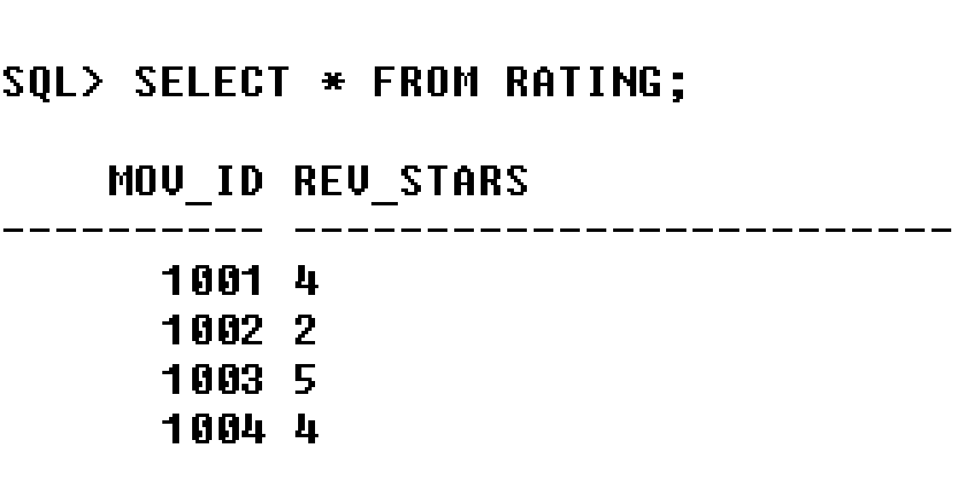

**Queries:**

**1. List the titles of all movies directed by ‘Hitchcock’.**

SELECT MOV_TITLE FROM MOVIES

WHERE DIR_ID IN (SELECT DIR_ID FROM DIRECTOR

WHERE DIR_NAME = ‗HITCHCOCK‘);



2. **Find the movie names where one or more actors acted in two or more movies.**

SELECT MOV_TITLE FROM MOVIES M, MOVIE_CAST MV

WHERE M.MOV_ID=MV.MOV_ID AND ACT_ID IN (SELECT ACT_ID

FROM MOVIE_CAST GROUP BY ACT_ID

HAVING COUNT (ACT_ID)>1)

GROUP BY MOV_TITLE

HAVING COUNT (*)>1;



3. **List all actors who acted in a movie before 2000 and also in a movie after 2015 (use JOIN operation).**

SELECT ACT_NAME, MOV_TITLE, MOV_YEAR FROM ACTOR A JOIN MOVIE_CAST C

ON A.ACT_ID=C.ACT_ID JOIN MOVIES M ON C.MOV_ID=M.MOV_ID

WHERE M.MOV_YEAR NOT BETWEEN 2000 AND 2015;

OR

SELECT A.ACT_NAME, A.ACT_NAME, C.MOV_TITLE, C.MOV_YEAR FROM ACTOR A, MOVIE_CAST B, MOVIES C WHERE A.ACT_ID=B.ACT_ID AND B.MOV_ID=C.MOV_ID AND C.MOV_YEAR NOT BETWEEN 2000 AND 2015;



4. **Find the title of movies and number of stars for each movie that has at least one rating and find the highest number of stars that movie received. Sort the result by movie title.**

SELECT MOV_TITLE, MAX (REV_STARS) FROM MOVIES INNER JOIN RATING USING (MOV_ID) GROUP BY MOV_TITLE HAVING MAX (REV_STARS)>0

ORDER BY MOV_TITLE;

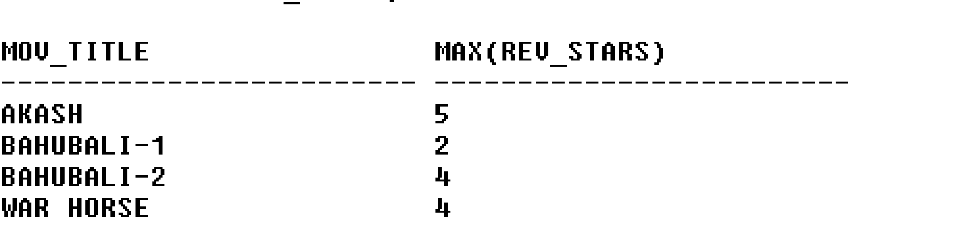

5. **Update rating of all movies directed by ‘Steven Spielberg’ to 5**

UPDATE RATING

SET REV_STARS=5

WHERE MOV_ID IN (SELECT MOV_ID FROM MOVIES

WHERE DIR_ID IN (SELECT DIR_ID

FROM DIRECTOR

WHERE DIR_NAME = ‗STEVEN SPIELBERG‘));

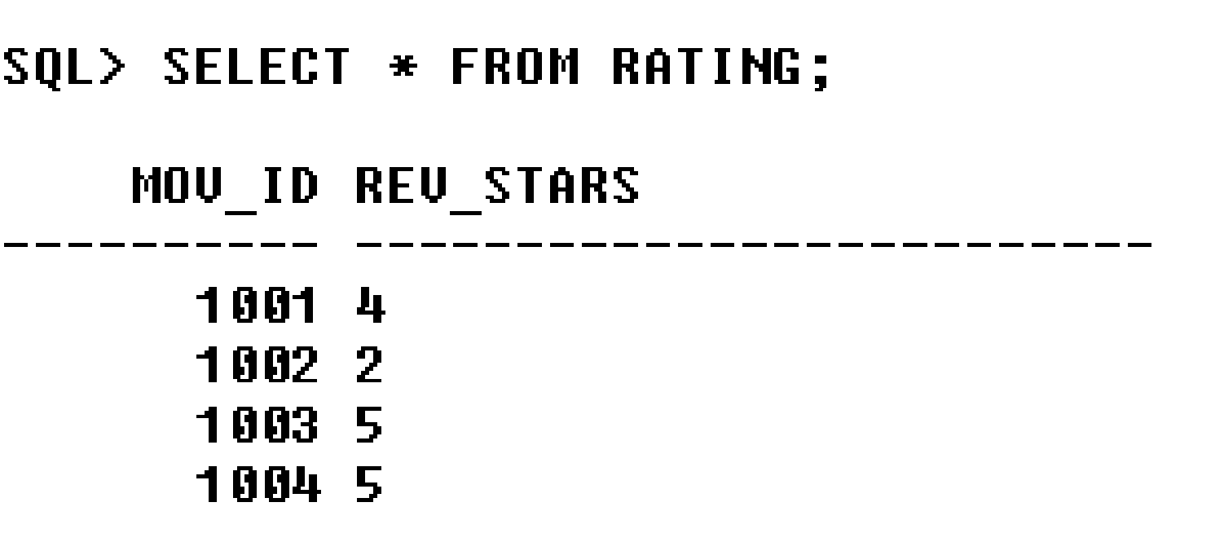

6. Demonstrate the CRUD operations on Mongodb database.

CRUD:

* Create Operations
* Read Operations
* Update Operations
* Delete Operations

**Create Operations**

Create or insert operations add new documents to a collection. If the collection does not currently exist, insert operations will create the collection.

MongoDB provides the following methods to insert documents into a collection:

db.collection.insertOne()

db.collection.insertMany()

In MongoDB, insert operations target a single collection. All write operations in MongoDB are atomic on the level of a single document.

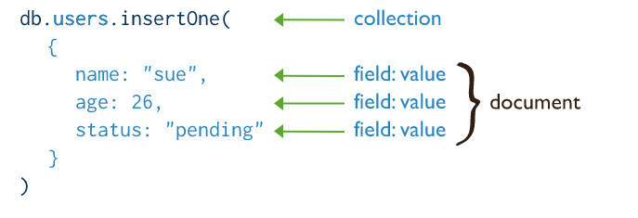

**Read Operations**

Read operations retrieve documents from a collection; i.e. query a collection for documents. MongoDB provides the following methods to read documents from a collection:

db.collection.find()

You can specify query filters or criteria that identify the documents to return.

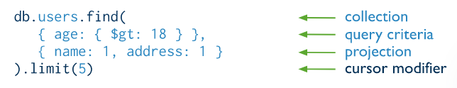

**Update Operations**

Update operations modify existing documents in a collection. MongoDB provides the following methods to update documents of a collection:

db.collection.updateOne() //New in version 3.2

db.collection.updateMany() // New in version 3.2

db.collection.replaceOne() //New in version 3.2

In MongoDB, update operations target a single collection. All write operations in MongoDB are atomic on the level of a single document.

You can specify criteria, or filters, that identify the documents to update. These filters use the same syntax as read operations.

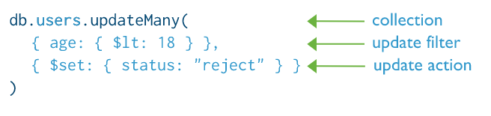

**Delete Operations**

Delete operations remove documents from a collection. MongoDB provides the following methods to delete documents of a collection:

db.collection.deleteOne() // New in version 3.2

db.collection.deleteMany() //New in version 3.2

In MongoDB, delete operations target a single collection. All write operations in MongoDB are atomic on the level of a single document.

one can specify criteria, or filters, that identify the documents to remove. These filters use the same syntax as read operations.

