DR
3dspace url is redirecting to 3dpassport DNS VIP/Remote Address:
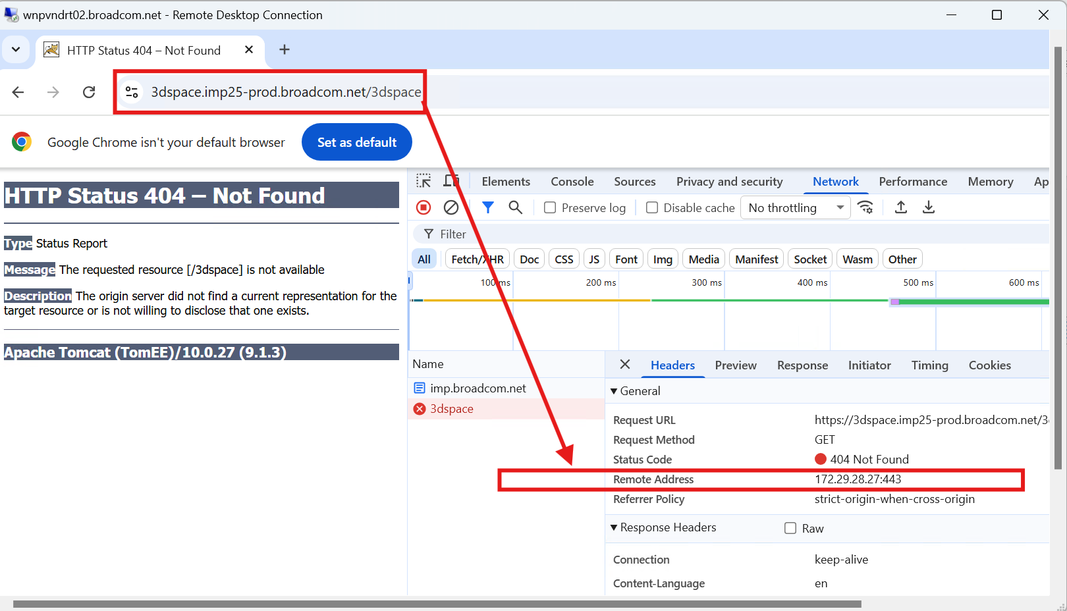

IMP PROD:
3dspace url is redirecting to 3dspace DNS VIP/Remote Address only:
