IMP 2025x UAT (& Prod): Breaking the IMP "Private" IP Security Model, & Other Oddities in Search
“Undefined String” issue analysis in IMP 2025x:

Dev25x
Corey | Likhith
MQL<6>print person cteffeta !history;  person cteffeta  email corey.teffetalor@broadcom.com  fullname Corey Teffetalor  phone +1 9703962071  fax  address 11900 Quantum Parkway  comment  password <RESTRICTED>  lattice eService Production  access all  type inactive,application,full  admin none  disable email  disable iconmail  assign group IMP_DTreeGroup  assign role ctx::VPLMProjectLeader.Broadcom Ltd.cteffeta_PRJ_ACCESS  assign role Grant.Broadcom Ltd.cteffeta_PRJ  assign role ctx::VPLMProjectLeader.Broadcom Ltd.IMP_IPSpace  assign role ctx::VPLMProjectLeader.APD.IMP_IPSpace  nothidden  property Company Key value 00000000000000000001  property IconMailLanguagePreference value kernel  property preference_Currency value Dollar  property preference_DefaultSecurityContext value VPLMProjectLeader.Broadcom Ltd.IMP_IPSpace  property preference_VPLMIntegVPLMContext value VPLMProjectLeader.Broadcom Ltd.IMP_IPSpace  created 12/14/2016 3:34:42 AM  modified 3/28/2025 7:29:13 AM | MQL<7>print person lk075732 !history;  person lk075732  email likhith.kommoju@broadcom.com  fullname Likhith Kommoju  phone +91 (79810) 64990  fax  address N/A  comment  password <NONE>  lattice eService Production  access all  type application,full  admin none  enable email  enable iconmail  assign group IMP_DTreeGroup  assign role ctx::VPLMProjectLeader.Broadcom Ltd.lk075732_PRJ_ACCESS  assign role Grant.Broadcom Ltd.lk075732_PRJ  assign role ctx::VPLMProjectLeader.Broadcom Ltd.IMP_IPSpace  assign role ctx::VPLMProjectLeader.APD.IMP_IPSpace  nothidden  property Company Key value 00000000000000000001  property MX_TABLEMENU_SELECTION value {"tableMenu":[],"selectedProgram":[]}  property preference_Currency value Dollar  property preference_DefaultSecurityContext value VPLMProjectLeader.APD.IMP_IPSpace  property preference_VPLMIntegVPLMContext value VPLMProjectLeader.APD.IMP_IPSpace  created 11/15/2024 6:09:44 AM  modified 7/9/2025 10:25:27 PM

ANA_FALCON Search Results:
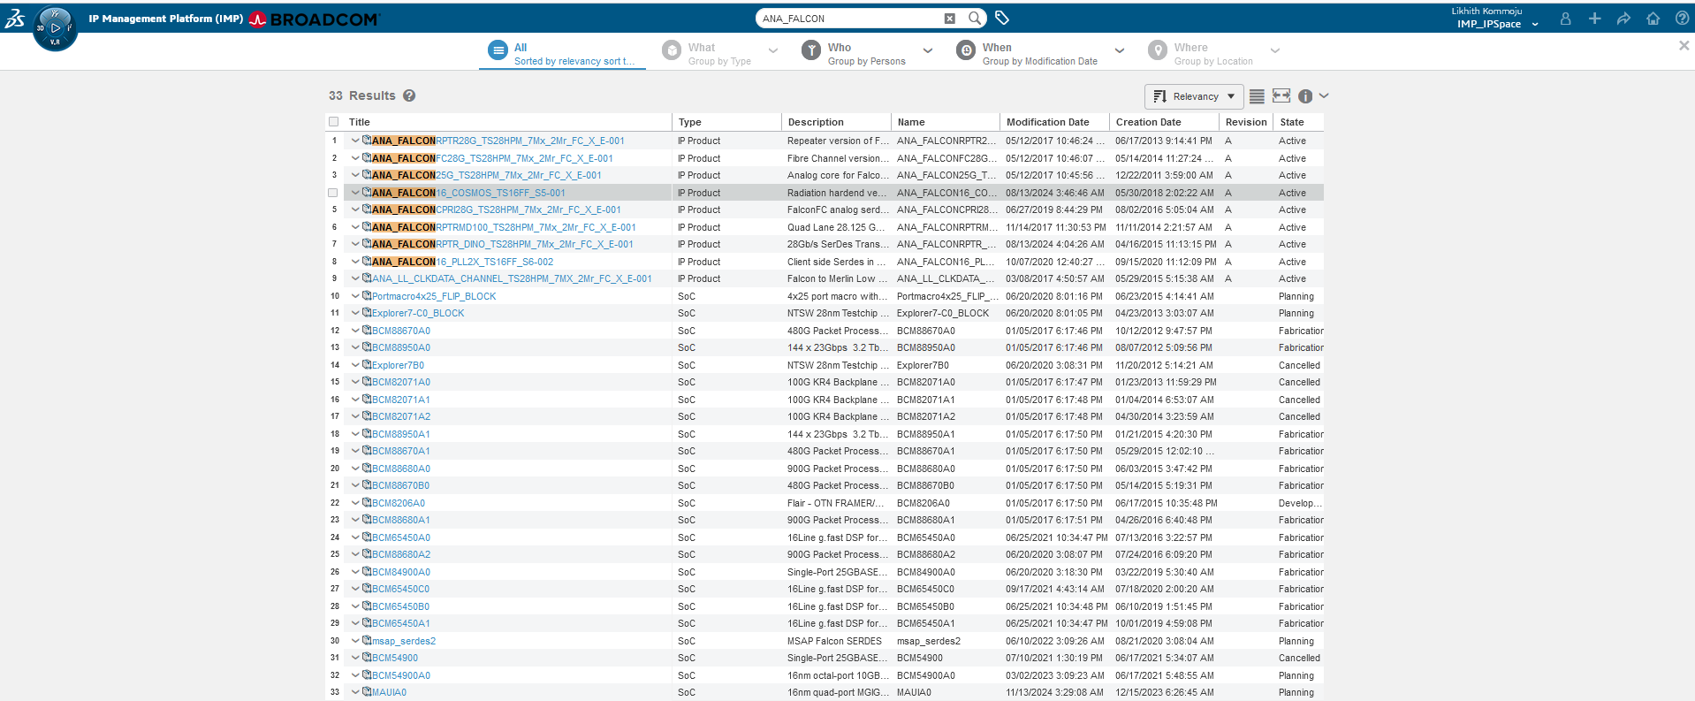

ANA_FALCON16_2X_TS16FFC_S6-001 Search Results:
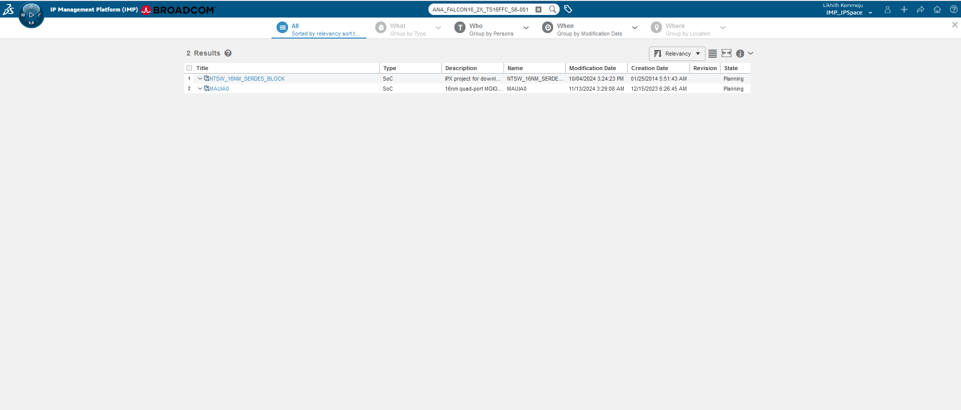

PQ: ANA_FALCON
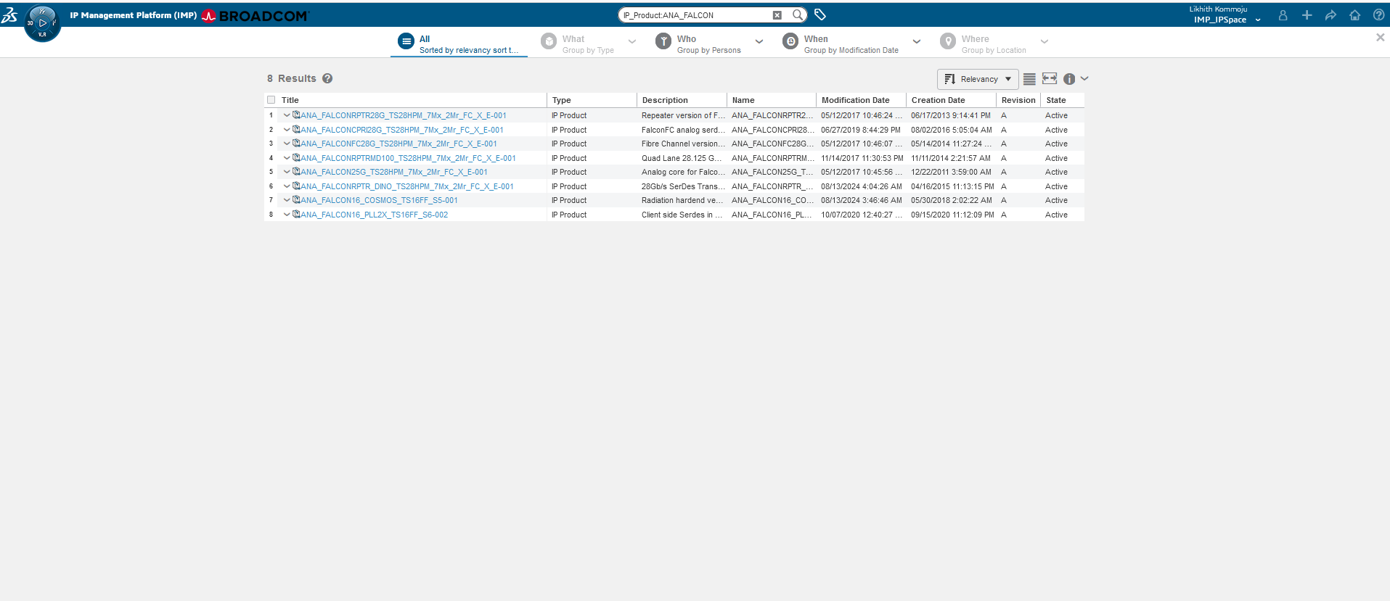

QA25x
Corey | Likhith
MQL<5>print person cteffeta !history;  person cteffeta  email corey.teffetalor@broadcom.com  fullname Corey Teffetalor  phone +1 9703962071  fax  address 11900 Quantum Parkway  comment  password <RESTRICTED>  lattice eService Production  access all  type application,full  admin none  enable email  enable iconmail  assign group IMP_DTreeGroup  assign role ctx::VPLMProjectLeader.Broadcom Ltd.cteffeta_PRJ_ACCESS  assign role Grant.Broadcom Ltd.cteffeta_PRJ  assign role ctx::VPLMProjectLeader.Broadcom Ltd.IMP_IPSpace  assign role ctx::VPLMProjectLeader.APD.IMP_IPSpace  nothidden  property Company Key value 00000000000000000001  property IconMailLanguagePreference value kernel  property preference_Currency value Dollar  property preference_DefaultSecurityContext value VPLMProjectLeader.Broadcom Ltd.IMP_IPSpace  property preference_VPLMIntegVPLMContext value VPLMProjectLeader.Broadcom Ltd.IMP_IPSpace  created 12/14/2016 3:34:42 AM  modified 6/18/2025 2:46:31 AM | MQL<6>print person lk075732 !history;  person lk075732  email likhith.kommoju@broadcom.com  fullname Likhith Kommoju  phone +91 (79810) 64990  fax  address N/A  comment  password <NONE>  lattice eService Production  access all  type application,full  admin none  enable email  enable iconmail  assign group IMP_DTreeGroup  assign role ctx::VPLMProjectLeader.Broadcom Ltd.lk075732_PRJ_ACCESS  assign role Grant.Broadcom Ltd.lk075732_PRJ  assign role ctx::VPLMProjectLeader.Broadcom Ltd.IMP_IPSpace  assign role ctx::VPLMProjectLeader.APD.IMP_IPSpace  nothidden  property Company Key value 00000000000000000001  property preference_Currency value Dollar  property preference_DefaultSecurityContext value VPLMProjectLeader.APD.IMP_IPSpace  property preference_VPLMIntegVPLMContext value VPLMProjectLeader.APD.IMP_IPSpace  created 11/15/2024 6:09:44 AM  modified 7/9/2025 2:42:38 AM

ANA_FALCON Search Results:
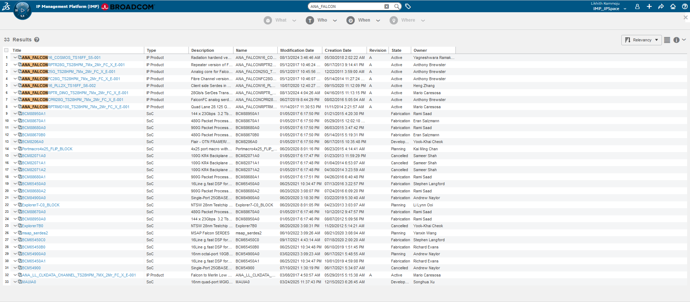

ANA_FALCON16_2X_TS16FFC_S6-001 Search Results:
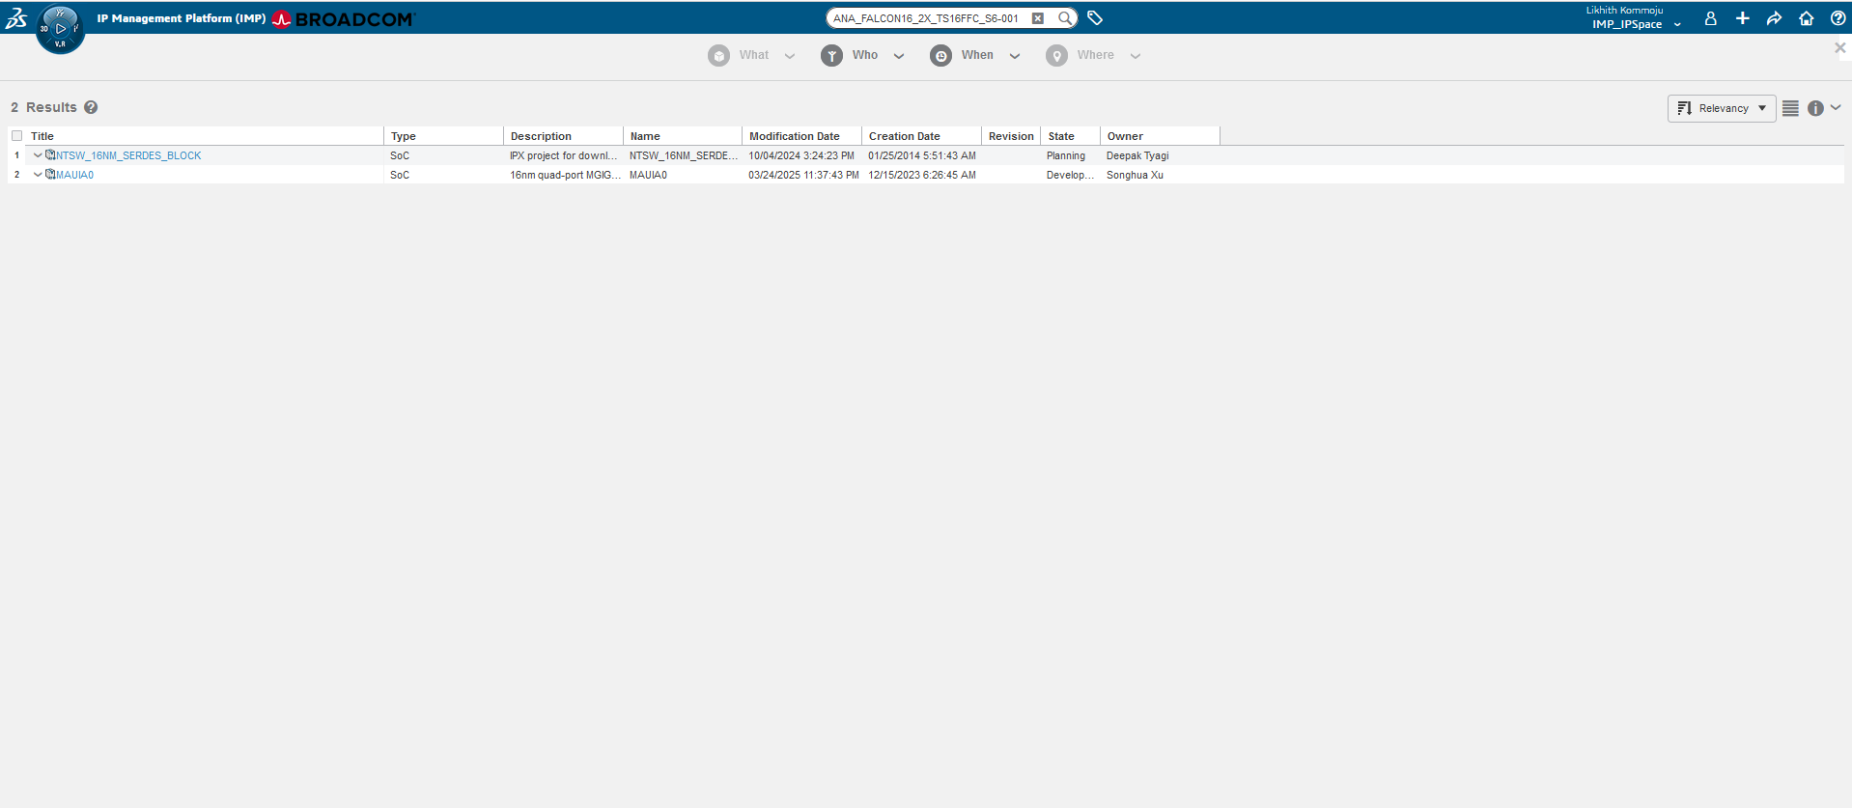

PQ : ANA_FALCON
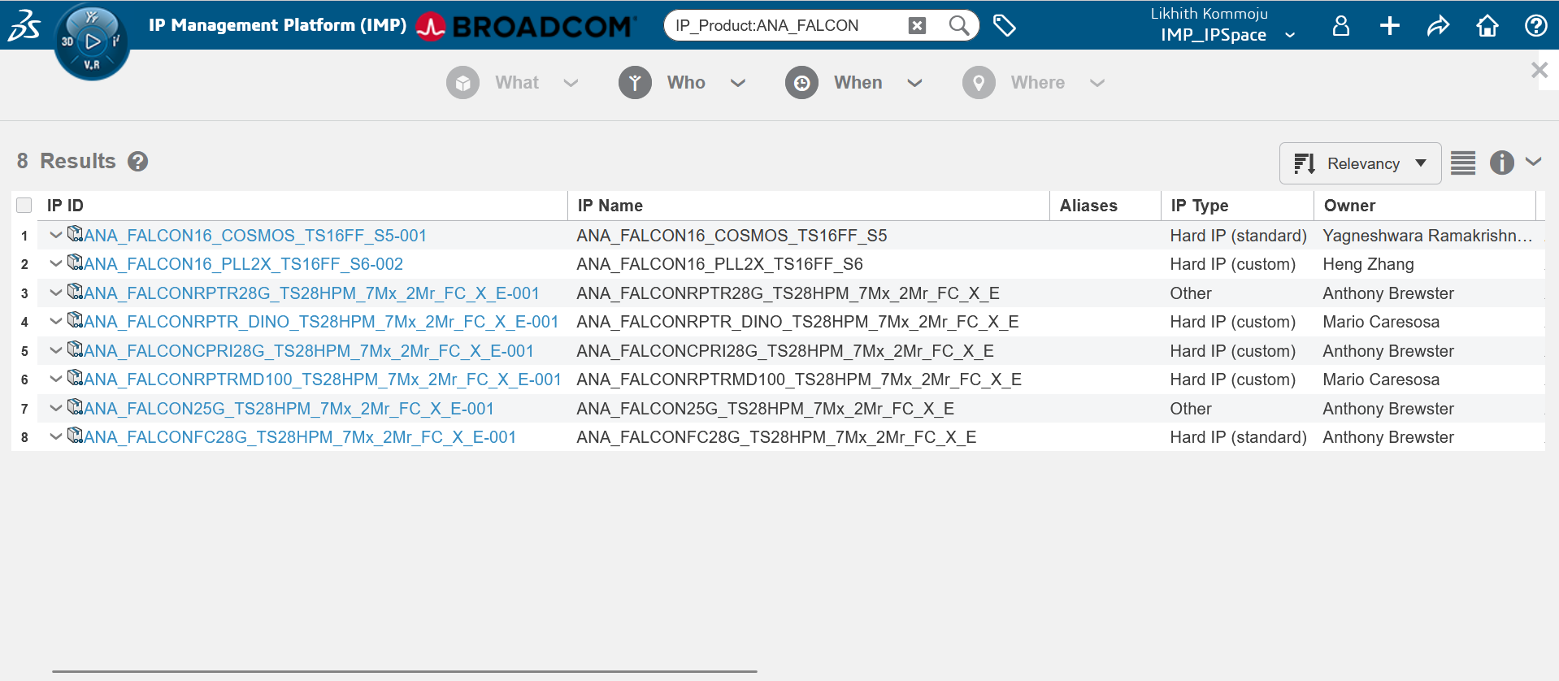

Observation in QA25X:
We found the “undefined” string bug in the search results while searching for Key “ANA_FALCON” only in datagrid view and in other views the undefined string is not displayed.

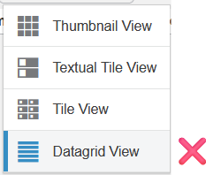

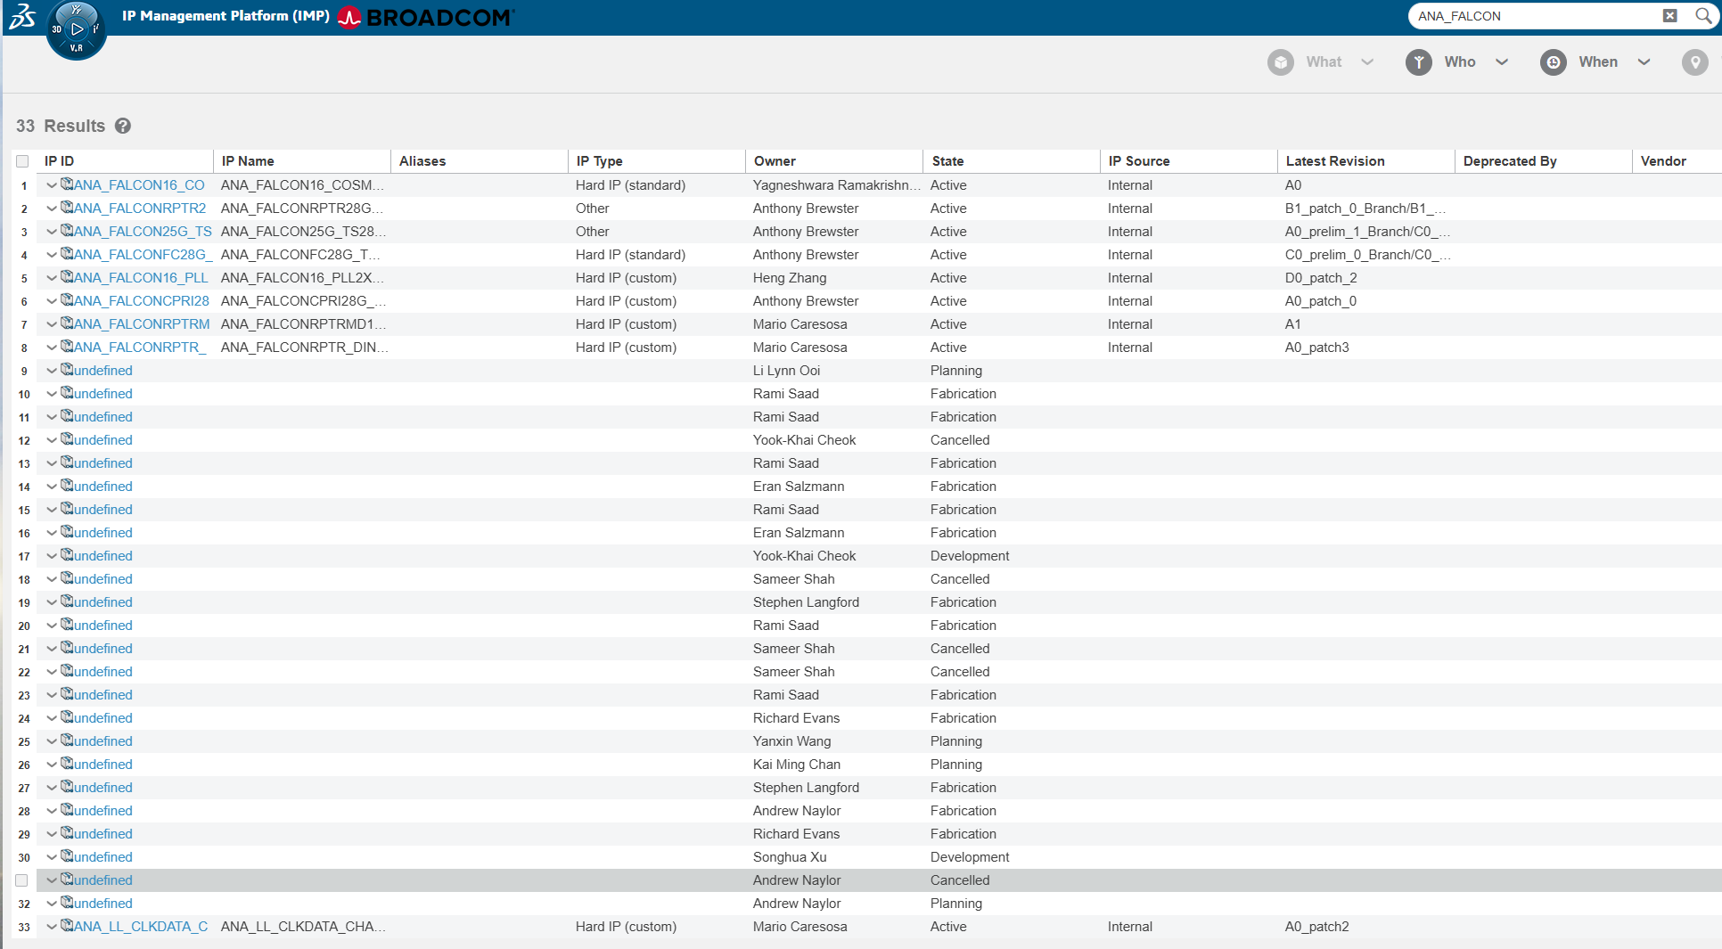

Resolution in QA25X:
We had re-ran full indexing in QA25x, the issue is fixed in the datagrid view.

PreProd25x
Corey | Likhith
MQL<5>print person cteffeta !history;  person cteffeta  email corey.teffetalor@broadcom.com  fullname Corey Teffetalor  phone +1 9703962071  fax  address 11900 Quantum Parkway  comment  password <RESTRICTED>  lattice eService Production  access all  type inactive,application,full  admin none  disable email  disable iconmail  assign group IMP_DTreeGroup  assign role ctx::VPLMProjectLeader.Broadcom Ltd.cteffeta_PRJ_ACCESS  assign role Grant.Broadcom Ltd.cteffeta_PRJ  assign role ctx::VPLMProjectLeader.Broadcom Ltd.IMP_IPSpace  assign role ctx::VPLMProjectLeader.APD.IMP_IPSpace  nothidden  property Company Key value 00000000000000000001  property IconMailLanguagePreference value kernel  property preference_Currency value Dollar  property preference_DefaultSecurityContext value VPLMProjectLeader.Broadcom Ltd.IMP_IPSpace  property preference_VPLMIntegVPLMContext value VPLMProjectLeader.Broadcom Ltd.IMP_IPSpace  created 12/14/2016 3:34:42 AM  modified 6/20/2025 3:48:12 AM | MQL<7>print person lk075732 !history;  person lk075732  email likhith.kommoju@broadcom.com  fullname Likhith Kommoju  phone +91 (79810) 64990  fax  address N/A  comment  password <NONE>  lattice eService Production  access all  type application,full  admin none  enable email  enable iconmail  assign group IMP_DTreeGroup  assign role ctx::VPLMProjectLeader.Broadcom Ltd.lk075732_PRJ_ACCESS  assign role Grant.Broadcom Ltd.lk075732_PRJ  assign role ctx::VPLMProjectLeader.Broadcom Ltd.IMP_IPSpace  assign role ctx::VPLMProjectLeader.APD.IMP_IPSpace  nothidden  property Company Key value 00000000000000000001  property preference_Currency value Dollar  property preference_DefaultSecurityContext value VPLMProjectLeader.APD.IMP_IPSpace  property preference_VPLMIntegVPLMContext value VPLMProjectLeader.APD.IMP_IPSpace  created 11/15/2024 6:09:44 AM  modified 7/10/2025 7:35:13 AM

ANA_FALCON Search Results:
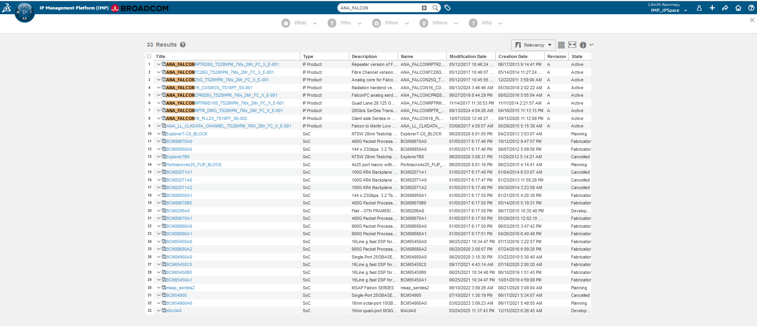

ANA_FALCON16_2X_TS16FFC_S6-001 Search Results:
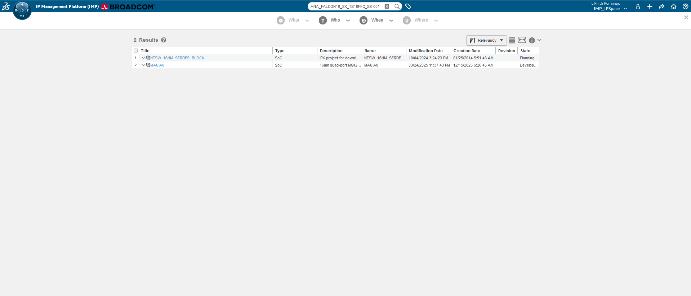

PQ: ANA_FALCON
