Pagination Dev Test Results:
Google Chrome Results:
1.Pagination by using DropDown for IP Verification:
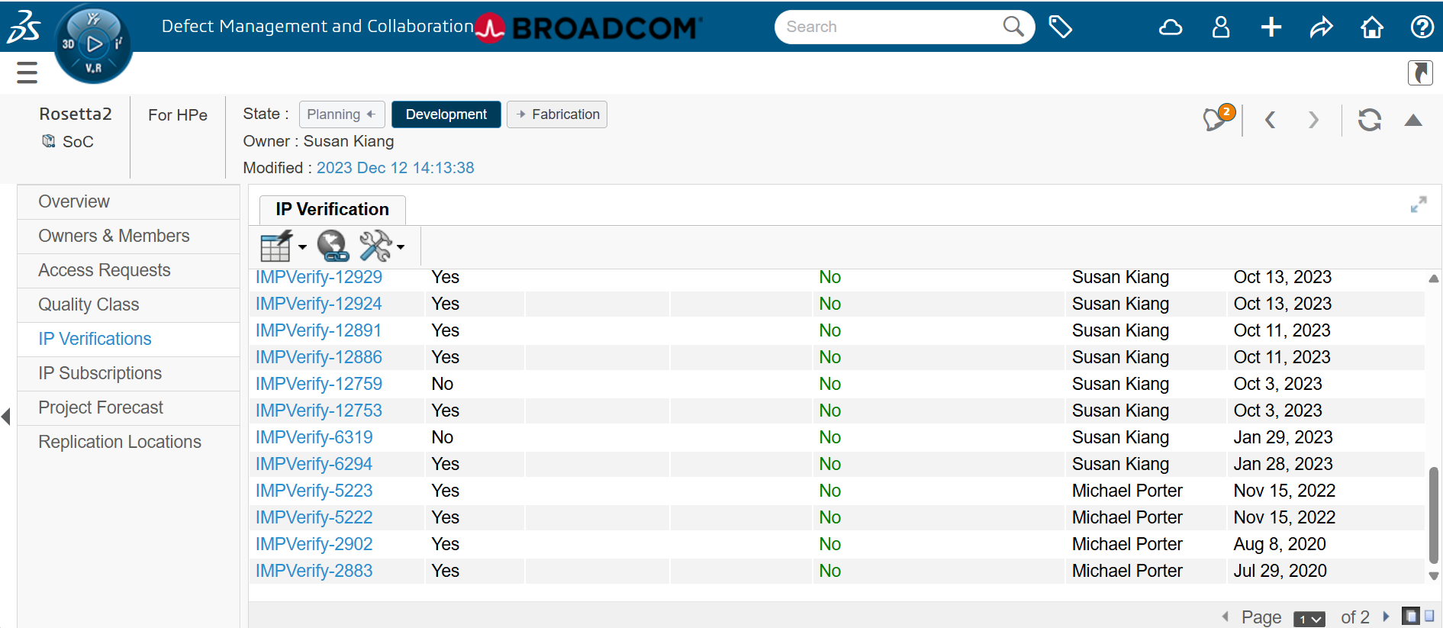

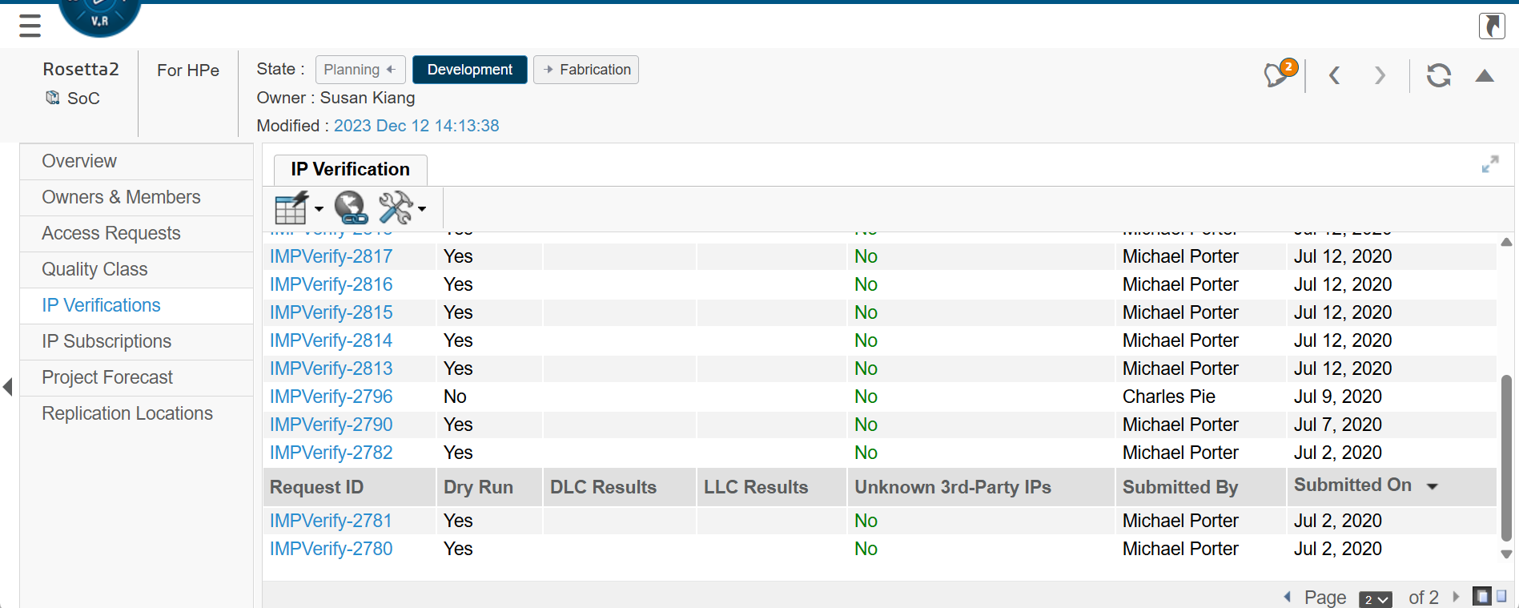

2.Pagination by using previous page / next page for IP Verification:




3. Pagination by using Pagination On/ Pagination Off
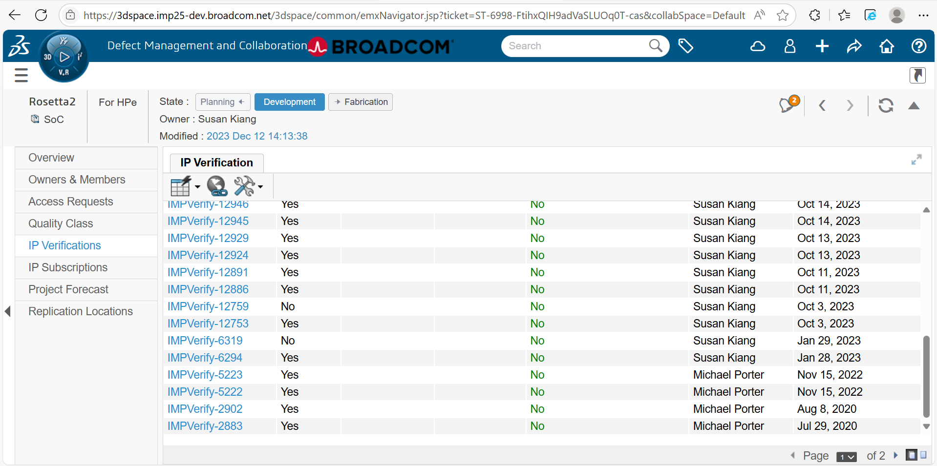

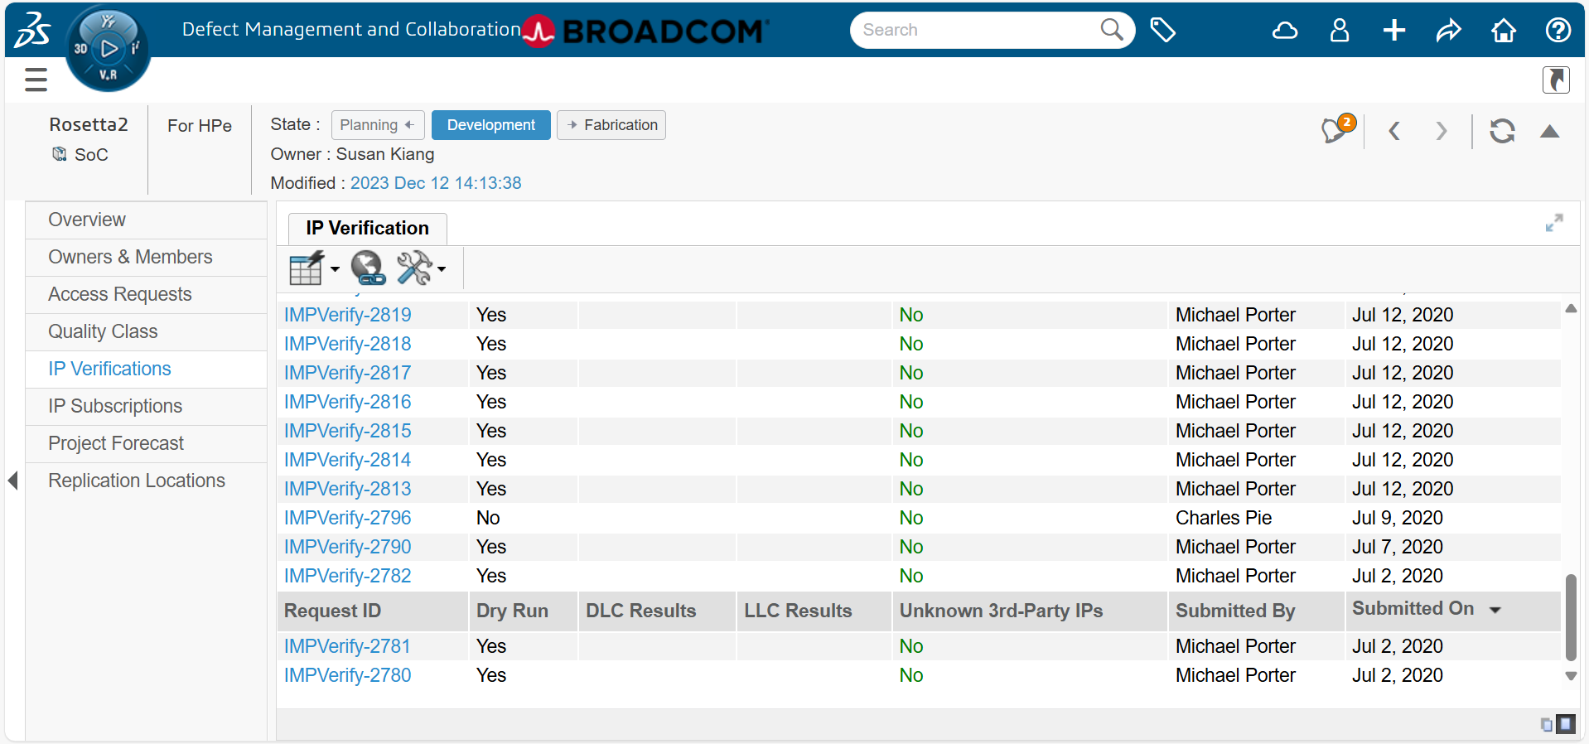

Open Issue in Chrome:
