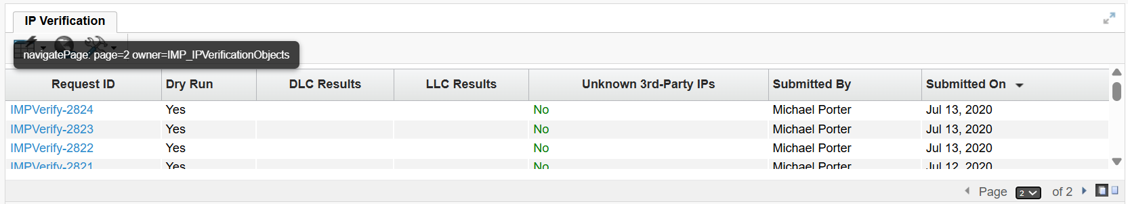

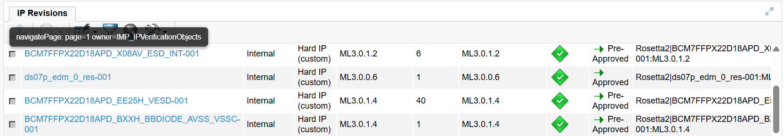

Pagination Findings: Firefox vs Chrome/Edge
Firefox is targeting correct frame for reload (OOTB & New Fix – is already working)
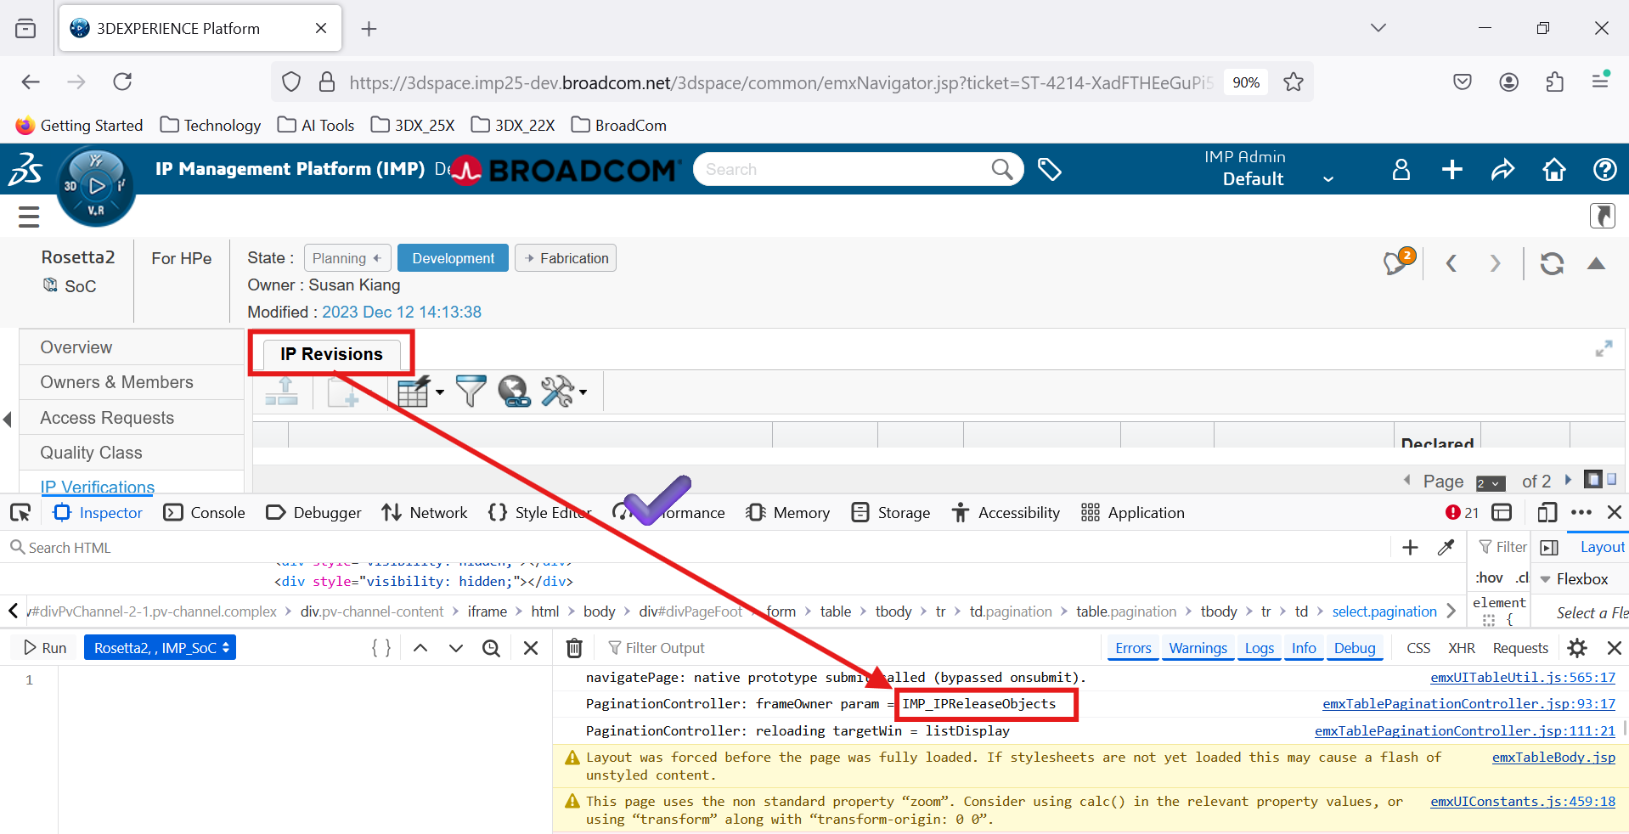

Chrome/Edge is targeting wrong frame for reload (OOTB & New Fix is not working)
