Dev25x
ANA_FALCON Search Results:
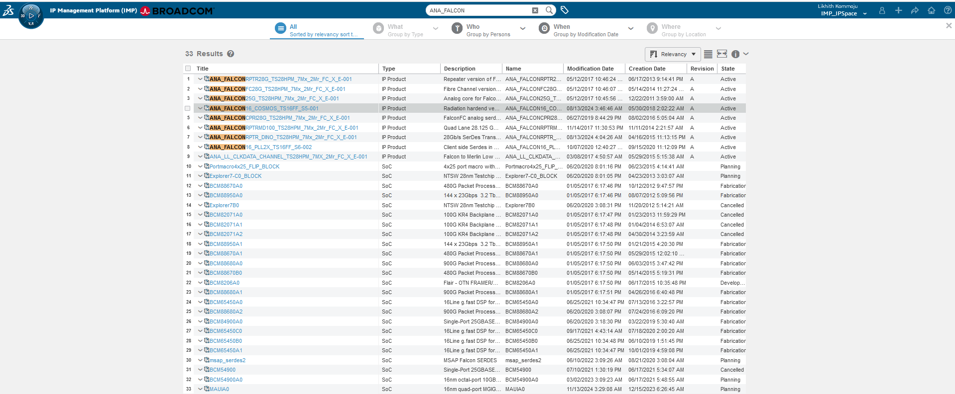
ANA_FALCON16_2X_TS16FFC_S6-001 Search Results:
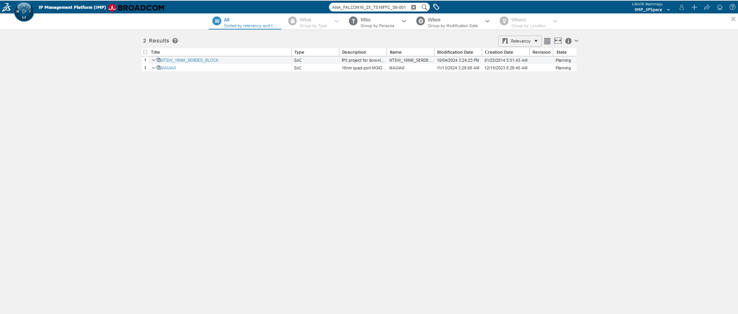
PQ: ANA_FALCON
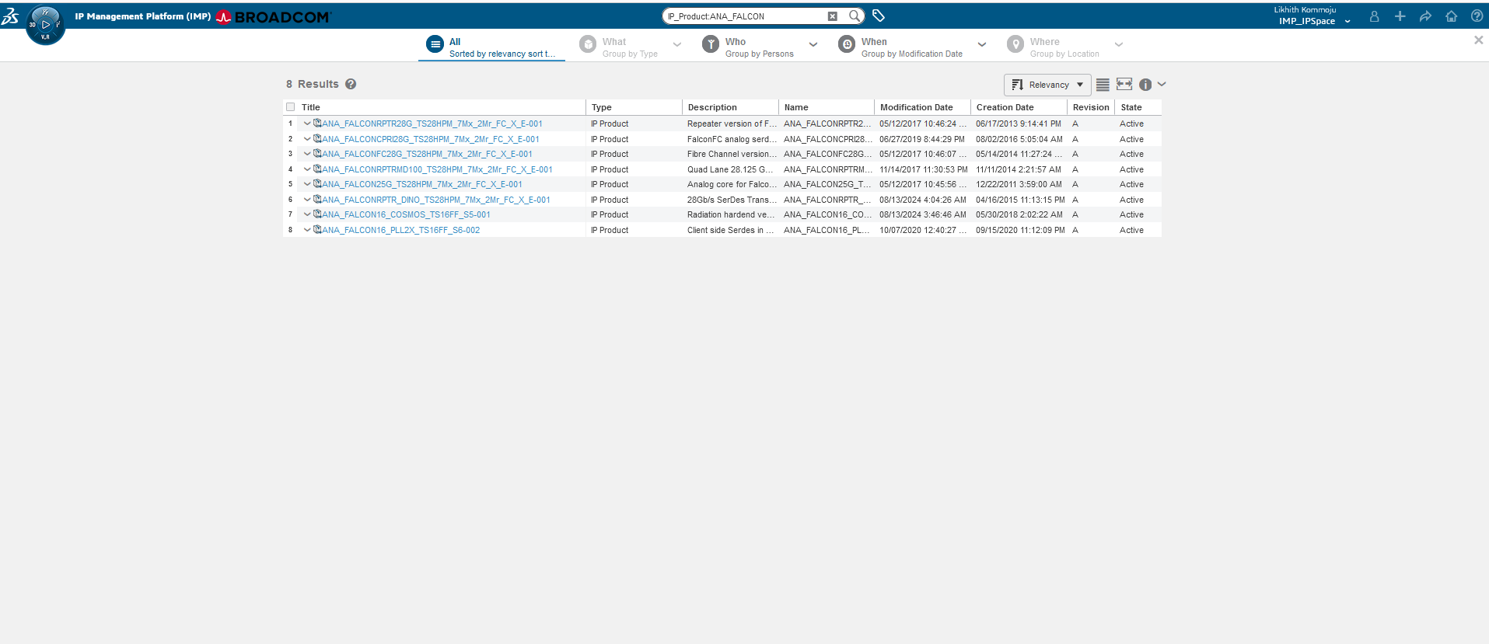

ANA_FALCON Search Results:
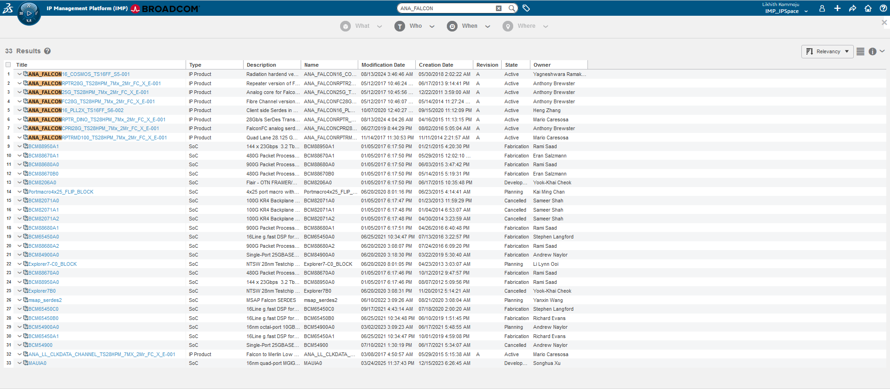

ANA_FALCON16_2X_TS16FFC_S6-001 Search Results:
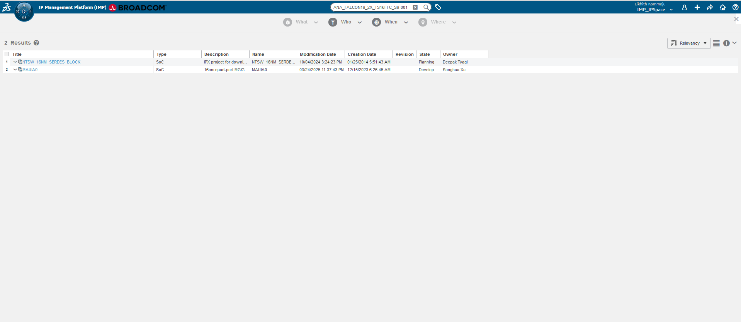

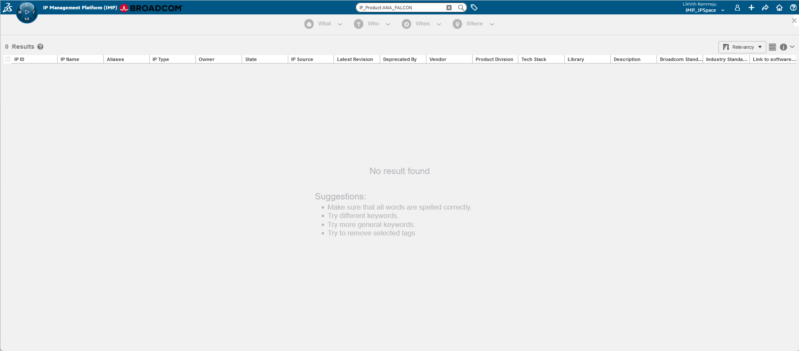

- We found the “Undefined String” bug in the search results while searching for Key “ANA_FALCON” only in data grid view and in other views the undefined string is not displayed.
- We had re-ran full indexing in QA25x, the issue is fixed in data grid view and also woking fine in all types of views.

ANA_FALCON Search Results:

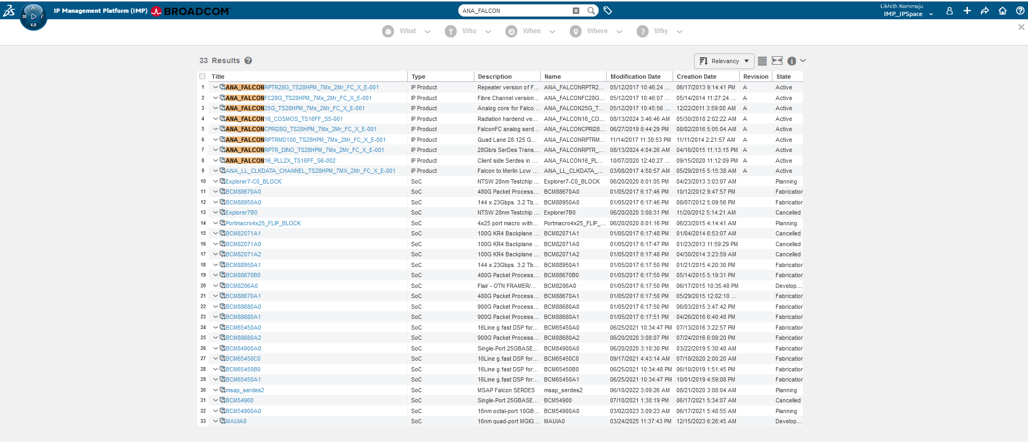

ANA_FALCON16_2X_TS16FFC_S6-001 Search Results:
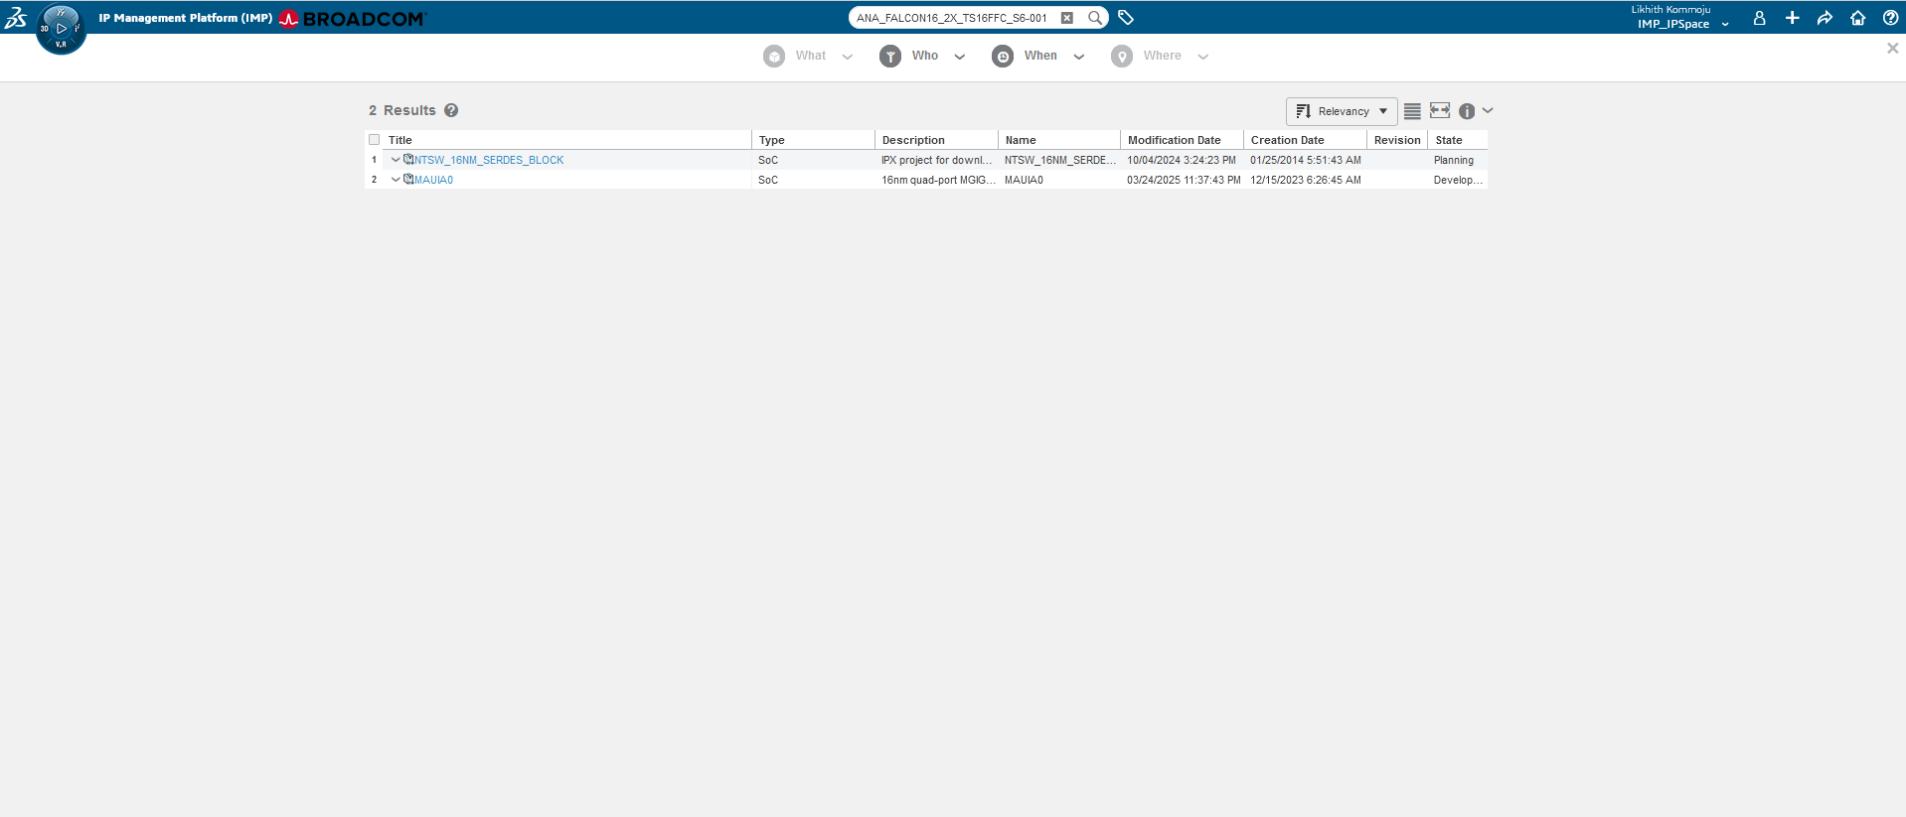

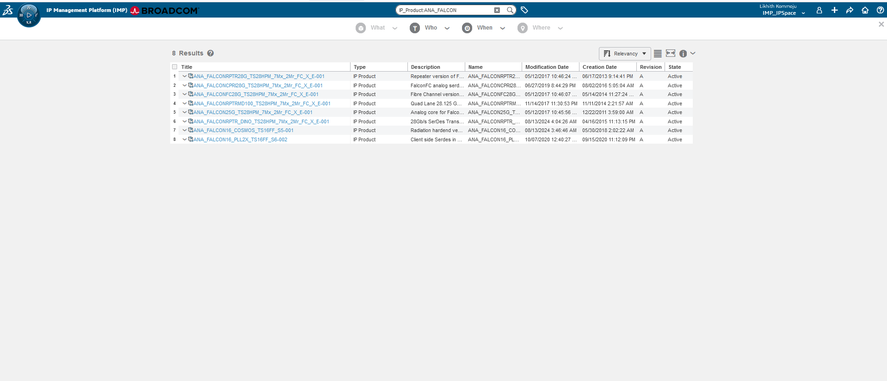

Prod22x
Corey | Likhith
MQL<5>print person cteffeta !history;  person cteffeta  email corey.teffetalor@broadcom.com  fullname Corey Teffetalor  phone +1 9703962071  fax  address 11900 Quantum Parkway  comment  password <RESTRICTED>  lattice eService Production  access all  type application,full  admin none  enable email  disable iconmail  assign group IMP_DTreeGroup  assign role ctx::VPLMProjectLeader.Broadcom Ltd.cteffeta_PRJ_ACCESS  assign role Grant.Broadcom Ltd.cteffeta_PRJ  assign role ctx::VPLMProjectLeader.Broadcom Ltd.IMP_IPSpace  assign role ctx::VPLMProjectLeader.APD.IMP_IPSpace  nothidden  property Company Key value 00000000000000000001  property IconMailLanguagePreference value kernel  property preference_Currency value Dollar  property preference_DefaultSecurityContext value VPLMProjectLeader.Broadcom Ltd.IMP_IPSpace  property preference_VPLMIntegVPLMContext value VPLMProjectLeader.Broadcom Ltd.IMP_IPSpace  created 12/14/2016 3:34:42 AM  modified 9/12/2022 11:01:27 PM | MQL<21>print person lk075732 !history;  person lk075732  email likhith.kommoju@broadcom.com  fullname Likhith Kommoju  phone +91 (79810) 64990  fax  address N/A  comment  password <NONE>  lattice eService Production  access all  type application,full  admin none  enable email  enable iconmail  assign group IMP_DTreeGroup  assign role ctx::VPLMProjectLeader.Broadcom Ltd.lk075732_PRJ_ACCESS  assign role Grant.Broadcom Ltd.lk075732_PRJ  assign role ctx::VPLMProjectLeader.Broadcom Ltd.IMP_IPSpace  assign role ctx::VPLMProjectLeader.APD.IMP_IPSpace  nothidden  property Company Key value 00000000000000000001  property preference_Currency value Dollar  property preference_DefaultSecurityContext value VPLMProjectLeader.APD.IMP_IPSpace  property preference_VPLMIntegVPLMContext value VPLMProjectLeader.APD.IMP_IPSpace  created 11/15/2024 6:09:44 AM  modified 7/13/2025 9:39:29 PM
ANA_FALCON Search Results:
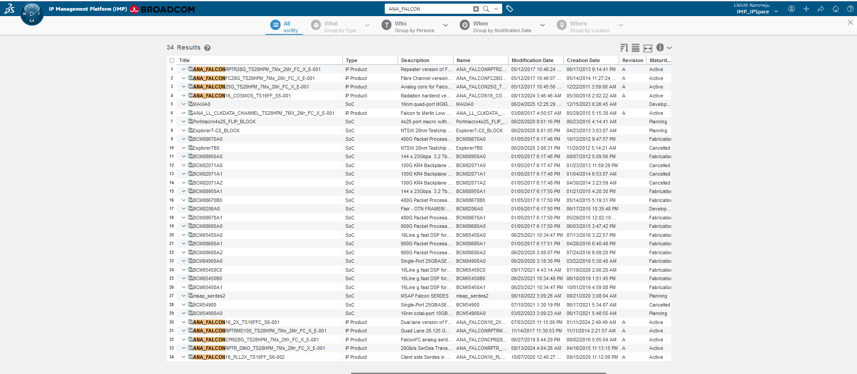

ANA_FALCON16_2X_TS16FFC_S6-001 Search Results:



