OS – Banana Problem – Unit 4
Likhith S
PES1UG24CS720
Section – L

Phase 1:

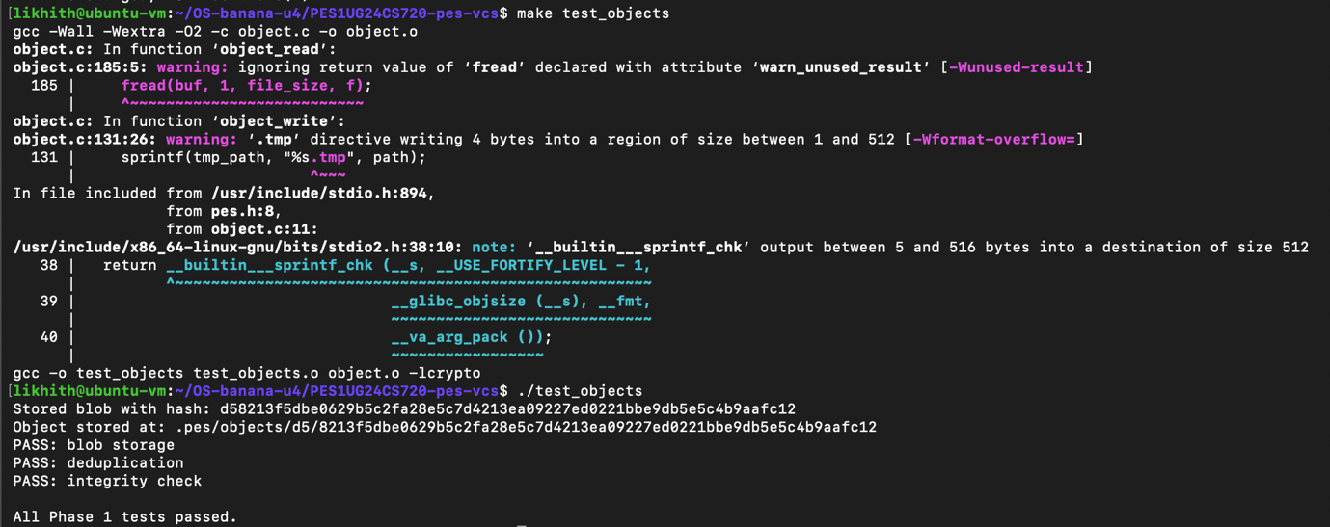

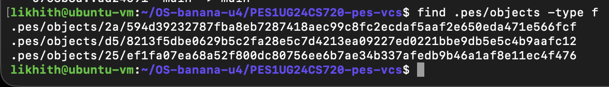

Phase 2:

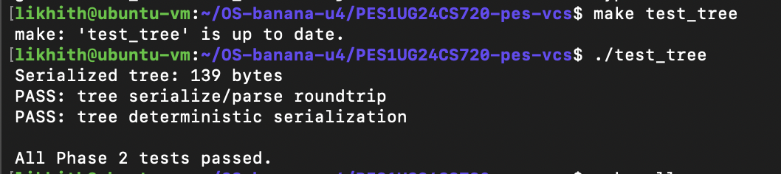

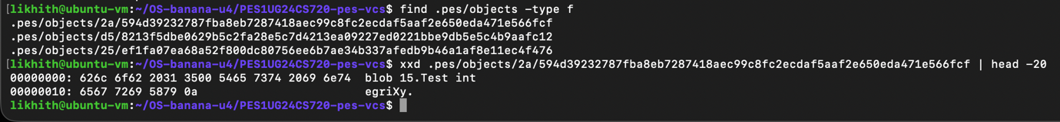

Phase 3:

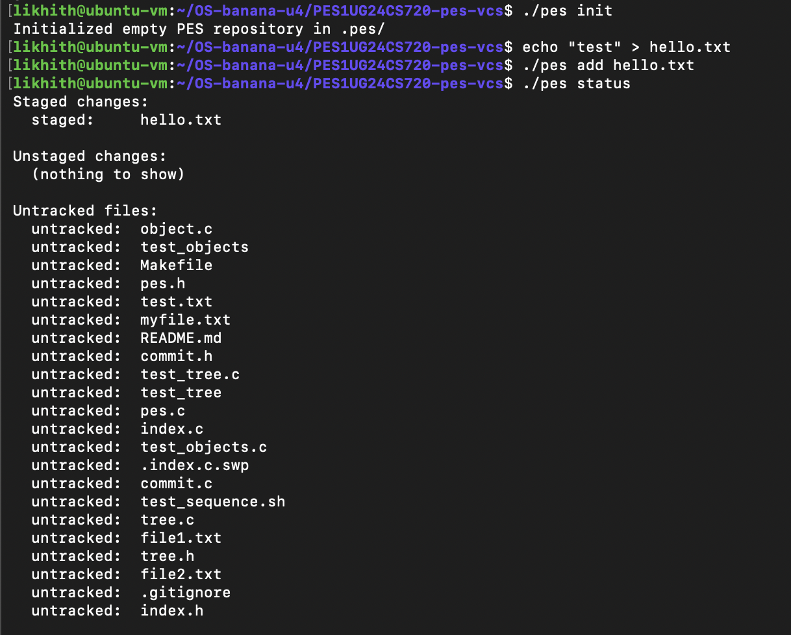

Phase 4:

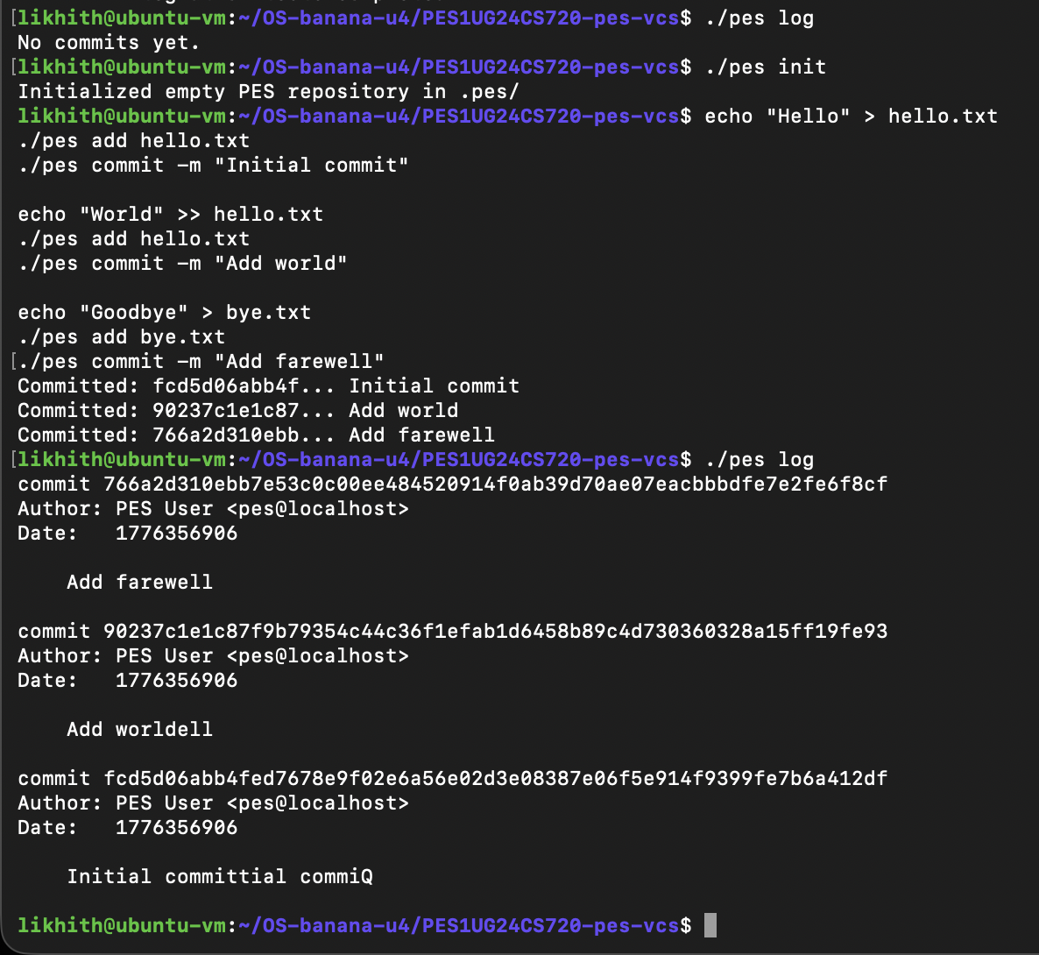

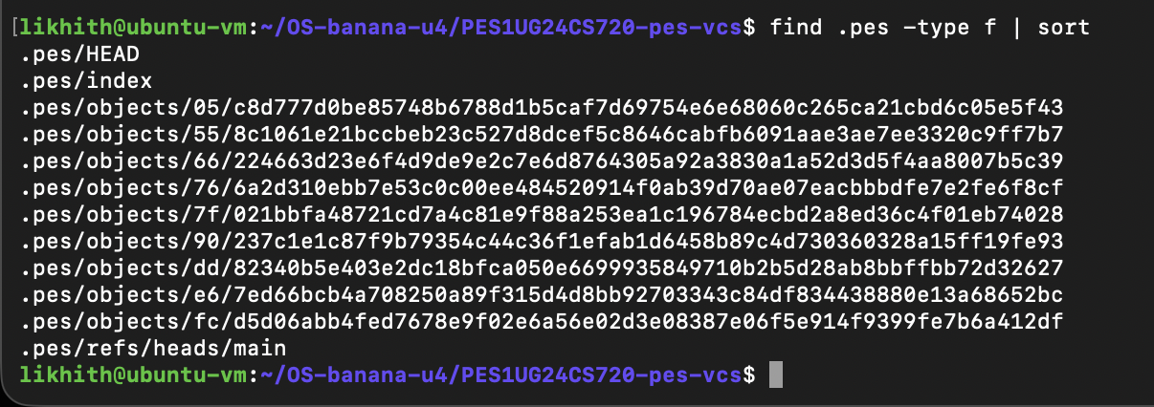

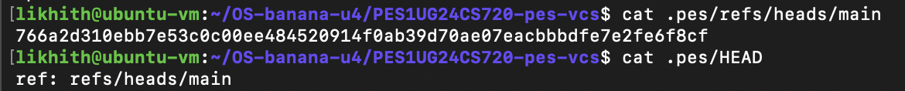

Phase 5:

Q5.1: A branch in Git is just a file in .git/refs/heads/ containing a commit hash. Creating a branch is creating a file. Given this, how would you implement pes checkout <branch> — what files need to change in .pes/, and what must happen to the working directory? What makes this operation complex?
- Files in .pes/ to change: The HEAD file must be updated to point to the new branch reference (e.g., ref: refs/heads/<branch>).
- Working Directory actions: The working directory must be "synchronized" with the snapshot recorded in the target branch’s commit. This involves deleting files that are not in the new commit, updating files that have changed, and adding files that exist in the target commit but not the current one.
- Complexity: The operation is complex because it must handle "safety." If the user has uncommitted changes, a naive checkout could overwrite their work. Additionally, updating the working directory requires recursive traversal of tree objects and efficient comparison with the current index.

Q5.2: When switching branches, the working directory must be updated to match the target branch's tree. If the user has uncommitted changes to a tracked file, and that file differs between branches, checkout must refuse. Describe how you would detect this "dirty working directory" conflict using only the index and the object store.
- Detection Logic: You would compare the SHA-256 hash of the file currently in the working directory (calculated on the fly) with the hash stored for that file in the current index. If the hashes differ, the file is "dirty."
- Conflict Check: If a file is dirty, you then compare the index hash with the hash of the same file in the target branch's tree. If the file in the target branch is different from what is in the index, and the working directory version is also different from the index, a conflict exists, and the operation should be aborted to prevent data loss.

Q5.3: "Detached HEAD" means HEAD contains a commit hash directly instead of a branch reference. What happens if you make commits in this state? How could a user recover those commits?
- Committing in Detached HEAD: Commits work normally, and each new commit points to the previous one as its parent. However, since no branch reference (like main) is being updated, there is no "name" attached to these new commits.
- Recovery: If the user switches away to another branch, the hashes of the "detached" commits may be lost from memory. To recover them, the user would need to find the commit hash (often found in the reflog in real Git) and manually create a new branch pointing to that hash using pes branch <name> <hash>.

Phase 6:

Q6.1: Over time, the object store accumulates unreachable objects — blobs, trees, or commits that no branch points to (directly or transitively). Describe an algorithm to find and delete these objects. What data structure would you use to track "reachable" hashes efficiently? For a repository with 100,000 commits and 50 branches, estimate how many objects you'd need to visit.
- Algorithm (Mark and Sweep):
  - Mark: Start at all known "roots" (every branch in refs/heads/ and the HEAD). Recursively traverse every commit, its tree, and all sub-trees/blobs, adding their hashes to a "reachable" set.
  - Sweep: Iterate through every file in the .pes/objects/ directory. If an object's hash is not in the "reachable" set, delete it.
- Data Structure: A Hash Set or a Bloom Filter (for initial screening) would be most efficient to track reachable hashes.
- Estimation: You would need to visit all 100,000 commits. Assuming an average of 10-20 unique objects (trees/blobs) per commit across history, you might visit 1 to 2 million objects.

Q6.2: Why is it dangerous to run garbage collection concurrently with a commit operation? Describe a race condition where GC could delete an object that a concurrent commit is about to reference. How does Git's real GC avoid this?
- Danger: GC might identify an object as "unreachable" and delete it just as another process is creating a new commit that intends to use that exact object.
- Race Condition:
  - Process A (Commit) creates a new blob and writes it to the object store.
  - Process B (GC) starts. It looks at the current branches, but Process A hasn't updated the branch reference yet.
  - Process B sees the new blob as "unreferenced" and deletes it.
  - Process A tries to finalize the commit, but its required blob is now missing.
- Git’s Solution: Real Git uses a "grace period" (the gc.pruneExpire setting). GC will only delete unreachable objects that are older than a certain age (e.g., 2 weeks), ensuring that brand-new objects currently being handled by concurrent processes are safe.

Full integration test:

