MULTI DISEASE PREDICTION BY USING ADVANCE MACHINE LEARNING MODELS
Dr. Ganji Ramanjaiah¹, R. L.S. D. Kalyani², P. Mounika³
¹Assoc. Prof., Dept. of CSE(DS), RVR & JC College of Engineering (Autonomous),
Chowdavaram, Guntur Dt., India.
^{2,3,}Students, Dept. of CSE(DS), RVR & JC College of Engineering (Autonomous),
Chowdavaram, Guntur Dt., India.
rangalikhitha2004@gmail.com, mounikaponugoti6@gmail.com.

Abstract - Clinical outcomes and efficiency in healthcare can be significantly improved by using machine learning to diagnose chronic diseases early and accurately. This project introduces a multi-disease prediction system that predicts diabetes, heart disease, and Parkinson's disease with a single CatBoost model, eliminating the complexity of managing multiple models. The system compares and assesses the performance of CatBoost with Random Forest and XGBoost based on critical metrics like accuracy, precision, recall, F1-score, and specificity.
For all models tested, CatBoost invariably reported the best accuracy at 84.5% for diabetes, 93.44% for heart disease, and 94.87% for Parkinson's disease, outperforming both Random Forest and XGBoost across all three cases. The model is assisted by preprocessing methods such as SMOTE for class imbalance and ANOVA-based feature selection. An end-user interface based on Streamlit enables users to enter health parameters and obtain real-time predictions. In addition, the app offers users with detailed symptom descriptions and cautionary advice for each sickness. Secure login via Base62 password hashing and an SQLite database provide personalized access and result history.
This efficient, high-performance solution shows the effectiveness of having a single, powerful model such as CatBoost handle multi-disease prediction, with a value add in user education and consumer-friendly diagnostics.

Keywords - Machine Learning, Multi-disease Prediction, CatBoost, Random Forest, XGBoost, Diabetes Detection, Heart Disease Prediction, Parkinson’s Disease Diagnosis, Streamlit, SMOTE, Feature Selection, Classification Models, Healthcare Analytics, Medical Diagnosis System, SQLite.

I. INTRODUCTION

El-Sofany [1] developed a heart disease prediction system using traditional machine learning classifiers, including Decision Trees and SVM. While the study demonstrated the remains difficult effectiveness of these models for diagnosing single diseases, it did not cover the application of new ensemble methods such as CatBoost, nor did it consider multi-disease predictions or real-time implementation strategies, thereby limiting its focus to integrated healthcare solutions.
The simultaneous presence of illnesses such as diabetes and cardiovascular diseases creates a diagnostic challenge that single-disease prediction models often overlook. Models of machine learning designed for comorbid conditions have shown potential in pinpointing overlapping risk factors and improving diagnostic precision, yet determining the long-term interactions between these diseases using historical data remains difficult [2].
Hybrid approaches utilizing machine learning and deep learning have demonstrated improved outcomes in predicting heart disease. These approaches capitalize on the advantages of both philosophies, improving feature extraction and classification; however, the interpretability of deep models remains a challenge in clinical settings, which affects trust and real-world application [3].
National health screening information has significant potential for forecasting diseases, and when utilized for Parkinson's disease, machine learning techniques have achieved impressive predictive accuracies. Nonetheless, population-level data often lack detailed, disease-specific characteristics and therefore require better feature engineering and model optimization to ensure clinical significance and reliability [4].
Wearable gadgets, particularly smartwatches, have turned into an immediate, non-invasive source of predictive information for Parkinson's disease. Algorithms utilizing sensor data from wearable devices can detect early motor symptoms through machine learning. While encouraging, the issues of patient adherence and fluctuations in sensor data continue to pose major challenges for widespread implementation [5].
Recent advancements in biomarker-driven prediction through AI-enhanced blood tests suggest the capability to identify Parkinson's disease years before symptoms appear. This approach utilizes machine learning to identify patterns in complex biological signals. Nevertheless, additional research is needed to validate the model in diverse cohorts and to apply
predictive findings to preventive care strategies [6].
Worldwide healthcare systems are facing growing demands due to chronic illnesses like diabetes, heart disease, and Parkinson’s disease. These illnesses progress silently, with signs manifesting only toward the disease's conclusion. A proper early diagnosis is essential for effective treatment and ongoing care. While efficient, traditional diagnostic methods are costly, require significant time, and depend on the presence of specialists. Lately, machine learning (ML) has emerged as a valuable technique for aiding medical diagnosis by identifying patterns in complex data that conventional analysis fails to detect.
The aim of this project is to establish a unified data-driven system that employs a blend of machine learning models to predict the development of diabetes, heart disease, and Parkinson's disease.
Using performance metrics like accuracy, precision, sensitivity (recall), specificity, and F1 score, the system evaluates and contrasts three popular classifiers: CatBoost, Random Forest, and XGBoost.
CatBoost outperformed the other two in all three scenarios and may serve as a viable option for real-world application.
ANOVA-driven feature selection and SMOTE for class balancing were among the preprocessing methods used to make the models more robust. Verified users can enter clinical parameters and receive instant predictions thanks to the user-friendly Streamlit interface of the system. Historical results are stored in an encrypted SQLite database, facilitating long-term tracking of disease risk.
This kind of system aims to facilitate early detection and decision-making in clinical settings or as a personal health monitoring tool by combining immediate usability with predictive analytics. The results suggest that this system has the potential to manage various chronic ailments at the same time with accurate and scalable diagnostics, especially leveraging CatBoost's capabilities.

II. RELATED WORKS

Surya et al. [7] designed a breast cancer classification model with MobileNetV2 and deployed it in real-time using Streamlit. While this framework illustrated the possibility of real-time diagnostic software, the research was limited to one disease and did not utilize sophisticated algorithms such as CatBoost or multi-disease prediction functions.
Gupta et al. [8] presented PCA-RF, a Random Forest-based predictive model for Parkinson's disease. Although the model was highly accurate, it considered only one disease and did not investigate comparisons among different ML approaches like CatBoost, nor did it provide an integrated deployment platform.
Haque et al. [9] applied a CatBoost model fine-tuned with nature-inspired algorithms and explainable AI to detect chronic kidney disease (CKD). Although the research proved to enhance detection efficiency, it was limited to CKD and did not cater to the larger requirement of holistic, user-friendly, multi-disease diagnosis systems.
Bai et al. [10] created ML models to forecast one-year mortality risk in hyperuricemic STEMI patients. Although pioneering in focusing on a particular subgroup, the study's limited scope and lack of multi-disease integration restrict its wider clinical use.
Dai et al. [11] investigated applications of ML in precision diabetes management and cardiovascular risk estimation. Their research offered insightful information on ML-based healthcare but did not go far in creating or implementing an integrated multi-disease prediction system.
Kolesnikov et al. [12] offered interdisciplinary discussion on the application of CatBoost in big data applications, including disease
prediction. Nevertheless, their work was mainly theoretical and had no empirical tests or emphasis on actual multi-disease systems.
A 2023 paper called Multiple Disease Prediction Using Machine Learning Algorithms [13] explored some ML models to predict multiple diseases. Although it touched on the overall topic of multi-disease prediction, it did not include in-depth performance analysis and failed to include user-friendly deployment techniques or sophisticated models such as CatBoost.
Another CKD prediction study [14] used boosting algorithms on clinical factors to achieve high diagnostic accuracy. Like other disease-specific studies, though, it did not try to combine predictions for multiple diseases or offer deployment strategies that are easy to deploy.
One recent paper by [15] suggested an optimized CatBoost model for boosting cardiovascular disease risk estimation. Although the application of CatBoost was an important contribution, the research was narrow in scope as it addressed only a single disease and did not consider deployment.
Al-Aidaroos et al. [16] presented a deep learning method employing Long Short-Term Memory (LSTM) networks for predicting multiple diseases from patient health records with efficient temporal dependency capture. Though their approach reported encouraging outcomes on real-world healthcare data sets and had potential in intelligent clinical decision aid, it had some constraints. For instance, the research did not investigate the usage of ensemble-based boosting techniques like CatBoost, which are especially well-suited for structured tabular medical data and can provide more interpretability. Moreover, the model was not implemented via an interactive or easy-to-use interface, limiting its accessibility and practical applicability in clinical environments. In contrast, the current research fills these voids by utilizing the CatBoost algorithm for better accuracy and interpretability in the prediction of multiple diseases and further implements a Streamlit-based web interface for real-time, user-friendly deployment, rendering the system more usable in actual healthcare settings.

III. PROPOSED WORK

The proposed machine learning (ML) implementation predicts the three conditions, that is, diabetes, heart disease, and Parkinson's disease. Workflow of the system is illustrated in Figure 1. Initials, datasets for each disease were collected from open sources such as Kaggle and the UCI Machine Learning Repository. The datasets contained a range of features based on health for each disease. Preprocessing ensured data quality and consistency. This also involved handling inconsistencies such as missing or null values, which were imputed with either the mean or the median depending on the data distribution. Categorical variables were also transformed into numerical values by applying encoding techniques such as label encoding or one-hot encoding where necessary.
Each dataset was then split after preprocessing into two datasets: a test set and a training set, typically in an 80:20 ratio. This allowed models to be trained against patterns within one portion of the data and then tested on a different portion to ensure performance validity. Each disease's best classifier was found by applying a number of machine learning algorithms, the best performing of which were selected where there was a best fit between accuracy and resilience. These subsequent ensemble machine learning algorithms were then chosen based on superior performance:
- CatBoost Classifier: CatBoost (Categorical Boosting) is a gradient boosting method developed by Yandex that is optimally suited to deal with categorical features natively without the need for manual encoding. CatBoost uses ordered boosting and other methods to avoid overfitting and improve generalization and is most effective when used on structured or tabular data.
- Random Forest (RF) Classifier: Random Forest is an ensemble technique that uses ensemble learning, producing many decision trees during training and outputting the class that is the mode of the classes (classification) or the mean prediction (regression) of the individual trees. It enhances predictive accuracy and deals with overfitting through the average of the outputs from different separate trees.
- XGBoost (Extreme Gradient Boosting): XGBoost is a fast and scalable version of gradient boosting with added features such as regularization (L1 and L2), parallelism, and tree pruning. These features improve the speed and performance of the model and are best suited for large data and competitions.
There was one model per disease trained on each of these classifiers to provide personalized predictions tailored and fine-tuned to the individual dataset features. These trained models were used in an accessible web application created with Streamlit. The application includes a secure login component, input interface for health parameter input, and real-time prediction visualization based on user input. Second, all the prediction outputs are stored into an SQLite database so users and medical professionals can see past results and analyze health trends over a period of time. Overall, the system is designed to produce rapid, accurate, and data-driven predictions to assist in early detection of long-term diseases, ultimately facilitating clinicians' and patients' improved better health decision-making.

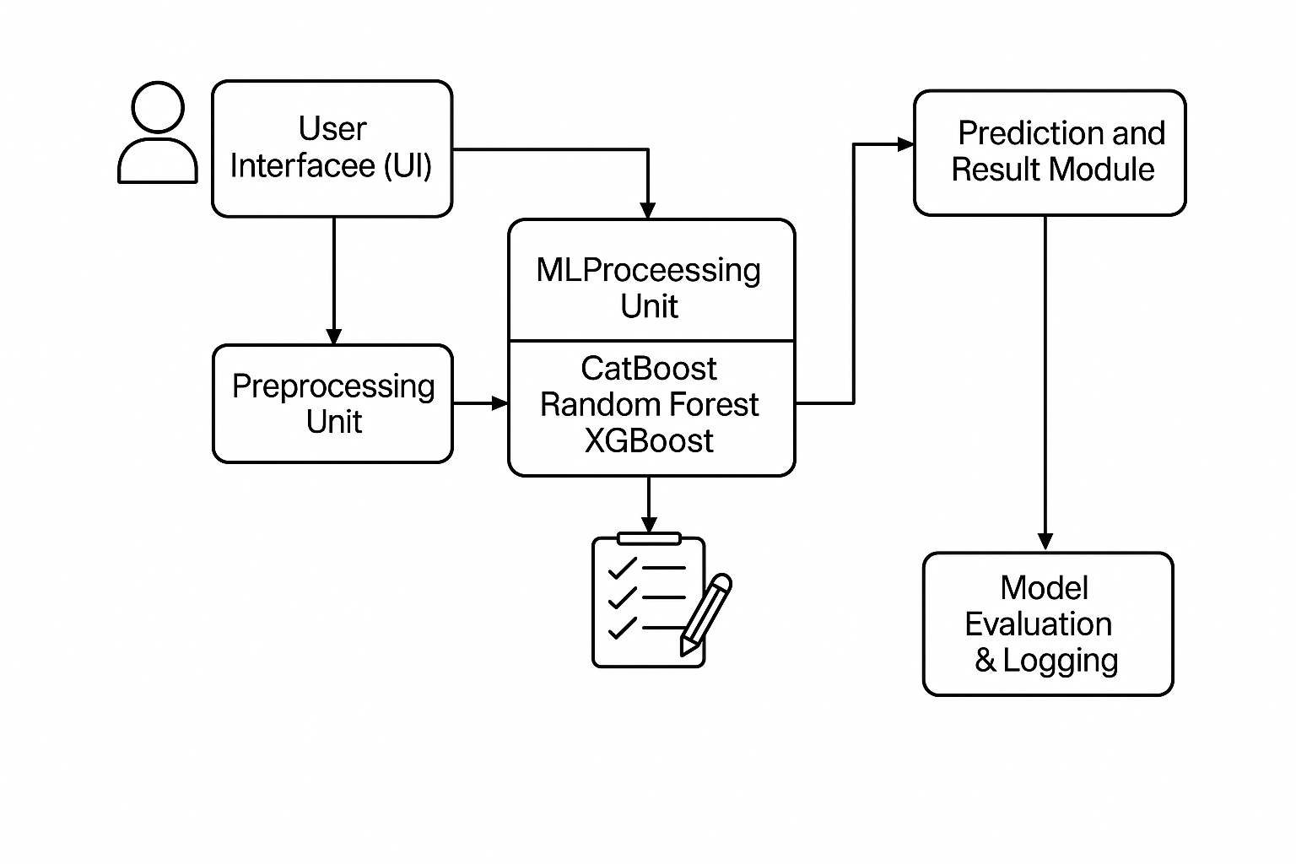Figure 1: Proposed ML Application for Predicting Diabetes, Heart Disease, and Parkinson's Disease

- Datasets and Dataset Features
This study employs three various clinical data sets for Parkinson's disease, diabetes, and heart disease prediction. Each data set has significant clinical, demographic, and biological measurements related to its respective condition.

1) Diabetes Dataset
PIMA Indians Diabetes Database diabetes data set comprises 768 patient sample instances and 8 significant clinical features related to glucose regulation and metabolic condition.
Key features are:
- Pregnancies: Number of times pregnant the patient is.
- Glucose: Concentration of two-hour plasma glucose on oral glucose tolerance test.
- Blood Pressure (mm Hg): Diastolic blood pressure.
- Skin Thickness (mm): Triceps skinfold.
- Insulin (mu U/ml): Concentration of 2-hour serum insulin.
- BMI: Body mass index (weight in kg/(height in m)^2).
- Diabetes Pedigree Function: Value that estimates diabetes risk from pedigree.
- Age: Age of patient.
These values are a set of genetic, physiological, and life-style-dependent risk factors for diabetes.

2) Heart Disease Dataset
The heart disease dataset utilized for this research is created by taking the Cleveland Heart Disease Dataset (CHDD) and a clinical dataset made private, amounting to 503 patient records. Every record holds 13 attributes and a binary target label (Target) whether the heart disease is present (1) or not (0).
Key features are:
- Age: The age of the patient in years.
- Sex: 1 = male, 0 = female.
- Type of Chest Pain: Varies from normal angina to asymptomatic.
- Resting Blood Pressure (mm Hg): Blood pressure at rest.
- Serum Cholesterol (mg/dl): Blood cholesterol.
- Fasting Blood Sugar (>120 mg/dl): Indicates whether the fasting blood sugar is more than 120 mg/dl.
- Resting ECG: Resting electrocardiograph results.
- Max Heart Rate Achieved: Maximum heart rate attained during exercise.
- Exercise-Induced Angina: Physical-exertion-induced chest pain.
- Oldpeak: Exercise-induced ST depression compared to rest.
- ST Slope: Peak exercise ST segment slope.
- Number of Major Vessels (0–3): Fluoroscopically colored.
- Thalassemia: An abnormality in the blood indicating degree of defect (normal, fixed, reversible).
These variables represent a comprehensive view of cardiac health based on physiological symptoms, test results, and patient history.

3) Parkinson's Disease Dataset
This dataset is utilized for the non-invasive prediction of Parkinson's disease, comprising 195 voice recordings of healthy and affected patients. It consists of 22 biomedical voice features.
Major features are:
- MDVP:Fo(Hz), Fhi(Hz), Flo(Hz): Fundamental frequency measurements.
- Jitter (local, abs): Pitch variations, reflecting vocal fold vibration instability.
- Shimmer (local, dB): Amplitude fluctuations, reflecting vocal instability.
- HNR, NHR: Harmonic-to-noise and noise-to-harmonic ratios, respectively, reflecting voice clarity.
- RPDE (Recurrence Period Density Entropy): Signal randomness measures.
- DFA (Detrended Fluctuation Analysis): Reveals long-term correlation.
- Spread1, Spread2: Descriptors of signal complexity.
- PPE (Pitch Period Entropy): Measures the randomness in pitch.

These acoustic features are useful in discriminating Parkinsonian speech dysfunctions from normal patterns.

The datasets and their respective features are consolidated in Table 1 for a comparative overview:
Disease | Sample Size | Key Features
Heart Disease | 503 | Age, Chest Pain Type, Cholesterol, Resting BP, ECG, Max Heart Rate, Thalassemia, ST Depression
Diabetes | 768 | Pregnancies, Glucose, BMI, Blood Pressure, Skin Thickness, Insulin, Pedigree Function, Age
Parkinson's | 195 | MDVP:Fo, Jitter, Shimmer, HNR, RPDE, DFA, Spread1, PPE

Table 1: Summary of Disease-Specific Dataset Characteristics

To further illustrate the dimensional richness of each dataset, Figure 2 visualizes the number of input features used per disease category:
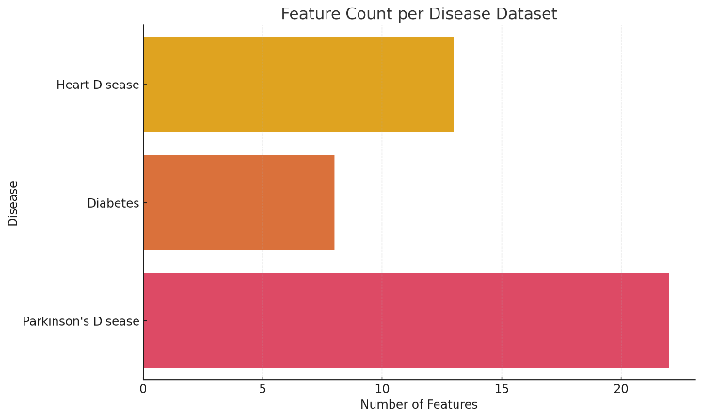
Figure 2: Number of input features per dataset for each disease category.

- DATASETS PREPARATION

A few openly accessible datasets were used for the detection of diseases such as diabetes, heart disease, and Parkinson's. Each of these datasets was read in CSV mode and preprocessed in a homogenous and structured manner.
The target labels (diagnosis results) and features (input variables) were split. The data was then split into test and training sets in an 80:20 ratio such that the distribution of the target classes was preserved in both sets using stratified sampling.
To address class imbalance—common in medical data—Synthetic Minority Over-sampling Technique (SMOTE) was applied to the training set. The algorithm enhances minority class presence by generating synthetic instances, allowing the model to learn more balanced decision boundaries.

- Feature Importance Analysis and Predictive Model Training

Feature selection helps in reducing model complexity, improving interpretability, and potentially boosting predictive performance. Three methods were used:
- ANOVA F-Test (Statistical Approach):
- Applied before training Random Forest and XGBoost models.
- Selected top 5 features based on F-scores from f_classif, highlighting those most statistically correlated with the target variable.
- Helps remove irrelevant or redundant features before model fitting.

- Model-Based Feature Importance (CatBoost):
- CatBoost inherently calculates feature importance based on the impact on model decision paths.
- No pre-selection was done; the model used all features, and post-training, feature importance was visualized.
- This gives insights into which features the model considered most discriminative.

- SHAP Values (Model Explainability):
- Applied to XGBoost for deeper understanding (optional).
- SHAP quantifies the contribution of each feature to a single prediction, offering a consistent view of importance across instances.

1) Diabetes Disease

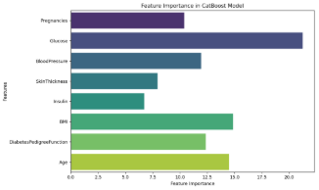
Figure 3: “Feature Importance in CatBoost Model" (Diabetes Dataset)
- Top Features:
- Glucose, BMI, Age, DiabetesPedigreeFunction
- Interpretation:
- Glucose has the highest impact, aligning with the disease's pathophysiology.
- BMI and Age are well-established risk factors.
- DiabetesPedigreeFunction incorporates genetic predisposition.

2) Heart Disease

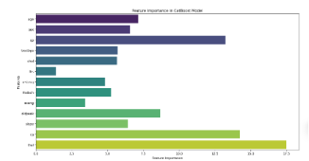
Figure 4: “Feature Importance in CatBoost Model" (Heart Dataset)
- Top Features Identified:
- thal, ca, cp, oldpeak were the most important.
- Clinical Interpretation:
- thal: Thalassemia test result — aligns with its known diagnostic value.
- ca: Number of major vessels colored — highly relevant to blockage detection.
- cp (chest pain type): Strong direct correlation to cardiac symptoms.
- oldpeak: ST depression — an indicator of myocardial stress.

3) Parkinson's Disease

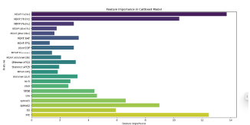
Figure 5: "Feature Importance in CatBoost Model" (Parkinson Dataset)
- Top Features Identified:
- PPE, D2, spread2, spread1, and DFA stood out in importance.
- Clinical Interpretation:
These are non-linear signal features from voice recordings, which are crucial for detecting motor and speech impairments caused by Parkinson’s.
- MDVP:Fo(Hz): Average vocal fundamental frequency – indicates pitch stability.
- PPE (Pitch Period Entropy) reflects pitch variation — highly diagnostic in voice disorders.
- MDVP:Fhi(Hz): Maximum pitch – vocal high range, often reduced in PD patients.
- spread2: Nonlinear measure of signal variation; high in dysphonic voices.
- spread1: Describes signal spread around average – instability indicator.
- D2, DFA, RPDE: Capture complexity and fractal dimensions of the voice, often altered in Parkinson’s.

Dataset | Top Features (CatBoost) | Clinical Relevance
Diabetes | Glucose, BMI, Age, DiabetesPedigreeFunction | Metabolic and hereditary risk
Heart Disease | thal, ca, cp, oldpeak | Cardiovascular function
Parkinson’s | MDVP:Fo(Hz), PPE, D2, spread2, spread1, DFA, RPDE | Voice signal anomalies

Table 2: Top CatBoost Features Across Disease Datasets

Three machine learning classifiers, XGBoost, Random Forest, and CatBoost, were employed in this study to predict disease outcomes on three medical datasets: Parkinson's Disease, Heart Disease, and Diabetes. Each model utilized a different pipeline based on the nature of the data and the compatibility of the model with feature selection and preprocessing techniques.
CatBoost classifier was trained on the entire set of input features of all datasets using no feature reduction or elimination technique. CatBoost supports categorical as well as numerical features natively, and it is appropriate for tabular clinical data. There was a dedicated data structure specifically for CatBoost called Pool to wrap training as well as evaluation datasets. The approach enhances the computational efficiency as well as enabling better handling of categorical variables. The model was also trained on 1000 iterations of boosting with a learning rate of 0.05 and maximum tree depth of 6. Early stopping with patience set to 50 rounds was also applied to prevent overfitting and to cease training when the performance was flat on the validation set.
On the other hand, Random Forest and XGBoost models were trained using a subset of features. The top five most informative features were selected using the ANOVA F-test method, which determines the statistical significance of each feature against the target variable. For the class imbalance problem, which is common in medical data, the Synthetic Minority Over-sampling Technique (SMOTE) was implemented for over-sampling the training data. In addition, the features were normalized using StandardScaler so that they would have unit variance and zero mean, which is particularly important for tree-based models when used together with sampling techniques.
The Random Forest classifier of 300 trees with 20 depth and using default splitting criteria was able to detect complex patterns from the resampled data. Concurrently, the XGBoost classifier trained with regularizations and boosting on 500 estimators with a learning rate of 0.05 and a depth of 6 trees was employed. Both the classifiers were applying identical preprocessed and feature-selected sets to facilitate fair comparisons in downstream analysis.
Together, these model training approaches ensured robust predictive performance by balancing model complexity, interpretability, and adaptability to the data distribution of each medical condition.
The primary learning algorithm employed was CatBoostClassifier, which inherently accommodates categorical features, delivers high accuracy, and exhibits resistance to overfitting. The model was enclosed in a pipeline that simplified training and assessment consistently across datasets.
Figure 6 depicts the overall structure and learning methodology of CatBoost, which was crucial for the classification tasks conducted in this project.
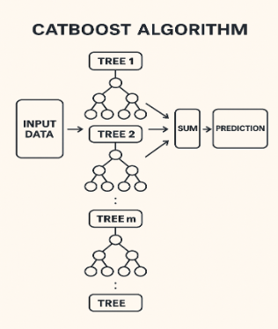
Figure 6. CatBoost model workflow used in disease classification.

- PROPOSED APP DEPLOYMENT
The multi-disease prediction application has been effectively deployed with the help of Streamlit Community Cloud, an easy and effective hosting platform for applications based on Python. Since the GitHub repository is linked directly with Streamlit, deployment becomes a seamless and automated process, eliminating the necessity for intricate server infrastructure or manual maintenance. Thus, the tool can be made accessible to most users, starting from health enthusiasts and students to non-tech individuals in need of risk calculations for chronic diseases.
In the application, three separate CatBoost models for Diabetes, Heart Disease, and Parkinson's Disease prediction are deployed as the final algorithms. These models are offline-trained and stored as .pkl files to load quickly at runtime. This architecture lowers the prediction latency and provides real-time responsiveness, which is essential for a smooth user interface. While Random Forest and XGBoost models were also trained, they are only utilized for benchmarking and comparison purposes at the time of evaluation.
The application has a secure login and registration mechanism developed based on SQLite, wherein passwords are encrypted before storage, guaranteeing user data privacy. Upon login, users are redirected to a minimal and interactive web interface developed using Streamlit. Here, users can input several medical parameters like blood pressure, cholesterol, heart rate, etc. to get disease prediction in real time. The program is created to not just make predictions but also serve as a guidance system by giving proper healthcare recommendations according to the disease predicted. It shows a list of typical symptoms and real-world precautions for each disease, thereby making the interface informative and interactive.
For further improving usability, the system also saves each prediction session within the SQLite database, including the inputs given by the user. This allows users to see their past results in the form of a prediction history, which can be accessed at any time they log on. This tracking ability helps in tracking the changes over time and invites regular use of the tool.
The overall deployment plan guarantees that the application remains lightweight, effective, and easily accessible. It effectively combines trained CatBoost models, real-time prediction logic, secure user login, persistent storage of data, and educational healthcare content into a unified, centralized platform. Thus, the application becomes an end-to-end machine learning solution for multi-disease prediction and health awareness at an early stage within an online system.

IV. RESULTS AND DISCUSSIONS

The multi-disease prediction system was implemented using Jupyter Notebook, which simplified the creation of visual analytics and live model training. The system was designed to predict Diabetes, Heart Disease, and Parkinson’s Disease using a single unified pipeline built around the CatBoost classifier, due to its superior performance across all three diseases.
In the initial step, the datasets corresponding to each disease were cleaned using Python’s Pandas and NumPy libraries. Following data cleaning, preprocessing was applied using StandardScaler from Scikit-learn to normalize the feature values. Additionally, SMOTE (Synthetic Minority Over-sampling Technique) was employed to address class imbalance in the datasets.
A. Performance Metrics
Each dataset was split into training and testing sets, where 80% of the data was used to train the model and the remaining 20% for evaluation. Three classification models—CatBoost, Random Forest, and XGBoost—were evaluated to determine the most efficient algorithm. Evaluation was based on key performance metrics including accuracy, precision, recall, specificity, and F1 score.
The CatBoost algorithm outperformed the other two models for all three diseases:

The performance of every model was measured by standard classification metrics: Accuracy, Precision, Recall (Sensitivity), F1 Score, and Specificity. A brief description of every metric is as follows:
Accuracy:
Accuracy is the overall accuracy of the model. It is the number of correct predictions divided by the total number of input samples. It is a helpful measure when the classes are balanced.
Accuracy = $\frac{True Positives+ True Negatives}{Total Samples}$
​
Precision:
Precision is the fraction of correct predictions of positive cases among all predicted positives. It is particularly crucial in medical diagnosis to avoid false positives.
Precision =$\frac{True Positives}{True Positives+False Positives}$

Recall (Sensitivity):
Also referred to as sensitivity or true positive rate, recall calculates the ratio of actual positive instances that were accurately predicted. High recall is crucial in the healthcare industry to make sure that all patients suffering from the disease are detected.
Recall = $\frac{True Positives}{True Positives+False Negatives}$

F1 Score:
The F1 Score is the harmonic mean between precision and recall. It offers a balance of the two and is a superior measure in cases of class imbalance.
F1 Score = 2 × $\frac{Precision×Recall​}{Precision + Recall}$
​
Specificity:
Specificity, or the true negative rate, calculates the percentage of actual negative cases that were accurately labeled. It is crucial to keep healthy people from being mislabeled.
Specificity = $\frac{True Negatives}{True Negatives+False Positives}$

Disease | Model | Accuracy | Precision | Recall (Sensitivity) | F1 Score | Specificity
Diabetes | CatBoost | 84.50% | 0.84 | 0.84 | 0.84 | 0.85
 | Random Forest | 78.50% | 0.77 | 0.81 | 0.79 | 0.76
 | XGBoost | 79.00% | 0.76 | 0.87 | 0.81 | 0.71
Heart Disease | CatBoost | 93.44% | 0.91 | 0.96 | 0.93 | 0.89
 | Random Forest | 78.69% | 0.79 | 0.78 | 0.78 | 0.79
 | XGBoost | 77.05% | 0.79 | 0.76 | 0.77 | 0.78
Parkinson’s | CatBoost | 94.87% | 0.95 | 0.95 | 0.95 | 0.94
 | Random Forest | 71.79% | 0.90 | 0.72 | 0.71 | 0.71
 | XGBoost | 71.79% | 0.91 | 0.72 | 0.71 | 0.8
Table 3: Model Performance Metrics Across All Diseases
B. Correlation Heatmap of Features
These heatmaps demonstrate the strong correlation of each feature with others, helping to identify multicollinearity and select features.
- Diabetes Heatmap: Found strong link between glucose levels and results. 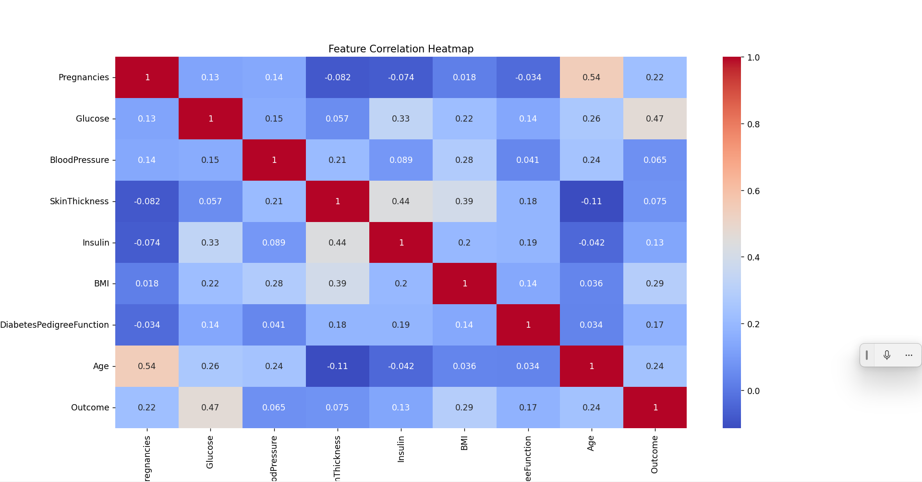
Figure 7. Correlation Heatmap of Input Features for Diabetes Prediction.

- Heart Disease Heatmap: Found a notable link between maximum heart rate and preferred result.
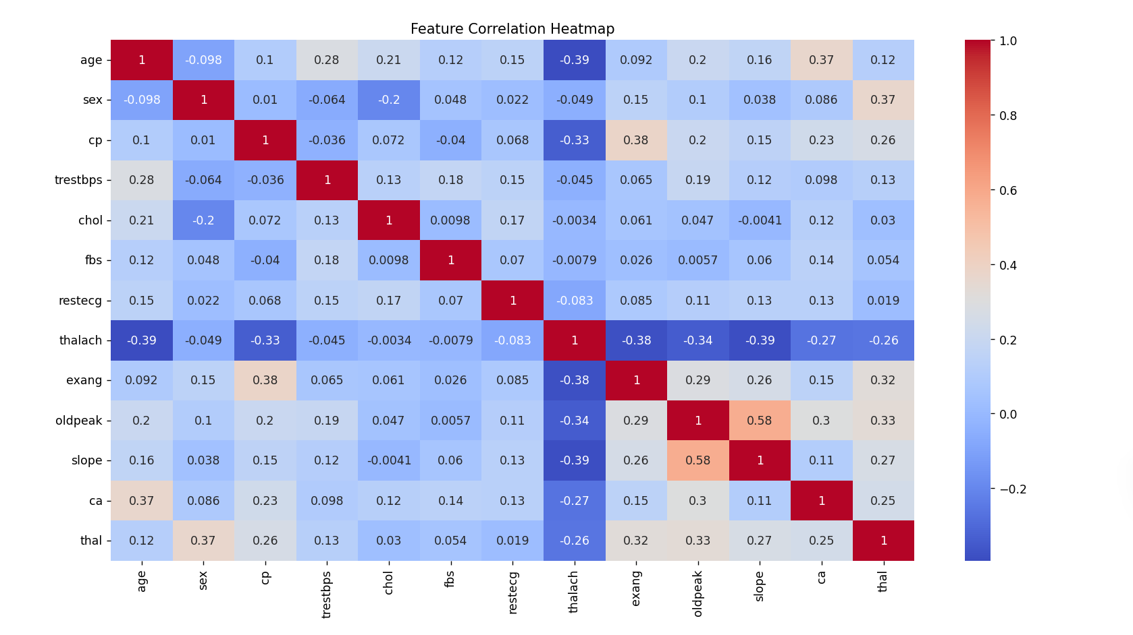
Figure 8. Correlation Heatmap of Input Features for Heart Disease Prediction.
- Parkinson’s Heatmap: Features like MDVP:Jitter and spread1 showed a strong positive correlation with the condition.

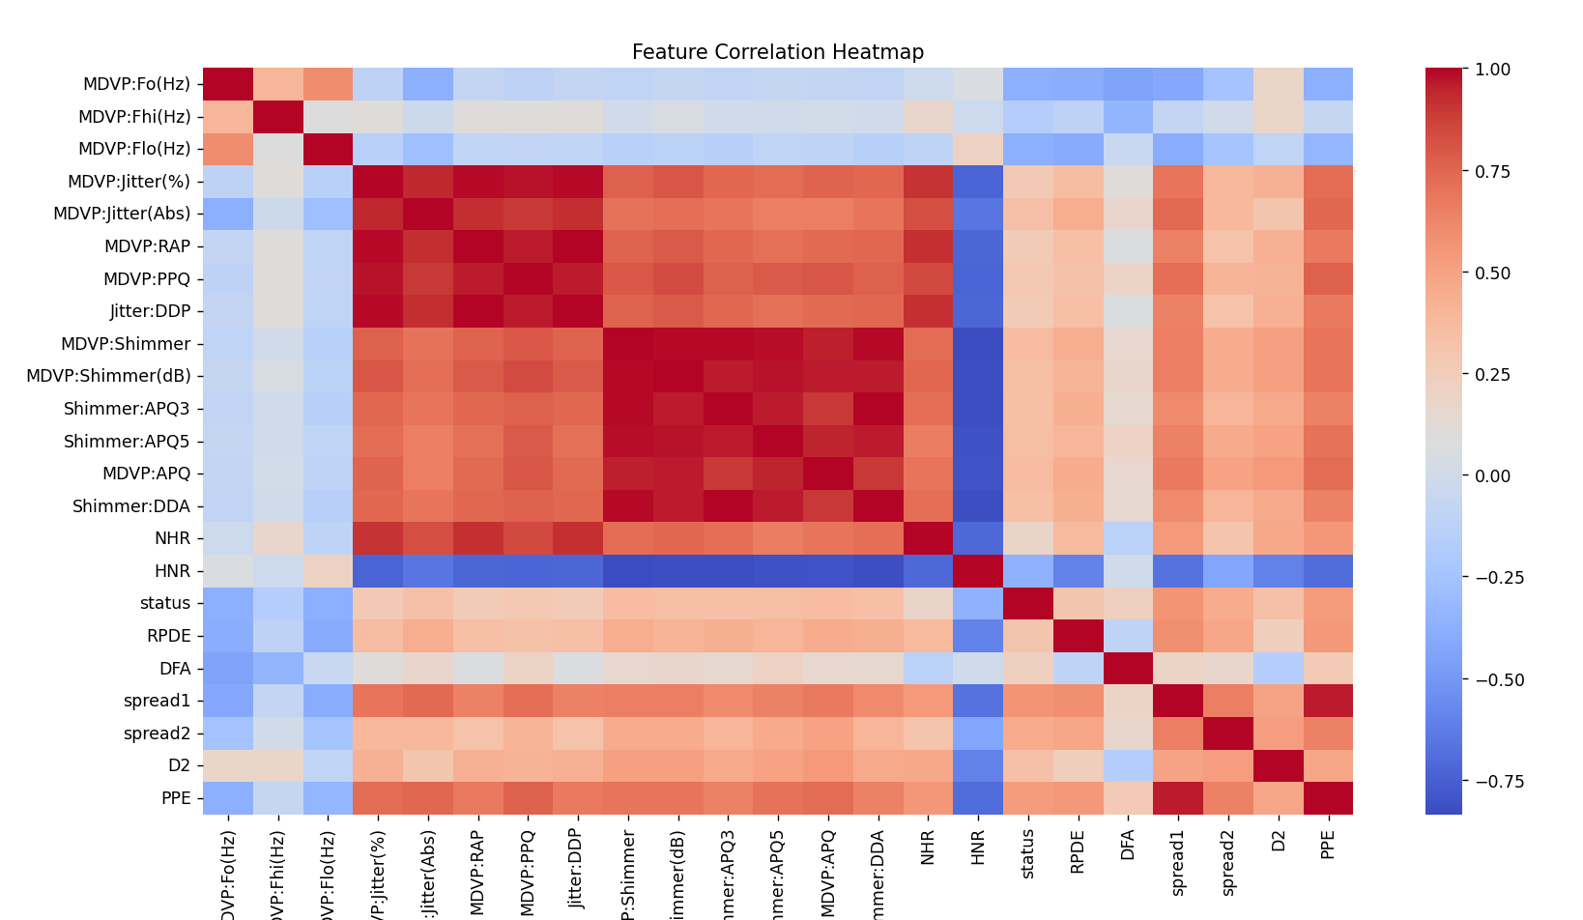
Figure 6. Correlation Heatmap of Input Features for Parkinson’s Disease Prediction.

C. Combined Model Performance Graphs
To facilitate more effective comparisons between models and provide visual insights, combined bar plots were created for each evaluation measure. The graphs allow users and stakeholders to quickly identify which model excels across all diseases.

Diabetes Forecasting Effectiveness
• CatBoost outperformed Random Forest and XGBoost in all metrics, achieving an accuracy of 84.50% along with strong recall and precision.
• Random Forest and XGBoost were alike but more unstable.
• This suggests that CatBoost is more reliable for early diabetes identification.
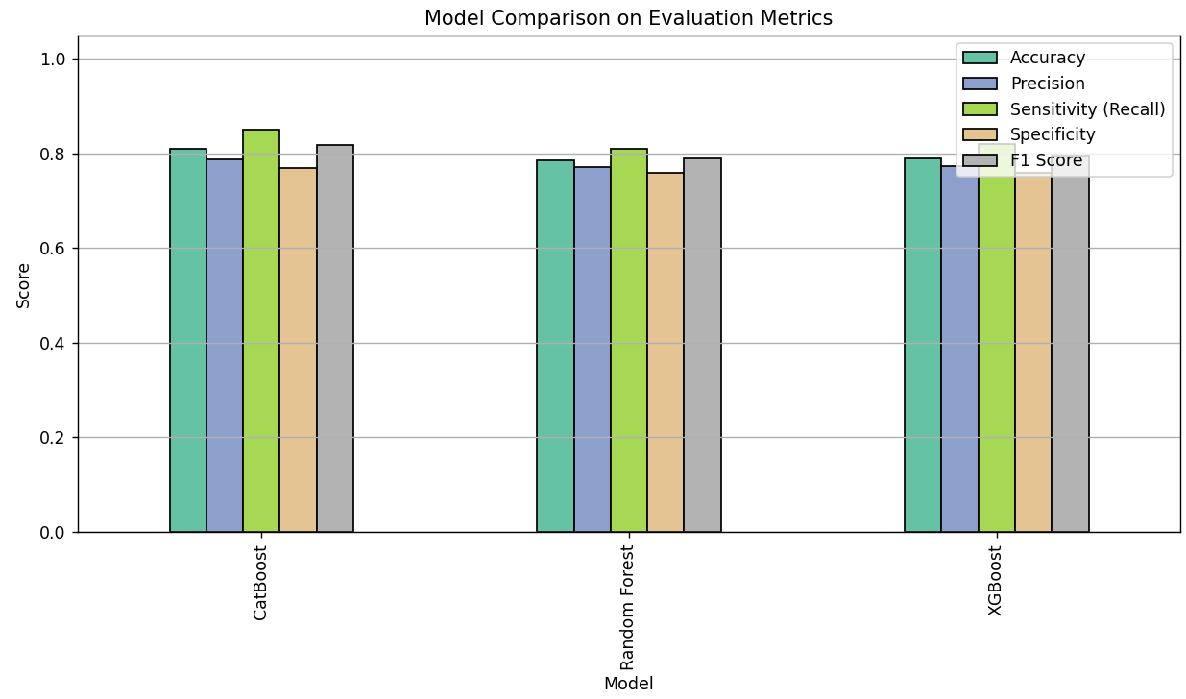
Figure 6. Comparison of Model Performance Metrics for Diabetes Prediction using CatBoost, Random Forest, and XGBoost.

Heart Disease Prediction Effectiveness
• CatBoost emerged on top with an accuracy of 93.44%, an improved F1-score, and strong recall.
• Random Forest and XGBoost showed moderate performance, but diminished sensitivity might lead to a rise in false negatives.
• Findings demonstrate the effectiveness of CatBoost in cardiovascular diagnosis.
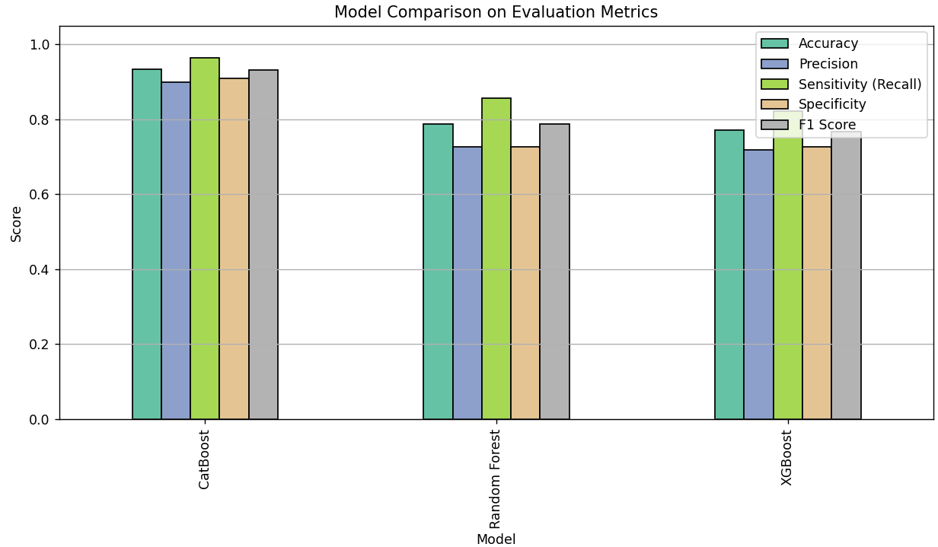
Figure 6. Comparison of Model Performance Metrics for Heart Disease Prediction using CatBoost, Random Forest, and XGBoost.

Parkinson's Disease Prediction Performance
• CatBoost had 94.87% accuracy, with outstanding precision and specificity, and hence the most reliable for Parkinson's prediction.
•Random Forest and XGBoost underperformed drastically compared to each other, both capped at 71.79% accuracy.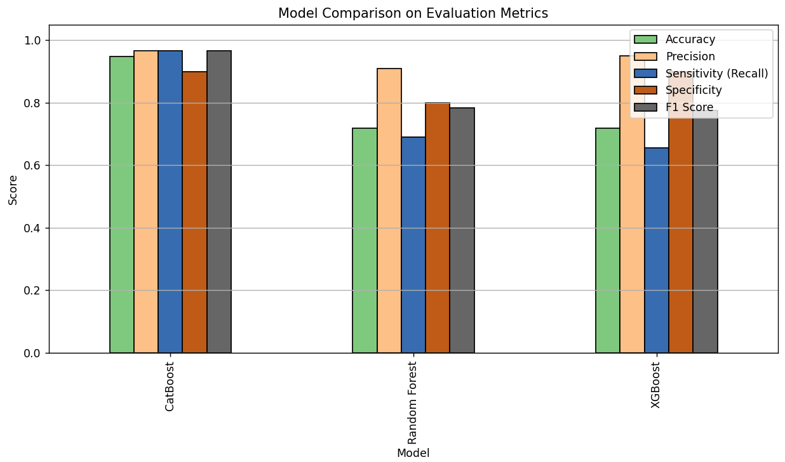
Figure 6. Comparison of Model Performance Metrics for Parkinson’s Disease Prediction using CatBoost, Random Forest, and XGBoost.

VII. CONCLUSIONS & FUTURE SCOPE

The development of a Multiple Disease Prediction System using CatBoost and Streamlit marks a significant step toward accessible and accurate health risk assessment. The project successfully demonstrates how machine learning can be leveraged to predict the likelihood of three critical diseases—heart attack, diabetes, and Parkinson’s disease based on structured health data. The use of CatBoost, a gradient boosting algorithm known for its superior performance on tabular data, ensures high prediction accuracy while reducing the need for extensive data preprocessing. Integrating this with Streamlit provides a clean and user-friendly web interface, making the system usable by both medical professionals and patients with minimal technical background.​
In the future, this system can be significantly enhanced by integrating with real-time health monitoring devices such as wearable sensors, enabling continuous health tracking and real-time alerts. The architecture is flexible enough to include more diseases such as liver disease or cancer, extending its utility. A web or mobile application interface can be developed to improve accessibility and usability for patients and healthcare providers alike. Deploying the system on cloud platforms like AWS, Azure, or Oracle Cloud would facilitate broader access and support real-time analytics. Further model optimization using deep learning or advanced ensemble techniques could improve prediction accuracy.
VIII. REFERENCES
[1] A. Abdalrada, H. A. Hussein, M. A. Mohammed, et al., "Machine learning models for prediction of co-occurrence of diabetes and cardiovascular diseases: a retrospective cohort study," Springer, 2022.
[2] A. Bharti, D. Soni, R. Kulkarni, and S. Singh, "Prediction of Heart Disease Using a Combination of Machine Learning and Deep Learning," Wiley, 2021.
[3] M. Baleshram, R. S. Raj, and N. D. Mahendran, "A Comprehensive Multiple Disease Forecasting Using Machine Learning Algorithms and Streamlit Interface," International Journal of Advanced Research in Engineering, Science and Management (IJARESM), vol. 10, no. 2, 2024.
[4] D. W. Kim, Y. Yoon, H. S. Lee, and K. H. Park, "Machine learning based risk prediction for Parkinson's disease with nationwide health screening data," PubMed Central, 2022.
[5] M. Ahsan and A. Siddique, "Machine Learning-Based Heart Disease Diagnosis: A Systematic Literature Review," arXiv preprint arXiv:2106.05031, 2021.
[6] N. Surya, M. R. Iyer, and R. B. Sharma, "Enhanced Breast Cancer Tumor Classification using MobileNetV2: A Detailed Exploration on Image Intensity, Error Mitigation, and Streamlit-driven Real-time Deployment," arXiv preprint arXiv:2301.00715, 2023.
[7] A. Gupta, P. Singh, and M. Yadav, "PCA-RF: An Efficient Parkinson's Disease Prediction Model based on Random Forest Classification," arXiv preprint arXiv:2202.04229, 2022.
[8] M. Haque, F. Rahman, and S. Ahmed, "Improving Chronic Kidney Disease Detection Efficiency: Fine Tuned CatBoost and Nature-Inspired Algorithms with Explainable AI," arXiv preprint arXiv:2501.00452, 2025.
[9] Y. Bai, X. Zhang, Y. Yu, J. Li, and Z. Liu, "Clinical Feature-Based Machine Learning Model for 1-Year Mortality Risk Prediction of ST-Segment Elevation Myocardial Infarction in Patients with Hyperuricemia: A Retrospective Study," PubMed Central, 2021.
[10] H. Dai, J. Chen, and M. Zhang, "Machine learning in precision diabetes care and cardiovascular risk prediction," Cardiovascular Diabetology, vol. 22, no. 1, pp. 112–124, 2023.
[11] A. Kolesnikov, T. Ryabinin, and A. Zheltonozhskii, "CatBoost for big data: an interdisciplinary review," Journal of Big Data, vol. 7, no. 1, pp. 1–22, 2020.
[12] R. Sharma and V. Bansal, "Multiple Disease Prediction Using Machine Learning Algorithms," ScienceDirect, 2023.
[13] S. N. Rao and V. Gupta, "Chronic Kidney Disease Prediction Using Boosting Techniques Based on Clinical Parameters," PubMed, 2023.
[14] L. Chen, W. Xu, and D. Wang, "A Robust Framework for Enhancing Cardiovascular Disease Risk Prediction Using an Optimized Category Boosting Model," PubMed, 2024.
[15] A. R. Al-Aidaroos, M. S. Islam, and A. A. Alghamdi, "Multi-disease prediction using LSTM recurrent neural networks," Expert Systems with Applications, vol. 177, pp. 114905, 2021.
[16] H. F. El-Sofany, Predicting Heart Diseases Using Machine Learning and Different Data Classification Techniques, College of Computer Science, King Khalid University, 2024.

