Employee Schema

- Employees(emp_id, name, department, salary, joining_date)
- Departments(dept_id, dept_name)
- Projects(project_id, project_name, emp_id)
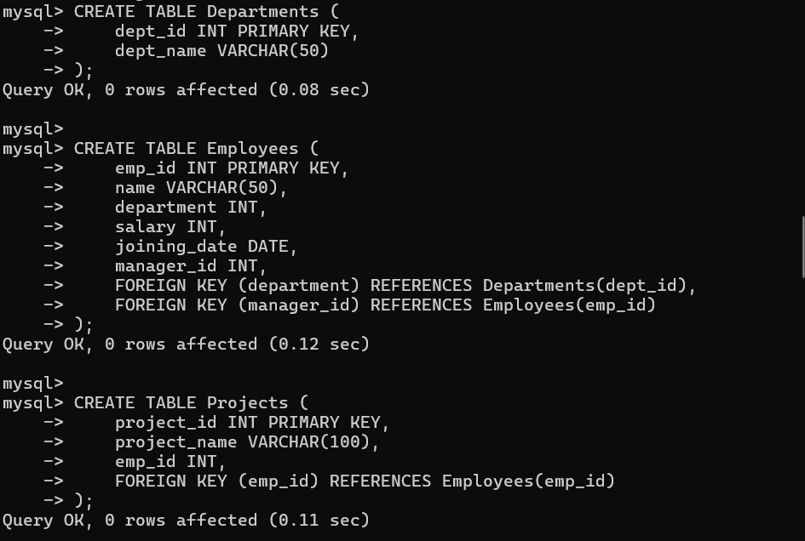
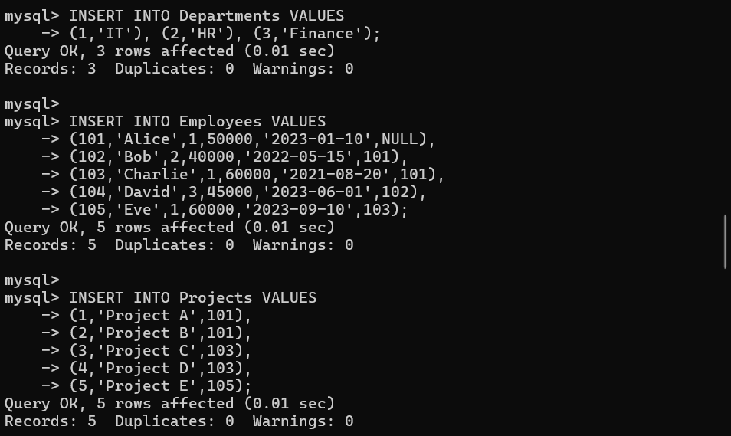

- How do you find the second highest salary in a table?

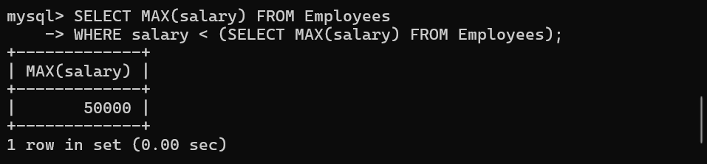

- How do you find the third highest salary of employees?

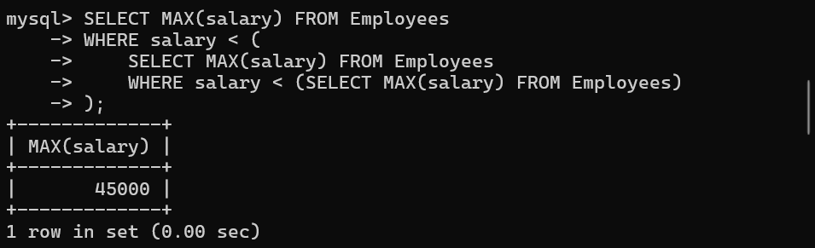

- How do you identify duplicate records in a table?

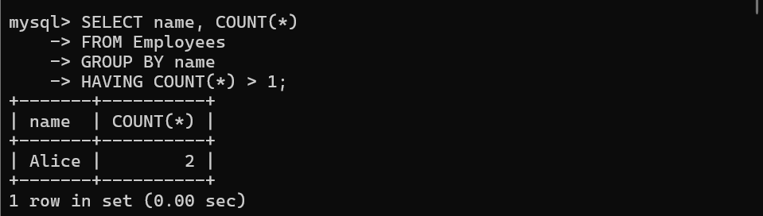

- How do you retrieve employees who earn more than the average salary?

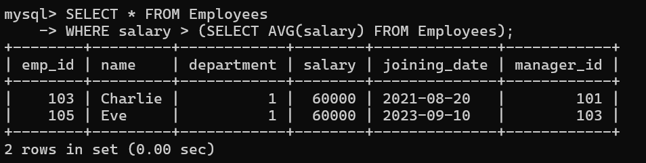
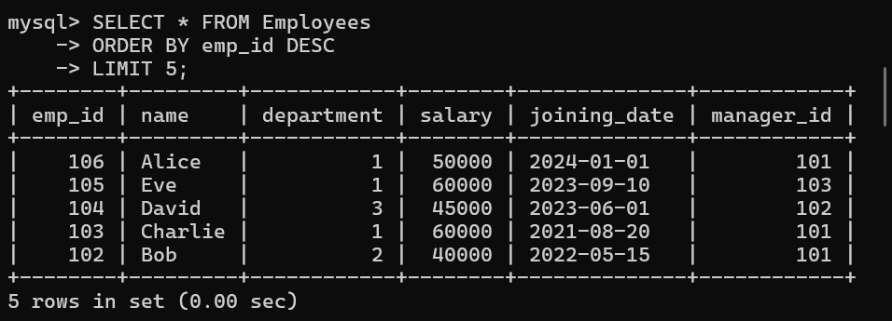
- How do you retrieve the last 5 records from a table?

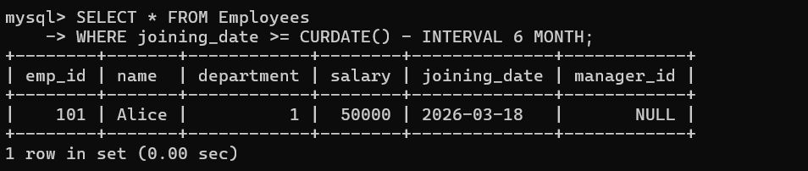
- How do you find employees who joined in the last 6 months?

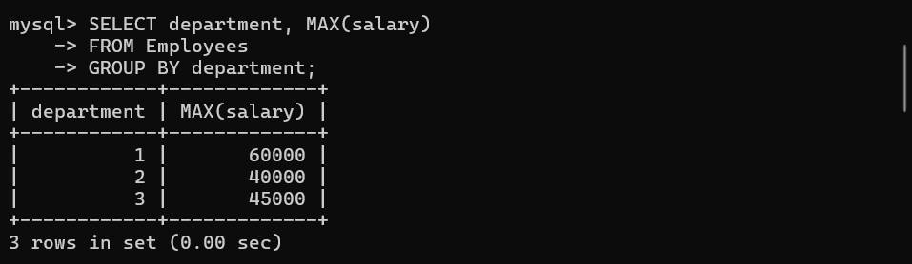
- How do you find the maximum salary in each department?

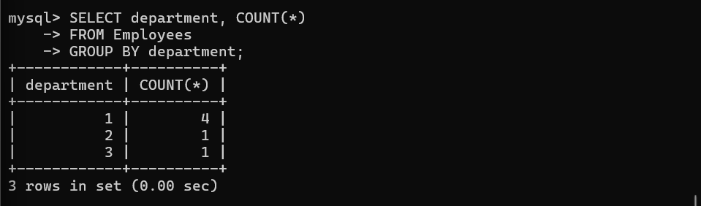
- How do you find the number of employees in each department?

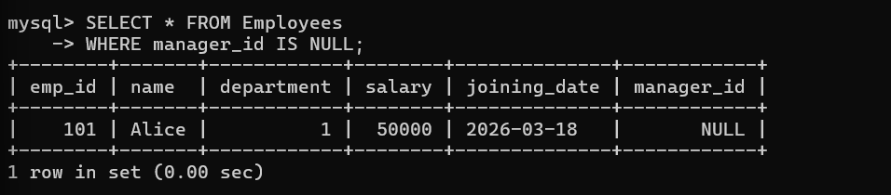
- How do you find employees who do not have a manager?

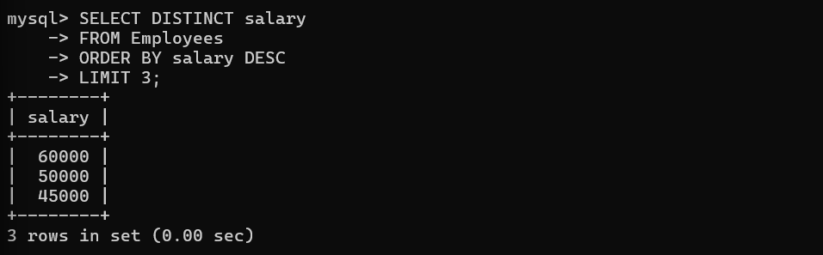
- How do you retrieve the top 3 highest salaries from a table?

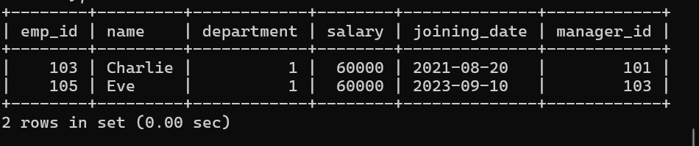
- How do you find employees who have the same salary?

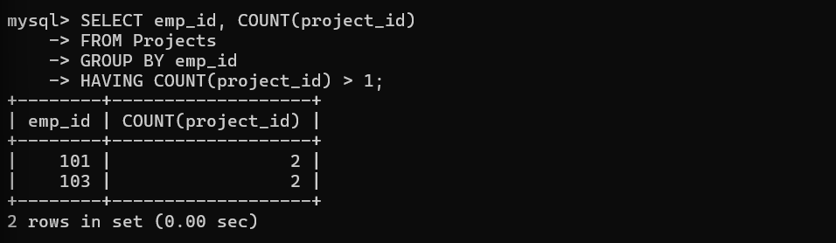
- How do you find employees working on multiple projects?

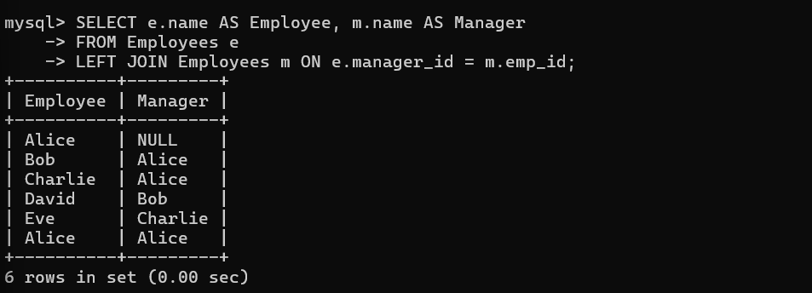
- How do you display employees along with their manager names?

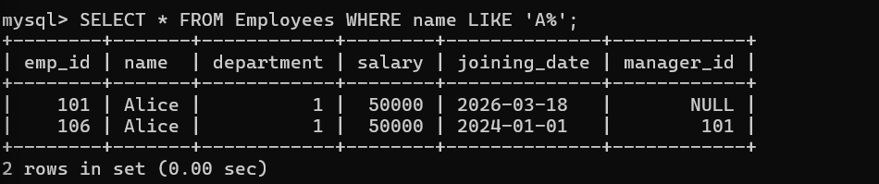
- How do you retrieve employees whose name starts with a specific letter (e.g., 'A')?

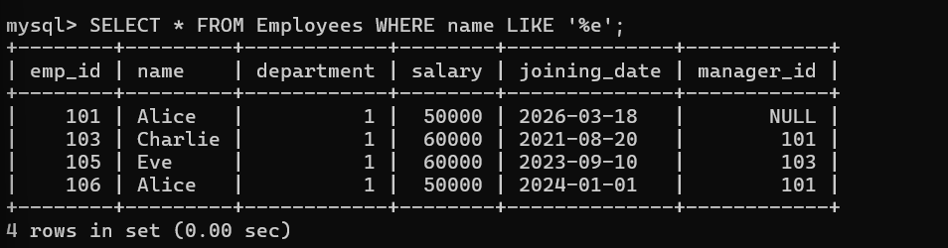
- How do you retrieve employees whose name ends with a specific letter?

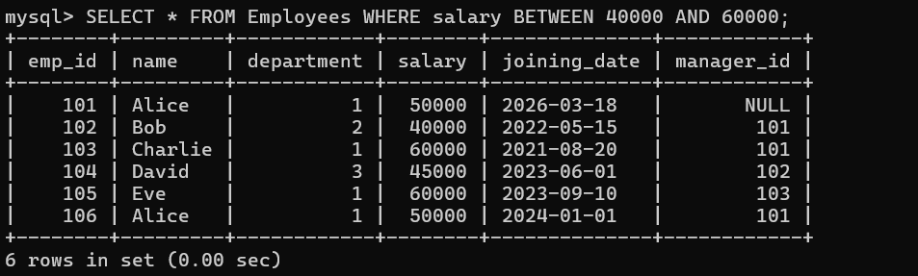
- How do you retrieve employees whose salary is between two values?

- How do you update the salary of a specific employee?


- How do you delete duplicate records from a table?

- How do you create an index to improve query performance?

- How do you create a view for employees in a specific department?

