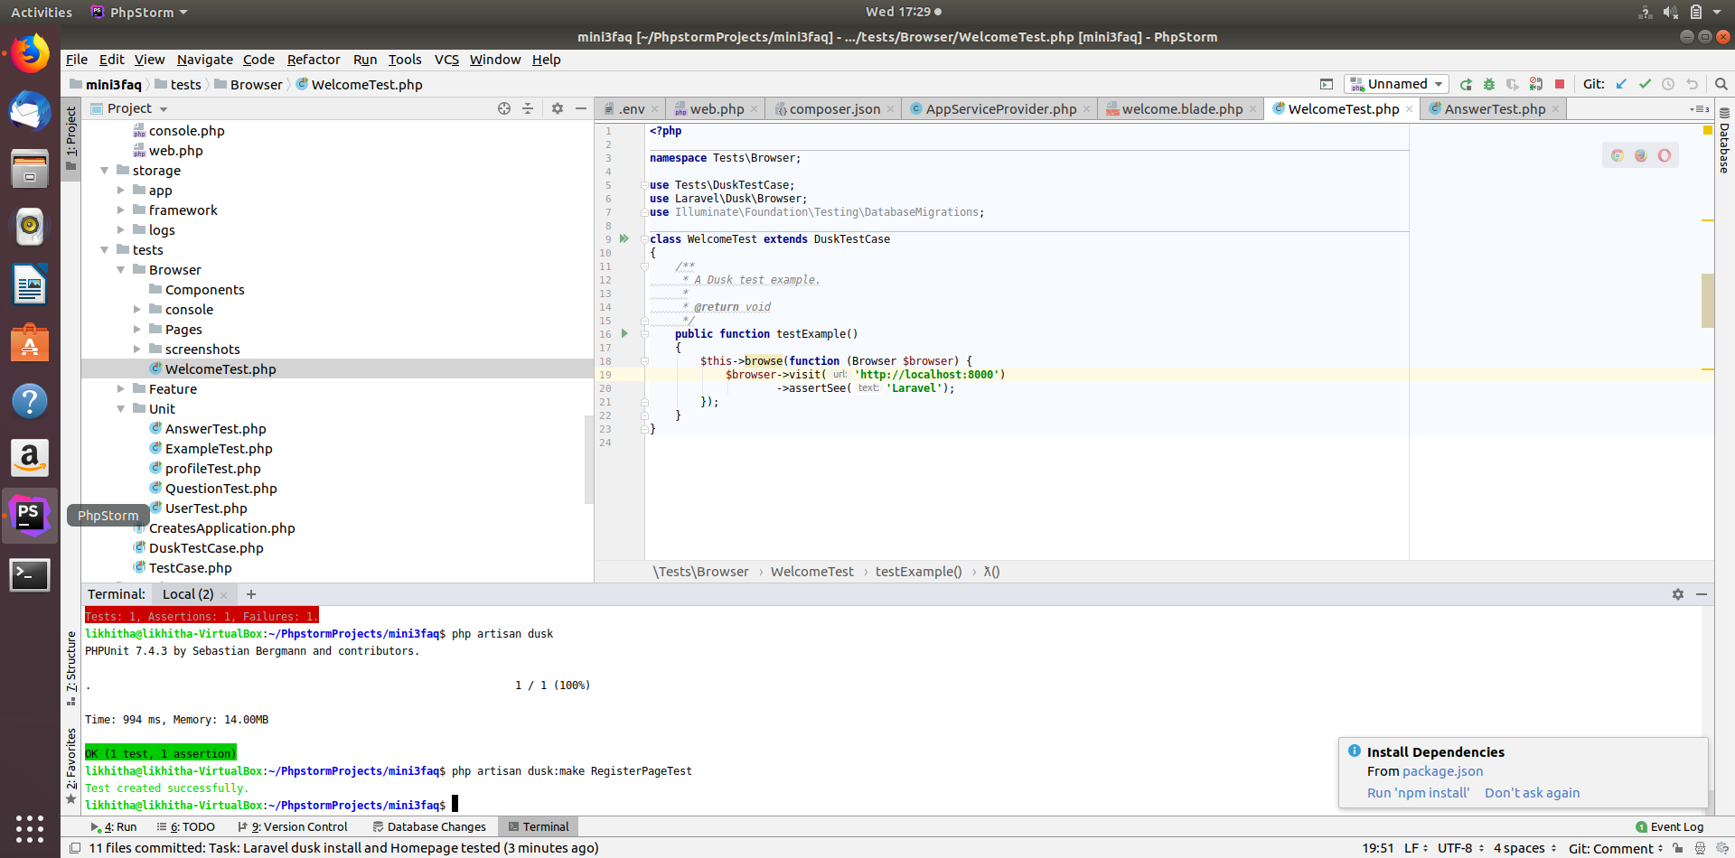
Welcome Page Test(Commit: Task: Laravel dusk install and Homepage tested)

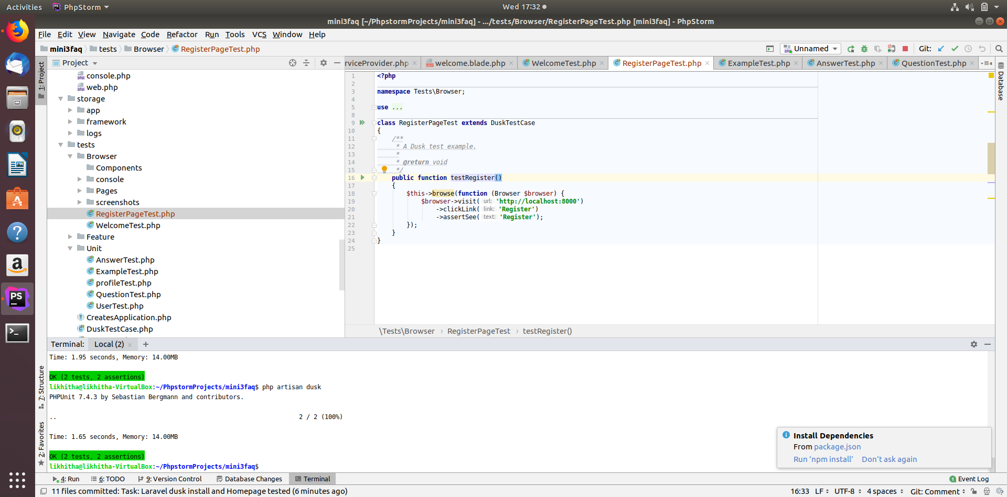
Register Page Test(Commit: Task: Registerpage tested )

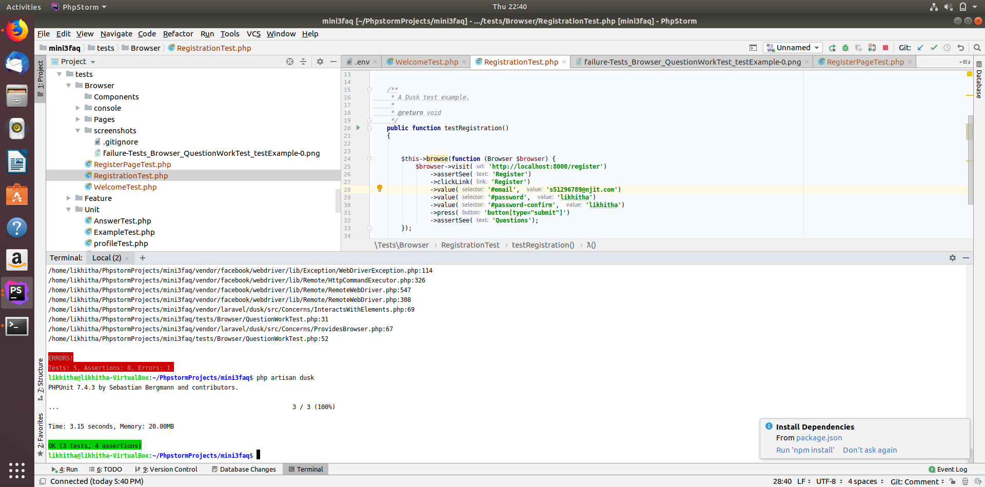
Registration Test(Task: Registration work test )

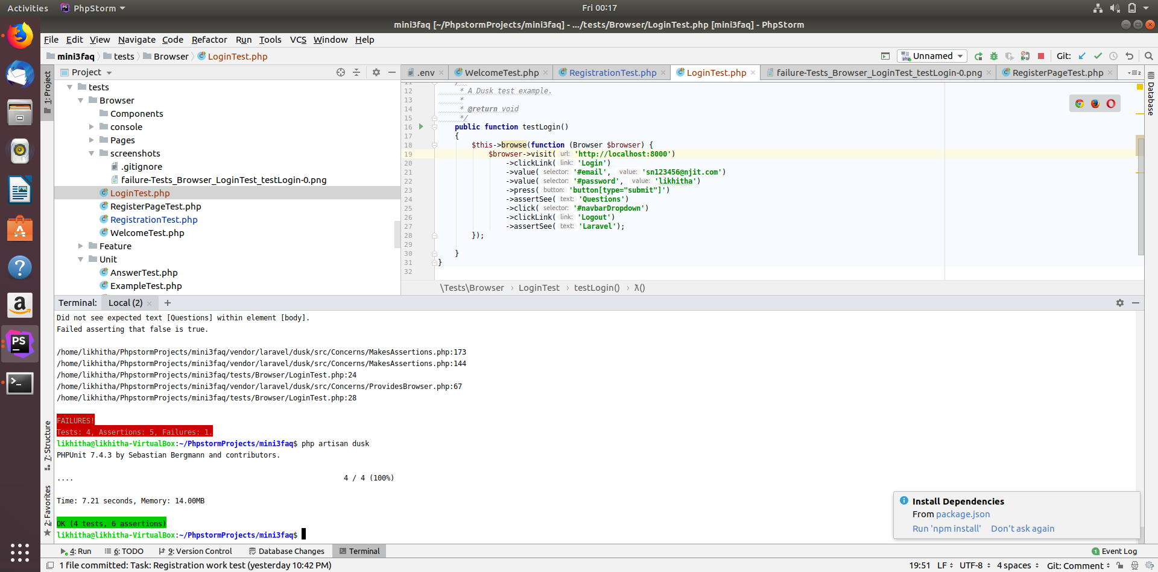
Login Process Test(Task: Login Work Test )

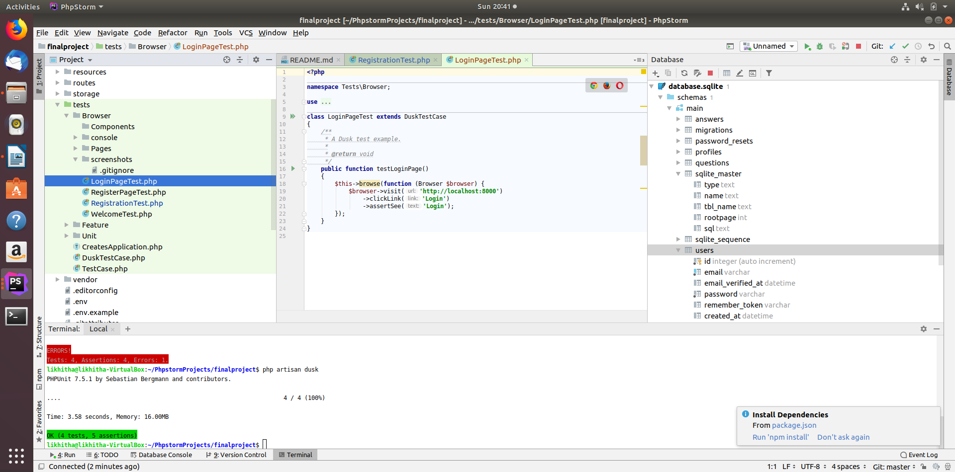
Login Page Test(Commit: Task:Task:Login Page Tested )

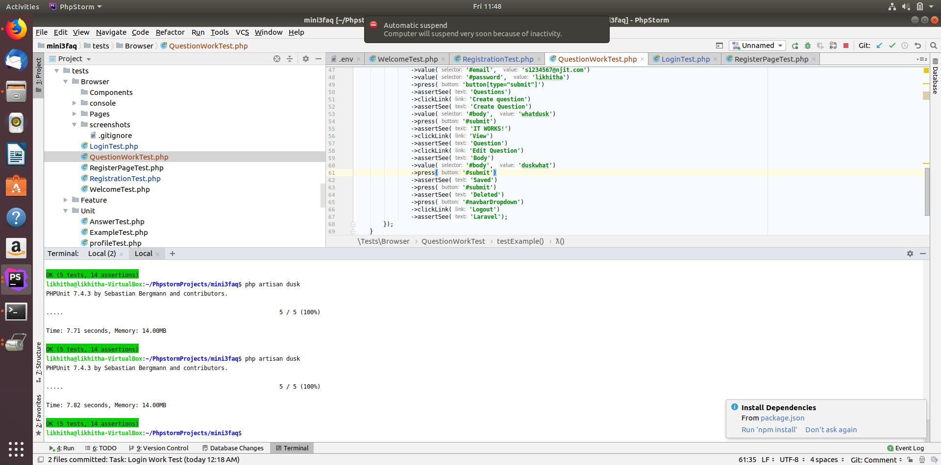
Questions Process Test(Commit: Task: Questions functions Working Test)

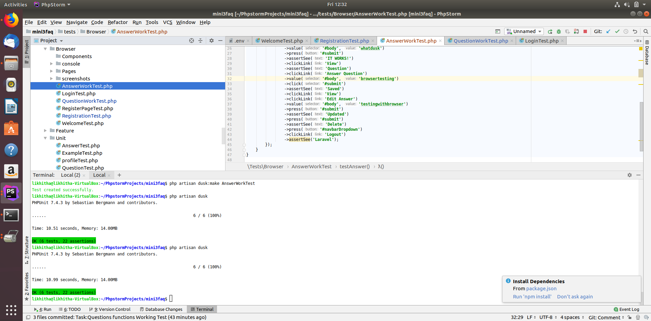
Answers Process Test(Commit: Task:Answers functions Working Test )

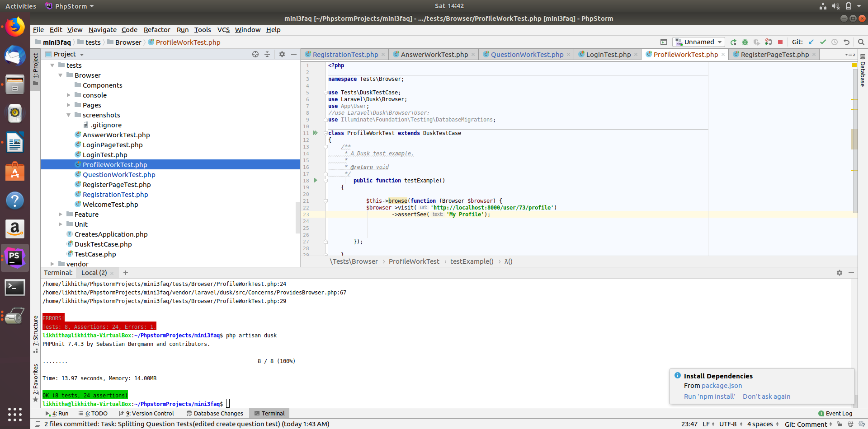
Profile Test(Commit: Task:Profile Display Test)

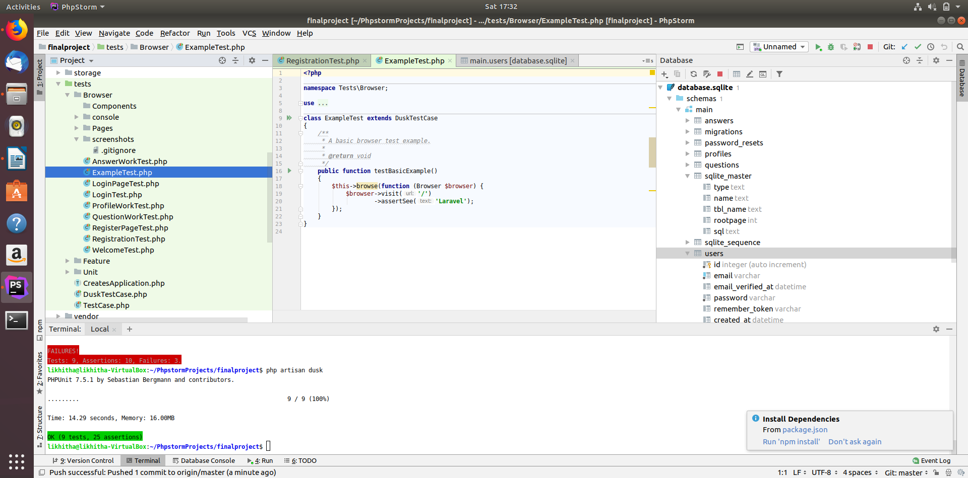
Example Test(Task: Default test added and tested )

Overall tests:

