ASSIGNMENT-2

2) Write a query to display all the records from the table.

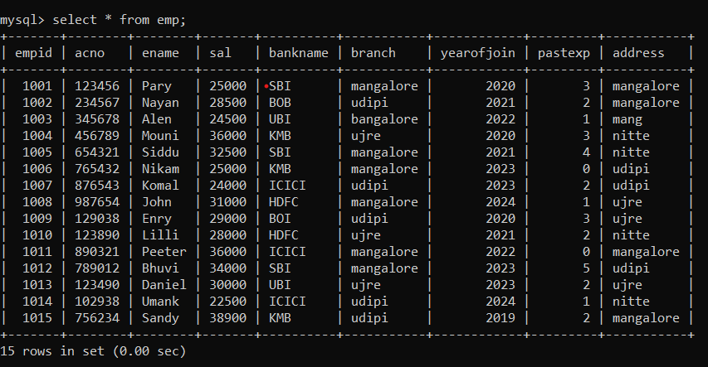

3) Write a query to display all the records from the table, whose branch and address both are the same.

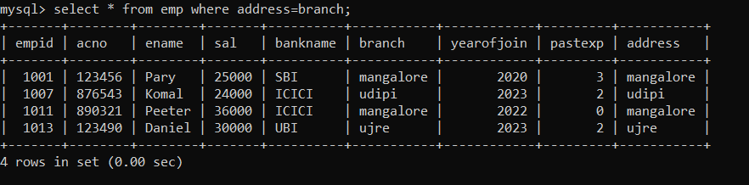

4) Write a query to display employee acno, ename, bankname, and branch details whose salary is more than 30000.

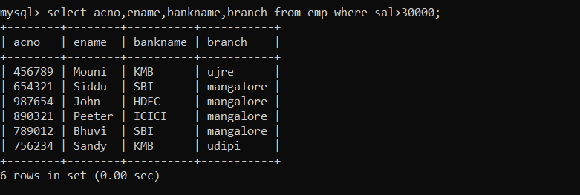

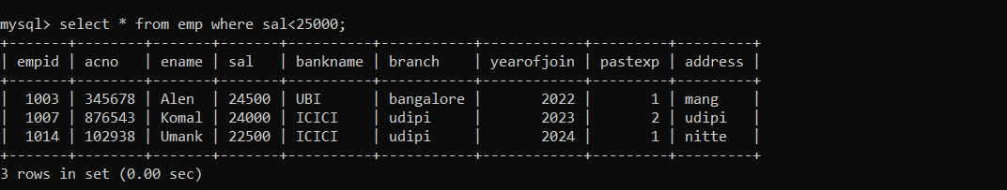5) Write a query to display employee records who are earning less than 25000

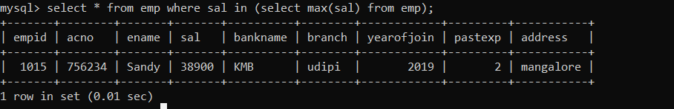6) Write a query to display the employee record of who is earning the highest salary.

7) Write a query to display the employee name who is earning less salary.

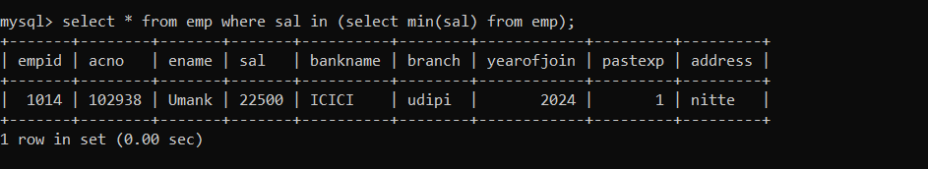

8) Write a query to the employee ename, acno, and bankname who are earning in between 25000 and 32000 (both are included).

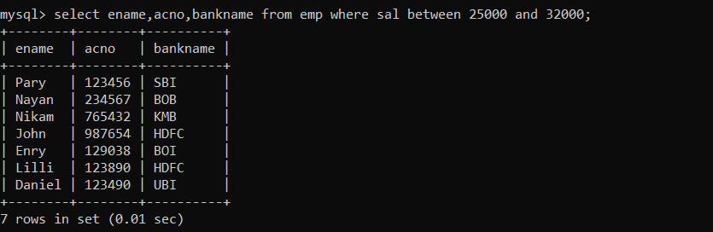

9) Write a query to display eid, ename, sal, acno who have an account in SBI bank.

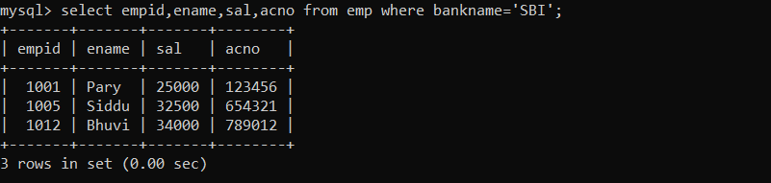

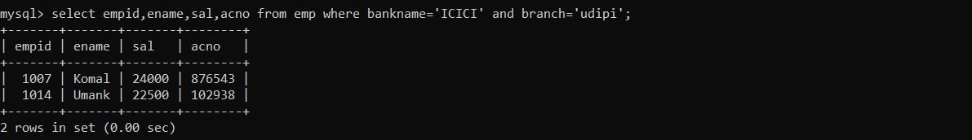10) Write a query to display eid, ename, sal, acno who have an account in ICICI bank and from udipi branch.

11) Write a query to display eid, ename, sal, acno who have joined before 2023(2023 is excluded).

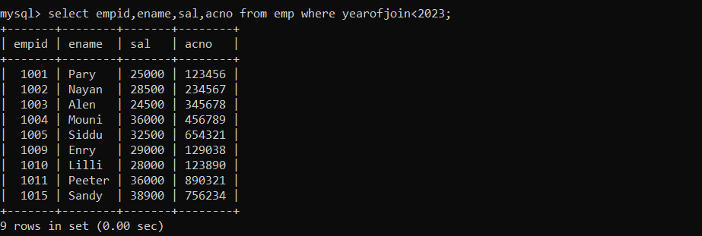

12) Write a query to display eid, ename, sal, acno, bankname and branch who have an account in SBI bank and joined after 2022.

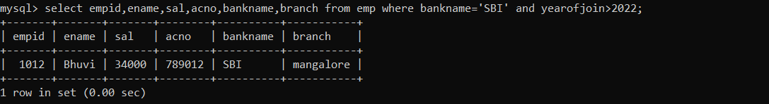

13) Write a query to display eid, ename, sal, acno,address who have joined early from mangalore.

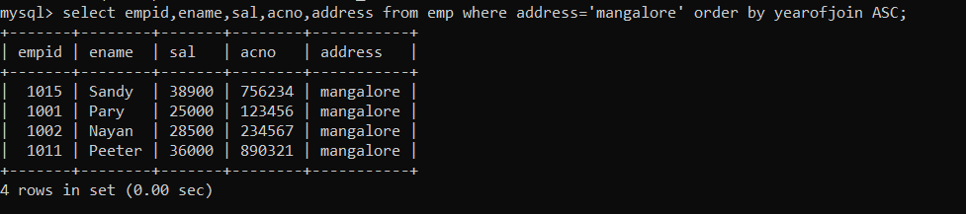

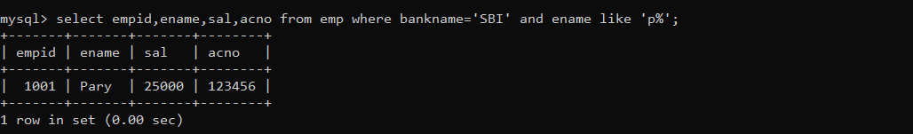14) Write a query to display eid, ename, sal, acno who have an account in SBI bank and whose name starts with ‘p’.

15) Write a query to display the number of employees having the same salary and that salary from the table.

