ASSIGNMENT -5

1. Write an HTML code to display images as in the following given output by using table and image tags.

<!DOCTYPE html>

<html lang="en">

<head>

<meta charset="UTF-8">

<meta name="viewport" content="width=device-width, initial-scale=1.0">

<title>Happy Family Picture</title>

</head>

<body>

<table border="2" >

<tr><td><img src="mother.png" width="230" height="300"></td><td rowspan="2"><img src="FullFam.jpg" height="600" width="500"></td><td><img src="Dog.png" height="300" width="230"></td></tr>

<tr><td><img src="daughter.png" height="300" width="230"></td><td><img src="Father.png" width="230" height="300"></td></tr>

<tr><th colspan="3">Happy Family</th></tr>

</table>

</body>

</html>

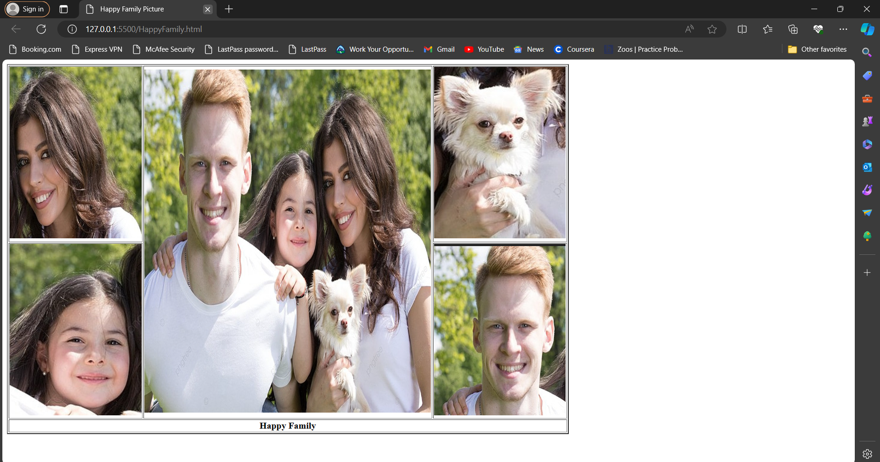**OUTPUT:**

1. Write an HTML document table with lists of veg food and Non-veg with unordered lists.

<!DOCTYPE html>

<html lang="en">

<head>

<meta charset="UTF-8">

<meta name="viewport" content="width=device-width, initial-scale=1.0">

<title>Veg or Non-Veg</title>

</head>

<body>

<table border="1">

<tr><th>Veg</th><th>Non-Veg</th></tr>

<td>

<ul type="square">

<li>Pulav</li>

<li>Ghee Rice</li>

<li>Idli-Dosa</li>

<li>Rajma Chawal </li>

<li>Chana Masala</li>

</ul>

</td>

<td>

<ul type="disk">

<li>Egg Kurma</li>

<li>Chicken Kebab</li>

<li>Fish Curry</li>

<li>Chicken Biriyani</li>

<li>Keema Samosa</li>

</ul>

</td>

</table>

</body>

</html>

**OUTPUT:**

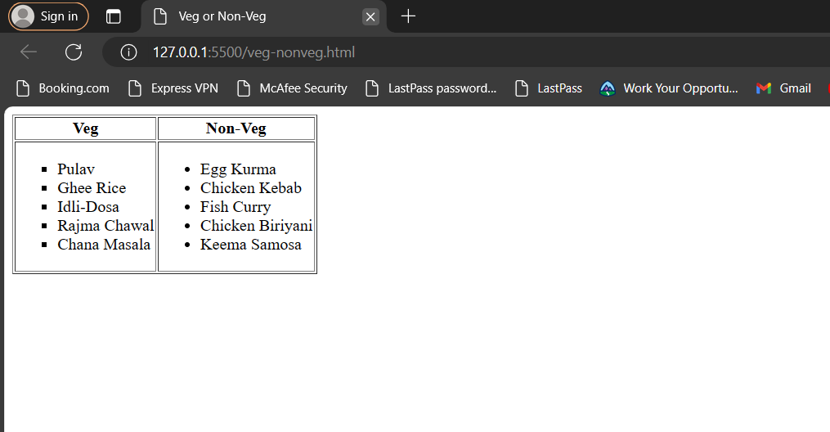

1. Write an HTML document to play audio and video files.

<!DOCTYPE html>

<html lang="en">

<head>

<meta charset="UTF-8">

<meta name="viewport" content="width=device-width, initial-scale=1.0">

<title>Audio and video</title>

</head>

<body>

<h1>Audio Files</h1>

<h4>This is Lord krishna's Flute Music</h4>

<p>You all will surely love this music.This gives us immense joy and Happiness.</p>

<audio src="flute.mpeg" controls>Flute Music</audio>

<h4>This is My favoriate Music</h4>

<p>You all will surely love this music too.This gives us immense joy and Happiness.</p>

<audio src="myfav.mpeg" controls>Flute Music</audio>

<br>

<h1>Video File</h1>

<h4>These are my favoriate People</h4>

<Video src="Us.mp4" controls height="240">Flute Music</Video>

</body>

</html>

**OUTPUT:**

