ASSIGNMENT-6

Register.html:

<!DOCTYPE html>

<html lang="en">

<head>

<meta charset="UTF-8">

<meta name="viewport" content="width=device-width, initial-scale=1.0">

<title>Register Page</title>

<link rel="stylesheet" href="Register.css"><!--used to link the css page--><!--external css-->

</head>

<body>

<div class="part1" id="part1_id"></div>

<div class="part2" id="part2_id">

<h1>Register Page</h1>

<form action="/Login.html">

<label for="name">Enter Your UserName</label>

<input type="text" placeholder="Enter your Name" name="Name" required><br><br>

<label for="name">Enter Your Email</label>

<input type="email" placeholder="Enter your Email" name="Email" required><br><br>

<label for="name">Enter Your Password</label>

<input type="password" placeholder="Enter your Password" name="Name" required><br><br>

<button type="submit">Submit</button>

</form>

</div>

</body>

</html>

Register.css:

.part2{

padding-left: 100px;

height:250px;

width:200px;

padding: 60px;

border:6px solid black;

}

.part1{

padding-left: 100px;

height:250px;

width:200px;

padding: 60px;

border:6px solid black;

}

#part1_id{

background-color: rgb(87, 153, 180);

position:absolute;

left: 380px;

top: 200px;

background-image: url(Register.jpg);

background-size: cover;

}

#part2_id{

background-color: rgb(94, 166, 192);

position:absolute;

left: 700px;

top: 200px;

}

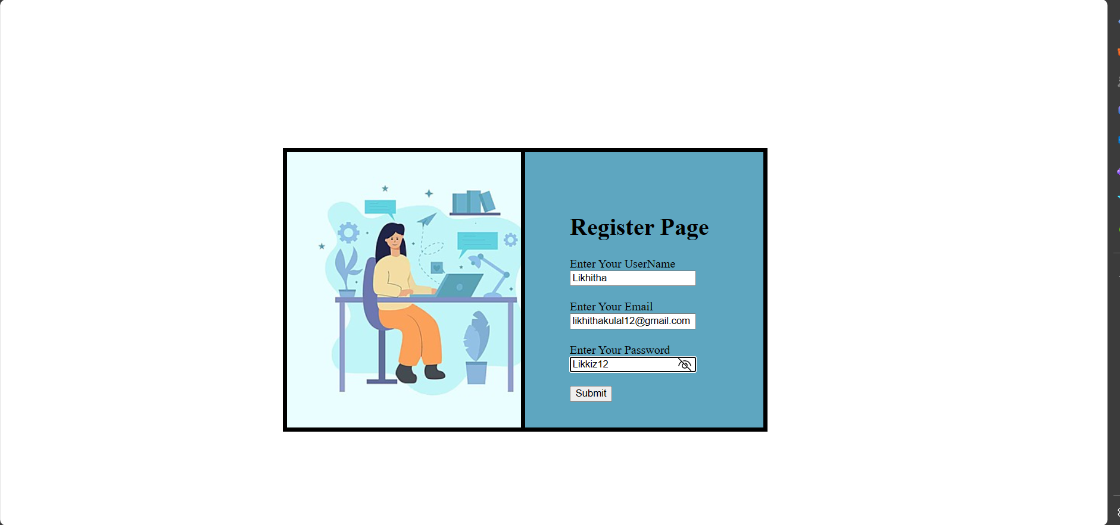

Login.html:

<!DOCTYPE html>

<html lang="en">

<head>

<meta charset="UTF-8">

<meta name="viewport" content="width=device-width, initial-scale=1.0">

<title>Login Page</title>

<link rel="stylesheet" href="Login.css"><!--used to link the css page--><!--external css-->

</head>

<body>

<div class="part1" id="part3_id"></div>

<div class="part2" id="part4_id">

<h1>Login Page</h1>

<form >

<label for="name">Enter Your Email</label><br>

<input type="email" placeholder="Enter your Email" name="Email" required><br><br>

<label for="name">Enter Your Password</label><br>

<input type="password" placeholder="Enter your Password" name="Email" required><br><br>

<input type="submit">

</form>

</div>

</body>

</html>

Login.css:

.part2{

padding-left: 100px;

height:200px;

width:200px;

padding: 60px;

border:6px solid black;

}

.part1{

padding-left: 100px;

height:200px;

width:200px;

padding: 60px;

border:6px solid black;

}

#part3_id{

background-color: rgb(87, 153, 180);

position:absolute;

left: 380px;

top: 200px;

background-image: url(Register.jpg);

background-size: cover;

}

#part4_id{

background-color: rgb(94, 166, 192);

position:absolute;

left: 700px;

top: 200px;

}

