Task 3: Unit Testing and Logging in Product API

Java Backend Development Internship – InternSpark
Name: Karakamukkala Matam Likhitha Gowri
Technology Stack: Java, Spring Boot, Spring Data JPA, JUnit 5, Mockito, SLF4J, Logback, Maven, IntelliJ IDEA
Objective
The objective of this task is to improve the reliability and maintainability of the Product Management REST API by implementing unit testing and application logging. Unit tests were written using JUnit 5 and Mockito to verify service layer functionality, while SLF4J with Logback was integrated to generate application logs for important operations.
Technologies Used
- Java 17
- Spring Boot
- Spring Data JPA
- MySQL
- JUnit 5
- Mockito
- SLF4J
- Logback
- Maven
- IntelliJ IDEA

Features Implemented
Unit Testing
Implemented unit tests for the Product Service layer using JUnit 5 and Mockito. Repository methods were mocked using Mockito to test business logic independently without connecting to the database.
The following test cases were implemented:
- Save Product
- Get All Products
- Get Product By ID
- Update Product
- Delete Product
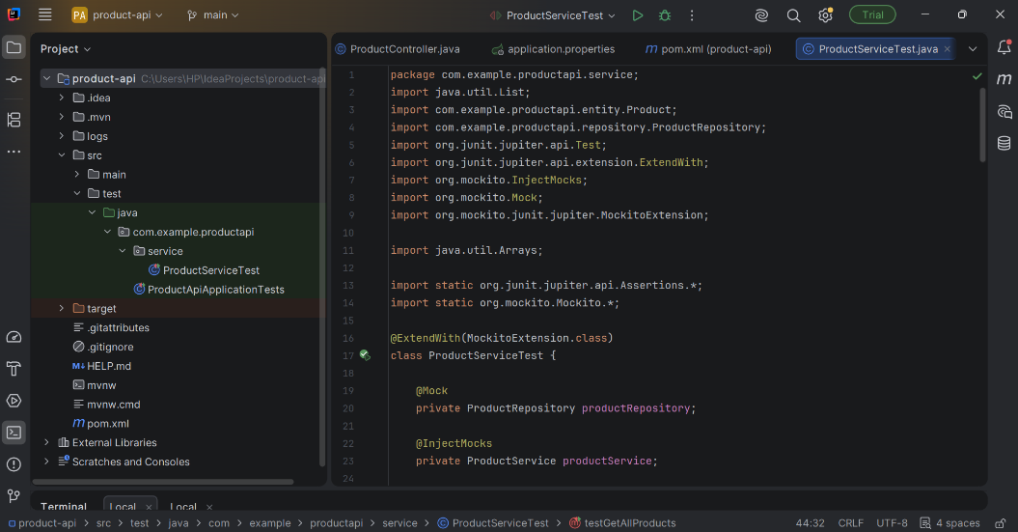
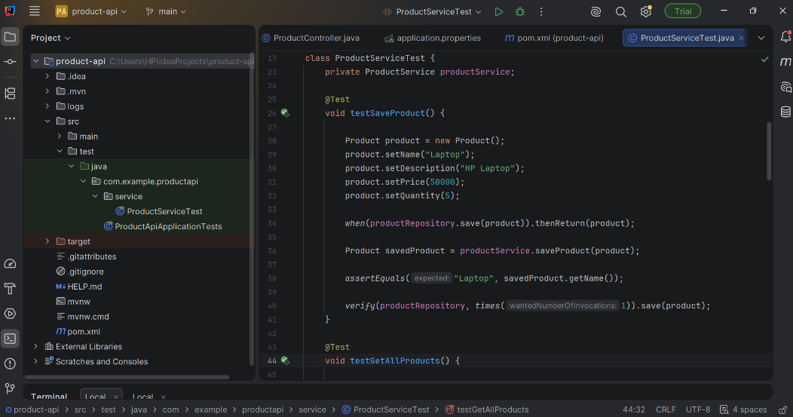
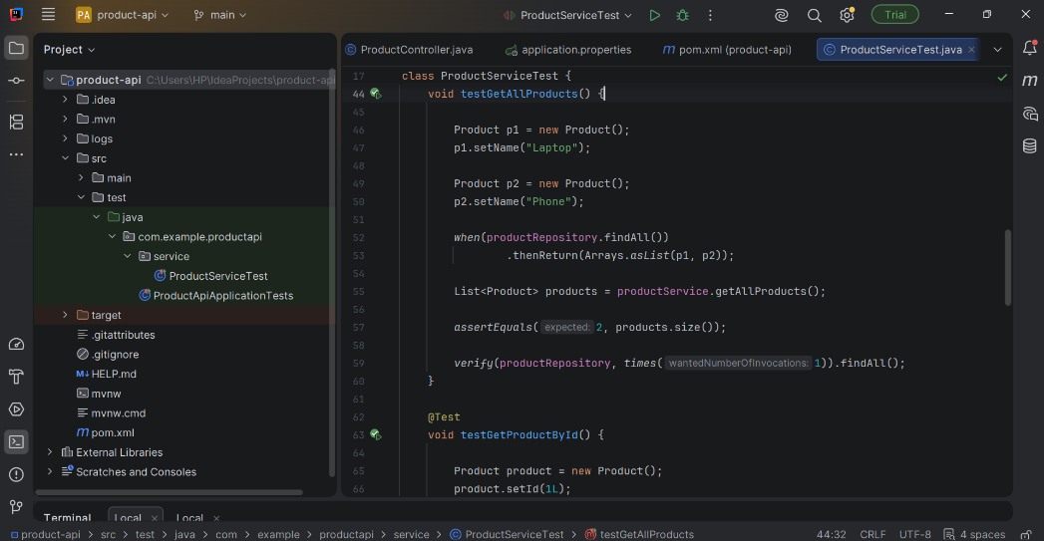
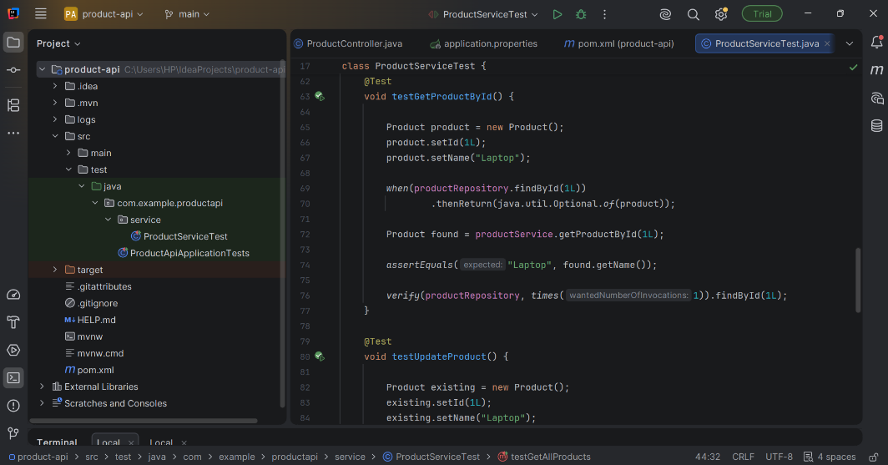
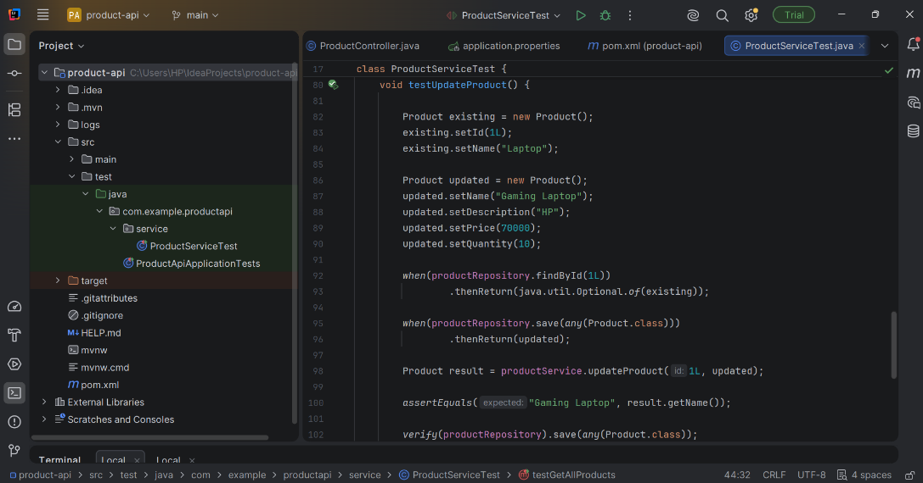
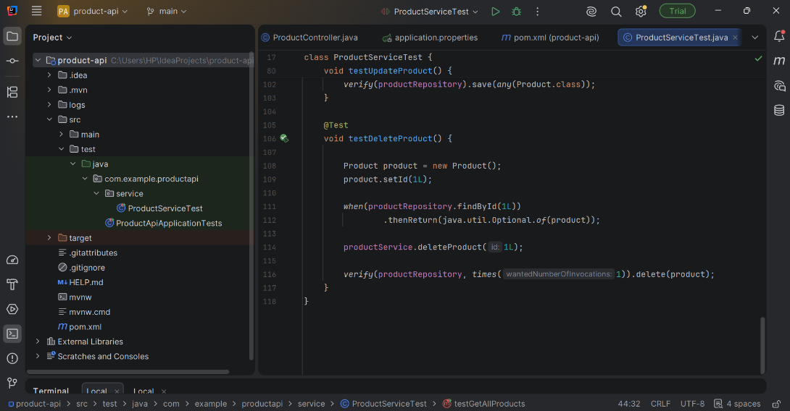

Application Logging
Implemented application logging using SLF4J Logger and Logback.
Logging statements were added for the following operations:
- Product Creation
- Fetching Products
- Updating Products
- Deleting Products
- Successful Completion of Operations
This helps monitor application behavior and simplifies debugging.
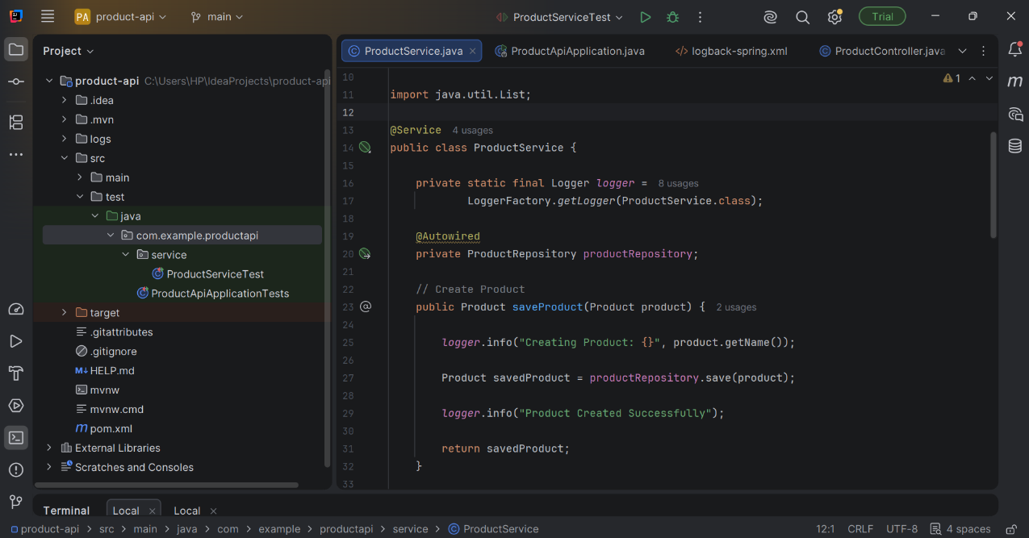
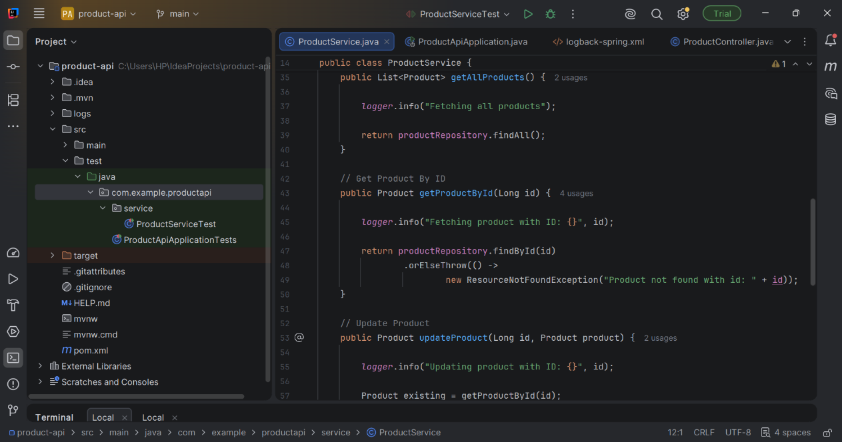
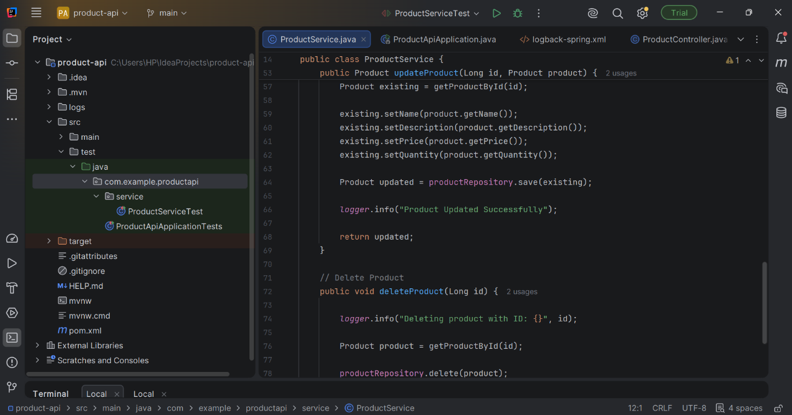
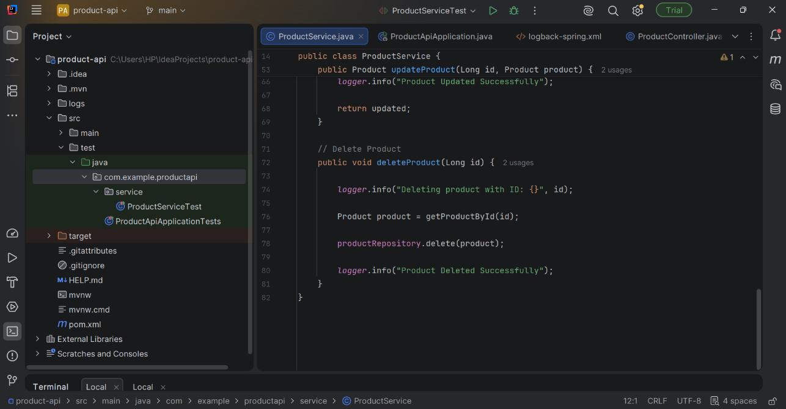

Logback Configuration
Configured Logback using the logback-spring.xml file.
The configuration records application logs and stores them in the application.log file while also displaying logs in the console.
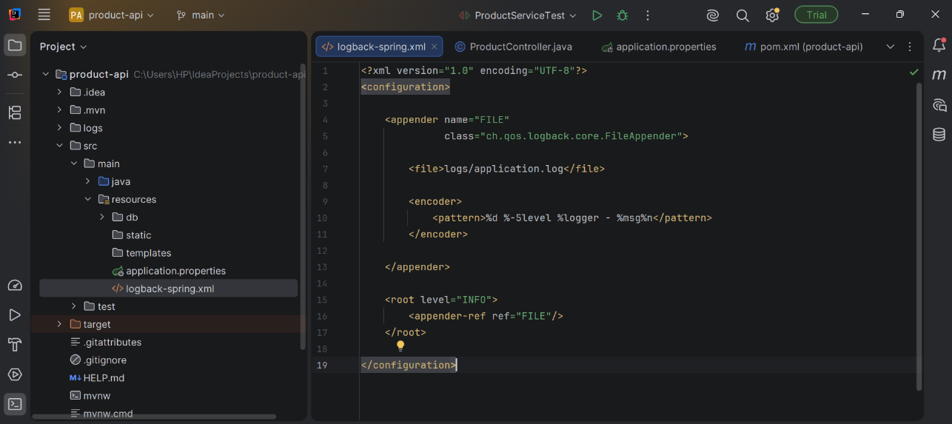
Console Output
After executing the application and unit tests, the console displays INFO logs for every major operation.
Example operations logged include:
- Creating Product
- Product Created Successfully
- Fetching Product
- Updating Product
- Product Updated Successfully
- Deleting Product
- Product Deleted Successfully
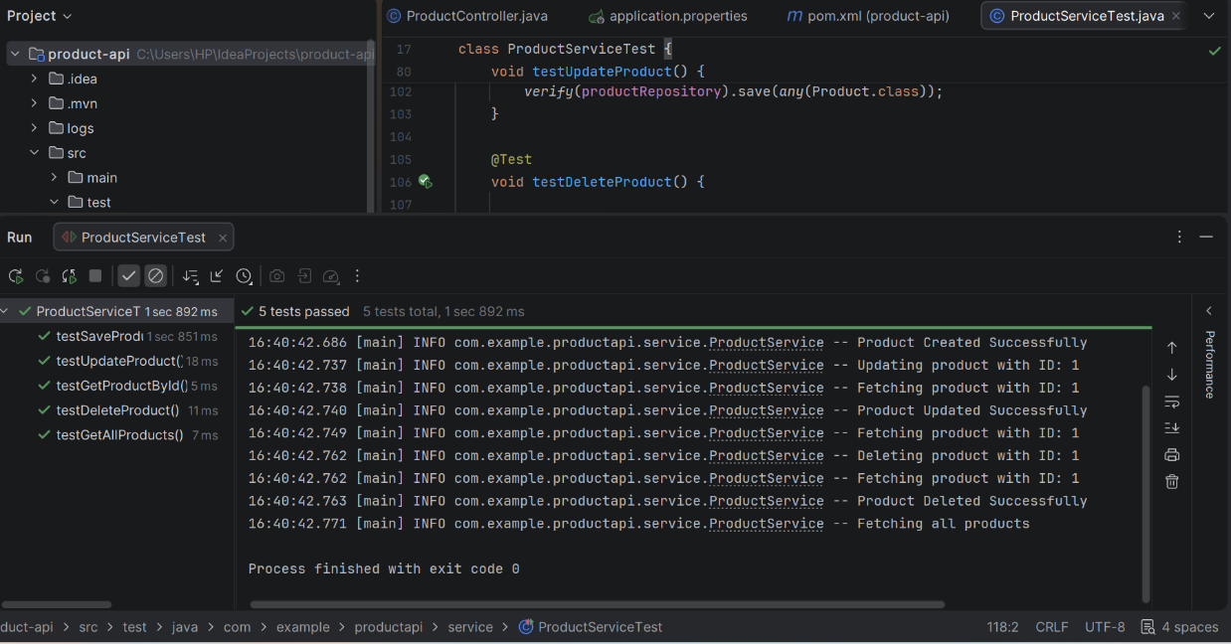
Application Log File
All application logs are stored inside the logs/application.log file.
This log file helps monitor API execution and troubleshoot issues efficiently.
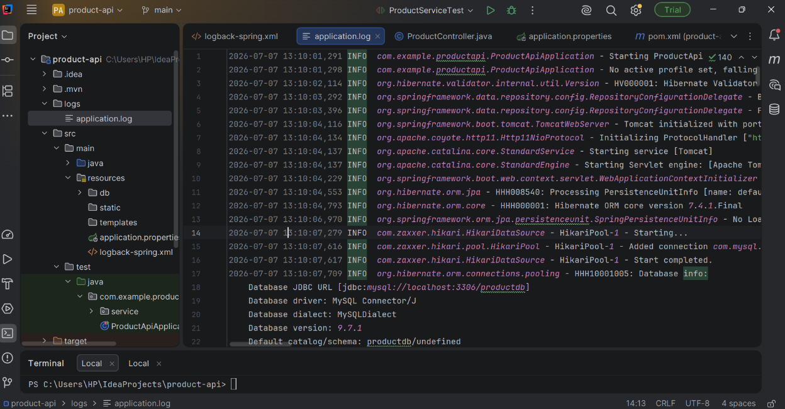

Unit Test Execution
All unit tests were executed successfully using JUnit 5.
The following test cases passed successfully:
- testSaveProduct()
- testGetAllProducts()
- testGetProductById()
- testUpdateProduct()
- testDeleteProduct()
- Result: 5 Tests Passed Successfully
- 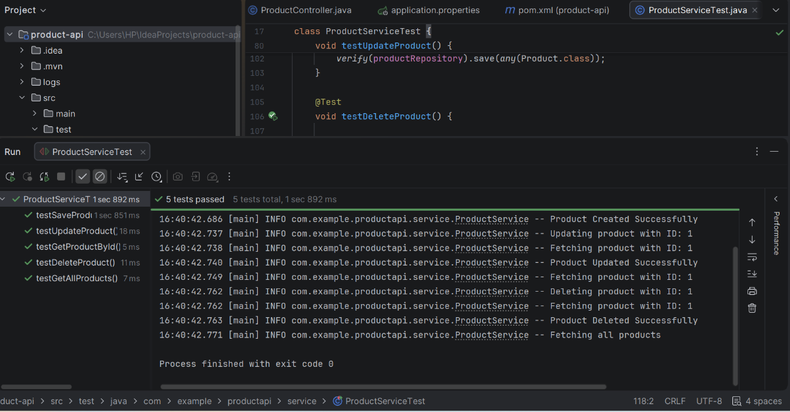

Outcome
Successfully implemented unit testing and logging in the Product Management REST API.
The application is now capable of:
- Performing automated unit testing using JUnit 5 and Mockito.
- Recording application events using SLF4J and Logback.
- Improving code quality through automated verification.
- Simplifying debugging and maintenance using detailed application logs.
This task enhanced the reliability, maintainability, and overall quality of the backend application.

