Task 1 - Product Management REST API

Objective:
Develop a REST API using Spring Boot for Product Management with CRUD operations.

Technologies Used:
> Java 17
> Spring Boot
> Spring Data JPA
> MySQL
> Maven

Features Implemented:
> Create Product
> Get All Products
> Get Product By ID
> Update Product
> Delete Product

Project Structure
This project follows a layered architecture using Controller, Service, Repository, and Entity classes
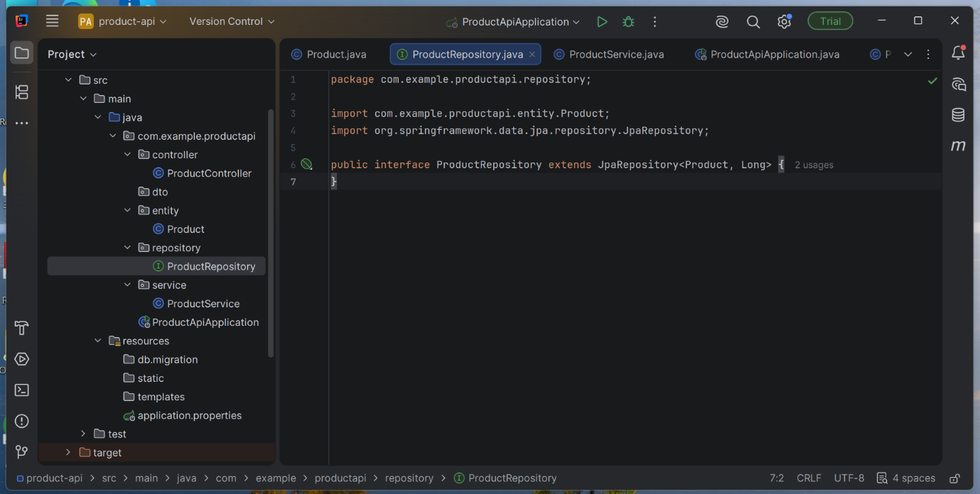

Product Entity
The Product entity represents product information such as name, description, price, and quantity
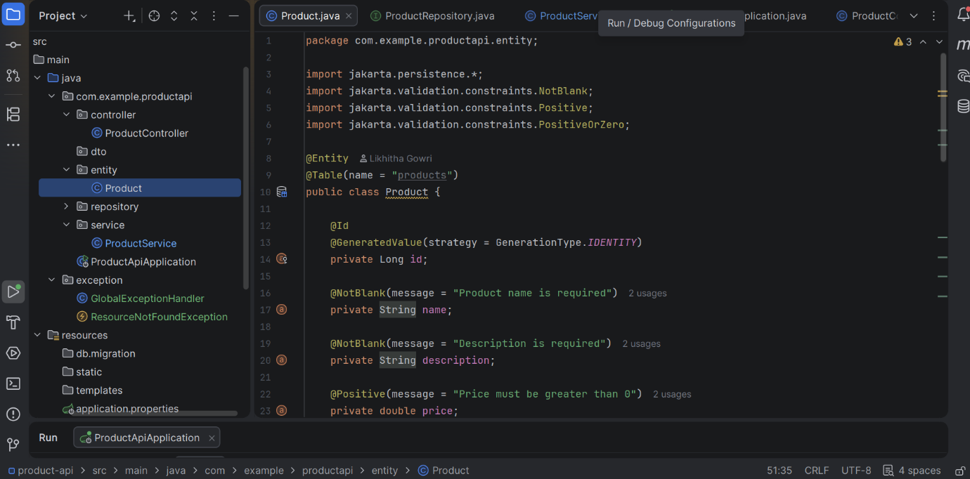

Repository Layer
The repository layer uses Spring Data JPA to perform database operations.

Service Layer
The service layer contains business logic for CRUD operations.
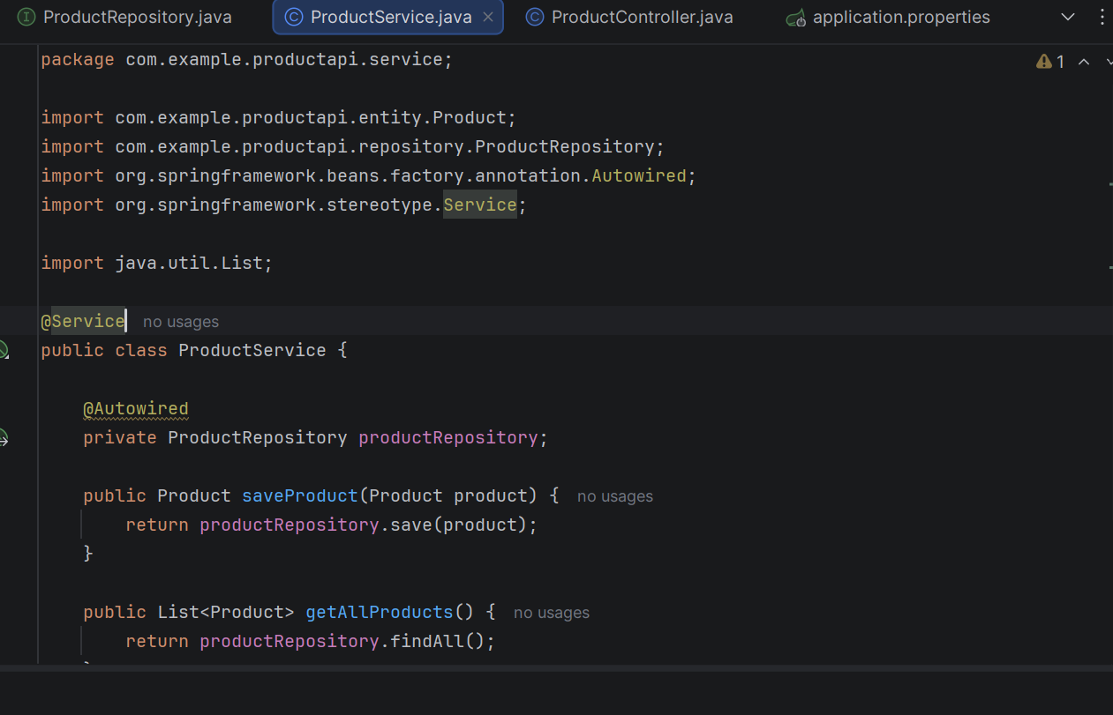
Application Execution
The Spring Boot application was executed successfully.

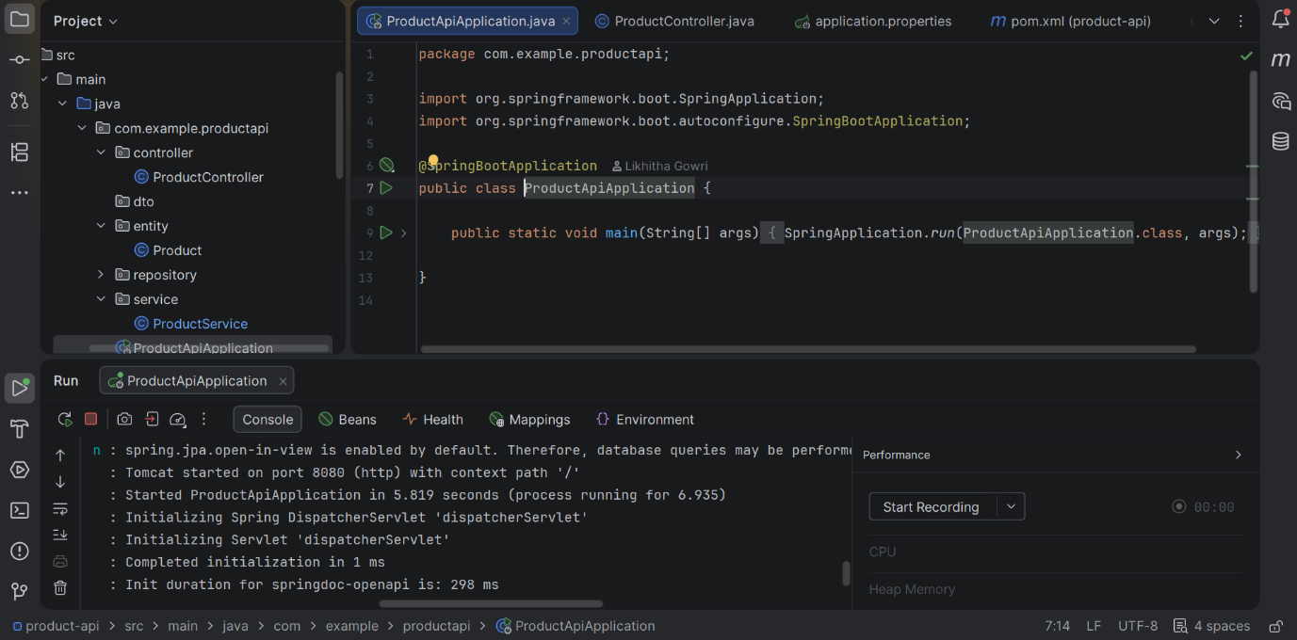

Swagger API Documentation
Swagger UI was integrated to test and document REST APIs.

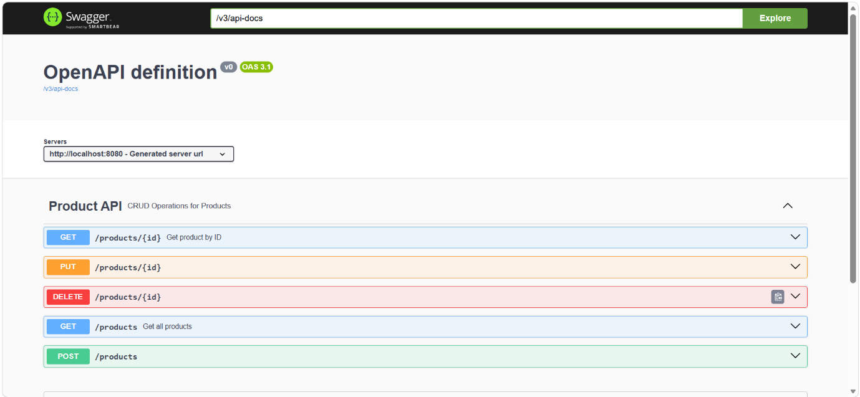

Get All Products API
Successfully retrieved product data from the database.

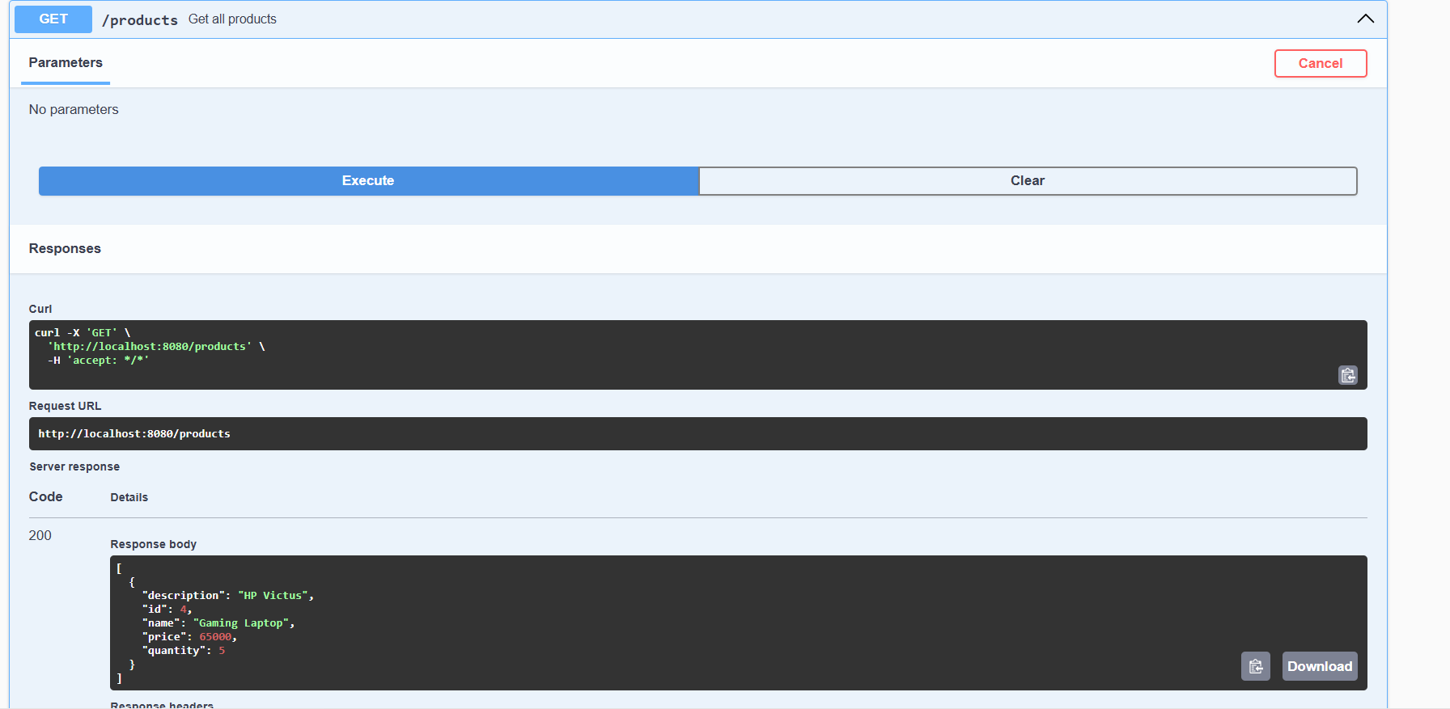

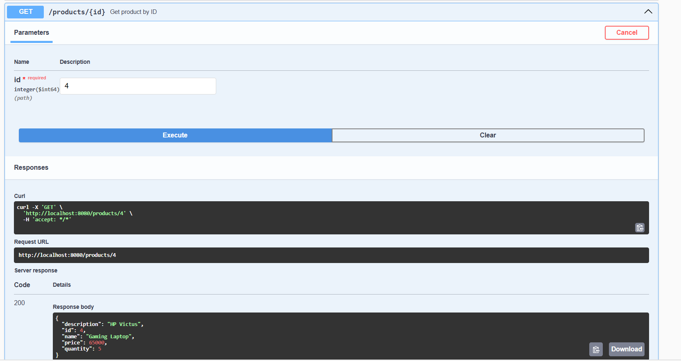

GitHub Repository
Project Source Code:
https://github.com/likhithagowri909/product-api

Result
Successfully developed and tested a Product Management REST API using Spring Boot, Spring Data JPA, and MySQL. Implemented complete CRUD operations and integrated Swagger UI for API documentation and testing.

