A Novel Hybrid Model to Predict Dissolved Oxygen for Efficient Water Quality in Intensive Aquaculture
In this paper author is introducing novel concept to predict water quality as many countries growth heavily dependent on exports of aquatic food and its necessary to maintain healthy water for aquatic life. One of the major components of water is Dissolved Oxygen and its excess or insufficient presence may degrade aquatic animal’s health condition. So it’s necessity to maintain good quality of water by maintaining oxygen level in water.
In past many existing algorithms were introduced like XGBOOST, CNN, LSTM and many more but its prediction error rate is not good enough so author of the paper employing combination of many algorithms such as LIGHTGBM for features selection and remove of irrelevant features from training data, BI-SRU (Bi-directional Simple RNN) and Attention. LIGHTGBM helps in getting relevant features and Bidirectional Simple RNN will filter model by optimizing training features from both backward and forward position. Learning and weighting parameters was updated using ATTENTION algorithm. Model with best MSE (mean square error) will have high weight. MSE, MAE or RMSE refers to difference between original and predicted values so the lower the MSE the better is the model.
To implement this project we have downloaded water quality dataset from KAGGLE website and below screen showing dataset details
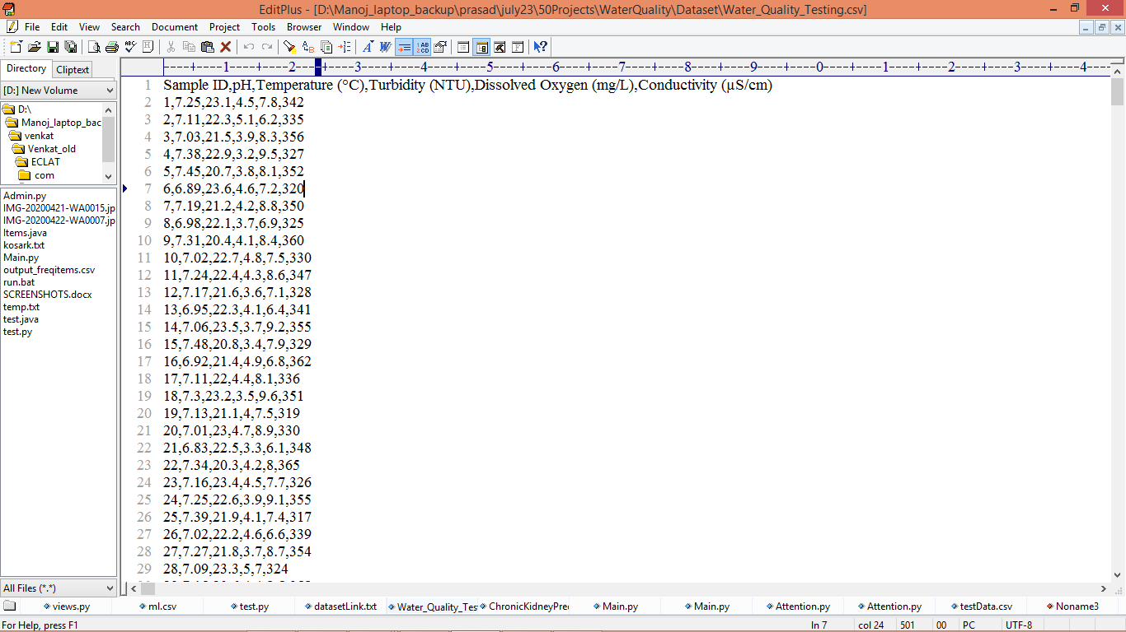
In above dataset screen first row represents dataset column names and remaining rows represents dataset values. So by using above values we will train and test all algorithms.
Propose algorithm is combination of LIGHTGBM, Bidirectional Simple RNN and Attention so it is called as Light-GBM-BISRU-Attention. Author comparing Propose algorithm with existing algorithm called LSTM, GRU and two more but we are implementing LSTM, GRU and propose algorithm.
Extension Concept
As extension work we have combined all 3 algorithms (Bidirectional LSTM, GRU, Simple RNN and Attention) together to form a new model called Ensemble model and then we got improvement in MSE error compare to other algorithms.
We have coded this project using JUPYTER notebook and below are the code and output screens with blue colour comments
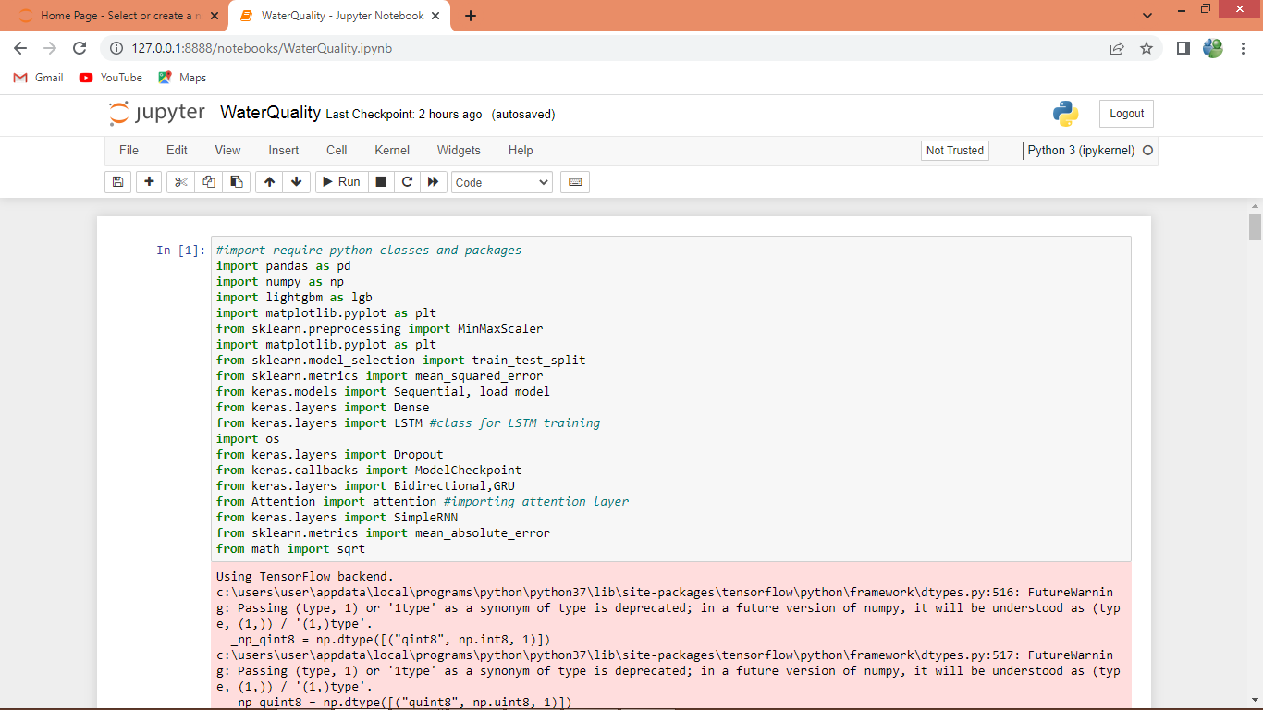
In above screen importing require python classes and packages
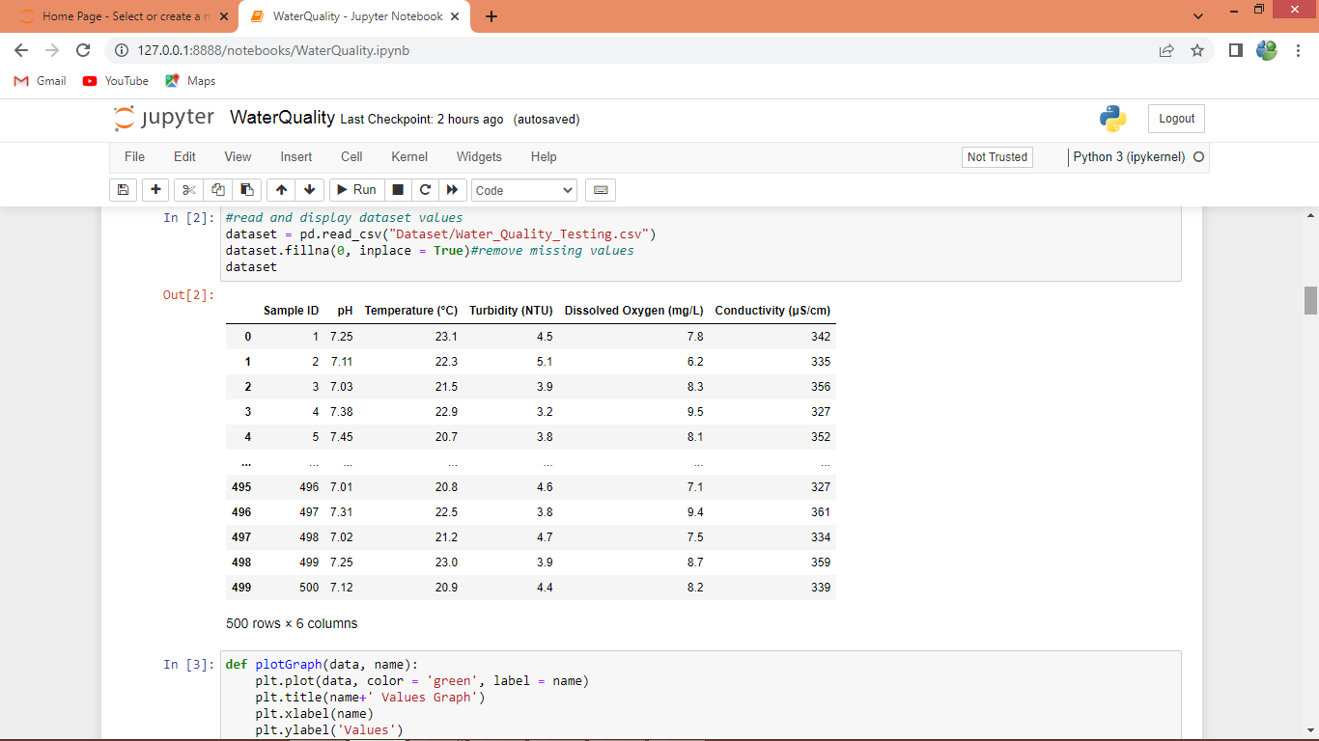
In above screen loading and displaying dataset values
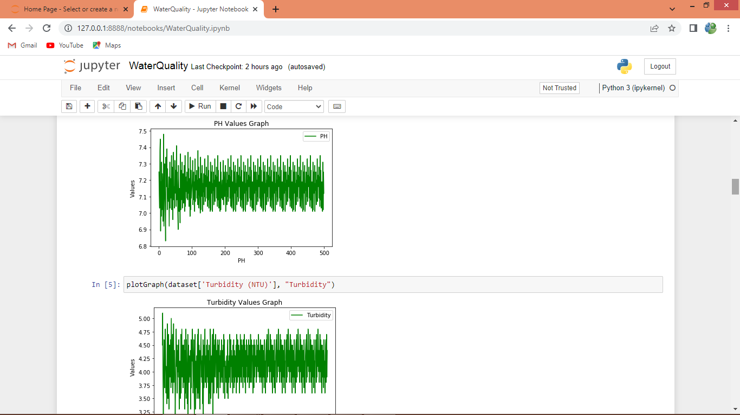
In above screen displaying PH and turbidity graph where X-axis represents record number and y-axis represents values
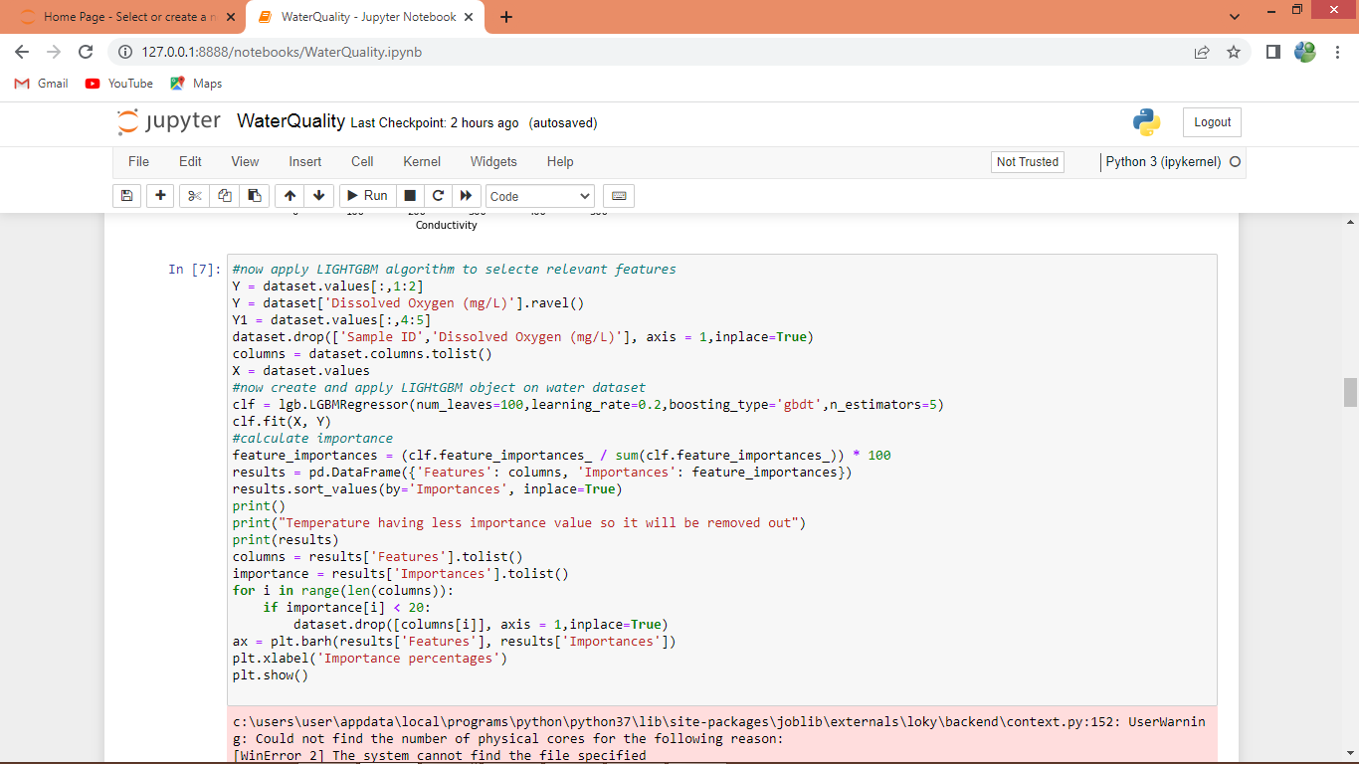
In above screen applying LIGHTGBM algorithm to select features with high importance and after executing above block will get below output
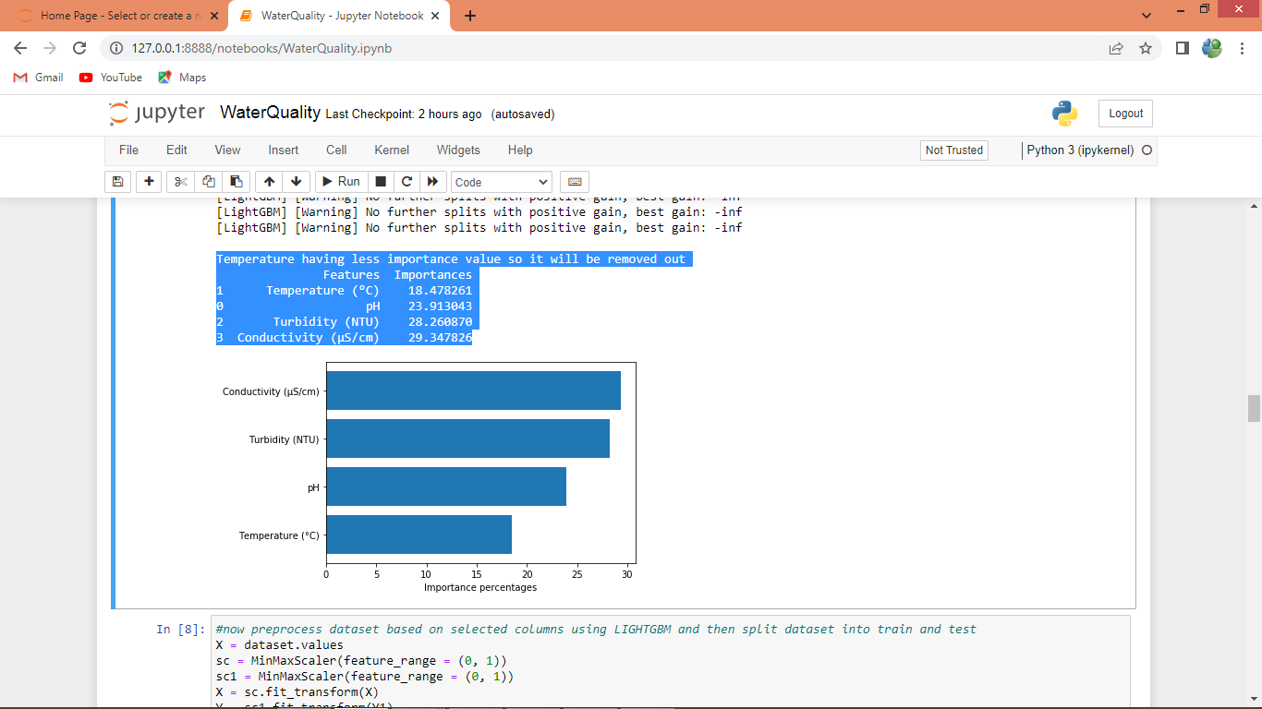
In above screen we can see importance value for each features obtained from LIGHTGBM and in all ‘Temperature’ got less value so it will be removed out and remaining 3 features will be used for training. In graph also we can Features Name and importance value.
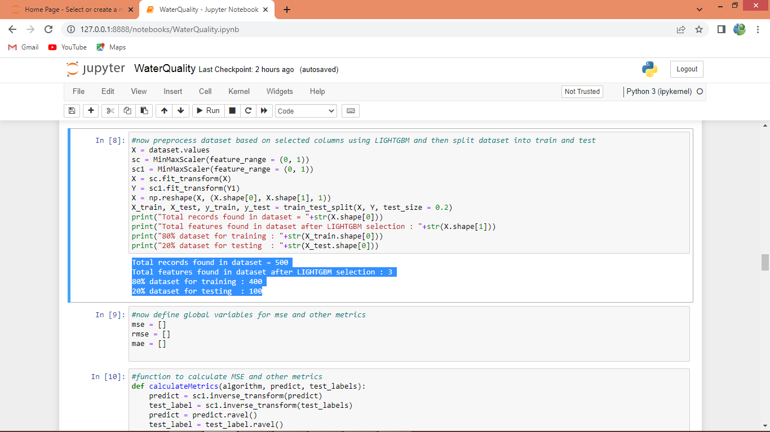
In above screen we are Pre-processing dataset such as normalization and then splitting dataset into train and test values and then defining array to save MSE and other metrics
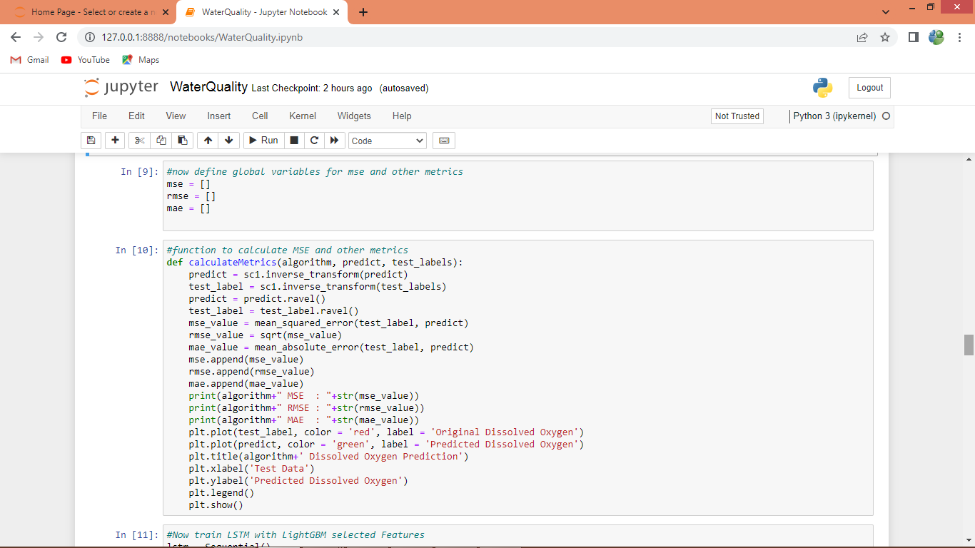
In above screen defining function to calculate MSE, RMSE and MAE values
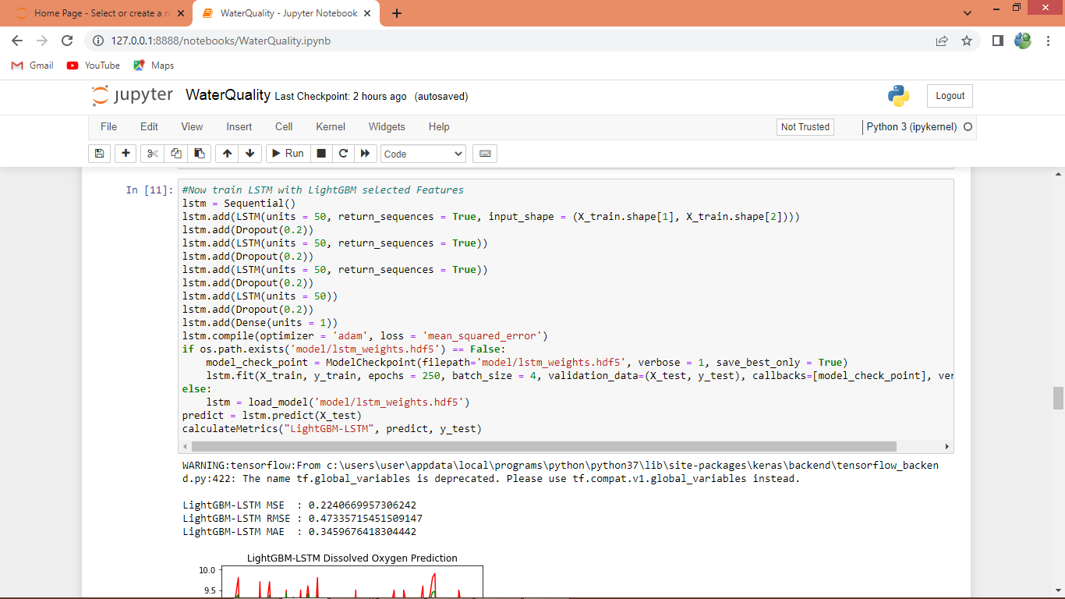
In above screen defining code to train LSTM with LIGHTGBM selected features and after executing above block will get below output
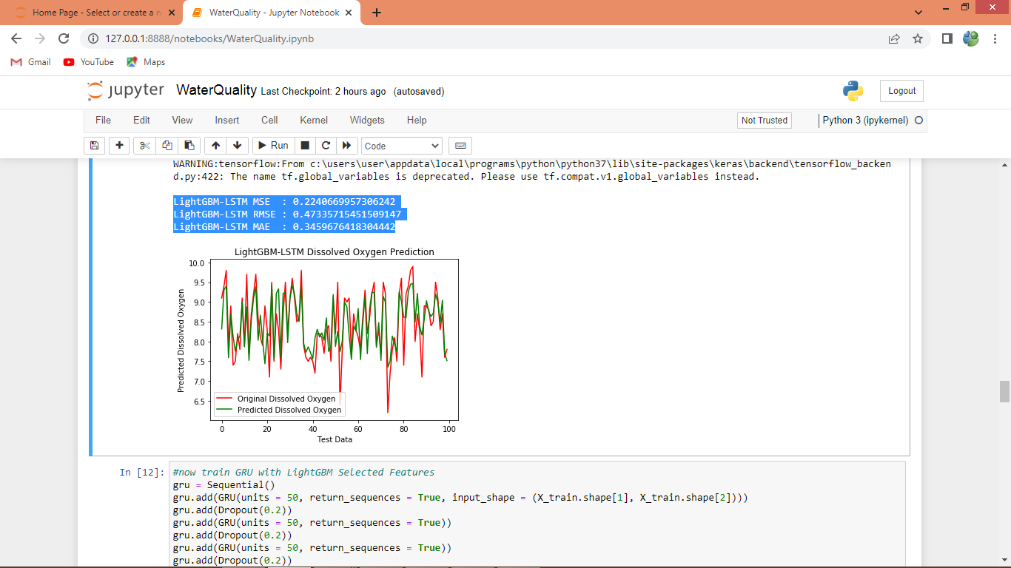
In above screen with LSTM we got 0.22 as the MSE value and we can see other metrics also (just divide 0.22 / 100). In graph x-axis represents Number of test Data and y-axis represents OXYGEN value and red line indicates TEST DATA OXYGEN LEVEL and green line indicates Predicted OXYGEN level and we can see both lines are overlapping with little GAP so LSTM is good but not accurate
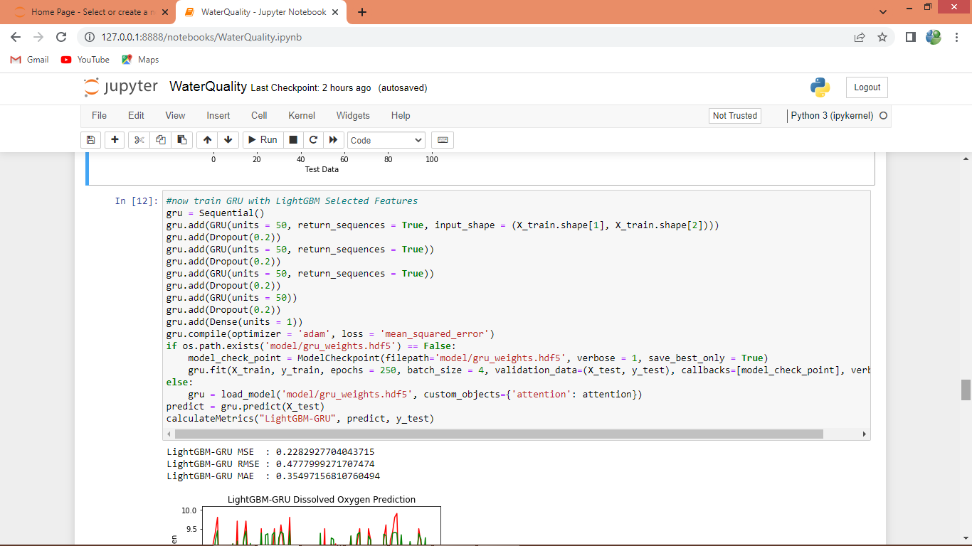
In above screen training GRU and after executing above block will get below output
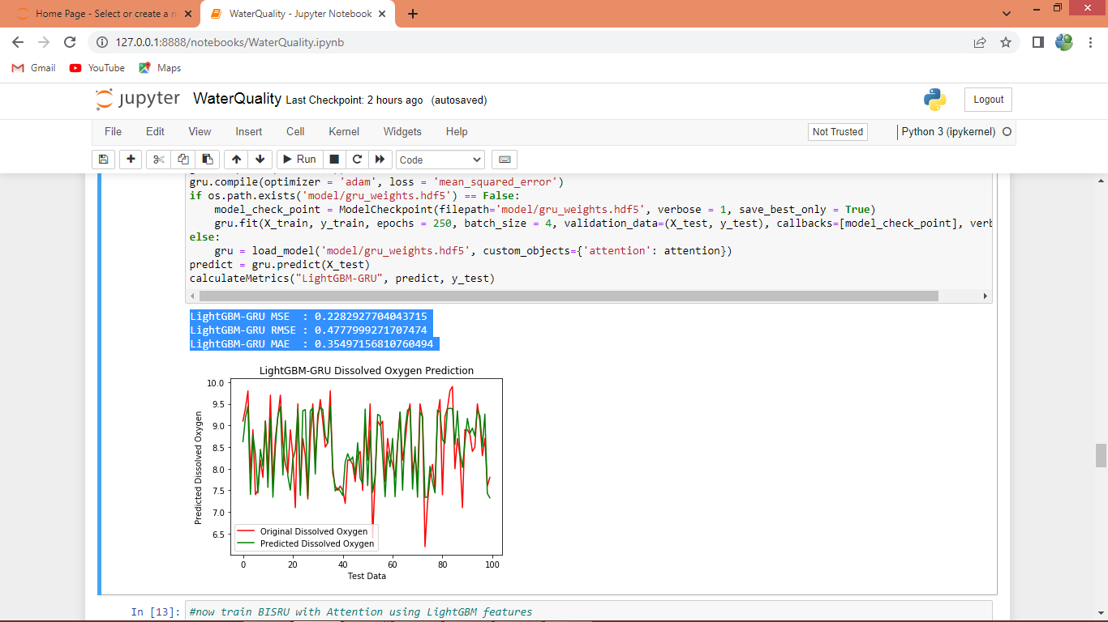
In above screen we can see GRU output and its MSE values as 0.22
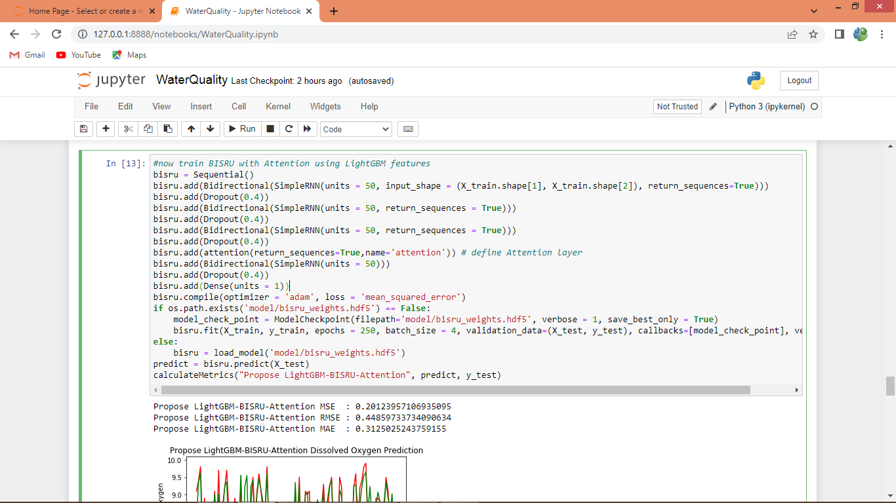in above screen defining SIMPLE RNN with bidirectional and Attention layer and after executing above block will get below output
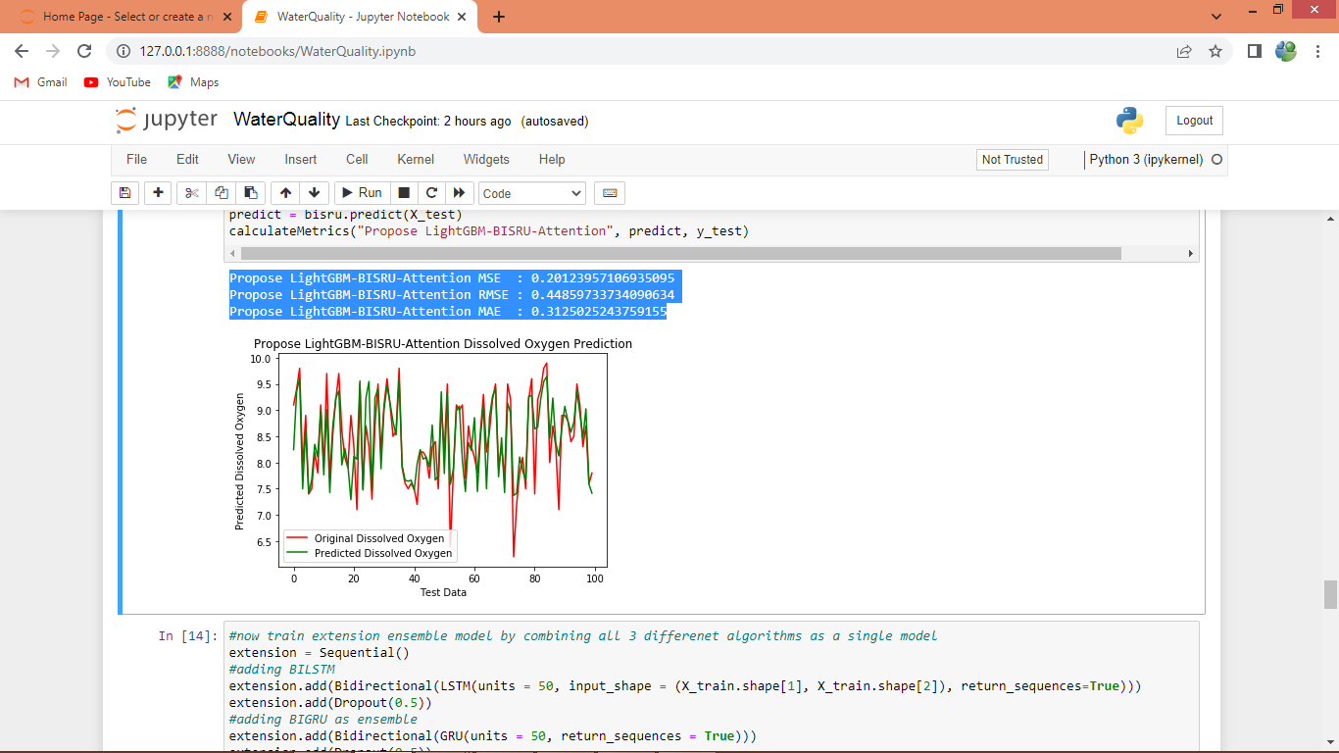
In above screen propose algorithm got 0.20 MSE which is lower than existing algorithm
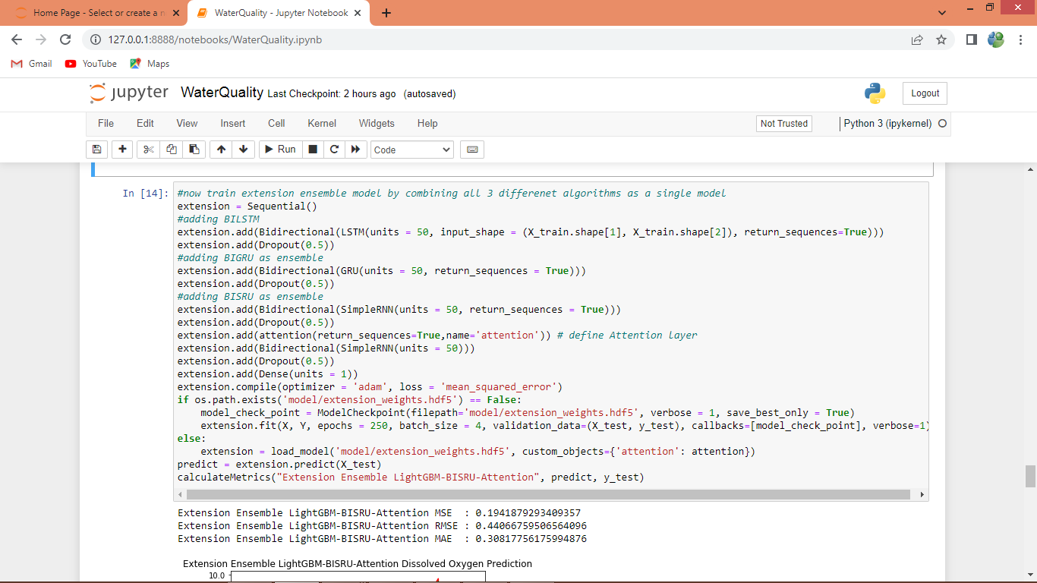
In above screen defining extension model by combing Bidirectional, LSTM, GRU and Simple RNN with attention in single model and after executing this model will get below output
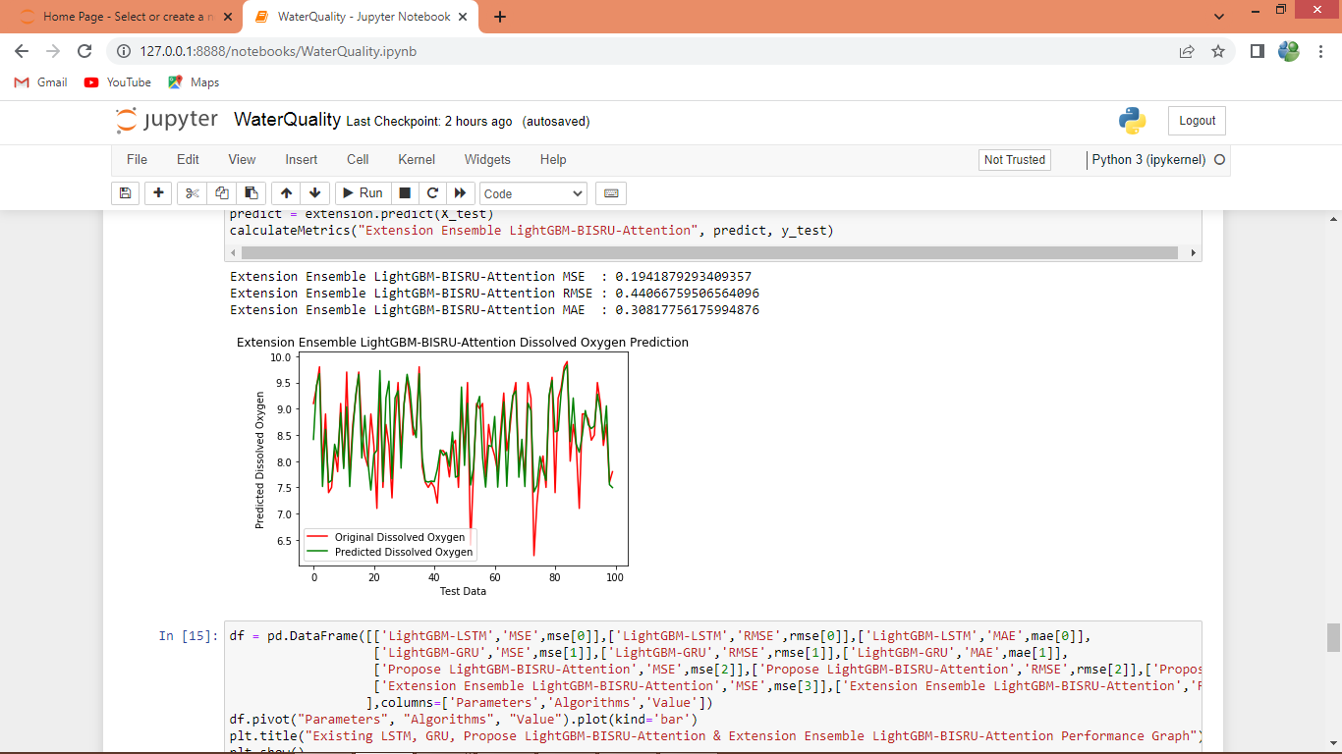
In above screen with Extension model we got 0.19 as the MSE value
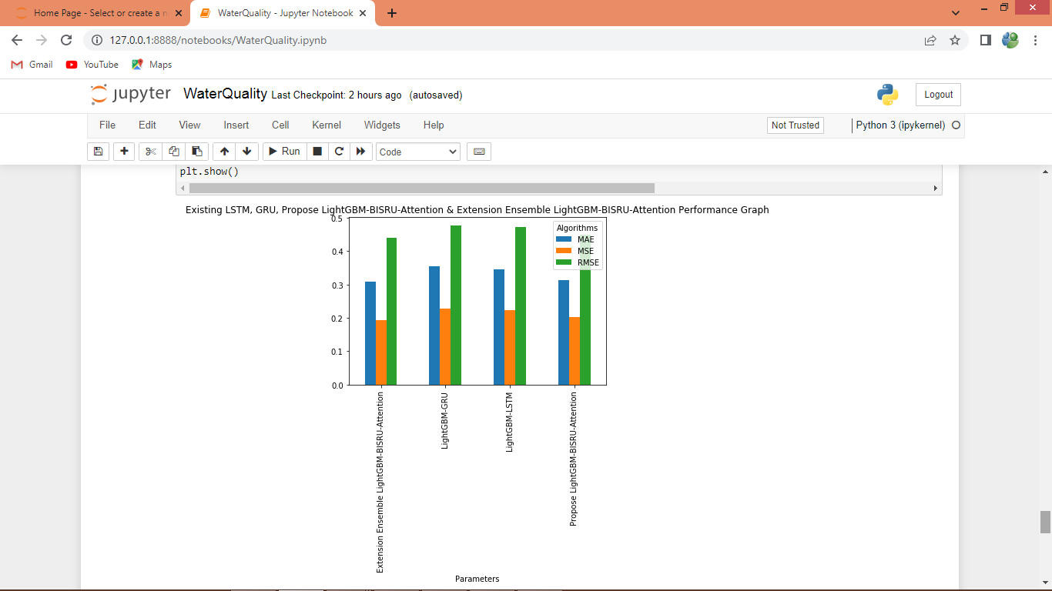
In above graph x-axis represents algorithm names and y-axis represents MSE, MAE and RMSE values in different colour bars and in all algorithms Extension has got less MSE error
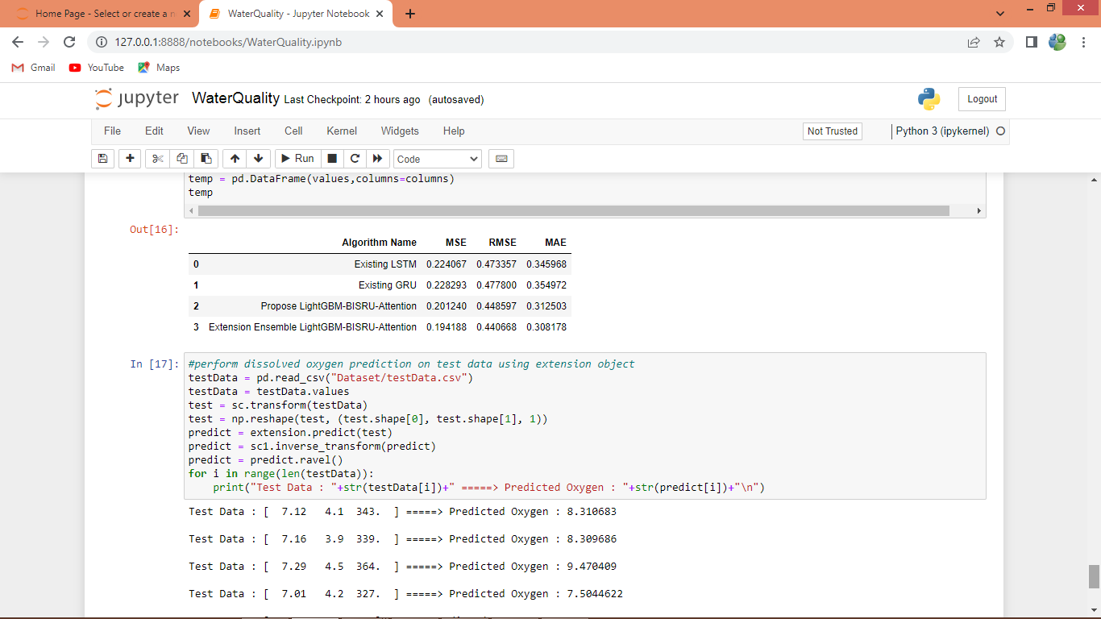
In above screen we can see all algorithms performance in tabular format
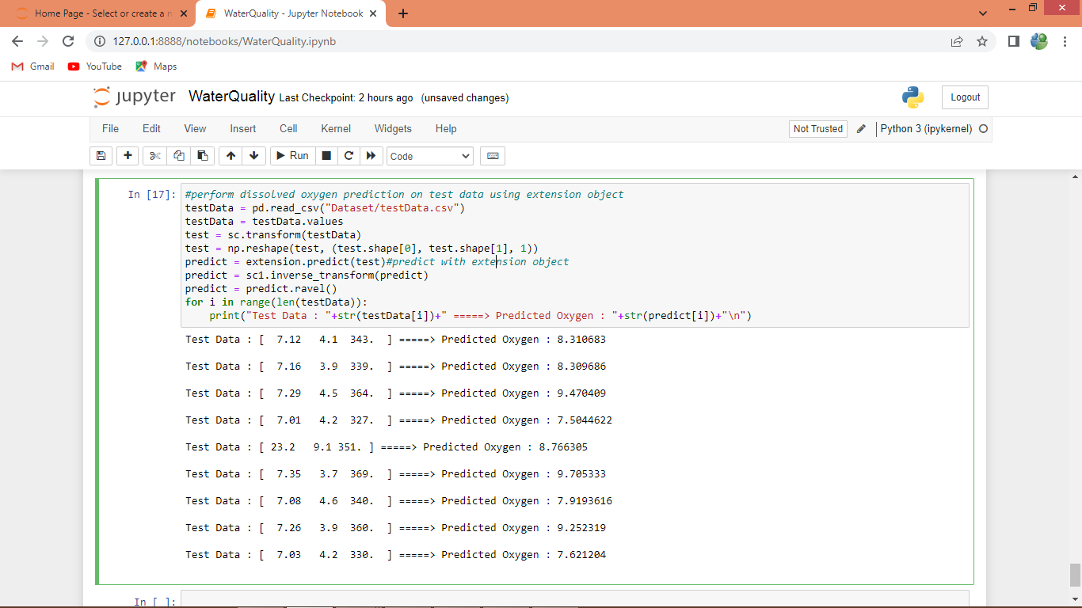
In above screen predicting Oxygen level in test data using extension object
Note: sometime propose or extension may give high error rate as every time we cannot win and in such situation rerun all blocks

