**TECHNICAL REPORT**

**IMAGE SHARPENING USING KNOWLEDGE DISTILLATION**

**TEAM NAME : TrackNtag**

**DATE OF SUBMISSION : 12/07/2023**

**Abstract**

This project focuses on sharpening blurred images using a lightweight CNN model trained via knowledge distillation. A high-capacity teacher model (Restormer) generates output that guides the training of the student CNN. The student model learns to approximate the teacher’s sharpened output without needing ground-truth labels. This method significantly reduces computational cost while maintaining acceptable image quality. The final model is efficient and suitable for real-time use in low-resource environments

**Introduction**

Image sharpening plays a vital role in enhancing visual quality in fields like surveillance, photography, and healthcare. It focuses on improving the clarity of blurred images by restoring lost details and textures. Modern deep learning models like Restormer offer impressive performance in this area. However, such models are extremely large and demand heavy computational resources.  
This makes them unsuitable for deployment on low-power or real-time systems.

To overcome this limitation, we apply the concept of knowledge distillation.  
Here, a large teacher model guides a smaller student model during training.  
The student learns from the teacher’s outputs, not from labeled ground-truth data. This allows the student model to remain compact while still performing well. In our case, Restormer acts as the teacher and a CNN as the student.

The project is entirely backend-oriented with no frontend or UI involved. We trained the student model on 104 blurred-sharp image pairs. Evaluation was done using PSNR and SSIM to assess output quality. The results showed good visual sharpness and structural retention. This validates the approach as efficient and practically deployable.

**Motivation Behind the Project**

With the growing use of visual data, enhancing image quality has become more important than ever. High-end models like Restormer offer excellent results but are too resource-heavy for real-time use. There is a strong need for lightweight models that can run efficiently on everyday devices. Knowledge distillation offers a way to achieve this by training compact models using powerful teachers. This project was motivated by the goal of building an accurate yet efficient image sharpening system.

**Data Source**

The dataset used for this project consists of paired blurred and sharp images specifically curated for image restoration tasks. It was obtained from an open-source repository designed for training and evaluating deblurring models. The dataset was around 1.9 GB in size and included over 100 high-resolution image pairs. Each blurred image has a corresponding sharp version with the same file name for easy alignment. The images were stored in separate folders named blur and sharp, located inside a common data directory. We used 104 image pairs for training and testing the student model. The dataset required no preprocessing apart from resizing for model input compatibility. This simple yet effective structure made it ideal for use in our knowledge distillation pipeline

**Work**

We worked on solving the problem of image blurriness using a backend-driven deep learning approach. We began by collecting a dataset of blurred and sharp images from an open-source repository. These images were organized into two folders: one for blurred inputs and the other for their corresponding sharp versions. The Restormer model, which is a transformer-based architecture, was used as the teacher to produce high-quality sharpened images from the blurred inputs. A lightweight student CNN was then trained to replicate the outputs of this teacher model. This training followed a knowledge distillation approach where no ground truth was used — only the teacher’s predictions guided the student. The entire training and testing process was done in Python using PyTorch, and we focused on evaluating the performance with PSNR and SSIM scores. All work was done on the backend, with no user interface or frontend design involved. This project involved multiple stages — dataset preparation, model integration, loss function design, student model training, and finally performance testing and visualization.

**Result**

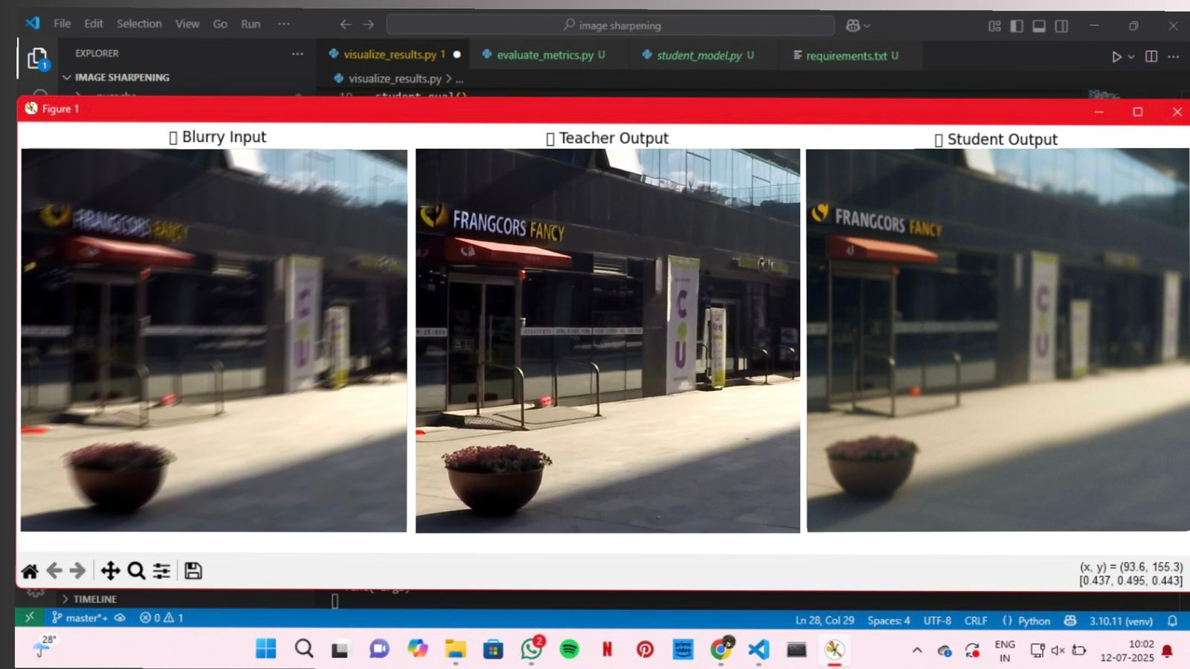

**Links of the result:**

Github link : [https://github.com/likhithakaruparti/Image-sharpening-using-knowledge-distillation](https://github.com/likhithakaruparti/Image-sharpening-using-knowledge-distillation%20)