TASK REPORT
Student Details
Name: Yallampalli Lakshmi Likhitha
Stickbook ID: STIK202655

Assignment:
Project Description:
Stikbook User Directory is an internal administration tool designed for platform managers to view and organize user data. Built with React, it fetches data from a REST API and provides real-time search, department-based filtering, and dynamic usage statistics.

Technologies Used
- JavaScript: Arrow functions, Destructuring, and Array methods like map() and filter().
- React: Components, Props, JSX, and Hooks (useState, useEffect, useRef) .
- Web: REST API interaction and JSON data handling.
Features Implemented
1) Data Management
- API Integration: Fetches user data automatically upon application load using the Fetch API and Async/Await .
- State Storage: Users are stored in local state, ensuring smooth transitions and updates.
- Loading and Errors: Displays clear messages while data is being fetched or if a network request
fails.
2. Search and Filtering
- Live Search: Includes a search bar that filters users by Name or Username instantly as you type .
- Department Assignment: Manually assigns users to specific departments (Development, Marketing, HR, Support) after the data is fetched
- Department Filter: Provides buttons to view users based on their assigned department or view All users.
3. User Interface
- Profile Details: Each user card features a View Details button that toggles additional info like Phone, Website, Company, and City .
- Statistics Panel: Displays total user counts and specific counts for each department calculated dynamically .
- Auto-Focus: The search input automatically focuses when the page loads using the useRef hook .

Folder Structure

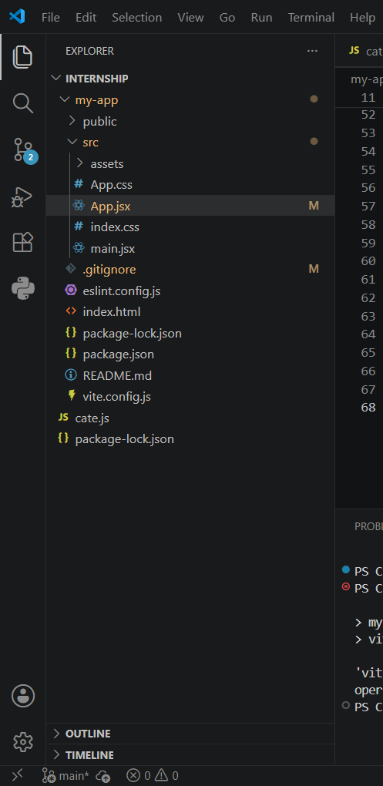

src/

├── components/

│ ├── SearchBar.jsx

│ ├── StatisticsPanel.jsx

│ ├── UserList.jsx

│ └── UserCard.jsx

├── App.jsx

├── App.css

└── main.jsx

Code:
SearchBar.jsx:
import React, { useEffect, useRef } from 'react';
function SearchBar({ searchQuery, setSearchQuery }) {
const inputRef = useRef(null);

useEffect(() => {
if (inputRef.current) {
inputRef.current.focus();
}
}, []);

return (
<div className="search-container">
<input
ref={inputRef}
type="text"
placeholder="Filter by name or username..."
value={searchQuery}
onChange={(e) => setSearchQuery(e.target.value)}
/>
</div>
);
}

export default SearchBar;
StatisticsPanel.jsx:
import React from 'react';

function StatisticsPanel({ users, departments }) {
return (
<div className="stats-container">
<div className="stat-box">
<strong>Total Users</strong>
<span>{users.length}</span>
</div>
{departments.map(dept => (
<div key={dept} className="stat-box">
<strong>{dept}</strong>
<span>{users.filter(u => u.department === dept).length}</span>
</div>
))}
</div>
);
}

export default StatisticsPanel;
UserList.jsx:
import React from 'react';
import UserCard from './UserCard';

function UserList({ users }) {
return (
<div className="grid">
{users.map(user => (
<UserCard key={user.id} user={user} />
))}
</div>
);
}

export default UserList;
UserCard.jsx:
import React, { useState } from 'react';

function UserCard({ user }) {
const [isExpanded, setIsExpanded] = useState(false);
return (
<div className="card">
<div className="card-header">
<h3>{user.name}</h3>
<span className="badge">{user.department}</span>
</div>
<p>Username: {user.username}</p>
<p>Email: {user.email}</p>
<button className="btn-details" onClick={() => setIsExpanded(!isExpanded)}>
{isExpanded ? 'Show Less' : 'View Details'}
</button>

{isExpanded && (
<div className="expanded-content">
<hr />
<p><strong>Phone:</strong> {user.phone}</p>
<p><strong>Website:</strong> {user.website}</p>
<p><strong>Company:</strong> {user.company.name}</p>
<p><strong>City:</strong> {user.address.city}</p>
</div>
)}
</div>
);
}

export default UserCard;
Steps to Run:
- Navigate to the directory: Open your terminal and move into the project folder (e.g., cd my-app).
- Install dependencies: Run npm install to download necessary React packages.
- Start the server: Run npm run dev to launch the local development environment.
- Access the tool: Open your browser and navigate to the local URL provided in the terminal(http://localhost:5173/)

Output:
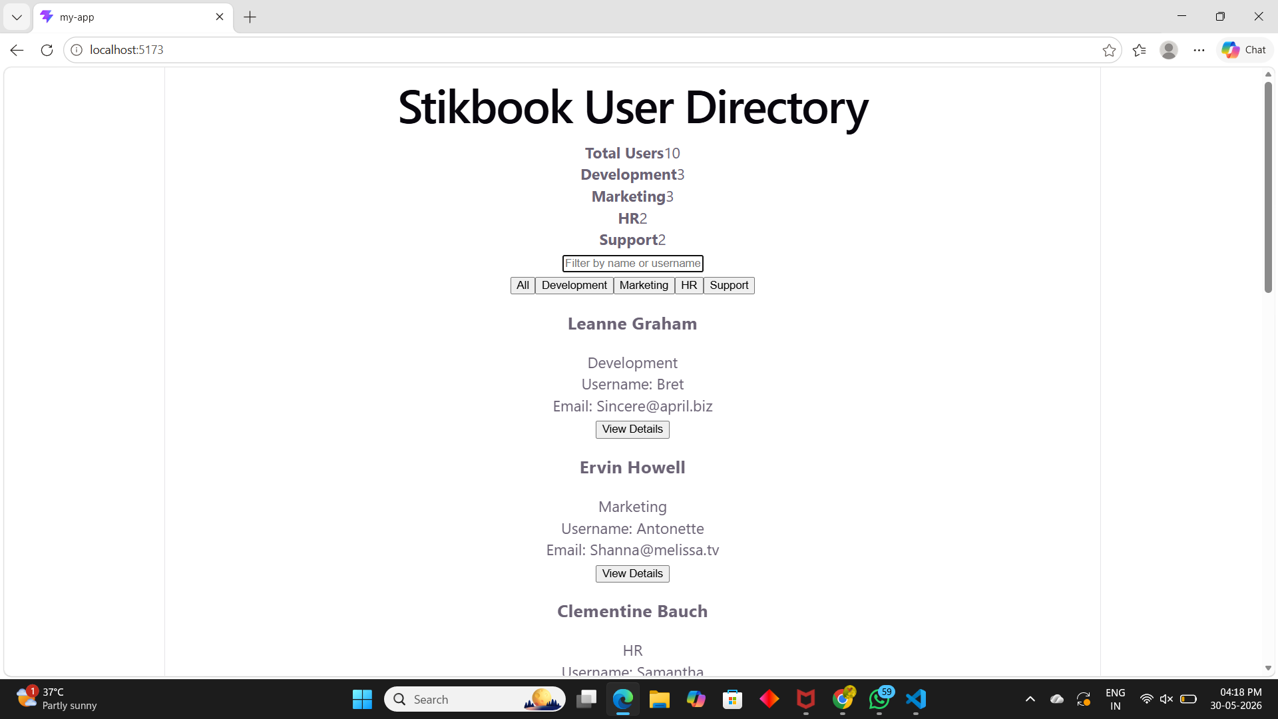
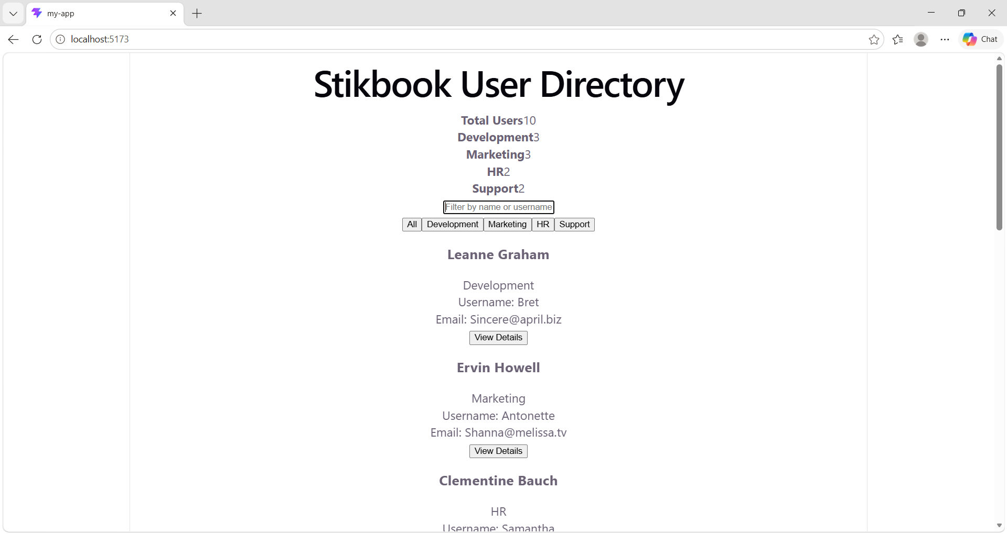

Development:
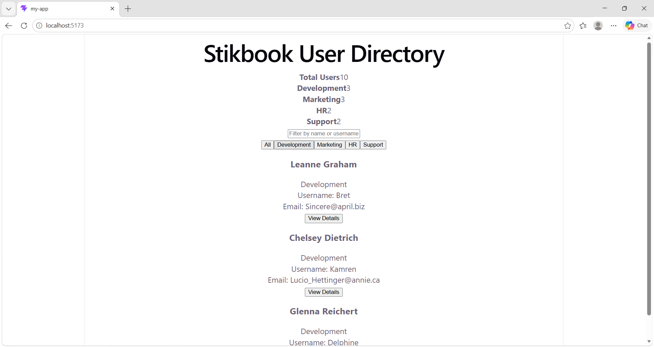
Marketing:
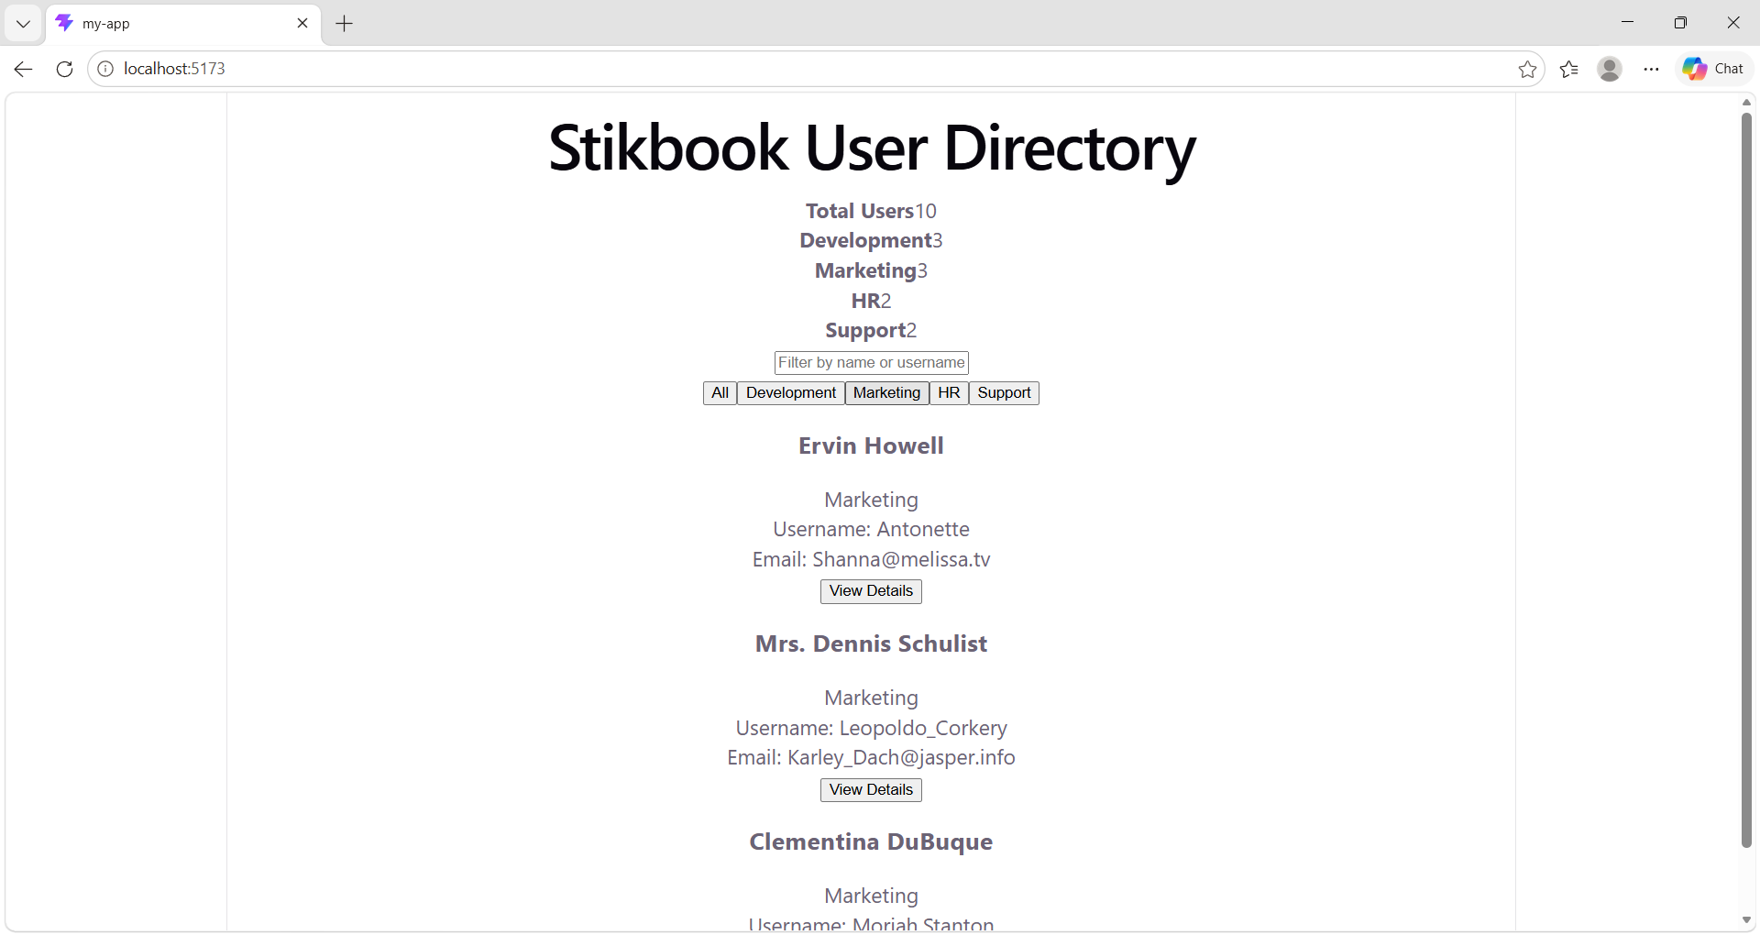
HR:
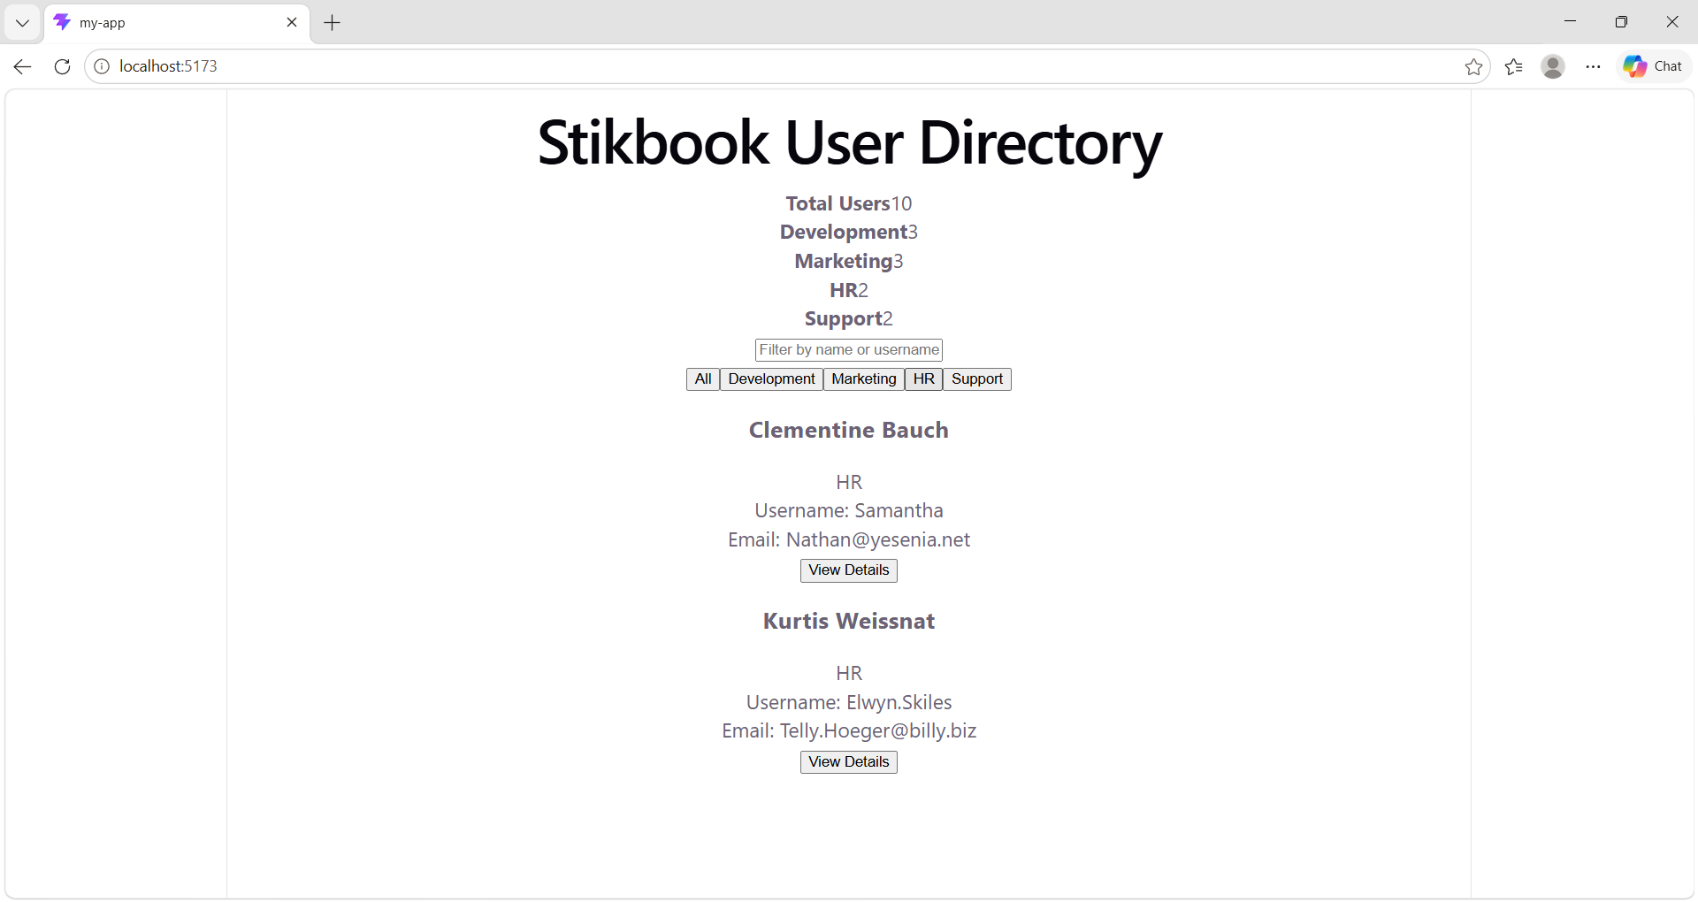
Support:
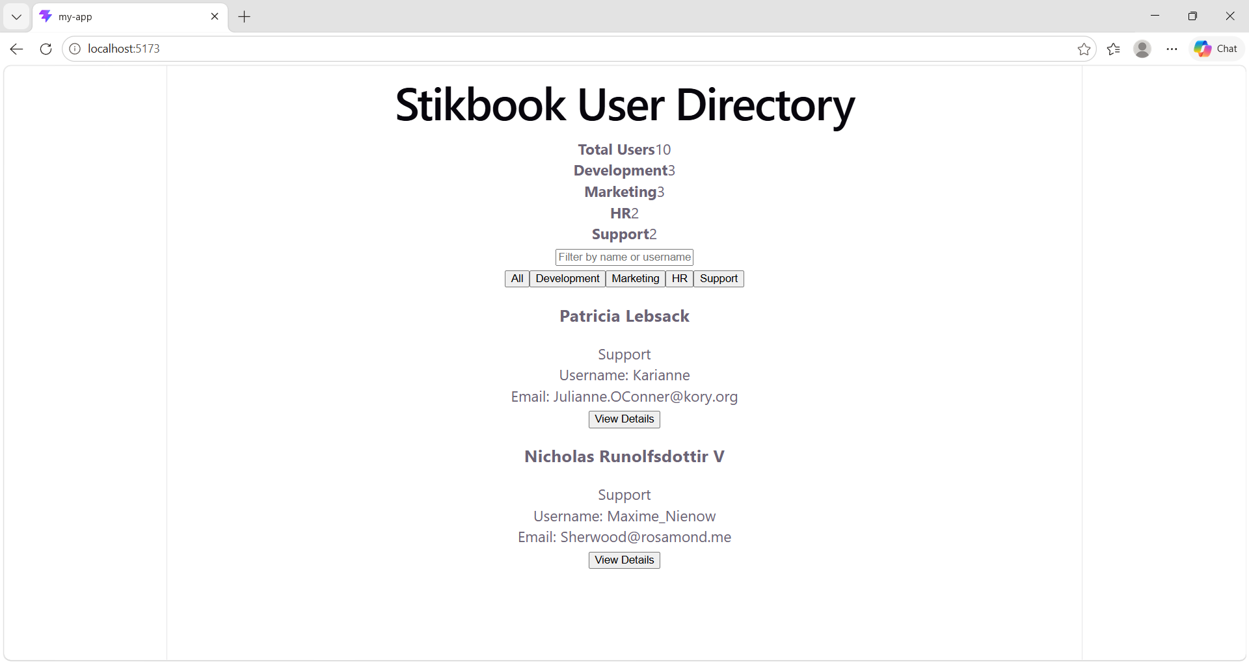
Filter by name or username:
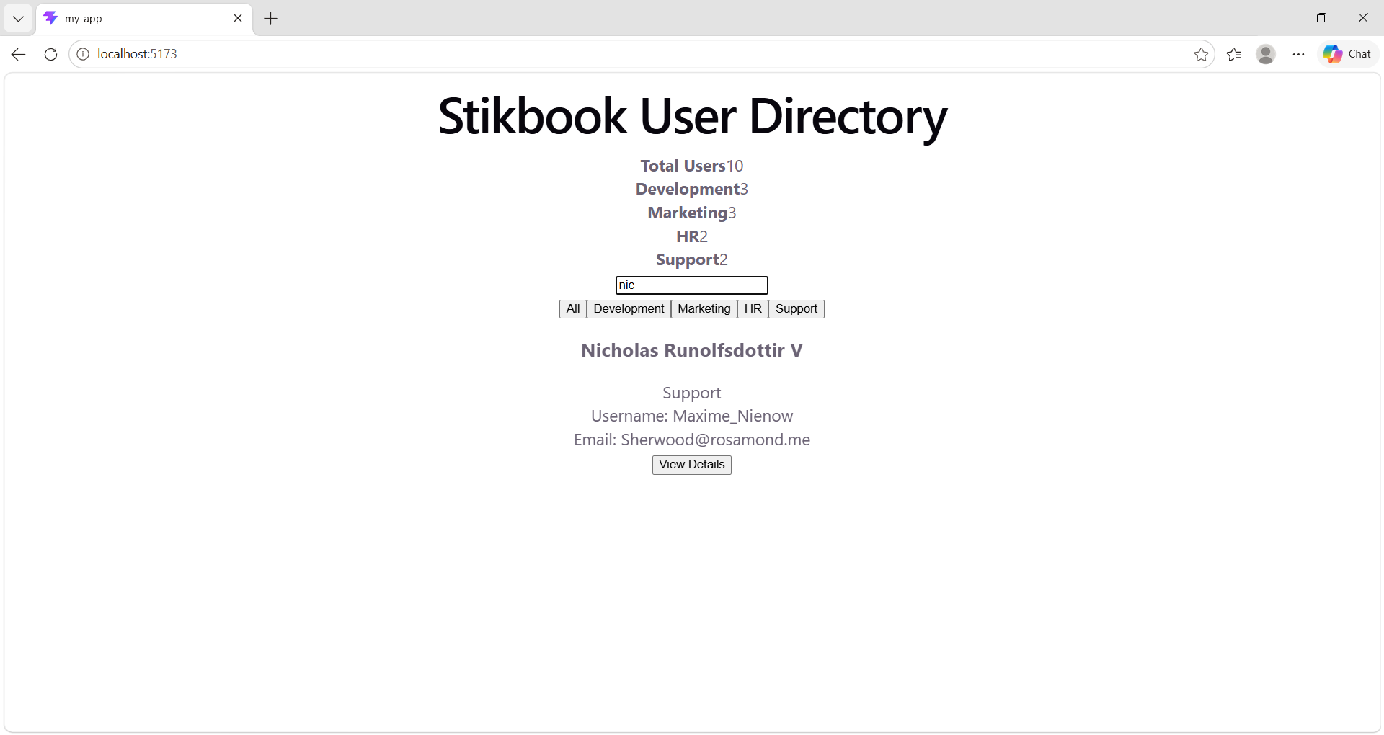
View by Details:
