SCREENSHORTS
1. Create a Post (POST Method)
This proves your API can receive data and save it.
- URL: http://localhost:3000/api/posts
- Method: POST
- Body (JSON): { "title": "Learning Express API",
"content": "This is a detailed description to ensure I pass the validation of twenty characters.", "author": "Anusha" }

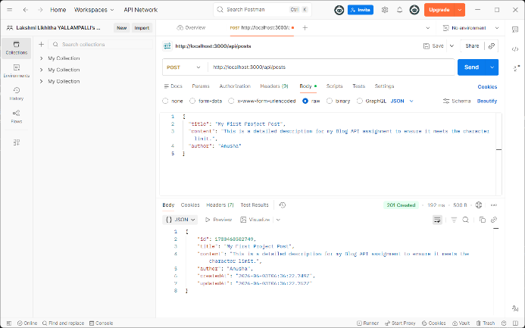

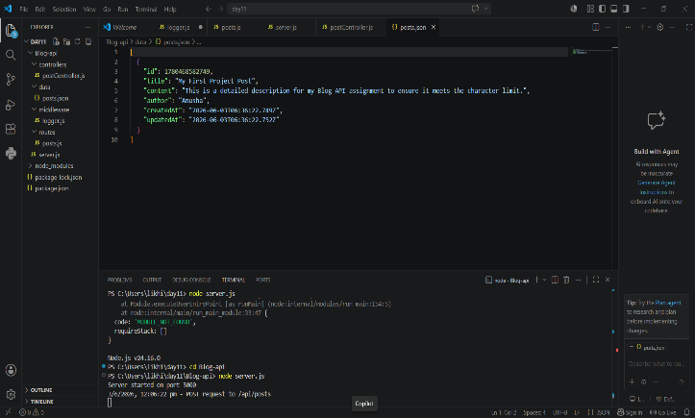
2. Get All Posts with Pagination (GET Method)
This proves your pagination and query parameter logic is working.
- URL: http://localhost:3000/api/posts?page=1&limit=5
- Method: GET
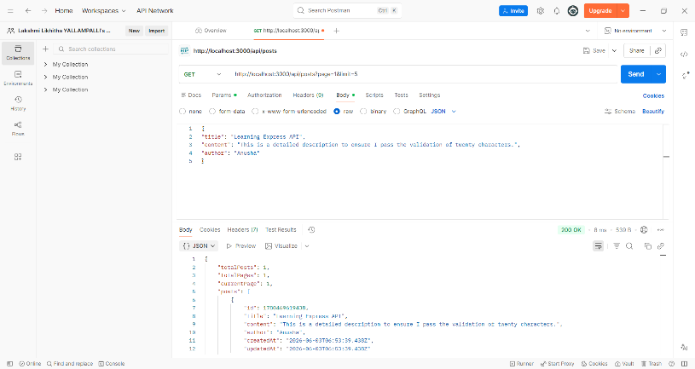
3. Title Validation Error (400 Bad Request)
This proves you have implemented the "min 5 chars" requirement.
- URL: http://localhost:3000/api/posts
- Method: POST
- Body (JSON): ```json { "title": "Bad", "content": "This content is long enough, but the title is too short.", "author": "Anusha" }
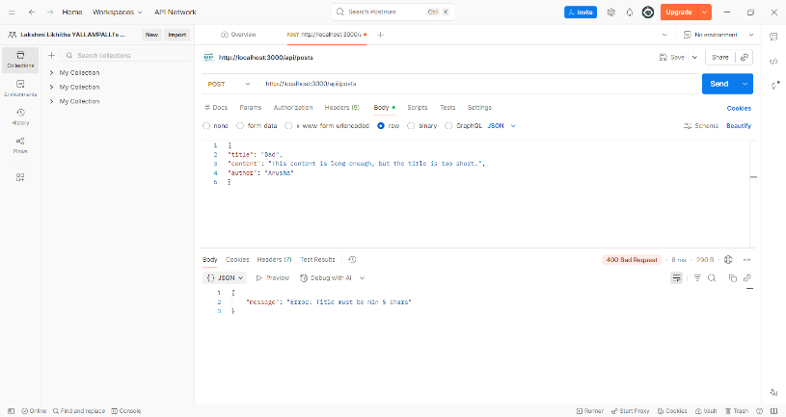
4. Content Validation Error (400 Bad Request)
This proves you have implemented the "min 20 chars" requirement.
- URL: http://localhost:3000/api/posts
- Method: POST
- Body (JSON): ```json { "title": "Perfect Title Name", "content": "Too short.", "author": "Anusha" }
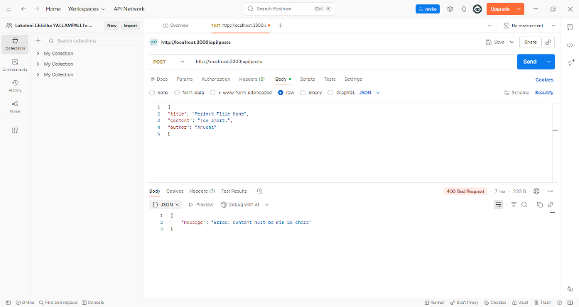
5. Invalid ID Error (404 Not Found)
This proves your "Handle edge cases" requirement for missing posts.
- URL: http://localhost:3000/api/posts/99999
- Method: GET
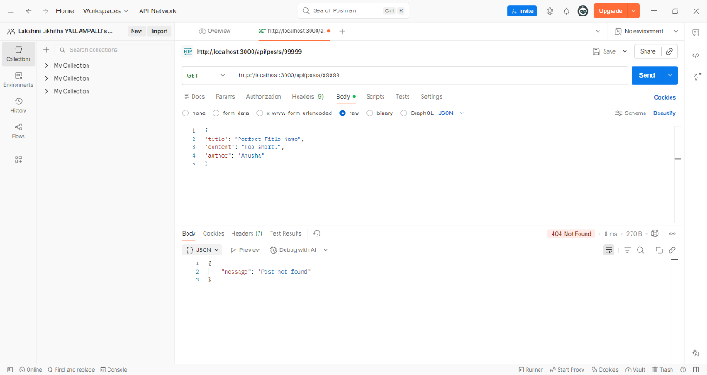
6. Delete a Post (DELETE Method)
This proves the final part of your CRUD operations.
- URL: http://localhost:3000/api/posts/1780469619438 .
- Method: DELETE
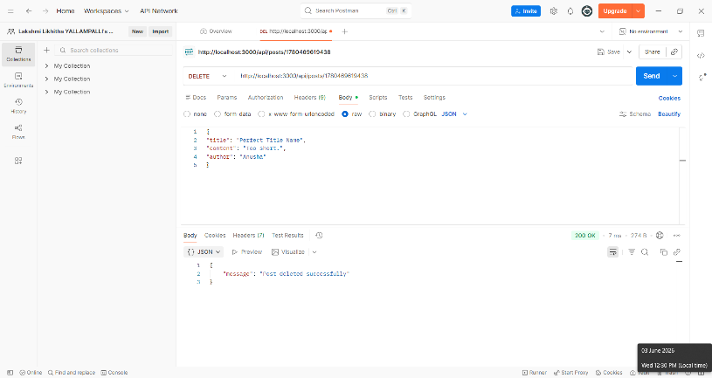
7. Middleware Logging (VS Code Terminal)
This proves your "Use middleware for logging" requirement.
