RoboSurvey
High-Level Design Document
v0.01

Confidential

Robosoft Technologies Pvt. Ltd.
Registered & Corporate Office
217, N.H.66, Santhekatte
New Udupi – 576 105
Karnataka, India
Tel: +91 820 2593930
Fax: +91 820 2593900

Document Revision History

Date | Version | Authors | Reviewed By | Approved By | Brief Description
13-02-2021 | 0.01 | Likhitha M -  SSE |  | - | Initial draft

Contents

1. High-Level Design 3
1.1 Introduction 4
1.1.1 Purpose 4
1.1.2 Scope 4
1.1.3 Audience 4
1.1.4 References 4
1.1.5 Terms and Abbreviations 5
1.2 Software Product Overview 5
1.3 Design Considerations 5
1.3.1 Assumptions and dependencies 5
1.3.2 Development methods 5
1.3.3 General constraints 5
1.4 Architectural Strategies 6
1.5 Software Product Architecture 6
1.6 Component Architecture 7
1.7 Bibliography 3
2. Reference 3

High-Level Design

Introduction

RoboSurvey is the codename of the project involving UI/UX design, and development of CMS, server and responsive website. Conducting surveys is a common necessity for a lot of organizations. Surveys forms are essential for collecting feedback from employees or groups. Conducting surveys physically on paper is a time consuming task and consumes time to collate/maintain the responses. Hence, creating dynamic forms online solves a lot of these problems. An online survey is a structured questionnaire that your target audience completes over the internet generally through a filling out a form. Online surveys can vary in length and format. The data is stored in a database and the survey tool generally provides some level of analysis of the data in addition to review by a trained expert.

Purpose

The purpose of this High Level Design Document (HLDD) is to provide architecture, functionality and methodologies and road map for the developers to implement the solution for RoboSurvey.

Scope

Project scope includes the following:
1. Responsive web application.
2. CMS
3. Backend Server
4. Development of the responsive web application includes the following:
a. View the survey form
b. Submit the survey form.
5. Development of CMS includes the following:
a. Admin login
b. Reset password
c. View/add/edit superadmins/admins.
d. Create survey
e. List surveys
f. List deleted surveys
g. View drafted surveys.
6. Development of server includes the following:
a. Admin management
b. Survey management
c. Participants management
d. Responses management.
e. Creation of email service.

Audience

The audience for this document includes customer, project manager, development team and the quality assurance team.

References

Requirement docs provided by customer on 13-02-2021.

Terms and Abbreviations

RoboSurvey Project code name
UI User Interface
UX User Experience
CMS Content Management System
DB Database
API Application Programming Interface

Software Product Overview

The scope of the project involves development of server, CMS and responsive web application. CMS and responsive web application shall be developed using AngularJS. Server shall be developed using NodeJS and MongoDB.

Design Considerations

Assumptions and dependencies
- Super admin will create the admins and other superadmins. Only a super Admin has the right to add anyone. The temporary passwords of the added members are automatically generated and are sent to their respective emails.
- Admins can add the survey, delete survey, view surveys based on permission set by the superadmin.
- Surveys can be saved as draft or published. All the surveys will be saved as ‘Drafts’ until they are published to the Participants.
- Once the survey is published admins have the option to upload the participants excel sheet which will have list of the participant to be invited to submit the survey.

Development methods
AGILE methodology will be used for this project. AGILE methodology is a practice that promotes continuous iteration of development and testing throughout the software development lifecycle of the project. Both development and testing activities are concurrent unlike the Waterfall model.

General constraints

Software constraints:

CMS : CMS portal will be supported on latest and one previous version of Chrome and Firefox versions.
End user website : The participants form UI should be responsive in nature. It should allow the participant to complete the form either from his desktop/laptop/mobile devices.

Communication:

App will communicate with the backend using the RESTFul APIs over HTTPS

Network:

Wi-Fi, 3G, 4G

Architectural Strategies
Development Environment

CMS:
IDE: Visual Studio Code
Language: JavaScript
Framework: Angular 8

Server:

IDE: Visual Studio Code
Language: JavaScript
Framework: NodeJS v10.16.2, MongoDB v4.0.10

Participants UI:

IDE: Visual Studio Code
Language: JavaScript
Framework: Angular 8

Software Product Architecture
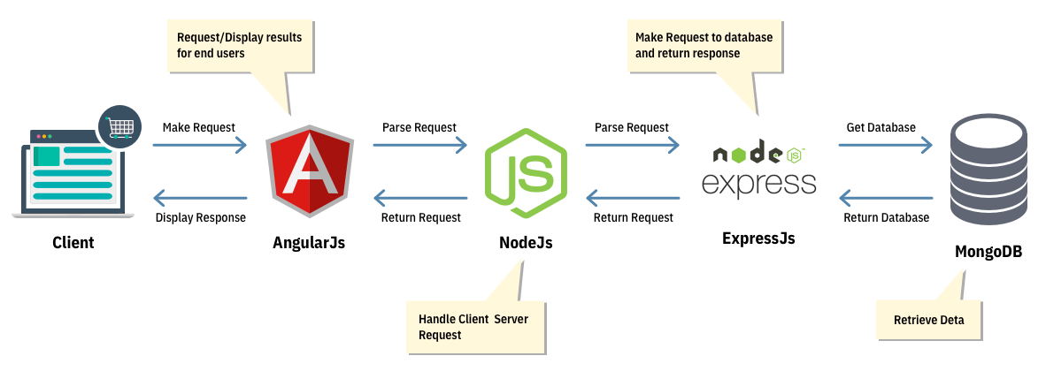
Figure 1: Software product architecture

Component Architecture
This section briefly explains the architecture used in server, CMS and mobile app development.

Server: The server development will use the architecture pattern as shown in Figure 2. The service layer classes will have all the business logic. The data access layer will have classes that contain different queries to communicate with the DB.

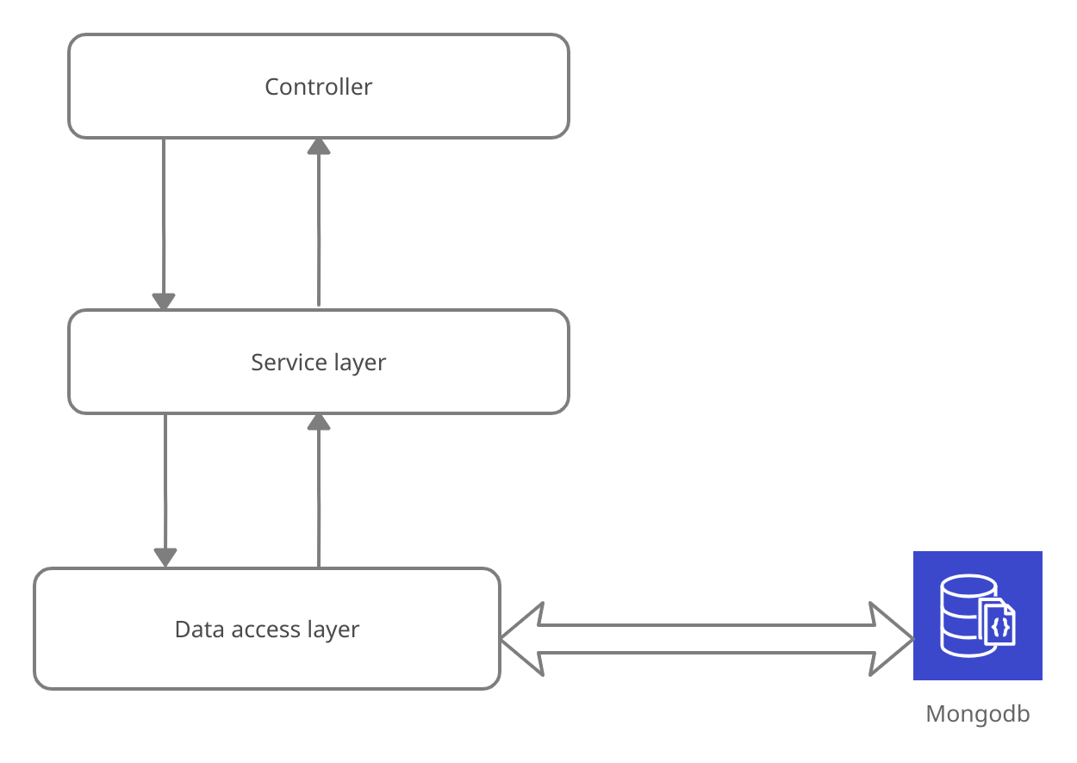
Fig 2. Server architecture

CMS/Partcipants UI website: The CMS and participant website development will use the architecture pattern as shown in Figure 3.

Model
The model is responsible for managing application data. It responds to the request from view and to the instructions from controller to update itself. Model acts as the data access layer.

View

Views are used to represent the presentation layer, which is shown to the end users.

Controller

The Controller represents the layer that has the business logic. User events trigger the functions, which are stored inside the controller. The user events are part of the controller.

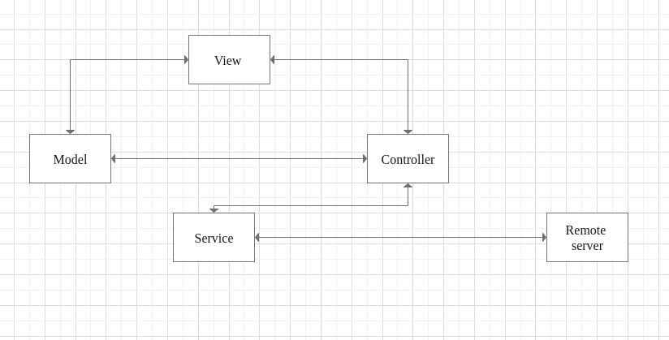

Fig 3. CMS architecture

Database Diagram

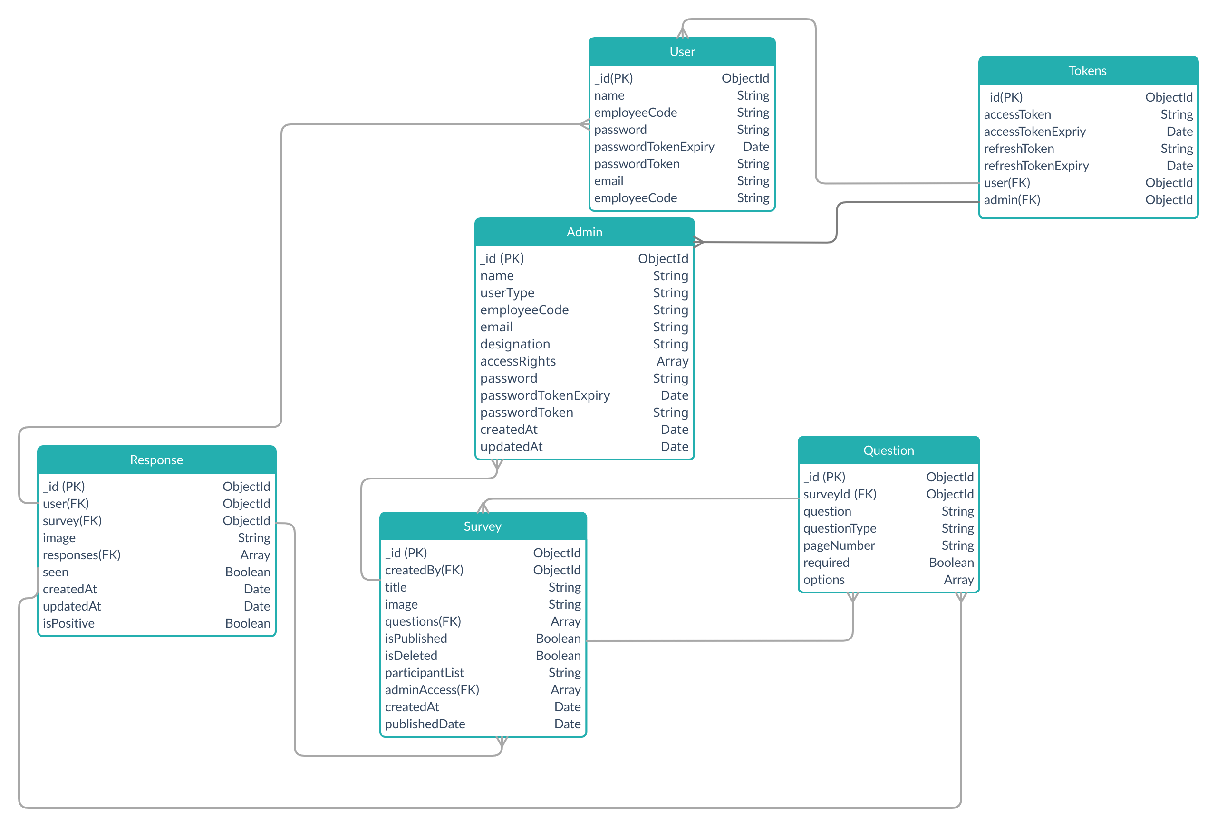

Admin sequence diagram:

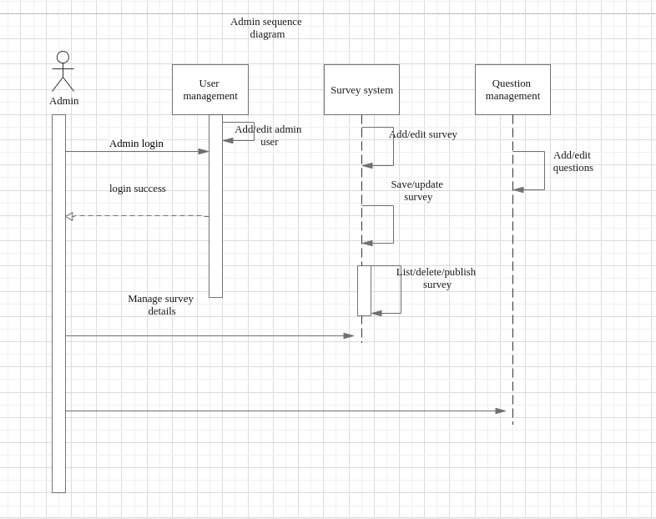

Flow diagram:

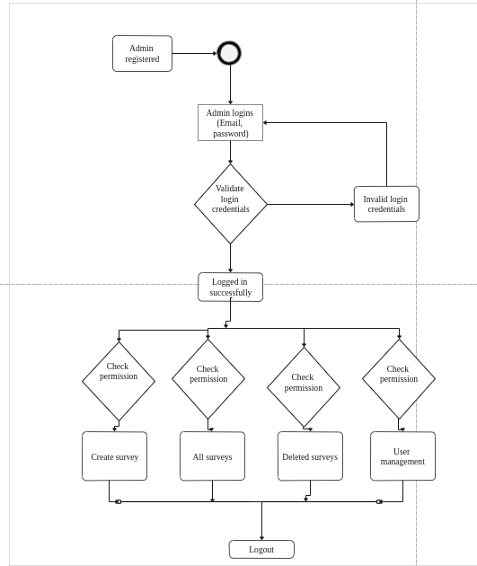

Create survey flow

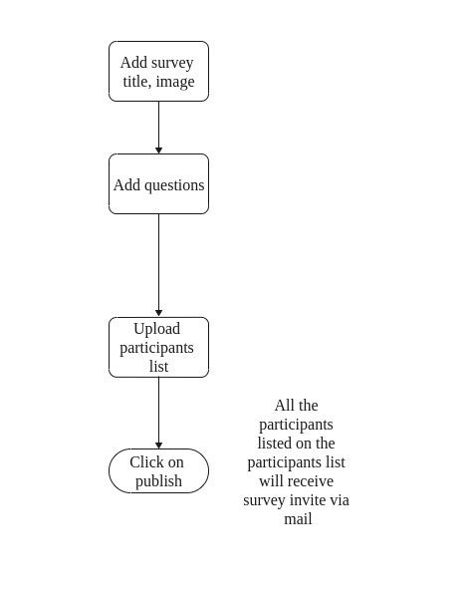

User management flow

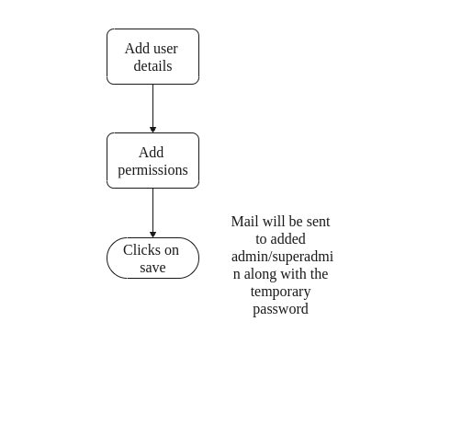

APIs required:

Title | Add admin or superadmin
Description | API to add a admin or a super admin. Only a super Admin has the right to add anyone. The temporary passwords of the added members are automatically generated and are sent to their respective emails.
HTTP Method | POST
Header | Authorization
Input Parameters | Name(String),  userType(String), //admin, superadmin  employeeCode(String),  accessRights(Array),  email(String),  designation(String)
Output parameters (On success) | statusCode : String  message : String  adminId : String
Output parameters (On failure) | statusCode : String  message : String (Error message )

Title | Delete admin/superadmin
Description | API that deletes the details of admin/ super admin
HTTP Method | DELETE
Header | Authorization
Input Parameters | adminId
Output parameters (On success) | statusCode : String  message : String  adminId : String
Output parameters (On failure) | statusCode : String  message : String (Error message )

Title | Edit admin/superadmin
Description | API that edits details of admin/ super admin
HTTP Method | PUT
Header | Authorization
Input Parameters | Name(String),  userType(String), //admin, superadmin  employeeCode(String),  accessRights(Array),  email(String),  designation(String)
Output parameters (On success) | statusCode : String  message : String  adminId : String
Output parameters (On failure) | statusCode : String  message : String (Error message )

Title | Admin forgot password
Description | API that sends an email consisting the link to the page where they can change their password.
HTTP Method | POST
Header | Authorization
Input Parameters | email(String)
Output parameters (On success) | statusCode : String  message : String  adminId : String
Output parameters (On failure) | statusCode : String  message : String (Error message )

Title | List admins/superadmins
Description | API to list all the admins/superadmins.
HTTP Method | GET
Header | Authorization
Input Parameters
Output parameters (On success) | statusCode : String  message : String  userData : Array
Output parameters (On failure) | statusCode : String  message : String (Error message )

Title | Admin login
Description | API that lets an admin login. If the credentials are a match then the admin is allowed to login.
HTTP Method | POST
Header | Authorization
Input Parameters | Email(String)  password(String)
Output parameters (On success) | statusCode : String  message : String  token : String  tokenExpiry: Date  refreshToken: String  refreshTokenexpiry: Date
Output parameters (On failure) | statusCode : String  message : String (Error message )

Title | Admin logout
Description | API that lets an admin/superAdmin to logout.
HTTP Method | POST
Header | Authorization
Input Parameters
Output parameters (On success) | statusCode : String  message : String
Output parameters (On failure) | statusCode : String  message : String (Error message )

Title | Set password
Description | API that changes the password of the admin who requested it. Usually when the admin has forgotten their password.
HTTP Method | POST
Header
Input Parameters | Passwordtoken(String)  password(String)
Output parameters (On success) | statusCode : String  message : String
Output parameters (On failure) | statusCode : String  message : String (Error message )

Title | change password
Description | API to change the password.
HTTP Method | POST
Header | Authorization
Input Parameters | password(String)
Output parameters (On success) | statusCode : String  message : String
Output parameters (On failure) | statusCode : String  message : String (Error message )

Title | Add survey
Description | API that saves the survey form as draft.
HTTP Method | POST
Header | Authorization
Input Parameters | title(String)  image(string)  participantList(String)  questions(Array)
Output parameters (On success) | statusCode : String  message : String
Output parameters (On failure) | statusCode : String  message : String (Error message )

Title | Delete survey
Description | API that deletes a survey form.
HTTP Method | DELETE
Header | Authorization
Input Parameters | surveyId
Output parameters (On success) | statusCode : String  message : String
Output parameters (On failure) | statusCode : String  message : String (Error message )

Title | List drafted survey
Description | API that is used to list all the drafted survey forms
HTTP Method | GET
Header | Authorization
Input Parameters
Output parameters (On success) | statusCode : String  message : String  paginationData: String  surveyData: array
Output parameters (On failure) | statusCode : String  message : String (Error message )

Title | List deleted surveys
Description | API that lists the deleted survey forms.
HTTP Method | GET
Header | Authorization
Input Parameters
Output parameters (On success) | statusCode : String  message : String  paginationData: String  surveyData: Array
Output parameters (On failure) | statusCode : String  message : String (Error message )

Title | Restores deleted survey
Description | API that adds the survey back to drafts.
HTTP Method | PUT
Header | Authorization
Input Parameters | surveyId
Output parameters (On success) | statusCode : String  message : String
Output parameters (On failure) | statusCode : String  message : String (Error message )

Title | API to update survey form
Description | API to update the survey form
HTTP Method | PUT
Header | Authorization
Input Parameters | title(String)  image(string)  participantList(String)  questions(Array)
Output parameters (On success) | statusCode : String  message : String  surveyData: String
Output parameters (On failure) | statusCode : String  message : String (Error message )

Title | API to upload the userList
Description | API to upload the excel sheet which contains the list of users
HTTP Method | POST
Header | Authorization
Input Parameters | file
Output parameters (On success) | statusCode : String  message : String
Output parameters (On failure) | statusCode : String  message : String (Error message )

Title | Delete questions
Description | API that lets an admin or a super admin delete a question from a survey.
HTTP Method | POST
Header | Authorization
Input Parameters | questionId
Output parameters (On success) | statusCode : String  message : String
Output parameters (On failure) | statusCode : String  message : String (Error message )

Title | API to edit the question
Description | API to edit an existing question.
HTTP Method | PUT
Header | Authorization
Input Parameters | Question :String  questionType :String  options : Array  required : boolean  pageNumber : string
Output parameters (On success) | statusCode : String  message : String
Output parameters (On failure) | statusCode : String  message : String (Error message )

Title | User – forgot password
Description | API that sends an email consisting the link to the page where they can change their password.
HTTP Method | PUT
Header
Input Parameters | Email : String
Output parameters (On success) | statusCode : String  message : String
Output parameters (On failure) | statusCode : String  message : String (Error message )

Title | Get pending surveys
Description | API that lists all the pending surveys that the particular user has yet to reply to.
HTTP Method | GET
Header | Authorization
Input Parameters | Email : String
Output parameters (On success) | statusCode : String  message : String  surveys : Array
Output parameters (On failure) | statusCode : String  message : String (Error message )

Title | Get list of completed survey
Description | API that lists all the pending surveys that the particular user has yet to reply to.
HTTP Method | GET
Header | Authorization
Input Parameters
Output parameters (On success) | statusCode : String  message : String  surveys : Array
Output parameters (On failure) | statusCode : String  message : String (Error message )

Title | Get contents of survey form
Description | API that gets the contents of a particular survey form.
HTTP Method | GET
Header | Authorization
Input Parameters
Output parameters (On success) | statusCode : String  message : String  Data : Object
Output parameters (On failure) | statusCode : String  message : String (Error message )

Title | User login
Description | API that lets an user login. If the credentials are a match then the user is allowed to login.
HTTP Method | POST
Header | Authorization
Input Parameters | Email(String)  password(String)
Output parameters (On success) | statusCode : String  message : String  token : String  tokenExpiry: Date  refreshToken: String  refreshTokenexpiry: Date
Output parameters (On failure) | statusCode : String  message : String (Error message )

Title | user logout
Description | API that lets an user to logout
HTTP Method | POST
Header | Authorization
Input Parameters
Output parameters (On success) | statusCode : String  message : String
Output parameters (On failure) | statusCode : String  message : String (Error message )

Title | Set password
Description | API that changes the password of the user who requested it. Usually when the user has forgotten their password.
HTTP Method | POST
Header
Input Parameters | Passwordtoken(String)  password(String)
Output parameters (On success) | statusCode : String  message : String
Output parameters (On failure) | statusCode : String  message : String (Error message )

Title | User- change password
Description | API to change the password of user.
HTTP Method | POST
Header | Authorization
Input Parameters | password(String)
Output parameters (On success) | statusCode : String  message : String
Output parameters (On failure) | statusCode : String  message : String (Error message )

Title | User- submit survey
Description | API to submit survey
HTTP Method | POST
Header | Authorization
Input Parameters | SurveyId: String  responses :{question : string, answer: string}
Output parameters (On success) | statusCode : String  message : String  surveydata : Object
Output parameters (On failure) | statusCode : String  message : String (Error message )

1.7 Bibliography
none

2. Reference

Requirement document issued on 13-02-2021

