Infosys Springboard Virtual Internship 6.0 Completion Report

Team-B
Batch No-13
Start Date- 02/02/2026
Names:
Ande Likhith
Keerti Kushwaha
Shreya Dubey
Internship Duration: 8 Weeks

1. Project Title
Smart Home Energy Management System.
2. Project Objective
The objective of this project is to develop a Smart Home Energy Management System that helps users monitor and manage their household electricity consumption efficiently.
The system allows users to track appliance usage, calculate electricity consumption, and estimate monthly electricity bills. The project aims to promote energy efficiency, cost savings, and better awareness of electricity usage.
By providing a user-friendly dashboard and automated calculations, the system helps users make better decisions about their energy consumption and reduce unnecessary electricity usage.

3. Project description in detail

The Smart Home Energy Management System is a web-based application developed to monitor and optimize electricity consumption in homes.

The system consists of both frontend and backend components. The frontend is built using React.js, providing an interactive dashboard for users to view appliance usage and energy consumption. The backend is developed using Spring Boot, which handles business logic, authentication, and communication with the database. The application uses MySQL for storing user data, appliance details, and energy consumption records.

The system includes several important features:

User Authentication with OTP Verification
Users can securely sign up and log in using OTP verification sent through email.

Energy Consumption Monitoring
Users can add appliances such as fans, lights, TVs, and ACs with their power ratings and usage duration.

Automatic Electricity Bill Calculation
The system calculates daily and monthly electricity consumption and displays the estimated electricity bill based on cost per unit.

Dashboard Interface
A user-friendly dashboard displays appliances, consumption statistics, and energy usage information with icons for better visualization.

Energy Saving Insights
The system shows how much energy can be saved by managing appliance usage effectively.

Real-world impact of this project includes:

Encouraging energy conservation

Helping households reduce electricity bills

Promoting smart home energy awareness

4. Timeline Overview
Week | Activities Planned | Activities Completed
Week 1 | Project planning and requirement analysis | Identified project problem and defined objectives
Week 2 | Designing system architecture | Designed system structure and selected technologies
Week 3 | Frontend development | Developed React login and signup pages
Week 4 | Backend development | Implemented Spring Boot backend and database connection
Week 5 | OTP authentication system | Implemented email OTP verification for login/signup
Week 6 | Dashboard implementation | Developed dashboard to display appliance usage
Week 7 | Energy calculation module | Implemented electricity consumption and monthly bill calculation
Week 8 | Testing and final improvements | Fixed bugs, improved UI, prepared final presentation

5a. Key Milestones
Milestone | Description | Date Achieved
Project Kickoff | Milestone-1 : | 10-02-2026
Prototype/First Draft | Milestone-2 : | 21-02-2026
Mid-Term Review | Milestone-3 : | 2--03-2026
Final Submission | Milestone-4 : | 11-03-2026
Presentation | Milestone-4 | 11-03-2026

5b. Project execution details
The project was executed in multiple stages.
Initially, the project requirements and objectives were defined. A system architecture was designed to integrate the frontend, backend, and database.
The frontend interface was developed using React to create responsive pages for login, signup, and dashboard functionality. The dashboard allows users to manage appliances and track energy usage.
The backend was implemented using Spring Boot, which handled authentication, API services, and data processing. A MySQL database was used to store user accounts and appliance data.
An OTP verification system was implemented for secure login and signup. Users receive a one-time password via email for authentication.
The energy calculation module was developed to compute electricity consumption using appliance power ratings and usage time. The system also calculates the estimated monthly electricity bill based on a defined unit cost.
Finally, the project was tested and improved by fixing errors, optimizing calculations, and improving the dashboard interface.
6. Snapshots / Screenshots

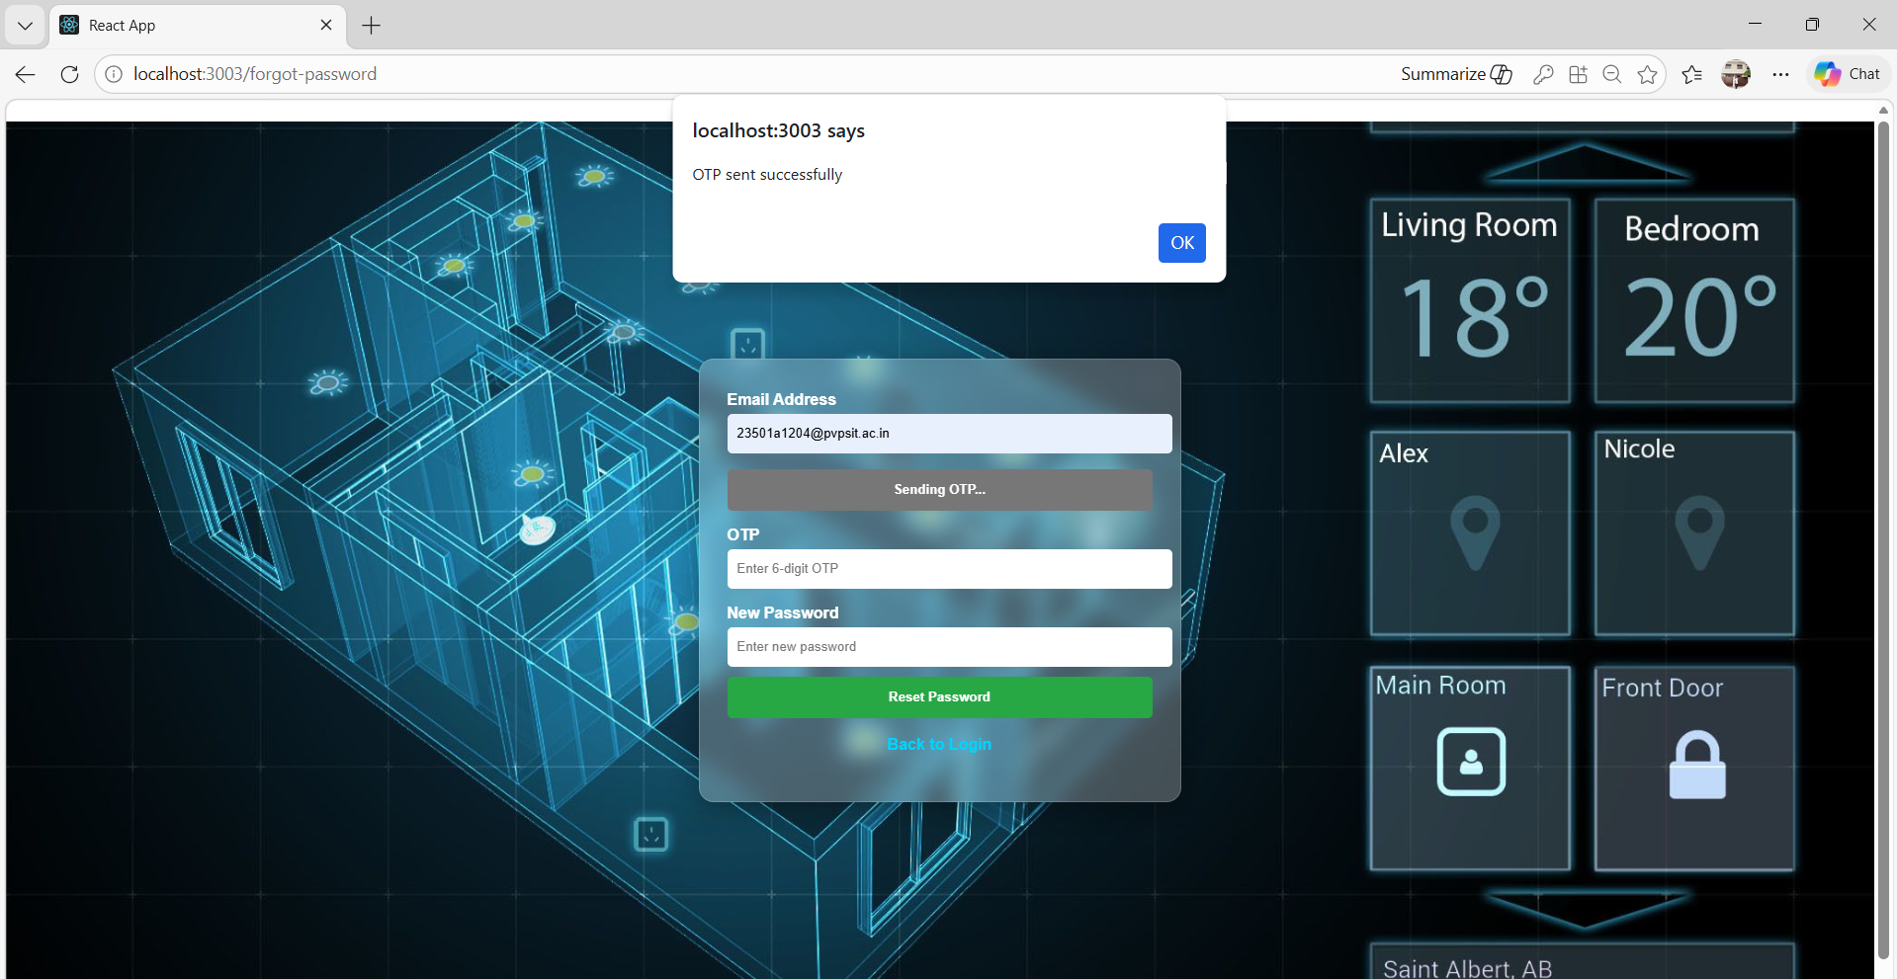

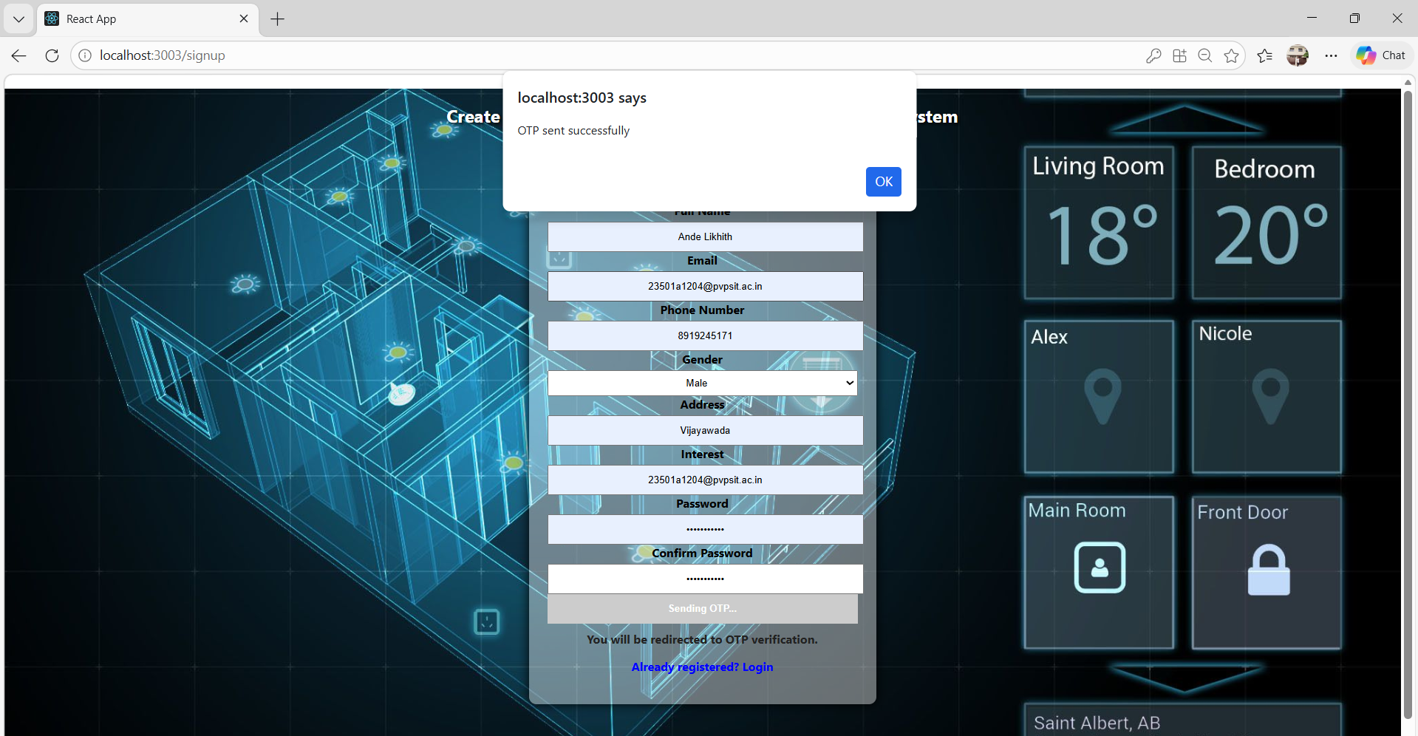

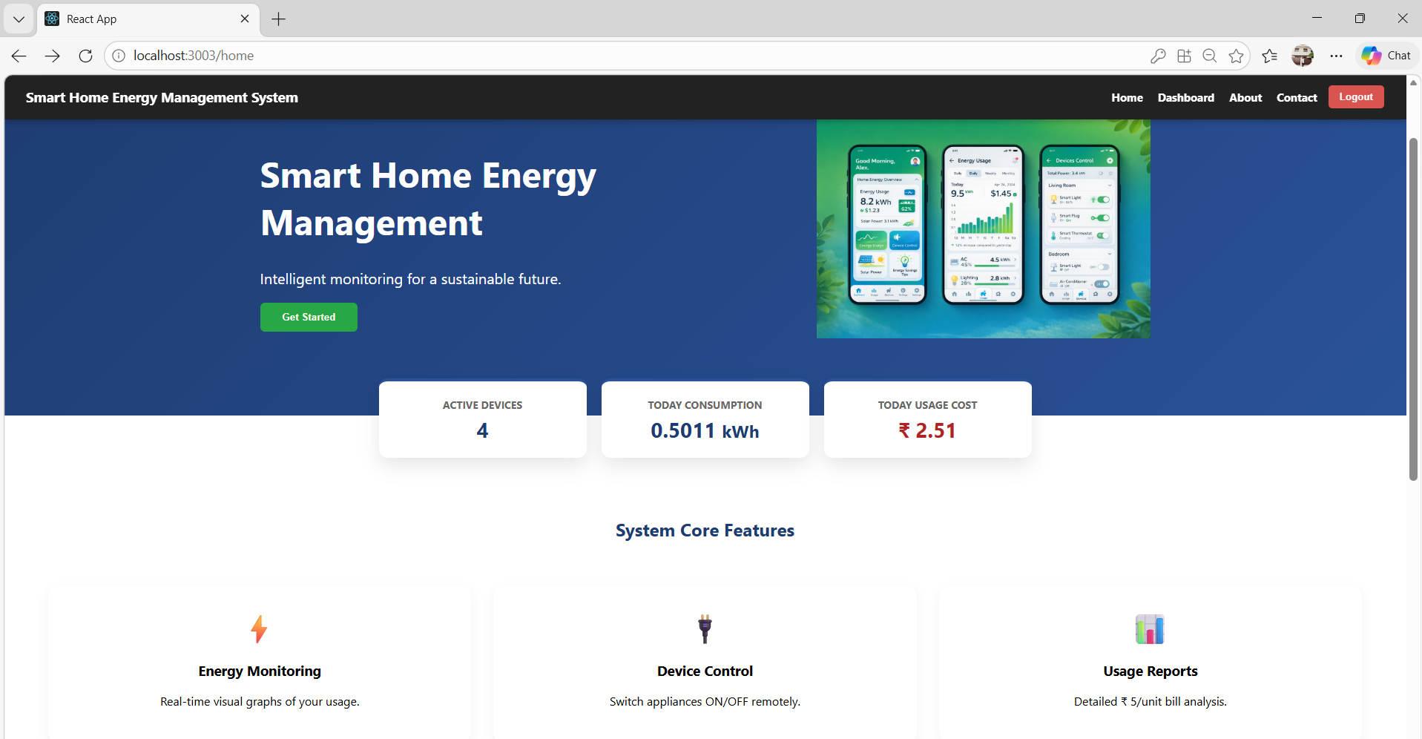
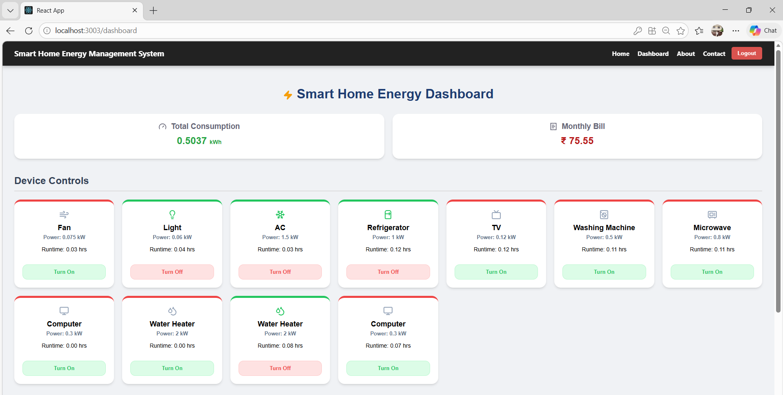

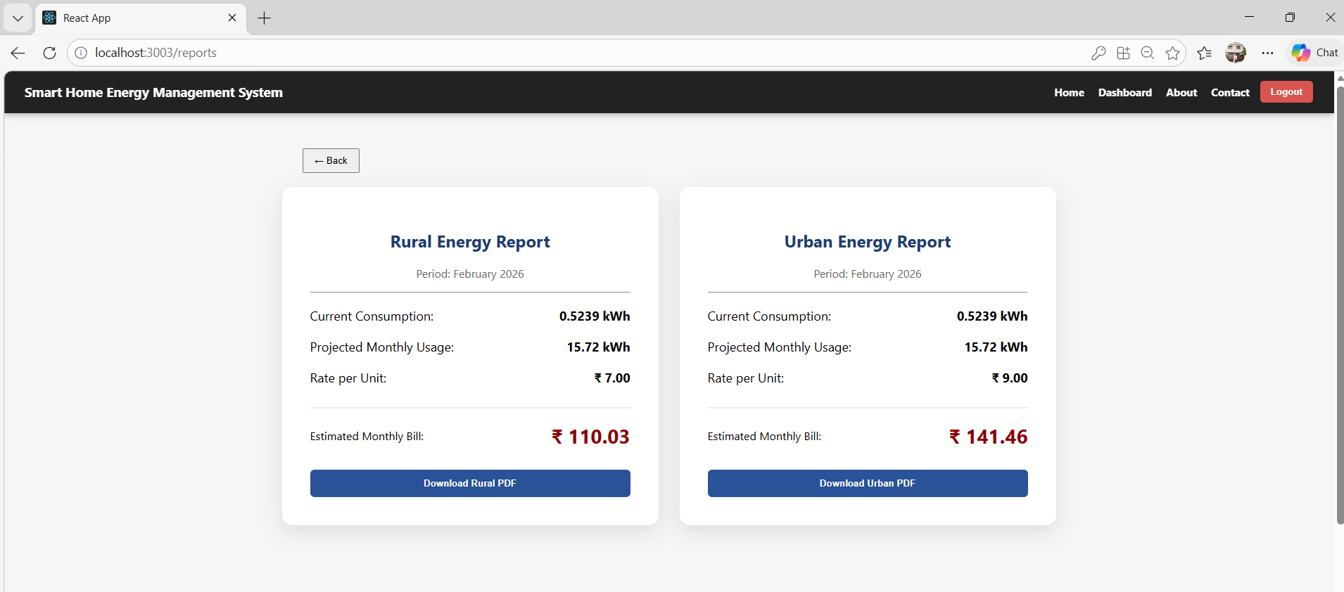

7. Challenges Faced

During the development of this project, several challenges were encountered:

Backend Integration Issues
Initially, connecting the React frontend with the Spring Boot backend caused errors due to incorrect API endpoints and port configuration.

OTP Email Configuration
Setting up email services for OTP verification required proper SMTP configuration and security settings.

Database Connectivity
Connecting MySQL with the backend required correct database configuration and dependency management.

Energy Calculation Logic
Implementing accurate energy consumption formulas required careful testing and validation.

These challenges were resolved through debugging, research, and testing different configurations.

8. Learnings & Skills Acquired

Through this internship project, several technical and professional skills were acquired:

Technical Skills:

React.js for frontend development

Spring Boot for backend development

MySQL database management

REST API development

Email OTP authentication implementation

Conceptual Skills:

Smart energy management systems

Electricity consumption calculation

Web application architecture

Soft Skills:

Problem solving

Project planning

Debugging and testing

Documentation and presentation

9. Testimonials from team

This internship provided valuable experience in developing a real-world web application. Working on the Smart Home Energy Management System helped improve both technical and analytical skills.

The project allowed us to understand how technology can be used to solve real-world problems such as energy conservation. The internship also helped in learning modern web technologies and full-stack development practices.

10. Conclusion
The Smart Home Energy Management System project successfully demonstrated how a web application can help monitor and manage household electricity consumption.
The system provides useful insights into energy usage and helps users reduce electricity costs through better appliance management.
This internship provided hands-on experience in full-stack development using React, Spring Boot, and MySQL, and strengthened knowledge of real-world software development practices.

11. Acknowledgements
I would like to express my sincere gratitude to Infosys Springboard for providing this valuable internship opportunity.
I would also like to thank to the mentor Vamsi Sir and program coordinators for their guidance and support throughout the internship. Their insights and encouragement helped in successfully completing this project.
I am also thankful to my teammates and peers for their collaboration and support during the development of the project.

