FROZEN PRODUCTS WEBSITE
A Skill Oriented Course Web Application report Submitted in the partial fulfillment of the requirements for the award of the degree of
Bachelor of Technology In
Computer Science and Engineering

by

SEELAM LIKHITHA

23761A05P1
Under the guidance of
Mr.R.Ashok,
Sr. Assistant Professor, Dept of CSE



Department of Computer Science and EngineeringLakireddyBaliReddyCollegeofEngineering(Autonomous)
AccreditedbyNAACwith‘A’ Grade&NBA(UnderTier-I),
An ISO 21001:2018,14001:2015,50001:2018 Certified InstitutionApprovedbyAICTE,NewDelhiandAffiliatedtoJNTUK,Kakinada

 | LAKIREDDYBALIREDDYCOLLEGEOFENGINEERING  (AUTONOMOUS)  AccreditedbyNAACwith‘A’ Grade&NBA(UnderTier-I),  An ISO 21001:2018,14001:2015,50001:2018 Certified InstitutionApprovedbyAICTE,NewDelhiandAffiliatedtoJNTUK,Kakinada  L.B.REDDYNAGAR,MYLAVARAM,NTRDIST.,A.P.-521230.  hodcse@lbrce.ac.in,cseoffice@lbrce.ac.in,Phone:08659-222933,Fax:08659-222931  DEPARTMENTOFCOMPUTERSCIENCE&ENGINEERING

CERTIFICATE

This is to certify that the project entitled “Frozen product website”, submitted by S.Likhitha Roll Number: 23761A05P1, in partial fulfillment of the requirements for the award of the Bachelor of Technology (B. Tech) degree in Computer Science and Engineering, under the 23CSS2 - Web Application Development using Full Stack Module-I (Frontend Development) course, is a record of bonafide work carried out by him/her under our guidance.
The results embodied in this Skill Oriented Course Web Application / Project Report have not been submitted to any other University or Institute for the award of any degree or diploma.

Project Guide Head of the department
Mr. R.Ashok, Dr. D.Veeraiah,
Sr. Assistant Professor. Professor.

ExternalExaminer

ACKNOWLEDGEMENT

I would like to express my heartfelt thanks to Mr. R. Ashok, Senior Assistant Professor, Department of Computer Science and Engineering, for his constant encouragement and support in carrying out this Skill Oriented Course Web Application project.
I also take this opportunity to express my sincere gratitude to Dr. D. Veeraiah, Professor and Head of the Department of CSE, for his valuable support, guidance, and motivation, which were instrumental in the successful completion of this project.
I am thankful to the management for providing the necessary infrastructure and support in completing this Web Application/Project. I would also like to express my deep sense of respect and gratitude to our Principal, Dr. K. Appa Rao, for making all required assistance available to us and for his constant support and inspiration throughout this Skill Oriented Course Web Application/Project.
I am also grateful to the teaching and non-teaching staff of the CSE department for their direct and indirect assistance during the course of this project.
Finally, I am deeply thankful to my parents for their unwavering support, encouragement, and blessings, which have been the foundation of all my achievements.

ABSTRACT

This project presents a dynamic and visually engaging website dedicated to frozen products, offering users a seamless and informative online shopping experience. The Frozen Product website is designed to showcase a range of premium frozen categories including Ice-creams, Fruits, Drinks, Flowers, Vegetables, and Meat. The homepage features a vibrant layout with eye-catching images and animated sections that highlight key offerings.
The navigation bar enables quick access to major sections such as Products, Order Status, Subscription. A limited-time promotional banner encourages users to take advantage of exclusive offers. On the left panel, categorized links allow users to explore specific product types with ease. The central content area displays high-quality product images with attractive hover effects and labels, enhancing user engagement.
This project emphasizes responsive design, accessibility, and user convenience. It aims to streamline the order process while providing visually appealing content. The website is an ideal platform for businesses to promoted sell frozen products online, ensuring freshness, convenience, and customer satisfaction.

CONTENTS

CONCEPTS PageNo
- Introduction 01
- Modules 02 - 03
- TechnologiesUsed 04 - 18
  - HTML
  - CSS
  - JAVA SCRIPT
- Implementation 19 - 42
  - HTMLCode
- ScreenShots 43 - 46
- Conclusion 47
- WebReferences 48

INTRODUCTION 1

Introduction to frozen products website
In today’s fast-paced digital world, consumers increasingly rely on online platforms to meet their daily needs, including grocery and food purchases. One of the most rapidly growing segments in the food industry is the frozen food market, which offers a convenient, accessible, and long-lasting solution for consumers seeking nutrition and flavor without the limitations of perishability. As consumer preferences shift towards convenien variety, and quality, businesses are also transitioning to digital platforms to offer their products more effective. This project introduces a feature-rich and visually compelling Frozen Product Website, which serves as an online marketplace for a wide range of frozen products.
Frozen Product Website is designed to bridge the gap between frozen food suppliers and consumers through user-friendly, visually attractive, and interactive interface. The platform offers an online catalog of premium frozen items that include Ice-creams, Frozen Fruits, Drinks, Vegetables, Flowers, and Meat. Each category is organized and displayed with high-resolution images, creating an immersive browsing experience. Users are able to explore various frozen goods, place orders, subscribe to services, and track their order status—all fro integrated platform.
Homepage of the website is designed to create a powerful first impression, featuring a bold header section with brand logo, a navigation bar, and promotional highlights. Below, product categories are beautifully arranged using card-based layouts with animated hover effects that make navigation intuitive and enjoyable. A sidebar menu provides quick links to each frozen product type, enhancing accessibility and user flow. The responsive design ensures that users can access the platform from various devices including desktops, tablets, and smartphones without any loss in functionality or design consistency.
Technologically, the website is built using HTML5, CSS3, and JavaScript, leveraging modern web developme standards to ensure performance, accessibility, and interactivity. HTML structures the content and layout, CSS adds styling and animations, while JavaScript manages the dynamic behaviors of the site such as order interas, greeting messages, cart updates, and more. Local storage is used to maintain cart and wishlist data, allowing fr client-side data persistence without the need for a backend database in the initial phase. The platform has been designed with scalability in mind, meaning new features and modules—such as login authentication, payment gateways, and feedback systems—can be added seamlessly in the future.
The core objective of this project is to digitize the traditional frozen product retail experience, making it smart faster, and more accessible to end users. It empowers businesses to reach a larger audience and enhances the customer experience by offering convenience, real-time interactions, and a visually engaging interface. In this being an e-commerce platform, this website also serves as a digital branding tool, helping sellers market their products in a more appealing way through visual storytelling, promotional banners, and seasonal offers.
The development of this website reflects current trends in e-commerce and web technology, emphasizing engagement, personalization, and mobile accessibility. It also focuses on visual elegance, functional clarity performance efficiency to deliver a website that is not only attractive but also purposeful and productive.

MODULES 2

Project Modules : Frozen Products website
The Frozen Product Website is divided into multiple interrelated modules, each handling a specific set of functionalities to ensure the smooth operation of the platform. These modules work together to provide an engaging user interface, seamless product browsing, order management, and promotional services. Below is detailed description of each key module included in the project:
1. Home Page Module
This is the introductory module that forms the entry point to the website. It showcases a welcome interface featuring the brand logo, navigation bar, promotional banner (such as limited-time offers), and highlighted product categories.
Features
* Responsive layout with seasonal themes and animated effects like snowfall
* Visual product category cards for quick navigation
* Promotional offers and call-to-action buttons like Order Now
2. Product Categories Module
This module displays the range of frozen product categories such as
Frozen Ice-creams
Frozen Fruits
Frozen Drinks
Frozen Flowers
Frozen Vegetables
Frozen Meat
Each category has its own sub-page with product listings, details, pricing, and availability.
Features
* Card-based product display with animations
* Stock status indicators like Out of Stock
* Product advantages and benefits on hover or click
* Option to add items to cart or wishlist
3. Navigation Module
A universal navigation system is implemented to help users move through the platform efficiently.
Features
* Top navigation bar with Home, Products, Order Status, Subscription, Login
* Sidebar for category filtering
* Return to menu or home buttons for intuitive navigation
* Smooth scrolling and page transition effects
4. Cart and Order Module
This module manages the customer's order flow, allowing them to add items to the cart, view cart contents proceed with the order.
Features
* Add to Cart using JavaScript and Local Storage
* View Cart as a popup or modal with quantity and pricing
* Remove item functionality
* Checkout popup with form input including Name, Address, and Phone
* Order summary table
* Discount code entry and billing logic
5. Order Status Module
This module helps users track their current and past orders, enhancing transparency and trust.
Features 3
* Display order ID, item details, quantity, total amount
* Real-time or simulated status like Pending, Shipped, Delivered
* Estimated delivery information
6. Subscription Module
This module allows users to subscribe to premium services or newsletters and receive special deals or early access to offers.
Features
* Email subscription form
* Premium membership benefits display
* Promotional banners for subscribers
7. User Authentication Module (Planned or Future)
Though not fully implemented, this module is proposed to manage user accounts, login or logout processes, personalized interactions.
Planned Features
* Secure login and registration system
* User profile management
* Order history access
8. Wishlist Module (Planned or Future)
This upcoming feature will allow users to save products they are interested in for future purchases.
Planned Features
* Heart icon toggle for wishlist items
* Wishlist page for easy access
* Add to cart from wishlist
9. Animation and Visual Enhancement Module
To create an immersive experience, this module handles UI animations and effects.
Features
* Snowfall or breeze animation across the website
* Card animations on hover
* Greeting popups after cart additions
* Responsive UI effects
10. Print or Invoice Module
This module generates printable order summaries for record-keeping or delivery.
Features
* Export or Print Invoice button
* Formatted order summary with buyer details
* Printable receipt layout using JavaScript

Technologies Used 4

HTML Basics:
Introduction to HTML
Hyper Text Markup Language (HTML) is the standard language used to create and design
web pages. It provides the basic structure of a webpage using a
system of elements enclosed within tags.
Structure of an HTML Document
An HTML document consists of the following main sections:
- DOCTYPE Declaration: Specifies the HTML version.
<!DOCTYPE html>
HTML Tag: The root element of an HTML document.
<html>
</html>
Head Section: Contains metadata, links to stylesheets, and the title of the webpage.
<!DOCTYPE html>
<html lang="en">
<head>
<meta charset="UTF-8">
<meta name="viewport" content="width=device-width, initial-scale=1.0">
<title>FROZENAPP</title>
<link rel="stylesheet" href="bha.css">

</head>
<body>
<div class="header">
<img src="j2.jpeg" alt="FROZENPRODUCTSAPP" >
<h1></h1>
</div>

<div class="menu">

<div class="menu-item">
<a href="#">Home</a>
<div class="submenu">
<ul style="list-style-type: none; padding-left: 0; margin-left: 0;">
<li><a href="s.html"> Seasonal sales</a></li>

<div class="submenu-item">
<li><a href="dis.html" >Discounted-items&#9656;</a></li>
<div class="submenu2">
<a href= "https://www.refrigeratedfrozenfood.com/customerservice">Customer 5 support</a>
<a href= "https://www.frozenfactorycenter.com/product/30223474/Hyfun-Pizza-7%E2%80%9D-Buy-1-Get-1-Free--Ready-To-Bake-">Buy-one Get-one</a>

<a href= "#">FAQS</a>
</div>
</div>
<li><a href="https://www.palfrozenfoods.in/">locations</a></li>
</UL>
</div>
</div>
<a href="product.html">Products</a>
<a href="order.html" class="order-btn">Order Now</a>

<a href="order2.html">Order status</a>

<a href="subs.html">Subscription</a>

<a href="valid.html">Login</a>

</div>
<marquee class="marquee" behavior="scroll" direction="left" scrollamount="20" >

<p> ************* Limited Time Offer!!!: Get 20% on premium subcription!!! *************</p>
</marquee>

<div class="center-section">

<div class="gallery">
<h2>premium images of Our Frozen Products</h2>
<div class="gallery-row">
<div class="gallery-item">
<img src="ice.jpeg" alt="Frozen Ice Cream">
<p>Ice Cream</p>
</div>
<div class="gallery-item">
<img src="https://encrypted-tbn0.gstatic.com/images?q=tbn:ANd9GcSe3FS9EuoMSiUtj_9bKcx0SDIrg9q2e38lrg&s" alt="Frozen Fruits">
<p>Fruits</p>
</div> 6
<div class="gallery-item">
<img src="https://hips.hearstapps.com/hmg-prod/images/20191205-frozen-pimms-cup-delish-ehg-6219-1591386625.jpg?crop=0.765xw:0.820xh;0.214xw,0.108xh&resize=980:*" alt="Frozen Drinks">
<p>Drinks</p>
</div>
<div class="gallery-item">
<img src="frmeat.jpeg" alt="Frozen Meat">
<p>Meat</p>
</div>
</div>
</div>

</div>
</div>
<div class="featured container">
<div class="center-section">

<div class="featured-drinks-row">
<!-- First Drink -->
<div class="featured-drink">
<div class="drink-image-container">
<img src="c.jpeg" alt="Signature Latte" a href="https://www.shutterstock.com/search/signature-coffee?image_type=illustration"class="drink-image">

</div>
<h3 class="drink-name">Signature Latte</h3>
<p class="drink-description">Our house specialty with hints of vanilla and cinnamon</p>
<p class="drink-description">Our house specialty with hints of vanilla and cinnamon</p>
<p class="drink-rate">Price: ₹180</p>
<p class="drink-gst">GST (18%): ₹32.40</p>
<a href="order.html" class="order-btn">Order Now</a>

</div>
<!-- Second Drink -->
<div class="featured-drink">
<div class="drink-image-container">
<img src="ice.jpeg" alt="Cold Brew" class="drink-image">
</div>
<h3 class="drink-name">Cold Brew</h3>
<p class="drink-description">Smooth and refreshing, steeped for 24 hours</p>
<p class="drink-description">Smooth and refreshing, steeped for 24 hours</p>
<p class="drink-rate">Price: ₹160</p>
<p class="drink-gst">GST (18%): ₹28.80</p> 7

<a href="order.html" class="order-btn">Order Now</a>

</div>

<!-- Third Drink -->
<div class="featured-drink">
<div class="drink-image-container">
<img src="sm.jpg" alt="Seasonal Mocha" class="drink-image">
</div>
<h3 class="drink-name">Seasonal Mocha</h3>
<p class="drink-description">Rich chocolate with seasonal flavors and whipped cream</p>
<p class="drink-description">Rich chocolate with seasonal flavors and whipped cream</p>
<p class="drink-rate">Price: ₹200</p>
<p class="drink-gst">GST (18%): ₹36.00</p>

<a href="order.html" class="order-btn">Order Now</a>
</div>

<!-- Fourth Drink (New) -->
<div class="featured-drink">
<div class="drink-image-container">
<img src="b1.jpg" alt="Chai Latte" class="drink-image">
</div>
<h3 class="drink-name">Chai Latte</h3>
<p class="drink-description">Spiced black tea with steamed milk and honey</p>
<p class="drink-description">Spiced black tea with steamed milk and honey</p>
<p class="drink-rate">Price: ₹150</p>
<p class="drink-gst">GST (18%): ₹27.00</p>

<a href="order.html" class="order-btn">Order Now</a>

</div>
</div>
</div>
</main>
</div>
<div class="container">
<div class="sidebar">
<a href="iw.html">Frozn Ice-creams</a>
<a href="fw.html">Frozn Fruits</a>
<a href="fdrinks.html" >Frozn Drinks</a>
<a href="fflower.html" >Frozn Flowers</a>
<a href="fveg.html">Frozn Vegetables</a> 8

<a href="fmeat.html">Frozn Meat</a>
</div>

<!-- Full-width top section -->
<div class="footer-top-full">
<div class="footer-top">
<div class="footer-item">
<h2>30+</h2>
<p>Frozen product varieties</p>
</div>
<div class="footer-item">
<h2>500+</h2>
<p>Satisfied customers</p>
</div>
<div class="footer-item">
<h2>4.9</h2>
<p>Average rating</p>
</div>
</div>
</div>

!-- Full-width footer -->
<footer class="custom-footer">
<div class="footer-columns">
<div class="footer-column">
<h3>Frozen Delights</h3>
<p>Delivering top-quality frozen foods since 2015. Trusted by families and food lovers for freshness, taste, and convenience.</p>
<div class="social-icons">
<span>FB</span>
<span>IG</span>
<span>YT</span>
</div>
</div>

<div class="footer-column">
<h3>Services</h3>
<ul>
<li>Frozen Vegetables</li>
<li>Ready-to-Eat Meals</li>
<li>Frozen Fruits</li>
<li>Desserts & Ice Creams</li>
<li>Bulk Orders</li> 9
</ul>
</div>

<div class="footer-column">
<h3>Contact Info</h3>
<p>Frozen Delights Pvt. Ltd.</p>
<p>456 Ice Valley Road, Chilltown, IN 10101</p>
<p>Phone: +91 99999 12345</p>
<p>Email: support@frozendelights.com</p>
</div>
</div>

<div class="footer-copy">
<p>&copy; 2025 FROZENPRODUCTSAPP. All rights reserved.</p>
</div>
</footer>

<style>
/* Top stats section */
. footer-top-full {
width: 100%;
background: #e6f0fa;
padding: 30px 20px;
}

.footer-top {
max-width: 1200px;
margin: 0 auto;
display: flex;
justify-content: space-around;
flex-wrap: wrap;
}

.footer-item {
text-align: center;
margin: 15px;
}

.footer-item h2 {
font-size: 2.2em;
color: #0077cc;
margin-bottom: 5px;
}

.footer-item p { 10
font-size: 1em;
color: #444;
}

/* Main footer styling */
.custom-footer {
background-color: #1a1a1a;
color: #fff;
padding: 40px 20px 20px;
}

.footer-columns {
max-width: 1200px;
margin: 0 auto;
display: flex;
flex-wrap: wrap;
justify-content: space-around;
gap: 30px;
}

.footer-column {
flex: 1;
min-width: 250px;
}

.footer-column h3 {
color: #00ccff;
margin-bottom: 15px;
}

.footer-column p,
.footer-column li {
font-size: 0.95em;
line-height: 1.6;
color: #ccc;
}

.footer-column ul {
V list-style: none;
padding-left: 0;
}

.social-icons span { 11
display: inline-block;
background: #0077cc;
color: white;
font-weight: bold;
width: 32px;
height: 32px;
line-height: 32px;
border-radius: 50%;
text-align: center;
margin-right: 8px;
font-size: 0.9em;
}

/* Footer bottom copy */
.footer-copy {
text-align: center;
font-size: 0.85em;
margin-top: 30px;
color: #aaa;
border-top: 1px solid #333;
padding-top: 15px;
}
</style>
</style>
</div>
</body>
</html>

CSS (Cascading Style Sheets)
Introduction to CSS
Cascading Style Sheets (CSS) is a stylesheet language used to control the presentation and
layout of HTML documents. It allows developers to apply styles such as colors, fonts,
spacing, and positioning to web pages.
Types of CSS
CSS can be applied in three different ways:
1. Inline CSS: Applied directly within an HTML element using the style attribute.
<p style="color: blue; font-size: 16px;">This is a paragraph.</p>
2. Internal CSS: Defined within a <style> tag inside the HTML <head>.
<style>
p {
color: blue;
font-size: 16px;
}
</style>
3. External CSS: Stored in a separate .css file and linked using the <link> tag.

<link rel="stylesheet" href="styles.css"> 12
CSS Selectors
Selectors are used to target HTML elements for styling. Some common
selectors include:
• Element Selector: Targets all instances of an element.
p {
color: green;
}
#css code
* {
margin: 0;
padding: 0;
box-sizing: border-box;
}
body {
background-image:url("log44.jpg");
background-SIZE:COVER;
background-SIZE:no-repeat;

font-family: Arial, sans-serif;
min-height: 90vh;
display: flex;
flex-direction: column;

}
.header {
background: url("BG.jpeg") no-repeat center center/cover;
color: white;
display: flex;
align-items: center;
justify-content:center;
padding: 10 50px;
height:120px;

/* width: 100%;
height: 120px;
padding: 10px 50px;
background-color: #4CAF50;
text-align: center;
display: flex;
align-items: center;
justify-content: center;
box-shadow: 0 4px 6px rgba(0, 0, 0, 0.1)*/
}
}
.header img {
height: 80px;
margin-right:20px;
}

.header h1 {
font-size: 40px;
font-family:Bebas Neue;
}
.menu {
background-color: #DE3163; 13
display: flex;
justify-content: center;
padding:10px 0;
position:relative;

}
.menu-item {
position: relative;
}
.menu a {
color: white;
padding: 30px 30px;
text-decoration: none;
text-align: center;
display:block;
}
.menu a:hover {
background-color: #FF00FF;
color: black;
}
.submenu {
display:none;
position: absolute;
background-color: PURPLE;
top:100%;
left: 0;
width: 150px;
z-index: 1001;
}
.gallery {
text-align: center;
padding: 40px 20px;
background-image:url("bg.jpeg");

border-radius: 20px;
margin: 20px auto;
width: 90%;
box-shadow: 0 10px 20px rgba(0,0,0,0.1);
}

.gallery h2 {
font-size: 2rem;
color: #00796b;
margin-bottom: 30px;
text-shadow: 1px 1px #ffffff;
}

.gallery-row {
display: flex;
flex-wrap: wrap;
justify-content: center;
gap: 30px;
}

.gallery-item {
background: white;
padding: 15px;
border-radius: 15px; 14
width: 200px;
box-shadow: 0 5px 15px rgba(0,0,0,0.15);
transition: transform 0.3s ease, box-shadow 0.3s ease;
animation: float 3s ease-in-out infinite;
}

.gallery-item img {
width: 100%;
height: 150px;
object-fit: cover;
border-radius: 10px;
transition: transform 0.5s ease;
}

.gallery-item p {
margin-top: 10px;
font-weight: bold;
color: #00695c;
}

.gallery-item:hover {
transform: translateY(-10px);
box-shadow: 0 15px 25px rgba(0,0,0,0.2);
}

.gallery-item:hover img {
transform: scale(1.05);
}
/* Example CSS tweak */
.center-section {
width: 90%; /* reduce this percentage */
margin: 20px auto; /* center align */
padding: 10px;
font-size: 1rem; /* reduce if needed */
transform: scale(0.9); /* Optional: scales entire section down */
}

/* Floating animation */
@keyframes float {
0% { transform: translateY(0px); }
50% { transform: translateY(-8px); }
100% { transform: translateY(0px); }
}

/* Featured Section */

.featured-title {
text-align: center;
color: #6b4226;
font-size: 28px;
margin-bottom: 30px;
}

.featured-drinks-row {
display: flex;
flex-direction: row;
justify-content: space-between;
gap: 20px; 15
flex-wrap: wrap;
}

.featured-drink {
flex: 1;
min-width: 200px;
max-width: 280px;
background-color: #f9f3e9;
border-radius: 8px;
padding: 15px;
text-align: center;
margin-bottom: 20px;
}

.drink-image-container {
width: 100%;
height: 180px;
overflow: hidden;
border-radius: 6px;
margin-bottom: 15px;
}

.drink-image {
width: 100%;
height: 100%;
object-fit: cover;
}

.drink-name {
color: #6b4226;
font-size: 20px;
margin: 10px 0;
}

.drink-description {
color: #666;
font-size: 14px;
line-height: 1.4;

}
.drink-rate,
.drink-gst {
font-size: 14px;
color: #4e3629;
margin-top: 2px;
}

.order-btn {
display: inline-block;
margin-top: 10px;
padding: 10px 20px;
background-color: #6e4f36;
color: #fff;
text-decoration: none;
border-radius: 25px;
font-weight: bold;
transition: background-color 0.3s ease, transform 0.2s ease;
} 16

.order-btn:hover {
background-color: #8b5e3c;
transform: scale(1.05);
}

.submenu a {
display: block;
color: white;
padding: 20px;
text-decoration: none;
text-align: left;
}
.submenu a:hover {
background-color:#d69c22;
}

.menu-item:hover .submenu {
display: block;
}
.submenu-item {
position: relative;
}
.submenu2 {
display: none;
position: absolute;
background-color: #47d6da;
top: 0;
left: 100%;
width: 150px;
z-index: 1002;
}
.submenu-item:hover .submenu2 {
display: block;
}
.submenu2 a {
display: block;
color: white;
padding: 10px;
text-decoration: none;
}
.submenu2 a:hover {
background-color: #b7d622;
}
.container {
display: flex;
margin-top: 10px;
}
.sidebar {
width: 200px;
background-color:#4a235a;
color: black;
padding-top: 35px;
box-shadow: 2px 2px 10px rgba(0, 0, 0, 0.2);
position: absolute;
top:305px;
left:0;
bottom:0; 17
min-height: 77vh;
}
.sidebar a {
display: block;
color: white;
padding: 20px;
text-decoration: none;
text-align: center;
}
.sidebar a:hover {
background-color: #b7d622;
}
.main-content {
flex-grow: 1;
padding:20px;
margin-left:220px;
display: flex;
justify-content: center;
align-items: center;
}
.info-box {
background-color:#9FE2BF;
padding: 30px;
box-shadow: 2px 2px 10px rgba(0, 0, 0, 0.2);
text-align: center;
width: 100%;
height:500px;
border-radius: 8px;
font-size:18px;
display:flex;
}
.title{
padding:50px;
}
.info-box img {
max-width: 40%;
height: auto;
border-radius: 8px;
margin-bottom: 15px;

}
.info-text{
flex-grow: 1;
text-align: left;
padding:20px;
}
.footer {
background-color: #333;
color: white;
text-align: center;
padding: 15px;
width: 100%;
margin-top: 430px;
}
.marquee {

background: #900C3F ;
color: white; 18
padding: 30px;
text-align:center;
scrollamount=10;

}

@keyframes scrollText {
from {
transform: translateX(100%);
}
to {
transform: translateX(-100%);
}
}

IMPLEMENTATION 19

HOME.html
<!DOCTYPE html>
<html lang="en">
<head>
<meta charset="UTF-8">
<title>Frozen Product Seasonal Sales</title>
<style>
* {
box-sizing: border-box;
}

body {
font-family: 'Segoe UI', sans-serif;
background: linear-gradient(to right, #a1c4fd, #c2e9fb);
margin: 0;
padding: 0;
display: flex;
flex-direction: column;
align-items: center;
overflow-x: hidden;
}

h1 {
color: #004e92;
margin-top: 40px;
animation: fadeIn 2s ease-in-out;
z-index: 1;
}

.season-container {
display: grid;
grid-template-columns: repeat(auto-fit, minmax(250px, 1fr));
gap: 25px;
margin: 40px;
width: 85%;
z-index: 1;
}

.card {
background: #ffffffee;
padding: 20px;
border-radius: 20px;
box-shadow: 0 10px 18px rgba(0, 0, 0, 0.15);
text-align: center;
transition: transform 0.3s ease, box-shadow 0.3s ease;
animation: slideInUp 1s ease-in-out;
cursor: pointer;
position: relative;
}

.card:hover {
transform: translateY(-8px) scale(1.03);
box-shadow: 0 12px 28px rgba(0, 0, 0, 0.2);
} 20

.card img {
width: 180px;
height: 180px;
object-fit: cover;
border-radius: 20px;
margin-bottom: 15px;
transition: transform 0.3s ease-in-out;
}

.card img:hover {
transform: scale(1.05) rotate(4deg);
}

.season {
font-size: 26px;
color: #003566;
margin-bottom: 10px;
font-weight: bold;
}

.sales {
font-size: 22px;
color: #0077b6;
font-weight: 600;
}

.desc {
font-size: 16px;
color: #333;
margin-top: 10px;
}

.message-box {
position: fixed;
bottom: 30px;
background: #ffffffdd;
color: #023e8a;
padding: 15px 25px;
border-radius: 15px;
box-shadow: 0 6px 12px rgba(0, 0, 0, 0.2);
font-size: 18px;
z-index: 1000;
display: none;
animation: fadeIn 0.5s ease;
}

.home-btn {
background: #0077b6;
color: white;
padding: 10px 25px;
border-radius: 10px;
text-decoration: none;
margin-bottom: 30px;
font-weight: bold;
transition: background 0.3s ease;
z-index: 1;
} 21

.home-btn:hover {
background: #023e8a;
}

canvas {
position: fixed;
top: 0;
left: 0;
pointer-events: none;
z-index: 0;
}

@keyframes fadeIn {
from { opacity: 0; transform: translateY(-20px); }
to { opacity: 1; transform: translateY(0); }
}

@keyframes slideInUp {
from { opacity: 0; transform: translateY(50px); }
to { opacity: 1; transform: translateY(0); }
}

@media (max-width: 768px) {
.card img {
width: 130px;
height: 130px;
}

h1 {
font-size: 24px;
text-align: center;
}
}
</style>
</head>
<body>
<canvas id="snow-canvas"></canvas>

<h1>Seasonal Sales for Frozen Products</h1>

<div class="season-container">
<div class="card" onclick="showMessage('❄️ Winter: People crave frozen desserts and warm dishes like soups!')">
<img src="https://encrypted-tbn0.gstatic.com/images?q=tbn:ANd9GcQx022h4LwlGWTmBdO5WqBAzmK9HkPb6L0O7A&s" alt="Winter">
<div class="season">Winter</div>
<div class="sales">₹80,000</div>
<div class="desc">Frozen meats, pies, and hearty soups top sales in this cozy season.</div>
</div>
<div class="card" onclick="showMessage('🌸 Spring: Freshness blooms! Frozen fruits and veggies dominate.')">
<img src="https://i.pinimg.com/736x/9b/7e/dd/9b7eddc17cd99db6ee493f80ee94a8c4.jpg" alt="Spring">
<div class="season">Spring</div>
<div class="sales">₹60,000</div>
<div class="desc">Smoothies and colorful frozen fruits are customer favorites during spring.</div>
</div>
<div class="card" onclick="showMessage('☀️ Summer: Ice creams and cold drinks soar in demand!')">
<img src="sum.jpeg" alt="Summer">
<div class="season">Summer</div> 22
<div class="sales">₹95,000</div>
<div class="desc">Frozen drinks, popsicles, and ice creams fly off the shelves in the heat!</div>
</div>
<div class="card" onclick="showMessage('🍂 Autumn: Time for comfort food like frozen pies and baked goodies!')">
<img src="aut.jpeg" alt="Autumn">
<div class="season">Autumn</div>
<div class="sales">₹70,000</div>
<div class="desc">Pumpkin-flavored items and frozen baked goods rule the cozy season.</div>
</div>
</div>

<h2 style="color: #023e8a; margin-bottom: 25px; z-index:1;">Total Sales: ₹3,05,000</h2>
<a href="Product.html" class="home-btn">GO to Products</a>

<div id="message" class="message-box"></div>

<script>
function showMessage(message) {
const msgBox = document.getElementById("message");
msgBox.innerText = message;
msgBox.style.display = "block";
setTimeout(() => {
msgBox.style.display = "none";
}, 3000);
}

// Snowfall using Canvas
const canvas = document.getElementById("snow-canvas");
const ctx = canvas.getContext("2d");

let width = window.innerWidth;
let height = window.innerHeight;
canvas.width = width;
canvas.height = height;

const snowflakes = [];

function createSnowflakes() {
for (let i = 0; i < 100; i++) {
snowflakes.push({
x: Math.random() * width,
y: Math.random() * height,
radius: Math.random() * 4 + 1,
speedY: Math.random() * 1.5 + 0.5,
speedX: Math.random() * 0.5 - 0.25
});
}
}

function drawSnowflakes() {
ctx.clearRect(0, 0, width, height);
ctx.fillStyle = "white";
ctx.beginPath();
for (let flake of snowflakes) {
ctx.moveTo(flake.x, flake.y);
ctx.arc(flake.x, flake.y, flake.radius, 0, Math.PI * 2);
}
ctx.fill(); 23
moveSnowflakes();
}

function moveSnowflakes() {
for (let flake of snowflakes) {
flake.y += flake.speedY;
flake.x += flake.speedX;

if (flake.y > height) {
flake.y = 0;
flake.x = Math.random() * width;
}
}
}

function update() {
drawSnowflakes();
requestAnimationFrame(update);
}

window.addEventListener("resize", () => {
width = window.innerWidth;
height = window.innerHeight;
canvas.width = width;
canvas.height = height;
});

createSnowflakes();
update();
</script>
</body>
</html>

Product.html

<!DOCTYPE html>
<html lang="en">
<head>
<meta charset="UTF-8">
<title>Frozen Products</title>
<style>
body {
font-family: 'Segoe UI', sans-serif;
margin: 0;
padding: 0;
background: linear-gradient(to bottom, #c9f2ff, #e0f7fa);
overflow-x: hidden;
}

h1 {
color: #004d40;
text-align: center;
margin: 40px 0 20px;
font-size: 3rem;
animation: fadeIn 1.5s ease-in-out;
} 24

.product-container {
display: flex;
flex-wrap: wrap;
justify-content: center;
gap: 40px;
padding: 30px;
z-index: 1;
position: relative;
}

.card {
background: white;
border-radius: 25px;
box-shadow: 0 10px 20px rgba(0,0,0,0.15);
padding: 25px;
width: 280px;
cursor: pointer;
transition: transform 0.3s ease, box-shadow 0.3s ease;
animation: slideIn 1s ease-in-out;
}

.card:hover {
transform: scale(1.07);
box-shadow: 0 15px 30px rgba(0,0,0,0.25);
}

.card img {
width: 200px;
height: 200px;
object-fit: cover;
border-radius: 50%;
margin-bottom: 20px;
border: 4px solid #b2ebf2;
}

.product-name {
font-size: 24px;
font-weight: bold;
color: #00796b;
}

/* Modal */
.modal {
display: none;
position: fixed;
z-index: 10;
left: 0; top: 0;
width: 100%;
height: 100%;
overflow: auto;
background-color: rgba(0,0,0,0.6);
}

.modal-content {
background: #ffffff;
margin: 5% auto;
padding: 40px; 25
border-radius: 25px;
width: 90%;
max-width: 700px;
text-align: center;
animation: fadeIn 0.5s ease;
box-shadow: 0 0 20px rgba(0,0,0,0.3);
}

.home-btn {
display: inline-block;
margin: 20px 10px;
padding: 14px 40px;
font-size: 18px;
background-color: #fff;
color: #d63384;
font-weight: bold;
border: 2px solid #ff69b4;
border-radius: 30px;
cursor: pointer;
box-shadow: 0 5px 15px rgba(0,0,0,0.3);
transition: all 0.3s ease;
text-decoration: none;
}
.modal-content img {
width: 220px;
height: 220px;
object-fit: cover;
border-radius: 20px;
border: 3px solid #81d4fa;
margin-bottom: 25px;
}

.modal-content ul {
text-align: left;
font-size: 18px;
color: #333;
line-height: 1.6;
padding: 0 20px;
}

.close-btn {
margin-top: 30px;
display: inline-block;
background: #00796b;
color: white;
padding: 12px 24px;
border-radius: 12px;
text-decoration: none;
font-size: 16px;
font-weight: bold;
cursor: pointer;
transition: background 0.3s;
}

.close-btn:hover {
background: #004d40;
}

/* Snowfall effect */ 26
.snow {
position: fixed;
top: 0;
left: 0;
width: 100%;
height: 100%;
pointer-events: none;
background-image: url('b1.jpg');
z-index: 0;
animation: snowfall 50s linear infinite;
opacity: 0.3;
}

@keyframes snowfall {
0% { background-position: 0 0; }
100% { background-position: 1000px 1000px; }
}

@keyframes fadeIn {
from { opacity: 0; transform: translateY(-20px); }
to { opacity: 1; transform: translateY(0); }
}

@keyframes slideIn {
from { opacity: 0; transform: translateY(40px); }
to { opacity: 1; transform: translateY(0); }
}
</style>
</head>
<body>

<div class="snow"></div>

<h1>Explore Our Frozen Products</h1>

<div class="product-container">
<div class="card" onclick="showModal('Ice Cream', 'ice.jpeg', ['Rich in calcium for strong bones', 'Boosts mood instantly', ' Great for all ages', 'Perfect summer refreshment'])">
<img src="Ice.jpeg" alt="Ice Cream">
<div class="product-name">Ice Cream</div>
</div>

<div class="card" onclick="showModal('Frozen Pizza', 'piza.jpeg', ['Quick meal option', 'Loaded with cheese and toppings', 'Long shelf life', 'Perfect party treat'])">
<img src="piza.jpeg" alt="Frozen Pizza">
<div class="product-name">Frozen Pizza</div>
</div>

<div class="card" onclick="showModal('Frozen Vegetables', 'veg.jpeg', ['Packed with nutrients', 'No preservatives', 'Easy to cook', 'Saves chopping time'])">
<img src="veg.jpeg" alt="Frozen Vegetables">
<div class="product-name">Frozen Vegetables</div>
</div>

<div class="card" onclick="showModal('Frozen Meat', 'frmeat.jpeg', ['High in protein', 'Safely preserved', 'Ideal for all recipes', 'Perfect for storage'])">
<img src="frmeat.jpeg" alt="Frozen Meat"> 27
<div class="product-name">Frozen Meat</div>
</div>
</div>

<div style="text-align:center">
<a class="home-btn" href="jyo.html">← Back to Home</a>

</div
<!-- Modal -->
<div id="productModal" class="modal">
<div class="modal-content">
<h2 id="modalTitle"></h2>
<img id="modalImage" src="" alt="">
<ul id="modalAdvantages"></ul>
<div class="close-btn" onclick="closeModal()">← Return to Menu</div>
</div>
</div>

<script>
function showModal(title, imageSrc, advantages) {
document.getElementById("modalTitle").innerText = title;
document.getElementById("modalImage").src = imageSrc;

const list = document.getElementById("modalAdvantages");
list.innerHTML = "";
advantages.forEach(item => {
const li = document.createElement("li");
li.textContent = "✅ " + item;
list.appendChild(li);
});

document.getElementById("productModal").style.display = "block";
}

function closeModal() {
document.getElementById("productModal").style.display = "none";
}

window.onclick = function(event) {
const modal = document.getElementById("productModal");
if (event.target == modal) {
closeModal();
}
};
</script>
</body>
</html>

Order.html

<!DOCTYPE html>
<html lang="en">
<head>
<meta charset="UTF-8" />
<meta name="viewport" content="width=device-width, initial-scale=1.0" /> 28
<title>Frozen Products Store</title>
<style>
* { box-sizing: border-box; }
body {
margin: 0; padding: 0;
font-family: 'Segoe UI', sans-serif;
background: linear-gradient(to bottom right, #e0f7ff, #ffffff);
transition: background 0.4s, color 0.4s;
}
body.dark {
background: linear-gradient(to bottom right, #1e1e2f, #2b2b3d);
color: #f0f0f0;
}
.container { max-width: 1200px; margin: auto; padding: 20px; }
.header { text-align: center; padding: 20px; }
.toggle-btn, .view-cart-btn, .home-btn {
position: fixed; top: 20px;
background: #333; color: white; border: none;
padding: 10px 20px; border-radius: 20px;
cursor: pointer; z-index: 2;
}
.home-btn {
display: inline-block;
margin: 20px 10px;
padding: 14px 40px;
font-size: 18px;
background-color: #fff;
color: #d63384;
font-weight: bold;
border: 2px solid #ff69b4;
border-radius: 30px;
cursor: pointer;
box-shadow: 0 5px 15px rgba(0,0,0,0.3);
transition: all 0.3s ease;
text-decoration: none;
}
.toggle-btn { right: 20px; }
.view-cart-btn { right: 160px; }
.home-btn { left: 20px; }
.product-list {
display: flex; flex-wrap: wrap; gap: 20px;
justify-content: center;
}
.product-card {
background: #f0f8ff;
border-radius: 10px;
padding: 20px;
width: 260px;
text-align: center;
box-shadow: 0 4px 10px rgba(0,0,0,0.1);
position: relative;
}
body.dark .product-card { background: #444; color: white; }
.product-card h3 { margin: 10px 0; }
.btn { margin: 10px 5px; padding: 8px 16px; border: none; border-radius: 6px; cursor: pointer; }
.cart-btn { background-color: #007acc; color: white; }
.wishlist-btn { background-color: transparent; border: none; font-size: 24px; color: red; cursor: pointer; position: absolute; top: 10px;
right: 10px; } 29
.wishlist-btn.active { color: pink; }
form {
background: #fff; padding: 20px; border-radius: 10px; box-shadow: 0 4px 10px rgba(0,0,0,0.1); margin-top: 30px;
}
body.dark form { background: #333; color: white; }
input, select {
padding: 10px; margin: 10px 0; width: 100%; border-radius: 6px;
border: 1px solid #ccc; font-size: 16px;
}
table {
width: 100%; border-collapse: collapse; margin-top: 20px;
}
th, td { padding: 10px; border: 1px solid #ccc; text-align: center; }
th { background: #f0f0f0; }
.snowflake {
position: fixed;
top: -10px;
z-index: 0;
color: white;
user-select: none;
pointer-events: none;
font-size: 1em;
animation: fall linear infinite;
}
@keyframes fall {
to { transform: translateY(100vh); }
}
</style>
</head>
<body>

<a class="home-btn" href="jyo.html">← Back to Home</a>
<button class="view-cart-btn" onclick="viewCart()">🛒 View Cart</button>
<button class="toggle-btn" onclick="toggleDarkMode()">🌙 Toggle Mode</button>
<div class="container">
<div class="header">
<h1>Frozen Product Store</h1>
</div>

<div class="product-list" id="productList"></div>

<form id="orderForm">
<h2>Place Your Order</h2>
<select id="orderItem" required></select>
<input type="number" id="quantity" placeholder="Quantity" min="1" required>
<input type="text" id="name" placeholder="Full Name" required>
<input type="text" id="address" placeholder="Delivery Address" required>
<input type="tel" id="phone" placeholder="Phone Number" pattern="[0-9]{10}" required>
<button type="submit" class="btn cart-btn">Confirm Order</button>
</form>

<div id="summary">
<h2>Order Summary</h2>
<table id="summaryTable">
<thead>
<tr>
<th>Item</th>
<th>Price</th> 30
<th>Quantity</th>
<th>Total</th>
<th>Name</th>
<th>Address</th>
<th>Phone</th>
</tr>
</thead>
<tbody></tbody>
</table>
</div>
</div>

<script>
const products = [
{ name: 'Frozen Berries', price: 180 },
{ name: 'Choco Fudge', price: 200 },
{ name: 'Vanilla Dream', price: 150 },
{ name: 'Signature Latte', price: 180 },
{ name: 'Cold Brew', price: 160 },
{ name: 'Strawberry', price: 160 },
{ name: 'Seasonal Mocha', price: 200 },
{ name: 'Chai Latte', price: 150 },
];

const cart = JSON.parse(localStorage.getItem("cart")) || [];
const wishlist = JSON.parse(localStorage.getItem("wishlist")) || [];

const productList = document.getElementById("productList");
const orderItemSelect = document.getElementById("orderItem");

function renderProducts() {
productList.innerHTML = '';
orderItemSelect.innerHTML = '';

products.forEach(product => {
const card = document.createElement('div');
card.className = 'product-card';

const heart = document.createElement('button');
heart.innerHTML = wishlist.includes(product.name) ? '❤️' : '🤍';
heart.className = 'wishlist-btn';
if (wishlist.includes(product.name)) heart.classList.add('active');
heart.onclick = () => {
toggleWishlist(product.name);
heart.innerHTML = wishlist.includes(product.name) ? '❤️' : '🤍';
};

const title = document.createElement('h3');
title.textContent = product.name;
const price = document.createElement('p');
price.textContent = `₹${product.price}`;

const addBtn = document.createElement('button');
addBtn.textContent = 'Add to Cart';
addBtn.className = 'btn cart-btn';
addBtn.onclick = () => {
cart.push(product);
localStorage.setItem("cart", JSON.stringify(cart)); 31
alert(`✅ ${product.name} added to cart!`);
};

card.appendChild(heart);
card.appendChild(title);
card.appendChild(price);
card.appendChild(addBtn);
productList.appendChild(card);

const option = document.createElement('option');
option.value = product.name;
option.textContent = `${product.name} - ₹${product.price}`;
option.setAttribute('data-price', product.price);
orderItemSelect.appendChild(option);
});
}

function toggleWishlist(name) {
const index = wishlist.indexOf(name);
if (index > -1) wishlist.splice(index, 1);
else wishlist.push(name);
localStorage.setItem("wishlist", JSON.stringify(wishlist));
}

function toggleDarkMode() {
document.body.classList.toggle("dark");
}

function viewCart() {
if (!cart.length) return alert("🛒 Your cart is empty!");
let message = "🛒 Cart Items:\n";
cart.forEach((item, i) => message += `${i+1}. ${item.name} - ₹${item.price}\n`);
alert(message);
}

const orderForm = document.getElementById("orderForm");
const summaryBody = document.querySelector("#summaryTable tbody");

orderForm.addEventListener("submit", (e) => {
e.preventDefault();
const item = orderItemSelect.value;
const price = parseFloat(orderItemSelect.selectedOptions[0].dataset.price);
const quantity = parseInt(document.getElementById("quantity").value);
const name = document.getElementById("name").value;
const address = document.getElementById("address").value;
const phone = document.getElementById("phone").value;
const total = price * quantity;

const row = document.createElement("tr");
row.innerHTML = `
<td>${item}</td>
<td>₹${price}</td>
<td>${quantity}</td>
<td>₹${total}</td>
<td>${name}</td>
<td>${address}</td>
<td>${phone}</td>`;
summaryBody.appendChild(row); 32

alert(`🎉 Order confirmed for ${item} x${quantity} by ${name}!`);
orderForm.reset();
});

for (let i = 0; i < 40; i++) {
const snowflake = document.createElement('div');
snowflake.classList.add('snowflake');
snowflake.innerText = '❄';
snowflake.style.left = Math.random() * 100 + 'vw';
snowflake.style.animationDuration = 5 + Math.random() * 10 + 's';
snowflake.style.fontSize = 12 + Math.random() * 24 + 'px';
document.body.appendChild(snowflake);
}

renderProducts();
</script>
</body>
</html>

Subscription.html

<!DOCTYPE html>
<html lang="en">
<head>
<meta charset="UTF-8">
<title>Frozen Subscriptions</title>
<style>
@import url('https://fonts.googleapis.com/css2?family=Quicksand:wght@500;700&display=swap');

* { box-sizing: border-box; }

body {
margin: 0;
padding: 0;
font-family: 'Quicksand', sans-serif;
background: linear-gradient(145deg, purple, #bde9f9);
color: greens;
overflow-x: hidden;
transition: background 0.5s ease, color 0.5s ease;
}

body.dark-mode {
background: pink;
color: green;
}

h1 {
text-align: center;
margin-top: 30px;
font-size: 36px;
text-shadow: 2px 2px #a0e9f7;
}

.toggle-btn {
position: fixed; 33
top: 15px;
right: 20px;
background: purple;
color: white;
border: none;
padding: 10px 18px;
border-radius: 20px;
cursor: pointer;
z-index: 1000;
}

.plans {
display: flex;
flex-wrap: wrap;
justify-content: center;
gap: 30px;
padding: 40px 20px;
position: relative;
}

.card {
width: 280px;
background: rgba(255, 255, 255, 0.15);
border-radius: 20px;
padding: 25px;
text-align: center;
box-shadow: 0 8px 30px rgba(0,0,0,0.15);
backdrop-filter: blur(10px);
border: 1px solid rgba(255, 255, 255, 0.2);
animation: floatCard 4s ease-in-out infinite;
transition: transform 0.3s ease;
}

.card:hover {
transform: scale(1.05);
}

.card img {
width: 100px;
height: 100px;
border-radius: 12px;
margin-bottom: 15px;
box-shadow: 0 0 12px #9de3f0;
}

.title {
font-size: 22px;
font-weight: 700;
margin-bottom: 10px;
}

.price {
font-size: 26px;
margin: 10px 0;
}

.features {
list-style: none; 34
padding: 0;
margin-bottom: 20px;
}

.features li {
margin: 8px 0;
}

.subscribe-btn {
background: linear-gradient(to right, #00d2ff, #3a47d5);
color: white;
border: none;
padding: 12px 25px;
border-radius: 30px;
font-weight: bold;
cursor: pointer;
position: relative;
overflow: hidden;
}

.subscribe-btn:hover {
transform: scale(1.05);
}

.subscribe-btn::after {
content: "";
position: absolute;
top: 0;
left: -75%;
width: 50%;
height: 100%;
background: rgba(255, 255, 255, 0.3);
transform: skewX(-30deg);
transition: left 0.5s;
}

.subscribe-btn:hover::after {
left: 125%;
}

/* Modal Popup */
.modal {
display: none;
position: fixed;
top: 0; left: 0;
width: 100%; height: 100%;
background: rgba(0,0,0,0.6);
justify-content: center;
align-items: center;
z-index: 999;
}

.modal-content {
background: white;
padding: 30px;
border-radius: 20px;
width: 300px;
text-align: center; 35
position: relative;
box-shadow: 0 10px 30px rgba(0,0,0,0.3);
}

.modal-content h2 {
margin-bottom: 15px;
}

.modal-content input {
padding: 10px;
width: 90%;
margin-bottom: 15px;
border: 1px solid #ccc;
border-radius: 10px;
}
.home-btn {
display: inline-block;
margin: 20px 10px;
padding: 14px 40px;
font-size: 18px;
background-color: #fff;
color: #d63384;
font-weight: bold;
border: 2px solid #ff69b4;
border-radius: 30px;
cursor: pointer;
box-shadow: 0 5px 15px rgba(0,0,0,0.3);
transition: all 0.3s ease;
text-decoration: none;
}

.modal-content button {
padding: 10px 20px;
background: #00778b;
color: white;
border: none;
border-radius: 20px;
cursor: pointer;
}

.close {
position: absolute;
top: 10px;
right: 15px;
font-size: 20px;
cursor: pointer;
}

/* Snow animation */
.snowflake {
position: fixed;
top: -10px;
width: 10px;
height: 10px;
background: white;
border-radius: 50%;
opacity: 0.7;
animation: fall 10s linear infinite; 36
}

@keyframes fall {
0% { transform: translateY(-10px); }
100% { transform: translateY(100vh); }
}

@keyframes floatCard {
0%, 100% { transform: translateY(0); }
50% { transform: translateY(-10px); }
}

</style>
</head>
<body>

<button class="toggle-btn" onclick="toggleDarkMode()">🌓 Toggle Mode</button>
<h1>❄️ Frozen Subscriptions</h1>
<a class="home-btn" href="jyo.html">← Back to Home</a>

<div class="plans">
<div class="card">
<img src="veg.jpeg" alt="Starter">
<div class="title">Frost Starter</div>
<div class="price">₹349/mo</div>
<ul class="features">
<li>3 frozen items</li>
<li>Weekly delivery</li>
<li>Email support</li>
</ul>
<button class="subscribe-btn" onclick="openModal('Frost Starter')">Subscribe Now</button>
</div>

<div class="card">
<img src="piza.jpeg" alt="Pro">
<div class="title">Icy Pro</div>
<div class="price">₹749/mo</div>
<ul class="features">
<li>7 frozen items</li>
<li>Fast delivery</li>
<li>Priority support</li>
</ul>
<button class="subscribe-btn" onclick="openModal('Icy Pro')">Subscribe Now</button>
</div>

<div class="card">
<img src="ice.jpeg" alt="Premium">
<div class="title">Glacier Premium</div>
<div class="price">₹1099/mo</div>
<ul class="features">
<li>Unlimited frozen items</li>
<li>Express delivery</li>
<li>24/7 live chat</li>
</ul>
<button class="subscribe-btn" onclick="openModal('Glacier Premium')">Subscribe Now</button>

</div>
</div> 37

<!-- Modal -->
<div class="modal" id="modal">
<div class="modal-content">
<span class="close" onclick="closeModal()">&times;</span>
<h2 id="modal-title">Subscribe</h2>

<input type="text" placeholder="Your Name" id="name">
<input type="email" placeholder="Your Email" id="email">
<button onclick="submitSubscription()">Subscribe</button>

</div>
</div>

<script>
let selectedPlan = "";

function openModal(plan) {
selectedPlan = plan;
document.getElementById("modal").style.display = "flex";
document.getElementById("modal-title").innerText = `Subscribe to ${plan}`;
}

function closeModal() {
document.getElementById("modal").style.display = "none";
}

function submitSubscription() {
const name = document.getElementById("name").value;
const email = document.getElementById("email").value;
if (name && email) {
alert(`Thank you ${name}, you've subscribed to ${selectedPlan}!`);
closeModal();
} else {
alert("Please fill in all fields.");
}
}

function toggleDarkMode() {
document.body.classList.toggle("dark-mode");
}

// Snowflakes animation
for (let i = 0; i < 30; i++) {
const snowflake = document.createElement("div");
snowflake.classList.add("snowflake");
snowflake.style.left = Math.random() * window.innerWidth + "px";
snowflake.style.animationDuration = (5 + Math.random() * 5) + "s";
snowflake.style.opacity = Math.random();
document.body.appendChild(snowflake);
}
</script>
</body>
</html>

38

Login.html

<!DOCTYPE html>
<html lang="en">
<head>
<meta charset="UTF-8" />
<meta name="viewport" content="width=device-width, initial-scale=1.0"/>
<title>Frozen Product Registration</title>
<link href="https://fonts.googleapis.com/css2?family=Quicksand:wght@500&display=swap" rel="stylesheet">
<style>
* {
box-sizing: border-box;
}

body {
margin: 0;
padding: 0;
font-family: 'Quicksand', sans-serif;
background: linear-gradient(to bottom, #a1c4fd, #c2e9fb);
height: 100vh;
overflow: hidden;
position: relative;
background: url('b1.jpg') no-repeat center center fixed;
background-size: cover;
font-family: 'Segoe UI', sans-serif;
margin: 0;
padding: 0;

}

.snowflake {
position: fixed;
top: -10px;
background: white;
border-radius: 50%;
width: 8px;
height: 8px;
animation: fall linear infinite;
opacity: 0.7;
z-index: 1;
}

@keyframes fall {
0% {
transform: translateY(0);
opacity: 1;
}
100% {
transform: translateY(100vh);
opacity: 0;
}
}

.form-container {
position: relative; 39
z-index: 2;
background: rgba(255, 255, 255, 0.85);
width: 400px;
margin: 70px auto;
padding: 35px 30px;
border-radius: 25px;
box-shadow: 0 0 30px rgba(0, 153, 255, 0.4);
backdrop-filter: blur(6px);
animation: fadeIn 1s ease-in-out;
}

@keyframes fadeIn {
from { opacity: 0; transform: translateY(20px); }
to { opacity: 1; transform: translateY(0); }
}

h2 {
text-align: center;
margin-bottom: 25px;
color: #0077cc;
text-shadow: 2px 2px 6px rgba(255,255,255,0.6);
font-size: 28px;
}

label {
display: block;
margin-bottom: 6px;
font-weight: bold;
color: #0652dd;
}

input[type="text"],
input[type="password"],
input[type="email"],
input[type="tel"] {
width: 100%;
padding: 12px;
margin-bottom: 18px;
border: none;
border-radius: 12px;
font-size: 15px;
background-color: #f0faff;
box-shadow: inset 0 0 6px rgba(0, 153, 255, 0.2);
transition: box-shadow 0.3s ease;
}

input:focus {
outline: none;
box-shadow: 0 0 10px #00ccff;
}

.checkbox-container {
margin-bottom: 18px;
color: #333;
font-size: 14px;
}

input[type="checkbox"] { 40
margin-right: 6px;
}

input[type="submit"] {
width: 100%;
padding: 12px;
background: linear-gradient(to right, #00c6ff, #0072ff);
color: white;
border: none;
border-radius: 12px;
font-size: 16px;
font-weight: bold;
cursor: pointer;
transition: transform 0.2s, background 0.4s;
}

input[type="submit"]:hover {
background: linear-gradient(to right, #0072ff, #00c6ff);
transform: scale(1.04);
}

.back-home {
display: block;
text-align: center;
margin-top: 20px;
text-decoration: none;
font-weight: bold;
background: linear-gradient(to right, #74ebd5, #acb6e5);
padding: 10px 20px;
border-radius: 12px;
color: #003366;
box-shadow: 0 0 10px rgba(0, 255, 255, 0.5);
transition: background 0.3s, transform 0.2s;
}

.back-home:hover {
background: linear-gradient(to right, #acb6e5, #74ebd5);
transform: scale(1.05);
}
</style>

<script>
function validateForm() {
var un = document.registration.uname.value.trim();
var password = document.registration.password.value.trim();
var mobileno = document.registration.mobile.value.trim();
var mail = document.registration.email.value.trim();

var usernamePattern = /^[a-zA-Z0-9_\s]+$/;
var mobilePattern = /^[0-9]{10}$/;
var emailPattern = /^[a-zA-Z0-9._-]+@[a-zA-Z0-9.-]+\.[a-zA-Z]{2,4}$/;
var passwordPattern = /^(?=.*[a-z])(?=.*[A-Z])(?=.*\d)(?=.*[@$!%*?&])[A-Za-z\d@$!%*?&]{8,}$/;

if (un === "") {
alert("❄️ Please enter your username");
document.registration.uname.focus();
return false;
} 41
if (un.length < 6) {
alert("❄️ Username must be at least 6 characters");
document.registration.uname.focus();
return false;
}
if (!usernamePattern.test(un)) {
alert("❄️ Username can only contain letters, numbers, and underscores");
document.registration.uname.focus();
return false;
}

if (password === "") {
alert("❄️ Please enter your password");
document.registration.password.focus();
return false;
}
if (!password.match(passwordPattern)) {
alert("❄️ Password must be at least 8 characters and include uppercase, lowercase, number, and special character");
document.registration.password.focus();
return false;
}

if (mobileno === "") {
alert("❄️ Please enter your mobile number");
document.registration.mobile.focus();
return false;
}
if (!mobilePattern.test(mobileno)) {
alert("❄️ Mobile number must be exactly 10 digits");
document.registration.mobile.focus();
return false;
}

if (!emailPattern.test(mail)) {
alert("❄️ Please enter a valid email address");
document.registration.email.focus();
return false;
}

alert("🎉 Registration Successful! Welcome to the Frozen Product World!");
return false; // prevent reload
}

function togglePassword() {
var passField = document.getElementById("password");
passField.type = passField.type === "password" ? "text" : "password";
}

// Snowflake generator
window.onload = function () {
for (let i = 0; i < 60; i++) {
const snow = document.createElement("div");
snow.className = "snowflake";
snow.style.left = Math.random() * window.innerWidth + "px";
snow.style.animationDuration = 3 + Math.random() * 5 + "s";
snow.style.width = snow.style.height = 4 + Math.random() * 5 + "px";
document.body.appendChild(snow);
} 42
};
</script>
</head>

<body>
<div class="form-container">
<h2>Frozen Product Registration</h2>
<form name="registration" onsubmit="return validateForm();">
<label for="uname">Your Name:</label>
<input type="text" name="uname" id="uname" placeholder="e.g. Ice Queen Elsa">

<label for="password">Password:</label>
<input type="password" name="password" id="password" placeholder="Strong password here">
<div class="checkbox-container">
<input type="checkbox" onclick="togglePassword()"> Show Password
</div>

<label for="mobile">Mobile Number:</label>
<input type="tel" name="mobile" id="mobile" placeholder="10-digit number">

<label for="email">Email Address:</label>
<input type="email" name="email" id="email" placeholder="e.g. icequeen@frozen.com">

<input type="submit" value="❄️ Register Now">
</form>

<a href="jyo.html" class="back-home">🏠 Back to Home</a>
</div>
</body>
</html>

43

ScreenShots

Home.html

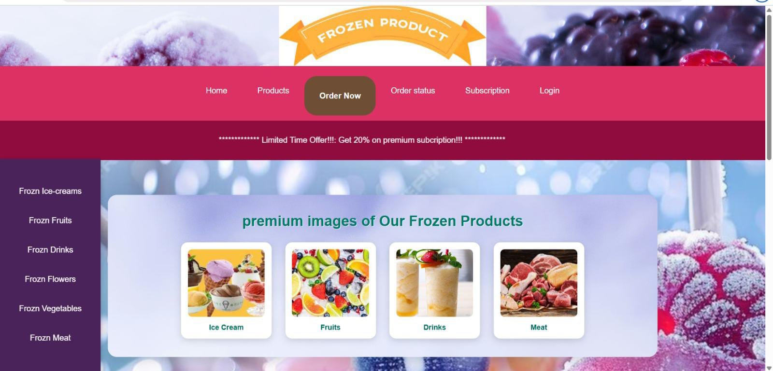

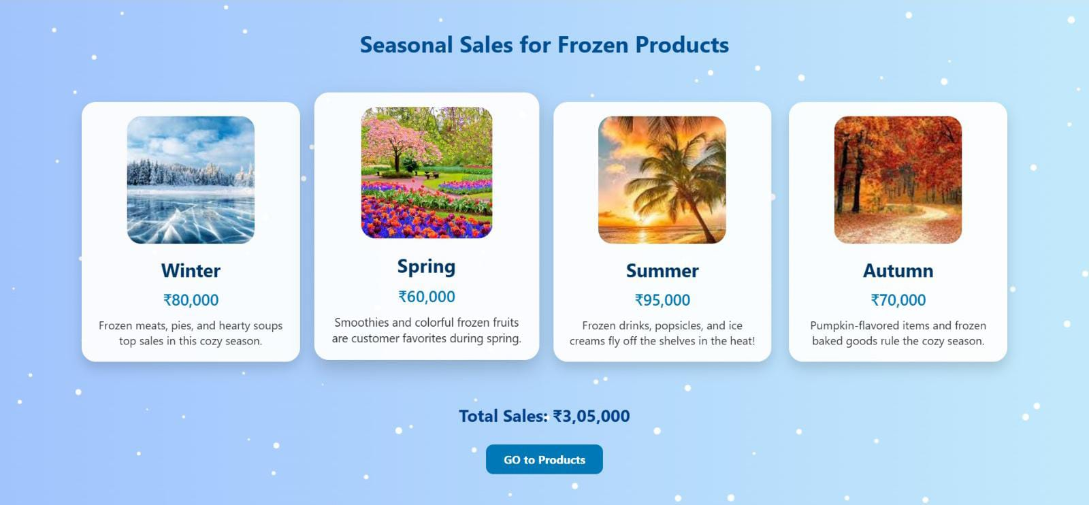

PRODUCT.html 44
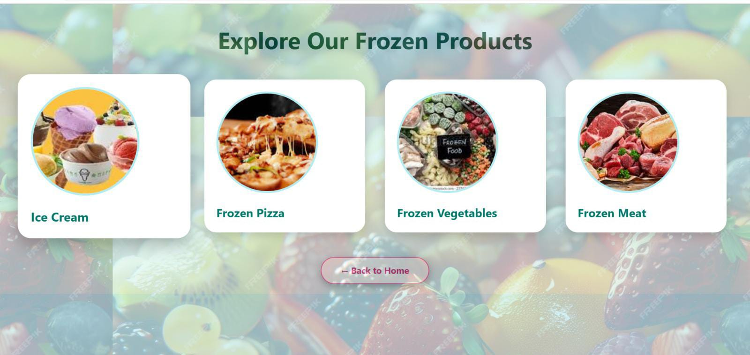

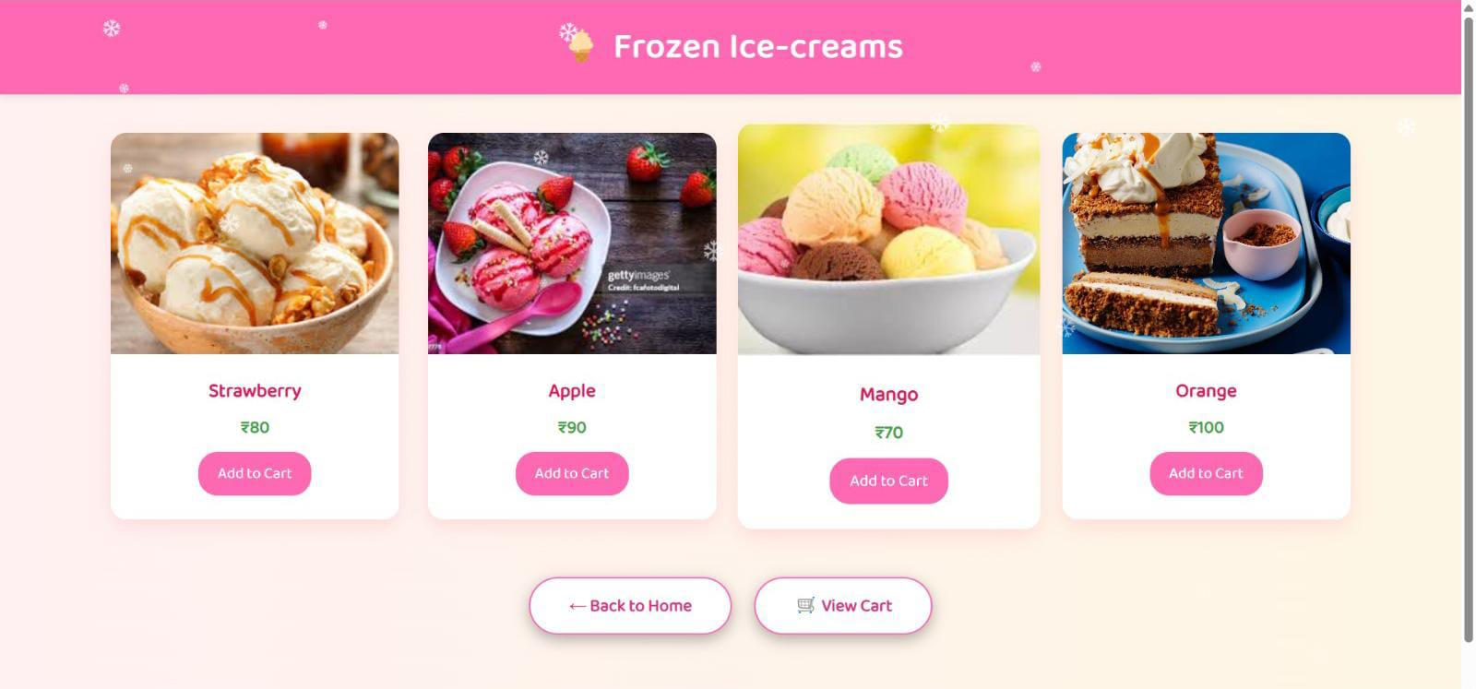

45

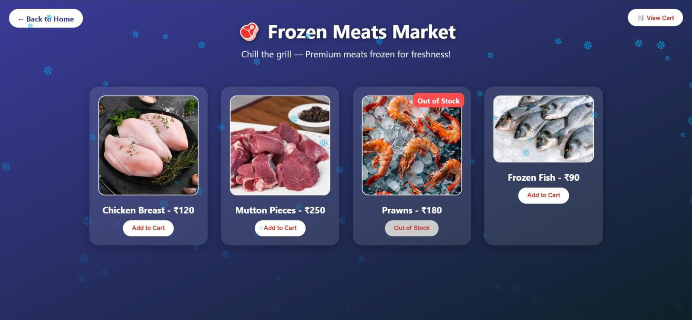

Order.html

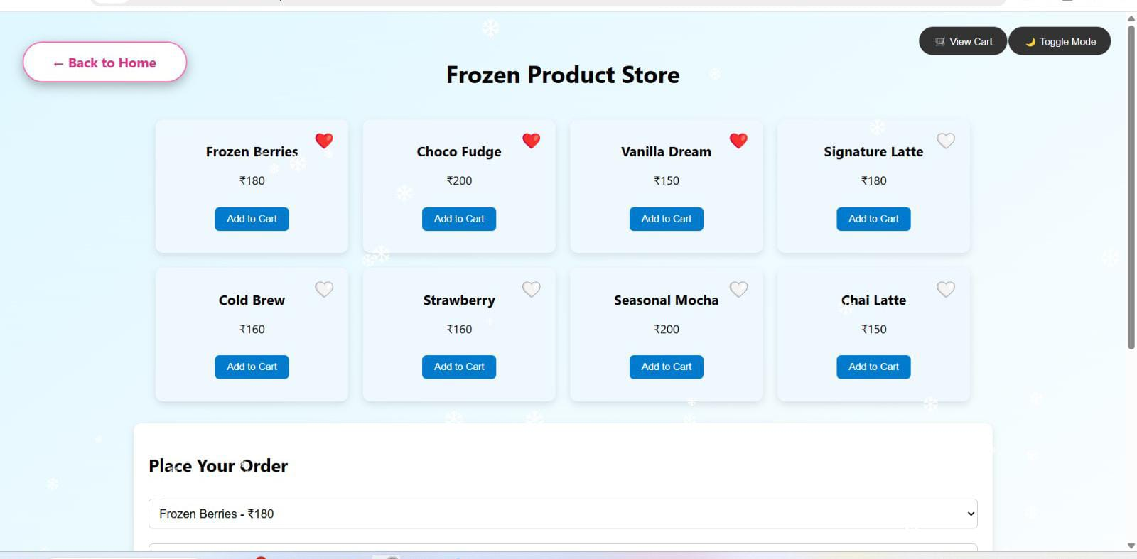

46

Subscription.html

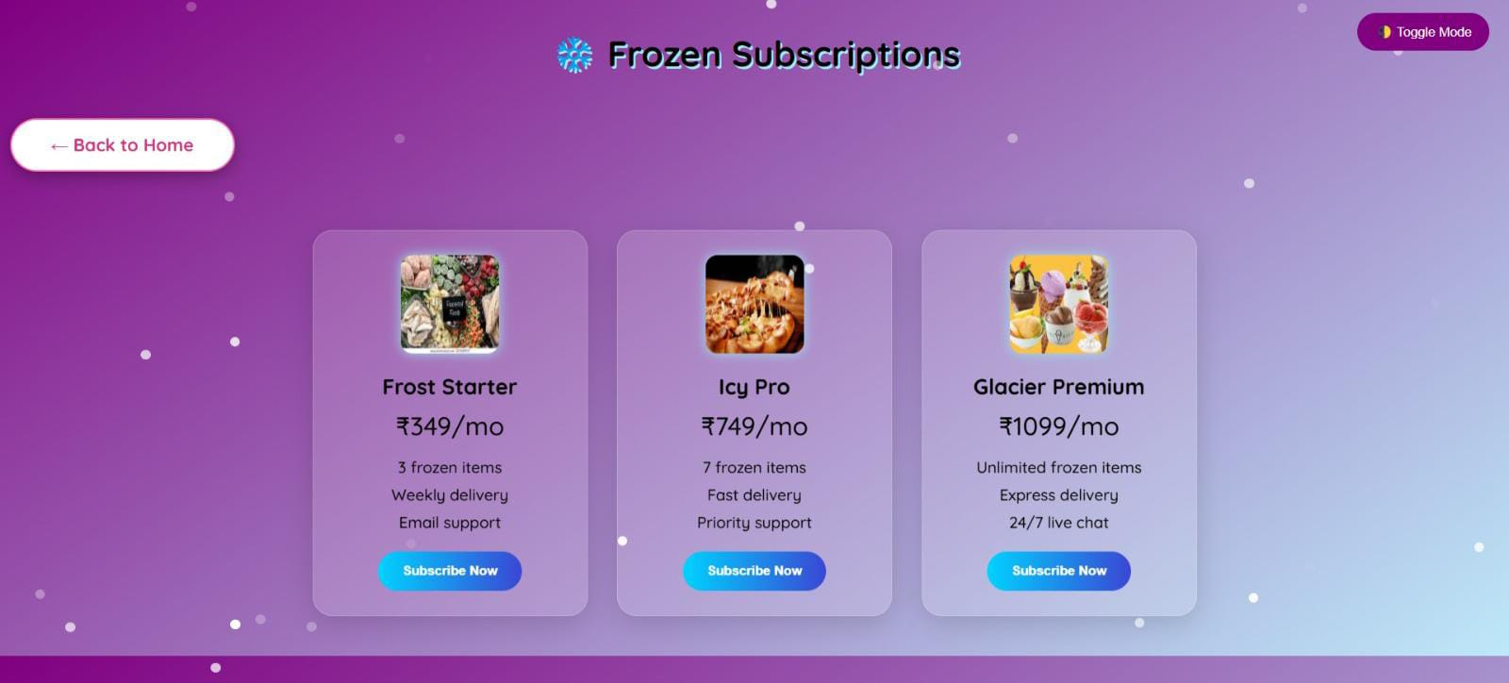
Login.html

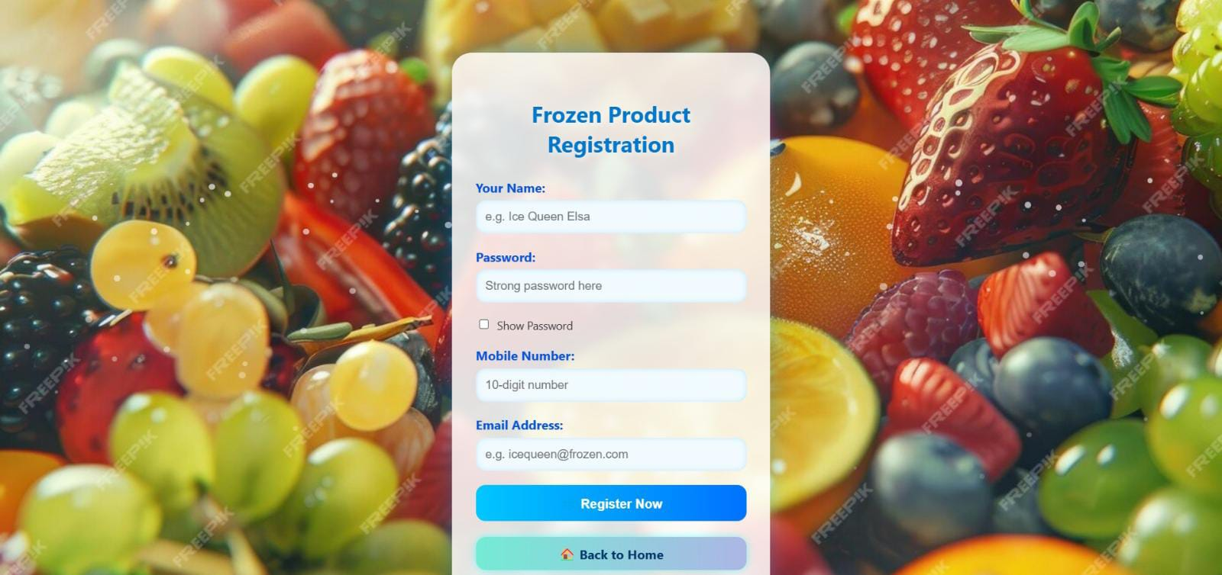

Conclusion 47
The Frozen Product Website is a modern, interactive, and user-friendly platform designed to simplify the proces of browsing, selecting, and ordering various frozen food products. It successfully bridges the gap between customers and frozen product suppliers by offering a visually attractive and functionally rich web-based solution. This project demonstrates how digital technologies can be leveraged to bring innovation and efficiency to the frozen food industry, addressing the growing demand for convenience and quality in consumer food habits.
The website provides a comprehensive shopping experience by allowing users to explore a wide range of frozen items including ice-creams, fruits, vegetables, drinks, flowers, and meat. Each section is carefully structured with visually appealing design elements, smooth animations, and responsive layouts that work across all device types. The integration of local storage ensures that cart and wishlist features function smoothly even without server-side storage, while additional features like checkout forms, discount options, animated effects, and future-ready modules such as user login and subscription plans enhance the overall value of the platform.
From a development perspective, the website utilizes core web technologies like HTML, CSS, and JavaScript ensure cross-platform compatibility, fast performance, and maintainability. Special attention is given to both vis and functional aspects, making the platform not only practical but also enjoyable for users to interact with. The project also leaves scope for future integration of advanced features like payment gateways, real-time order tracking, user account management, and admin dashboards.
In summary, this project is a successful step toward digital transformation in the frozen food retail sector. It combines creativity with functionality to deliver a product that is not only technically sound but also market-relevant. With its scalable design and planned future modules, the Frozen Product Website lays a strong foundat for further development and commercial deployment. It also serves as a significant learning experience in morn web development, UI/UX design, and e-commerce integration.

Web References 48

1.https://www.w3schools.com
For learning and referencing HTML, CSS, and JavaScript syntax and examples
2.https://developer.mozilla.org/en-US/
MDN Web Docs – For in-depth documentation and best practices on web development
3.https://getbootstrap.com/
For inspiration and responsive layout techniques using Bootstrap framework
4.https://stackoverflow.com/
For resolving coding doubts, debugging issues, and viewing developer discussions
5.https://codepen.io/
For exploring UI/UX designs, animations, and CSS or JS effects for web pages
6.https://fontawesome.com/
For integrating icons and symbols in the navigation bar and product UI
7.https://coolors.co/
For selecting appealing color palettes and gradients for styling the site
8.https://animate.style/
For implementing smooth CSS animations to enhance interactivity
9.https://www.freepik.com/ and https://unsplash.com/
For sourcing high-quality product images and backgrounds
10.https://fonts.google.com/
For applying custom fonts to enhance typography and overall design

FUTURE SCOPE OF FROZEN WEBSITE 49

The Frozen Product Website has been designed with scalability and future integration in mind. Although the current version is focused on providing a smooth and interactive front-end experience, there are numerous possibilities for enhancing its functionality and expanding its scope in the future.
One of the primary areas of future usage is the integration of a secure backend system. This will enable dynam data handling, user authentication, order history management, real-time stock updates, and personalized user dashboards. By connecting the website to a database and using server-side technologies such as PHP, Node.js, Python with frameworks like Express or Django, the platform can become a fully functional e-commerce application
Another future enhancement involves adding a secure payment gateway. This will allow customers to complet transactions online using credit/debit cards, UPI, or digital wallets. Integration with payment processors like Razorpay, Stripe, or PayPal will make the platform suitable for commercial deployment.
Mobile optimization and the development of a dedicated mobile app is also a promising area. With an increasing number of users shopping via smartphones, having a Progressive Web App (PWA) or native mobile version will improve accessibility and user engagement.
The website could also include smart features like product recommendation systems using artificial intelligence, chatbot assistance for customer support, and voice-based search for hands-free browsing. These innovations wou enhance the user experience and bring the platform in line with modern e-commerce trends.

