DAA LAB-2

~CH.SC.U4CSE24208
~CHEBROLU LIKHITH VINAY

1)BUBBLE SORT
CODE:
#include <stdbool.h>
#include <stdio.h>

void swap(int* xp, int* yp){
int temp = *xp;
*xp = *yp;
*yp = temp;
}

void bubbleSort(int arr[], int n){
int i, j;
bool swapped;
for (i = 0; i < n - 1; i++) {
swapped = false;
for (j = 0; j < n - i - 1; j++) {
if (arr[j] > arr[j + 1]) {
swap(&arr[j], &arr[j + 1]);
swapped = true;
}
}

if (swapped == false)
break;
}
}

void printArray(int arr[], int size){
int i;
for (i = 0; i < size; i++)
printf("%d ", arr[i]);
}

int main(){
int arr[] = { 84, 32, 21, 18, 45, 11, 90 };
int n = sizeof(arr) / sizeof(arr[0]);
bubbleSort(arr, n);
printf("Sorted array: \n");
printArray(arr, n);
return 0;
}
OUTPUT:
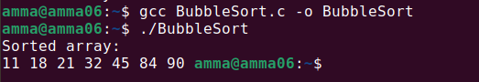

2)INSERTION SORT
CODE:
#include <stdio.h>

void insertionSort(int arr[], int n){
for (int i = 1; i < n; ++i){
int key = arr[i];
int j = i - 1;

while (j >= 0 && arr[j] > key){
arr[j + 1] = arr[j];
j = j - 1;
}
arr[j + 1] = key;
}
}

void printArray(int arr[],int n){
for (int i = 0; i < n;++i)
printf("%d ", arr[i]);
printf("\n");
}

int main(){
int arr[] = { 12, 11, 13, 5, 6 };
int n = sizeof(arr) / sizeof(arr[0]);

insertionSort(arr, n);
printArray(arr, n);
return 0;
}
OUTPUT:
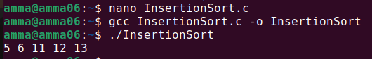

3)SELECTION SORT:
CODE:
#include <stdio.h>

void selectionSort(int arr[], int n) {
for (int i = 0; i < n - 1; i++) {

int min_idx = i;

for (int j = i + 1; j < n; j++) {
if (arr[j] < arr[min_idx]) {

min_idx = j;
}
}

int temp = arr[i];
arr[i] = arr[min_idx];
arr[min_idx] = temp;
}
}

void printArray(int arr[], int n) {
for (int i = 0; i < n; i++) {
printf("%d ", arr[i]);
}
printf("\n");
}

int main() {
int arr[] = {64, 25, 12, 22, 11};
int n = sizeof(arr) / sizeof(arr[0]);

printf("Original array: ");
printArray(arr, n);

selectionSort(arr, n);

printf("Sorted array: ");
printArray(arr, n);

return 0;
}
OUTPUT:
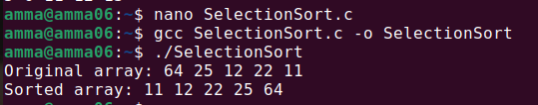

4)BUCKET SORT
CODE:
#include <stdio.h>

#define MAX 100

void insertionSort(float bucket[], int size) {
for (int i = 1; i < size; ++i) {
float key = bucket[i];
int j = i - 1;
while (j >= 0 && bucket[j] > key) {
bucket[j + 1] = bucket[j];
j--;
}
bucket[j + 1] = key;
}
}

void bucketSort(float arr[], int n) {
// Buckets
float buckets[n][MAX];
int bucketSize[n];

for (int i = 0; i < n; i++) {
bucketSize[i] = 0;
}

for (int i = 0; i < n; i++) {
int bi = (int)(n * arr[i]);
buckets[bi][bucketSize[bi]++] = arr[i];
}

for (int i = 0; i < n; i++) {
insertionSort(buckets[i], bucketSize[i]);
}

int index = 0;
for (int i = 0; i < n; i++) {
for (int j = 0; j < bucketSize[i]; j++) {
arr[index++] = buckets[i][j];
}
}
}

int main() {
float arr[] = {0.897, 0.565, 0.656, 0.1234, 0.665, 0.3434};
int n = sizeof(arr) / sizeof(arr[0]);

bucketSort(arr, n);

printf("Sorted array is:\n");
for (int i = 0; i < n; i++) {
printf("%f ", arr[i]);
}

return 0;
}
OUTPUT:
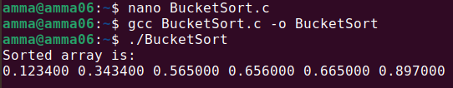

5)HEAP SORT:
CODE:
#include <stdio.h>

void heapify(int arr[], int n, int i){

int largest = i;

int l = 2 * i + 1;

int r = 2 * i + 2;

if (l < n && arr[l] > arr[largest])
largest = l;

if (r < n && arr[r] > arr[largest])
largest = r;

if (largest != i) {
int temp = arr[i];
arr[i] = arr[largest];
arr[largest] = temp;

heapify(arr, n, largest);
}
}

void heapSort(int arr[], int n){

for (int i = n / 2 - 1; i >= 0; i--)
heapify(arr, n, i);

for (int i = n - 1; i > 0; i--) {

int temp = arr[0];
arr[0] = arr[i];
arr[i] = temp;

heapify(arr, i, 0);
}
}

int main() {
int arr[] = { 9, 4, 3, 8, 10, 2, 5 };
int n = sizeof(arr) / sizeof(arr[0]);

heapSort(arr, n);

for (int i = 0; i < n; ++i)
printf("%d ", arr[i]);

return 0;
}
OUTPUT:
