DAA LAB-5
~CHEBROLU LIKHITH VINAY
~CH.SC.U4CSE24208

1) MERGE SORT
CODE:
#include <stdio.h>

void merge(int arr[], int left, int mid, int right)
{
int i, j, k;
int n1 = mid - left + 1;
int n2 = right - mid;

int L[n1], R[n2];

for (i = 0; i < n1; i++)
L[i] = arr[left + i];
for (j = 0; j < n2; j++)
R[j] = arr[mid + 1 + j];

i = 0;
j = 0;
k = left;

while (i < n1 && j < n2)
{
if (L[i] <= R[j])
arr[k++] = L[i++];
else
arr[k++] = R[j++];
}

while (i < n1)
arr[k++] = L[i++];

while (j < n2)
arr[k++] = R[j++];
}

void mergeSort(int arr[], int left, int right)
{
if (left < right)
{
int mid = (left + right) / 2;

mergeSort(arr, left, mid);
mergeSort(arr, mid + 1, right);
merge(arr, left, mid, right);
}
}

int main()
{
int arr[100], n, i;

printf("Enter number of elements: ");
scanf("%d", &n);

printf("Enter array elements:\n");
for (i = 0; i < n; i++)
scanf("%d", &arr[i]);

mergeSort(arr, 0, n - 1);

printf("Sorted array:\n");
for (i = 0; i < n; i++)
printf("%d ", arr[i]);

return 0;
}
OUTPUT: 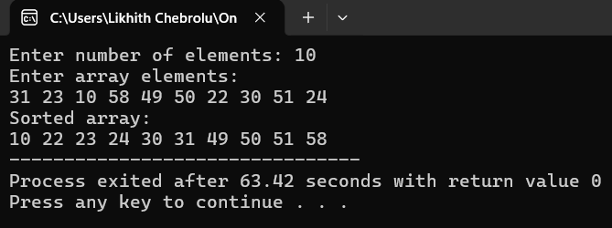
Complexity Analysis Of Merge Sort
- Best Case: O(n log n), When the array is already sorted or nearly sorted.
- Average Case: O(n log n), When the array is randomly ordered.
- Worst Case: O(n log n), When the array is sorted in reverse order.

2)QUICK SORT
CODE:
#include <stdio.h>

void swap(int *a, int *b)
{
int temp = *a;
*a = *b;
*b = temp;
}

int partition(int arr[], int low, int high)
{
int pivot = arr[high];
int i = low - 1;

for (int j = low; j < high; j++)
{
if (arr[j] < pivot)
{
i++;
swap(&arr[i], &arr[j]);
}
}

swap(&arr[i + 1], &arr[high]);
return i + 1;
}

void quickSort(int arr[], int low, int high)
{
if (low < high)
{
int pi = partition(arr, low, high);

quickSort(arr, low, pi - 1);
quickSort(arr, pi + 1, high);
}
}

int main()
{
int arr[100], n;

printf("Enter number of elements: ");
scanf("%d", &n);

printf("Enter array elements:\n");
for (int i = 0; i < n; i++)
scanf("%d", &arr[i]);

quickSort(arr, 0, n - 1);

printf("Sorted array:\n");
for (int i = 0; i < n; i++)
printf("%d ", arr[i]);

return 0;
}

OUTPUT:
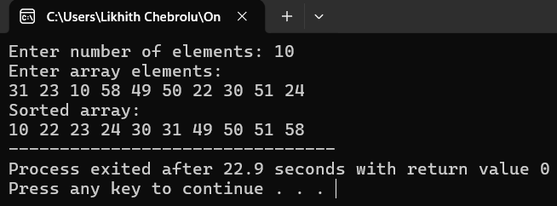

Complexity Analysis Of Merge Sort
- Best: O(n)
- Average: O(n^2)
- Worst: O(n^2)

3)BINARY SEARCH TREE
CODE:
#include <stdio.h>
#include <stdlib.h>

struct Node {
int key;
struct Node *left, *right;
};
struct Node *newNodeCreate(int value) {
struct Node *temp = (struct Node *)malloc(sizeof(struct Node));
temp->key = value;
temp->left = temp->right = NULL;
return temp;
}

// Function to insert a node into the BST
struct Node *insertNode(struct Node *node, int value) {
if (node == NULL)
return newNodeCreate(value);

if (value < node->key)
node->left = insertNode(node->left, value);
else if (value > node->key)
node->right = insertNode(node->right, value);

return node;
}

// In-order traversal (Left, Root, Right)
void inOrder(struct Node *root) {
if (root != NULL) {
inOrder(root->left);
printf("%d ", root->key);
inOrder(root->right);
}
}

// Pre-order traversal (Root, Left, Right)
void preOrder(struct Node *root) {
if (root != NULL) {
printf("%d ", root->key);
preOrder(root->left);
preOrder(root->right);
}
}

int main() {
struct Node *root = NULL;
int elements[] = {31, 23, 10, 58, 49, 50, 22, 30, 51, 24};
int n = sizeof(elements) / sizeof(elements[0]);

printf("Inserting elements into BST...\n");
for (int i = 0; i < n; i++) {
root = insertNode(root, elements[i]);
}

printf("\nIn-order Traversal (Sorted): \n");
inOrder(root);

printf("\n\nPre-order Traversal: \n");
preOrder(root);

printf("\n");
return 0;
}

OUTPUT:
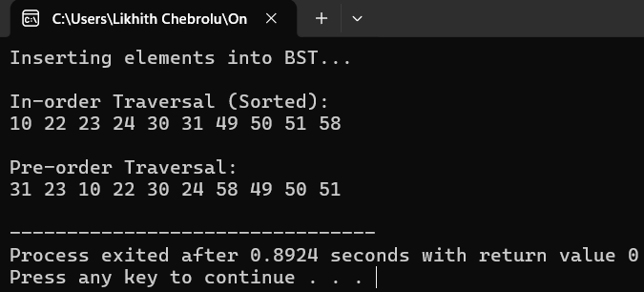

Points To Remember
- All nodes in the left subtree of a node contain values strictly less than the node’s value.
- All nodes in the right subtree of a node contain values strictly greater than the node’s value.

