**Computer Organization and Architecture**

**LAB ASSIGNMENT – 6**

**E.Likhith**

**AP22110010386**

**CSE – F**

**1. (a) Write a program in assembly language to print single character on screen.**

**Code:**

org 100h

mov dl, 'S'

mov ah, 02h

int 21h

; Terminate the program

mov ah, 4Ch

int 21h

**Output:**

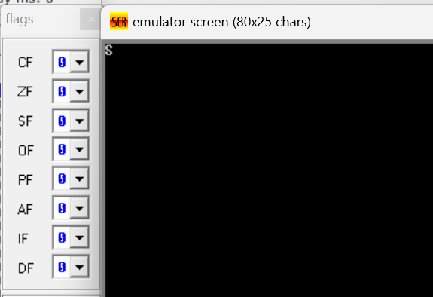

**1. (b) Write an assembly language program to convert an upper-case letter to the**

**corresponding lower-case letter.**

**Code:**

org 100h

mov al, 'S'

; Convert to lower-case by adding 32 (20h)

add al, 20h ; Add 32 to ASCII value

mov dl, al

mov ah, 02h

int 21h

; Terminate the program

mov ah, 4Ch

int 21h

**Output:**

**Practice set:**

**2. (a) Write a program in assembly language to print multiple characters on screen.**

**Code:**

org 100h

jmp start

msg: db "COA", 0Dh, 0Ah, 24h

start:

mov dx, msg

mov ah, 09h

int 21h

mov ah, 0

int 16h

ret

**Output:**

**2. (b) Write an assembly language program to convert a lower-case letter to the**

**corresponding upper-case letter.**

**Code:**

org 100h

mov al,'s'

; Convert to upper-case by subtracting 32 (20h)

sub al,20h ; Subtract 32 to get the corresponding upper-case letter

mov dl,al

mov ah,02h

int 21h

; Terminate the program

mov ah,4Ch

int 21h

**Output:**

