**Computer Organization and Architecture Lab**

**LAB ASSIGNMENT – 7**

**E. Likhith**

**AP22110010386**

**CSE-F**

**1 Write a program in assembly language to take a single-digit integer from the user and print it on the screen.**

**Code:**

ORG 100h ; Origin, to specify that the program starts at 100h (COM file format)

; Display message "Enter an uppercase letter: "

MOV DX, OFFSET msg_input ; Load the address of the message

MOV AH, 09h ; Function 09h of INT 21h is used to display a string

INT 21h ; Call DOS interrupt to print the message

; Read a single character from the user

MOV AH, 01h ; Function 01h of INT 21h is used to read a character

INT 21h ; Call DOS interrupt to get the character

MOV AL, AL ; Store the input character in AL

; Check if the character is an uppercase letter (A-Z)

CMP AL, '0' ; Compare AL with 'A'

JL NotDigit ; If the input is less than 'A', it is not uppercase

CMP AL, '9' ; Compare AL with 'Z'

JG NotDigit ; If the input is greater than 'Z', it is not uppercase

mov cl,al

; Convert the uppercase letter to lowercase

;ADD AL, 20h ; Add 32 (20h) to convert uppercase to lowercase

; Print the message "The lowercase letter is: "

MOV DX, OFFSET msg_output ; Load the address of the output message

MOV AH, 09h ; Function 09h of INT 21h is used to display a string

INT 21h ; Call DOS interrupt to print the output message

; Print the converted lowercase letter

MOV DL, CL ; Move the lowercase letter to DL

MOV AH, 02h ; Function 02h of INT 21h is used to print a single character

INT 21h ; Call DOS interrupt to print the character

JMP EndProgram ; Jump to the end of the program

NotDigit:

; If the input is not an uppercase letter, display an error message

MOV DX, OFFSET msg_error ; Load the address of the error message

MOV AH, 09h ; Function 09h of INT 21h is used to display a string

INT 21h ; Call DOS interrupt to print the error message

EndProgram:

; Terminate the program

MOV AH, 4Ch ; Function 4Ch of INT 21h terminates the program

INT 21h ; Call DOS interrupt to exit

msg_input DB 'Enter a digit: $'

msg_output DB 0Dh, 0Ah, 'The entered digit is: $' ; Output message

msg_error DB 0Dh, 0Ah, 'Error: Not a digit! $' ; Error message

END ; End of program

**OUTPUT:**

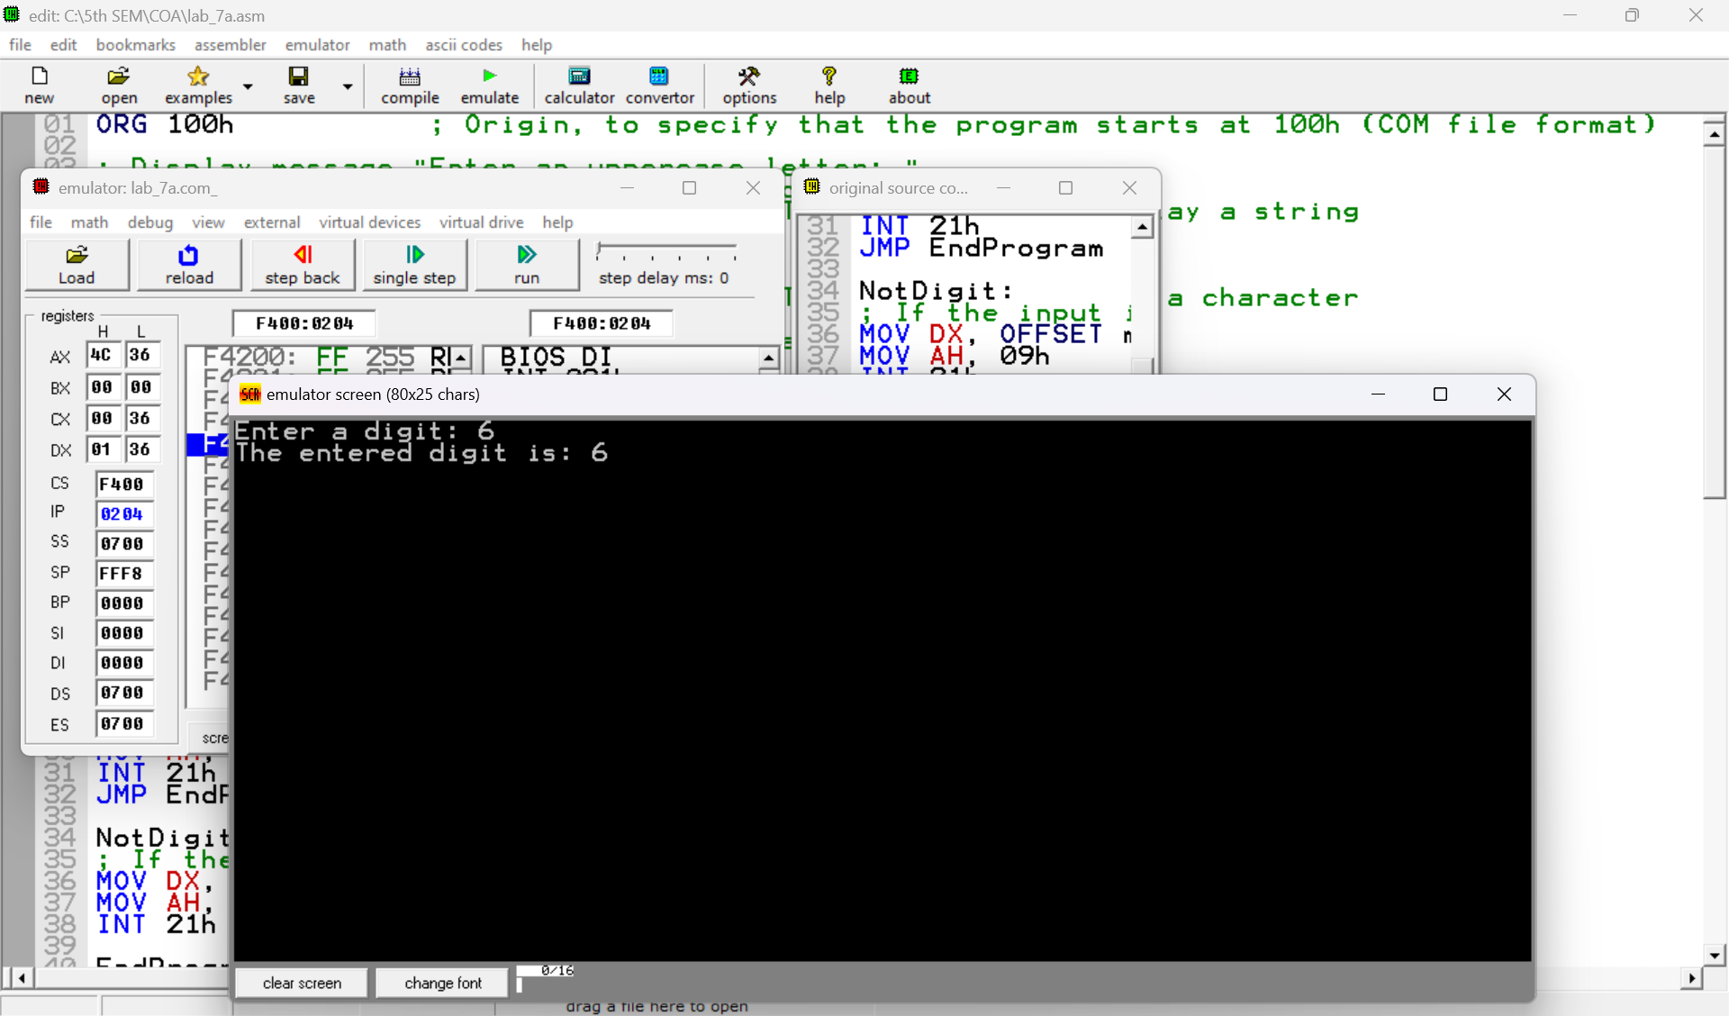

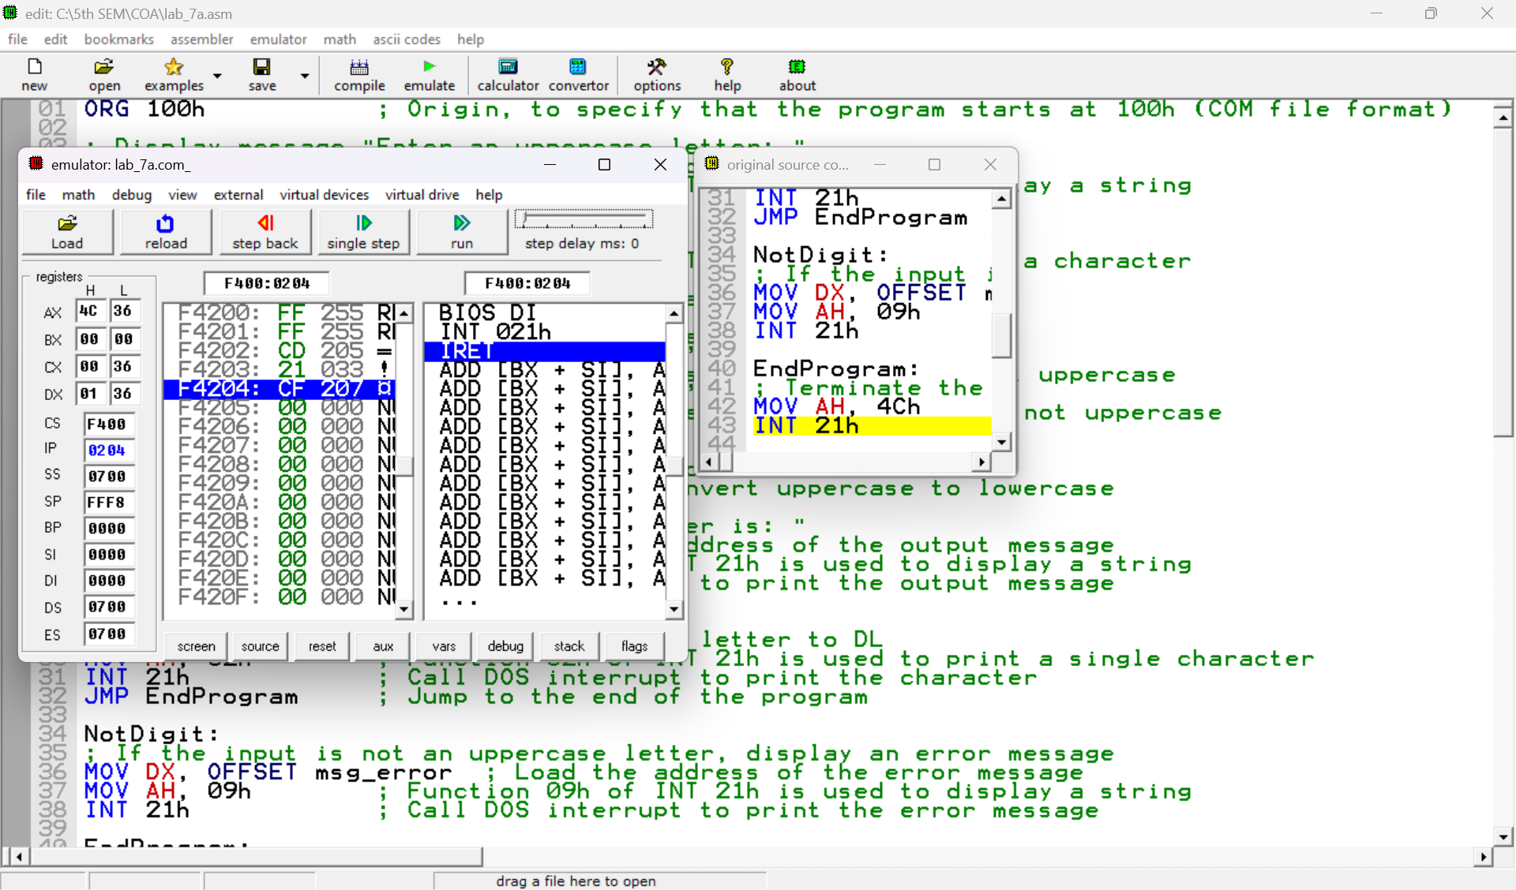

**Practice set:**

**2. Write a program in assembly language to take two single-digit integers from the user and print the result of subtraction on the screen.**

**Code:**

org 100h

mov dx,offset msg_input1

mov ah,09h

int 21h

mov ah,01h

int 21h

mov bl,al

cmp al,'0'

jl NotDigit

cmp al,'9'

jg NotDigit

mov dx,offset msg_output1

mov ah,09h

int 21h

mov dl,bl

mov ah,02h

int 21h

mov dx,offset msg_input2

mov ah,09h

int 21h

mov ah,01h

int 21h

mov cl,al

cmp al,'0'

jl NotDigit

cmp al,'9'

jg NotDigit

mov dx,offset msg_output2

mov ah,09h

int 21h

mov dl,cl

mov ah,02h

int 21h

mov dx,offset msg_sub

mov ah,09h

int 21h

sub bl,cl

js NegativeResult

add bl,30h

mov dl,bl

mov ah,02h

int 21h

jmp endprogram

NegativeResult:

mov dl, '-'

mov ah, 02h

int 21h

neg bl

add bl, 30h

mov dl, bl

mov ah, 02h

int 21h

jmp endprogram

NotDigit:

mov dx,offset msg_error

mov ah,09h

int 21h

endprogram:

mov ah,4Ch

int 21h

msg_input1 DB "enter first digit:$"

msg_output1 Db 0dh,0ah,"The entered digit is: $"

msg_input2 DB 0dh,0ah,"enter second digit:$"

msg_output2 Db 0dh,0ah,"The entered digit is: $"

msg_sub db 0dh,0ah,"The subtraction of given two digits is: $"

msg_error db 0dh,0ah,"Error: Not a digit!$ "

END

**Output:**

