In this lab, I have tried to demonstrate an android app which includes navigation drawer, UI elements like Map View, Material Theme for App Bar, Buttons, Recycler view to show a list of places. Also, it includes search bar to search near by places in the map.

I have used the following external tools/services to execute this lab:-

1. Flutter framework
2. Googe Maps SDK
3. Google Places API

**Home Screen (***Café Map)*

* First screen shows the map view along with a search bar to query the google map database within a certain radius ( **I have fixed the radius to 2500**) in my app.
* The users current location is displayed with the help of location services.
* If the user has turned off the internet or GPS, a message is displayed to the user and thus preventing the app from crashing.
* A list of near by cafes are listed to the user by default using recycler view when they open the screen as this lab focuses on cafes.
* A click event is added to each list ( place card – place name, location and type) .
* A Navigation drawer is also showed which can be seen on the top left corner with a ‘Hamburger Menu Icon’.

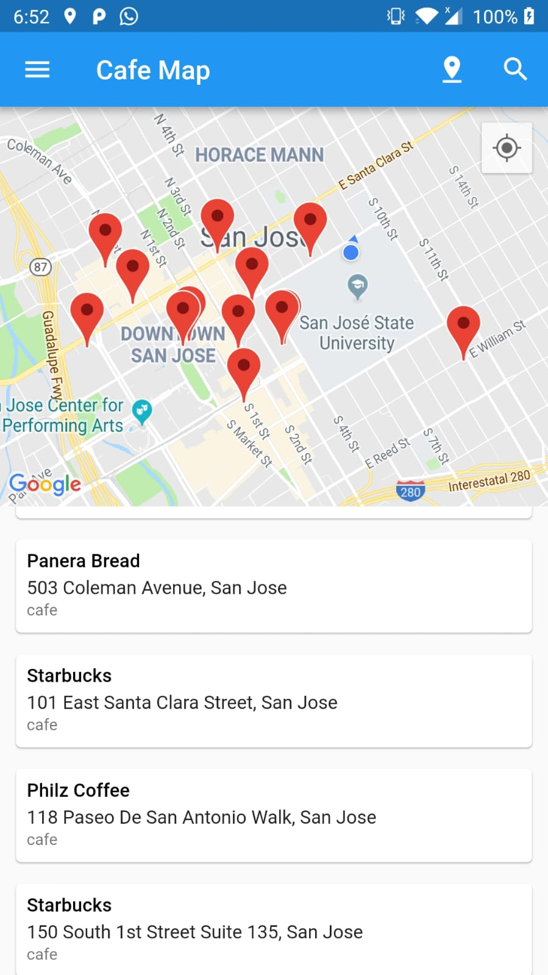 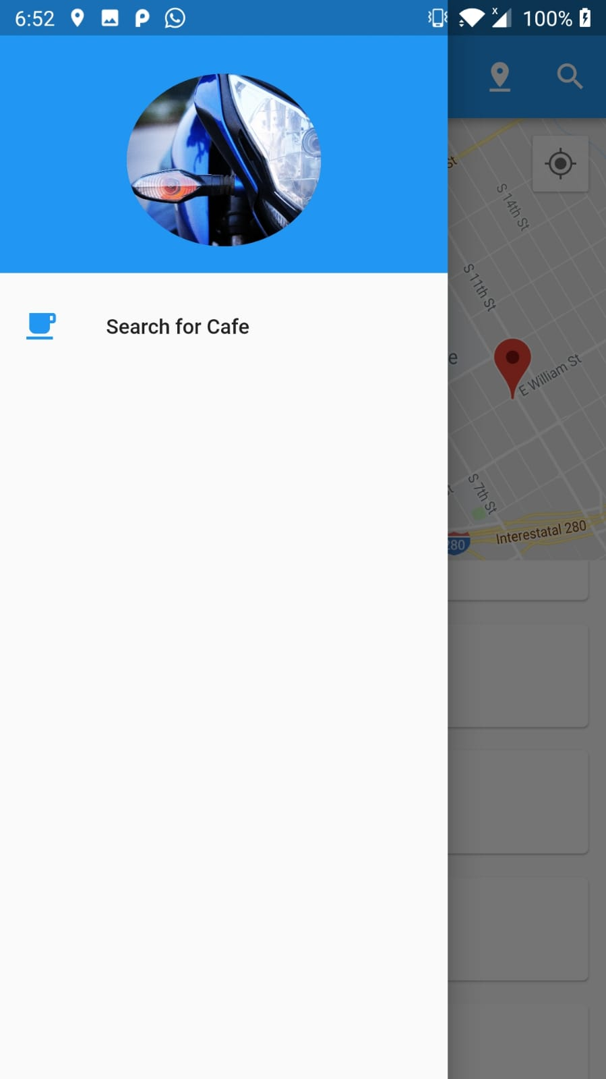

**Fig:** *Screenshot shows**Markers, Current Focus Area, Café List, Navigation drawer*

**Second Screen ( Results)**

* Users can access this by going to the navigation drawer and selecting ‘Search for Café’ or just by clicking on the search bar on top.
* Along with the searched place, near by cafes are predicted and shown to the user.
* List of ***Images*** are provided along with ***user ratings***, phone number, website address and opening hours are provided (if available).
* Interactive ***expansion tile*** is used to enhance user experience.

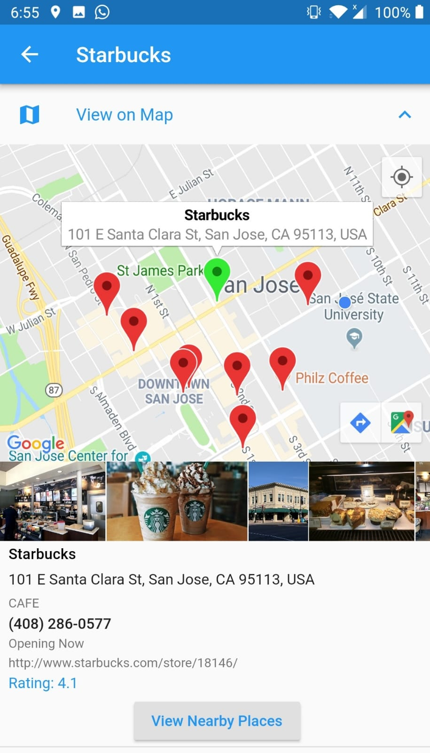 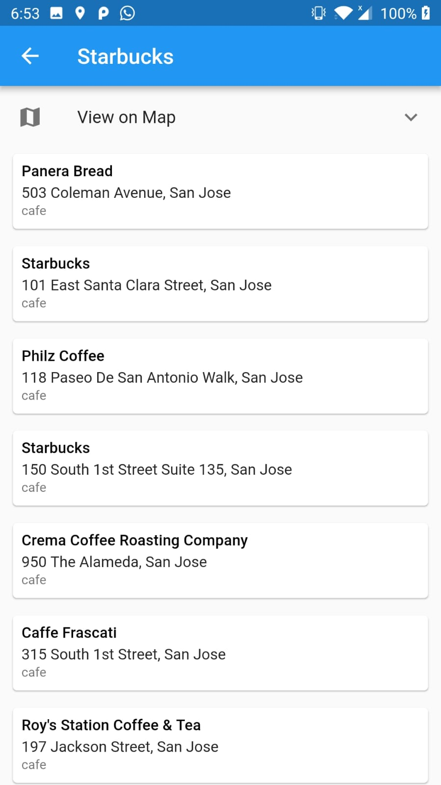

**Fig:** *Searched Place*  **Fig:** *Nearby Places(cafes)*

The searched place is shown with a green marker and other near by places are shown in red. Also, the images and other info related to the place are shown.

In figure 2, the nearby cafes are listed and shown in recycler view. It can be viwed when user clicks on ‘View Nearby Places’.

 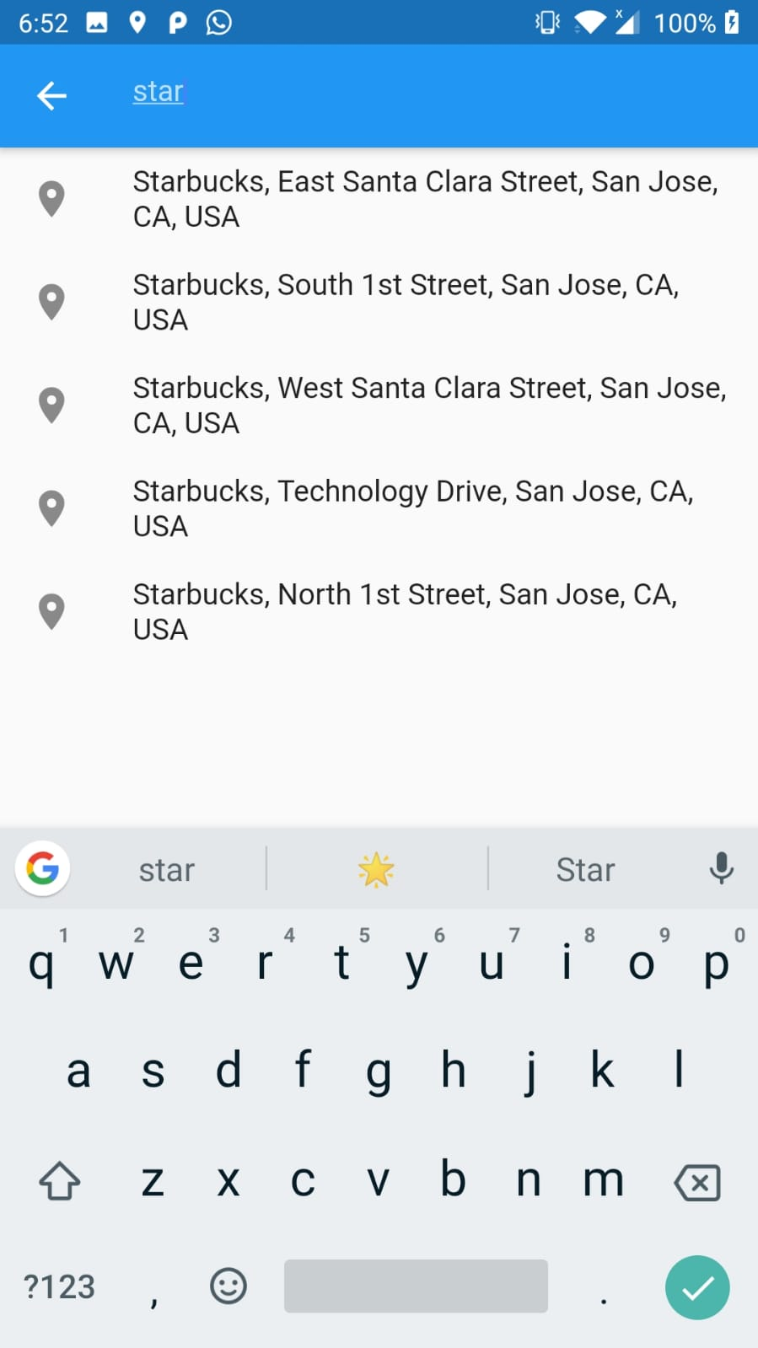

**Fig:** *Navigation Drawer* **Fig:** *Search Bar (for map)*

**REFERENCES and LINKS**

* <https://flutter.io/>
* Android Programming: The Big Nerd Ranch Guide (By: B. Phillips, C. Stewart, B. Hardy and K. Marsicano)
* <https://developer.android.com>
* <https://medium.com/flutter-community/building-places-location-search-with-map-view-using-flutter-1-0-alfian-losari-66cacb3bcc24>