In this lab, I have showcased all the features listed that were listed in lab 2 document. The app is named “movie app” which is used to search movies, tv shows and watch their trailer using **“The Movie Database API”.** Also, users can make use of SQLite feature to save their favourite movies and share the movie name explicitly to other apps. The app was developed using “**Flutter**”.

**1. Multiple Activities**

The below screenshots show the two activities that are used in this App :-

1. Movie Diary (The Main Activity)
2. Trailer Activity

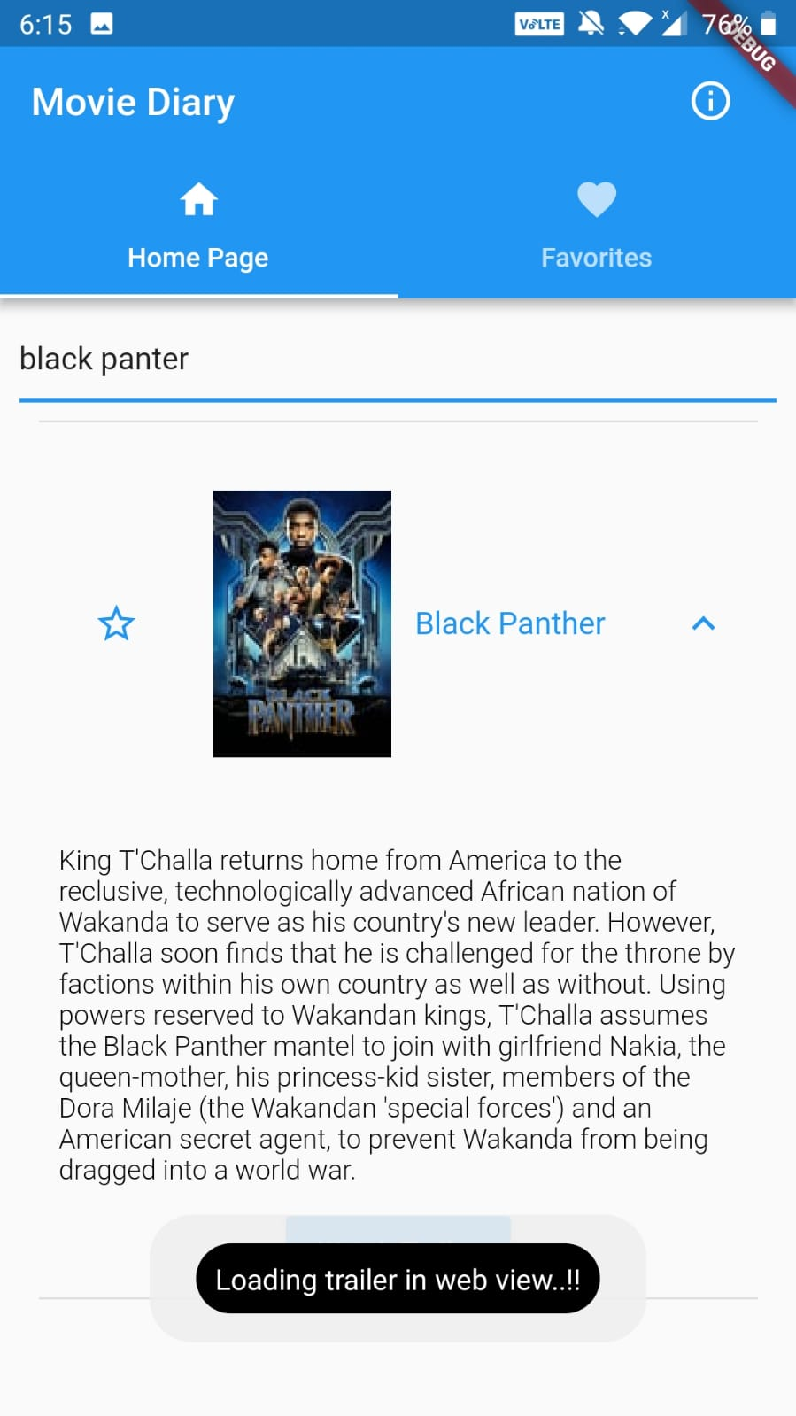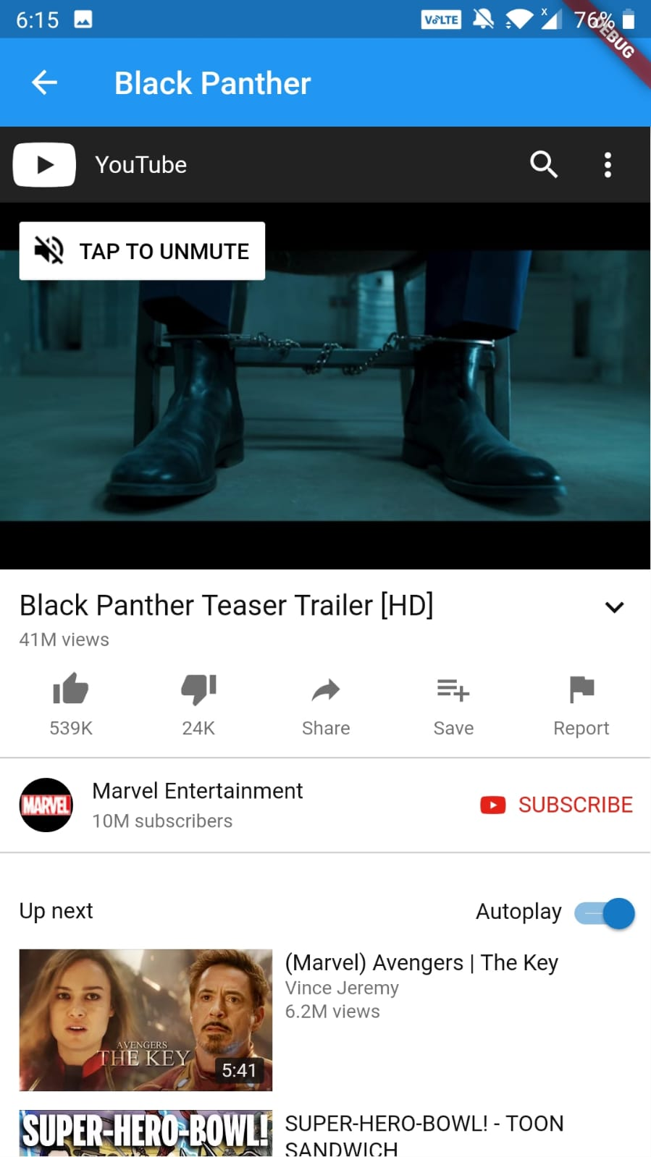

*Fig: Multiple Activities: Home Screen ( Movie Diary) & Trailer Screen ( uses Web View)*

**2. Simple UI Elements**

**2.1 Text View**

Text view is used to display the description of the movie, which is visible when you search for a movie in the search bar and then click on the expansion icon. It is shown in the screenshot below.

**2.2 Toast Notifications**

Toast notifications are showed when user favourites/unfavourites a movie and when he clicks on watch trailer button. It is clearly shown in the screenshot below.

**2.3 Buttons**

Button is used to switch from one activity to another, in my app, on click of ‘watch trailer button’ user will be taken to web view.

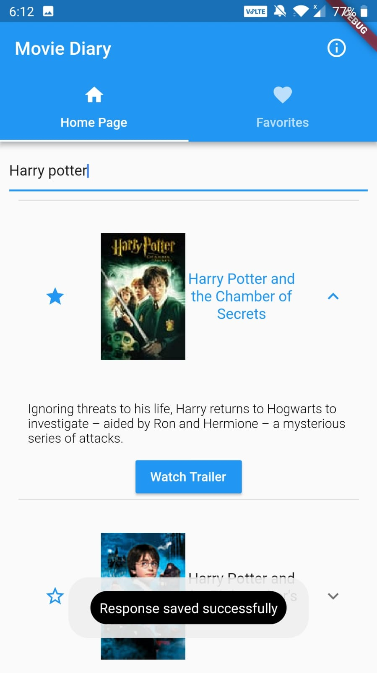 

*Fig: Simple UI Elements: Text View, Toast Notifications, Buttons*

**2.4 Dialogs**

I have used a dialog where it is necessary. When a user clicks on delete to remove his favourited movie, I am confirming it by displaying a dialog box. It is showed in the below screenshot.

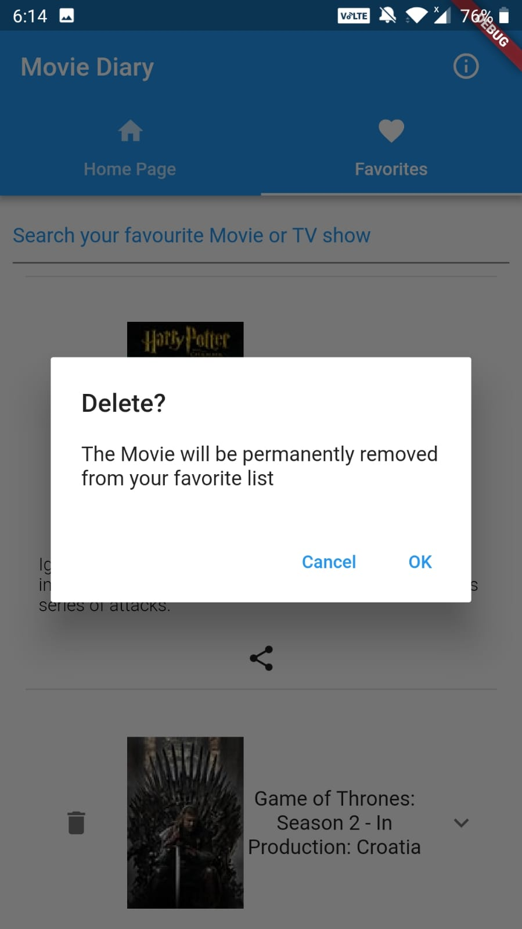

*Fig: Simple UI Elements: Dialog*

**3. SQLite database**

As I mentioned in the beginning, SQLite feature is to save users favourite movies. Thus, even when they close the app or switch off their phone, their data will be saved in the internal storage. The actual location is shown in the screenshot, which is captured from logcat. Also you can see the table which I have used to create the database.

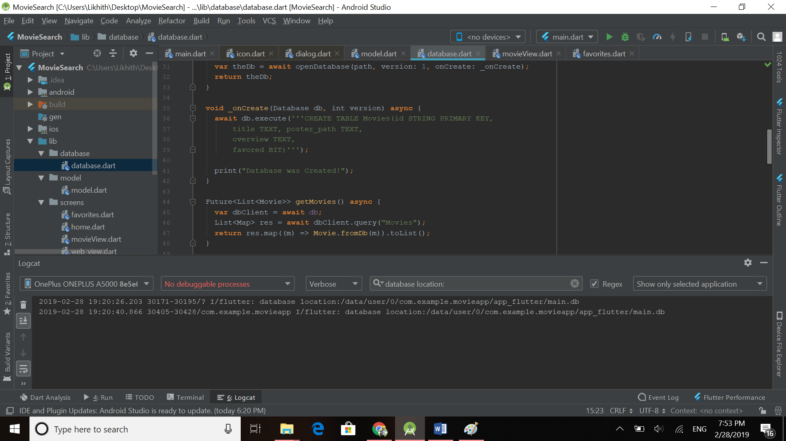

*Fig: SQLite database (file location of database)*

**4. Fragments**

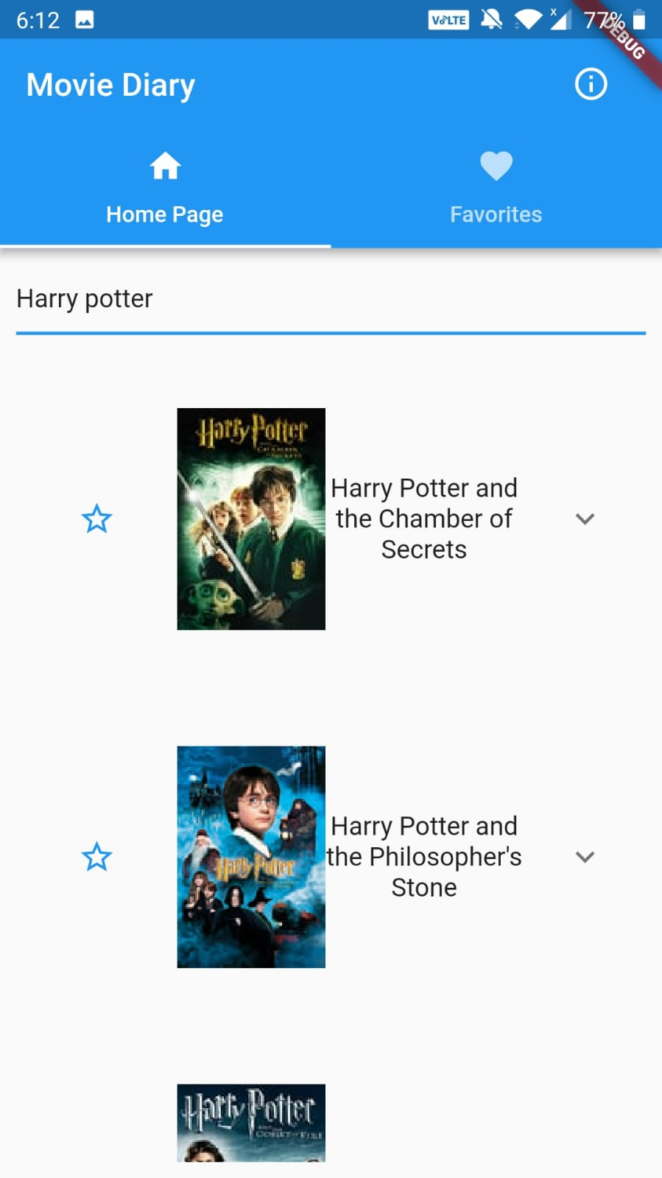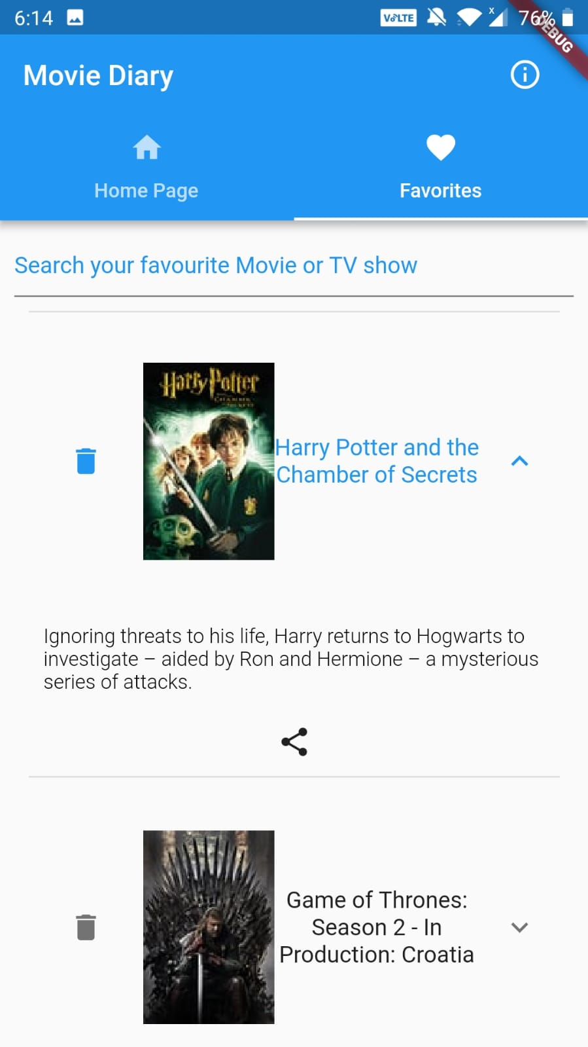

*Fig: Fragments - Home Page Fragment and Favourites Fragment*

In the above figure, you can clearly see the two fragments used in Main Activity :-

1. Home Page fragment
2. Favourites fragment

**5. Action Bar**

The action bar is used to show the app name/activity name and an **Info button (action button)** on the right side. Upon click, it shows a toast message of the data source being used in this app.

Action Button


*Fig: Action bar with action button “(i)”*

**6. Passing data b/w activities**

Here, I have demonstrated the use of both implicit and explicit intents.

**6.1 Implicit Intent**

Implicit intent is used to pass movie name when user switches from main screen to

trailer screen upon click of ‘watch trailer’ button. The dynamic name which is passed

will be seen on App bar. It is depicted below:-

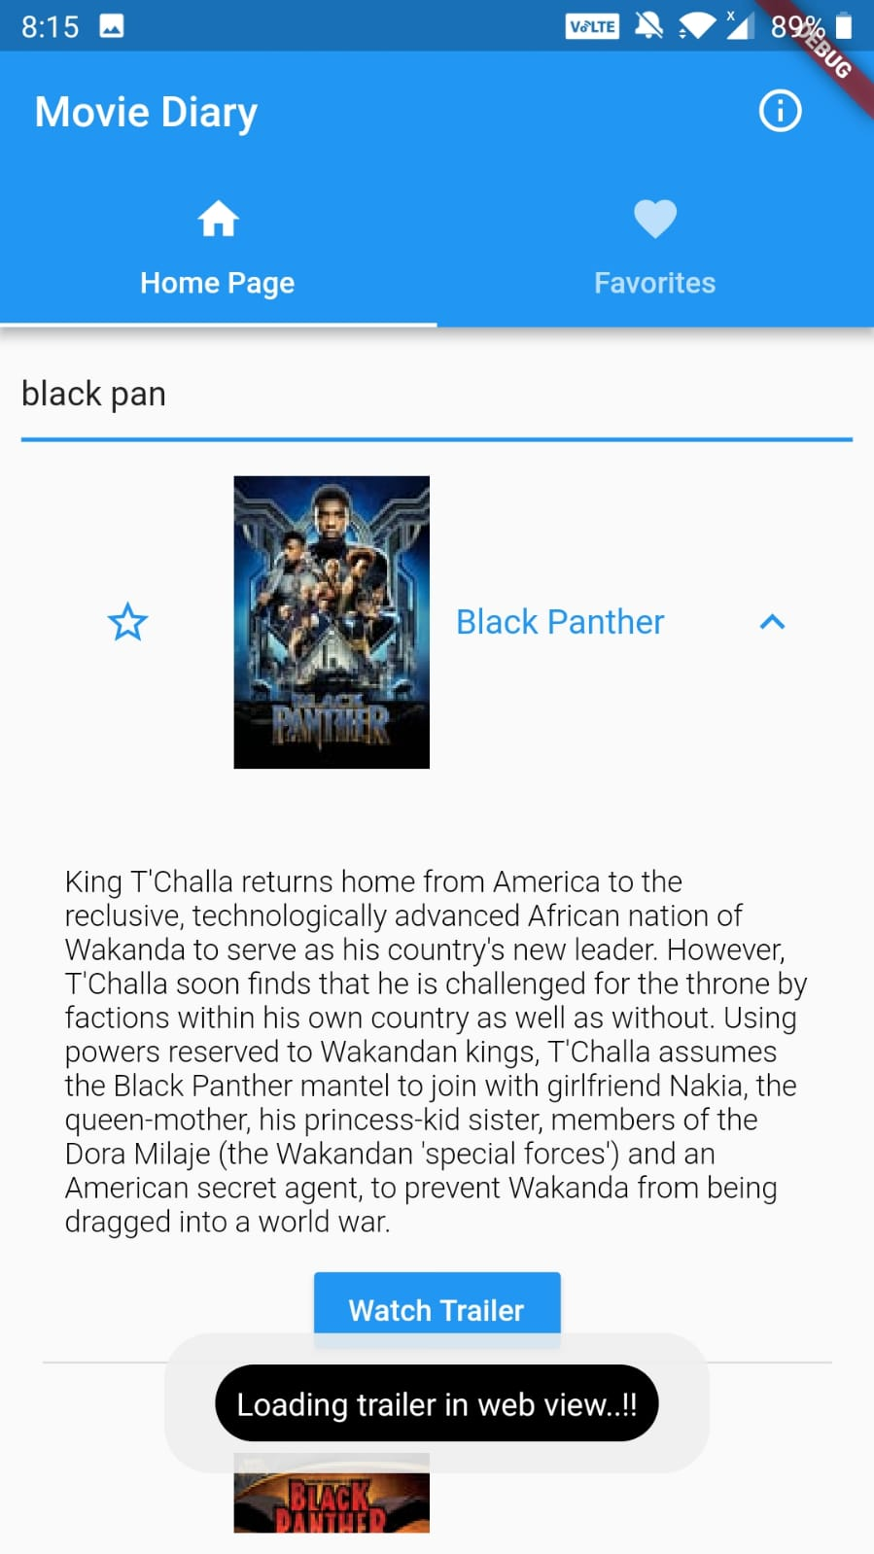 

*Fig: Implicit Intent - Movie Name is Passed from Home Screen to Trailer Screen*

**6.2 Explicit Intent**

For explicit intent, I am passing the movie name to other apps, when the user clicks

on share icon in the favorites fragment. It is clearly shown in below screenshot:-

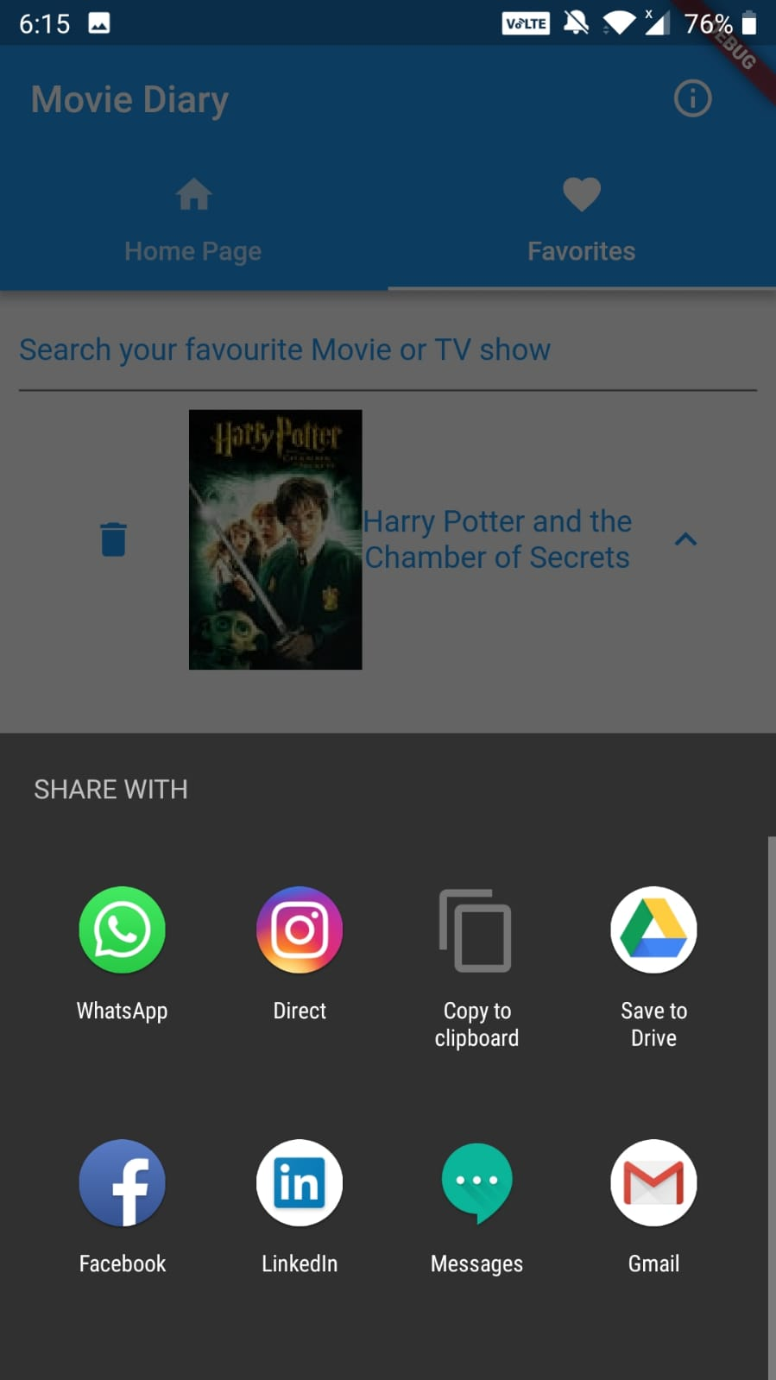 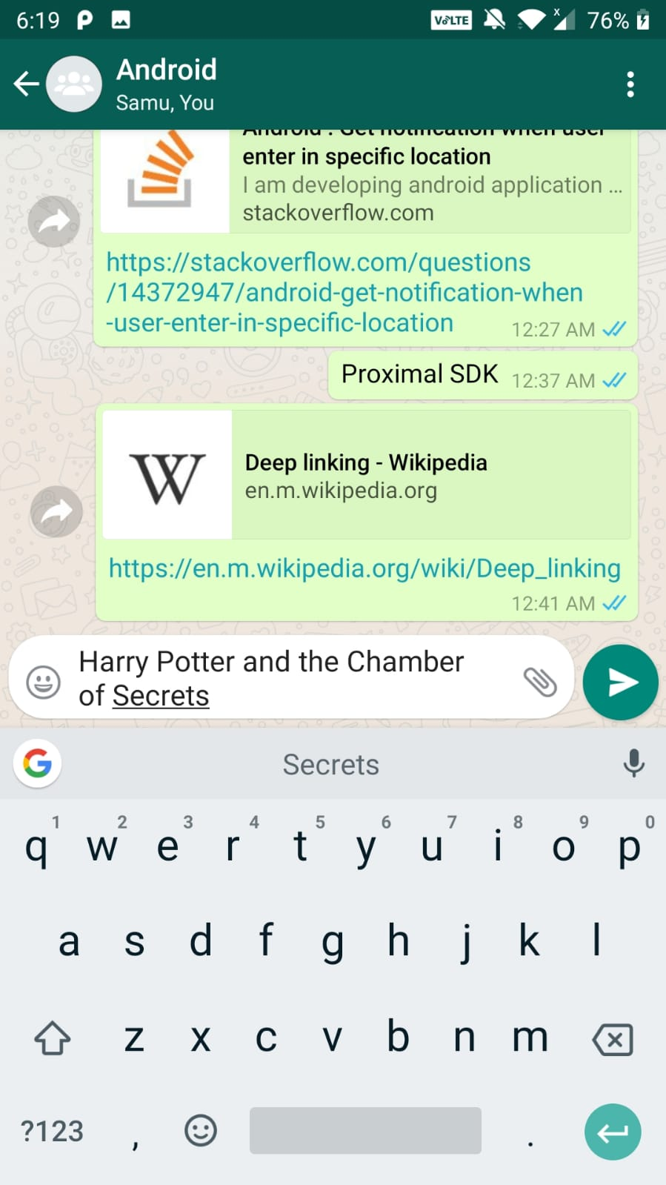

*Fig: Explicit intent: - Movie Name is Passed from Home Screen to Other apps*

**REFERENCES and LINKS**

* <https://flutter.io/>
* Android Programming: The Big Nerd Ranch Guide (By: B. Phillips, C. Stewart, B. Hardy and K. Marsicano)
* <https://developer.android.com>