**Project:** [**APPLE Inc. (india)**](https://www.apple.com/in/)

**Overview**:

Apple Inc. (India) **designs, manufactures, and markets Smart phones, tablets, personal computers (PCs), portable and wearable devices**. The company also offers software and related services, accessories, networking solutions, and third-party digital content and applications.

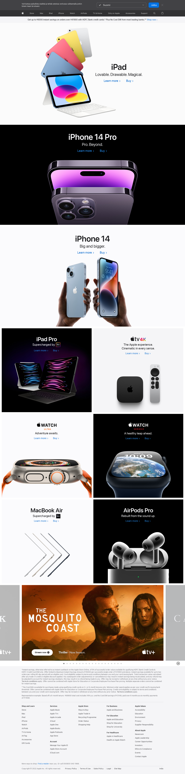

**Foreword:**

I have chosen this particular Apple Inc. website to design as my main project for Edureka’s internship program.  While this website appears to be clean and decent for its valuable customers, it also includes all major kinds of visual and programming wonders that are trending among the full stack developer world. This is the crucial aspect that attracted my curiosity and attention to it over the remaining websites. My admiration of designing a well structured and appreciated websites are well preserved with in this Single Project.

1. **HOME PAGE:**
   * + **Nav Bar:**
       - Logo
       - Store
       - Products
       - Services
       - Support
       - Icons(Search & Cart)
     + **Main Body:**
       - Products demonstration & links
       - Services demonstration & links
       - Shows & Movies Carousel
     + **Footer:**
       - Offers discription
       - Terms & conditions
       - Others Activities of the Firm
       - Links of different categories available
       - About Firm
       - CopyRights
2. **BAG (CART):**
   * + - Contents in my Bag
       - Saved items
       - Orders
       - Accounts
       - Sign In
3. **SUPPORT PAGE:**
   * + - Products Session
       - Previous Queries
       - Search for topics
       - Get Support
       - Apple Services programs
4. **PRODUCT’S PAGE:**
   * + **Nav Bar:**
       - Overview
       - Why this?
       - [Tech Specs](https://www.apple.com/in/ipad-10.9/specs/)
       - [Buy](https://www.apple.com/in/shop/goto/buy_ipad/ipad)
     + **Main Body:**
       - Demonstration
       - Video Show of Prducts
       - VR view (360 )
       - Ways to buy
       - Other Versions
       - Filters (color , discount range , country of origin , material , features , fit , occasion , pattern , rating , size )

1. **SERVICES’S PAGE:**
   * + **Nav Bar:**
       - Search Bar
       - Sign In
     + **Main Body:**
       - Start Free Trail
       - Add to up next
       - Trailers
       - Related
       - How to Get this
2. **BUYING PAGE:**
   * + **Nav Bar:**
       - Cost for Now
       - EMI
     + **Main Body:**
       - Product Name
       - Specifcations
       - features
       - Cost for Now
       - EMI
       - Deliery ways
       - Add to bag
       - What’s in the box
       - Theres always more to explore
       - Which version is right for you
       - Frequently asked questions
3. **PAYMENT’S PAGE:**
   * + **Main Body:**
       - Address selection
       - Payment method - (phonepe , google pay , bhim upi, credit/debit card , net- banking , emi , paytm)
       - Save Things for now

Visit My [Github](https://www.github.com/likhithteja/)