1) In Navbar.js

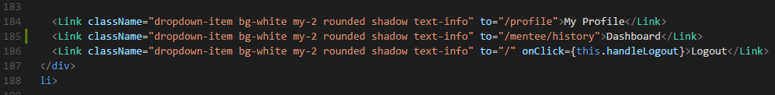

Copy paste from below:

<div className="dropdown-menu bg-transparent border-0" aria-labelledby="navbarDropdown">

<Link className="dropdown-item bg-white my-2 rounded shadow text-info" to="/profile">My Profile</Link>

<Link className="dropdown-item bg-white my-2 rounded shadow text-info" to="/mentee/history">Dashboard</Link>

<Link className="dropdown-item bg-white my-2 rounded shadow text-info" to="/" onClick={this.handleLogout}>Logout</Link>

</div>

Dashboard link added

2) In mentomeet\backend\server\routes\mentee\index.js



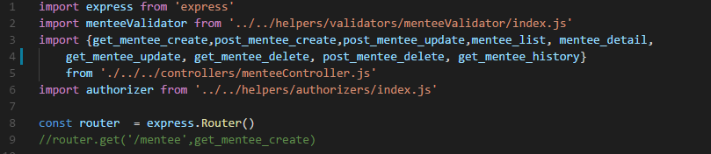

3) In App.js





To copy-paste:

<Route path="/mentee/history" render={props => <MenteeHistory {...props} />} />

4) CallBackRequest folder path:

mentomeet\backend\database\models\CallbackRequest

5) menteeController.js path:

mentomeet\backend\server\controllers\menteeController.js

6) made changes in mentee history file ..

Path: mentomeet\frontend\src\components\Mentee\MenteeHistory.js