

**INTERNET AND WEB TECHNOLOGY ASSIGNMENT**

**DIARY WEB APPLICATION**

**Prepared for**

The Department of Computer Science Department

Chaitanya Bharathi Institute of Technology, Hyderabad

**Prepared by**

Jyothi Sree Perumallu ----------------------------------------------160120733006

Meghana Ganapuram ----------------------------------------------160120733009

Nikhitha Tubati ------------------------------------------------------ 160120733012

Satvika Basanamoni ------------------------------------------------ 160120733014

Likith Reddy Irigela --------------------------------------------------160120733033

Uday Rose -------------------------------------------------------------160120733057

**TABLE OF CONTENTS**

|  |  |  |
| --- | --- | --- |
| **S No** | **TOPIC** | **PAGE NO** |
| **1** | Abstract | 2 |
| **2** | Objective | 2 |
| **3** | Introduction | 3 |
| **4** | Technologies Used | 3 |
| **5** | Database Design | 4 |
| **6** | Source Code | 5 |
| **7** | Outputs | 8 |
| **8** | Conclusion | 11 |

**Abstract:**

This research paper discussing the various useful tools and techniques that are used in a development of a website.We also discuss about the procedure follow in a website, mostly focused on a local host named Xampptool.Next, we compare different development frameworksweb application. In addition, we discuss life cycle model and framework development of web application.

In this report, various review papers result also included for understanding of problems can be facing by the users. This Paper tells about the technologies used in this development, PHP and explained in result its functionality with Xampp with screenshots. It is hoped it will gives a useful framework for guiding the process.

**Objective:**   
To create a diary Web Application. Here we try to build a user -friendly diary website such that any one can register in that website and create their own note

**Introduction:**

Our project is a web application which provides users to maintain a digital diary. Since users would like to ensure their privacy for what they write here, appropriate functions are used to protect their data. The project outcome is to present a more functional and efficient way to maintain their diaries than the traditional paper diaries.

A diary, then, in its simplest form, is a record of each day. Keeping a diary is a matter of keeping a record of what happens in your life: the interesting and the mundane, and your thoughts and feelings about both. Diaries have the unique ability to slow us down a little, allowing us to function more efficiently and effectively, improving our well-being in the long run. It will offer a range of advantages compared to the paper version of diaries.

Following are some of the benefits of keeping a diary:

* Keeping a diary has been shown to be good for the mental health
* Keeping a diary helps to improve one’s writing
* Keeping a diary can help one to remember events and activities

The project uses PHP, MySQL, HTML, CSS, JavaScript, JQuery and Bootstrap to develop a responsive user-friendly web application

**Technologies Used:**

1. Php
2. JavaScript
3. CSS
4. HTML
5. Database
6. XAMPP Server

**Database Design:**

Database name: edmsdb

Database has 4 tables:

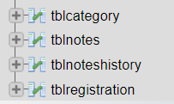

1. 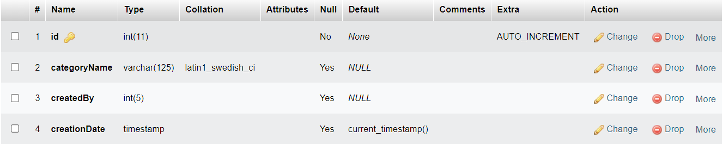tblcategory:
2. tblnotes:

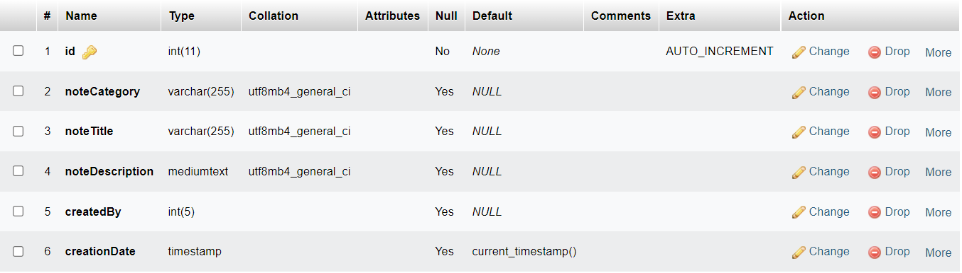

1. 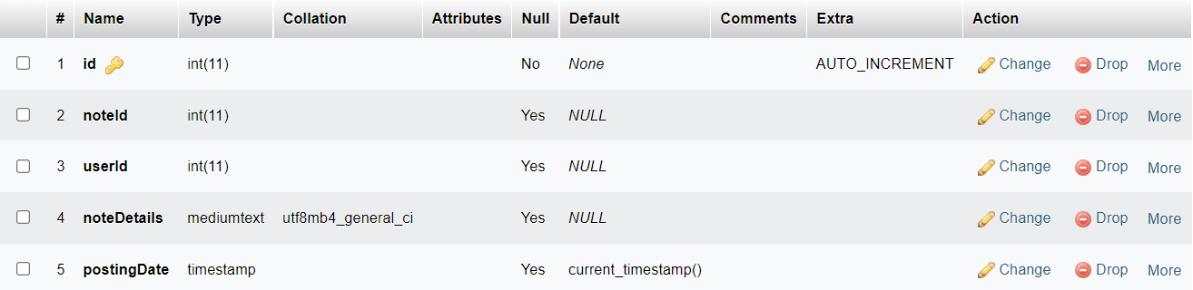tblnoteshistory:
2. 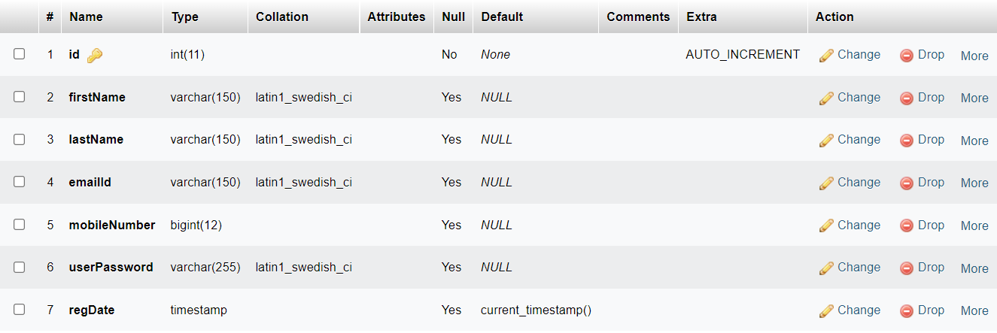tblregistration:

**Source Code:**

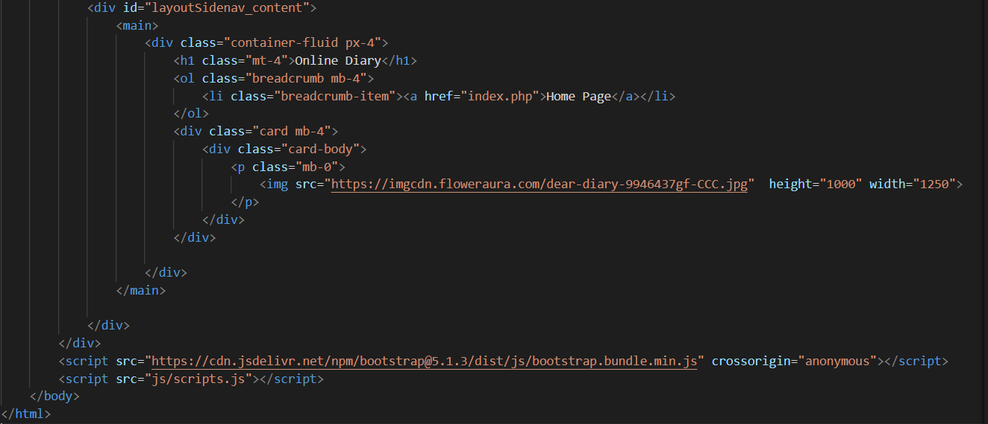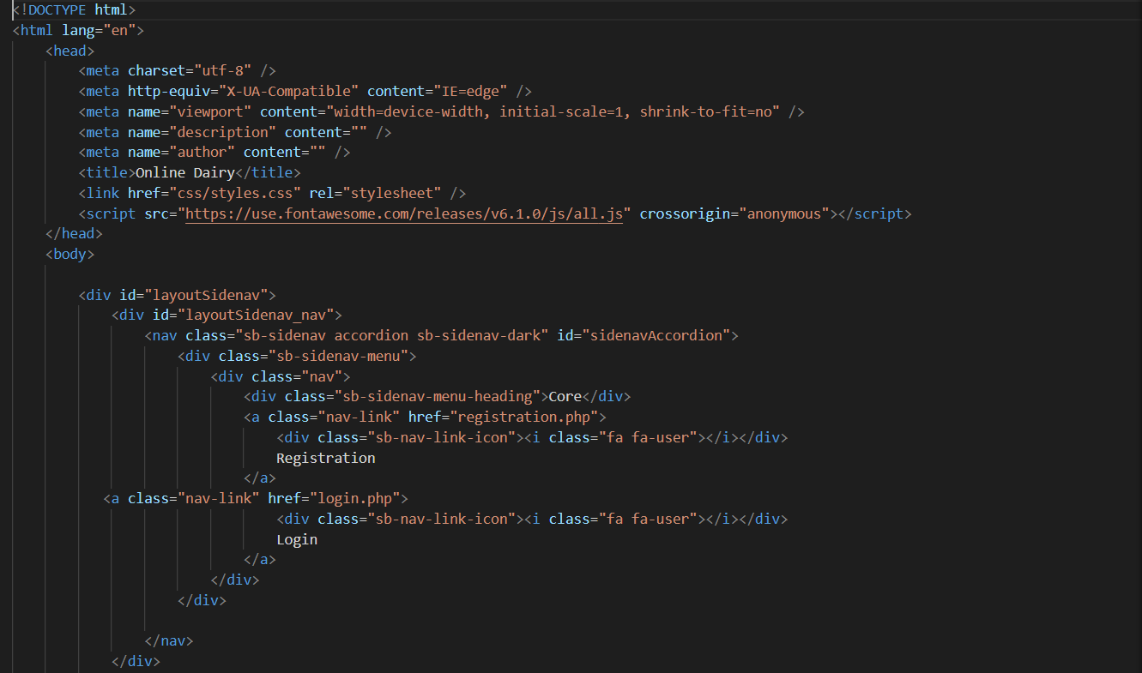**Index.php file:**

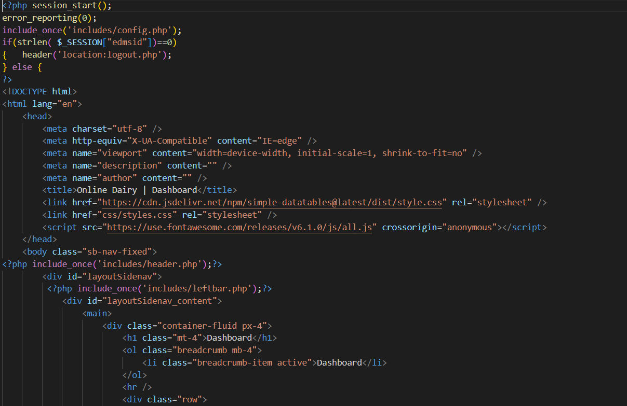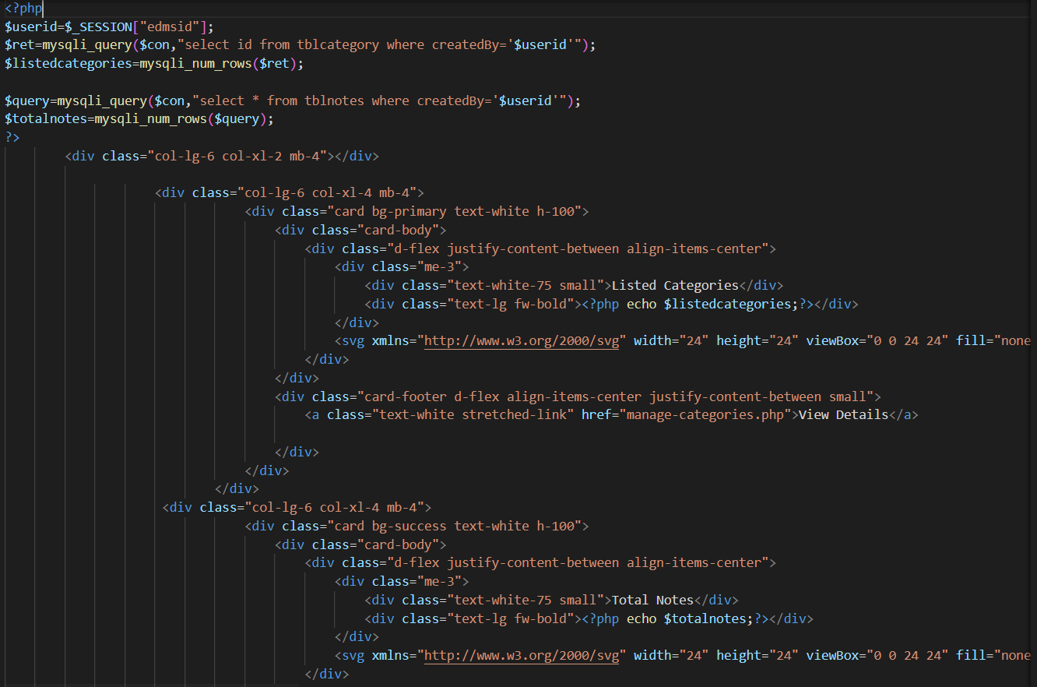**Dashboard.php file:**

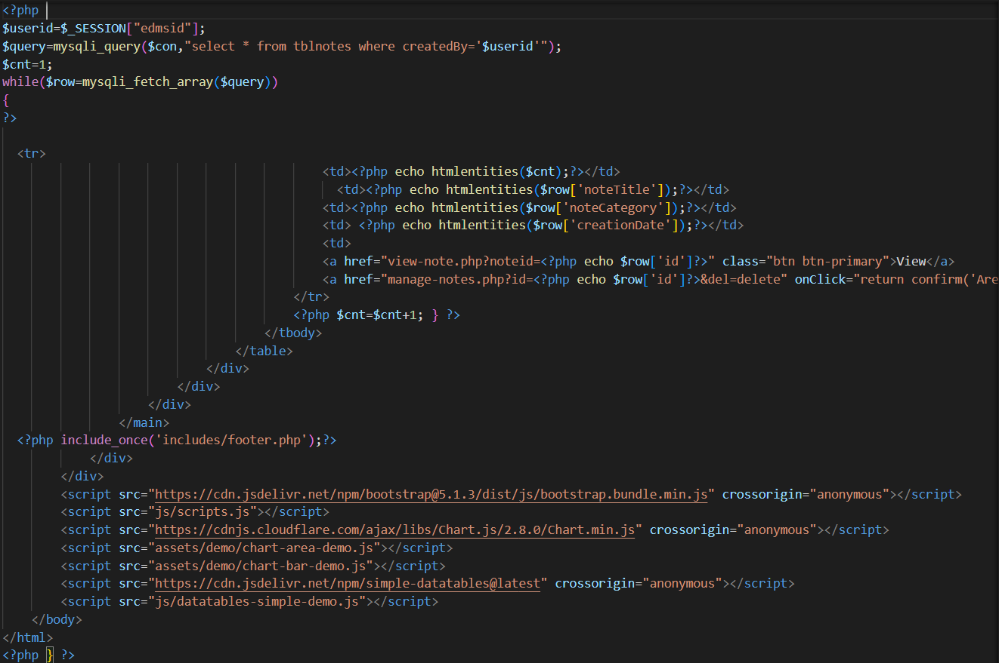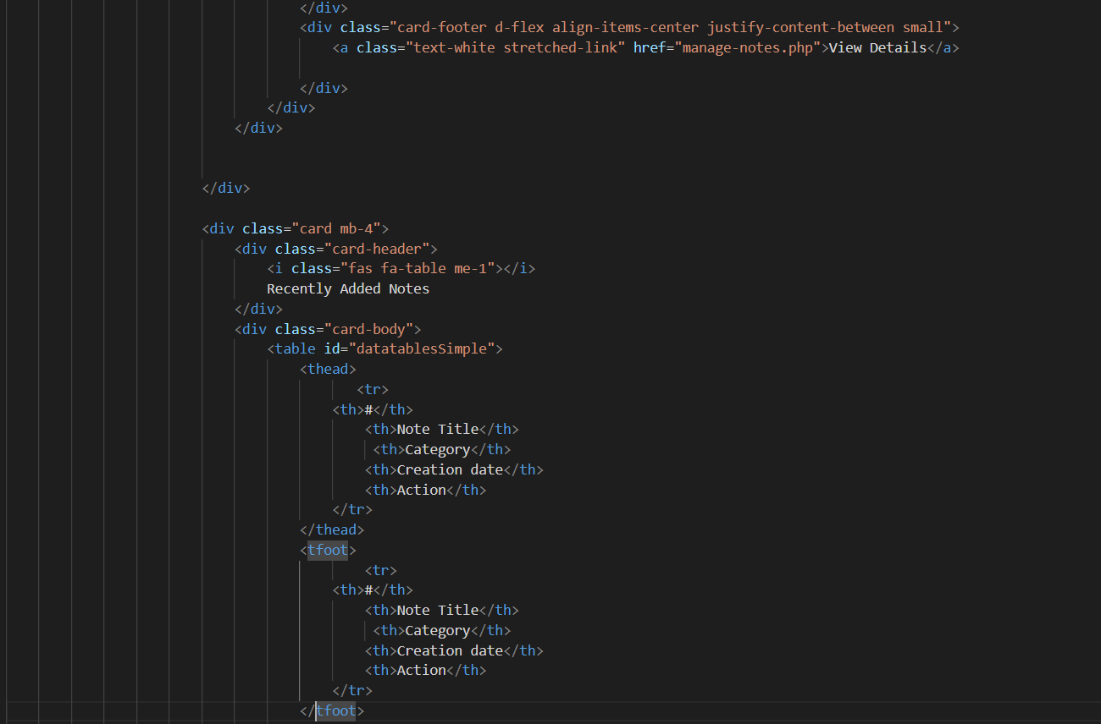

**Output:**

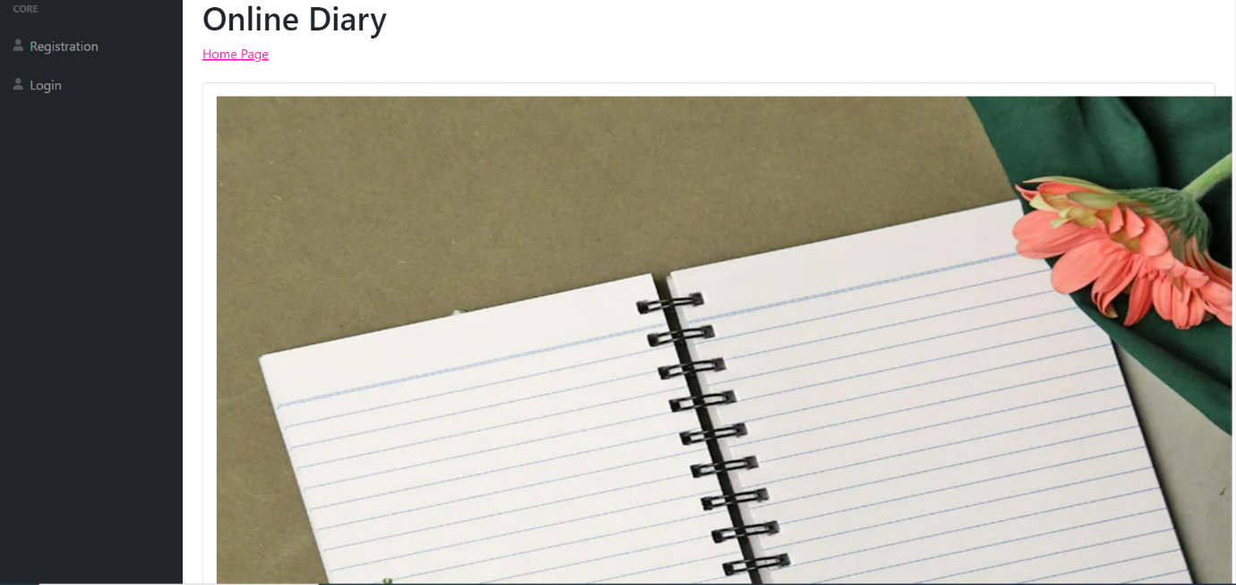**Home Page:**

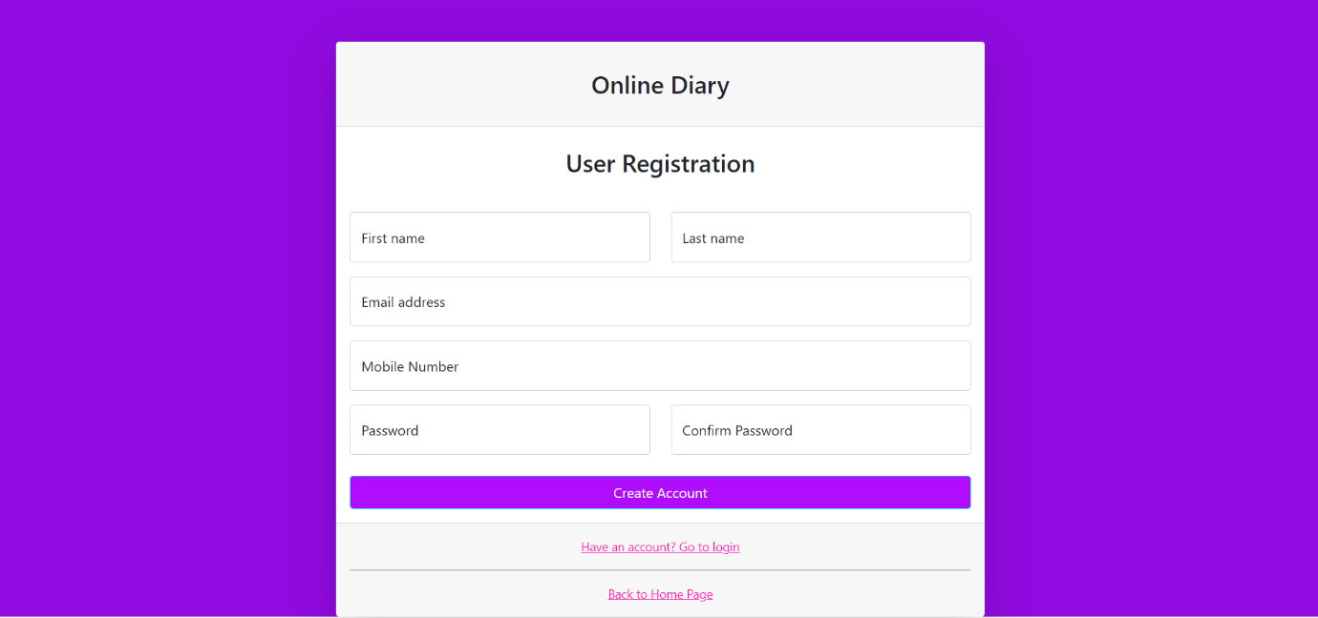**Registration Page:**

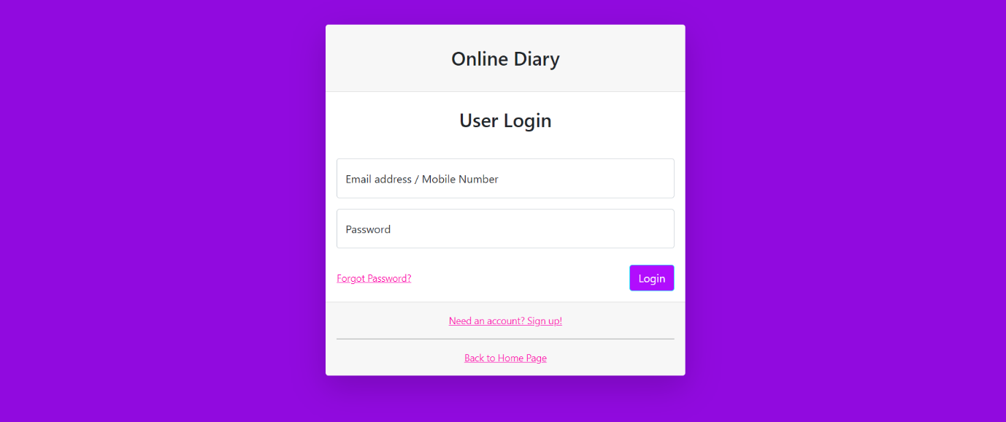**Login Page:**

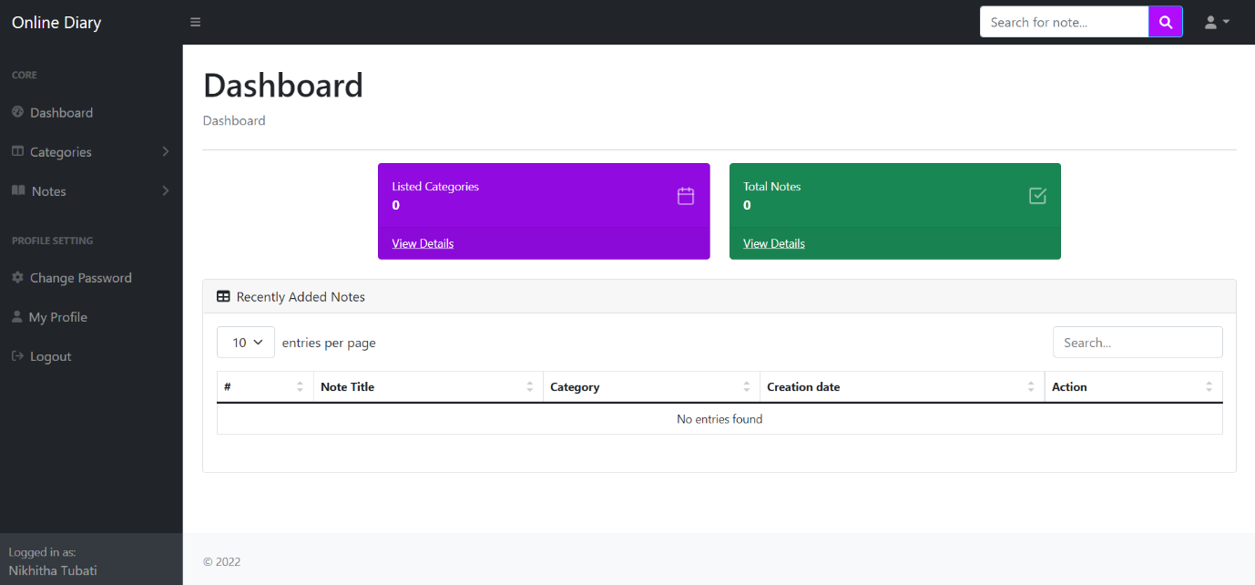**Main Page After Logging In:**

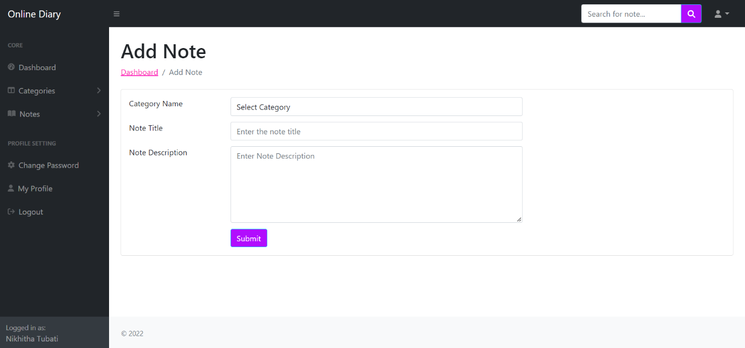**To Add Note:**

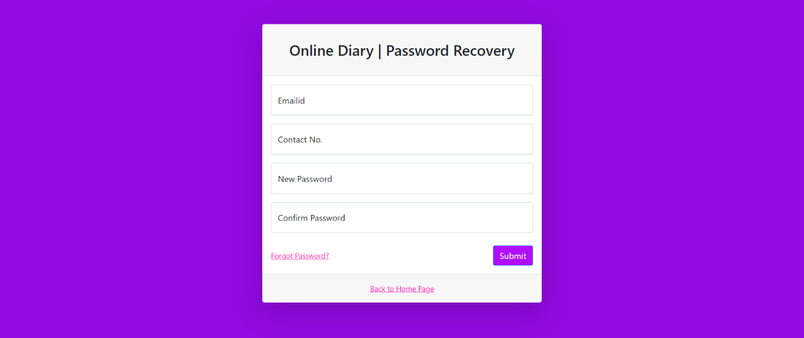**Profile Updation Page:**

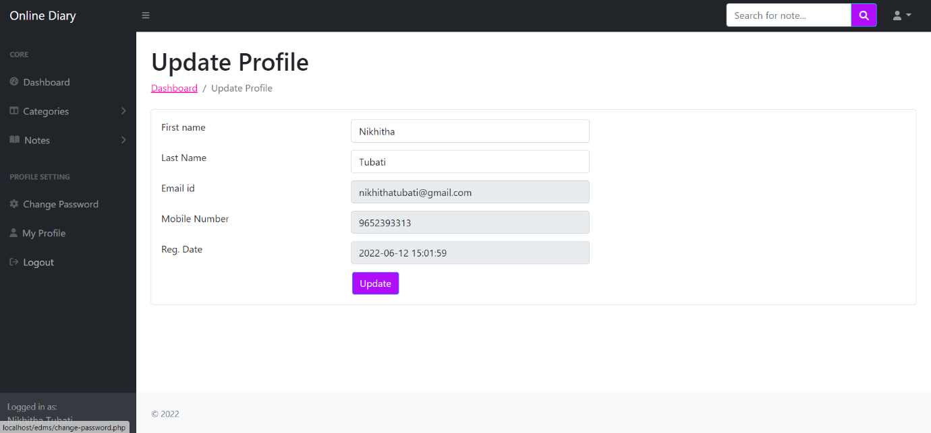**Password Recovery Page:**

**Conclusion:**

This web-based Online Diary System developed using PHP, HTML, JavaScript, text API and MySQL fulfills the basic objectives of the system for which it has been developed. The system has reached a steady state as far as raw php coding. The system is operated at a high level of efficiency and its advantage quite understood.