Experiment 14: Cracking the Password Using Hydra in Kali Linux
Aim
To study the Hydra tool in Kali Linux and understand password auditing using a wordlist in an authorized test environment.
Algorithm
- Start Kali Linux and open the terminal.
- Check whether Hydra is installed.
- Verify the availability of the rockyou.txt password wordlist.
- Examine Hydra's help options and supported services.
- Use a controlled lab environment to understand password auditing.
- Observe the output and record the result.
Commands
1. Check Hydra installation
hydra -h
Use: Displays Hydra's help information and command-line options.
2. Check the password wordlist
ls -l /usr/share/wordlists/rockyou.txt
Use: Verifies that the extracted password wordlist exists.
3. Display the first 10 entries
head /usr/share/wordlists/rockyou.txt
Use: Displays the first 10 lines of the wordlist.
4. View Hydra usage examples
hydra -U
Use: Displays module-specific help when supported by the installed Hydra version. If it reports that a service argument is required, use hydra -h for general help.
5.Command to execute hydra
hydra -l msfadmin -P /home/kali/password.txt ftp://10.0.2.3 -V
Sample Output
After running the wordlist verification command, you should see file information similar to:
-rw-r--r-- 1 root root ... /usr/share/wordlists/rockyou.txt
After running hydra -h, Hydra displays its usage information and available options.
Note: These are illustrative outputs; your actual output may differ.
Use of Hydra
- Hydra is a password-auditing tool.
- It supports authentication testing for various network services.
- It can use wordlists to evaluate password strength.
- It helps security professionals identify weak authentication in authorized test environments.

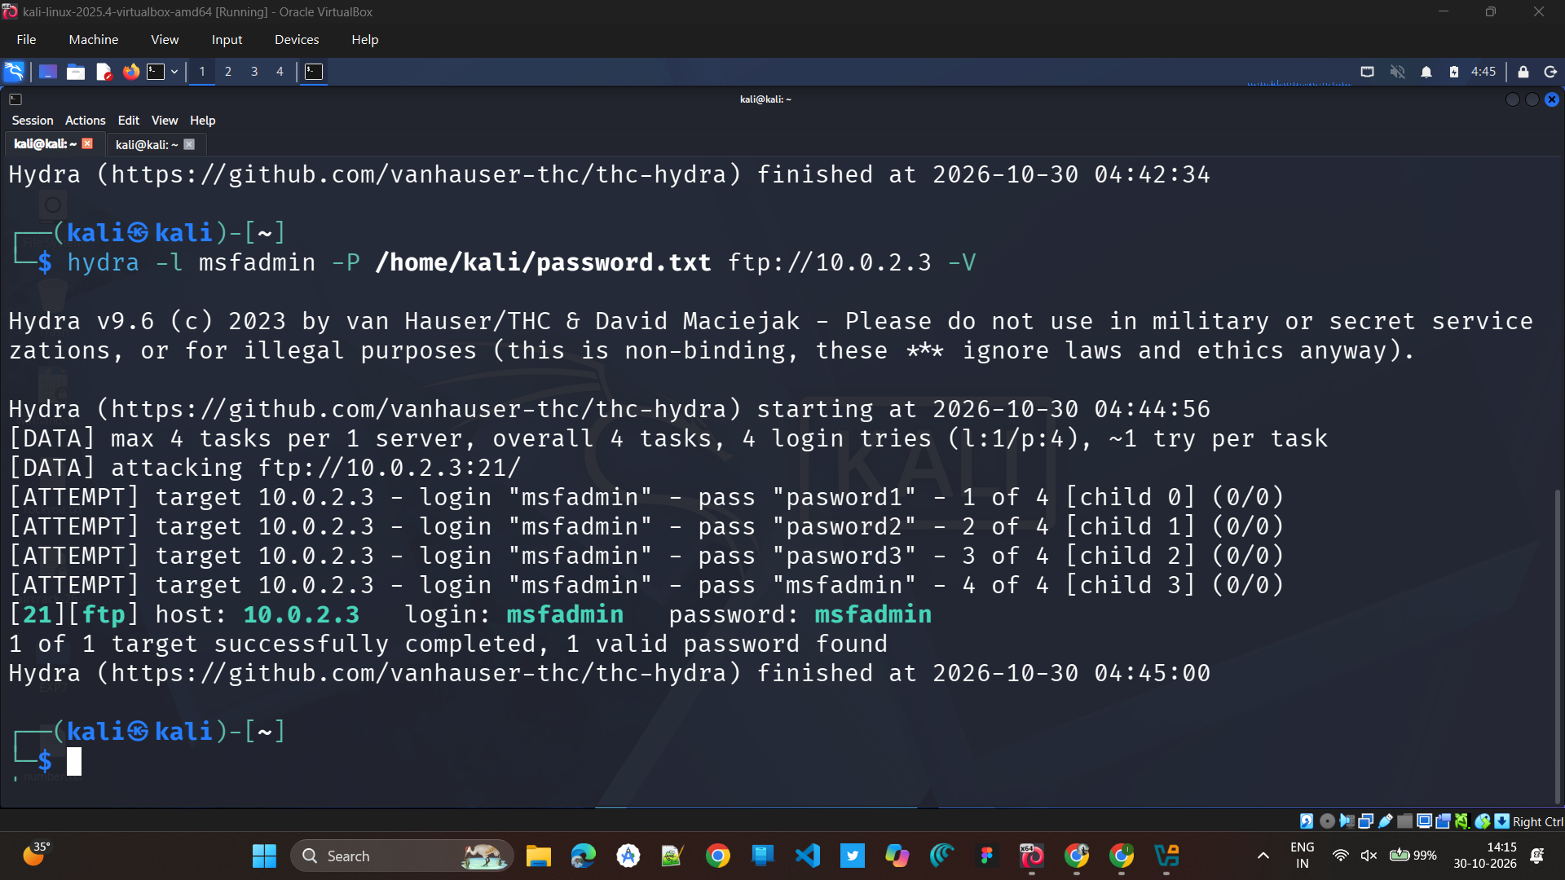

Result
Hydra was verified in Kali Linux, and the rockyou.txt wordlist was successfully extracted and checked. Hydra's help options were examined to understand its use in authorized password-security testing.

