Experiment -1
1. Execute and display the results for the following commands in Kali Linux Operating
Systems:

rm command
users command
tree command

Aim:- To execute and study the rm, users, and tree commands in the Kali Linux operating system and observe their outputs.

rm command:- The rm command is used to remove/delete files and directories in Linux.

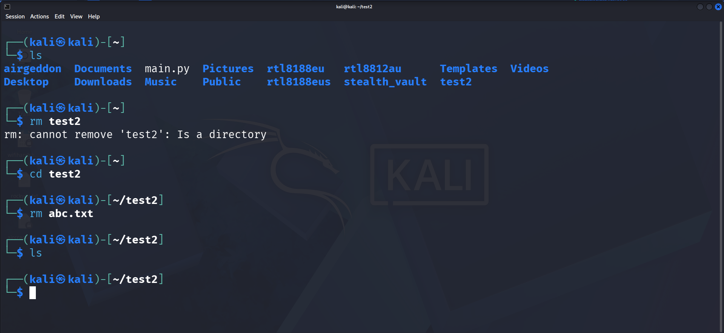

Users command:- The users command displays the usernames of users currently logged into the system.
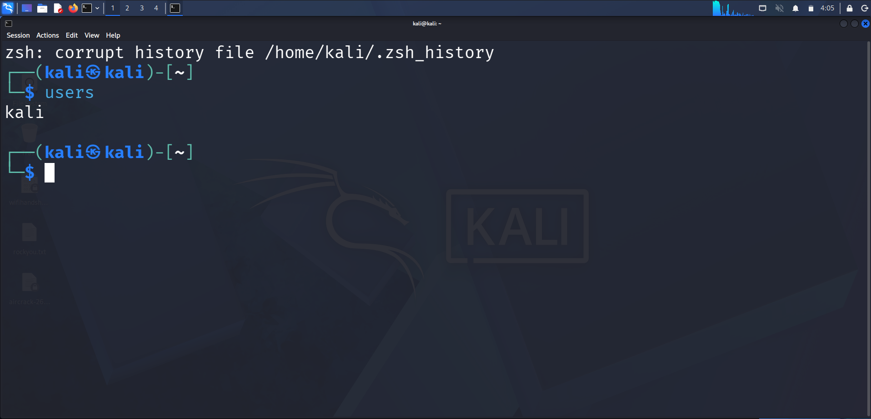

tree command:The tree command displays the files and directories in a hierarchical/tree structure.

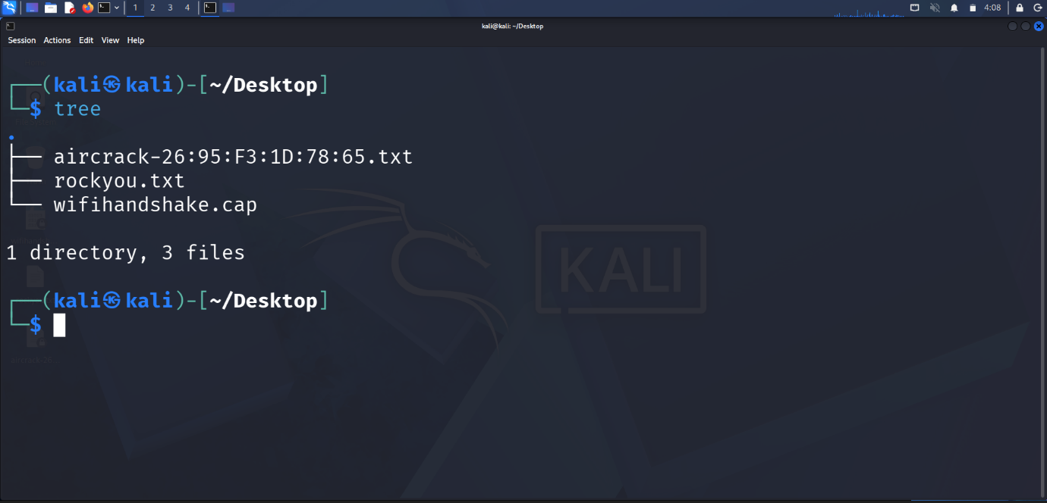
Result
Thus, the rm, users, and tree commands were successfully executed in Kali Linux and their results were displayed.

