Experiment -2
2. Execute and display the results for the following commands in Kali Linux Operating
Systems:

less command
more command
vi command
Aim
To execute and study the less, more, and vi commands in the Kali Linux operating system and observe their results.
1.LESS COMMAND
Command:
less sample.txt
Use:
The less command is used to view the contents of a text file one page at a time. It is useful for reading large files.
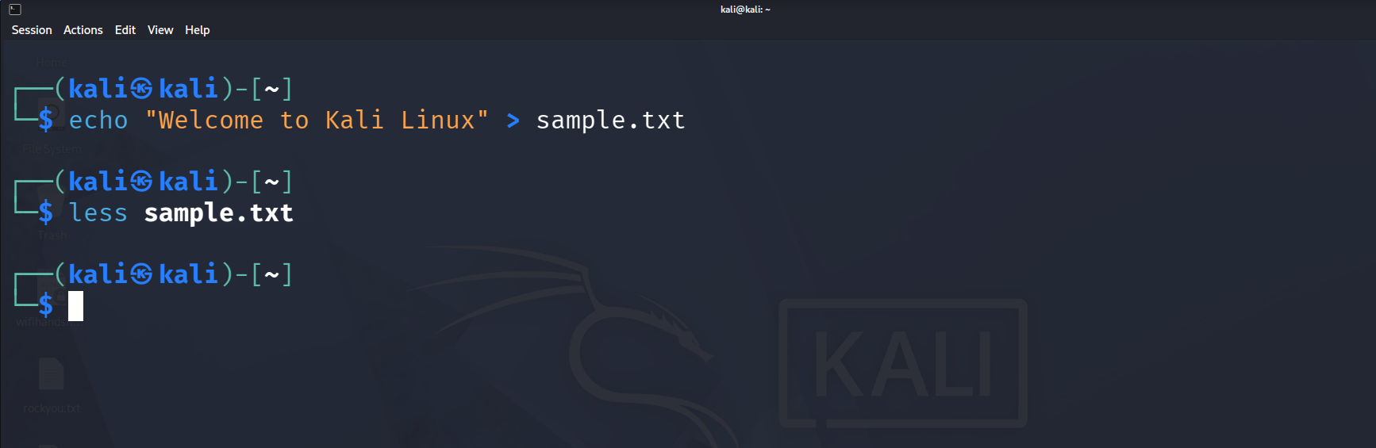

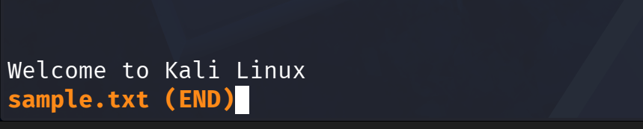 2.MORE COMMAND:-
Command:
more sample.txt
Use:
The more command is also used to display the contents of a text file one page at a time. 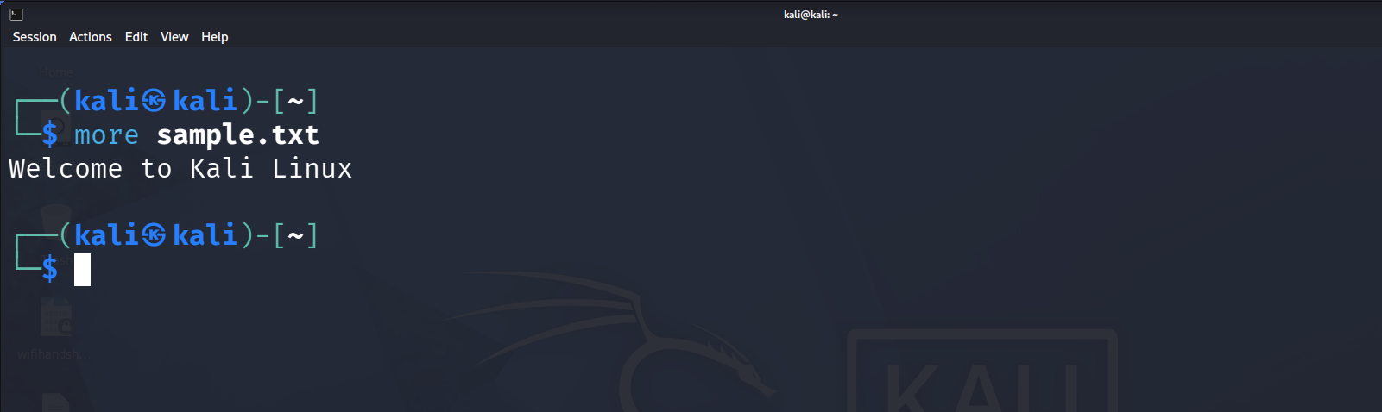

3. VI COMMAND:
Command:
vi sample.txt
Use:
The vi command is used to create, edit, and modify text files in Linux. 